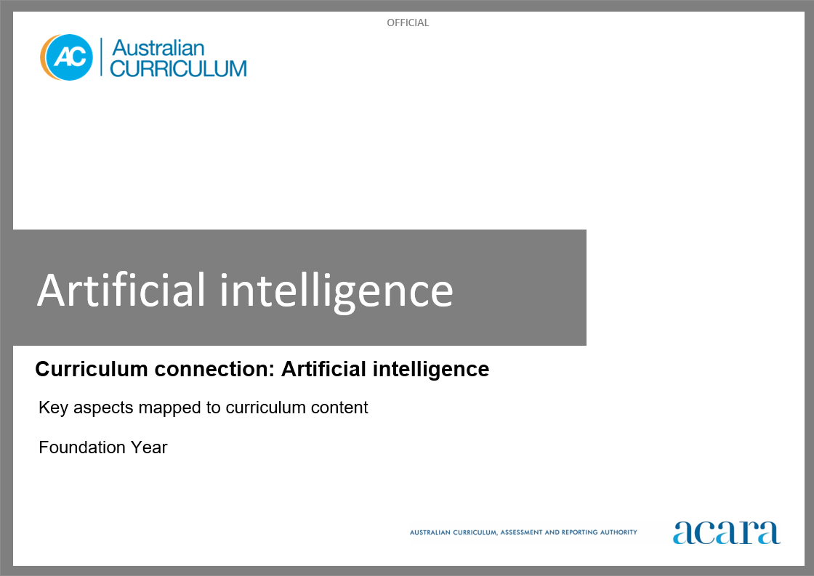

**Copyright and Terms of Use Statement**

**© Australian Curriculum, Assessment and Reporting Authority 2023**

The material published in this work is subject to copyright pursuant to the *Copyright Act 1968* (Cth) and is owned by the Australian Curriculum, Assessment and Reporting Authority (ACARA) (except to the extent that copyright is held by another party, as indicated).

The viewing, downloading, displaying, printing, reproducing (such as by making photocopies) and distributing of these materials is permitted only to the extent permitted by, and is subject to the conditions imposed by, the terms and conditions of using the ACARA website (see, especially, clauses 2, 3 and 4 of those terms and conditions). The terms and conditions can be viewed at [https://www.acara.edu.au/contact-us/copyright](https://aus01.safelinks.protection.outlook.com/?url=https%3A%2F%2Fwww.acara.edu.au%2Fcontact-us%2Fcopyright&data=04%7C01%7CSharon.Foster%40acara.edu.au%7C9931e11fa7684c603e6308d98331bbfb%7C6cf76a3aa824427092003d71673ec678%7C0%7C0%7C637685071906340874%7CUnknown%7CTWFpbGZsb3d8eyJWIjoiMC4wLjAwMDAiLCJQIjoiV2luMzIiLCJBTiI6Ik1haWwiLCJXVCI6Mn0%3D%7C1000&sdata=U5O4Vlbpf271IGmGiMh7fDwU4pLzzAiHpCQFylkp6s4%3D&reserved=0)

**Artificial intelligence (AI): Foundation year**

The following table identifies how the key aspects of understanding how AI works, types of AI, and responsible use and application of AI are evident in content descriptions from across the Australian Curriculum Version 9.0. From this information, teachers can develop a sequential program for learning about AI by connecting the key aspects of learning with learning area and subject-specific content descriptions.

|  |  |  |  |
| --- | --- | --- | --- |
| Foundation Year | | | |
| Key aspect 1: Understanding how AI works | | | |
| Learning area/subject | Strand/sub-strand | Content descriptions | Content elaborations |
| **Digital Technologies** | **Knowledge and understanding**  Data representation | represent data as objects, pictures and symbols  AC9TDIFK02 | * drawing a picture representing each of their family members and their interests, for example drawing one family member with a surfboard and another with a skateboard * using coloured blocks to represent an attribute of people, for example representing students and their sports houses with different coloured blocks * using a symbol to represent an idea, but knowing that the symbol is not the data itself, for example the symbols and colour on both the Australian Aboriginal flag and the Torres Strait Islander flag |
| **Mathematics** | **Algebra** | recognise, copy and continue repeating patterns represented in different ways  AC9MFA01 | * recognising and discussing repeating patterns in images created using dynamic geometric software or a generative artificial intelligence tool, describing what has been repeated in the pattern |
| **Space** | describe the position and location of themselves and objects in relation to other people and objects within a familiar space  AC9MFSP02 | * describing the position of a robotic toy in relation to other objects as it moves around a familiar space; for example, describing the position of a robotic car as being under the desk or next to the chair |
| **Statistics** | collect, sort and compare data represented by objects and images in response to given investigative questions that relate to familiar situations  AC9MFST01 | * role-playing being a robot that sorts objects into groups based on a set of instructions; for example, imitating a robot designed to pack things away in the classroom or an industrial robot programmed to sort products on an assembly line by colour or shape * role-playing, as a class, at training an artificial intelligence system to recognise objects, asking yes/no questions to gather data to make the best guess about the identification of a mystery object * exploring what and how information from the environment is collected and used by First Nations Australians to predict weather events |

|  |  |  |  |
| --- | --- | --- | --- |
| Foundation Year | | | |
| Key aspect 2: Types of AI | | | |
| Learning area/subject | Strand/sub-strand | Content descriptions | Content elaborations |
| **Digital Technologies** | **Knowledge and understanding**  Digital systems | recognise and explore digital systems (hardware and software) for a purpose  AC9TDIFK01 | * recognising digital systems that they interact with at home and school, for example smartphone, laptop or programmable toy * playing with (with guidance) and using different digital systems to explore what they do for a purpose, for example the class speaking to an expert via videoconference * making a model of a digital system, using it in a role-play scenario and describing its features, for example a cardboard box with a keyboard and screen with app icons |
| **Design and Technologies** | **Knowledge and understanding**  Technologies and society | explore how familiar products, services and environments are designed by people  AC9TDEFK01 | * exploring how local delivery services meet different needs of people, for example describing how gift packages can be sent to and from people who live in different locations and how online shopping items arrive at a person’s home |
| **Mathematics** | **Algebra** | recognise, copy and continue repeating patterns represented in different ways  AC9MFA01 | * recognising and discussing repeating patterns in images created using dynamic geometric software or a generative artificial intelligence tool, describing what has been repeated in the pattern |
| **Space** | describe the position and location of themselves and objects in relation to other people and objects within a familiar space  AC9MFSP02 | * describing the position of a robotic toy in relation to other objects as it moves around a familiar space; for example, describing the position of a robotic car as being under the desk or next to the chair |
| **Statistics** | collect, sort and compare data represented by objects and images in response to given investigative questions that relate to familiar situations  AC9MFST01 | * role-playing being a robot that sorts objects into groups based on a set of instructions; for example, imitating a robot designed to pack things away in the classroom or an industrial robot programmed to sort products on an assembly line by colour or shape |

|  |  |  |  |
| --- | --- | --- | --- |
| Foundation Year | | | |
| Key aspect 3: Responsible use and application of AI | | | |
| Learning area/subject | Strand/sub-strand | Content descriptions | Content elaborations |
| **Digital Technologies** | **Processes and production skills**  Privacy and security | identify some data that is personal and owned by them  AC9TDIFP01 | * listing things that contain personal and public data, for example photos of themselves with their family (private) and photos of local community sites (public) * identifying apps and websites they use where their personal data could be made visible, for example photos of themselves on parents' or carers’ social media, or their username being shown to others in online games |
| **Design and Technologies** | **Knowledge and understanding**  Technologies and society | explore how familiar products, services and environments are designed by people  AC9TDEFK01 | * exploring how local delivery services meet different needs of people, for example describing how gift packages can be sent to and from people who live in different locations and how online shopping items arrive at a person’s home |