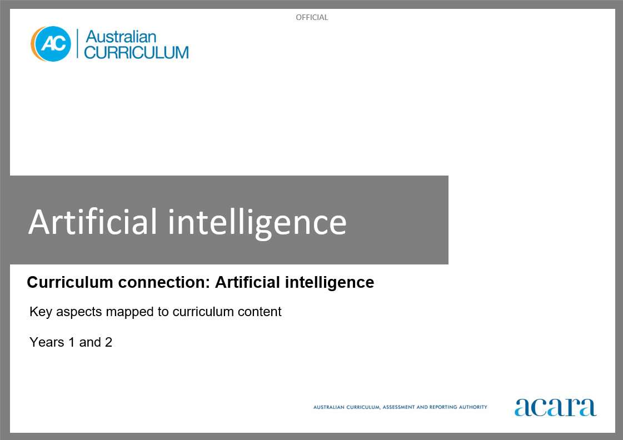

**Copyright and Terms of Use Statement**

**© Australian Curriculum, Assessment and Reporting Authority 2023**

The material published in this work is subject to copyright pursuant to the *Copyright Act 1968* (Cth) and is owned by the Australian Curriculum, Assessment and Reporting Authority (ACARA) (except to the extent that copyright is held by another party, as indicated).

The viewing, downloading, displaying, printing, reproducing (such as by making photocopies) and distributing of these materials is permitted only to the extent permitted by, and is subject to the conditions imposed by, the terms and conditions of using the ACARA website (see, especially, clauses 2, 3 and 4 of those terms and conditions). The terms and conditions can be viewed at [https://www.acara.edu.au/contact-us/copyright](https://aus01.safelinks.protection.outlook.com/?url=https%3A%2F%2Fwww.acara.edu.au%2Fcontact-us%2Fcopyright&data=04%7C01%7CSharon.Foster%40acara.edu.au%7C9931e11fa7684c603e6308d98331bbfb%7C6cf76a3aa824427092003d71673ec678%7C0%7C0%7C637685071906340874%7CUnknown%7CTWFpbGZsb3d8eyJWIjoiMC4wLjAwMDAiLCJQIjoiV2luMzIiLCJBTiI6Ik1haWwiLCJXVCI6Mn0%3D%7C1000&sdata=U5O4Vlbpf271IGmGiMh7fDwU4pLzzAiHpCQFylkp6s4%3D&reserved=0)

**Artificial intelligence (AI): years 1 and 2**

The following table identifies how the key aspects of understanding how AI works, types of AI, and responsible use and application of AI are evident in content descriptions from across the Australian Curriculum Version 9.0. From this information, teachers can develop a sequential program for learning about AI by connecting the key aspects of learning with learning area and subject-specific content descriptions.

|  |  |  |  |
| --- | --- | --- | --- |
| Years 1 and 2 | | | |
| Key aspect 1: Understanding how AI works | | | |
| Learning area/subject | Strand/sub-strand | Content descriptions | Content elaborations |
| **Digital Technologies** | **Knowledge and understanding**  Data representation | represent data as pictures, symbols, numbers and words  AC9TDI2K02 | * recognising that letter combinations represent different phonemes and that words are spelled the same way regardless of the accent of the speaker * recognising the equivalence of different representations of numbers, including words, digits and tally marks * recognising that pictures in First Nations Australians’ seasonal calendars are used to represent and communicate data, such as how the appearance of a flower can signify a connected event or a resource availability, for example how the Gulumoerrgin Peoples from the Darwin region of the Northern Territory understand that the fruiting of freshwater mangrove signifies it is time to harvest magpie geese |
| **Processes and production skills**  Generating and designing | follow and describe algorithms involving a sequence of steps, branching (decisions) and iteration (repetition)  AC9TDI2P02 | * following a short, ordered sequence of steps and making decisions to solve a simple problem, for example follow a recipe or directions to reach a location * describing the steps and decisions (in the correct order) needed to solve a simple problem, for example writing, saying, drawing or photographing the steps needed to make a sandwich * rearranging into the correct order a series of mixed-up pictures that describe a story, for example stories authored and published by First Nations Australians * identifying the steps needed to solve a problem, and understanding when their order is important, for example socks must be put on before shoes but a jumper can be put on before or after shoes * identifying the decisions needed to solve a problem and the next steps to follow in each case, for example if it is raining, take a raincoat, otherwise take a hat * following algorithms that repeat a single step a fixed number of times, for example practise spelling a word 5 times or throw and catch a ball with a partner 10 times |
| **Mathematics – Year 1** | **Algebra** | recognise, continue and create pattern sequences, with numbers, symbols, shapes and objects, formed by skip counting, initially by twos, fives and tens  AC9M1A01 | * role-playing being an industrial robot on an assembly line that packs various items into boxes or packets in groups of five or ten, keeping count of the total number of items produced |
| recognise, continue and create repeating patterns with numbers, symbols, shapes and objects, identifying the repeating unit  AC9M1A02 | * collaboratively creating a repeating geometric pattern using dynamic geometric software or a generative artificial intelligence tool, discussing as a class what instructions they would need to input to produce a repeating pattern |
| **Space** | give and follow directions to move people and objects to different locations within a space  AC9M1SP02 | * creating and following an algorithm consisting of a set of instructions to move an object to a different location; for example, role-playing being a robot and following step-by-step instructions given by another classmate to move from one place to another, only moving as instructed * describing a familiar journey across Country/Place using directional language |
| **Statistics** | acquire and record data for categorical variables in various ways including using digital tools, objects, images, drawings, lists, tally marks and symbols  AC9M1ST01 | * role-playing being a chatbot asking simple yes/no questions and collecting data, and representing the data using virtual manipulatives, stickers or emojis |
| represent collected data for a categorical variable using one-to-one displays and digital tools where appropriate; compare the data using frequencies and discuss the findings  AC9M1ST02 | * discussing what data frequency means in terms of the total count for a particular category and relating the highest frequency to being the most popular category in the collected data |
| **Mathematics – Year 2** | **Algebra** | recognise, describe and create additive patterns that increase or decrease by a constant amount, using numbers, shapes and objects, and identify missing elements in the pattern  AC9M2A01 | * using dynamic geometric software or a generative artificial intelligence tool to create patterns that increase or decrease by a constant amount; for example, creating a geometric pattern using shapes, that adds the same number of elements to the pattern as the pattern increases, and discussing what instructions they input to achieve the output |

|  |  |  |  |
| --- | --- | --- | --- |
|  | **Measurement** | identify, describe and demonstrate quarter, half, three-quarter and full measures of turn in everyday situations  AC9M2M05 | * giving or following directions to locate an object in the room, or provide a pathway through a grid, referring to quarter, half, three-quarter and full turns to the left or right |
| **Space** | locate positions in two-dimensional representations of a familiar space; move positions by following directions and pathways  AC9M2SP02 | * following and creating movement instructions that need to be carried out to move through a 4 x 4 grid mat on the classroom floor or on a computer screen; for example, one forward, 2 to the right and one backwards, and so on to reach a target square; using a robotic toy to follow a path on a street scene on a floor mat, adjusting their directions as they consider the order of their instructions, the direction and how far they want the toy to travel |

|  |  |  |  |
| --- | --- | --- | --- |
| Years 1 and 2 | | | |
| Key aspect 2: Types of AI | | | |
| Learning area/subject | Strand/sub-strand | Content descriptions | Content elaborations |
| **Digital Technologies** | **Knowledge and understanding**  Digital systems | identify and explore digital systems and their components for a purpose  AC9TDI2K01 | * naming and using digital systems that they interact with at home and school, for example using a touchpad to move the cursor on a laptop, or the keyboard to type a simple message on a tablet * using different digital systems to explore what they do and how to use them, for example selecting the camera icon allows them to take photos of things that are a familiar shape |
| **Design and Technologies** | **Knowledge and understanding**  Technologies and society | identify how familiar products, services and environments are designed and produced by people to meet personal or local community needs and sustainability  AC9TDE2K01 | * exploring how particular services meet different needs of people in the community, for example describing why doctors provide medical care to people in many ways including by phone, video conference, plane, car or outdoor clinic * exploring how people come up with new ideas or modify existing designs, for example preventing water wastage when caring for plants |
| **Mathematics – Year 1** | **Algebra** | recognise, continue and create pattern sequences, with numbers, symbols, shapes and objects, formed by skip counting, initially by twos, fives and tens  AC9M1A01 | * role-playing being an industrial robot on an assembly line that packs various items into boxes or packets in groups of five or ten, keeping count of the total number of items produced |
| recognise, continue and create repeating patterns with numbers, symbols, shapes and objects, identifying the repeating unit  AC9M1A02 | * collaboratively creating a repeating geometric pattern using dynamic geometric software or a generative artificial intelligence tool, discussing as a class what instructions they would need to input to produce a repeating pattern |
| **Space** | give and follow directions to move people and objects to different locations within a space  AC9M1SP02 | * creating and following an algorithm consisting of a set of instructions to move an object to a different location; for example, role-playing being a robot and following step-by-step instructions given by another classmate to move from one place to another, only moving as instructed |
| **Statistics** | acquire and record data for categorical variables in various ways including using digital tools, objects, images, drawings, lists, tally marks and symbols  AC9M1ST01 | * role-playing being a chatbot asking simple yes/no questions and collecting data, and representing the data using virtual manipulatives, stickers or emojis |
| **Mathematics – Year 2** | **Space** | locate positions in two-dimensional representations of a familiar space; move positions by following directions and pathways  AC9M2SP02 | * following and creating movement instructions that need to be carried out to move through a 4 x 4 grid mat on the classroom floor or on a computer screen; for example, one forward, 2 to the right and one backwards, and so on to reach a target square; using a robotic toy to follow a path on a street scene on a floor mat, adjusting their directions as they consider the order of their instructions, the direction and how far they want the toy to travel |

|  |  |  |  |
| --- | --- | --- | --- |
|  | **Statistics** | acquire data for categorical variables through surveys, observation, experiment and using digital tools; sort data into relevant categories and display data using lists and tables  AC9M2ST01 | * using familiar software or generative artificial intelligence tools, to construct a survey to collect class data, sorting and interpreting responses, and considering the questions asked and whether they need to be modified to reuse the survey |
| create different graphical representations of data using software where appropriate; compare the different representations, identify and describe common and distinctive features in response to questions  AC9M2ST02 | * using digital tools, including generative artificial intelligence tools, to create picture graphs to represent data using one-to-one correspondence, deciding on an appropriate title for the graph and considering whether the categories of data are appropriate for the context |
| **Science – Year 1** | **Science inquiry**  Planning and conducting | make and record observations, including informal measurements, using digital tools as appropriate  AC9S1I03 | * exploring what an observation is, and different ways to make observations through guided discussion |
| **Science as a human endeavour**  Use and influence of science | describe how people use science in their daily lives, including using patterns to make scientific predictions  AC9S1H01 | * sharing examples of how they have used science knowledge at home, such as by listening to or viewing weather forecasts or observing weather patterns when planning family events or outings, or wearing appropriate clothing for the season |

|  |  |  |  |
| --- | --- | --- | --- |
| **Science – Year 2** | **Science inquiry**  Planning and conducting | make and record observations, including informal measurements, using digital tools as appropriate  AC9S2I03 | * exploring how digital tools can be used to make observations, such as simple clap-o-meter apps that measure sound volume, time lapse digital photography for observing apparent movement of celestial objects or slow-motion videos for observing a vibrating ruler |
| **Science as a human endeavour**  Use and influence of science | describe how people use science in their daily lives, including using patterns to make scientific predictions  AC9S2H01 | * investigating toys and digital tools that are voice activated, and engaging in guided discussion about how some devices use voice patterns to recognise the unique features of an individual’s voice * exploring how sound-activated and voice-activated tools help people manage daily activities such as turning on lights and communicating with others |

|  |  |  |  |
| --- | --- | --- | --- |
| Years 1 and 2 | | | |
| Key aspect 3: Responsible use and application of AI | | | |
| Learning area/subject | Strand/sub-strand | Content descriptions | Content elaborations |
| **Digital Technologies** | **Processes and production skills**  Investigating and defining | investigate simple problems for known users that can be solved with digital systems  AC9TDI2P01 | * exploring how a familiar problem could be solved using a robot, for example creating a model robot using cardboard boxes and explaining how it could be used to clean up the classroom floor at the end of the day |
| **Processes and production skills**  Evaluating | discuss how existing digital systems satisfy identified needs for known users  AC9TDI2P03 | * describing how familiar digital systems meet the needs of individuals, for example how different family members use a tablet for different needs – to play videos, read the news or follow a recipe |
| **Processes and production skills**  Collaborating and managing | use the basic features of common digital tools to create, locate and communicate content  AC9TDI2P04 | * using familiar digital systems to create content with others, for example using presentation software to retell a story |
| use the basic features of common digital tools to share content and collaborate demonstrating agreed behaviours, guided by trusted adults  AC9TDI2P05 | * considering the need for online safety when sharing information, for example recognising that personal information such as a photo can be used inappropriately |
| **Processes and production skills**  Privacy and security | discuss that some websites and apps store their personal data online  AC9TDI2P07 | * discussing the importance of asking permission from a parent or carer before entering personal details online such as address, phone number and date of birth |
| **Design and Technologies** | **Knowledge and understanding**  Technologies and society | identify how familiar products, services and environments are designed and produced by people to meet personal or local community needs and sustainability  AC9TDE2K01 | * exploring how particular services meet different needs of people in the community, for example describing why doctors provide medical care to people in many ways including by phone, video conference, plane, car or outdoor clinic * exploring how people come up with new ideas or modify existing designs, for example preventing water wastage when caring for plants |
| **Science – Year 1** | **Science inquiry**  Planning and conducting | make and record observations, including informal measurements, using digital tools as appropriate  AC9S1I03 | * exploring what an observation is, and different ways to make observations through guided discussion |
| **Science as a human endeavour**  Use and influence of science | describe how people use science in their daily lives, including using patterns to make scientific predictions  AC9S1H01 | * sharing examples of how they have used science knowledge at home, such as by listening to or viewing weather forecasts or observing weather patterns when planning family events or outings, or wearing appropriate clothing for the season |

|  |  |  |  |
| --- | --- | --- | --- |
| **Science – Year 2** | **Science inquiry**  Planning and conducting | make and record observations, including informal measurements, using digital tools as appropriate  AC9S2I03 | * exploring how digital tools can be used to make observations, such as simple clap-o-meter apps that measure sound volume, time lapse digital photography for observing apparent movement of celestial objects or slow-motion videos for observing a vibrating ruler |
| **Science as a human endeavour**  Use and influence of science | describe how people use science in their daily lives, including using patterns to make scientific predictions  AC9S2H01 | * investigating toys and digital tools that are voice activated, and engaging in guided discussion about how some devices use voice patterns to recognise the unique features of an individual’s voice * exploring how sound-activated and voice-activated tools help people manage daily activities such as turning on lights and communicating with others |