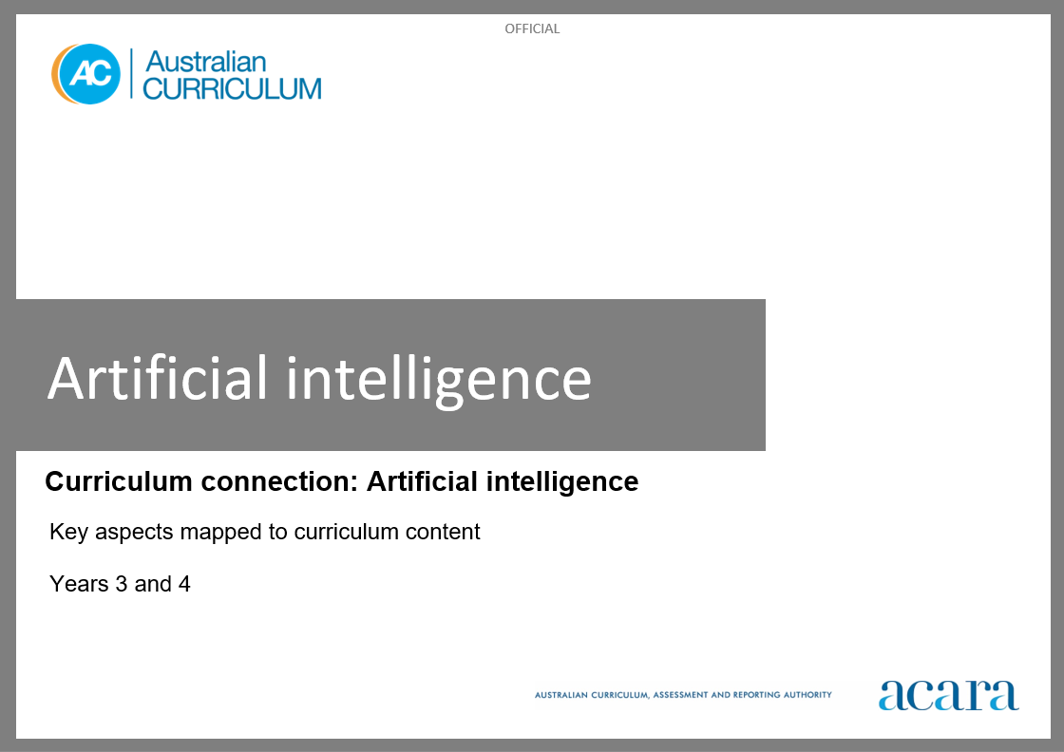

**Copyright and Terms of Use Statement**

**© Australian Curriculum, Assessment and Reporting Authority 2023**

The material published in this work is subject to copyright pursuant to the *Copyright Act 1968* (Cth) and is owned by the Australian Curriculum, Assessment and Reporting Authority (ACARA) (except to the extent that copyright is held by another party, as indicated).

The viewing, downloading, displaying, printing, reproducing (such as by making photocopies) and distributing of these materials is permitted only to the extent permitted by, and is subject to the conditions imposed by, the terms and conditions of using the ACARA website (see, especially, clauses 2, 3 and 4 of those terms and conditions). The terms and conditions can be viewed at [https://www.acara.edu.au/contact-us/copyright](https://aus01.safelinks.protection.outlook.com/?url=https%3A%2F%2Fwww.acara.edu.au%2Fcontact-us%2Fcopyright&data=04%7C01%7CSharon.Foster%40acara.edu.au%7C9931e11fa7684c603e6308d98331bbfb%7C6cf76a3aa824427092003d71673ec678%7C0%7C0%7C637685071906340874%7CUnknown%7CTWFpbGZsb3d8eyJWIjoiMC4wLjAwMDAiLCJQIjoiV2luMzIiLCJBTiI6Ik1haWwiLCJXVCI6Mn0%3D%7C1000&sdata=U5O4Vlbpf271IGmGiMh7fDwU4pLzzAiHpCQFylkp6s4%3D&reserved=0)

**Artificial intelligence (AI): years 3 and 4**

The following table identifies how the key aspects of understanding how AI works, types of AI and responsible use and application of AI are evident in content descriptions from across the Australian Curriculum Version 9.0. From this information, teachers can develop a sequential program for learning about AI by connecting the key aspects of learning with learning area and subject-specific content descriptions.

|  |  |  |  |
| --- | --- | --- | --- |
| Years 3 and 4 | | | |
| Key aspect 1: Understanding how AI works | | | |
| Learning area/subject | Strand/sub-strand | Content descriptions | Content elaborations |
| **Digital Technologies** | **Knowledge and understanding**  Data representation | recognise different types of data and explore how the same data can be represented differently depending on the purpose  AC9TDI4K03 | * describing different types of data and how they can be used, for example numbers, letters, symbols and pictures * explaining how the same data can be represented in different ways and why some representations are better than others in certain contexts, for example four vs 4 vs IV vs I I I I vs *quatre* and that numerals are better for calculation than words |
| **Processes and production skills**  Generating and designing | follow and describe algorithms involving sequencing, comparison operators (branching) and iteration  AC9TDI4P02 | * following the steps and decisions of algorithms and knowing what step they are up to, for example following rules to form the past tense of regular verbs such as ‘create’ to ‘created’, ‘try’ to ‘tried’ and ‘cook’ to ‘cooked’ and checking off items on a list as they are completed * describing algorithms using representations such as a list of steps or a diagram, for example drawing a diagram of a recipe involving decisions * understanding there can be more than one sequence of steps to solve a problem, some are better than others, and the steps should be unambiguous, for example describing 2 different ways to get to the same location * describing the decisions needed to solve a problem, including numerical and text comparisons, for example if the UV index is above 3, put on sunscreen and a hat * describing algorithms that repeat steps a fixed number of times, for example calculating multiplication using repeated addition, where the sum changes in each iteration |
|  | **Processes and production skills**  Producing and implementing | implement simple algorithms as visual programs involving control structures and input  AC9TDI4P04 | * writing programs that take input from the user or environment, for example asking the user for their name and displaying it or sensing the temperature from the environment to make a decision * writing programs that make decisions involving comparison, for example comparing whether the temperature is above 25 degrees Celsius to label the weather hot or cold |
| **Mathematics – Year 3** | **Number** | follow and create algorithms involving a sequence of steps and decisions to investigate numbers; describe any emerging patterns  AC9M3N07 | * following or creating an algorithm to generate number patterns formed by doubling and halving using technology to assist where appropriate; identifying and describing emerging patterns * following or creating an algorithm that determines whether a given number is a multiple of 2,5 or 10, identifying and discussing emerging patterns * creating an algorithm as a set of instructions that a classmate can follow to generate multiples of 3 using the rule “To multiply by 3 you double the number and add on one more of the number”; for example, for 3 threes you double 3 and add on 3 to get 9, for 3 fours you double 4 and add one more 4 to get 12 ... * creating a sorting algorithm that will sort a collection of 5 cent and 10 cent coins and providing the total value of the collection by applying knowledge of multiples of 5 and 10 |
| **Space** | interpret and create two-dimensional representations of familiar environments, locating key landmarks and objects relative to each other  AC9M3SP02 | * creating a two-dimensional plan of the school on a floor mat, representing key buildings and landmarks, then programming a robot to move to different locations within the space |

|  |  |  |  |
| --- | --- | --- | --- |
|  | **Probability** | identify practical activities and everyday events that involve chance; describe possible outcomes and events as ‘likely’ or ‘unlikely’ and identify some events as ‘certain’ or ‘impossible’ explaining reasoning  AC9M3P01 | * role-playing being a chatbot or virtual assistant responding to a user about the likelihood of events; for example, using preset questions on cards relating to the likelihood of events, role-playing in pairs responding as a virtual assistant, giving reasons for their response |
| conduct repeated chance experiments; identify and describe possible outcomes, record the results, recognise and discuss the variation  AC9M3P02 | * discussing how the process of conducting repeated chance experiments is crucial in the training of artificial intelligence applications like recommendation systems; for example, if they were building a recommendation system for an online shopping website, they could conduct repeated experiments by tracking user interactions over time |
| **Mathematics – Year 4** | **Number** | follow and create algorithms involving a sequence of steps and decisions that use addition or multiplication to generate sets of numbers; identify and describe any emerging patterns  AC9M4N09 | * creating an algorithm that will generate number sequences involving multiples of one to 10 using digital tools to assist, identifying and explaining emerging patterns, recognising that number sequences can be extended indefinitely * creating a basic flow chart that represents an algorithm that will generate a sequence of numbers using multiplication by a constant term; using a calculator to model and follow the algorithm, and record the sequence of numbers generated; checking results and describing any emerging patterns * using a multiplication formula in a spreadsheet and the “fill down” function to generate a sequence of numbers; for example, entering the number one in the cell A1, using “fill down” to cell A100, entering the formula “ = A1*4 “ in the cell B1 and using the “fill down” function to generate a sequence of 100 numbers; describing emerging patterns * creating an algorithm that will generate number sequences involving multiples of one to 10 using digital tools to assist, identifying and explaining emerging patterns, recognising that number sequences can be extended indefinitely |
| **Space** | create and interpret grid reference systems using grid references and directions to locate and describe positions and pathways  AC9M4SP02 | * simulating the actions of autonomous or robotic vehicles moving to different positions within a grid, using grid references and directional language to describe positions and pathways; for example, imitating an autonomous mobile warehouse robot moving stock to different aisles, using grid reference systems to locate positions |
| **Statistics** | acquire data for categorical and discrete numerical variables to address a question of interest or purpose using digital tools; represent data using many-to-one pictographs, column graphs and other displays or visualisations; interpret and discuss the information that has been created  AC9M4ST01 | * co-creating an online poll to survey students in their school about a topic of interest, exploring how online platforms use generative artificial intelligence and other digital tools to make word clouds, quizzes, polls and graphical representations of the collected data |

|  |  |  |  |
| --- | --- | --- | --- |
|  | **Statistics** | analyse the effectiveness of different displays or visualisations in illustrating and comparing data distributions, then discuss the shape of distributions and the variation in the data  AC9M4ST02 | * discussing how analysing data distributions and visualising data is a fundamental step in data preparation for AI developers |
| **Probability** | describe possible everyday events and the possible outcomes of chance experiments and order outcomes or events based on their likelihood of occurring; identify independent or dependent events  AC9M4P01 | * exploring how ordering outcomes based on their likelihood of occurring is an essential component of early warning systems that use artificial intelligence to make decisions, such as natural disaster warning systems * discussing how likelihood relates to the decisions an artificial intelligence tool makes when generating predictive text; for example, discussing which word would most likely come next in a sentence, then refining the decision as the first letter is revealed |
| conduct repeated chance experiments to observe relationships between outcomes; identify and describe the variation in results  AC9M4P02 | * recording and ordering the outcomes of experiments using different physical or virtual random generators such as coins, dice and a variety of spinners, and discussing how AI systems use random generators to train algorithms |

|  |  |  |  |
| --- | --- | --- | --- |
| Years 3 and 4 | | | |
| Key aspect 2: Types of AI | | | |
| Learning area/subject | Strand/sub-strand | Content descriptions | Content elaborations |
| **Digital Technologies** | **Knowledge and understanding**  Digital systems | explore and describe a range of digital systems and their peripherals for a variety of purposes  AC9TDI4K01 | * exploring how they can use digital systems differently depending on the task, recognising that many digital systems can perform multiple tasks, for example a student can use a tablet to take photos, record audio and find information to create a presentation |
| explore transmitting different types of data between digital systems  AC9TDI4K02 | * exploring examples of different types of data that can be transferred between digital systems, for example streaming music or making a video call to a friend using a smartphone |
| **Design and Technologies** | **Knowledge and understanding**  Technologies and society | examine design and technologies occupations and factors including sustainability that impact on the design of products, services and environments to meet community needs  AC9TDE4K01 | * exploring how design and technologies occupations in the local area (urban, suburban, regional or rural) meet community needs, for example bakers, builders, engineers, farmers, seafood industry workers, mechanics, radiographers, textile designers and others in science, technology, engineering and mathematics roles * examining the suitability of a service or system and proposing improvements, for example a water-saving system for a bathroom at home or school, traffic management systems to reduce traffic jams around the school, remote and regional services including medical services |
| **Mathematics – Year 3** | **Space** | interpret and create two-dimensional representations of familiar environments, locating key landmarks and objects relative to each other  AC9M3SP02 | * creating a two-dimensional plan of the school on a floor mat, representing key buildings and landmarks, then programming a robot to move to different locations within the space |
| **Statistics** | create and compare different graphical representations of data sets including using software where appropriate; interpret the data in terms of the context  AC9M3ST02 | * using digital tools, including generative artificial intelligence tools or graphing software, to construct graphs of data acquired through experiments or observation and interpreting the data and making inferences; for example, graphing data from a science experiment and interpreting the results |
| **Probability** | identify practical activities and everyday events that involve chance; describe possible outcomes and events as ‘likely’ or ‘unlikely’ and identify some events as ‘certain’ or ‘impossible’ explaining reasoning  AC9M3P01 | * role-playing being a chatbot or virtual assistant responding to a user about the likelihood of events; for example, using preset questions on cards relating to the likelihood of events, role-playing in pairs responding as a virtual assistant, giving reasons for their response |
| conduct repeated chance experiments; identify and describe possible outcomes, record the results, recognise and discuss the variation  AC9M3P02 | * discussing how the process of conducting repeated chance experiments is crucial in the training of artificial intelligence applications like recommendation systems; for example, if they were building a recommendation system for an online shopping website, they could conduct repeated experiments by tracking user interactions over time |

|  |  |  |  |
| --- | --- | --- | --- |
| **Mathematics – Year 4** | **Space** | create and interpret grid reference systems using grid references and directions to locate and describe positions and pathways  AC9M4SP02 | * simulating the actions of autonomous or robotic vehicles moving to different positions within a grid, using grid references and directional language to describe positions and pathways; for example, imitating an autonomous mobile warehouse robot moving stock to different aisles, using grid reference systems to locate positions |
| recognise line and rotational symmetry of shapes and create symmetrical patterns and pictures, using dynamic geometric software where appropriate  AC9M4SP03 | * using dynamic geometric software or generative artificial intelligence tool to manipulate shapes and create symmetrical patterns; for example, creating tessellation patterns that are symmetrical and discussing any line or rotational symmetries |
| **Statistics** | acquire data for categorical and discrete numerical variables to address a question of interest or purpose, using digital tools; represent data using many-to-one pictographs, column graphs and other displays or visualisations; interpret and discuss the information that has been created  AC9M4ST01 | * co-creating an online poll to survey students in their school about a topic of interest, exploring how online platforms use generative artificial intelligence and other digital tools to make word clouds, quizzes, polls and graphical representations of the collected data |
| **Probability** | describe possible everyday events and the possible outcomes of chance experiments and order outcomes or events based on their likelihood of occurring; identify independent or dependent events  AC9M4P01 | * exploring how ordering outcomes based on their likelihood of occurring is an essential component of early warning systems that use artificial intelligence to make decisions, such as natural disaster warning systems |
| **Science – Year 3** | **Science inquiry**  Planning and conducting | follow procedures to make and record observations, including making formal measurements using familiar scaled instruments and using digital tools as appropriate  AC9S3I03 | * using appropriate equipment to make and record observations, such as digital cameras, video, voice recorders and scaled instruments with appropriate increments |
| **Science – Year 4** | **Science inquiry**  Planning and conducting | follow procedures to make and record observations, including making formal measurements using familiar scaled instruments and using digital tools as appropriate  AC9S4I03 | * using appropriate equipment to make and record observations, such as digital cameras, video, voice recorders and familiar scaled instruments with appropriate increments |

|  |  |  |  |
| --- | --- | --- | --- |
| Years 3 and 4 | | | |
| Key aspect 3: Responsible use and application of AI | | | |
| Learning area/subject | Strand/sub-strand | Content descriptions | Content elaborations |
| **Digital Technologies** | **Processes and production skills**  Investigating and defining | define problems with given design criteria and by co-creating user stories  AC9TDI4P01 | * using responses to guiding questions to write a user story, for example a family member wants a way of entertaining their puppy when they are at school to stop it digging holes * co-creating a user story using a template such as ‘A <type of user> has <some goal> so that <some reason>’, for example ‘a sports team wants to access league rankings online so that they can see their progress’ |
| **Processes and production skills**  Generating and designing | generate, communicate and compare designs  AC9TDI4P03 | * ideating multiple design ideas and comparing them against user stories, for example as a class, discussing the needs identified from the user story and brainstorming multiple design ideas (accepting all suggestions as possibilities) |
| **Processes and production skills**  Producing and implementing | implement simple algorithms as visual programs involving control structures and input  AC9TDI4P04 | * writing programs that take input from the user or environment, for example asking the user for their name and displaying it or sensing the temperature from the environment to make a decision * writing programs that make decisions involving comparison, for example comparing whether the temperature is above 25 degrees Celsius to label the weather hot or cold |
| **Processes and production skills**  Evaluating | discuss how existing and student solutions satisfy the design criteria and user stories  AC9TDI4P05 | * describing the way familiar digital systems allow the user to perform tasks, for example discussing how a family member could place an order online for something they cannot buy locally * discussing how a digital solution meets the different needs of users, for example how maps help people to locate places in the community or interactive store directories help shoppers to find a particular store in a shopping centre |

|  |  |  |  |
| --- | --- | --- | --- |
|  | **Processes and production skills**  Collaborating and managing | use the core features of common digital tools to create, locate and communicate content, following agreed conventions  AC9TDI4P06 | * discussing and creating as a class a set of steps they need to follow to safely find information online * using an online search engine to find suitable sources to create and communicate information, following agreed steps, for example creating a presentation on life cycles * grouping, naming and itemising objects using a logical hierarchy, for example creating a section of a virtual library or virtual supermarket using folders and files * using autocomplete features in text authoring tools; for example, using suggestions in a word processor to complete words or sentences, or using predictive text in SMS or messaging apps |
| use the core features of common digital tools to share content, plan tasks, and collaborate, following agreed behaviours, supported by trusted adults  AC9TDI4P07 |  |
| **Processes and production skills**  Privacy and security | identify what personal data is stored and shared in their online accounts and discuss any associated risks  AC9TDI4P09 | * discussing how personal data stored in online accounts forms a person’s digital identity and can reveal detailed information about people, for example looking at photographs of themselves, friends or fictional characters that reveal details about a person's location, habits or home |

|  |  |  |  |
| --- | --- | --- | --- |
| **Design and Technologies** | **Knowledge and understanding**  Technologies and society | examine design and technologies occupations and factors including sustainability that impact on the design of products, services and environments to meet community needs  AC9TDE4K01 | * exploring how design and technologies occupations in the local area (urban, suburban, regional or rural) meet community needs, for example bakers, builders, engineers, farmers, seafood industry workers, mechanics, radiographers, textile designers and others in science, technology, engineering and mathematics roles * examining the suitability of a service or system and proposing improvements, for example a water-saving system for a bathroom at home or school, traffic management systems to reduce traffic jams around the school, remote and regional services including medical services |
| **Science – Year 3** | **Science inquiry**  Planning and conducting | follow procedures to make and record observations, including making formal measurements using familiar scaled instruments and using digital tools as appropriate  AC9S3I03 | * using appropriate equipment to make and record observations, such as digital cameras, video, voice recorders and scaled instruments with appropriate increments |
| **Science as a human endeavour**  Nature and development of science | examine how people use data to develop scientific explanations  AC9S3H01 | * exploring how farmers use soil tests to monitor and manage the health of farms |

|  |  |  |  |
| --- | --- | --- | --- |
| **Science – Year 4** | **Science inquiry**  Planning and conducting | follow procedures to make and record observations, including making formal measurements using familiar scaled instruments and using digital tools as appropriate  AC9S4I03 | * using appropriate equipment to make and record observations, such as digital cameras, video, voice recorders and familiar scaled instruments with appropriate increments |
|  | **Science as a human endeavour**  Nature and development of science | examine how people use data to develop scientific explanations  AC9S4H01 | * investigating how ecologists use food chain data to develop explanations for population decline of native species such as the Richmond birdwing butterfly, and to develop strategies to increase their population * explore how hydrologists use rainfall and water use data to explain the amount of water flowing in rivers and why this changes over time |