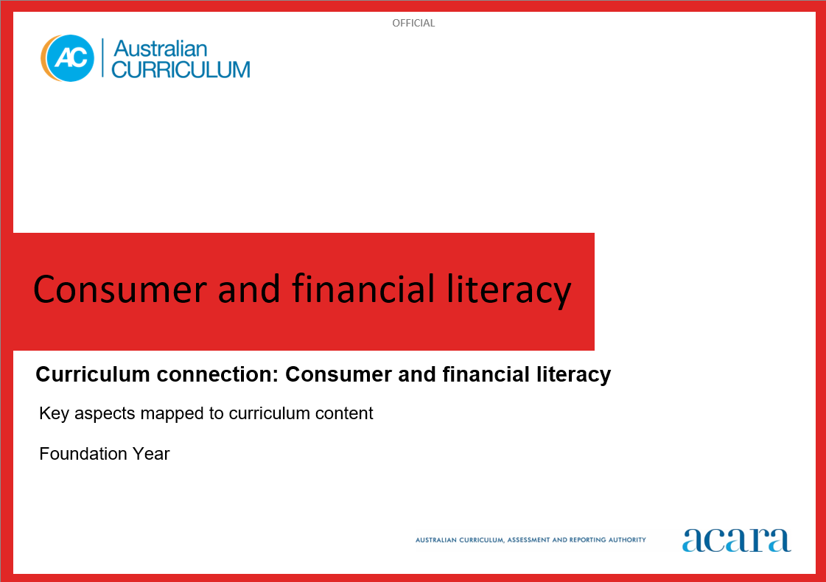

**Copyright and Terms of Use Statement**

**© Australian Curriculum, Assessment and Reporting Authority 2024**

The material published in this work is subject to copyright pursuant to the *Copyright Act 1968* (Cth) and is owned by the Australian Curriculum, Assessment and Reporting Authority (ACARA) (except to the extent that copyright is held by another party, as indicated).

The viewing, downloading, displaying, printing, reproducing (such as by making photocopies) and distributing of these materials is permitted only to the extent permitted by, and is subject to the conditions imposed by, the terms and conditions of using the ACARA website (see, especially, clauses 2, 3 and 4 of those terms and conditions). The terms and conditions can be viewed at [https://www.acara.edu.au/contact-us/copyright](https://aus01.safelinks.protection.outlook.com/?url=https%3A%2F%2Fwww.acara.edu.au%2Fcontact-us%2Fcopyright&data=04%7C01%7CSharon.Foster%40acara.edu.au%7C9931e11fa7684c603e6308d98331bbfb%7C6cf76a3aa824427092003d71673ec678%7C0%7C0%7C637685071906340874%7CUnknown%7CTWFpbGZsb3d8eyJWIjoiMC4wLjAwMDAiLCJQIjoiV2luMzIiLCJBTiI6Ik1haWwiLCJXVCI6Mn0%3D%7C1000&sdata=U5O4Vlbpf271IGmGiMh7fDwU4pLzzAiHpCQFylkp6s4%3D&reserved=0)

**CONSUMER AND FINANCIAL LITERACY**

|  |  |
| --- | --- |
| Key Aspects | |
| Personal finance | Understanding and being able to effectively manage your personal finance in a modern world requires a combination of knowledge, skills and dispositions to make informed, responsible financial decisions. Having financial confidence and being adaptable to change, as the digital revolution influences the way we manage our money day-to-day, enables us to make sound financial choices and set solid financial goals for the future.  In this key aspect, students explore the knowledge and skills required to make personal financial decisions. Students learn about the difference between wants and needs, and understand spending, saving, investing and borrowing money. They have opportunities to engage with money and other financial transactions such as those conducted online and with digital systems. They understand varied payment methods such as cash, debit cards, credit cards, gift cards, buy now and pay later schemes, in-app and online payments.  Students understand a range of concepts related to finance such as earning money (including payslips, tax and superannuation), budgeting, spending and saving priorities (including loans, subscriptions and payment plans), operating securely and safely with their money online, and the importance of long-term planning. |
| Roles, rights and responsibilities | Awareness of the roles, rights and responsibilities that relate to consumer and financial literacy fosters students’ understanding of their rights and responsibilities as consumers. This can help students make fair and informed decisions about their future finances. As consumers, they also have a right to privacy. They need to adopt protective strategies and mitigate risk when sharing or exchanging personal information and financial data.  In this key aspect, students explore how governments, financial institutions, employers, consumer and financial literacy service providers and other key stakeholders have a responsibility to consumers. Through understanding the different roles, rights and responsibilities of each party, students are empowered to make informed, responsible financial decisions, recognise scams and plan their future finances. |
| Economic environment | Developing consumer and financial capability in young people is a strong investment in Australia’s social and economic prosperity. Economic awareness includes knowledge of basic economic principles and how factors such as inflation, the cost of living and interest rates impact personal finances.  In this key aspect, students explore the complexity of the economic environment and how it is globally connected. They learn how it can be affected by geopolitical shifts, technological change and global events.  Students identify economic indicators such as economic growth rates, interest rates, unemployment trends, inflation rates and sustainability indexes. They understand how these influence government economic decision-making. They understand how the Australian government may intervene in response to economic environment changes, such as responding to a decline in Gross Domestic Product (GDP). |
| Enterprise | In an increasingly complex, globalised and rapidly changing world, it is critical for every young Australian to not only be able to cope with life’s challenges but also to flourish as a financially literate and enterprising citizen in the 21st century. All young people need opportunities to develop financial and enterprising capabilities that enable them to confidently operate in a complex, information-rich financial world.  In this key aspect, students explore enterprise skills and how these can be used to create innovative approaches to processes and solutions. They also explore how these skills can contribute to success in their future careers. They have opportunities to develop these skills including problem-solving, decision-making, communication, initiative, resilience, adaptability and commercial awareness through rich connections between learning area content, the general capabilities and authentic financial contexts.  Students explore different types of enterprise including business enterprise and social enterprise. They identify processes that businesses use to create competitive advantage, including using digital tools and digital systems, optimising costs and managing the workforce to improve productivity. |

For more information:

<https://v9.australiancurriculum.edu.au/content/acara-curriculum/au/en/teacher-resources/understand-this-curriculum-connection/consumer-and-financial-literacy/>

**CONSUMER AND FINANCIAL LITERACY: Foundation year**

The following table identifies how the key aspects of consumer and financial literacy are evident in content descriptions from across the Australian Curriculum Version 9.0. From this information, teachers can develop a sequential program for learning about consumer and financial literacy by connecting the key aspects of learning with learning area and subject-specific content descriptions.

|  |  |  |  |
| --- | --- | --- | --- |
| Foundation Year | | | |
| Key aspect 1: Personal finance | | | |
| Learning area/subject | Strand/sub-strand | Content descriptions | Content elaborations |
| **Mathematics** | **Number** | represent practical situations involving addition, subtraction and quantification with physical and virtual materials and use counting or subitising strategies  AC9MFN05 | * role playing or actively engaging in situations that involve quantifying or comparing collections of items or simple money transactions; for example, “Do we have enough scissors for our group so that each person has their own pair?”; role-playing using $1 coins to pay for items in a shop where items are priced in whole dollars |
| represent practical situations involving equal sharing and grouping with physical and virtual materials and use counting or subitising strategies  AC9MFN06 | * representing situations that involve counting several items; for example, 9 beads or 6 $1 coins, and sharing them equally between 3 people by subitising or counting each group by ones to decide how many beads or coins each person will receive |
| **Digital Technologies** | **Knowledge and understanding**  Digital systems | recognise and explore digital systems (hardware and software) for a purpose  AC9TDIFK01 | * playing with (with guidance) and using different digital systems to explore what they do for a purpose, for example the class speaking to an expert via videoconference * making a model of a digital system, using it in a role-play scenario and describing its features, for example a cardboard box with a keyboard and screen with app icons |

|  |  |  |  |
| --- | --- | --- | --- |
| Foundation Year | | | |
| Key aspect 2: Roles, rights and responsibilities | | | |
| Learning area/subject | Strand/sub-strand | Content descriptions | Content elaborations |
| **Mathematics** | **Number** | represent practical situations involving equal sharing and grouping with physical and virtual materials and use counting or subitising strategies  AC9MFN06 | * representing situations that involve counting several items; for example, 9 beads or 6 $1 coins, and sharing them equally between 3 people by subitising or counting each group by ones to decide how many beads or coins each person will receive |
| **Digital Technologies** | **Process and production skills**  Privacy and security | identify some data that is personal and owned by them  AC9TDIFP01 | * listing things that contain personal and public data, for example photos of themselves with their family (private) and photos of local community sites (public) * identifying apps and websites they use where their personal data could be made visible, for example photos of themselves on parents' or carers’ social media, or their username being shown to others in online games |