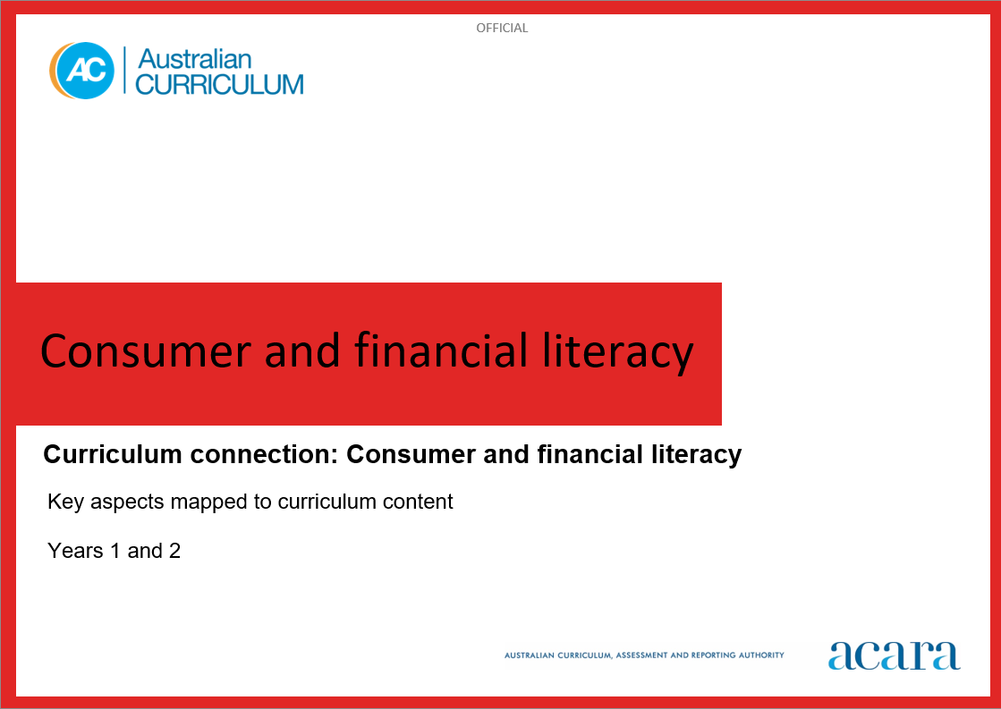

**Copyright and Terms of Use Statement**

**© Australian Curriculum, Assessment and Reporting Authority 2024**

The material published in this work is subject to copyright pursuant to the *Copyright Act 1968* (Cth) and is owned by the Australian Curriculum, Assessment and Reporting Authority (ACARA) (except to the extent that copyright is held by another party, as indicated).

The viewing, downloading, displaying, printing, reproducing (such as by making photocopies) and distributing of these materials is permitted only to the extent permitted by, and is subject to the conditions imposed by, the terms and conditions of using the ACARA website (see, especially, clauses 2, 3 and 4 of those terms and conditions). The terms and conditions can be viewed at [https://www.acara.edu.au/contact-us/copyright](https://aus01.safelinks.protection.outlook.com/?url=https%3A%2F%2Fwww.acara.edu.au%2Fcontact-us%2Fcopyright&data=04%7C01%7CSharon.Foster%40acara.edu.au%7C9931e11fa7684c603e6308d98331bbfb%7C6cf76a3aa824427092003d71673ec678%7C0%7C0%7C637685071906340874%7CUnknown%7CTWFpbGZsb3d8eyJWIjoiMC4wLjAwMDAiLCJQIjoiV2luMzIiLCJBTiI6Ik1haWwiLCJXVCI6Mn0%3D%7C1000&sdata=U5O4Vlbpf271IGmGiMh7fDwU4pLzzAiHpCQFylkp6s4%3D&reserved=0)

**CONSUMER AND FINANCIAL LITERACY**

|  |  |
| --- | --- |
| Key Aspects | |
| Personal finance | Understanding and being able to effectively manage your personal finance in a modern world requires a combination of knowledge, skills and dispositions to make informed, responsible financial decisions. Having financial confidence and being adaptable to change, as the digital revolution influences the way we manage our money day-to-day, enables us to make sound financial choices and set solid financial goals for the future.  In this key aspect, students explore the knowledge and skills required to make personal financial decisions. Students learn about the difference between wants and needs, and understand spending, saving, investing and borrowing money. They have opportunities to engage with money and other financial transactions such as those conducted online and with digital systems. They understand varied payment methods such as cash, debit cards, credit cards, gift cards, buy now and pay later schemes, in-app and online payments.  Students understand a range of concepts related to finance such as earning money (including payslips, tax and superannuation), budgeting, spending and saving priorities (including loans, subscriptions and payment plans), operating securely and safely with their money online, and the importance of long-term planning. |
| Roles, rights and responsibilities | Awareness of the roles, rights and responsibilities that relate to consumer and financial literacy fosters students’ understanding of their rights and responsibilities as consumers. This can help students make fair and informed decisions about their future finances. As consumers, they also have a right to privacy. They need to adopt protective strategies and mitigate risk when sharing or exchanging personal information and financial data.  In this key aspect, students explore how governments, financial institutions, employers, consumer and financial literacy service providers and other key stakeholders have a responsibility to consumers. Through understanding the different roles, rights and responsibilities of each party, students are empowered to make informed, responsible financial decisions, recognise scams and plan their future finances. |
| Economic environment | Developing consumer and financial capability in young people is a strong investment in Australia’s social and economic prosperity. Economic awareness includes knowledge of basic economic principles and how factors such as inflation, the cost of living and interest rates impact personal finances.  In this key aspect, students explore the complexity of the economic environment and how it is globally connected. They learn how it can be affected by geopolitical shifts, technological change and global events.  Students identify economic indicators such as economic growth rates, interest rates, unemployment trends, inflation rates and sustainability indexes. They understand how these influence government economic decision-making. They understand how the Australian government may intervene in response to economic environment changes, such as responding to a decline in Gross Domestic Product (GDP). |
| Enterprise | In an increasingly complex, globalised and rapidly changing world, it is critical for every young Australian to not only be able to cope with life’s challenges but also to flourish as a financially literate and enterprising citizen in the 21st century. All young people need opportunities to develop financial and enterprising capabilities that enable them to confidently operate in a complex, information-rich financial world.  In this key aspect, students explore enterprise skills and how these can be used to create innovative approaches to processes and solutions. They also explore how these skills can contribute to success in their future careers. They have opportunities to develop these skills including problem-solving, decision-making, communication, initiative, resilience, adaptability and commercial awareness through rich connections between learning area content, the general capabilities and authentic financial contexts.  Students explore different types of enterprise including business enterprise and social enterprise. They identify processes that businesses use to create competitive advantage, including using digital tools and digital systems, optimising costs and managing the workforce to improve productivity. |

For more information:

<https://v9.australiancurriculum.edu.au/content/acara-curriculum/au/en/teacher-resources/understand-this-curriculum-connection/consumer-and-financial-literacy/>

**CONSUMER AND FINANCIAL LITERACY: years 1 and 2**

The following tables identify how the key aspects of consumer and financial literacy are evident in content descriptions from across the Australian Curriculum Version 9.0. From this information, teachers can develop a sequential program for learning about consumer and financial literacy by connecting the key aspects of learning with learning area and subject-specific content descriptions. *NB: Banded subjects will appear in both Year 1 and Year 2 tables.*

|  |  |  |  |  |
| --- | --- | --- | --- | --- |
| Year 1 | | | | |
| Key aspect 1: Personal finance | | | | |
| Learning area/subject | | Strand/sub-strand | Content descriptions | Content elaborations |
| **HASS** | | **Knowledge and understanding**  History | continuity and change between aspects of their daily lives and their parents’ and grandparents’ childhoods  AC9HS1K02 | * comparing what has changed in daily life over time; for example, homes, family traditions, diverse religious and cultural practices, leisure, school life, rules, and shopping/consumer habits |
| **Skills**  Interpreting, analysing and evaluating | discuss perspectives related to objects, people, places and events  AC9HS1S04 | * comparing students’ daily lives with those of their parents, grandparents, elders or a familiar older person and identifying which aspects of the past they would or would not want to experience |
| **Skills**  Concluding and decision-making | draw conclusions and make proposals  AC9HS1S05 | * using collected information (for example, from stories told by parents, grandparents, elders or familiar older people; from comparison of objects; from geographic pictures) to make conclusions about continuity and change over time (for example, how family roles, occupations and/or technologies have changed or remained the same) and how places change (for example, because of the seasons) |
| **Mathematics** | | **Number** | quantify sets of objects, to at least 120, by partitioning collections into equal groups using number knowledge and skip counting  AC9M1N03 | * counting a large collection of Australian $1 coins by stacking them into piles of 10, skip counting in tens and including any leftover coins to determine the total value |
| use mathematical modelling to solve practical problems involving additive situations, including simple money transactions; represent the situations with diagrams, physical and virtual materials, and use calculation strategies to solve the problem  AC9M1N05 | * modelling simple money problems involving addition and subtraction using whole dollar amounts; for example, setting up a shop and role-playing practical problems of buying and selling of goods, using addition and subtraction with play money and prices in whole dollar amounts; solving the problem “I had $14 and was given $15 for my birthday” using addition to answer the problem |
| use mathematical modelling to solve practical problems involving equal sharing and grouping; represent the situations with diagrams, physical and virtual materials, and use calculation strategies to solve the problem  AC9M1N06 | * modelling money problems involving equal sharing; for example, sorting coins from a money box according to their denominations, sharing the coins equally between 4 people, and using counting or subitising to ensure they have equal amounts of each denomination |
| **Algebra** | recognise, continue and create pattern sequences, with numbers, symbols, shapes and objects, formed by skip counting, initially by twos, fives and tens  AC9M1A01 | * counting by twos, fives, or tens to determine how much money is in a collection of coins or notes of the same denomination; for example, 5 cent, 10 cent and $2 coins or $5 and $10 notes |
| **Digital Technologies** | | **Knowledge and understanding**  Digital systems | identify and explore digital systems and their components for a purpose  AC9TDI2K01 | * exploring digital systems to better understand how they are used to provide communities with essential services, for example looking at the systems and components that allow First Nations Australians in communities classified as remote to watch their favourite television shows * using different digital systems to explore what they do and how to use them, for example selecting the camera icon allows them to take photos of things that are a familiar shape |
| **Process and production skills**  Collaborating and managing | use the basic features of common digital tools to create, locate and communicate content  AC9TDI2P04 | * using familiar digital systems to create content with others, for example using presentation software to retell a story * creating individual pieces of work that contribute to a group task, for example each student contributes a recipe and photo of their favourite food to create a class recipe book |
| use the basic features of common digital tools to share content and collaborate demonstrating agreed behaviours, guided by trusted adults  AC9TDI2P05 | * considering the need for online safety when sharing information, for example recognising that personal information such as a photo can be used inappropriately |
| Key aspect 2: Roles, rights and responsibilities | | | | |
| Learning area/subject | Strand/sub-strand | | Content descriptions | Content elaborations |
| **Mathematics** | **Number** | | use mathematical modelling to solve practical problems involving additive situations, including simple money transactions; represent the situations with diagrams, physical and virtual materials, and use calculation strategies to solve the problem  AC9M1N05 | * modelling simple money problems involving addition and subtraction using whole dollar amounts; for example, setting up a shop and role-playing practical problems of buying and selling of goods, using addition and subtraction with play money and prices in whole dollar amounts; solving the problem “I had $14 and was given $15 for my birthday” using addition to answer the problem |
| use mathematical modelling to solve practical problems involving equal sharing and grouping; represent the situations with diagrams, physical and virtual materials, and use calculation strategies to solve the problem  AC9M1N06 | * modelling money problems involving equal sharing; for example, sorting coins from a money box according to their denominations, sharing the coins equally between 4 people, and using counting or subitising to ensure they have equal amounts of each denomination |
| **Digital Technologies** | **Process and production skills**  Privacy and security | | access their school account with a recorded username and password  AC9TDI2P06 | * using username and password recorded in a private place to access a digital system, for example logging into a school computer using details given on a card by the teacher |
| discuss that some websites and apps store their personal data online  AC9TDI2P07 | * discussing the importance of asking permission from a parent or carer before entering personal details online such as address, phone number and date of birth |

|  |  |  |  |  |
| --- | --- | --- | --- | --- |
| Year 2 | | | | |
| Key aspect 1: Personal finance | | | | |
| Learning area/subject | | Strand/sub-strand | Content descriptions | Content elaborations |
| **Mathematics** | | | **Number** | add and subtract one- and two-digit numbers, representing problems using number sentences and solve using part-part-whole reasoning and a variety of calculation strategies  AC9M2N04 | * using a physical or mental number line or hundreds chart to solve addition or subtraction problems, by moving along or up and down in tens and ones; for example, “I was given a $100 gift card for my birthday and spent $38 on a pair of shoes and $15 on a t-shirt. How much money do I have left on the card?” |
| multiply and divide by one-digit numbers using repeated addition, equal grouping, arrays, and partitioning to support a variety of calculation strategies  AC9M2N05 | * using a Think Board to solve partition and quotition division problems; for example, sharing a prize of $36 between 4 people, using materials, a diagram and skip counting to find the answer; explaining whether the answer 9 refers to people or dollars |
| use mathematical modelling to solve practical problems involving additive and multiplicative situations, including money transactions; represent situations and choose calculation strategies; interpret and communicate solutions in terms of the situation  AC9M2N06 | * modelling and solving simple money problems involving whole dollar amounts with addition, subtraction, multiplication or division; for example, if each member of our class contributes $5, how much money will we have in total? |
| **Digital Technologies** | | | **Knowledge and understanding**  Digital systems | identify and explore digital systems and their components for a purpose  AC9TDI2K01 | * exploring digital systems to better understand how they are used to provide communities with essential services, for example looking at the systems and components that allow First Nations Australians in communities classified as remote to watch their favourite television shows * using different digital systems to explore what they do and how to use them, for example selecting the camera icon allows them to take photos of things that are a familiar shape |
| **Process and production skills**  Collaborating and managing | use the basic features of common digital tools to create, locate and communicate content  AC9TDI2P04 | * using familiar digital systems to create content with others, for example using presentation software to retell a story * creating individual pieces of work that contribute to a group task, for example each student contributes a recipe and photo of their favourite food to create a class recipe book |
| use the basic features of common digital tools to share content and collaborate demonstrating agreed behaviours, guided by trusted adults  AC9TDI2P05 | * considering the need for online safety when sharing information, for example recognising that personal information such as a photo can be used inappropriately |
| Key aspect 2: Roles, rights and responsibilities | | | | |
| Learning area/subject | Strand/sub-strand | | Content descriptions | Content elaborations |
| **Mathematics** | **Number** | | multiply and divide by one-digit numbers using repeated addition, equal grouping, arrays, and partitioning to support a variety of calculation strategies | * using a Think Board to solve partition and quotition division problems; for example, sharing a prize of $36 between 4 people, using materials, a diagram and skip counting to find the answer; explaining whether the answer 9 refers to people or dollars |
| use mathematical modelling to solve practical problems involving additive and multiplicative situations, including money transactions; represent situations and choose calculation strategies; interpret and communicate solutions in terms of the situation  AC9M2N06 | * modelling and solving simple money problems involving whole dollar amounts with addition, subtraction, multiplication or division; for example, if each member of our class contributes $5, how much money will we have in total? |
| **Digital Technologies** | **Process and production skills**  Privacy and security | | access their school account with a recorded username and password  AC9TDI2P06 | * using username and password recorded in a private place to access a digital system, for example logging into a school computer using details given on a card by the teacher |
| discuss that some websites and apps store their personal data online  AC9TDI2P07 | * discussing the importance of asking permission from a parent or carer before entering personal details online such as address, phone number and date of birth |