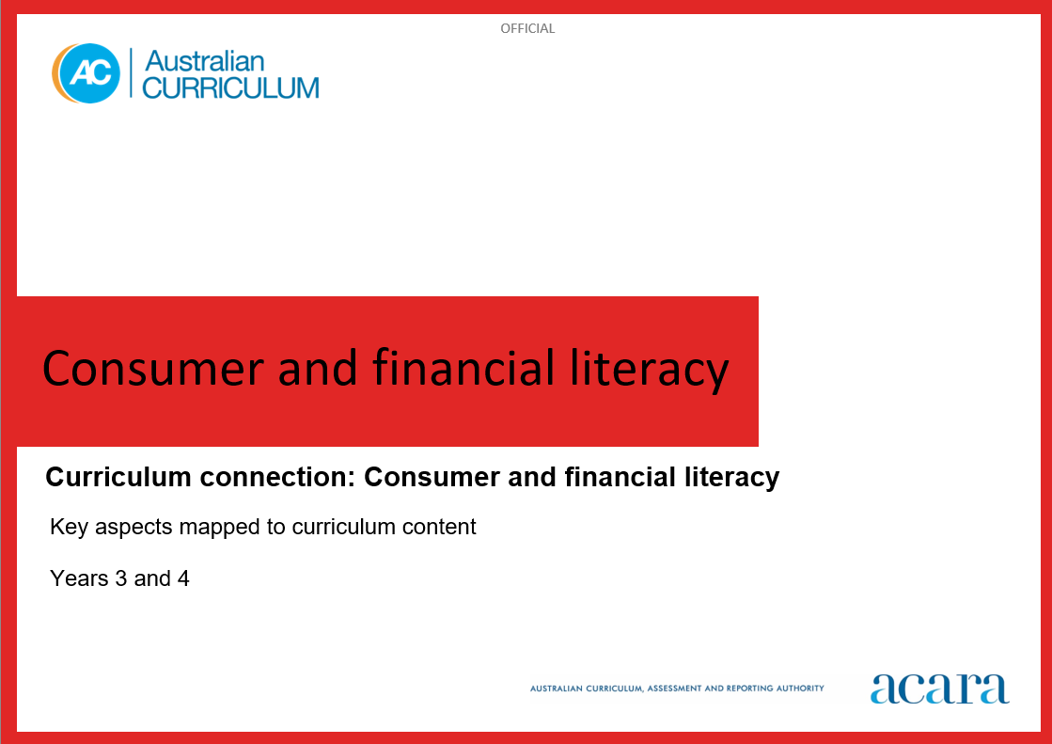

**Copyright and Terms of Use Statement**

**© Australian Curriculum, Assessment and Reporting Authority 2024**

The material published in this work is subject to copyright pursuant to the *Copyright Act 1968* (Cth) and is owned by the Australian Curriculum, Assessment and Reporting Authority (ACARA) (except to the extent that copyright is held by another party, as indicated).

The viewing, downloading, displaying, printing, reproducing (such as by making photocopies) and distributing of these materials is permitted only to the extent permitted by, and is subject to the conditions imposed by, the terms and conditions of using the ACARA website (see, especially, clauses 2, 3 and 4 of those terms and conditions). The terms and conditions can be viewed at [https://www.acara.edu.au/contact-us/copyright](https://aus01.safelinks.protection.outlook.com/?url=https%3A%2F%2Fwww.acara.edu.au%2Fcontact-us%2Fcopyright&data=04%7C01%7CSharon.Foster%40acara.edu.au%7C9931e11fa7684c603e6308d98331bbfb%7C6cf76a3aa824427092003d71673ec678%7C0%7C0%7C637685071906340874%7CUnknown%7CTWFpbGZsb3d8eyJWIjoiMC4wLjAwMDAiLCJQIjoiV2luMzIiLCJBTiI6Ik1haWwiLCJXVCI6Mn0%3D%7C1000&sdata=U5O4Vlbpf271IGmGiMh7fDwU4pLzzAiHpCQFylkp6s4%3D&reserved=0)

**CONSUMER AND FINANCIAL LITERACY**

|  |  |
| --- | --- |
| Key Aspects | |
| Personal finance | Understanding and being able to effectively manage your personal finance in a modern world requires a combination of knowledge, skills and dispositions to make informed, responsible financial decisions. Having financial confidence and being adaptable to change, as the digital revolution influences the way we manage our money day-to-day, enables us to make sound financial choices and set solid financial goals for the future.  In this key aspect, students explore the knowledge and skills required to make personal financial decisions. Students learn about the difference between wants and needs, and understand spending, saving, investing and borrowing money. They have opportunities to engage with money and other financial transactions such as those conducted online and with digital systems. They understand varied payment methods such as cash, debit cards, credit cards, gift cards, buy now and pay later schemes, in-app and online payments.  Students understand a range of concepts related to finance such as earning money (including payslips, tax and superannuation), budgeting, spending and saving priorities (including loans, subscriptions and payment plans), operating securely and safely with their money online, and the importance of long-term planning. |
| Roles, rights and responsibilities | Awareness of the roles, rights and responsibilities that relate to consumer and financial literacy fosters students’ understanding of their rights and responsibilities as consumers. This can help students make fair and informed decisions about their future finances. As consumers, they also have a right to privacy. They need to adopt protective strategies and mitigate risk when sharing or exchanging personal information and financial data.  In this key aspect, students explore how governments, financial institutions, employers, consumer and financial literacy service providers and other key stakeholders have a responsibility to consumers. Through understanding the different roles, rights and responsibilities of each party, students are empowered to make informed, responsible financial decisions, recognise scams and plan their future finances. |
| Economic environment | Developing consumer and financial capability in young people is a strong investment in Australia’s social and economic prosperity. Economic awareness includes knowledge of basic economic principles and how factors such as inflation, the cost of living and interest rates impact personal finances.  In this key aspect, students explore the complexity of the economic environment and how it is globally connected. They learn how it can be affected by geopolitical shifts, technological change and global events.  Students identify economic indicators such as economic growth rates, interest rates, unemployment trends, inflation rates and sustainability indexes. They understand how these influence government economic decision-making. They understand how the Australian government may intervene in response to economic environment changes, such as responding to a decline in Gross Domestic Product (GDP). |
| Enterprise | In an increasingly complex, globalised and rapidly changing world, it is critical for every young Australian to not only be able to cope with life’s challenges but also to flourish as a financially literate and enterprising citizen in the 21st century. All young people need opportunities to develop financial and enterprising capabilities that enable them to confidently operate in a complex, information-rich financial world.  In this key aspect, students explore enterprise skills and how these can be used to create innovative approaches to processes and solutions. They also explore how these skills can contribute to success in their future careers. They have opportunities to develop these skills including problem-solving, decision-making, communication, initiative, resilience, adaptability and commercial awareness through rich connections between learning area content, the general capabilities and authentic financial contexts.  Students explore different types of enterprise including business enterprise and social enterprise. They identify processes that businesses use to create competitive advantage, including using digital tools and digital systems, optimising costs and managing the workforce to improve productivity. |

For more information:

<https://v9.australiancurriculum.edu.au/content/acara-curriculum/au/en/teacher-resources/understand-this-curriculum-connection/consumer-and-financial-literacy/>

**CONSUMER AND FINANCIAL LITERACY: years 3 and 4**

The following tables identify how the key aspects of consumer and financial literacy are evident in content descriptions from across the Australian Curriculum Version 9.0. From this information, teachers can develop a sequential program for learning about consumer and financial literacy by connecting the key aspects of learning with learning area and subject-specific content descriptions. *NB: Banded subjects will appear in both Years 3 and Year 4 tables.*

|  |  |  |  |  |  |
| --- | --- | --- | --- | --- | --- |
| Year 3 | | | | | |
| Key aspect 1: Personal finance | | | | | |
| Learning area/subject | | Strand/sub-strand | Content descriptions | Content elaborations | |
| **Mathematics** | | **Number** | use mathematical modelling to solve practical problems involving additive and multiplicative situations including financial contexts; formulate problems using number sentences and choose calculation strategies, using digital tools where appropriate; interpret and communicate solutions in terms of the situation  AC9M3N06 |  | |
| follow and create algorithms involving a sequence of steps and decisions to investigate numbers; describe any emerging patterns  AC9M3N07 | * creating a sorting algorithm that will sort a collection of 5 cent and 10 cent coins and providing the total value of the collection by applying knowledge of multiples of 5 and 10 | |
| **Algebra** | recognise and explain the connection between addition and subtraction as inverse operations, apply to partition numbers and find unknown values in number sentences  AC9M3A01 | * using the inverse relationship between addition and subtraction to find unknown values with a calculator; for example, representing the problem, “Peter had some money and then spent $375, now he has $158 left. How much did Peter have to start with?” as □ – $375 = $158 and solving the problem using $375 + $158 = $533 ; solving 27 + □ = 63 using subtraction, □ = 63 – 27 or by counting on; 27, 37, 47, 57, 60, 63, so add 3 tens and 6 ones, so □ = 36 | |
| **Measurement** | recognise the relationships between dollars and cents and represent money values in different ways  AC9M3M06 | * investigating the relationship between dollars and cents, using physical or virtual materials to make different combinations of the same amount of money * presenting money amounts in different ways using knowledge of part-part-whole relationships; for example, knowing that $1 is equal to 100 cents; representing $1.85 as $1 + 50c + 20c + 10c + 5c or 50c + 50c + 50c + 10c + 10c + 10c + 5c; when calculating change from buying an item for $1.30 from $2, starting from $1.30 add 20c and 50c which gives $2 * representing money values in multiple ways when role-playing money transactions; for example, using play money to represent the coins and dollars you could use to pay for items | |
| **Digital Technologies** | | **Knowledge and understanding**  Digital systems | explore and describe a range of digital systems and their peripherals for a variety of purposes  AC9TDI4K01 | * exploring how they can use digital systems differently depending on the task, recognising that many digital systems can perform multiple tasks, for example a student can use a tablet to take photos, record audio and find information to create a presentation | |
| explore transmitting different types of data between digital systems  AC9TDI4K02 | * exploring examples of different types of data that can be transferred between digital systems, for example streaming music or making a video call to a friend using a smartphone | |
| **Process and production skills**  Collaborating and managing | use the core features of common digital tools to create, locate and communicate content, following agreed conventions  AC9TDI4P06 | * discussing and creating as a class a set of steps they need to follow to safely find information online * using an online search engine to find suitable sources to create and communicate information, following agreed steps, for example creating a presentation on life cycles * grouping, naming and itemising objects using a logical hierarchy, for example creating a section of a virtual library or virtual supermarket using folders and files | |
| Key aspect 2: Roles, rights and responsibilities | | | | | |
| Learning area/subject | Strand/sub-strand | | Content descriptions | | Content elaborations |
| **HASS** | **Knowledge and understanding**  Civics and Citizenship | | the differences between “rules” and “laws”, why laws are important and how they affect the lives of people  AC9HS4K07 | | * exploring examples of laws and their purpose, recognising that laws apply to everyone in society and why they are important to students’ lives |
| **Digital Technologies** | **Process and production skills**  Privacy and security | | access their school account using a memorised password and explain why it should be easy to remember, but hard for others to guess  AC9TDI4P08 | | * explaining how keeping a password secret prevents others from accessing their data, for example how their work is saved in their account and can only be accessed using their secret password * exploring techniques to create an easy to remember and hard to guess password, for example creating a password using 3 unrelated but easy to remember words |
| identify what personal data is stored and shared in their online accounts and discuss any associated risks  AC9TDI4P09 | | * identifying the personal data stored in accounts they use at school and at home and who has access to it, for example documents in their school cloud storage are accessible by the teacher, or their nickname in their online gaming accounts is visible to all players * discussing how personal data stored in online accounts forms a person’s digital identity and can reveal detailed information about people, for example looking at photographs of themselves, friends or fictional characters that reveal details about a person's location, habits or home |
| Key aspect 3: Economic environment | | | | | |
| Learning area/subject | | Strand/sub-strand | Content descriptions | | Content elaborations |
| **HASS** | | **Knowledge and understanding**  History | causes and effects of changes to the local community, and how people who may be from diverse backgrounds have contributed to these changes  AC9HS3K01 | | * identifying individuals and groups of diverse backgrounds from the past, who have contributed to the community’s economic, social, cultural, civic and environmental development and character |
| Key aspect 4: Enterprise | | | | | |
| Learning area/subject | | Strand/sub-strand | Content descriptions | | Content elaborations |
| **Mathematics** | | **Number** | follow and create algorithms involving a sequence of steps and decisions to investigate numbers; describe any emerging patterns  AC9M3N07 | | * creating a sorting algorithm that will sort a collection of 5 cent and 10 cent coins and providing the total value of the collection by applying knowledge of multiples of 5 and 10 |
| **Digital Technologies** | | **Process and production skills**  Generating and designing | follow and describe algorithms involving sequencing, comparison operators (branching) and iteration  AC9TDI4P02 | | * understanding there can be more than one sequence of steps to solve a problem, some are better than others, and the steps should be unambiguous, for example describing 2 different ways to get to the same location |
| **Process and production skills**  Evaluating | discuss how existing and student solutions satisfy the design criteria and user stories  AC9TDI4P05 | | * describing the way familiar digital systems allow the user to perform tasks, for example discussing how a family member could place an order online for something they cannot buy locally |
| **Process and production skills**  Collaborating and managing | use the core features of common digital tools to share content, plan tasks, and collaborate, following agreed behaviours, supported by trusted adults  AC9TDI4P07 | | * demonstrating safe sharing of content with a select audience, for example sharing a holiday adventure without revealing exact dates, specific names or other personal information |

|  |  |  |  |  |
| --- | --- | --- | --- | --- |
| Year 4 | | | | |
| Key aspect 1: Personal finance | | | | |
| Learning area/subject | | Strand/sub-strand | Content descriptions | Content elaborations |
| **Mathematics** | | **Number** | recognise and extend the application of place value to tenths and hundredths and use the conventions of decimal notation to name and represent decimals  AC9M4N01 | * counting large quantities of mixed notes and coins, writing the total using dollars and cents, and recognising the cents as parts of the next dollar * comparing the way money and measures are read and said, and explaining how they are the same and different; for example, $2.75 is said, “two dollars seventy-five” and 2.75 metres is said “two point seven five metres”; recognising that the 7 means seven-tenths and the 5 means five-hundredths in both |
| choose and use estimation and rounding to check and explain the reasonableness of calculations including the results of financial transactions  AC9M4N07 | * using proficiency with basic facts to estimate the result of a calculation and say what amounts the answer will be between; for example, 5 packets of biscuits at $2.60 each will cost between $10 and $15 as 5 ×$2=$10 and 5×$3=$15 * using rounded amounts to complete an estimated budget for a shopping trip or an excursion, explaining why overestimating the amounts is appropriate |
| use mathematical modelling to solve practical problems involving additive and multiplicative situations including financial contexts; formulate the problems using number sentences and choose efficient calculation strategies, using digital tools where appropriate; interpret and communicate solutions in terms of the situation  AC9M4N08 | * modelling and solving multiplication problems involving money, such as buying 5 toy scooters for $96 each, using efficient mental strategies and written jottings to keep track if needed; for example, rounding $96 up to $100 and subtracting 5×$4=$20, so 5×$96 is the same as 5×$100 less $20, giving the answer $500 – $20=$480 |
| **Measurement** | recognise the relationships between dollars and cents and represent money values in different ways | * investigating the relationship between dollars and cents, using physical or virtual materials to make different combinations of the same amount of money * presenting money amounts in different ways using knowledge of part-part-whole relationships; for example, knowing that $1 is equal to 100 cents; representing $1.85 as $1 + 50c + 20c + 10c + 5c or 50c + 50c + 50c + 10c + 10c + 10c + 5c; when calculating change from buying an item for $1.30 from $2, starting from $1.30 add 20c and 50c which gives $2 * representing money values in multiple ways when role-playing money transactions; for example, using play money to represent the coins and dollars you could use to pay for items |
| **Digital Technologies** | | **Knowledge and understanding**  Digital systems | explore and describe a range of digital systems and their peripherals for a variety of purposes  AC9TDI4K01 | * exploring how they can use digital systems differently depending on the task, recognising that many digital systems can perform multiple tasks, for example a student can use a tablet to take photos, record audio and find information to create a presentation |
| explore transmitting different types of data between digital systems  AC9TDI4K02 | * exploring examples of different types of data that can be transferred between digital systems, for example streaming music or making a video call to a friend using a smartphone |
| **Process and production skills**  Collaborating and managing | use the core features of common digital tools to create, locate and communicate content, following agreed conventions  AC9TDI4P06 | * discussing and creating as a class a set of steps they need to follow to safely find information online * using an online search engine to find suitable sources to create and communicate information, following agreed steps, for example creating a presentation on life cycles * grouping, naming and itemising objects using a logical hierarchy, for example creating a section of a virtual library or virtual supermarket using folders and files |
| Key aspect 2: Roles, rights and responsibilities | | | | |
| Learning area/subject | Strand/sub-strand | | Content descriptions | Content elaborations |
| **HASS** | **Knowledge and understanding**  Civics and Citizenship | | the differences between “rules” and “laws”, why laws are important and how they affect the lives of people  AC9HS4K07 | * exploring examples of laws and their purpose, recognising that laws apply to everyone in society and why they are important to students’ lives |
| **Digital Technologies** | **Process and production skills**  Privacy and security | | access their school account using a memorised password and explain why it should be easy to remember, but hard for others to guess  AC9TDI4P08 | * explaining how keeping a password secret prevents others from accessing their data, for example how their work is saved in their account and can only be accessed using their secret password * exploring techniques to create an easy to remember and hard to guess password, for example creating a password using 3 unrelated but easy to remember words |
| identify what personal data is stored and shared in their online accounts and discuss any associated risks  AC9TDI4P09 | * identifying the personal data stored in accounts they use at school and at home and who has access to it, for example documents in their school cloud storage are accessible by the teacher, or their nickname in their online gaming accounts is visible to all players * discussing how personal data stored in online accounts forms a person’s digital identity and can reveal detailed information about people, for example looking at photographs of themselves, friends or fictional characters that reveal details about a person's location, habits or home |
| Key aspect 4: Enterprise | | | | |
| Learning area/subject | | Strand/sub-strand | Content descriptions | Content elaborations |
| **Digital Technologies** | | **Process and production skills**  Generating and designing | follow and describe algorithms involving sequencing, comparison operators (branching) and iteration  AC9TDI4P02 | * understanding there can be more than one sequence of steps to solve a problem, some are better than others, and the steps should be unambiguous, for example describing 2 different ways to get to the same location |
| **Process and production skills**  Evaluating | discuss how existing and student solutions satisfy the design criteria and user stories  AC9TDI4P05 | * describing the way familiar digital systems allow the user to perform tasks, for example discussing how a family member could place an order online for something they cannot buy locally |
| **Process and production skills**  Collaborating and managing | use the core features of common digital tools to share content, plan tasks, and collaborate, following agreed behaviours, supported by trusted adults  AC9TDI4P07 | * demonstrating safe sharing of content with a select audience, for example sharing a holiday adventure without revealing exact dates, specific names or other personal information |