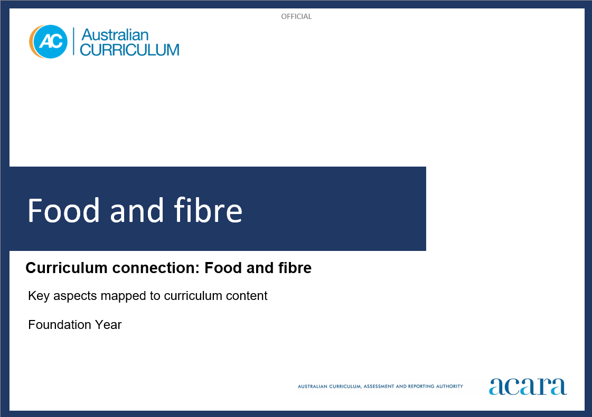

**Copyright and Terms of Use Statement**

**© Australian Curriculum, Assessment and Reporting Authority 2023**

The material published in this work is subject to copyright pursuant to the *Copyright Act 1968* (Cth) and is owned by the Australian Curriculum, Assessment and Reporting Authority (ACARA) (except to the extent that copyright is held by another party, as indicated).

The viewing, downloading, displaying, printing, reproducing (such as by making photocopies) and distributing of these materials is permitted only to the extent permitted by, and is subject to the conditions imposed by, the terms and conditions of using the ACARA website (see, especially, clauses 2, 3 and 4 of those terms and conditions). The terms and conditions can be viewed at [https://www.acara.edu.au/contact-us/copyright](https://aus01.safelinks.protection.outlook.com/?url=https%3A%2F%2Fwww.acara.edu.au%2Fcontact-us%2Fcopyright&data=04%7C01%7CSharon.Foster%40acara.edu.au%7C9931e11fa7684c603e6308d98331bbfb%7C6cf76a3aa824427092003d71673ec678%7C0%7C0%7C637685071906340874%7CUnknown%7CTWFpbGZsb3d8eyJWIjoiMC4wLjAwMDAiLCJQIjoiV2luMzIiLCJBTiI6Ik1haWwiLCJXVCI6Mn0%3D%7C1000&sdata=U5O4Vlbpf271IGmGiMh7fDwU4pLzzAiHpCQFylkp6s4%3D&reserved=0)

**food and fibre: Foundation year**

The following table identifies how the key aspects of understanding food and fibre production are evident in content descriptions from across the Australian Curriculum Version 9.0. From this information, teachers can develop a sequential program for learning about food and fibre by connecting the key aspects of learning with learning area and subject-specific content descriptions.

|  |  |  |  |
| --- | --- | --- | --- |
| Foundation Year | | | |
| Key aspect 1: Sustaining life | | | |
| Learning area/subject | Strand/sub-strand | Content descriptions | Content elaborations |
| **Science** | **Science understanding**  Biological sciences | observe external features of plants and animals and describe ways they can be grouped based on these features  AC9SFU01 | * observing fruits and vegetables and identifying them as parts of plants such as roots, flowers, fruits or leaves |
| **Science as a human endeavour**  Use and influence of science | explore the ways people make and use observations and questions to learn about the natural world  AC9SFH01 | * exploring how First Nations Australians gain knowledge about the land and its vital resources, such as water and food, through observation |

|  |  |  |  |
| --- | --- | --- | --- |
| Foundation Year | | | |
| Key aspect 2: Valuing resources | | | |
| Learning area/subject | Strand/sub-strand | Content descriptions | Content elaborations |
| Not applicable for Foundation Year. | | | |

|  |  |  |  |
| --- | --- | --- | --- |
| Foundation Year | | | |
| Key aspect 3: Designing solutions and meeting challenges | | | |
| Learning area/subject | Strand/sub-strand | Content descriptions | Content elaborations |
| **Design and Technologies** | **Knowledge and understanding**  Technologies and society | explore how familiar products, services and environments are designed by people  AC9TDEFK01 | * asking questions about the design of products from the local store, for example why certain packaging materials might have been selected, and how people design the text and images on the packaging to attract people’s attention |
| **Processes and production skills**  Designing and making | generate, communicate and evaluate design ideas, and use materials, equipment and steps to safely make a solution for a purpose  AC9TDEFP01 | * exploring ideas by drawing or modelling and choosing the most suitable idea, for example drawing or modelling designs for bee hotels to attract native bees to the school garden and choosing one to make, and changing perspectives from front view to plan view * practising a range of technical skills safely using equipment, for example joining techniques when making a product from materials, such as a greenhouse to keep a seedling warm or a trellis for holding up tomato plants |
| **Science** | **Science as a human endeavour**  Use and influence of science | explore the ways people make and use observations and questions to learn about the natural world  AC9SFH01 | * exploring how First Nations Australians gain knowledge about the land and its vital resources, such as water and food, through observation |

|  |  |  |  |
| --- | --- | --- | --- |
| Foundation Year | | | |
| Key aspect 4: Economy | | | |
| Learning area/subject | Strand/sub-strand | Content descriptions | Content elaborations |
| Not applicable for Foundation Year. | | | |

|  |  |  |  |
| --- | --- | --- | --- |
| Foundation Year | | | |
| Key aspect 5: People | | | |
| Learning area/subject | Strand/sub-strand | Content descriptions | Content elaborations |
| **Design and Technologies** | **Knowledge and understanding**  Technologies and society | explore how familiar products, services and environments are designed by people  AC9TDEFK01 | * identifying how First Nations Australians have long designed and produced domestic items including clothing, tools and shelter, for example the Lamalama Peoples of the eastern Cape York Peninsula weave the reddish coloured fibres from *Acacia latifolia* alternately with white coloured fibres from *Brachychiton diversifolium* to produce a striped woven bag |
| **Science** | **Science as a human endeavour**  Use and influence of science | explore the ways people make and use observations and questions to learn about the natural world  AC9SFH01 | * exploring how First Nations Australians gain knowledge about the land and its vital resources, such as water and food, through observation |