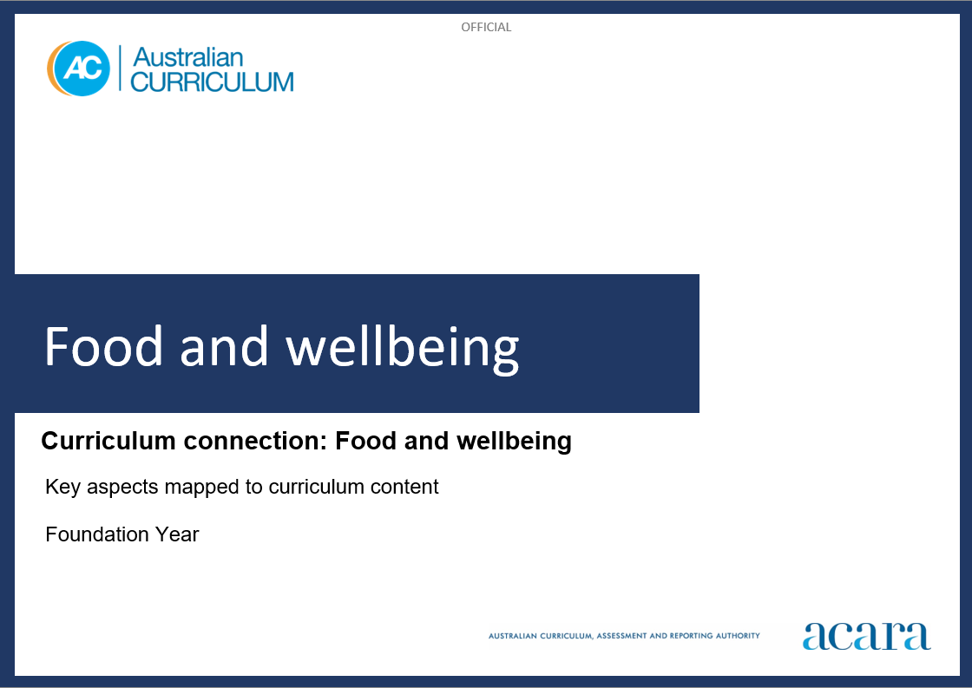

**Copyright and Terms of Use Statement**

**© Australian Curriculum, Assessment and Reporting Authority 2023**

The material published in this work is subject to copyright pursuant to the Copyright Act 1968 (Cth) and is owned by the Australian Curriculum, Assessment and Reporting Authority (ACARA) (except to the extent that copyright is held by another party, as indicated).

The viewing, downloading, displaying, printing, reproducing (such as by making photocopies) and distributing of these materials is permitted only to the extent permitted by, and is subject to the conditions imposed by, the terms and conditions of using the ACARA website (see, especially, clauses 2, 3 and 4 of those terms and conditions). The terms and conditions can be viewed at [https://www.acara.edu.au/contact-us/copyright](https://aus01.safelinks.protection.outlook.com/?url=https%3A%2F%2Fwww.acara.edu.au%2Fcontact-us%2Fcopyright&data=04%7C01%7CSharon.Foster%40acara.edu.au%7C9931e11fa7684c603e6308d98331bbfb%7C6cf76a3aa824427092003d71673ec678%7C0%7C0%7C637685071906340874%7CUnknown%7CTWFpbGZsb3d8eyJWIjoiMC4wLjAwMDAiLCJQIjoiV2luMzIiLCJBTiI6Ik1haWwiLCJXVCI6Mn0%3D%7C1000&sdata=U5O4Vlbpf271IGmGiMh7fDwU4pLzzAiHpCQFylkp6s4%3D&reserved=0)

**Food and wellbeing: Foundation year**

The following table identifies how the key aspects of food and wellbeing are evident in content descriptions from across the Australian Curriculum Version 9.0. From this information, teachers could develop a sequential program for food and wellbeing by connecting the key aspects of learning with learning area and subject-specific content descriptions.

|  |  |  |  |
| --- | --- | --- | --- |
| Foundation Year | | | |
| Key aspect 1: Individuals, families and communities | | | |
| Learning area/subject | Strand/sub-strand | Content descriptions | Content elaborations |
| **Technologies -**  **Design and Technologies** | **Knowledge and understanding**  Technologies and society | explore how familiar products, services and environments are designed by people  AC9TDEFK01 | * exploring how local delivery services meet different needs of people, for example describing how gift packages can be sent to and from people who live in different locations and how online shopping items arrive at a person’s home * asking questions about the design of products from the local store, for example why certain packaging materials might have been selected, and how people design the text and images on the packaging to attract people’s attention |
| **Health and Physical Education** | **Personal, social and community health**  Identities and change | investigate who they are and the people in their world  AC9HPFP01 | * making personal connections with stories that explore identity and belonging; discussing who they are, where they come from and people in their lives * exploring similarities and differences in family structures in First Nations Australian communities and other cultures * exploring cultural practices from different cultures, including the cultures of Asia, that are important to individuals, families and communities * identifying different families in their communities; for example, 2-parent, single-parent, extended and non-traditional families * recognising that they have a right to belong and contribute to a variety of groups |
| **Personal, social and community health**  Interacting with others | practise personal and social skills to interact respectfully with others  AC9HPFP02 | * explaining their reasons and actions in response to challenging situations in shared play experiences * identifying characters in texts who have been excluded from a group, exploring why they have been excluded and discussing how other characters could have been more inclusive * identifying behaviours that may be disrespectful and cause hurt or harm to others during play |
| **Personal, social and community health**  Interacting with others | express and describe emotions they experience  AC9HPFP03 | * identifying and describing the emotions of people who are happy, sad, excited, tired, angry, scared or confused * learning and using appropriate language and actions to communicate their feelings in different situations * recalling and sharing emotional responses to different situations and representing these in a variety of ways talking about connections between feelings, body reactions and body language * expressing a variety of emotions, thoughts and views in a range of situations |
| **Personal, social and community health**  Making healthy and safe choices | identify health symbols, messages and strategies in their community that support their health and safety  AC9HPFP06 | * identifying symbols on food packages that indicate healthier choices * identifying different types of advertising that influence choices about food * exploring different community strategies that keep children safe; for example, pedestrian crossings and traffic lights, safety procedures at swimming pools and beaches, and traffic controllers at school crossings |
| **Humanities and Social Sciences (HASS)** | **Knowledge and understanding**  History | the celebrations and commemorations of significant events shared with their families and others  AC9HSFK02 | * responding to a provided calendar of events that students, their families and friends celebrate or commemorate; for example, birthdays; religious festivals such as Easter, Ramadan, Buddha’s Birthday, Feast of Passover and Coming of the Light; family reunions; cultural festivals; and community commemorations such as NAIDOC Week and Anzac Day, and discussing why they are important * discussing ways of celebrating these significant occasions; for example, special meals, family gatherings, visiting special places, and the role of art, music, telling stories and handing on traditions from generation to generation for First Nations Australians |
| **Skills**  Questioning and researching | pose questions about familiar objects, people, places and events  AC9HSFS01 | * posing questions about family and places, such as How old was I?, Where was I? and What was I doing?, having explored sources relating to their own life; for example, family interviews, photographs, stories, film, classmates’ paintings, excursions to places * posing questions about what makes events and places special; for example What special events do my family celebrate?, What makes my favourite places special? |

|  |  |  |  |
| --- | --- | --- | --- |
| Foundation Year | | | |
| Key aspect 2: Nutrition and food specialisations | | | |
| Learning area/subject | Strand/sub-strand | Content descriptions | Content elaborations |
| **Health and Physical Education** | **Personal, social and community health**  Making healthy and safe choices | identify health symbols, messages and strategies in their community that support their health and safety  AC9HPFP06 | * identifying symbols on food packages that indicate healthier choices * identifying different types of advertising that influence choices about food * exploring different community strategies that keep children safe; for example, pedestrian crossings and traffic lights, safety procedures at swimming pools and beaches, and traffic controllers at school crossings |

|  |  |  |  |
| --- | --- | --- | --- |
| Foundation Year | | | |
| Key aspect 3: Informed choices and sustainable practices | | | |
| Learning area/subject | Strand/sub-strand | Content descriptions | Content elaborations |
| Not applicable for Foundation Year. | | | |

|  |  |  |  |
| --- | --- | --- | --- |
| Foundation Year | | | |
| Key aspect 4: Taking action towards futures that support wellbeing | | | |
| Learning area/subject | Strand/sub-strand | Content descriptions | Content elaborations |
| Not applicable for Foundation Year. | | | |