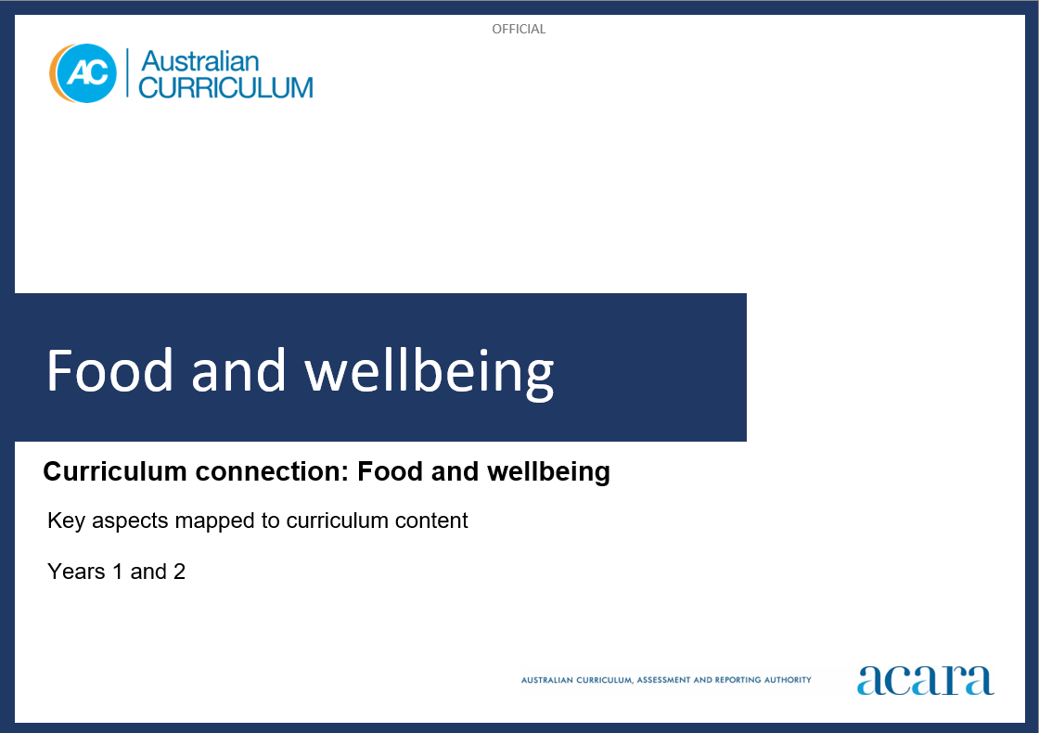

**Copyright and Terms of Use Statement**

**© Australian Curriculum, Assessment and Reporting Authority 2023**

The material published in this work is subject to copyright pursuant to the Copyright Act 1968 (Cth) and is owned by the Australian Curriculum, Assessment and Reporting Authority (ACARA) (except to the extent that copyright is held by another party, as indicated).

The viewing, downloading, displaying, printing, reproducing (such as by making photocopies) and distributing of these materials is permitted only to the extent permitted by, and is subject to the conditions imposed by, the terms and conditions of using the ACARA website (see, especially, clauses 2, 3 and 4 of those terms and conditions). The terms and conditions can be viewed at [https://www.acara.edu.au/contact-us/copyright](https://aus01.safelinks.protection.outlook.com/?url=https%3A%2F%2Fwww.acara.edu.au%2Fcontact-us%2Fcopyright&data=04%7C01%7CSharon.Foster%40acara.edu.au%7C9931e11fa7684c603e6308d98331bbfb%7C6cf76a3aa824427092003d71673ec678%7C0%7C0%7C637685071906340874%7CUnknown%7CTWFpbGZsb3d8eyJWIjoiMC4wLjAwMDAiLCJQIjoiV2luMzIiLCJBTiI6Ik1haWwiLCJXVCI6Mn0%3D%7C1000&sdata=U5O4Vlbpf271IGmGiMh7fDwU4pLzzAiHpCQFylkp6s4%3D&reserved=0)

**Food and wellbeing: years 1 and 2**

The following table identifies how the key aspects of food and wellbeing are evident in content descriptions from across the Australian Curriculum Version 9.0. From this information, teachers could develop a sequential program for food and wellbeing by connecting the key aspects of learning with learning area and subject-specific content descriptions.

|  |  |  |  |
| --- | --- | --- | --- |
| Years 1 and 2 | | | |
| Key aspect 1: Individuals, families and communities | | | |
| Learning area/subject | Strand/sub-strand | Content descriptions | Content elaborations |
| **Technologies -**  **Design and Technologies** | **Knowledge and understanding**  Technologies context: Technologies and society | identify how familiar products, services and environments are designed and produced by people to meet personal or local community needs and sustainability  AC9TDE2K01 | * exploring how particular services meet different needs of people in the community, for example describing why doctors provide medical care to people in many ways including by phone, video conference, plane, car or outdoor clinic |
| **Technologies –**  **Digital Technologies** | **Processes and production skills**  Evaluating | discuss how existing digital systems satisfy identified needs for known users  AC9TDI2P03 | * describing how familiar digital systems meet the needs of individuals, for example how different family members use a tablet for different needs – to play videos, read the news or follow a recipe |
| **Health and Physical Education** | **Personal, social and community health**  Identities and change | describe their personal qualities and those of others, and explain how they contribute to developing identities  AC9HP2P01 | * describing how belonging to First Nations Australian cultural groups contributes to identities * exploring examples of cultural practices, including those of Australians of Asian heritage, that recognise the contributions of family and friends to identities * explaining how personal and cultural identities are influenced by the groups and communities to which we belong |
| **Personal, social and community health**  Interacting with others | identify and explore skills and strategies to develop respectful relationships  AC9HP2P02 | * describing behaviours that may cause hurt or harm to others, or cause them to feel disrespected, including verbal and physical forms of bullying |
| **Personal, social and community health**  Interacting with others | identify how different situations influence emotional responses  AC9HP2P03 | * identifying situations that may trigger strong emotional responses in themselves and others, and recognising the impact the responses can have on others * predicting how a person or character might be feeling based on the words they use, their facial expressions and body language recognising how self and others are feeling in a range of situations |
| **Humanities and Social Sciences (HASS)**  **Year 1** | **Knowledge and understanding**  History | differences in family structures and roles today, and how these have changed or remained the same over time  AC9HS1K01 | * examining the roles of family members over time, such as roles of parents, children and extended family members, and comparing these with family roles today |
| **Knowledge and understanding**  History | continuity and change between aspects of their daily lives and their parents’ and grandparents’ childhoods  AC9HS1K02 | * comparing what has changed in daily life over time; for example, homes, family traditions, diverse religious and cultural practices, leisure, school life, rules, and shopping/consumer habits |
| **Humanities and Social Sciences (HASS)**  **Year 2** | **Knowledge and understanding**  History | a local individual, group, place or building and the reasons for their importance, including social, cultural or spiritual significance  AC9HS2K01 | * discussing why a particular site has heritage significance or cultural value for present generations; for example, it provides a record of a significant historical event, has aesthetic value, reflects the community’s identity * identifying and visiting, where appropriate, local sites, places and landscapes of significance to First Nations Australians; for example, engraving sites, rock paintings, natural sites or features such as the creeks or mountains |
| **Knowledge and understanding**  History | how technological developments changed people’s lives at home, and the ways they worked, travelled and communicated  AC9HS2K02 | * examining changes in technologies over several generations by comparing past and present objects and photographs, and discussing how these changes have shaped people’s lives; for example, changes to land, air and sea transport; the introduction of transistors, television and FM radio moving to digital streaming, including how people communicated over long distances * identifying the technologies used by local First Nations Australians for aspects of daily life such as providing food, shelter and transportation |
| **Knowledge and understanding**  Geography | the interconnections of First Nations Australians to a local Country/Place  AC9HS2K04 | * listening to stories connecting local First Nations Australians with the land, sea, waterways, sky and animals of their Country/Place |

|  |  |  |  |
| --- | --- | --- | --- |
| Years 1 and 2 | | | |
| Key aspect 2: Nutrition and food specialisations | | | |
| Learning area/subject | Strand/sub-strand | Content descriptions | Content elaborations |
| **Technologies –**  **Design and Technologies** | **Knowledge and understanding**  Technologies context: Food and fibre production; Food specialisations | Explore how food can be selected and prepared for healthy eating  AC9TDE2K04 | * identifying a wide range of foods, categorising them into food groups according to the Australian Guide to Healthy Eating or the Aboriginal and Torres Strait Islander Guide to Healthy Eating and discussing ways to eat a variety of food groups, including cooking methods, tools and equipment needed to prepare them for healthy eating * exploring how people including peoples from the countries of Asia design and produce food for healthy eating based on the available plants and animals in their region, the influence of cultural practices, and locally available tools and equipment * exploring the Australian Guide to Healthy Eating and the Aboriginal and Torres Strait Islander Guide to Healthy Eating and identifying foods in each of the 5 food groups which contribute to health and wellbeing, for example choosing foods from each of the 5 food groups which they are familiar with and designing a menu for a day * exploring the local supermarket to observe the variety of foods and the placement of foods on shelves, in aisles and displays; and considering how their design may influence the purchase of foods for healthy food eating * exploring different ways of preparing the products from the school kitchen garden, farmers’ market or supermarket, for example preparing vegetables for a salad, steaming or roasting vegetables and noticing the changes in flavour and texture |
| **Technologies –**  **Digital Technologies** | **Processes and production skills**  Generating and designing | follow and describe algorithms involving a sequence of steps, branching (decisions) and iteration (repetition)  AC9TDI2P02 | * following a short, ordered sequence of steps and making decisions to solve a simple problem, for example follow a recipe or directions to reach a location * describing the steps and decisions (in the correct order) needed to solve a simple problem, for example writing, saying, drawing or photographing the steps needed to make a sandwich |
| **Processes and production skills**  Evaluating | discuss how existing digital systems satisfy identified needs for known users  AC9TDI2P03 | * describing how familiar digital systems meet the needs of individuals, for example how different family members use a tablet for different needs – to play videos, read the news or follow a recipe |
| **Health and Physical Education** | **Personal, social and community health**  Making healthy and safe choices | investigate a range of health messages and practices in their community and discuss their purposes  AC9HP2P06 | * discussing how eating a variety of fresh foods can influence health and wellbeing by using The Australian Guide to Healthy Eating * investigating how foods are marketed and promoted to children through advertisements in online spaces, promotion in supermarkets, and labelling and packaging |
| **Science**  **Year 1** | **Science as a human endeavour**  Use and influence of science | describe how people use science in their daily lives, including using patterns to make scientific predictions  AC9S1H01 | * investigating how First Nations Australians use science to meet their needs, such as food and water supply and shelter * identifying how we use pushes and pulls when preparing meals, and the tools that help us push or pull objects |

|  |  |  |  |
| --- | --- | --- | --- |
| Years 1 and 2 | | | |
| Key aspect 3: Informed choices and sustainable practices | | | |
| Learning area/subject | Strand/sub-strand | Content descriptions | Content elaborations |
| **Technologies –**  **Design and Technologies** | **Processes and production skills**  Generating and designing | generate and communicate design ideas through describing, drawing or modelling, including using digital tools  AC9TDE2P01 | * describing the results from exploring design ideas, for example recording the results from people taste-testing a food product |
| **Processes and production skills**  Producing and implementing | use materials, components, tools, equipment and techniques to safely make designed solutions  AC9TDE2P02 | * practising a range of technical skills using tools and equipment safely, for example joining techniques when making products, watering and mulching gardens, preparing a recipe using a knife safely |
| **Processes and production skills**  Evaluating | evaluate the success of design ideas and solutions based on personal preferences and including sustainability  AC9TDE2P03 | * reflecting on the challenges of designing and producing a solution and recording these reflections, for example when growing a food product, designing a structure to take a load or making a nutritious snack |
| **Processes and production skills**  Collaborating and managing | sequence steps for making designed solutions cooperatively  AC9TDE2P04 | * recording the procedure for making a product, for example the ordered steps for making a salad, instructions for making a container or bag * identifying roles for each member of a group when working cooperatively, for example when making a number of items for a school fete |
| **Health and Physical Education** | **Personal, social and community health**  Making healthy and safe choices | investigate a range of health messages and practices in their community and discuss their purposes  AC9HP2P06 | * exploring sustainable practices that students can implement in the classroom to improve the health and wellbeing of the class, such as composting food waste, creating an edible garden and reducing single-use plastics |

|  |  |  |  |
| --- | --- | --- | --- |
| Years 1 and 2 | | | |
| Key aspect 4: Taking action towards futures that support wellbeing | | | |
| Learning area/subject | Strand/sub-strand | Content descriptions | Content elaborations |
| **Technologies –**  **Design and Technologies** | **Processes and production skills**  Generating and designing | generate and communicate design ideas through describing, drawing or modelling, including using digital tools  AC9TDE2P01 | * describing the results from exploring design ideas, for example recording the results from people taste-testing a food product |
| **Processes and production skills**  Producing and implementing | use materials, components, tools, equipment and techniques to safely make designed solutions  AC9TDE2P02 | * practising a range of technical skills using tools and equipment safely, for example joining techniques when making products, watering and mulching gardens, preparing a recipe using a knife safely |
| **Processes and production skills**  Evaluating | evaluate the success of design ideas and solutions based on personal preferences and including sustainability  AC9TDE2P03 | * reflecting on the challenges of designing and producing a solution and recording these reflections, for example when growing a food product, designing a structure to take a load or making a nutritious snack |
| **Processes and production skills**  Collaborating and managing | sequence steps for making designed solutions cooperatively  AC9TDE2P04 | * recording the procedure for making a product, for example the ordered steps for making a salad, instructions for making a container or bag * identifying roles for each member of a group when working cooperatively, for example when making a number of items for a school fete |
| **Technologies –**  **Digital Technologies** | **Processes and production skills**  Collaborating and managing | use the basic features of common digital tools to create, locate and communicate content  AC9TDI2P04 | * creating individual pieces of work that contribute to a group task, for example each student contributes a recipe and photo of their favourite food to create a class recipe book |
| **Humanities and Social Sciences (HASS)**  **Year 1** | **Skills**  Questioning and researching | develop questions about objects, people, places and events in the past and present  AC9HS1S01 | * posing questions with the stems where, what, how and why about families and places when provided with everyday objects and other sources, such as photos, found objects, maps and observation sketches asking questions before, during and after listening to stories about people and places, and about their past and present * preparing questions for parents and members of older generations about how and where they lived in the past, and the places they value |
| **Humanities and Social Sciences (HASS)**  **Year 2** | **Skills**  Questioning and researching | develop questions about objects, people, places and events in the past and present  AC9HS2S01 | * developing inquiry questions about places; for example, What are the features of the place?, How far away is it?, How easy is it to get to?, How am I connected to it?, How is it connected to other places? * posing questions using the stems: How do I feel about …?, ‘What would it be like to …? and What effect …? |