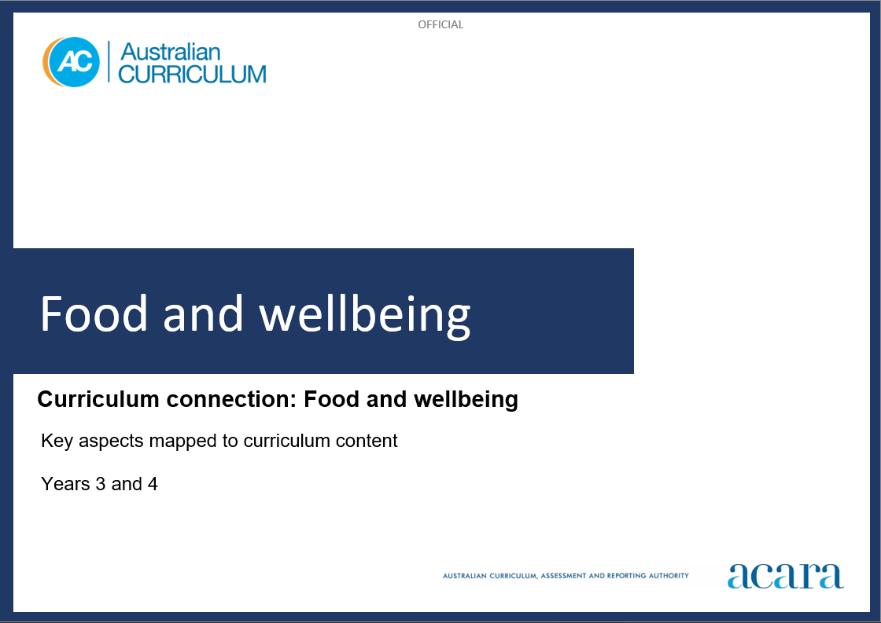

**Copyright and Terms of Use Statement**

**© Australian Curriculum, Assessment and Reporting Authority 2023**

The material published in this work is subject to copyright pursuant to the Copyright Act 1968 (Cth) and is owned by the Australian Curriculum, Assessment and Reporting Authority (ACARA) (except to the extent that copyright is held by another party, as indicated).

The viewing, downloading, displaying, printing, reproducing (such as by making photocopies) and distributing of these materials is permitted only to the extent permitted by, and is subject to the conditions imposed by, the terms and conditions of using the ACARA website (see, especially, clauses 2, 3 and 4 of those terms and conditions). The terms and conditions can be viewed at [https://www.acara.edu.au/contact-us/copyright](https://aus01.safelinks.protection.outlook.com/?url=https%3A%2F%2Fwww.acara.edu.au%2Fcontact-us%2Fcopyright&data=04%7C01%7CSharon.Foster%40acara.edu.au%7C9931e11fa7684c603e6308d98331bbfb%7C6cf76a3aa824427092003d71673ec678%7C0%7C0%7C637685071906340874%7CUnknown%7CTWFpbGZsb3d8eyJWIjoiMC4wLjAwMDAiLCJQIjoiV2luMzIiLCJBTiI6Ik1haWwiLCJXVCI6Mn0%3D%7C1000&sdata=U5O4Vlbpf271IGmGiMh7fDwU4pLzzAiHpCQFylkp6s4%3D&reserved=0)

**Food and wellbeing: years 3 and 4**

The following table identifies how the key aspects of food and wellbeing are evident in content descriptions from across the Australian Curriculum Version 9.0. From this information, teachers could develop a sequential program for food and wellbeing by connecting the key aspects of learning with learning area and subject-specific content descriptions.

|  |  |  |  |
| --- | --- | --- | --- |
| Years 3 and 4 | | | |
| Key aspect 1: Individuals, families and communities | | | |
| Learning area/subject | Strand/sub-strand | Content descriptions | Content elaborations |
| **Technologies -**  **Design and Technologies** | **Knowledge and understanding**  Technologies context: Technologies and society | examine design and technologies occupations and factors including sustainability that impact on the design of products, services and environments to meet community needs  AC9TDE4K01 | * exploring how design and technologies occupations in the local area (urban, suburban, regional or rural) meet community needs, for example bakers, builders, engineers, farmers, seafood industry workers, mechanics, radiographers, textile designers and others in science, technology, engineering and mathematics roles * examining products and environments to discover the factors that may have influenced the design and, choice of technologies used, for example discussing energy-efficient cooking with a wok, or sustainable wood products for home use including furniture made from plantation timbers, bamboo toothbrushes or coconut shell bowls |
| **Health and Physical Education** | **Personal, social and community health**  Identities and change | investigate how success, challenge, setbacks and failure strengthen resilience and identities in a range of contexts  AC9HP4P01 | * investigating how First Nations Australians’ pride in cultural background strengthens identities * exploring how responses to success, challenge, setbacks and failures are influenced by cultural beliefs and values |
| **Personal, social and community health**  Identities and change | describe how choices and actions can be influenced by stereotypes  AC9HP4P03 | * exploring different gender stereotypes in texts and media, and discussing the messages they portray and how they can influence choices and actions * describing ways to make roles and responsibilities at home, at school and in communities fair, equitable and inclusive |
| **Personal, social and community health**  Interacting with others | select, use and refine personal and social skills to establish, manage and strengthen relationships  AC9HP4P04 | * predicting and reflecting on how other students might feel in a range of challenging situations, and discussing what they can do to support them * describing characters in texts who have demonstrated respect for difference and diversity in individuals and communities, and exploring the strategies they used to do this |
| **Personal, social and community health**  Interacting with others | describe how valuing diversity influences wellbeing and identify actions that promote inclusion in their communities  AC9HP4P05 | * planning ways to celebrate the cultural diversity of students in their class, such as sharing recipes, stories and games from their cultural heritage * recognising the important role of cultural narratives in describing the diversity, and sharing beliefs and practices, of First Nations Australian communities |
| **Personal, social and community health**  Interacting with others | explain how and why emotional responses can vary and practise strategies to manage their emotions  AC9HP4P06 | * analysing scenarios and identifying possible triggers and warning signs to predict emotional responses * implementing self-regulation strategies to manage the expression of emotional responses |
| **Humanities and Social Sciences (HASS)**  **Year 3** | **Knowledge and understanding**  History | causes and effects of changes to the local community, and how people who may be from diverse backgrounds have contributed to these changes  AC9HS3K01 | * exploring photographs, newspapers, oral histories, diaries and letters to investigate how an aspect of life in the local community, such as transport, entertainment, the natural and built environment, and technologies, has changed over time; for example, from the time of European settlement to the present day |
| **Knowledge and understanding**  History | significant events, symbols and emblems that are important to Australia’s identity and diversity, and how they are celebrated, commemorated or recognised in Australia, including Australia Day, Anzac Day, NAIDOC Week, National Sorry Day, Easter, Christmas, and other religious and cultural festivals  AC9HS3K02 | * identifying and discussing the historical origins of an important Australian celebration or commemoration, including Australia Day, Anzac Day, NAIDOC Week and National Sorry Day, as well as significant religious or cultural festivals, such as Easter, Christmas, Lunar New Year, Diwali and Eid |
| **Knowledge and understanding**  Geography | the ways First Nations Australians in different parts of Australia are interconnected with Country/Place  AC9HS3K04 | * exploring the ways Australian First Nations Peoples connect to Country/Place, by reading and viewing poems, songs, paintings and stories from outside the local area |
| **Humanities and Social Sciences (HASS)**  **Year 4** | **Knowledge and understanding**  Geography | the importance of environments, including natural vegetation and water sources, to people and animals in Australia and on another continent  AC9HS4K05 | * identifying the importance of water to the environment and to sustaining the lives of people and animals |

|  |  |  |  |
| --- | --- | --- | --- |
| Years 3 and 4 | | | |
| Key aspect 2: Nutrition and food specialisations | | | |
| Learning area/subject | Strand/sub-strand | Content descriptions | Content elaborations |
| **Technologies -**  **Design and Technologies** | **Knowledge and understanding**  Technologies context: Food and fibre production; Food specialisations | Describe the ways food can be selected and prepared for healthy eating  AC9TDE4K04 | * exploring how First Nations Australians consider the nutrient content of seasonal foods as a means of maintaining a balanced diet * recognising the benefits food technologies provide for health and food safety and to ensure that a wide variety of food is available and can be prepared for healthy eating, for example pasteurisation of milk for food safety and freezing of vegetables to retain nutrients and reduce food waste * exploring the differences between fresh food and processed food by researching nutrient content of fresh food using a nutrition calculator app and examining nutrition information labels on processed foods for  nutritional values * considering creative ways foods can be prepared for maximum taste and appeal, for example locating and discussing images online that show colourful or fun ways to present food that might encourage healthy eating * describing foods using the senses, for example describing the colour, aroma, sound, texture and taste of the ingredients in a salad or stir-fry and how our senses influence what we select to eat |
| **Health and Physical Education** | **Personal, social and community health**  Identities and change | describe how choices and actions can be influenced by stereotypes  AC9HP4P03 | * exploring different gender stereotypes in texts and media, and discussing the messages they portray and how they can influence choices and actions |
| **Personal, social and community health**  Making healthy and safe choices | interpret the nature and intention of health information and messages, and reflect on how they influence personal decisions and behaviours  AC9HP4P09 | * accessing different sources of health information and examining the accuracy of these sources, including brochures, websites, TV shows and advertisements, online promotions and food labels * examining health messages relating to food and nutrition from different sources and exploring choices, behaviours and outcomes conveyed in these messages * identifying, examining and combining information and opinions from a range of sources to inform decisions and behaviours on a range of health issues * investigating the level of influence health messages from different people and sources may have on their health decisions |
| **Personal, social and community health**  Making healthy and safe choices | investigate and apply behaviours that contribute to their own and others’ health, safety, relationships and wellbeing  AC9HP4P10 | * exploring the benefits of following eating patterns that reflect The Australian Guide to Healthy Eating, and investigating nutritional information about foods |
| **Science**  **Year 3** | **Science as a human endeavour**  Use and influence of science | consider how people use scientific explanations to meet a need or solve a problem  AC9S3H02 | * investigating why salt, was so important to people’s diets, food preservation and medicine in ancient times that it was known as ‘white gold’ * exploring how science knowledge of heat transfer has helped people develop different ways to cook food, such as by boiling, frying or roasting |
| **Science inquiry**  Communicating | write and create texts to communicate findings and ideas for identified purposes and audiences, using scientific vocabulary and digital tools as appropriate AC9S3I06 | * creating posters to display around school on the importance of placing compostable lunchtime food scraps such as apple cores in compost bins for use in kitchen gardens |

|  |  |  |  |
| --- | --- | --- | --- |
| Years 3 and 4 | | | |
| Key aspect 3: Informed choices and sustainable practices | | | |
| Learning area/subject | Strand/sub-strand | Content descriptions | Content elaborations |
| **Technologies –**  **Design and Technologies** | **Processes and production skills**  Investigating and defining | explore needs or opportunities for designing, and test materials, components, tools, equipment and processes needed to create designed solutions  AC9TDE4P01 | * examining the production of local products, services and environments to enhance their own design ideas, for example discussing the processes and systems that might be used to distribute hot food to a large number of people at a community event * exploring and testing a range of materials under different conditions for suitability including sustainability considerations, for example the compostability of paper-based materials or the strength and durability of natural materials * exploring the different uses of materials in a range of products, including those from a country in Asia, to inform design decisions, for example in shelters, boats, handmade tools, baskets, wooden items, musical instruments, clothing and fabric |
| **Processes and production skills**  Generating and designing | generate and communicate design ideas and decisions using appropriate attributions, technical terms and graphical representation techniques, including using digital tools  AC9TDE4P02 | * planning, sharing and documenting creative designs, ideas and processes using digital tools and appropriate terms and privacy considerations, for example a class blog or collaborative document that has been selectively shared with peers |
| **Processes and production skills**  Producing and implementing | select and use materials, components, tools, equipment and techniques to safely make designed solutions  AC9TDE4P03 | * using tools and equipment accurately when measuring, marking and cutting, for example when creating a template or pattern, measuring ingredients in a recipe or preparing a garden bed for sowing seeds * explaining the importance of safe, responsible, inclusive and cooperative work practices when designing and making, for example when handling sharp equipment such as knives and scissors |
| **Processes and production skills**  Evaluating | use given or co-developed design criteria including sustainability to evaluate design ideas and solutions  AC9TDE4P04 | * comparing the amount of waste that would be produced from different design ideas and the potential for recycling waste, for example exploring the choice of materials to construct a toy and whether these materials are repairable or able to be recycled once the toy breaks or is no longer wanted * reflecting on how well their designed solution meets design criteria, such as ensuring safety and wellbeing of users and meeting the needs of communities or different cultures, for example reviewing and discussing the choice of fabrics used to make re-usable bags and how they could be made more appealing to all cultural groups by considering modifications to style |
| **Processes and production skills**  Collaborating and managing | sequence steps to individually and collaboratively make designed solutions  AC9TDE4P05 | * determining planning processes as a class, for example recording when parts of a project need to be completed on a timeline, in a spreadsheet, calendar or list * discussing the importance of managing time and resource allocation throughout production, for example discussing the roles different people might take in a team and identifying the tasks they will complete and the resources they will each need * identifying the steps in a mass production process, for example drawing a flowchart or making a video recording of a procedure for packing identical boxes of food for community members in need, where each student in a group has a separate task as part of the production process |
| **Health and Physical Education** | **Personal, social and community health**  Making healthy and safe choices | investigate and apply behaviours that contribute to their own and others’ health, safety, relationships and wellbeing  AC9HP4P10 | * identifying ways they can change their behaviours to support the sustainability of the Earth’s systems; for example, recycling or composting systems to minimise waste in the school, and community fruit and vegetable gardens to create healthy and sustainable lunches or snacks |
| **Humanities and Social Sciences (HASS)**  **Year 3** | **Skills**  Questioning and researching | develop questions to guide investigations about people, events, places and issues  AC9HS3S01 | * developing inquiring questions as they investigate; for example, Why there? questions about location; What might happen? questions about future consequences of natural processes or people’s actions in places; and What ought to happen? questions about ethical behaviour, sustainability and preferred futures * asking probing questions during an investigation; for example, Why is that so?, What else do we need to know? * posing questions to compare such as How have things changed? and How is my house the same or different to one in a neighbouring country? |
| **Humanities and Social Sciences (HASS)**  **Year 4** | **Skills**  Questioning and researching | develop questions to guide investigations about people, events, places and issues  AC9HS4S01 | * asking questions before, during and after an investigation, using tools such as a KWL chart (what they know, what they want to know and what they have learned) and five W’s + H (who, what, when, where, why and how) * developing How do we know? questions for evidence; How are these ideas connected to each other? What is similar/different about what you have found out? questions about comparisons; What could be done? questions about alternatives; Is that right or fair? questions about decisions in the past and present; How did/do certain groups respond/act when…? questions about diverse groups; What rules apply when…? Who was/is involved…? questions about rules and citizenship * discussing how an investigation about the past, such as through a museum display, video or interactive website, is guided by questions at different stages, including Why is that important now? * developing questions that address the disciplinary concepts; for example, What was the cause…?, Why was this event significant?, How did daily life change?, What are the characteristics of this place?, How can we manage resources sustainably?, What rules are used by different groups I belong to? and What laws protect our local environment? |
| **Science**  **Year 3** | **Science inquiry**  Communicating | write and create texts to communicate findings and ideas for identified purposes and audiences, using scientific vocabulary and digital tools as appropriate  AC9S3I06 | * creating posters to display around school on the importance of placing compostable lunchtime food scraps such as apple cores in compost bins for use in kitchen gardens |

|  |  |  |  |
| --- | --- | --- | --- |
| Years 3 and 4 | | | |
| Key aspect 4: Taking action towards futures that support wellbeing | | | |
| Learning area/subject | Strand/sub-strand | Content descriptions | Content elaborations |
| **Technologies -**  **Design and Technologies** | **Processes and production skills**  Investigating and defining | explore needs or opportunities for designing, and test materials, components, tools, equipment and processes needed to create designed solutions  AC9TDE4P01 | * examining the production of local products, services and environments to enhance their own design ideas, for example discussing the processes and systems that might be used to distribute hot food to a large number of people at a community event * exploring and testing a range of materials under different conditions for suitability including sustainability considerations, for example the compostability of paper-based materials or the strength and durability of natural materials * exploring the different uses of materials in a range of products, including those from a country in Asia, to inform design decisions, for example in shelters, boats, handmade tools, baskets, wooden items, musical instruments, clothing and fabric |
| **Processes and production skills**  Generating and designing | generate and communicate design ideas and decisions using appropriate attributions, technical terms and graphical representation techniques, including using digital tools  AC9TDE4P02 | * planning, sharing and documenting creative designs, ideas and processes using digital tools and appropriate terms and privacy considerations, for example a class blog or collaborative document that has been selectively shared with peers |
| **Processes and production skills**  Producing and implementing | select and use materials, components, tools, equipment and techniques to safely make designed solutions  AC9TDE4P03 | * using tools and equipment accurately when measuring, marking and cutting, for example when creating a template or pattern, measuring ingredients in a recipe or preparing a garden bed for sowing seeds * explaining the importance of safe, responsible, inclusive and cooperative work practices when designing and making, for example when handling sharp equipment such as knives and scissors |
| **Processes and production skills**  Evaluating | use given or co-developed design criteria including sustainability to evaluate design ideas and solutions  AC9TDE4P04 | * comparing the amount of waste that would be produced from different design ideas and the potential for recycling waste, for example exploring the choice of materials to construct a toy and whether these materials are repairable or able to be recycled once the toy breaks or is no longer wanted * reflecting on how well their designed solution meets design criteria, such as ensuring safety and wellbeing of users and meeting the needs of communities or different cultures, for example reviewing and discussing the choice of fabrics used to make re-usable bags and how they could be made more appealing to all cultural groups by considering modifications to style |
| **Processes and production skills**  Collaborating and managing | sequence steps to individually and collaboratively make designed solutions  AC9TDE4P05 | * determining planning processes as a class, for example recording when parts of a project need to be completed on a timeline, in a spreadsheet, calendar or list * discussing the importance of managing time and resource allocation throughout production, for example discussing the roles different people might take in a team and identifying the tasks they will complete and the resources they will each need * identifying the steps in a mass production process, for example drawing a flowchart or making a video recording of a procedure for packing identical boxes of food for community members in need, where each student in a group has a separate task as part of the production process |
| **Technologies –**  **Digital Technologies** | **Processes and production skills**  Generating and designing | follow and describe algorithms involving sequencing, comparison operators (branching) and iteration  AC9TDI4P02 | * describing algorithms using representations such as a list of steps or a diagram, for example drawing a diagram of a recipe involving decisions |
| **Processes and production skills**  Collaborating and managing | use the core features of common digital tools to share content, plan tasks, and collaborate, following agreed behaviours, supported by trusted adults  AC9TDI4P07 | * interacting cooperatively in a group in an online environment to plan and complete a task, for example writing and responding to others’ views on canteen products |
| **Health and Physical Education** | **Personal, social and community health**  Identities and change | describe how choices and actions can be influenced by stereotypes  AC9HP4P03 | * describing ways to make roles and responsibilities at home, at school and in communities fair, equitable and inclusive |
| **Personal, social and community health**  Interacting with others | select, use and refine personal and social skills to establish, manage and strengthen relationships  AC9HP4P04 | * recognising that bullying behaviour can take many forms, including online, and proposing strategies to challenge bullying in and out of school |
| **Personal, social and community health**  Interacting with others | describe how valuing diversity influences wellbeing and identify actions that promote inclusion in their communities  AC9HP4P05 | * planning ways to celebrate the cultural diversity of students in their class, such as sharing recipes, stories and games from their cultural heritage * recognising the important role of cultural narratives in describing the diversity, and sharing beliefs and practices, of First Nations Australian communities |
| **Humanities and Social Sciences (HASS)**  **Year 3** | **Skills**  Questioning and researching | develop questions to guide investigations about people, events, places and issues  AC9HS3S01 | * developing inquiring questions as they investigate; for example, Why there? questions about location; What might happen? questions about future consequences of natural processes or people’s actions in places; and What ought to happen? questions about ethical behaviour, sustainability and preferred futures * asking probing questions during an investigation; for example, Why is that so?, What else do we need to know? * posing questions to compare such as How have things changed? and How is my house the same or different to one in a neighbouring country? |
| **Humanities and Social Sciences (HASS)**  **Year 4** | **Skills**  Questioning and researching | develop questions to guide investigations about people, events, places and issues  AC9HS4S01 | * asking questions before, during and after an investigation, using tools such as a KWL chart (what they know, what they want to know and what they have learned) and five W’s + H (who, what, when, where, why and how) * developing How do we know? questions for evidence; How are these ideas connected to each other? What is similar/different about what you have found out? questions about comparisons; What could be done? questions about alternatives; Is that right or fair? questions about decisions in the past and present; How did/do certain groups respond/act when…? questions about diverse groups; What rules apply when…? Who was/is involved…? questions about rules and citizenship * discussing how an investigation about the past, such as through a museum display, video or interactive website, is guided by questions at different stages, including Why is that important now? * developing questions that address the disciplinary concepts; for example, What was the cause…?, Why was this event significant?, How did daily life change?, What are the characteristics of this place?, How can we manage resources sustainably?, What rules are used by different groups I belong to? and What laws protect our local environment? |