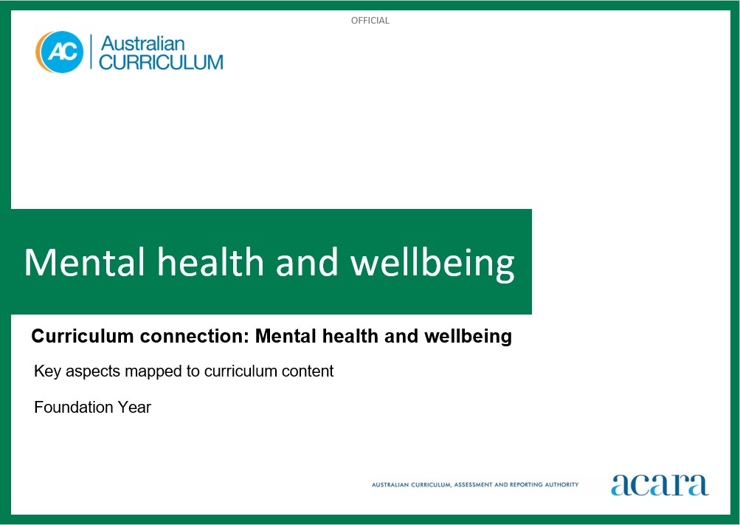

**Copyright and Terms of Use Statement**

**© Australian Curriculum, Assessment and Reporting Authority 2023**

The material published in this work is subject to copyright pursuant to the Copyright Act 1968 (Cth) and is owned by the Australian Curriculum, Assessment and Reporting Authority (ACARA) (except to the extent that copyright is held by another party, as indicated).

The viewing, downloading, displaying, printing, reproducing (such as by making photocopies) and distributing of these materials is permitted only to the extent permitted by, and is subject to the conditions imposed by, the terms and conditions of using the ACARA website (see, especially, clauses 2, 3 and 4 of those terms and conditions). The terms and conditions can be viewed at [https://www.acara.edu.au/contact-us/copyright](https://aus01.safelinks.protection.outlook.com/?url=https%3A%2F%2Fwww.acara.edu.au%2Fcontact-us%2Fcopyright&data=04%7C01%7CSharon.Foster%40acara.edu.au%7C9931e11fa7684c603e6308d98331bbfb%7C6cf76a3aa824427092003d71673ec678%7C0%7C0%7C637685071906340874%7CUnknown%7CTWFpbGZsb3d8eyJWIjoiMC4wLjAwMDAiLCJQIjoiV2luMzIiLCJBTiI6Ik1haWwiLCJXVCI6Mn0%3D%7C1000&sdata=U5O4Vlbpf271IGmGiMh7fDwU4pLzzAiHpCQFylkp6s4%3D&reserved=0)

MENTAL HEALTH AND WEllbeing: Foundation

The following table identifies how the key aspects of mental health and wellbeing are evident in content descriptions from across the Australian Curriculum Version 9.0. From this information, teachers could develop a sequential program for mental health and wellbeing by connecting the key aspects of learning with learning area and subject-specific content descriptions.

|  |  |  |  |
| --- | --- | --- | --- |
| Foundation | | | |
| Key aspect 1: Connectedness and belonging | | | |
| Learning area/subject | Strand/sub-strand | Content descriptions | Content elaborations |
| **Health and Physical Education** | **Personal, social and community health**  Identities and change | investigate who they are and the people in their world  AC9HPFP01 | * making personal connections with stories that explore identity and belonging; discussing who they are, where they come from and people in their lives * exploring similarities and differences in family structures in First Nations Australian communities and other cultures * exploring cultural practices from different cultures, including the cultures of Asia, that are important to individuals, families and communities * identifying different families in their communities; for example, 2-parent, single-parent, extended and non-traditional families * identifying ways they use their strengths in physical activities to help themselves and others to be successful * recognising that they have a right to belong and contribute to a variety of groups |
| **Humanities and Social Sciences** | **Knowledge and understanding**  History | the people in their family, where they were born and raised, and how they are related to each other  AC9HSFK01 | * discussing the members of a family (for example, mother, father, caregiver, sister, brother, grandparent, auntie, uncle, cousin) and acknowledging other varieties of kinship structure that may be represented in the cultural backgrounds of students (for example, cousin-brother and mother-auntie in First Nations Australian families) * creating drawings of family members accompanied by information collected from questions and observations to share details of that person’s life, including the places they were born and raised * creating concept maps of their family with pictures or photographs to show connections to those people who make up their family |
| **Knowledge and understanding**  Geography | the features of familiar places they belong to, why some places are special and how places can be looked after  AC9HSFK03 | * identifying the places, communities, Country/Place they live in and belong to, and why that place may be special to them; for example, a neighbourhood, suburb, town or rural locality, or community * exploring the features of their own place, and places they are familiar with or aware of; for example, places they have visited, places family members have come from, imaginary places in stories, or places featured on television and websites, in books or ebooks * identifying reasons why people live in or visit places, such as the provision of basic needs (water, food, shelter), to enhance lives (holiday places, places for recreation, for religious observance) and to maintain cultural connections to Country/Place * discussing different ways they could or do contribute to caring for special places, including those that are unique; for example, planting trees for a local endangered species, cleaning up litter at a local park or beach, or planting flora in a local wetland |
| **Knowledge and understanding**  Geography | the importance of Country/Place to First Nations Australians and the Country/Place on which the school is located  AC9HSFK04 | * identifying how and why the words “Country/Place” are used by First Nations Australians for the places they belong to * identifying and using the name of the local First Nations Australian language group or groups * listening and responding to invited members of the Traditional Owner group talking about Country/Place, and places of cultural and historical significance to the First Nations Australian community in the local neighbourhood, suburb, town or rural area * identifying local places of significance for First Nations Australians in the local area |
| **Skills**  Interpreting, analysing and evaluating | share a perspective on information, such as stories about significant events and special places  AC9HSFS03 | * sharing aspects of events special to past generations of their family from provided stories and discussing why those events and places are special * identifying a place in their local area that they like, and talking about why they like it and how they could care for it |

|  |  |  |  |
| --- | --- | --- | --- |
| Foundation | | | |
| Key aspect 2: Developing personal and social skills | | | |
| Learning area/subject | Strand/sub-strand | Content descriptions | Content elaborations |
| **Health and Physical Education** | **Personal, social and community health**  Interacting with others | practise personal and social skills to interact respectfully with others  AC9HPFP02 | * explaining their reasons and actions in response to challenging situations in shared play experiences * identifying characters in texts who have been excluded from a group, exploring why they have been excluded and discussing how other characters could have been more inclusive * cooperating, collaborating and negotiating with others when participating in physical activities to achieve agreed outcomes * identifying behaviours that may be disrespectful and cause hurt or harm to others during play |
| **Personal, social and community health**  Interacting with others | express and describe emotions they experience  AC9HPFP03 | * identifying and describing the emotions of people who are happy, sad, excited, tired, angry, scared or confused * learning and using appropriate language and actions to communicate their feelings in different situations * recalling and sharing emotional responses to different situations and representing these in a variety of ways * reading and viewing stories about adventures, and talking about how characters feel and react when taking risks or responding to emergencies * talking about connections between feelings, body reactions and body language * expressing a variety of emotions, thoughts and views in a range of situations |
| **Personal, social and community health**  Interacting with others | explore how to seek, give or deny permission respectfully when sharing possessions or personal space  AC9HPFP04 | * practising and refining how to ask for permission when sharing possessions or personal space * negotiating roles and demonstrating awareness of rights (such as body autonomy/ integrity) and respect for different perspectives through imaginative and shared play experiences * exploring the importance of asking for permission and giving permission when sharing or negotiating in play and respecting someone's right to say no |
| **The Arts – All subjects** | **Developing practices and skills** | use play, imagination, arts knowledge, processes and/or skills to discover possibilities and develop ideas  AC9ADAFD01; AC9ADRFD01; AC9AMAFD01; AC9AMUD01; AC9AVAFD01 | * imagining how the characters in a story they are reading might dress or move, and making still or moving images to communicate ideas about the characters; for example, working in groups and using dramatic play to imagine possibilities about characters and situations or asking questions such as “What happens next?” * playing games to develop subject-specific practices such as pitch, beat and/or rhythm recognition; exploring ways that body parts, zones and bases can be moved safely and expressively; taking on the point of view of a fictional character in dramatic play * responding to the emotions they experience while listening to different pieces of music and using movement to share their response; for example, using scarves and movement, or creating visual images using materials such as crayons or paint * exploring their speaking and singing voices and discovering ways to use their voices/vocalisation to communicate ideas and feelings |
| **English** | **Language**  Language for interacting with others | explore different ways of using language to express preferences, likes and dislikes  AC9EFLA02 | * recognising how feelings and preferences might be communicated in speech and gesture * recognising the ways emotions and feelings can be conveyed in visual and media texts; for example, in advertising and animations |
| **Literacy**  Interacting with others | interact in informal and structured situations by listening while others speak and using features of voice including volume levels  AC9EFLY02 | * exchanging ideas with peers in pairs and small groups, engaging in class discussions, listening to others and contributing ideas * showing understanding of appropriate listening behaviour, such as listening without interrupting, and looking at the speaker, if culturally appropriate * altering volume for inside and outside situations and when speaking to an audience * participating in informal interaction situations; for example, play-based experiences that involve the imaginative use of spoken language * listening to and following instructions |

|  |  |  |  |
| --- | --- | --- | --- |
| Foundation | | | |
| Key aspect 3: Accessing support | | | |
| Learning area/subject | Strand/sub-strand | Content descriptions | Content elaborations |
| **Health and Physical Education** | **Personal, social and community health**  Making healthy and safe choices | demonstrate protective behaviours, name body parts and rehearse help-seeking strategies that help keep them safe  AC9HPFP05 | * exploring protective behaviours and help-seeking strategies they can use when they or others feel unsafe or uncomfortable * exploring and demonstrating assertive strategies to seek help when they or others feel unsafe * recognising online spaces and digital tools that are safe for them to use and recognising the importance of seeking help from a trusted adult if they feel unsafe while online * identifying a support network of adults they can trust to help them if they feel unsafe, uncomfortable or scared * recognising that all people have the right to bodily autonomy: the right to make choices about what others ask them to do with and to their bodies |
|  | **Personal, social and community health**  Making healthy and safe choices | identify health symbols, messages and strategies in their community that support their health and safety  AC9HPFP06 | * identifying household substances that are dangerous and explaining what symbols are used to identify the danger * identifying symbols on food packages that indicate healthier choices * identifying different types of advertising that influence choices about food * exploring different community strategies that keep children safe; for example, pedestrian crossings and traffic lights, safety procedures at swimming pools and beaches, and traffic controllers at school crossings * recognising and following safety symbols and procedures at home and in water and road environments |
| **English** | **Literacy**  Analysing, interpreting and evaluating | use comprehension strategies such as visualising, predicting, connecting, summarising and questioning to understand and discuss texts listened to, viewed or read independently  AC9EFLY05 | * listening for specific purposes; for example, details of a character or to answer a given question * relating one or two key facts from informative texts |

|  |  |  |  |
| --- | --- | --- | --- |
| Foundation | | | |
| Key Aspect 4: Health-enhancing behaviours | | | |
| Learning area/subject | Strand/sub-strand | Content descriptions | Content elaborations |
| **Health and Physical Education** | **Movement and physical activity**  Making active choices | participate in a range of activities in natural and outdoor settings and explore the benefits of being physically active  AC9HPFM03 | * exploring a range of ways to be active and participate safely in outdoor or natural settings * playing traditional First Nations Australian games and discussing how they are like other games they have experienced * discussing opportunities to be active in spaces in and around their homes * exploring strategies for taking considered risks and developing self-regulation skills when moving and playing in outdoor settings |
| **The Arts – All subjects** | **Creating and making** | create arts works that communicate ideas  AC9ADAFC01; AC9ADRFC01; AC9AMAFC01; AC9AMUFC01; AC9AVAFC01 | * creating arts works in a range of forms to communicate ideas from lived personal or social experiences; for example, creating a dance or scenes showing favourite activities such as games; using digital devices to record their peers playing a game and creating a voice-over that describes what's happening; composing a song or chant about a favourite food or activity; drawing a home scene of people and animals * creating works in response to inspiration from sources such as play, imagination, observation, literature, artworks from their cultures and communities or arts knowledge and skill development activities * manipulating objects, puppets, 2D images and/or available technologies to create or retell stories * devising a chant/rap that a character from an animated series, a text or a fictional hero could use to communicate a health or sustainability message or to learn the steps in a process; recording the chant/rap using an available digital device and sharing live or via a school-managed space such as a learning management system * repurposing materials and objects such as clothing or packing boxes as starting points for imagining and developing scenes and scenarios; for example, using packing boxes to create an imagined environment or vehicle * considering as a class the characters and situations associated with a story and then re-imagining them by asking questions of the story, such as “What’s up?”, “What happens next?” or “What else might/could happen?" to support the development of their own socio-dramatic or miniature worlds play |