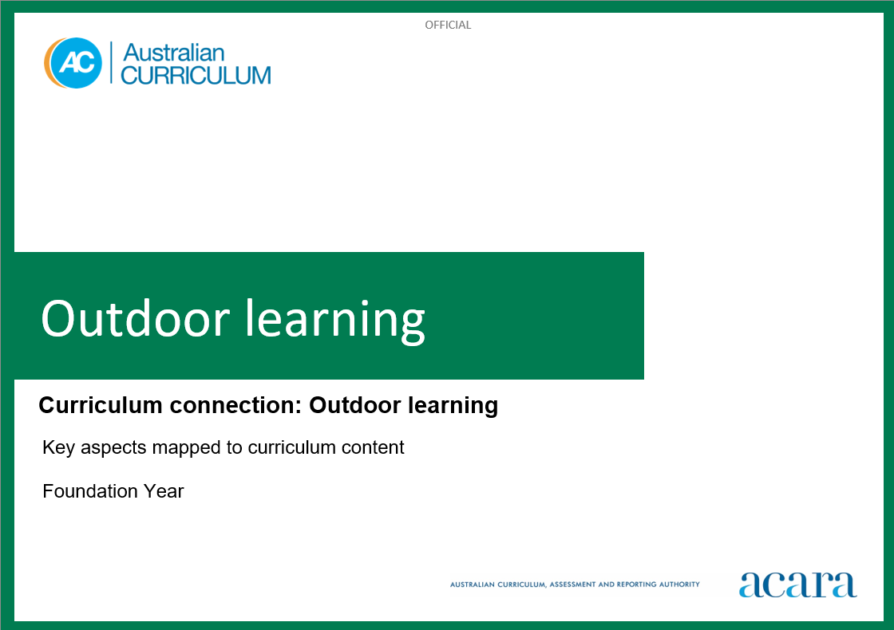

**Copyright and Terms of Use Statement**

**© Australian Curriculum, Assessment and Reporting Authority 2023**

The material published in this work is subject to copyright pursuant to the Copyright Act 1968 (Cth) and is owned by the Australian Curriculum, Assessment and Reporting Authority (ACARA) (except to the extent that copyright is held by another party, as indicated).

The viewing, downloading, displaying, printing, reproducing (such as by making photocopies) and distributing of these materials is permitted only to the extent permitted by, and is subject to the conditions imposed by, the terms and conditions of using the ACARA website (see, especially, clauses 2, 3 and 4 of those terms and conditions). The terms and conditions can be viewed at [https://www.acara.edu.au/contact-us/copyright](https://aus01.safelinks.protection.outlook.com/?url=https%3A%2F%2Fwww.acara.edu.au%2Fcontact-us%2Fcopyright&data=04%7C01%7CSharon.Foster%40acara.edu.au%7C9931e11fa7684c603e6308d98331bbfb%7C6cf76a3aa824427092003d71673ec678%7C0%7C0%7C637685071906340874%7CUnknown%7CTWFpbGZsb3d8eyJWIjoiMC4wLjAwMDAiLCJQIjoiV2luMzIiLCJBTiI6Ik1haWwiLCJXVCI6Mn0%3D%7C1000&sdata=U5O4Vlbpf271IGmGiMh7fDwU4pLzzAiHpCQFylkp6s4%3D&reserved=0)

**Outdoor Learning: foundation year**

The following table identifies how the key aspects of outdoor learning are evident in content descriptions from across the Australian Curriculum Version 9.0. From this information, teachers could develop a sequential program for outdoor learning by connecting the key aspects of learning with learning area and subject-specific content descriptions.

|  |  |  |  |
| --- | --- | --- | --- |
| Foundation Year | | | |
| Key aspect 1: Skills and knowledge | | | |
| Learning area/subject | Strand/sub-strand | Content descriptions | Content elaborations |
| **Health and Physical Education** | **Personal, social and community health**  Interacting with others | practise personal and social skills to interact respectfully with others  AC9HPFP02 | * explaining their reasons and actions in response to challenging situations in shared play experiences * cooperating, collaborating and negotiating with others when participating in physical activities to achieve agreed outcomes * identifying behaviours that may be disrespectful and cause hurt or harm to others during play |
| **Personal, social and community health**  Interacting with others | express and describe emotions they experience  AC9HPFP03 | * identifying and describing the emotions of people who are happy, sad, excited, tired, angry, scared or confused * learning and using appropriate language and actions to communicate their feelings in different situations * recalling and sharing emotional responses to different situations and representing these in a variety of ways * reading and viewing stories about adventures, and talking about how characters feel and react when taking risks or responding to emergencies * talking about connections between feelings, body reactions and body language * expressing a variety of emotions, thoughts and views in a range of situations |
| **Personal, social and community health**  Making healthy and safe choices | demonstrate protective behaviours, name body parts and rehearse help-seeking strategies that help keep them safe  AC9HPFP05 | * exploring protective behaviours and help-seeking strategies they can use when they or others feel unsafe or uncomfortable * exploring and demonstrating assertive strategies to seek help when they or others feel unsafe * identifying a support network of adults they can trust to help them if they feel unsafe, uncomfortable or scared * recognising that all people have the right to bodily autonomy: the right to make choices about what others ask them to do with and to their bodies |
| **Personal, social and community health**  Making healthy and safe choices | identify health symbols, messages and strategies in their community that support their health and safety  AC9HPFP06 | * identifying household substances that are dangerous and explaining what symbols are used to identify the danger * identifying symbols on food packages that indicate healthier choices * exploring different community strategies that keep children safe; for example, pedestrian crossings and traffic lights, safety procedures at swimming pools and beaches, and traffic controllers at school crossings * recognising and following safety symbols and procedures at home and in water and road environments |
| **Movement and physical activity**  Moving our bodies | practise fundamental movement skills in minor game and play situations  AC9HPFM01 | * applying different locomotor skills to move from one point to another * combining fine and gross motor skills in increasingly complex patterns * sending, controlling and receiving objects at different levels and in different ways * performing a range of water confidence skills such as floating with a buoyancy aid and putting their face in the water * demonstrating how to transfer weight from one part of the body to another * applying fundamental movement skills for purpose and enjoyment in natural environments |
| **Movement and physical activity**  Moving our bodies | experiment with different ways of moving their body safely and manipulating objects and space  AC9HPFM02 | * suggesting and testing different ways to move in a playing space or different ways to use equipment and objects, and making judgements about which are most effective and which movements and equipment they prefer * persisting with challenges and demonstrating resilience while moving their body in a range of situations * participating in games that require them to be aware of personal safety in relation to game boundaries, rules and safe use of equipment * manipulating equipment in a range of different movement situations and tasks, including in minor games, imaginative play and when practising fundamental movement skills * demonstrating spatial awareness when moving around and through indoor and outdoor (natural) environments confidently and safely |
| **Movement and physical activity**  Moving our bodies | participate in a range of activities in natural and outdoor settings and explore the benefits of being physically active  AC9HPFM03 | * exploring a range of ways to be active and participate safely in outdoor or natural settings * discussing opportunities to be active in spaces in and around their homes * exploring strategies for taking considered risks and developing self-regulation skills when moving and playing in outdoor settings |
| **Movement and physical activity**  Learning through movement | follow rules to promote fair play in a range of physical activities  AC9HPFM04 | * identifying and describing actions that would constitute fair and unfair play while participating in minor games * demonstrating how to play fairly in a range of minor games and play situations * discussing rules of different games that relate to safety, boundaries and appropriate use of equipment |
| **Science** | **Science understanding**  Chemical sciences | recognise that objects can be composed of different materials and describe the observable properties of those materials  AC9SFU03 | * investigating the ways in which First Nations Australians make utensils for different purposes by combining different materials |
| **Science understanding**  Science as a human endeavour | explore the ways people make and use observations and questions to learn about the natural world  AC9SFH01 | * using their senses to make observations and exploring how scientists use their senses as well as equipment to make observations * viewing examples of observations such as rock paintings, bark drawings, age-appropriate written reports, labelled drawings or photographs to explore ways they can make and record observations * exploring how First Nations Australians gain knowledge about the land and its vital resources, such as water and food, through observation * interacting with stories or documentaries about scientists such as Dame Jane Goodall or Sir Joseph Banks and noticing the ways they make their observations such as through drawings, collections, sound recordings and photography and how they ask questions about what they think they will observe and find * watching an age-appropriate documentary; noticing how people including scientists, engineers, naturalists or citizen scientists ask questions; and posing their own questions |
| **Science inquiry**  Questioning and predicting | pose questions and make predictions based on experiences  AC9SFI01 | * making predictions before field work, such as which plants and animals they may observe in the school grounds |
| **Science inquiry**  Planning and conducting | engage in investigations safely and make observations using their senses  AC9SFI02 | * explaining safety considerations for using the senses of touch, smell, sight and hearing, and discussing why we do not use taste to make observations in science * using provided tools such as binoculars, magnifying glasses, digital photography or video to enhance their observations of plants and animals * recording observations using numbers, dots, drawings, voice recordings, digital photography or video |
| **Science inquiry**  Communicating | share questions, predictions, observations and ideas with others  AC9SFI05 | * recounting stories and posing questions about their own experiences learning about the natural world, such as when gardening or observing plants and animals at home or visits to conservation areas or centres * acknowledging and exploring First Nations Australians’ ways of communicating information about anatomical features of plants and animals |

|  |  |  |  |
| --- | --- | --- | --- |
| Foundation Year | | | |
| Key aspect 2: Connections | | | |
| Learning area/subject | Strand/sub-strand | Content descriptions | Content elaborations |
| **Health and Physical Education** | **Personal, social and community health**  Interacting with others | investigate who they are and the people in their world  AC9HPFP01 | * making personal connections with stories that explore identity and belonging; discussing who they are, where they come from and people in their lives * exploring similarities and differences in family structures in First Nations Australian communities and other cultures * exploring cultural practices from different cultures, including the cultures of Asia, that are important to individuals, families and communities * identifying different families in their communities; for example, 2-parent, single-parent, extended and non-traditional families * identifying ways they use their strengths in physical activities to help themselves and others to be successful * recognising that they have a right to belong and contribute to a variety of groups |
| **Movement and physical activity**  Making active choices | participate in a range of activities in natural and outdoor settings and explore the benefits of being physically active  AC9HPFM03 | * playing traditional First Nations Australian games and discussing how they are like other games they have experienced |
| **Humanities and Social Sciences (HASS)**  **Foundation Year** | **Knowledge and understanding**  Geography | the features of familiar places they belong to, why some places are special and how places can be looked after  AC9HSFK03 | * identifying the places, communities, Country/Place they live in and belong to, and why that place may be special to them; for example, a neighbourhood, suburb, town or rural locality, or community exploring the features of their own place, and places they are familiar with or aware of; for example, places they have visited, places family members have come from, imaginary places in stories, or places featured on television and websites, in books or ebooks * identifying reasons why people live in or visit places, such as the provision of basic needs (water, food, shelter), to enhance lives (holiday places, places for recreation, for religious observance) and to maintain cultural connections to Country/Place * discussing different ways they could or do contribute to caring for special places, including those that are unique; for example, planting trees for a local endangered species, cleaning up litter at a local park or beach, or planting flora in a local wetland |
| **Knowledge and understanding**  Geography | the importance of Country/Place to First Nations Australians and the Country/Place on which the school is located  AC9HSFK04 | * identifying how and why the words Country/Place are used by First Nations Australians for the places they belong to * identifying and using the name of the local First Nations Australian language group or groups * listening and responding to invited members of the Traditional Owner group talking about Country/Place, and places of cultural and historical significance to the First Nations Australian community in the local neighbourhood, suburb, town or rural area * identifying local places of significance for First Nations Australians in the local area |
| **Science** | **Science inquiry**  Communicating | share questions, predictions, observations and ideas with others  AC9SFI05 | * recounting stories and posing questions about their own experiences learning about the natural world, such as when gardening or observing plants and animals at home or visits to conservation areas or centres * acknowledging and exploring First Nations Australians’ ways of communicating information about anatomical features of plants and animals |

|  |  |  |  |
| --- | --- | --- | --- |
| Foundation Year | | | |
| Key aspect 3: Conservation and sustainability | | | |
| Learning area/subject | Strand/sub-strand | Content descriptions | Content elaborations |
| **Humanities and Social Sciences (HASS)**  **Foundation Year** | **Knowledge and understanding**  Geography | the features of familiar places they belong to, why some places are special and how places can be looked after  AC9HSFK03 | * identifying the places, communities, Country/Place they live in and belong to, and why that place may be special to them; for example, a neighbourhood, suburb, town or rural locality, or community * exploring the features of their own place, and places they are familiar with or aware of; for example, places they have visited, places family members have come from, imaginary places in stories, or places featured on television and websites, in books or ebooks * identifying reasons why people live in or visit places, such as the provision of basic needs (water, food, shelter), to enhance lives (holiday places, places for recreation, for religious observance) and to maintain cultural connections to Country/Place * discussing different ways they could or do contribute to caring for special places, including those that are unique; for example, planting trees for a local endangered species, cleaning up litter at a local park or beach, or planting flora in a local wetland |
| **Knowledge and understanding**  Geography | the importance of Country/Place to First Nations Australians and the Country/Place on which the school is located  AC9HSFK04 | * identifying how and why the words Country/Place are used by First Nations Australians for the places they belong to * identifying and using the name of the local First Nations Australian language group or groups * listening and responding to invited members of the Traditional Owner group talking about Country/Place, and places of cultural and historical significance to the First Nations Australian community in the local neighbourhood, suburb, town or rural area * identifying local places of significance for First Nations Australians in the local area |

|  |  |  |  |
| --- | --- | --- | --- |
| Foundation Year | | | |
| Key aspect 4: Health and wellbeing | | | |
| Learning area/subject | Strand/sub-strand | Content descriptions | Content elaborations |
| **Health and Physical Education** | **Personal, social and community health**  Interacting with others | investigate who they are and the people in their world  AC9HPFP01 | * making personal connections with stories that explore identity and belonging; discussing who they are, where they come from and people in their lives * exploring similarities and differences in family structures in First Nations Australian communities and other cultures * exploring cultural practices from different cultures, including the cultures of Asia, that are important to individuals, families and communities * identifying different families in their communities; for example, 2-parent, single-parent, extended and non-traditional families * identifying ways they use their strengths in physical activities to help themselves and others to be successful * recognising that they have a right to belong and contribute to a variety of groups |
| **Personal, social and community health**  Making healthy and safe choices | identify health symbols, messages and strategies in their community that support their health and safety  AC9HPFP06 | * identifying household substances that are dangerous and explaining what symbols are used to identify the danger * identifying symbols on food packages that indicate healthier choices * exploring different community strategies that keep children safe; for example, pedestrian crossings and traffic lights, safety procedures at swimming pools and beaches, and traffic controllers at school crossings * recognising and following safety symbols and procedures at home and in water and road environments |
| **Movement and physical activity**  Making active choices | participate in a range of activities in natural and outdoor settings and explore the benefits of being physically active  AC9HPFM03 | * playing traditional First Nations Australian games and discussing how they are like other games they have experienced |