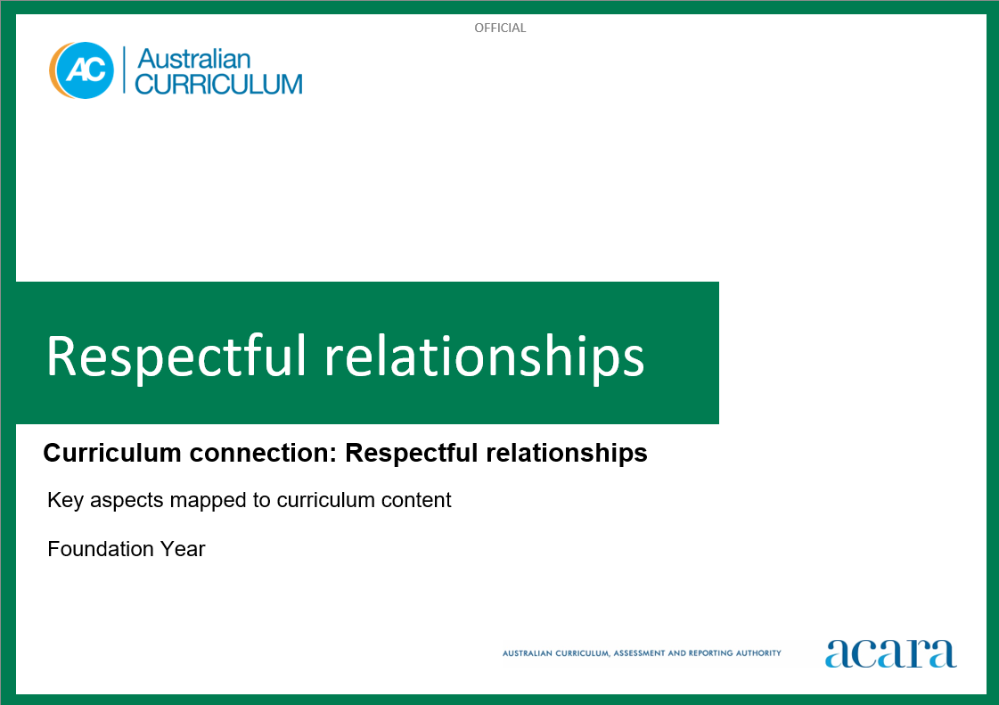

**Copyright and Terms of Use Statement**

**© Australian Curriculum, Assessment and Reporting Authority 2023**

The material published in this work is subject to copyright pursuant to the Copyright Act 1968 (Cth) and is owned by the Australian Curriculum, Assessment and Reporting Authority (ACARA) (except to the extent that copyright is held by another party, as indicated).

The viewing, downloading, displaying, printing, reproducing (such as by making photocopies) and distributing of these materials is permitted only to the extent permitted by, and is subject to the conditions imposed by, the terms and conditions of using the ACARA website (see, especially, clauses 2, 3 and 4 of those terms and conditions). The terms and conditions can be viewed at [https://www.acara.edu.au/contact-us/copyright](https://aus01.safelinks.protection.outlook.com/?url=https%3A%2F%2Fwww.acara.edu.au%2Fcontact-us%2Fcopyright&data=04%7C01%7CSharon.Foster%40acara.edu.au%7C9931e11fa7684c603e6308d98331bbfb%7C6cf76a3aa824427092003d71673ec678%7C0%7C0%7C637685071906340874%7CUnknown%7CTWFpbGZsb3d8eyJWIjoiMC4wLjAwMDAiLCJQIjoiV2luMzIiLCJBTiI6Ik1haWwiLCJXVCI6Mn0%3D%7C1000&sdata=U5O4Vlbpf271IGmGiMh7fDwU4pLzzAiHpCQFylkp6s4%3D&reserved=0)

**RESPECTFUL RELATIONSHIPS: Foundation**

The following table identifies how the key aspects of respectful relationships are evident in content descriptions from across the Australian Curriculum Version 9.0. From this information, teachers could develop a sequential program for respectful relationships by connecting the key aspects of learning with learning area and subject-specific content descriptions.

|  |  |  |  |
| --- | --- | --- | --- |
| Foundation | | | |
| Key aspect 1: Recognising and practising respect | | | |
| Learning area/subject | Strand/sub-strand | Content descriptions | Content elaborations |
| **Health and Physical Education** | **Personal, social and community health**  Identities and change | investigate who they are and the people in their world  AC9HPFP01 | * making personal connections with stories that explore identity and belonging; discussing who they are, where they come from and people in their lives * exploring similarities and differences in family structures in First Nations Australian communities and other cultures * exploring cultural practices from different cultures, including the cultures of Asia, that are important to individuals, families and communities * identifying different families in their communities; for example, 2-parent, single-parent, extended and non-traditional families * identifying ways they use their strengths in physical activities to help themselves and others to be successful * recognising that they have a right to belong and contribute to a variety of groups |
| **Personal, social and community health**  Identities and change | practise personal and social skills to interact respectfully with others  AC9HPFP02 | * explaining their reasons and actions in response to challenging situations in shared play experiences * identifying characters in texts who have been excluded from a group, exploring why they have been excluded and discussing how other characters could have been more inclusive * cooperating, collaborating and negotiating with others when participating in physical activities to achieve agreed outcomes * identifying behaviours that may be disrespectful and cause hurt or harm to others during play |
| **Humanities and Social Sciences (HASS)** | **Knowledge and understanding**  History | the people in their family, where they were born and raised, and how they are related to each other  AC9HSFK01 | * discussing the members of a family (for example, mother, father, caregiver, sister, brother, grandparent, auntie, uncle, cousin) and acknowledging other varieties of kinship structure that may be represented in the cultural backgrounds of students (for example, cousin-brother and mother-auntie in First Nations Australian families) * creating drawings of family members accompanied by information collected from questions and observations to share details of that person’s life, including the places they were born and raised * creating concept maps of their family with pictures or photographs to show connections to those people who make up their family |
| **Knowledge and understanding**  History | the celebrations and commemorations of significant events shared with their families and others  AC9HSFK02 | * responding to a provided calendar of events that students, their families and friends celebrate or commemorate; for example, birthdays; religious festivals such as Easter, Ramadan, Buddha’s Birthday, Feast of Passover and Coming of the Light; family reunions; cultural festivals; and community commemorations such as NAIDOC Week and Anzac Day, and discussing why they are important * discussing ways of celebrating these significant occasions; for example, special meals, family gatherings, visiting special places, and the role of art, music, telling stories and handing on traditions from generation to generation for First Nations Australians |

|  |  |  |  |
| --- | --- | --- | --- |
| Foundation | | | |
| Key aspect 2: Developing personal and social skills | | | |
| Learning area/subject | Strand/sub-strand | Content descriptions | Content elaborations |
| **Health and Physical Education** | **Personal, social and community health**  Interacting with others | practise personal and social skills to interact respectfully with others  AC9HPFP02 | * explaining their reasons and actions in response to challenging situations in shared play experiences * identifying characters in texts who have been excluded from a group, exploring why they have been excluded and discussing how other characters could have been more inclusive * cooperating, collaborating and negotiating with others when participating in physical activities to achieve agreed outcomes * identifying behaviours that may be disrespectful and cause hurt or harm to others during play |
| **Personal, social and community health**  Interacting with others | express and describe emotions they experience  AC9HPFP03 | * identifying and describing the emotions of people who are happy, sad, excited, tired, angry, scared or confused * learning and using appropriate language and actions to communicate their feelings in different situations * recalling and sharing emotional responses to different situations and representing these in a variety of ways * reading and viewing stories about adventures, and talking about how characters feel and react when taking risks or responding to emergencies * talking about connections between feelings, body reactions and body language * expressing a variety of emotions, thoughts and views in a range of situations |
| **Personal, social and community health**  Interacting with others | explore how to seek, give or deny permission respectfully when sharing possessions or personal space AC9HPFP04 | * practising and refining how to ask for permission when sharing possessions or personal space * negotiating roles and demonstrating awareness of rights (such as body autonomy/ integrity) and respect for different perspectives through imaginative and shared play experiences * exploring the importance of asking for permission and giving permission when sharing or negotiating in play and respecting someone's right to say no |
| **English** | **Language**  Language for interacting with others | explore how language is used differently at home and school depending on the relationships between people  AC9EFLA01 | * asking relevant questions, and expressing requests and opinions in ways that suit the contexts * learning to use language according to the relationship between people; for example, between a parent and a child, a teacher and a student, siblings or friends, shopkeepers and customers |
| **Literacy**  Interacting with others | interact in informal and structured situations by listening while others speak and using features of voice including volume levels  AC9EFLY02 | * exchanging ideas with peers in pairs and small groups, engaging in class discussions, listening to others and contributing ideas * showing understanding of appropriate listening behaviour, such as listening without interrupting, and looking at the speaker, if culturally appropriate * altering volume for inside and outside situations and when speaking to an audience * participating in informal interaction situations; for example, play-based experiences that involve the imaginative use of spoken language * listening to and following instructions |
| **The Arts – All subjects** | **Exploring and responding** | explore how and why the arts are important for people and communities  AC9ADAFE01; AC9ADRFE01; AC9AMAFE01; AC9AMUE01; AC9AVAFE01 | * exploring how facial expressions, gestures and other ways of moving, and using voice or language, can communicate emotions and feelings in arts works; for example, characters in portraits, cartoons, songs, chants or dances from different times and cultures * using dramatic play to explore ideas or understandings they observe or perceive in a text or image (print or screen); for example, exploring questions such as “What is happening?”, “What will happen next?” * identifying arts works and experiences in their lives, such as songs they sing, dances or drama they watch or perform, animations, computer games or music videos, public art, 2D, 3D or screen-based works they encounter at school or in community settings, and sharing ideas and feelings about the works with peers and teachers * exploring how illustrations/images in a text (fiction or non-fiction, print or screen) help to communicate narrative or information about characters, settings and/or mood * listening to First Nations Australians talk about the importance of the arts for connecting to people, culture and Country/Place; for example, using resources created or co-created by First Nations Australians |
| **Developing practices and skills** | use play, imagination, arts knowledge, processes and/or skills to discover possibilities and develop ideas  AC9ADAFD01; AC9ADRFD01; AC9AMAFD01; AC9AMUD01; AC9AVAFD01 | * imagining how the characters in a story they are reading might dress or move, and making still or moving images to communicate ideas about the characters; for example, working in groups and using dramatic play to imagine possibilities about characters and situations or asking questions such as “What happens next?” * playing games to develop subject-specific practices such as pitch, beat and/or rhythm recognition; exploring ways that body parts, zones and bases can be moved safely and expressively; taking on the point of view of a fictional character in dramatic play * responding to the emotions they experience while listening to different pieces of music and using movement to share their response; for example, using scarves and movement, or creating visual images using materials such as crayons or paint * exploring their speaking and singing voices and discovering ways to use their voices/vocalisation to communicate ideas and feelings |

|  |  |  |  |
| --- | --- | --- | --- |
| Foundation | | | |
| Key aspect 3: Recognising how gender norms and stereotypes can influence choices and actions | | | |
| Learning area/subject | Strand/sub-strand | Content descriptions | Content elaborations |
| **Health and Physical Education** | **Personal, social and community health**  Identities and change | investigate who they are and the people in their world  AC9HPFP01 | * making personal connections with stories that explore identity and belonging; discussing who they are, where they come from and people in their lives * exploring similarities and differences in family structures in First Nations Australian communities and other cultures * exploring cultural practices from different cultures, including the cultures of Asia, that are important to individuals, families and communities * identifying different families in their communities; for example, 2-parent, single-parent, extended and non-traditional families * identifying ways they use their strengths in physical activities to help themselves and others to be successful * recognising that they have a right to belong and contribute to a variety of groups |
| **Humanities and Social Sciences (HASS)** | **Knowledge and understanding**  History | the people in their family, where they were born and raised, and how they are related to each other  AC9HSFK01 | * discussing the members of a family (for example, mother, father, caregiver, sister, brother, grandparent, auntie, uncle, cousin) and acknowledging other varieties of kinship structure that may be represented in the cultural backgrounds of students (for example, cousin-brother and mother-auntie in First Nations Australian families) * creating drawings of family members accompanied by information collected from questions and observations to share details of that person’s life, including the places they were born and raised * creating concept maps of their family with pictures or photographs to show connections to those people who make up their family |

|  |  |  |  |
| --- | --- | --- | --- |
| Foundation | | | |
| Key aspect 4: Taking action to create equal and respectful communities | | | |
| Learning area/subject | Strand/sub-strand | Content descriptions | Content elaborations |
| **Health and Physical Education** | **Personal, social and community health**  Making healthy and safe choices | demonstrate protective behaviours, name body parts and rehearse help-seeking strategies that help keep them safe  AC9HPFP05 | * exploring protective behaviours and help-seeking strategies they can use when they or others feel unsafe or uncomfortable * exploring and demonstrating assertive strategies to seek help when they or others feel unsafe * recognising online spaces and digital tools that are safe for them to use and recognising the importance of seeking help from a trusted adult if they feel unsafe while online * identifying a support network of adults they can trust to help them if they feel unsafe, uncomfortable or scared * recognising that all people have the right to bodily autonomy: the right to make choices about what others ask them to do with and to their bodies |
| **Movement and physical activity**  Learning through movement | follow rules to promote fair play in a range of physical activities  AC9HPFM04 | * identifying and describing actions that would constitute fair and unfair play while participating in minor games * demonstrating how to play fairly in a range of minor games and play situations * discussing rules of different games that relate to safety, boundaries and appropriate use of equipment |
| **Digital Technologies** | **Processes and production skills**  Privacy and security | identify some data that is personal and owned by them  AC9TDIFP01 | * listing things that contain personal and public data, for example photos of themselves with their family (private) and photos of local community sites (public) * identifying apps and websites they use where their personal data could be made visible, for example photos of themselves on parents’ or carers’ social media, or their username being shown to others in online games |