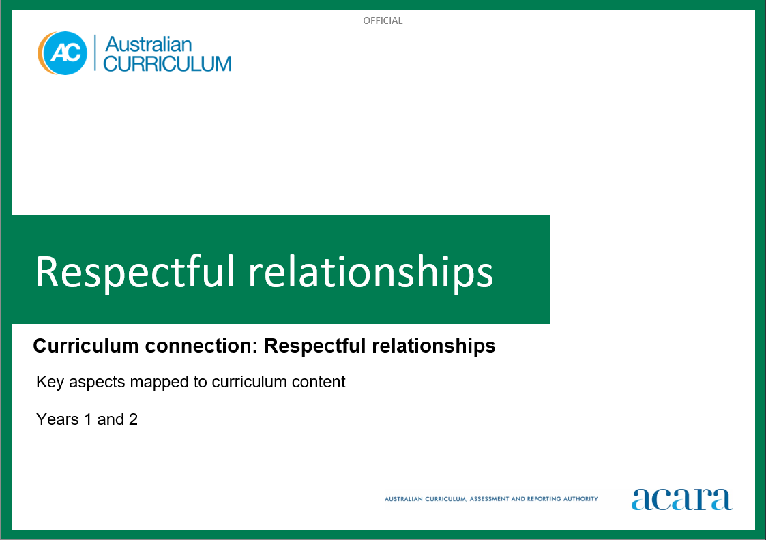

**Copyright and Terms of Use Statement**

**© Australian Curriculum, Assessment and Reporting Authority 2023**

The material published in this work is subject to copyright pursuant to the Copyright Act 1968 (Cth) and is owned by the Australian Curriculum, Assessment and Reporting Authority (ACARA) (except to the extent that copyright is held by another party, as indicated).

The viewing, downloading, displaying, printing, reproducing (such as by making photocopies) and distributing of these materials is permitted only to the extent permitted by, and is subject to the conditions imposed by, the terms and conditions of using the ACARA website (see, especially, clauses 2, 3 and 4 of those terms and conditions). The terms and conditions can be viewed at [https://www.acara.edu.au/contact-us/copyright](https://aus01.safelinks.protection.outlook.com/?url=https%3A%2F%2Fwww.acara.edu.au%2Fcontact-us%2Fcopyright&data=04%7C01%7CSharon.Foster%40acara.edu.au%7C9931e11fa7684c603e6308d98331bbfb%7C6cf76a3aa824427092003d71673ec678%7C0%7C0%7C637685071906340874%7CUnknown%7CTWFpbGZsb3d8eyJWIjoiMC4wLjAwMDAiLCJQIjoiV2luMzIiLCJBTiI6Ik1haWwiLCJXVCI6Mn0%3D%7C1000&sdata=U5O4Vlbpf271IGmGiMh7fDwU4pLzzAiHpCQFylkp6s4%3D&reserved=0)

**RESPECTFUL RELATIONSHIPS: years 1 and 2**

The following table identifies how the key aspects of respectful relationships are evident in content descriptions from across the Australian Curriculum Version 9.0. From this information, teachers could develop a sequential program for respectful relationships by connecting the key aspects of learning with learning area and subject-specific content descriptions.

|  |  |  |  |
| --- | --- | --- | --- |
| Years 1 and 2 | | | |
| Key aspect 1: Recognising and practising respect | | | |
| Learning area/subject | Strand/sub-strand | Content descriptions | Content elaborations |
| **Health and Physical Education** | **Personal, social and community health**  Interacting with others | identify and explore skills and strategies to develop respectful relationships  AC9HP2P02 | * identifying characters in texts who demonstrate respect and cooperation to develop respectful relationships * demonstrating appropriate language (including verbal, non-verbal, body language and gestures) when encouraging and including others in physical activities, when completing movement tasks or practising for performance * discussing strategies we can use to show respect to First Nations Australians and acknowledge difference using appropriate language * describing behaviours that may cause hurt or harm to others, or cause them to feel disrespected, including verbal and physical forms of bullying |
| **Humanities and Social Sciences (HASS) –  Year 1** | **Knowledge and understanding**  History | differences in family structures and roles today, and how these have changed or remained the same over time  AC9HS1K01 | * identifying the similarities and differences of a range of family structures; for example, nuclear families, one-child families, large families, single-parent families, extended families, blended or step families, adoptive and foster parent families, grandparent families, and kinship groups * comparing families in the present with those from the recent past; for example, the size of families across the generations * examining the roles of family members over time, such as roles of parents, children and extended family members, and comparing these with family roles today |

|  |  |  |  |
| --- | --- | --- | --- |
| Years 1 and 2 | | | |
| Key aspect 2: Developing personal and social skills | | | |
| Learning area/subject | Strand/sub-strand | Content descriptions | Content elaborations |
| **Health and Physical Education** | **Personal, social and community health**  Interacting with others | identify and explore skills and strategies to develop respectful relationships  AC9HP2P02 | * identifying characters in texts who demonstrate respect and cooperation to develop respectful relationships * identifying characters in texts who demonstrate respect for different types of families and carers, including those of different cultures, abilities or compositions * demonstrating appropriate language (including verbal, non-verbal, body language and gestures) when encouraging and including others in physical activities, when completing movement tasks or practising for performance * discussing strategies we can use to show respect to First Nations Australians and acknowledge difference using appropriate language * describing behaviours that may cause hurt or harm to others, or cause them to feel disrespected, including verbal and physical forms of bullying |
| **Personal, social and community health**  Interacting with others | identify how different situations influence emotional responses  AC9HP2P03 | * recognising own emotions and demonstrating ways to manage how they express their emotions in different situations * exploring self-regulation strategies to manage emotional responses * identifying situations that may trigger strong emotional responses in themselves and others, and recognising the impact the responses can have on others * identifying how someone might feel, think and act during an emergency through role-play and imaginative play * predicting how a person or character might be feeling based on the words they use, their facial expressions and body language * recognising how self and others are feeling in a range of situations |
| **Personal, social and community health**  Interacting with others | practise strategies they can use when they need to seek, give or deny permission respectfully  AC9HP2P04 | * practising strategies they can use when they need to give or refuse consent; for example, saying yes and no in an assertive manner, using non-verbal body cues and gestures * practising ways to interact with others in a fair and respectful way in play and other activities, regardless of differences in gender, abilities, race or personality * exploring situations where they need to seek, give or deny permission and practising strategies to assert themselves; for example, saying no to inappropriate touching |
| **Digital Technologies** | **Processes and production skills**  Collaborating and managing | use the basic features of common digital tools to create, locate and communicate content  AC9TDI2P04 | * using familiar digital systems to create content with others, for example using presentation software to retell a story * creating individual pieces of work that contribute to a group task, for example each student contributes a recipe and photo of their favourite food to create a class recipe book |
| **English – Year 1** | **Language**  Language for interacting with others | understand how language, facial expressions and gestures are used to interact with others when asking for and providing information, making offers, exclaiming, requesting and giving commands  AC9E1LA01 | * recognising the effects of words, signing, gestures and body language on the way communications are received by others * understanding that symbols, gestures and body language are key components of communication in First Nations Australian communities * viewing short films and discussing how characters use words and body language to convey emotions * learning the difference between closed questions; for example, “Are you ready?”, and open questions; for example, “What made this text so exciting?” |
| **Language**  Language for interacting with others | explore language to provide reasons for likes, dislikes and preferences  AC9E1LA02 | * using words including “because” to introduce reasons for likes, dislikes and preferences * exploring comparative words (adjectives) to express the degree of preference; for example, “better”, “faster” |
| **Literacy**  Interacting with others | use interaction skills including turn-taking, speaking clearly, using active listening behaviours and responding to the contributions of others, and contributing ideas and questions  AC9E1LY02 | * using turn-taking in group and pair work * building a conversation by staying on topic, supporting other speakers, eliciting responses, listening supportively and attentively, asking relevant questions, providing useful feedback and prompting * participating in informal and structured class, group and pair discussions about content area topics, ideas and information * interacting appropriately with peers, teachers and visitors * formulating different types of questions to ask a speaker, such as open and closed questions and “when”, “why” and “how” questions |
| **English – Year 2** | **Language**  Language for interacting with others | investigate how interpersonal language choices vary depending on the context, including the different roles taken on in interactions  AC9E2LA01 | * exploring culturally specific greetings and expressions of politeness * exploring First Nations Australian cultural protocols in Welcome to Country and Acknowledgement of Country, and the greeting words used by local First Nations Australians * exploring how familiarity with a group or individual influences language choices |
| **Literacy**  Interacting with others | use interaction skills when engaging with topics, actively listening to others, receiving instructions and extending own ideas, speaking appropriately, expressing and responding to opinions, making statements, and giving instructions  AC9E2LY02 | * exploring ways to comment on what others say, including using sentence starters such as “I like the way you …”, “I agree that …”, “I have a different thought …”, “I’d like to say something different …” * demonstrating appropriate listening behaviours, responding to and paraphrasing a partner’s contribution to a discussion; for example, in think pair share activities * asking relevant questions and making connections with personal experiences and the contributions of others * understanding how to disagree or respectfully offer an alternative |
| **The Arts – Media Arts** | **Exploring and responding** | explore where, why and how people across cultures, communities and/or other contexts experience media arts  AC9AMA2E01 | * discussing the roles of media artists and what permission means; for example, deciding on a class set of rules for using and creating images, sounds and text in media arts works |
| **Presenting and performing** | share media arts works with audiences in informal settings  AC9AMA2P01 | * collecting and sharing class stories and presenting them in the form of a class news bulletin, with permission of the people involved and observing relevant protocols, such as obtaining permission to use cultural material that belongs to a collective or a cultural group rather than an individual * presenting a media arts work they have made to the class, a small group or their teacher, and explaining how they made it and what they enjoyed about making it * considering relationships that peers may have with their work when creating, rehearsing and recording a radio play, and seeking permission to share it with another class * exploring what permission means; for example, consulting relevant people such as cultural knowledge holders or using online safety resources, and deciding on a class set of rules for using and creating images, sounds and text in media arts works |

|  |  |  |  |
| --- | --- | --- | --- |
| Years 1 and 2 | | | |
| Key aspect 3: Recognising how gender norms and stereotypes can influence choices and actions | | | |
| Learning area/subject | Strand/sub-strand | Content descriptions | Content elaborations |
| **Health and Physical Education** | **Personal, social and community health**  Identities and change | describe their personal qualities and those of others, and explain how they contribute to developing identities  AC9HP2P01 | * describing the personal qualities of characters in stories and how they are similar to and different from their own * describing how belonging to First Nations Australian cultural groups contributes to identities * exploring examples of cultural practices, including those of Australians of Asian heritage, that recognise the contributions of family and friends to identities * explaining how personal and cultural identities are influenced by the groups and communities to which we belong * participating in physical activities and describing how their own and others’ personal qualities contribute to successful outcomes * describing personal achievements and sharing how they felt and how it influenced their personal identities |
| **Humanities and Social Sciences (HASS) –  Year 1** | **Knowledge and understanding**  History | differences in family structures and roles today, and how these have changed or remained the same over time  AC9HS1K01 | * Identifying the similarities and differences of a range of family structures; for example, nuclear families, one-child families, large families, single-parent families, extended families, blended or step families, adoptive and foster parent families, grandparent families, and kinship groups * comparing families in the present with those from the recent past; for example, the size of families across the generations * examining the roles of family members over time, such as roles of parents, children and extended family members, and comparing these with family roles today |
| **Knowledge and understanding**  History | continuity and change between aspects of their daily lives and their parents’ and grandparents’ childhoods  AC9HS1K02 | * comparing and commenting on photographs and oral histories to find out how daily lives have changed and remained the same over time; for example, talking to parents, grandparents and other elders * comparing what has changed in daily life over time; for example, homes, family traditions, diverse religious and cultural practices, leisure, school life, rules, and shopping/consumer habits * examining the traditional toys used by First Nations Australian children to play and learn; for example, Arrernte children learn to play string games so they can remember stories they have been told * identifying similarities and differences in classroom equipment, learning activities, school playgrounds and playground games through observations of provided artefacts and photos, and asking questions of adults from different generations |

|  |  |  |  |
| --- | --- | --- | --- |
| Years 1 and 2 | | | |
| Key aspect 4: Taking action to create equal and respectful communities | | | |
| Learning area/subject | Strand/sub-strand | Content descriptions | Content elaborations |
| **Health and Physical Education** | **Personal, social and community health**  Making healthy and safe choices | identify and demonstrate protective behaviours and help-seeking strategies they can use to help them and others stay safe  AC9HP2P05 | * identifying the body’s reaction to a range of situations, including safe and unsafe situations, and comparing the different emotional responses * identifying and rehearsing strategies they can use when requiring assistance, such as asking an adult they trust, reading signs and symbols to identify safe places, and solving a problem with friends * proposing strategies they can use at school and home that promote healthy use of digital tools * recognising photos and locations of safe places and a network of people who can help * discussing the importance of seeking help when problems are too big to solve by themselves * exploring how characters in texts use protective behaviours and help-seeking strategies to keep themselves and others safe |
| **Movement and physical activity**  Learning through movement | co-construct and apply rules to promote fair play in a range of physical activities  AC9HP2M04 | * discussing changes to rules that will make an activity fairer or more inclusive of all learners * explaining how rules contribute to fair play and applying them in group activities * demonstrating turn-taking and sharing equipment when participating in play and minor games |
| **Movement and physical activity**  Learning through movement | apply strategies to work collaboratively when participating in physical activities  AC9HP2M05 | * working cooperatively with a partner when practising new skills * describing and demonstrating how to include others in physical activities * proposing and trialling how a game can be changed so that everyone can be included |
| **Digital Technologies** | **Processes and production skills**  Collaborating and managing | use the basic features of common digital tools to share content and collaborate demonstrating agreed behaviours, guided by trusted adults  AC9TDI2P05 | * taking and sharing photos of class work with parents or carers using classroom messaging software with teacher guidance * applying agreed standards of behaviour when sharing content with classmates, for example using language that is considered by all students and the teacher to be appropriate when they are writing messages to each other * considering the need for online safety when sharing information, for example recognising that personal information such as a photo can be used inappropriately |
| **Processes and production skills**  Privacy and security | discuss that some websites and apps store their personal data online  AC9TDI2P07 | * sharing examples of the data collected by apps and websites they commonly use, for example usernames and email addresses used by school websites and games to log in * discussing the importance of asking permission from a parent or carer before entering personal details online such as address, phone number and date of birth |