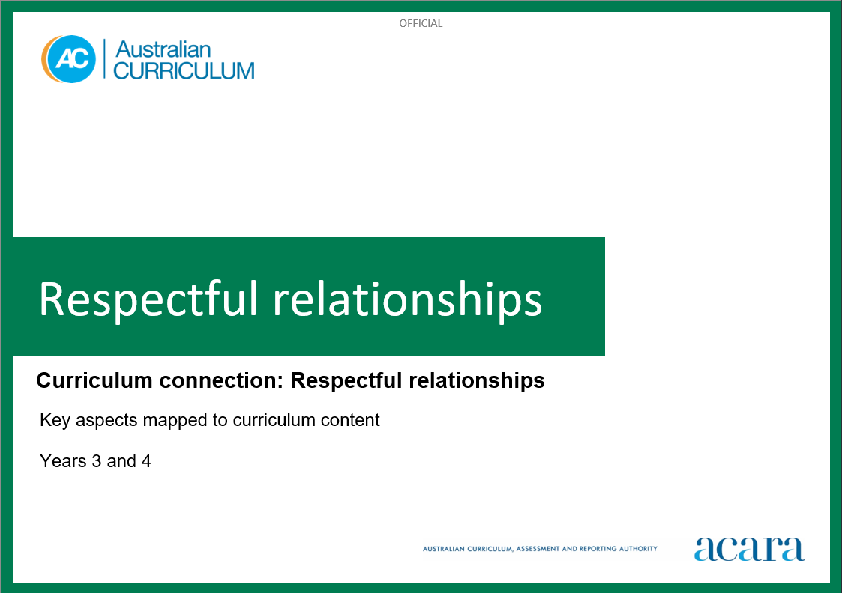

**Copyright and Terms of Use Statement**

**© Australian Curriculum, Assessment and Reporting Authority 2023**

The material published in this work is subject to copyright pursuant to the Copyright Act 1968 (Cth) and is owned by the Australian Curriculum, Assessment and Reporting Authority (ACARA) (except to the extent that copyright is held by another party, as indicated).

The viewing, downloading, displaying, printing, reproducing (such as by making photocopies) and distributing of these materials is permitted only to the extent permitted by, and is subject to the conditions imposed by, the terms and conditions of using the ACARA website (see, especially, clauses 2, 3 and 4 of those terms and conditions). The terms and conditions can be viewed at [https://www.acara.edu.au/contact-us/copyright](https://aus01.safelinks.protection.outlook.com/?url=https%3A%2F%2Fwww.acara.edu.au%2Fcontact-us%2Fcopyright&data=04%7C01%7CSharon.Foster%40acara.edu.au%7C9931e11fa7684c603e6308d98331bbfb%7C6cf76a3aa824427092003d71673ec678%7C0%7C0%7C637685071906340874%7CUnknown%7CTWFpbGZsb3d8eyJWIjoiMC4wLjAwMDAiLCJQIjoiV2luMzIiLCJBTiI6Ik1haWwiLCJXVCI6Mn0%3D%7C1000&sdata=U5O4Vlbpf271IGmGiMh7fDwU4pLzzAiHpCQFylkp6s4%3D&reserved=0)

**RESPECTFUL RELATIONSHIPS: Years 3 and 4**

The following table identifies how the key aspects of respectful relationships are evident in content descriptions from across the Australian Curriculum Version 9.0. From this information, teachers could develop a sequential program for respectful relationships by connecting the key aspects of learning with learning area and subject-specific content descriptions.

|  |  |  |  |
| --- | --- | --- | --- |
| Years 3 and 4 | | | |
| Key aspect 1: Recognising and practising respect | | | |
| Learning area/subject | Strand/sub-strand | Content descriptions | Content elaborations |
| **Health and Physical Education** | **Personal, social and community health**  Interacting with others | select, use and refine personal and social skills to establish, manage and strengthen relationships  AC9HP4P04 | * predicting and reflecting on how other students might feel in a range of challenging situations, and discussing what they can do to support them * describing characters in texts who have demonstrated respect for difference and diversity in individuals and communities, and exploring the strategies they used to do this |
| **Personal, social and community health**  Interacting with others | describe how valuing diversity influences wellbeing and identify actions that promote inclusion in their communities  AC9HP4P05 | * planning ways to celebrate the cultural diversity of students in their class, such as sharing recipes, stories and games from their cultural heritage * researching and participating in games from their own and others’ cultural heritage, and learning why games are important to build cultural awareness and appreciation * recognising the important role of cultural narratives in describing the diversity, and sharing beliefs and practices, of First Nations Australian communities * exploring the diversity of backgrounds, experiences, beliefs and practices of different cultures, including the cultures of Asia |
| **Movement and physical activity**  Learning through movement | perform a range of roles in respectful ways to achieve successful outcomes in group or team movement activities  AC9HP4M09 | * using cooperative skills to complete a movement task, such as a partner balance, partner passing strategy or team strategy * working cooperatively with team members to maintain possession in a game by passing to other players and listening to teammates * modifying physical activities to ensure that everyone is included, such as changing equipment, rules or playing space |
| **Humanities and Social Sciences (HASS) –  Year 3** | **Knowledge and understanding**  History | causes and effects of changes to the local community, and how people who may be from diverse backgrounds have contributed to these changes  AC9HS3K01 | * identifying individuals and groups of diverse backgrounds from the past, who have contributed to the community’s economic, social, cultural, civic and environmental development and character * investigating reasons for change in the local community, why change was brought about and what happened because of it; for example, the change in use of a building, wasteland turning to wetland |
| **Knowledge and understanding**  History | significant events, symbols and emblems that are important to Australia’s identity and diversity, and how they are celebrated, commemorated or recognised in Australia, including Australia Day, Anzac Day, NAIDOC Week, National Sorry Day, Easter, Christmas, and other religious and cultural festivals  AC9HS3K02 | * identifying and discussing the historical origins of an important Australian celebration or commemoration, including Australia Day, Anzac Day, NAIDOC Week and National Sorry Day, as well as significant religious or cultural festivals, such as Easter, Christmas, Lunar New Year, Diwali and Eid * recognising that people have different points of view on some events that are commemorated and celebrated; for example, some First Nations Australians regard “Australia Day” as “Invasion Day” and many non-Christians celebrate Christmas * generating a list of local, state/territory, national and religious symbols and emblems (for example, the Commonwealth Coat of Arms, the Australian Flag and First Nations Australians’ flags, state/territory flags and coats of arms, club emblems, school logos, flags, floral emblems, and religious symbols, such as the Christian cross, the Crescent and Star, and the Magen David), and discussing their origins, use and significance * examining the symbolism found in the design and positioning of flags (for example, the Australian flag, First Nations Australians’ flags) and recognising special occasions when they are flown (for example, all three flags are flown during NAIDOC Week, National Reconciliation Week, National Sorry Day and Mabo Day) * examining the roles, rights and responsibilities the community has when observing protocols around flag flying |

|  |  |  |  |
| --- | --- | --- | --- |
| Years 3 and 4 | | | |
| Key aspect 2: Developing personal and social skills | | | |
| Learning area/subject | Strand/sub-strand | Content descriptions | Content elaborations |
| **Health and Physical Education** | **Personal, social and community health**  Interacting with others | select, use and refine personal and social skills to establish, manage and strengthen relationships  AC9HP4P04 | * using cooperative skills and offering encouragement to successfully complete a movement task, such as a partner balance, partner passing strategy or team strategy * discussing how demonstrating respect and empathy for First Nations Australians can build positive relationships * recognising that bullying behaviour can take many forms, including online, and proposing strategies to challenge bullying in and out of school |
| **Personal, social and community health**  Interacting with others | explain how and why emotional responses can vary and practise strategies to manage their emotions  AC9HP4P06 | * recognising how the depth and strength of their own emotional responses may vary in different situations and practising strategies to manage emotions * analysing scenarios and identifying possible triggers and warning signs to predict emotional responses * analysing scenarios and identifying how someone might respond in a helpful way during an emergency * explaining the strategies characters in texts use to identify and manage their emotions before deciding to act * implementing self-regulation strategies to manage the expression of emotional responses |
| **Personal, social and community health**  Interacting with others | rehearse and refine strategies for seeking, giving and denying permission respectfully and describe situations when permission is required  AC9HP4P07 | * practising and refining strategies for seeking and giving consent; for example, giving consent for their photo to be shared * exploring actions they can take if someone has done something hurtful or disrespectful to them without their permission or consent including in online environments * exploring actions they can take when they or others are unsafe, such as saying no, leaving the situation and reporting the incident, and discussing how to use these strategies in situations in which someone posts an embarrassing picture online without permission, touches private parts of their body, or uses violence against them |
| **English – Year 3** | **Language**  Language for interacting with others | understand that cooperation with others depends on shared understanding of social conventions, including turn-taking language, which vary according to the degree of formality  AC9E3LA01 | * recognising and using collaborative language in group and pair work; for example, initiating a topic, changing a topic through negotiation, affirming other speakers and building on their comments, asking relevant questions, providing useful feedback, prompting, and checking individual and group understanding * understanding some First Nations Australian cultural protocols, cultural practices, specific roles, and ways of interacting and speaking |
| **Language**  Language for interacting with others | understand how the language of evaluation and emotion, such as modal verbs, can be varied to be more or less forceful  AC9E3LA02 | * exploring how modal verbs; for example, “must”, “might” and “could”, indicate degrees of probability or obligation * recognising how choice of adverbs, nouns and verbs present different evaluations of characters in texts * exploring examples of language that demonstrate a range of emotions and positions, and building a vocabulary to express judgements about characters or events; for example, “the wizard was cunning, expert, inventive” |
| **Literacy**  Interacting with others | use interaction skills to contribute to conversations and discussions to share information and ideas  AC9E3LY02 | * building on and connecting ideas and opinions expressed by others * listening actively, including listening for specific information, recognising the value of others’ contributions and responding through comments, recounts and summaries of information * learning the specific speaking or listening skills of different group roles; for example, group leader, note taker and reporter * using language appropriately in different situations; for example, explaining a procedure to a group, engaging in a game with friends |
| **English – Year 4** | **Language**  Language for interacting with others | explore language used to develop relationships in formal and informal situations  AC9E4LA01 | * recognising that language is adjusted in different contexts; for example, in degree of formality when moving between group discussions and presenting a group report * understanding how age, expertise and familiarity influence the ways in which people interact and how these codes and conventions vary across cultures * recognising the importance of using inclusive language * exploring cultural respects for First Nations Australian Elders, and greeting conventions between First Nations Australians |
| **Language**  Language for interacting with others | identify the subjective language of opinion and feeling, and the objective language of factual reporting  AC9E4LA02 | * identifying ways thinking verbs are used to express opinions; for example, “I think”, “I believe”, and ways summary verbs are used to report findings; for example, “we concluded” * comparing statements that have similar information presented objectively and subjectively; for example, “The man has 6 cats.” “The man has too many noisy cats.” |
| **Literacy**  Interacting with others | listen for key points and information to carry out tasks and contribute to discussions, acknowledging another opinion, linking a response to the topic, and sharing and extending ideas and information  AC9E4LY02 | * making notes about a task, asking questions to clarify or follow up information, and seeking assistance if required * developing speaking and listening behaviours including acknowledging and extending others’ contributions, presenting ideas and opinions clearly and coherently |
| **Digital Technologies** | **Processes and production skills**  Collaborating and managing | use the core features of common digital tools to share content, plan tasks, and collaborate, following agreed behaviours, supported by trusted adults  AC9TDI4P07 | * demonstrating safe sharing of content with a select audience, for example sharing a holiday adventure without revealing exact dates, specific names or other personal information * listening to others when participating in online environments to share content, for example respecting the rights of others by taking turns to suggest and add words or images to a factual slide deck to share with the teacher * interacting cooperatively in a group in an online environment to plan and complete a task, for example writing and responding to others’ views on canteen products * using digital tools to plan an event as a class, for example jointly creating a class survey to help plan an end-of-year party, where responses conform to the class’s accepted behavioural expectations |
| **The Arts – Media Arts** | **Presenting and performing** | share media arts works in informal settings considering responsible media practice  AC9AMA4P01 | * seeking permission to take photos of class members; for example, documenting a school excursion for publication on the school intranet and acknowledging that this permission has been obtained when sharing the work |

|  |  |  |  |
| --- | --- | --- | --- |
| Years 3 and 4 | | | |
| Key aspect 3: Recognising how gender norms and stereotypes can influence choices and actions | | | |
| Learning area/subject | Strand/sub-strand | Content descriptions | Content elaborations |
| **Health and Physical Education** | **Personal, social and community health**  Identities and change | describe how choices and actions can be influenced by stereotypes  AC9HP4P03 | * exploring different gender stereotypes in texts and media, and discussing the messages they portray and how they can influence choices and actions * recognising that unfair or unequal treatment of people based on their gender, abilities or other differences is wrong and against their human rights * describing ways to make roles and responsibilities at home, at school and in communities fair, equitable and inclusive * practising ways in which they can contribute to people of different genders being treated in fair and equal ways |
| **Humanities and Social Sciences (HASS) –  Year 4** | **Knowledge and understanding**  Civics and Citizenship | diversity of cultural, religious and/or social groups to which they and others in the community belong, and their importance to identity  AC9HS4K09 | * identifying diversity through the different social, cultural and religious groups students belong to and describing what makes them feel that they belong to the groups * listing and comparing the different beliefs, traditions and symbols used by groups * recognising that the identity of First Nations Australians is shaped by Country/Place, language and knowledge traditions |
| **English – Year 3** | **Literature**  Engaging with and responding to literature | discuss connections between personal experiences and character experiences in literary texts and share personal preferences  AC9E3LE02 | * discussing relevant prior knowledge and past experiences to make meaningful connections to the people, places, events, issues and ideas in texts |
| **Literacy**  Analysing, interpreting and evaluating | use comprehension strategies when listening and viewing to build literal and inferred meaning, and begin to evaluate texts by drawing on a growing knowledge of context, text structures and language features  AC9E3LY05 | * making predictions about a text, drawing on knowledge of the topic, subject-specific vocabulary and experience of texts on the same topic * determining important ideas, events or details in texts * comparing and contrasting how different texts present similar ideas or information * drawing inferences, using evidence from the text and prior knowledge and experience; for example, making predictions about a character's likely actions or about the content of tabbed pages on a website |
| **English – Year 4** | **Literacy**  Texts in context | compare texts from different times with similar purposes and audiences to identify similarities and differences in their depictions of events  AC9E4LY01 | * viewing documentaries and news footage from different periods, comparing the purpose and audience; for example, coverage of major sporting events * comparing the texts used to communicate between family members, noting similarities and differences as a result of changing technology |
| **Literacy**  Analysing, interpreting and evaluating | use comprehension strategies such as visualising, predicting, connecting, summarising, monitoring and questioning to build literal and inferred meaning, to expand topic knowledge and ideas, and evaluate texts  AC9E4LY05 | * making connections between information in print, images and sound * reading or listening for key topic-specific vocabulary words to build understanding * reading or listening to interpret the main idea and supporting ideas * identifying evidence and reasoning used by authors to support points or arguments * evaluating an author’s use of evidence to support arguments |
| **The Arts – Media Arts** | **Exploring and responding** | explore where, why and how media arts is created and/or distributed across cultures, times, places and/or other contexts  AC9AMA4E01 | * identifying meaning and describing representations in media arts works from different social, cultural or historical contexts; for example, examining the different ways traditional stories are retold using media technologies or the use of stereotypes in advertising |

|  |  |  |  |
| --- | --- | --- | --- |
| Years 3 and 4 | | | |
| Key aspect 4: Taking action to create equal and respectful communities | | | |
| Learning area/subject | Strand/sub-strand | Content descriptions | Content elaborations |
| **Health and Physical Education** | **Personal, social and community health**  Interacting with others | describe how valuing diversity influences wellbeing and identify actions that promote inclusion in their communities  AC9HP4P05 | * planning ways to celebrate the cultural diversity of students in their class, such as sharing recipes, stories and games from their cultural heritage * researching and participating in games from their own and others’ cultural heritage, and learning why games are important to build cultural awareness and appreciation * describing and practising safe bystander actions when they notice unfair or disrespectful behaviour towards others * modifying physical activities to ensure that everyone is included, such as by changing equipment, rules, playing space and number of players |
| **Personal, social and community health**  Making healthy and safe choices | describe and apply protective behaviours and help-seeking strategies in a range of online and offline situations  AC9HP4P08 | * describing warning signs (physical, emotional and external) that can help them to know if they are safe or unsafe * examining protective behaviours to stay safe in different situations, including near water or roads, in the park, when they are online or when someone makes them feel uncomfortable or unsafe * identifying a range of help-seeking strategies to negotiate positive outcomes when challenging situations, such as reporting negative or harmful online behaviour by seeking help from trusted adults * indicating on a local map the location of safe places and people who can help if they feel unsafe or scared * proposing strategies for managing online safety by recognising when they feel uncomfortable or unsafe, and identifying steps for reporting negative or harmful behaviour * discussing different protective behaviours and help-seeking strategies characters in texts use to keep themselves and others safe |
| **Movement and physical activity**  Learning through movement | apply rules and scoring systems to promote fair play when participating or designing physical activities  AC9HP4M08 | * collaborating to decide rules for a new game to promote fair play and inclusion of all learners * describing processes of decision making that ensure fairness in games and contributing to fair decision-making by applying the rules appropriately in physical activities * interpreting and applying rules fairly in physical activities where they are in the role of officiating |
| **Movement and physical activity**  Learning through movement | perform a range of roles in respectful ways to achieve successful outcomes in group or team movement activities  AC9HP4M09 | * using cooperative skills to complete a movement task, such as a partner balance, partner passing strategy or team strategy * working cooperatively with team members to maintain possession in a game by passing to other players and listening to teammates * modifying physical activities to ensure that everyone is included, such as changing equipment, rules or playing space |
| **Humanities and Social Sciences (HASS) –  Year 3** | **Knowledge and understanding**  Civics and Citizenship | who makes rules, why rules are important in the school and/or the local community, and the consequences of rules not being followed  AC9HS3K06 | * developing and justifying a set of fair rules and consequences for the class * identifying familiar rules, how rules protect the rights of others, what their responsibilities are to others, and the consequences when rules are not followed * exploring who has the authority to make rules in different contexts (for example, parents, teachers, coaches) and considering why rules differ across these contexts, such as a school playground, in class, at home, or in sport * discussing situations where it is not fair to have one rule that treats everyone the same; for example, if some people, such as students with disability, have different needs or would be unable to follow the rules * exploring cultural norms behind some rulemaking; for example, removing shoes before entering places of cultural or religious significance |
| **Skills**  Concluding and decision-making | propose actions or responses to an issue or challenge that consider possible effects of actions  AC9HS3S06; AC9HS4S06 | * considering anticipated effects of actions designed to protect and improve places that people perceive as important, such as places of environmental, cultural or religious value, or historic significance * developing a plan of action to achieve a set goal; for example, to protect a place, to participate in a community festival or commemoration, to raise awareness about an issue, to raise money for a purpose * arguing a point of view on a civics and citizenship issue relevant to their lives (for example, the consequences of breaking school rules, the value of contributing to their community, the need to preserve an endangered species) and making effective use of persuasive language such as “I think” and “I dis/agree that” to gain the support of others |