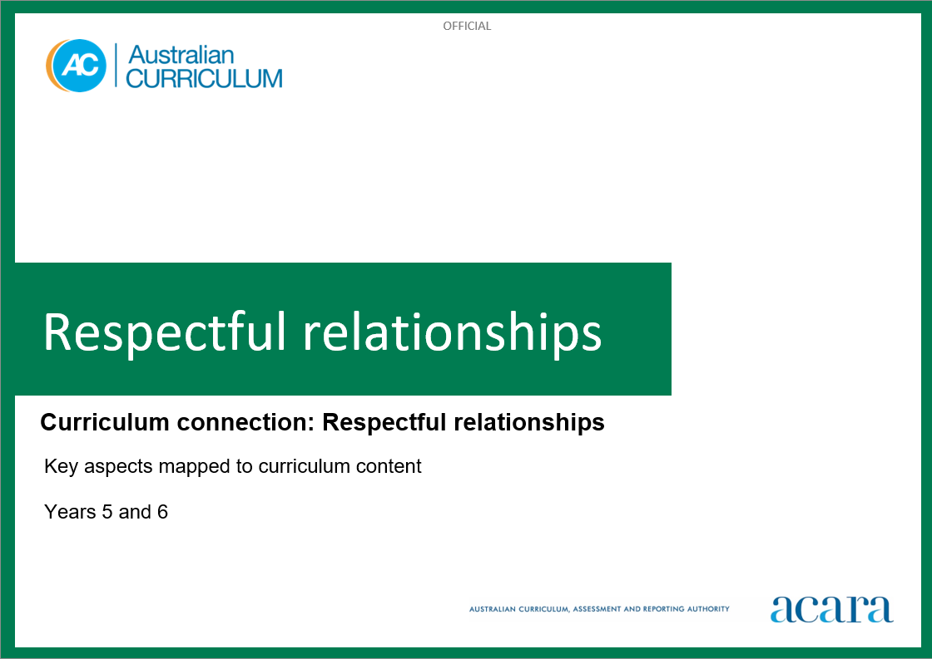

**Copyright and Terms of Use Statement**

**© Australian Curriculum, Assessment and Reporting Authority 2023**

The material published in this work is subject to copyright pursuant to the Copyright Act 1968 (Cth) and is owned by the Australian Curriculum, Assessment and Reporting Authority (ACARA) (except to the extent that copyright is held by another party, as indicated).

The viewing, downloading, displaying, printing, reproducing (such as by making photocopies) and distributing of these materials is permitted only to the extent permitted by, and is subject to the conditions imposed by, the terms and conditions of using the ACARA website (see, especially, clauses 2, 3 and 4 of those terms and conditions). The terms and conditions can be viewed at [https://www.acara.edu.au/contact-us/copyright](https://aus01.safelinks.protection.outlook.com/?url=https%3A%2F%2Fwww.acara.edu.au%2Fcontact-us%2Fcopyright&data=04%7C01%7CSharon.Foster%40acara.edu.au%7C9931e11fa7684c603e6308d98331bbfb%7C6cf76a3aa824427092003d71673ec678%7C0%7C0%7C637685071906340874%7CUnknown%7CTWFpbGZsb3d8eyJWIjoiMC4wLjAwMDAiLCJQIjoiV2luMzIiLCJBTiI6Ik1haWwiLCJXVCI6Mn0%3D%7C1000&sdata=U5O4Vlbpf271IGmGiMh7fDwU4pLzzAiHpCQFylkp6s4%3D&reserved=0)

**RESPECTFUL RELATIONSHIPS: Years 5 and 6**

The following table identifies how the key aspects of respectful relationships are evident in content descriptions from across the Australian Curriculum Version 9.0. From this information, teachers could develop a sequential program for respectful relationships by connecting the key aspects of learning with learning area and subject-specific content descriptions.

|  |  |  |  |
| --- | --- | --- | --- |
| Years 5 and 6 | | | |
| Key aspect 1: Recognising and practising respect | | | |
| Learning area/subject | Strand/sub-strand | Content descriptions | Content elaborations |
| **Health and Physical Education** | **Personal, social and community health**  Interacting with others | describe and demonstrate how respect and empathy can be expressed to positively influence relationships  AC9HP6P04 | * exploring strategies for responding when relationships change, such as starting a new school, changing priorities or interests, family break-up, or joining a new sports team * proposing strategies for managing the changing nature of relationships, including dealing with bullying and harassment, and building new friendships * exploring and performing different roles and responsibilities in physical activities that promote enjoyment, safety and positive outcomes for all participants * recognising how words and labels used regarding First Nations Australians can cause offence and how this awareness can support and strengthen respectful relationships * examining the behaviours people demonstrate when treating others in respectful ways, and comparing to those behaviours that constitute forms of bullying, racism or gender-based violence |
| **Personal, social and community health**  Interacting with others | describe and implement strategies to value diversity in their communities  AC9HP6P05 | * proposing strategies to help others understand points of view that differ from their own and to encourage discussion about individual and cultural similarities and differences to tackle discrimination such as sexism, racism and homophobia * exploring initiatives that sporting and cultural groups use to celebrate diversity, counter discrimination and racism, and support the wellbeing of their communities * discussing the role bystanders can play in promoting respectful interactions and challenging disrespect and discrimination such as homophobia, transphobia and racism * exploring the importance of cultural expressions of First Nations Australians in maintaining a continuing deep connection to Country/Place and its influence on wellbeing * examining how beliefs, values and cultural practices convey meaning and influence peoples’ sense of identity and belonging, including Australians of Asian heritage |
| **Humanities and Social Sciences (HASS) –  Year 5** | **Knowledge and understanding**  Civics and Citizenship | how citizens (members of communities) with shared beliefs and values work together to achieve a civic goal  AC9HS5K07 | * discussing how and why people volunteer for community groups such as religious and other charities, rural fire services, surf life-saving clubs, emergency services groups, First Nations community groups and youth groups * using social media to share and discuss ideas about how people can work together as local, regional and global citizens; for example, to promote access to educational opportunities for women and girls in developing countries * examining First Nations Australian organisations and the services they provideinvestigating reasons for change in the local community, why change was brought about and what happened because of it; for example, the change in use of a building, wasteland turning to wetland |

|  |  |  |  |
| --- | --- | --- | --- |
| Years 5 and 6 | | | |
| Key aspect 2: Developing personal and social skills | | | |
| Learning area/subject | Strand/sub-strand | Content descriptions | Content elaborations |
| **Health and Physical Education** | **Personal, social and community health**  Interacting with others | apply strategies to manage emotions and analyse how emotional responses influence interactions  AC9HP6P06 | * exploring the emotions associated with feeling unsafe or uncomfortable and proposing strategies to manage these situations * analysing situations in which emotions can influence decision-making, including in peer-group, family and movement situations * exploring when emotional responses can be intense or unpredictable and practising strategies to self-regulate and manage expression of strong emotions |
| **Personal, social and community health**  Interacting with others | describe strategies for seeking, giving or denying consent and rehearse how to communicate their intentions effectively and respectfully  AC9HP6P07 | * exploring the steps of seeking, giving or denying consent (asking, responding, listening and reacting) and practising how to communicate their intentions effectively at each step * practising and refining strategies for interpreting verbal and non-verbal cues related to seeking, giving and denying consent in a range of situations * analysing how a person’s reaction to being denied permission to do something can affect others’ feelings and discussing options for dealing with situations when this may occur; for example, feelings of disappointment, shame and anger associated with rejection |
| **Digital Technologies** | **Processes and production skills**  Privacy and security | access their school account using a memorised password and explain why it should be easy to remember, but hard for others to guess  AC9TDI4P08 | * recalling their school username and password from memory to login to a school laptop or desktop * explaining how keeping a password secret prevents others from accessing their data, for example how their work is saved in their account and can only be accessed using their secret password * exploring techniques to create an easy to remember and hard to guess password, for example creating a password using 3 unrelated but easy to remember words |
| **English – Year 5** | **Language**  Language for interacting with others | understand that language is selected for social contexts and that it helps to signal social roles and relationships  AC9E5LA01 | * using language that signals the roles of chairperson and the different speaker positions in a debate * identifying ways in which cultures differ in making and responding to common requests; for example, periods of silence, degrees of formality * identifying some cultural protocols and communication processes of First Nations Australians |
| **Literacy**  Interacting with others | use appropriate interaction skills including paraphrasing and questioning to clarify meaning, make connections to own experience, and present and justify an opinion or idea  AC9E5LY02 | * participating in pair, group, class and school speaking and listening situations, including informal conversations, discussions and presentations * asking specific questions to clarify a speaker’s meaning, making constructive comments that keep conversation moving, reviewing ideas expressed and conveying tentative conclusions * using strategies for discussion, such as speaking clearly, pausing, asking questions and linking students’ own responses to the contributions of others * choosing vocabulary and sentence structures for particular purposes including formal and informal contexts, to report and explain new concepts and topics, to offer an opinion and to persuade others |
| **English – Year 6** | **Language**  Language for interacting with others | understand that language varies as levels of formality and social distance increase  AC9E6LA01 | * recognising language protocols for formal address; for example, words used to address principals, heads of state and monarchs * discussing levels of language such as slang, colloquial, conversational and formal, and how their appropriateness changes with the situation and audience * presenting ideas and opinions at levels of formality appropriate to the context and audience |
| **Language**  Language for interacting with others | understand the uses of objective and subjective language, and identify bias  AC9E6LA02 | * identifying language choices that evoke emotion and judgements in direct and indirect ways, and how they are used to persuade different audiences to take a position and/or action * understanding when to share feelings and opinions; for example, in a personal recount, and when to remain more objective; for example, in a factual recount * differentiating between reporting the facts; for example, in a factual recount or unedited photograph, and providing a commentary; for example, in an editorial |
| **Literacy**  Interacting with others | use interaction skills and awareness of formality when paraphrasing, questioning, clarifying and interrogating ideas, developing and supporting arguments, and sharing and evaluating information, experiences and opinions  AC9E6LY02 | * participating in pair, group, class, school and community speaking and listening situations, including informal conversations, discussions, debates and presentations * using strategies; for example, pausing, questioning, rephrasing, repeating, summarising, reviewing and asking clarifying questions when discussing topics * recognising that closed questions ask for precise responses while open questions prompt a speaker to provide more information |

|  |  |  |  |
| --- | --- | --- | --- |
| Years 5 and 6 | | | |
| Key aspect 3: Recognising how gender norms and stereotypes can influence choices and actions | | | |
| Learning area/subject | Strand/sub-strand | Content descriptions | Content elaborations |
| **Health and Physical Education** | **Personal, social and community health**  Identities and change | investigate how the portrayal of societal roles and responsibilities can be influenced by gender stereotypes  AC9HP6P03 | * identifying characters in texts who are not constrained by traditional gender stereotypes and how this influences their choices and actions * questioning the fairness of gender roles and proposing ways to challenge those practices that infringe on an individual’s human rights * investigating how social and cultural norms about gender can influence the roles and responsibilities of family members and people within their community * identifying those gender norms that can have limiting and harmful effects, and proposing strategies to advance gender equality and respect for human rights |
| **Humanities and Social Sciences (HASS) –  Year 5** | **Skills**  Interpreting, analysing and evaluating | evaluate primary and secondary sources to determine origin, purpose and perspectives  AC9HS5S04 | * identifying inferred messages, stereotypes and over-generalisations relating to age, gender, ethnicity, ability, religion and/or politics, and other beliefs or attitudes presented in sources and media of the past (for example, a newspaper caricature or photos of a colonial-era Chinese goldfield worker, businesspeople, First Nations Australians, South Sea Islander workers, women and children) and in sources and media of the present, such as social media opinions about a particular industry * evaluating the accuracy and the perspectives in information gained from primary and secondary sources; for example, checking publication details for the author of speeches, advertisements, campaign materials, symbols and how-to-vote cards, or comparing sources of evidence to identify similarities and/or differences in accounts of the past that reflect different perspectives * comparing sources of evidence to identify similarities and/or differences in accounts of and perspectives on the past; for example, comparing the differing experiences and feelings of miners, Chinese workers, women, children, leaders and First Nations Australian occupants during the Eureka Stockade; comparing colonial descriptions of Burke and Wills’s achievements with those that have been recently published giving First Nations Australian perspectives; comparing representations of Ned Kelly in past and present publications |
| **Humanities and Social Sciences (HASS) –  Year 6** | **Skills**  Interpreting, analysing and evaluating | evaluate primary and secondary sources to determine origin, purpose and perspectives  AC9HS6S04 | * examining the publishing details and content of a text to help clarify the publication’s purpose, to distinguish fact from opinion, to identify potential bias in the content, to assess its relevance, and to put information presented in a historical or geographical context * identifying persuasive techniques such as modality (for example, “would”, “could”, “may” and “might”) and the use of the passive voice (for example, “It is claimed by the government that…”) rather than the active voice (for example, “The government claims that...”), and considering reasons for these choices * discussing issues explored through sources where there are, or were, a range of views, such as deportation of South Sea Islanders from 1901, the vote for women, how to manage an environment more sustainably and the encouragement of migration, and proposing reasons for different perspectives |
| **English – Year 5** | **Literature**  Engaging with and responding to literature | present an opinion on a literary text using specific terms about literary devices, text structures and language features, and reflect on the viewpoints of others  AC9E5LE02 | * posing and discussing questions, such as “Should characters have behaved as they did?” and “How did the author support or challenge your belief about the characters?”, and beginning to make judgements about the dilemmas characters face * identifying language features such as use of dialogue and rich descriptive language, and presenting an opinion about their effect on readers |
| **Literature**  Examining literature | recognise that the point of view in a literary text influences how readers interpret and respond to events and characters  AC9E5LE03 | * comparing texts narrated from a first person and third person point of view, and discussing what information the audience can access and how this influences the audience’s sympathies * discussing why an author might choose a particular point of view |
| **Literacy**  Texts in context | describe the ways in which a text reflects the time and place in which it was created  AC9E5LY01 | * describing how ideas in texts are conveyed by vocabulary, including idiomatic expressions, and that these can change according to time and place * describing how ideas in texts reflect the social expectations of the time and place in which they were created |
| **Literacy**  Analysing, interpreting and evaluating | use comprehension strategies such as visualising, predicting, connecting, summarising, monitoring and questioning to build literal and inferred meaning to evaluate information and ideas  AC9E5LY05 | * summarising ideas and information to determine the main idea of a text * using research skills including identifying research purpose, locating texts, gathering and organising information, evaluating relative value, evaluating the accuracy and currency of print and digital sources, and summarising information from several sources * comparing texts on the same topic to identify similarities and differences in the ideas or information that are included |
| **English – Year 6** | **Language**  Language for interacting with others | understand the uses of objective and subjective language, and identify bias  AC9E6LA02 | * identifying language choices that evoke emotion and judgements in direct and indirect ways, and how they are used to persuade different audiences to take a position and/or action * understanding when to share feelings and opinions; for example, in a personal recount, and when to remain more objective; for example, in a factual recount * differentiating between reporting the facts; for example, in a factual recount or unedited photograph, and providing a commentary; for example, in an editorial |
| **Literacy**  Texts in context | examine texts including media texts that represent ideas and events, and identify how they reflect the context in which they were created  AC9E6LY01 | * identifying news reports of the same type of event over time and how they reflect their contexts * comparing advertising posters for animated children's films in different countries and explaining the impact of these choices on audience expectations of the film * identifying how advertisements for the same products reflect the context in which they were created |
| **Literacy**  Analysing, interpreting and evaluating | use comprehension strategies such as visualising, predicting, connecting, summarising, monitoring and questioning to build literal and inferred meaning, and to connect and compare content from a variety of sources  AC9E6LY05 | * making connections between the text and students’ own experience or other texts * making connections between information in print and images * using prior knowledge and textual information to make inferences * asking and answering questions * using graphic organisers to visualise connections, categories and hierarchies of information * summarising a text or part of a text |
| **The Arts – Media Arts** | **Exploring and responding** | explore ways that media languages and media technologies are used in media arts works and practices across cultures, times, places and/or other contexts  AC9AMA6E01 | * investigating characters in games, considering issues such as stereotyping or bias as background to designing and drawing a game character for a particular genre, and considering the appropriate costume, cultural background and/or sample dialogue * exploring status, such as power relationships, and showing different perspectives of character by using framing, colour and costume to create a hero or villain character * researching and comparing media representations created in different times and places, and explaining how context influences the characters, stories and values portrayed in media arts works; for example, comparing TV representations of family * using Viewpoints to develop questions to explore new ideas; for example, “How are values demonstrated in this media representation?”, “Can we judge a culture from popular media images?” |

|  |  |  |  |
| --- | --- | --- | --- |
| Years 5 and 6 | | | |
| Key aspect 4: Taking action to create equal and respectful communities | | | |
| Learning area/subject | Strand/sub-strand | Content descriptions | Content elaborations |
| **Health and Physical Education** | **Personal, social and community health**  Interacting with others | describe and implement strategies to value diversity in their communities  AC9HP6P05 | * proposing strategies to help others understand points of view that differ from their own and to encourage discussion about individual and cultural similarities and differences to tackle discrimination such as sexism, racism and homophobia * exploring initiatives that sporting and cultural groups use to celebrate diversity, counter discrimination and racism, and support the wellbeing of their communities * discussing the role bystanders can play in promoting respectful interactions and challenging disrespect and discrimination such as homophobia, transphobia and racism * discussing how adaptations and modifications to physical activities can enable inclusivity for students with a range of abilities |
| **Personal, social and community health**  Making healthy and safe choices | analyse and rehearse protective behaviours and help-seeking strategies that can be used in a range of online and offline situations  AC9HP6P08 | * researching sources of health information and places where they can seek help, and prioritising those that are reliable and trustworthy * examining ways to normalise and de-stigmatise help-seeking behaviour so all students feel more comfortable and confident to seek help when needed * discussing strategies for maintaining online safety when using digital tools and environments, including the options and processes for reporting negative or harmful behaviour * exploring actions they can take when they feel unsafe when online; for example, who to speak to if someone posts an embarrassing picture of them without permission or when to step away from negative online social interactions * proposing strategies they can use if they witness others in unsafe situations, such as accessing support networks or telling an adult they trust * analysing the responses of characters in TV shows or movies when in unsafe or risky situations and discussing the efficacy of their response to the situation |
| **Movement and physical activity**  Learning through movement | participate positively in groups and teams by contributing to group activities, encouraging others and negotiating roles and responsibilities  AC9HP6M09 | * exploring and performing the different roles and responsibilities in physical activities that promote enjoyment, safety and positive outcomes for participants * demonstrating negotiation skills when dealing with conflicts or disagreements in movement situations * using reflective listening and assertive communication when working in small groups on movement tasks or challenges |
| **Digital Technologies** | **Processes and production skills**  Collaborating and managing | select and use appropriate digital tools effectively to share content online, plan tasks and collaborate on projects, demonstrating agreed behaviours  AC9TDI6P08 | * following a previously created plan to report back to the class on a given problem, using digital tools, for example small groups reporting on the best location for a new skate park in the local government area * defining and acting collectively using online community standards and valuing the work of others, for example moderating language and behaviour in an online class forum, not deleting the work of collaborators, and respecting others’ intellectual property * demonstrating agreed behaviours; following cultural protocols, including relevant permissions and attributions; acknowledging diversity, capability and strength; and addressing risks and responsibilities such as privacy, security, and accuracy of data; for example when sharing images of First Nations Australians’ cultural artefacts * using a range of communication tools to share ideas and information with stakeholders, for example presenting content for a school celebration such as a graduation celebration with the parents and citizens association or school executive in an online forum |
| **Humanities and Social Sciences (HASS) –  Year 5** | **Knowledge and understanding**  Civics and Citizenship | how citizens (members of communities) with shared beliefs and values work together to achieve a civic goal  AC9HS5K07 | * discussing how and why people volunteer for community groups such as religious and other charities, rural fire services, surf life-saving clubs, emergency services groups, First Nations community groups and youth groups * using social media to share and discuss ideas about how people can work together as local, regional and global citizens; for example, to promote access to educational opportunities for women and girls in developing countries * examining First Nations Australian organisations and the services they provide |
| **Skills**  Concluding and decision-making | propose actions or responses to issues or challenges and use criteria to assess the possible effects  AC9HS6S06 | * forecasting probable futures for an issue; for example, how native fauna populations might change if an introduced species such as the cane toad, carp, feral cats or rabbits continues to increase in population and proposing preferred futures that relate to the issue * undertaking a project that responds to an identified challenge or issue with strategies to be used that will achieve desired outcomes; for example, a school fundraising activity, an ecological preservation project, a school-based opinion poll about a relevant issue * asking questions in order to consider potential effects; for example, “What could be the effects of my purchasing decisions?”, “Are needs and wants the same for everyone?”, “Why can’t all needs and wants be satisfied?”, “How can I contribute to a sustainable environment?” * participating in a relevant democratic process, such as class votes, mock parliament and school decision-making processes such as student councils * making judgements about how effectively challenges have been addressed in the past (for example, relative success of a response to challenges during colonial settlement) or how effectively a current challenge is being addressed (for example, the solution to an environmental issue or a strategy for economic development) * using criteria to evaluate the possible options that people could take to resolve challenges, such as improving water quality, managing excess waste and providing resources, and using criteria to improve responses in communities to environmental hazards; for example, considering economic factors such as needs, wants and costs, as well as environmental, health and social factors |
|  | **Skills**  Concluding and decision-making | propose actions or responses to issues or challenges and use criteria to assess the possible effects  AC9HS6S06 | * planning a project, campaign or enterprise around an identified challenge with specification of the sequence of tasks and activities, responsibilities and deadlines * brainstorming solutions to an issue that is significant to a group, collecting evidence to build a case for action that takes account of alternative views, minimises risks and mitigates any negative outcomes, and using negotiation to reach consensus on a preferred approach to resolving the issue * relating the decisions made by individuals and organisations to criteria used to evaluate options; for example, the criteria for Australian of the Year, for the award of the Order of Australia, for the selection of a school captain * determining a preferred option for action by identifying the advantages and disadvantages of different proposals, surveying people’s views and opinions, analysing the data, and debating and voting on alternatives * identifying the possible social, cultural, economic and environmental effects of consumer or financial choices and developing strategies to minimise negative effects |