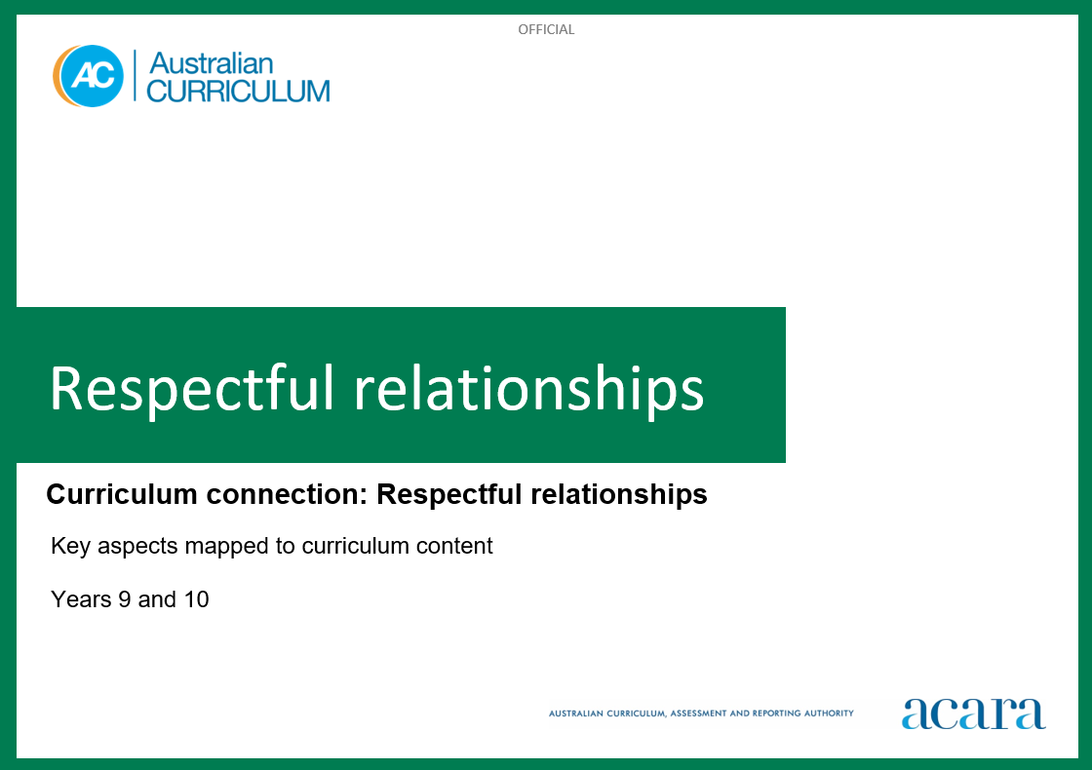

**Copyright and Terms of Use Statement**

**© Australian Curriculum, Assessment and Reporting Authority 2023**

The material published in this work is subject to copyright pursuant to the Copyright Act 1968 (Cth) and is owned by the Australian Curriculum, Assessment and Reporting Authority (ACARA) (except to the extent that copyright is held by another party, as indicated).

The viewing, downloading, displaying, printing, reproducing (such as by making photocopies) and distributing of these materials is permitted only to the extent permitted by, and is subject to the conditions imposed by, the terms and conditions of using the ACARA website (see, especially, clauses 2, 3 and 4 of those terms and conditions). The terms and conditions can be viewed at [https://www.acara.edu.au/contact-us/copyright](https://aus01.safelinks.protection.outlook.com/?url=https%3A%2F%2Fwww.acara.edu.au%2Fcontact-us%2Fcopyright&data=04%7C01%7CSharon.Foster%40acara.edu.au%7C9931e11fa7684c603e6308d98331bbfb%7C6cf76a3aa824427092003d71673ec678%7C0%7C0%7C637685071906340874%7CUnknown%7CTWFpbGZsb3d8eyJWIjoiMC4wLjAwMDAiLCJQIjoiV2luMzIiLCJBTiI6Ik1haWwiLCJXVCI6Mn0%3D%7C1000&sdata=U5O4Vlbpf271IGmGiMh7fDwU4pLzzAiHpCQFylkp6s4%3D&reserved=0)

**RESPECTFUL RELATIONSHIPS: Years 9 and 10**

The following table identifies how the key aspects of respectful relationships are evident in content descriptions from across the Australian Curriculum Version 9.0. From this information, teachers could develop a sequential program for respectful relationships by connecting the key aspects of learning with learning area and subject-specific content descriptions

|  |  |  |  |
| --- | --- | --- | --- |
| Years 9 and 10 | | | |
| Key aspect 1: Recognising and practising respect | | | |
| Learning area/subject | Strand/sub-strand | Content descriptions | Content elaborations |
| **Health and Physical Education** | **Personal, social and community health**  Interacting with others | evaluate the influence of respect, empathy, power and coercion on establishing and maintaining respectful relationships  AC9HP10P04 | * investigating the characteristics of positive, respectful relationships and the rights and ethical responsibilities of individuals in relationships * investigating how the balance of power influences the nature of relationships and proposing actions that can be taken when a relationship is not respectful * investigating how demonstrating support for causes that promote truth-telling can build cultural awareness, empathy and respectful relationships * identifying the ways in which historical patterns of inequity, violence and discrimination can have lasting intergenerational effects on wellbeing, and considering strategies to build the cultural awareness, empathy, compassion and respect that contribute to reconciliation * investigating how bullying, racism and gender-based violence can take different forms, including verbal, physical, emotional, sexual and economic forms, and can occur in both face-to-face and online environments |
| **Personal, social and community health**  Interacting with others | propose strategies and actions individuals and groups can implement to challenge biases, stereotypes, prejudices and discrimination, and promote inclusion in their communities  AC9HP10P05 | * analysing the implications of attitudes and behaviours such as prejudice, marginalisation, homophobia, racism, discrimination, violence and harassment on individuals and communities, and proposing countermeasures to prevent these behaviours * critiquing media representations of different cultural and racial groups and analysing whether the representations are respectful, realistic and inclusive * analysing messages about gender norms and stereotypes in popular culture and considering the impact these might have on individuals, institutions and communities |
| **English – Year 9** | **Language**  Language for interacting with others | recognise how language empowers relationships and roles  AC9E9LA01 | * identifying the various communities to which students belong and how language reinforces membership of these communities; for example, the intimate language of family members, the jargon of teenage groups, the technicality of some online communities, the language specific to recreational groups and the interaction patterns of the classroom * exploring language used by First Nations Australian authors to reinforce relationships to Country/Place and with others; for example, “Hello” in Turrabul language is “Galang nguruindhau” |
| **English – Year 10** | **Language**  Language for interacting with others | understand how language can have inclusive and exclusive social effects, and can empower or disempower people  AC9E10LA01 | * identifying language that seeks to align the listener or reader; for example, “of course”, “obviously”, “as you can imagine” * identifying the use of first person (“I”, “we”) and second person (“you”) pronouns to distance or involve the audience * identifying language used to reference or indicate shared assumptions * identifying language that appeals to shared cultural knowledge, values and beliefs * identifying examples of language that are inclusive or marginalising |

|  |  |  |  |
| --- | --- | --- | --- |
| Years 9 and 10 | | | |
| Key aspect 2: Developing personal and social skills | | | |
| Learning area/subject | Strand/sub-strand | Content descriptions | Content elaborations |
| **Health and Physical Education** | **Personal, social and community health**  Interacting with others | evaluate the influence of respect, empathy, power and coercion on establishing and maintaining respectful relationships  AC9HP10P04 | * investigating the characteristics of positive, respectful relationships and the rights and ethical responsibilities of individuals in relationships * investigating how the balance of power influences the nature of relationships and proposing actions that can be taken when a relationship is not respectful |
| **Personal, social and community health**  Interacting with others | evaluate emotional responses in different situations to refine strategies for managing emotions  AC9HP10P06 | * proposing strategies for managing emotional responses and resolving conflict in a family, school or social situation, or online environment * reflecting on the possible consequences of not recognising their own or others’ emotions in a range of challenging situations, including responses to rejection, failure, harassment and violence * evaluating situations where an individual may react with extreme or uncontrolled emotion and reflecting on the impact that this response may have on the situation and/or their relationships |
| **Personal, social and community health**  Interacting with others | examine how strategies, such as communicating choices, seeking, giving and denying consent, and expressing opinions and needs can support the development of respectful relationships, including sexual relationships  AC9HP10P07 | * describing strategies that enhance the safety and wellbeing of sexual partners, such as communicating feelings of each party, respecting boundaries and choices, gaining affirmative consent, assertive communication and respecting individuals’ rights * investigating the legal requirements for their state or territory in relation to seeking, giving, refusing and accepting the refusal of consent, and considering how these laws relate to relationships with friends, colleagues, strangers and intimate partners, in both online and offline interactions * reflecting on the potential impact of their own behaviour on others and the importance of taking responsibility for their own actions to ensure they do no harm to others * refining strategies to communicate clearly and respectfully their choices, needs and opinions in a range of relationship scenarios, such as in peer group, family or work situations |
| **English – Year 9** | **Language**  Language for interacting with others | recognise how language empowers relationships and roles  AC9E9LA01 | * identifying the various communities to which students belong and how language reinforces membership of these communities; for example, the intimate language of family members, the jargon of teenage groups, the technicality of some online communities, the language specific to recreational groups and the interaction patterns of the classroom * exploring language used by First Nations Australian authors to reinforce relationships to Country/Place and with others; for example, “Hello” in Turrabul language is “Galang nguruindhau” |
| **English – Year 10** | **Language**  Language for interacting with others | understand how language can have inclusive and exclusive social effects, and can empower or disempower people  AC9E10LA01 | * identifying language that seeks to align the listener or reader; for example, “of course”, “obviously”, “as you can imagine” * identifying the use of first person (“I”, “we”) and second person (“you”) pronouns to distance or involve the audience * identifying language used to reference or indicate shared assumptions * identifying language that appeals to shared cultural knowledge, values and beliefs * identifying examples of language that are inclusive or marginalising |

|  |  |  |  |
| --- | --- | --- | --- |
| Years 9 and 10 | | | |
| Key aspect 3: Recognising how gender norms and stereotypes can influence choices and actions | | | |
| Learning area/subject | Strand/sub-strand | Content descriptions | Content elaborations |
| **Health and Physical Education** | **Personal, social and community health**  Identities and change | investigate how gender equality and challenging assumptions about gender can prevent violence and abuse in relationships  AC9HP10P03 | * investigate and challenge attitudes that lead to people enacting, excusing or condoning gender-based violence * analysing ways that attitudes towards gender equality and power can affect expectations and behaviour, and lead to practices of sexual coercion, harassment, violence and submission * evaluating how gender equality can empower people to develop equal and respectful relationships * exploring scenarios in texts that demonstrate how gender inequality can arise from intergenerational patterns of inequity and unequal power in relationships, and proposing strategies for challenging inequality in their communities |
| **Personal, social and community health**  Making healthy and safe choices | critique health information, services and media messaging about relationships, lifestyle choices, health decisions and behaviours to evaluate their influence on individual attitudes and actions  AC9HP10P09 | * critiquing health information and services that provide advice and support on issues targeted at specific groups of young people, including support with substance use, healthy food choices, fitness and exercise plans, mental health support, sexual health and personal safety * evaluating strategies and actions to increase personal safety and planning to promote these in the school and community * investigating health issues specific to First Nations Australian communities and proposing proactive community strategies for promoting better access and health outcomes; for example, remote area dialysis buses and community-based treatment options * discussing how the portrayal of sexual relationships in TV shows, advertisements, movies, popular music and online content (such as pornography) may influence people’s beliefs about respectful, safe and consensual relationships |
| **Civics and Citizenship – Years 9 and 10** | **Knowledge and understanding**  Citizenship, diversity and identity | the influence of a range of media, including social media, in shaping identity and attitudes to diversity  AC9HC9K06 | * analysing how media represent different groups in Australian society, such as First Nations Australians, immigrant groups, male and female sporting figures, and people with disability, and assessing the impact those representations have on community cohesiveness * investigating a human rights campaign that uses social media and how members of the public have engaged with the issue |
| **Skills**  Analysis, evaluation and interpretation | analyse information, data and ideas about political, legal or civic issues to identify and evaluate differences in perspectives and interpretations  AC9HC9S03 | * identifying the values, motivations and contexts that underpin different perspectives about political and legal systems and processes; for example, calls for constitutional recognition for First Nations Australians, First Nations Voice and Makarrata, or the impact of reducing or extending mining activity on particular communities * examining information that includes a diversity of perspectives about the effectiveness of a political or legal institution; for example, “Is Australia’s parliament representative of the Australian community?” or “Does the court system deliver justice for the victims of crime?” * investigating how the Australian Government responds to an issue and examining the process of policy development and implementation, such as the development of welfare changes and financial support in response to natural disasters or emergencies |
|  | **Skills**  Analysis, evaluation and interpretation | analyse information, data and ideas about political, legal or civic issues to identify and evaluate differences in perspectives and interpretations  AC9HC10S03 | * examining information from traditional and social media sources to identify examples of different views on and responses to a contemporary Australian political, legal or civic issue, such as limiting freedoms, placing restrictions on movement, trade or association, or debates about the use of public resources |
| **English – Year 9** | **Literature**  Literature and contexts | analyse the representations of people and places in literary texts, drawn from historical, social and cultural contexts, by First Nations Australian, and wide-ranging Australian and world authors  AC9E9LE01 | * exploring and comparing representations of values of characters; for example, exploring the values associated with authority, community and family in literature drawn from different cultures and times * exploring how texts by First Nations Australian authors reflect unique ways of being, knowing, thinking and doing * exploring the way wide-ranging Australian novels, poems and films represent water and characters’ relationships with water |
| **Literacy**  Texts in context | analyse how representations of people, places, events and concepts reflect contexts  AC9E9LY01 | * examining the representation of public figures in media and recognising how these vary in different contexts * identifying and analysing how news is conveyed in texts; for example, analysing representations of an event at a particular time reported in the media * comparing texts from different time periods and analysing the language features used to represent individuals or groups |
| **English – Year 10** | **Literature**  Literature and contexts | analyse representations of individuals, groups and places and evaluate how they reflect their context in literary texts by First Nations Australian, and wide-ranging Australian and world authors  AC9E10LE01 | * analysing the ways in which cultural stories may be retold and adapted across a range of contexts, such as the story of the “anti-hero”, and evaluating how the “anti-hero” reflects the context * analysing how stories written by First Nations Australian authors contemporise or modernise traditional stories and evaluating the responses of contemporary audiences * analysing how humour is used to represent the underdog in Australian texts and evaluating how the underdog reflects the context |
| **Literature**  Engaging with and responding to literature | evaluate the social, moral or ethical positions represented in literature  AC9E10LE04 | * identifying and analysing ethical positions on a significant issue, including values and/or principles involved, and evaluating the strengths and weaknesses of the position presented |
| **Literacy**  Texts in context | analyse and evaluate how people, places, events and concepts are represented in texts and reflect contexts  AC9E10LY01 | * evaluating stereotypes of people, places, events and concepts, and expressing opinions on these representations in the contexts for which they are created * analysing representations of events and issues in First Nations Australian media |
| **The Arts – Media Arts** | **Exploring and responding** | investigate the ways that media artists use media arts concepts to construct representations in media arts works and practices from across cultures, times, places and/or other contexts  AC9AMA10E01 | * analysing and evaluating the social, cultural and/or ethical implications of the changing nature of representations in media arts works over time; for example, deconstructing representations constructed at different times or in different places to compare the representations of gender in print, screen and/or interactive media, or deconstructing the representation of multiculturalism or youth in Australian television * justifying, in a video commentary, the technical and symbolic code choices they have made in constructing representations, their framework of social and cultural values, and communicating alternative points of view * analysing and evaluating the way social beliefs and values can be communicated to audiences through the manipulation of technical and symbolic codes in media arts works they view and make * evaluating relationships embedded within media practices and discussing how media arts works and institutions can influence or challenge media practices and audience perceptions * analysing and evaluating the ways technical and symbolic codes have been used to construct stereotypical representations in media arts works targeted to specific audiences in a range of historical and contemporary contexts or across traditional and emerging media formats * identifying, describing and explaining the way technical and symbolic codes such as camera techniques, editing, sound, rhythm or mise-en-scène are manipulated in media arts works they have viewed or made to evoke audience responses such as excitement or fear, and/or to convey an intended meaning or position about an issue or idea, such as an opinion about climate change * examining the role of media makers in perpetuating and/or challenging prevailing views on issues of contemporary relevance |
| **Creating and making** | design and structure media arts works that examine and communicate ideas, perspectives and/or meaning  AC9AMA10C01 | * using media technologies, languages and representations when designing a media arts work such as a computer game, community service announcement, website or music video, with the intention of developing audience awareness of a social or cultural issue * using media technologies to design a media arts work that communicates stereotypical representations for a specific target audience; for example, creating a film poster for a genre that relies on stereotypical representations, a music video that perpetuates stereotypical representations of youth, a movie trailer that manipulates genre conventions to meet audiences' expectations, or a social media campaign to advertise a community event * designing the camera work, sound, editing or mise-en-scène to construct alternative representations of people, places, ideas and events in a narrative media arts work such as a genre film, music video, documentary or animation * examining the way technical and symbolic codes and conventions of specific film, television or radio genres have been used in a media arts work to communicate values, themes or ideas to an audience; using pre-production processes such as a shot list, shooting script, screenplay, treatment or storyboard to trial ideas, designing a different media arts work that communicates or challenges these values, themes or ideas; for example, a film trailer, short genre film or soundscape |

|  |  |  |  |
| --- | --- | --- | --- |
| Years 9 and 10 | | | |
| Key aspect 4: Taking action to create equal and respectful communities | | | |
| Learning area/subject | Strand/sub-strand | Content descriptions | Content elaborations |
| **Health and Physical Education** | **Personal, social and community health**  Interacting with others | propose strategies and actions individuals and groups can implement to challenge biases, stereotypes, prejudices and discrimination, and promote inclusion in their communities  AC9HP10P05 | * investigating community health resources to evaluate how accessible they are for marginalised individuals and groups, and proposing changes to improve inclusiveness and accessibility * designing strategies and actions they can implement to challenge stereotypes, prejudices and discrimination, and publicly acknowledge the contributions First Nations Australians make to Australia’s sporting and health fields * proposing strategies to challenge prejudices, biases and discrimination that target specific cultural groups, including Australians of Asian heritage |
| **Personal, social and community health**  Making healthy and safe choices | plan, rehearse and evaluate strategies for managing situations where their own or others’ health, safety or wellbeing may be at risk  AC9HP10P08 | * critiquing the appropriateness and effectiveness of help and support services available for young people in the local community * proposing and practising a range of realistic responses to scenarios where peers are encouraging them to take unnecessary risks, such as in relation to the use of e-cigarettes, cannabis, psychostimulants, opiates or hallucinogens * investigating a range of behaviours to determine positive, safe, legal and ethical behaviour when using digital tools and environments and recognising what actions can be taken when behaviour becomes abusive * planning and practising responses to emergencies where they may be required to administer first aid to a friend or stranger, including CPR * understanding the factors that impact a person’s ability to seek, give or deny consent, including when a person is affected by alcohol and other drugs, or there is an imbalance of power or coercion within the relationship * examining practices, policies and processes for ensuring safe blood practices in a range of situations, including not sharing needles, precautions when participating in physical activities and safe practices during sexual activity, including use of condoms and dams |
| **Personal, social and community health**  Making healthy and safe choices | plan, justify and critique strategies to enhance their own and others’ health, safety, relationships and wellbeing  AC9HP10P10 | * investigating community-action initiatives young people have started that have a positive influence on the health and wellbeing of their communities * investigating how cultural rights of First Nations Australians include maintaining traditional diets and explaining how these have proven health and wellbeing benefits * investigating the pharmacopeia and health practices of First Nations Australian communities while showing respect for Indigenous Cultural and Intellectual Property (ICIP) protocols and cultural knowledge * proposing constructive, healthy and manageable actions when using tools and digital environments to promote respect, inclusion and the wellbeing of others, such as researching what to do if they, or someone they know, is being targeted online |
| **Movement and physical activity**  Learning through movement | devise, implement and refine strategies for decision-making when working in groups or teams that demonstrate leadership and collaboration skills  AC9HP10M09 | * evaluating the contribution they make as an individual to teamwork, leadership and enjoyable participation for all * analysing the use of self-talk and encouragement to motivate themselves and team members to continue to participate, persist when things get challenging and improve performance * identifying and critiquing leadership styles and group dynamics through collaboratively solving initiative games |
| **Civics and Citizenship –Years 9 and 10** | **Skills**  Civic participation and decision-making | evaluate the methods or strategies related to making decisions about civic participation  AC9HC9S04 | * examining a government action plan, identifying the actions, the measures, and the intended and unintended effects of the plan; for example, a recycling program in a local community or a national campaign to improve post-school literacy * developing a plan of action to address a contemporary issue that incorporates a consultation process to ensure a range of views are heard and recorded, and participants are provided with opportunities to contribute; for example, planning a campaign to raise awareness about a personal or road safety issue at a local level; developing a strategy to aid a group in another region or country (a developing nation) with educational resources and opportunities * evaluating the government media campaigns and community supported activities that have been used over time to promote reduction in littering and disposal of waste, and determine if they have been effective |
|  | **Skills**  Civic participation and decision-making | evaluate the methods or strategies related to making decisions about civic participation  AC9HC10S04 |  |