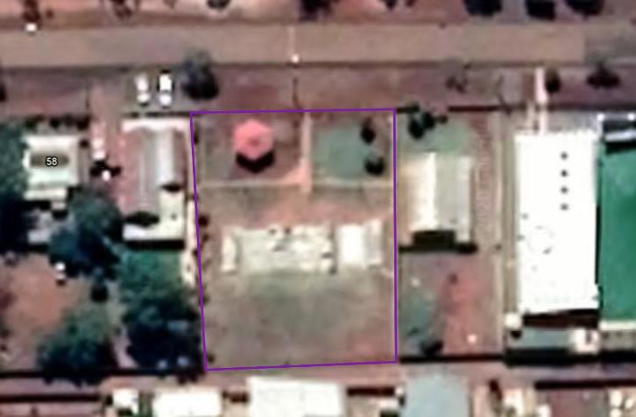

imagery: Google, ©2021 CNES / Airbus, Maxar Technologies

# Leonora Skate Park

s are there?

• How many tree



# A picture containing clock Description automatically generatedLeonora Skate Park

## A picture containing bird Description automatically generatedare there?

• How many trees

imagery: Google, ©2021 CNES / Airbus, Maxar Technologies Tree images added using PowerPoint icons



# A picture containing clock Description automatically generatedLeonora Skate Park

## A picture containing bird Description automatically generatedplant trees?

• Where could we

imagery: Google, ©2021 CNES / Airbus, Maxar Technologies Tree images added using PowerPoint icons



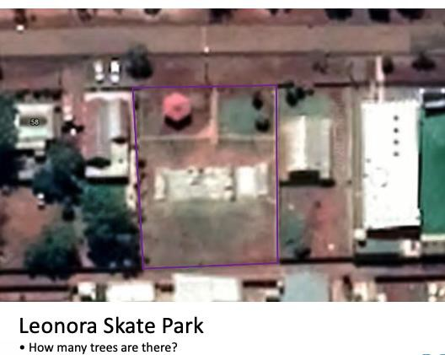

Step 1

## Step 2 Step 3

Maps – imagery: Google, ©2021 CNES / Airbus, Maxar Technologies

A picture containing bird  Description automatically generatedTree images added using PowerPoint icons