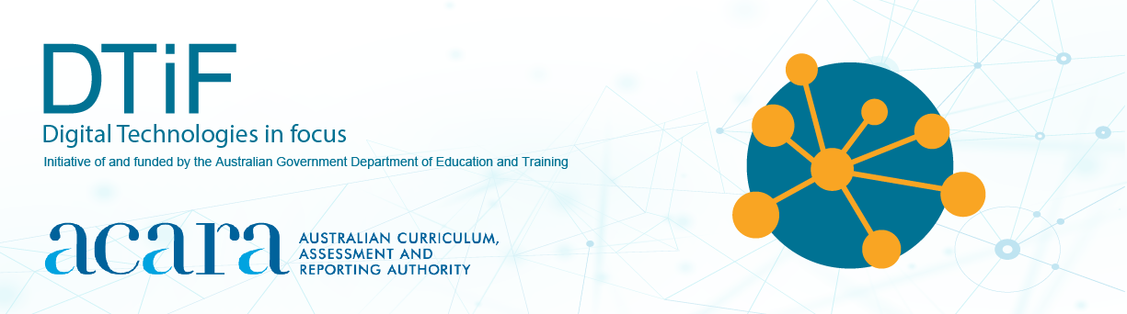
BOOKS FOR EXPLORING DIGITAL TECHNOLOGIES CONCEPTS

To implement the Australian Curriculum: Digital Technologies, equipment or materials that will allow students to identify and discuss core concepts, and related ways of thinking are required. The following list is an indicative sample only*. ACARA advises teachers to use their own judgement as to the value of the references for their teaching context and, also, to use the list as a model for identifying other appropriate materials. Search online for more information about these books such as International Standard Book Number (ISBN), reviews and videos of discussions or readings*.
Book details | Age group | Technologies/ Digital Technologies Core concepts
Name: Which one is Nettie?  Authors: Wendy Goucher  Publisher: University of Buckingham, 2021  Description: Nettie is terrified to discover Scammy the dog pretending to be her after she had left her device unattended. | 4–7 years | - privacy and security  - digital systems  computational thinking (CT)
Name: The technology tail  Authors: Julia Cook and Anita Dufalla  Publisher: Boys town PR, 2017  Description: Whether tapping out messages on their computers, tablets or phones, Screen wants kids to know their words will follow them for life, creating a digital trail that can't be erased. | 4 years+ | - privacy and security  - digital systems  computational thinking (CT)
Name: Kids get coding: our digital world  Authors: Heather Lyons and Elizabeth Tweedale  Publisher: Wayland, 2016  Description: An explanatory text with quick activities for children to do as they read. | 4–7 years | - algorithms  - digital systems  computational thinking (CT)
Name: Kids get coding: learn to program  Authors: Heather Lyons and Elizabeth Tweedale  Publisher: Wayland, 2016  Description: A basic introduction to programming. The extension activities may be challenging but are useful to work towards mastery. | 4–7 years | - abstraction  - algorithms  - specification  computational thinking (CT)
Name: Kids get coding: coding, bugs and fixes  Authors: Heather Lyons and Elizabeth Tweedale  Publisher: Lerner Classroom, 2016  Description: Explores how computers know what we want them to do. The book describes how computers receive instructions called code with the specific steps needed to perform a task. The reader will learn how to create codes, what happens when instructions are out of order, and how mistakes in code are fixed. There is a link in the book for users to go online and try coding for themselves. | 4–7 years | - abstraction  - algorithms  - specification  computational thinking (CT)
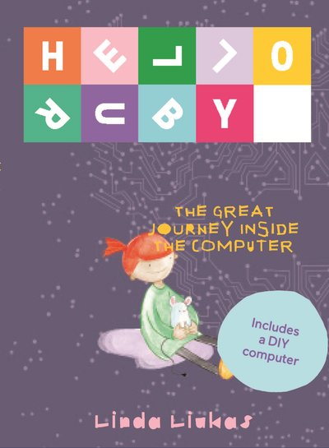  Name: Hello Ruby: the great journey inside the computer  Author and illustrator: Linda Liukas  Publisher: Penguin Random House Australia, 2017 (Melbourne, Victoria)  Description: In this story, Ruby puts her mind to fixing her father's broken computer. Ruby and her friend Mouse go on a journey inside the computer searching for  the missing Cursor. Ruby learns about computer hardware and the basic elements of the machines in our world. Using the knowledge gained in the story, readers can try some fun included activities.  Notes: Visit www.helloruby.com for ideas, videos and free resources that link to the book. See also other titles in the Hello Ruby series. | 4–8 years | - abstraction  - digital systems  computational thinking (CT)  systems thinking (ST)
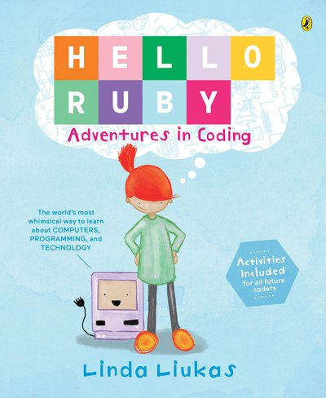  Name: Hello Ruby: adventures in coding  Author and illustrator: Linda Liukas  Publisher: Penguin Random House Australia, 2016 (Melbourne, Victoria)  Description: In this adventure with Ruby, readers are introduced to the basic concepts of coding. Each chapter includes activities to try along the way.  Notes: Visit www.helloruby.com for ideas, videos and free resources that link to the book.  See also other titles in the Hello Ruby series. | 4–8 years | - abstraction  - algorithms  - specification  computational thinking (CT)
Name: How to code a sandcastle  Author: Josh Funk  Publisher: Viking Books for Young Readers, 2018  Description: A little girl named Pearl discovers the best way to make a sandcastle at the beach. This fun narrative is also an introduction to coding principles. | 4–8 years | - abstraction  - algorithms  - specification  computational thinking (CT)
Name: Once upon a time … online  Authors: David Bedford and Rosie Reeve  Publisher: Parragon, 2016  Description: Once upon a time, a laptop arrived in Fairy-tale Land and things to do are just a click away. What will happen when the fairy-tale characters use a laptop? Will they learn a lesson in online safety? | 4–8 years | - interactions and impact
Name: Nerdy Birdy Tweets  Author: Aaron Reynolds  Publisher: Roaring Brook Press, 2017  Description: Nerdy Birdy joins Tweetster, and the friend requests start flying in. Vulture watches as Nerdy Birdy gets swept up in his new friendships, but when she finally gets angry, Nerdy Birdy knows just what to do to make things right. | 5–8 years | - privacy and security  - digital systems  computational thinking (CT)
Name: Rosie Revere, engineer  Author: Andrea Beaty  Publisher: Harry N Abrams, 2013  Description: The story of a girl in Year 2 who wants to be a great engineer. She loves making gadgets and tries to make a machine for her great-great-great-aunt so she can fly. The story encourages readers to follow their dreams and to understand that failure is part of the inventor's (or engineer's) process. | 5–7 years | - algorithms  - interactions and impact  computational thinking (CT)  design thinking (DT)
Name: The most magnificent thing  Author: Ashley Spires  Publisher: Kids Can Press, 2014  Description: A story about a little girl who is trying and failing to design the most magnificent thing. Children can learn about the design process, iteration and never giving up. | 5–8 years | - algorithms  - specification  computational thinking (CT)  design thinking (DT)
Name: Peter and Pablo the printer: adventures in making the future  Author: Jeffrey Ito  Publisher: CreateSpace Independent Publishing Platform, 2016  Description: Peter is about to turn seven years old. On his birthday he is given a 3D printer by his father. It’s a special printer that is capable of printing  anything … | 5–8 years | - abstraction  - digital systems  - interactions and impact
Name: Brilliant ideas from wonderful women  Author: Aitziber Lopez  Publisher: Wide Eyed Editions, 2019  Description: Did you know that all kinds of revolutionary inventions were all pioneered by women? These include  wi-fi, diagnostic tests and eBooks. Learn all about the women who invented these things in this colourful book. | 5–8 years | - digital systems  - interactions and impact  computational thinking (CT)  design thinking (DT)  systems thinking (ST)
Name: The technology tail  Author: Julia Cook  Publisher: Boys Town Press, 2017  Description: A story about what we do online and how it creates the digital footprint we all leave behind us | 5 years+ | - abstraction  - interactions and impact  computational thinking (CT)  systems thinking (ST)
Name: Grace Hopper: queen of computer code  Author: Laurie Wallmark  Publisher: Sterling Children's Books, 2017  Description: Grace Hopper coined the term ‘computer bug’ and taught computers to ‘speak English’. During her lifetime, she succeeded in doing things no one had ever done before. She was right at home with difficult ideas and in defying expectations. | 5 years+ | - interactions and impact  computational thinking (CT)  systems thinking (ST)
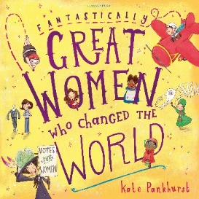  Name: Fantastically great women who changed the world  Author: Kate Pankhurst  Publisher: Bloomsbury USA Children's Books, 2016  Description: Empowering stories of women who changed the world. | 6 years+ | - interactions and impact
Name: Three little hackers  Author: Marcus J. Carey  Publisher: Self-published, 2020  Description: A focus on how criminals use social engineering and how children can guard their privacy online. The book revamps the classic story of the three little pigs to help children understand the concept of privacy. | 6 years+ | - privacy and security  computational thinking (CT)
Name: Sarah the Cyber Hero  Author: Emily Rauer  Publisher: Book Baby, 2017  Description: A school cyber education program has been teaching Sarah all about cyber safety and how to protect a computer from intruders. Can Sarah use her new cyber skills to shut down the dreaded virus? | 8 years+ | - privacy and security  computational thinking (CT)
Name: Webster’s Email  Author: Hannah Whaley  Publisher: Born Digital Books, 2014  Description: Webster's Email is a wonderfully witty rhyming story that gathers pace as the little spider begins to regret emailing a funny picture of his sister. | 8 years+ | - privacy and security  computational thinking (CT)
Name: If I were a wizard  Author: Paul Hamilton  Publisher: Edtechteam Press, 2016  Description: This picture book introduces the concepts of coding through a story about a boy named Ralph. It includes a glossary to aid understanding. | 8 years+ | - abstraction  - algorithms  - specification  computational thinking (CT)
Name: Create your own secret language  Author: David J. Peterson  Publisher: Odd Dot 2020  Description: This book is a guide to creating secret languages, codes, ciphers, and hidden messages. From simple cyphers to entirely new alphabets, mastering the skills of secret communication, whether it’s written, drawn, or spoken. | 10 years+ | - privacy and security  - algorithms  - data representation  computational thinking (CT)
Name: How it works: book of amazing technology, volume 2 (magazine)  Author: Aaron Asadi (Editor)  Publisher: Imagine Publishing, 2013  Description: From computing to engineering, gadgets to domestic appliances, discover how things work with interesting cutaways and cross-sections. | 10 years+ | - abstraction  - digital systems  - interactions and impact  systems thinking (ST)
Name: The way things work now  Author: David Macaulay  Publisher: HMH Books for Young Readers, 2016  Description: Full of information on the inner workings of everything from windmills to wi-fi. Readers are guided through the fundamental principles of machines, and the developments of the past and how they are building the world of tomorrow. Also available in a board game format. | 12 years+ | - abstraction  - digital systems  - interactions and impact  computational thinking (CT)  systems thinking (ST)
Name: A Hacker I am  Author: Craig Ford  Publisher: Self-published, 2019  Description: Covers many topics in cyber security including IoT, autonomous cars, hackers and many more. This book will be great at helping introduce individuals to the area and help them get a better understanding of what to look out for, what problems we are all going to face in the future but also have a bit of fun while we are at it. | 13 years+ | - privacy and security  - algorithms  - data representation  - digital systems  computational thinking (CT)

*Disclaimer: ACARA does not endorse any product or make any representations as to the quality of such products. This resource is an indicative sample only. ACARA advises teachers and other readers to use their own judgement
as to the value of the references for their teaching context and, also, to use the list as a model for identifying other appropriate materials. Any product that uses material published on the ACARA website should not be taken to be affiliated with ACARA or have the sponsorship or approval of ACARA. It is up to each person to make their own assessment of the product, taking into account matters including, but not limited to, the degree to which the materials align with the content descriptions and achievement standards of the Australian Curriculum.
The Creative Commons licence below does not apply to any trademark protected material.

All images in this resource are used with permission

