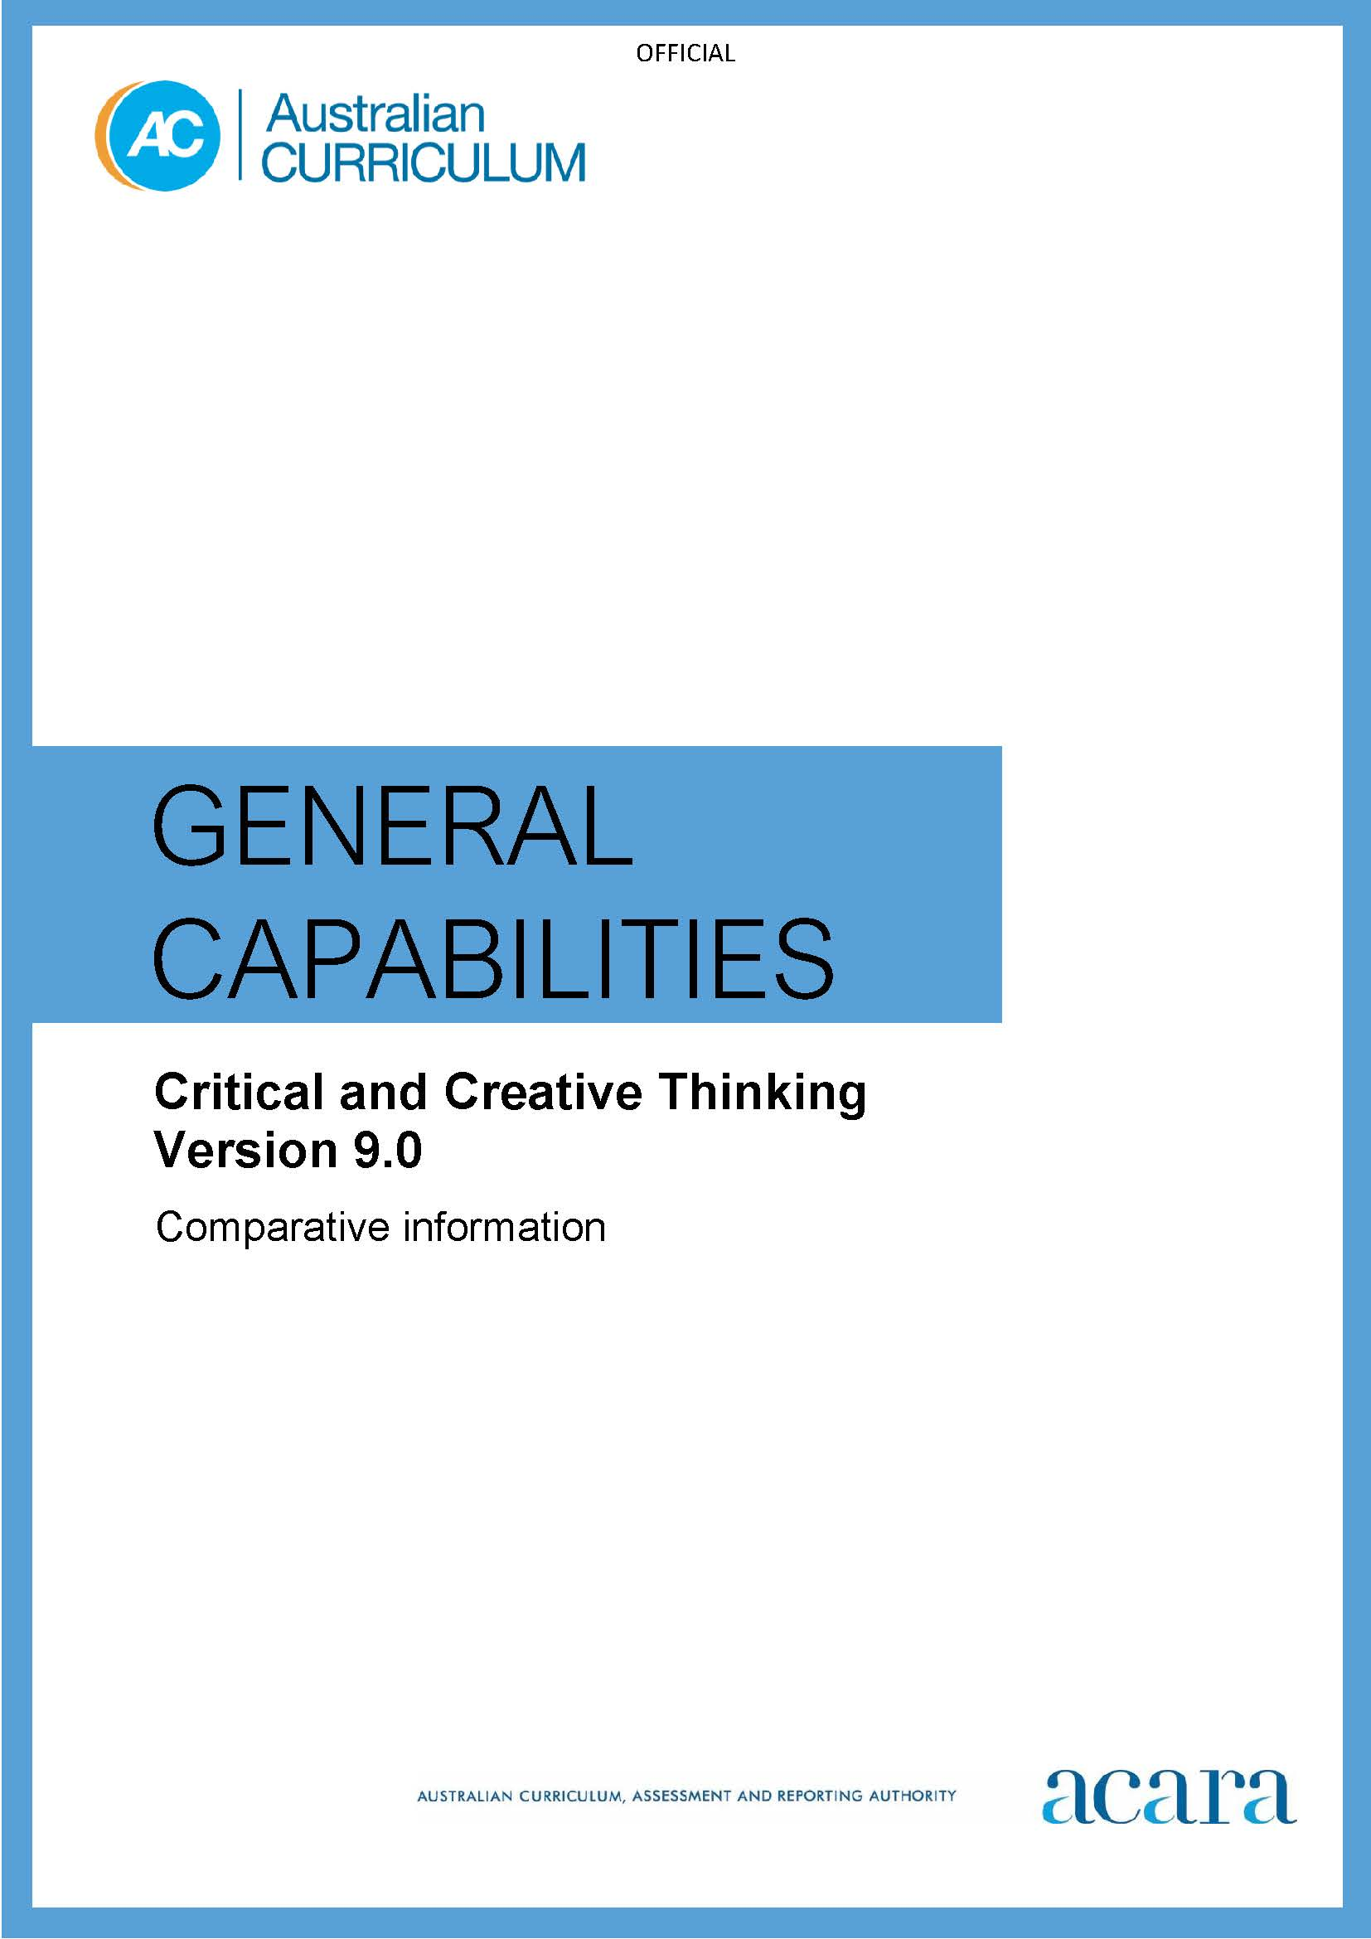

**Copyright and Terms of Use Statement**

**© Australian Curriculum, Assessment and Reporting Authority 2022**

The material published in this work is subject to copyright pursuant to the Copyright Act 1968 (Cth) and is owned by the Australian Curriculum, Assessment and Reporting Authority (ACARA) (except to the extent that copyright is held by another party, as indicated).

The viewing, downloading, displaying, printing, reproducing (such as by making photocopies) and distributing of these materials is permitted only to the extent permitted by, and is subject to the conditions imposed by, the terms and conditions of using the ACARA website (see, especially, clauses 2, 3 and 4 of those terms and conditions). The terms and conditions can be viewed at [https://www.acara.edu.au/contact-us/copyright](https://aus01.safelinks.protection.outlook.com/?url=https%3A%2F%2Fwww.acara.edu.au%2Fcontact-us%2Fcopyright&data=04%7C01%7CSharon.Foster%40acara.edu.au%7C9931e11fa7684c603e6308d98331bbfb%7C6cf76a3aa824427092003d71673ec678%7C0%7C0%7C637685071906340874%7CUnknown%7CTWFpbGZsb3d8eyJWIjoiMC4wLjAwMDAiLCJQIjoiV2luMzIiLCJBTiI6Ik1haWwiLCJXVCI6Mn0%3D%7C1000&sdata=U5O4Vlbpf271IGmGiMh7fDwU4pLzzAiHpCQFylkp6s4%3D&reserved=0)

## *Table 1: Critical and Creative Thinking learning continuum version 9.0*

| **INQUIRING** | | | | | | |
| --- | --- | --- | --- | --- | --- | --- |
| **Sub-element** | **Level 1 (Foundation)** | **Level 2**  **(Years 1–2)** | **Level 3**  **(Years 3–4)** | **Level 4**  **(Years 5–6)** | **Level 5**  **(Years 7–8)** | **Level 6**  **(Years 9–10)** |
| **Develop questions** | develop questions to explore a familiar idea or topic  questions developed reflect their curiosity about the world | develop questions to explore a familiar idea or topic  questions developed are fit for the purpose of the investigation | develop questions to examine unfamiliar ideas and topics  questions developed support the process of improving knowledge and understanding about a topic or investigation | develop questions to examine unfamiliar ideas and topics  questions developed focus on improving understanding about a topic and clarifying information about processes or procedures | develop questions to investigate complex issues and topics  questions developed assist in forming an understanding of why phenomena or issues arise | develop questions to investigate complex issues and topics  questions developed facilitate increasing understanding of abstract ideas and concepts |
| **Identify, process and evaluate information** | identify and explore relevant points in information provided on a topic  prioritise the information that is most relevant to the topic of study | identify and explore relevant information from a range of sources, including visual information and digital sources  identify and explain similarities and differences in selected information | identify and examine relevant information and opinion from a range of sources, including visual information and digital sources  condense and combine selected information related to the topic of study | identify and examine relevant information and opinion from a range of sources, including visual information and digital sources  compare information and opinion that can be verified against claims based on personal preference | identify and clarify significant information and opinion from a range of sources, including visual information and digital sources  evaluate the accuracy, validity and relevance of the information and opinion to the topic of study | identify and clarify significant information and opinion from a range of sources, including visual information and digital sources  evaluate the information selected to determine bias and reliability |

| **GENERATING** | | | | | | |
| --- | --- | --- | --- | --- | --- | --- |
| **Create possibilities** | use imagination to create possibilities by exploring and connecting ideas in ways that are new to them | create possibilities by connecting or creatively expanding on ideas in ways that are new to them | create possibilities by connecting or creatively expanding on new and known ideas in a variety of ways | create possibilities by changing, combining or elaborating on new and known ideas in a variety of creative ways | create possibilities by adapting, combining or elaborating on new and known ideas, and proposing a range of different or creative combinations | create possibilities by connecting or adapting complex ideas and proposing innovative and detailed variations or combinations |
| **Consider alternatives** | consider alternatives by suggesting a different way to approach a given task or problem | consider alternatives and explore different or creative ways to approach a task or problem | consider alternatives by comparing different or creative ways to approach a task, issue or problem and recommend a preferred option | consider alternatives by challenging or creatively adjusting existing ideas in situations where current approaches do not work and recommend a preferred option | consider alternatives by creatively adapting ideas when information is limited or conflicting and recommend a preferred option | consider alternatives by creatively revising and modifying ideas and recommendations when circumstances change |
| **Put ideas into action** | put ideas into action through trial-and-error experiences | put ideas into action by experimenting with options and predicting possible results | put ideas into action by predicting an outcome, trialling options and assessing their effectiveness | put ideas into action by predicting potential or future outcomes and systematically testing a range of options | put ideas into action by making predictions, testing and evaluating options, and reconsidering approaches in complex or unfamiliar situations | put ideas into action by making predictions, testing and evaluating options, proposing modifications and adapting approaches in complex or unfamiliar situations |

| **ANALYSING** | | | | | | |
| --- | --- | --- | --- | --- | --- | --- |
| **Interpret concepts and problems** | identify the main parts of a concept or problem | identify the main parts of a concept or problem and describe how these relate to each other | identify and prioritise significant elements and relationships within a concept or problem | identify the relevant and significant aspects of a concept or problem, understanding that approaches may change depending on the subject or learning area | identify the relevant aspects of a concept or problem, recognising gaps or missing elements necessary for understanding by using approaches and strategies suitable for the context | identify the objective and subjective aspects of a complex concept or problem, with sensitivity to context |
| **Draw conclusions and provide reasons** | draw conclusions and make choices when completing tasks and identify the reasons for choices made | draw conclusions and make choices when completing tasks and explain the reasons for choices made | draw conclusions and make choices when completing tasks, using observation and prior knowledge to provide reasons and construct arguments for choices made | draw conclusions and make choices when completing tasks, using discipline knowledge to provide reasons and evaluate arguments for choices made | draw conclusions and make choices when completing tasks by connecting evidence from within and across discipline areas to provide reasons and evaluate arguments for choices made | draw conclusions and make choices when completing tasks, using analysis of complex evidence and arguments before making recommendations |
| **Evaluate actions and outcomes** | evaluate whether they are satisfied with the outcome of tasks or actions | evaluate whether they have accomplished what they set out to achieve, including using a given set of criteria to support decisions | evaluate the outcome of a task by explaining ideas, conclusions and actions, including using a given set of criteria to support decisions | evaluate the effectiveness of a course of action or the outcome of a task, including using a given or co-developed set of criteria to support decisions | evaluate the effectiveness of a course of action or the outcome of a task and account for expected and unexpected results, including using a given or co-developed set of criteria to support decisions | evaluate the effectiveness of a course of action to achieve desired outcomes and suggest improvements, including using a personally developed set of criteria to support judgements and decisions |

| **REFLECTING** | | | | | | |
| --- | --- | --- | --- | --- | --- | --- |
| **Think about thinking (metacognition)** | identify thinking and learning strategies used when completing activities and drawing conclusions | identify and describe thinking and learning strategies they have used when completing activities and drawing conclusions | select, describe and reflect on the thinking and learning strategies and processes used when completing activities and drawing conclusions | identify and reflect on thinking and assumptions when completing activities or drawing conclusions  invite alternative perspectives or feedback in order to improve future outcomes | reflect on the thinking and processes used when completing activities or drawing conclusions  invite alternative perspectives and feedback, and consider reasonable criticism to adjust thinking and approaches | reflect on the thinking and processes used when completing activities and drawing conclusions  identify possible limitations in their own positions by considering opposing viewpoints, reasonable criticism and feedback |
| **Transfer knowledge** | connect ideas and information between familiar learning experiences | use ideas and information from a previous experience to inform similar learning experiences | use aspects of knowledge and skills gained in one setting to inform learning in a new setting or context | apply aspects of knowledge and skills gained in one context to a new or unrelated context to achieve a specific purpose | transfer knowledge and skills gained in previous experiences to both similar and different contexts, and explain reasons for decisions and choices made | identify, plan and justify opportunities to transfer knowledge into new contexts |

*Table 2: Critical and Creative Thinking learning continuum version 8.4*

|  |  |  |  |  |  |  |
| --- | --- | --- | --- | --- | --- | --- |
| **Sub-element** | **Level 1**  Typically, by the end of Foundation Year, students: | **Level 2**  Typically, by the end of Year 2, students: | **Level 3**  Typically, by the end of Year 4, students: | **Level 4**  Typically, by the end of Year 6, students: | **Level 5**  Typically, by the end of Year 8, students: | **Level 6**  Typically, by the end of Year 10, students: |
| **Inquiring – identifying, exploring, and organising information and ideas element** | | | | | | |
| **Pose questions** | pose factual and exploratory questions based on personal interests and experiences | pose questions to identify and clarify issues, and compare information in their world | pose questions to expand their knowledge about the world | pose questions to clarify and interpret information and probe for causes and consequences | pose questions to probe assumptions and investigate complex issues | pose questions to critically analyse complex issues and abstract ideas |
| **Identify and clarify information and ideas** | identify and describe familiar information and ideas during a discussion or investigation | identify and explore information and ideas from source materials | identify main ideas and select and clarify information from a range of sources | identify and clarify relevant information and prioritise ideas | clarify information and ideas from texts or images when exploring challenging issues | clarify complex information and ideas drawn from a range of sources |
| **Organise and process information** | gather similar information or depictions from given sources | organise information based on similar or relevant ideas from several sources | collect, compare and categorise facts and opinions found in a widening range of sources | analyse, condense and combine relevant information from multiple sources | critically analyse information and evidence according to criteria such as validity and relevance | critically analyse independently sourced information to determine bias and reliability |
| **Generating ideas, possibilities and actions element** | | | | | | |
| **Imagine possibilities and connect ideas** | use imagination to view or create things in new ways and connect two things that seem different | build on what they know to create ideas and possibilities in ways that are new to them | expand on known ideas to create new and imaginative combinations | combine ideas in a variety of ways and from a range of sources to create new possibilities | draw parallels between known and new ideas to create new ways of achieving goals | create and connect complex ideas using imagery, analogies and symbolism |

|  |  |  |  |  |  |  |
| --- | --- | --- | --- | --- | --- | --- |
| **Consider alternatives** | suggest alternative and creative ways to approach a given situation or task | identify and compare creative ideas to think broadly about a given situation or problem | explore situations using creative thinking strategies to propose a range of alternatives | identify situations where current approaches do not work, challenge existing ideas and generate alternative solutions | generate alternatives and innovative solutions, and adapt ideas, including when information is limited or conflicting | speculate on creative options to modify ideas when circumstances change |
| **Seek solutions and put ideas into action** | predict what might happen in a given situation and when putting ideas into action | investigate options and predict possible outcomes when putting ideas into action | experiment with a range of options when seeking solutions and putting ideas into action | assess and test options to identify the most effective solution and to put ideas into action | predict possibilities,  and identify and test consequences when seeking solutions and putting ideas into action | assess risks and explain contingencies, taking account of a range of perspectives, when seeking solutions and putting complex ideas into action |
| **Reflecting on thinking and processes element** | | | | | | |
| **Think about thinking (metacognition)** | describe what they are thinking and give reasons why | describe the thinking strategies used in given situations and tasks | reflect on, explain and check the processes used to come to conclusions | reflect on assumptions made, consider reasonable criticism and adjust their thinking if necessary | assess assumptions in their thinking and invite alternative opinions | give reasons to support their thinking, and address opposing viewpoints and possible weaknesses in their own positions |
| **Reflect on processes** | identify the main elements of the steps in a thinking process | outline the details and sequence in a whole task and separate it into workable parts | identify pertinent information in an investigation and separate into smaller parts or ideas | identify and justify the thinking behind choices they have made | evaluate and justify the reasons behind choosing a particular problem-solving strategy | balance rational and irrational components of a complex or ambiguous problem to evaluate evidence |
| **Transfer knowledge into new contexts** | connect information from one setting to another | use information from a previous experience to inform a new idea | transfer and apply information in one setting to enrich another | apply knowledge gained from one context to another unrelated context and identify new meaning | justify reasons for decisions when transferring information to similar and different contexts | identify, plan and justify transference of knowledge to new contexts |

|  |  |  |  |  |  |  |
| --- | --- | --- | --- | --- | --- | --- |
| **Analysing, synthesising, and evaluating reasoning and procedures element** | | | | | | |
| **Apply logic and reasoning** | identify the thinking used to solve problems in given situations | identify reasoning used in choices or actions in specific situations | identify and apply appropriate reasoning and thinking strategies for particular outcomes | assess whether there is adequate reasoning and evidence to justify  a claim, conclusion or outcome | identify gaps in reasoning and missing elements in information | analyse reasoning used in finding and applying solutions, and in choice of resources |
| **Draw conclusions and design a course of action** | share their thinking about possible courses of action | identify alternative courses of action or possible conclusions when presented with new information | draw on prior knowledge and use evidence when choosing a course of action or drawing a conclusion | scrutinise ideas or concepts, test conclusions and modify actions when designing a course of action | differentiate the components of a designed course of action and tolerate ambiguities when drawing conclusions | use logical and abstract thinking to analyse and synthesise complex information to inform a course of action |
| **Evaluate procedures and outcomes** | check whether they are satisfied with the outcome of tasks or actions | evaluate whether they have accomplished what they set out to achieve | explain and justify ideas and outcomes | evaluate the effectiveness of ideas, products, performances, methods and courses of action against given criteria | explain intentions and justify ideas, methods and courses of action, and account for expected and unexpected outcomes against criteria they have identified | evaluate the effectiveness of ideas, products and performances and implement courses of action to achieve desired outcomes against criteria they have identified |