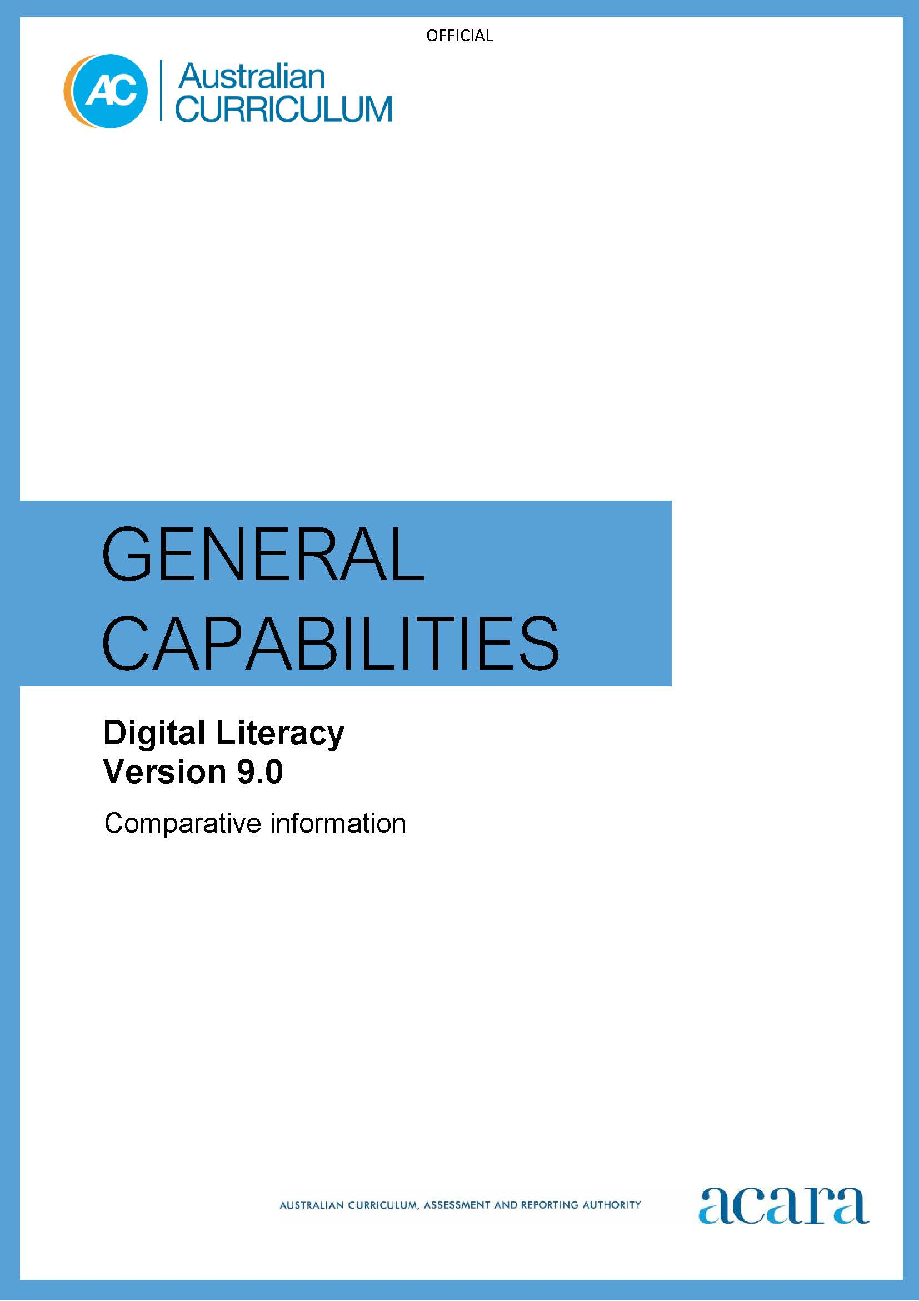

**Copyright and Terms of Use Statement**

**© Australian Curriculum, Assessment and Reporting Authority 2022**

The material published in this work is subject to copyright pursuant to the Copyright Act 1968 (Cth) and is owned by the Australian Curriculum, Assessment and Reporting Authority (ACARA) (except to the extent that copyright is held by another party, as indicated).

The viewing, downloading, displaying, printing, reproducing (such as by making photocopies) and distributing of these materials is permitted only to the extent permitted by, and is subject to the conditions imposed by, the terms and conditions of using the ACARA website (see, especially, clauses 2, 3 and 4 of those terms and conditions). The terms and conditions can be viewed at [https://www.acara.edu.au/contact-us/copyright](https://aus01.safelinks.protection.outlook.com/?url=https%3A%2F%2Fwww.acara.edu.au%2Fcontact-us%2Fcopyright&data=04%7C01%7CSharon.Foster%40acara.edu.au%7C9931e11fa7684c603e6308d98331bbfb%7C6cf76a3aa824427092003d71673ec678%7C0%7C0%7C637685071906340874%7CUnknown%7CTWFpbGZsb3d8eyJWIjoiMC4wLjAwMDAiLCJQIjoiV2luMzIiLCJBTiI6Ik1haWwiLCJXVCI6Mn0%3D%7C1000&sdata=U5O4Vlbpf271IGmGiMh7fDwU4pLzzAiHpCQFylkp6s4%3D&reserved=0)

## *Table 1: Digital Literacy learning continuum version 9.0*

|  |  |  |  |  |  |  |
| --- | --- | --- | --- | --- | --- | --- |
| **Sub-element** | **Level 1 (Foundation)** | **Level 2**  **(Years 1–2)** | **Level 3**  **(Years 3–4)** | **Level 4**  **(Years 5–6)** | **Level 5**  **(Years 7–8)** | **Level 6**  **(Years 9–10)** |
| **PRACTISING DIGITAL SAFETY AND WELLBEING** | | | | | | |
| **Manage online safety** | use online tools that are safe or only used under direct supervision, seeking help from trusted adults when feeling unsafe | use online tools that are age appropriate or only used under supervision, seeking help from trusted adults when feeling unsafe | report negative or harmful online behaviour by seeking help from trusted adults | report negative or harmful online behaviour to trusted adults, know how to report it in online tools  recognise when to step away from negative online social interactions | identify online abuse and bullying and report them to trusted adults, appropriate authorities and in online tools  stop engaging in negative online social interactions | engage in safe, legal and ethical online behaviour and defuse negative online social interactions  recognise the benefits and risks of anonymity online |
| **Manage digital privacy and identity** | recognise their personal data and that data (including text, images, and video) can be seen by others when shared online | recognise that online tools (website and apps) store their personal data, which may give an impression of them | identify their digital footprint (personal data stored by online tools)  recognise that their digital identity represents them online and can give a negative impression  give and seek consent before sharing online with peers and trusted adults | recognise the permanence of their digital footprint and digital identity, and the associated risks, including to their reputation  give and seek consent before sharing online in trusted groups | recognise that their digital footprint is valuable, used by online tools for targeting, and that data shared online is no longer under their control  consider who they trust with their data and review privacy policies before giving consent, and seek consent before sharing online | recognise that their actions contribute to their passive digital footprint  manage their digital identity by controlling privacy, connections and group settings, and curating posts  consent selectively to data collection after assessing the benefits and risks of an online tool privacy policy |
| **Manage digital wellbeing** | follow adult directions for the use of digital tools at school and home | follow agreed rules for the healthy use of digital tools and apply them at school and home | follow an agreed code of conduct for the healthy use of digital tools | follow an agreed code of conduct for the healthy and productive use of digital tools, considering the impact of tool use on wellbeing | develop routines to support their balanced and constructive use of digital tools  identify indicators of unhealthy usage | self-regulate the use of digital tools to purposefully enhance their wellbeing  identify how tools are designed to capture their attention |
| **INVESTIGATING** | | | | | | |
| **Locate information** | use simple digital tools to explore sorting data and information provided as part of learning experiences | locate information through search engines and in documents by applying search terms, and select relevant information | locate information through search engines and in documents by applying specific search terms, and select and retrieve relevant information from multiple sources | locate information through search engines and in documents by applying specific search terms based on set criteria, and select and retrieve relevant information from multiple sources | locate, select and retrieve relevant information from multiple sources, exploring advanced search functions and targeted criteria | locate relevant information by applying advanced search functions across multiple sources involving purposefully selected and contextually specific terms and criteria |
| **Acquire and collate data** | collect data by counting, measuring and observing with familiar digital tools | collect and access data using a range of digital tools and methods in response to a defined question | collect and access data, using a range of digital tools and methods in response to a defined question or problem | collect and access data from a range of sources, using specialised digital tools in response to problems, and evaluate it for relevance | collect and evaluate quantitative and qualitative data using specialised digital tools and processes in the context of identified problems |

| **Interpret data** |  | classify and group data using familiar digital tools to answer simple questions | organise, summarise and visualise data using a range of digital tools to identify patterns and answer questions | analyse and visualise data using a range of digital tools to identify patterns and make predictions | analyse and visualise data by selecting and using a range of digital tools to infer relationships and make predictions | analyse and visualise multidimensional data by selecting and using a range of interactive tools to draw conclusions and make predictions |
| --- | --- | --- | --- | --- | --- | --- |
| **CREATING AND EXCHANGING** | | | | | | |
| **Plan** |  | use simple digital tools to contribute to a basic plan to complete a task | use familiar digital tools to develop and follow a basic plan to complete a task | select and use digital tools to develop and follow a plan to complete individual tasks and group projects | use simple planning tools to develop and follow a plan to complete individual and collaborative projects | use project management tools to develop and track a plan to complete individual and collaborative projects |
| **Create, communicate and collaborate** | use simple digital tools to create content | experiment with the features of familiar digital tools to create content | use the core features of a range of digital tools to create content and communicate and collaborate with peers and trusted adults | select and control a variety of features in appropriate digital tools to create content and communicate and collaborate with trusted groups | select and control advanced features of appropriate digital tools to independently create content and effectively communicate and collaborate with wider groups | select and control the features of digital tools to purposefully create content and effectively communicate and collaborate, inclusive of diverse groups |

| **Respect intellectual property** | identify who owns class data | recognise ownership of products that others produce or that are produced collaboratively | respect products created by someone else by acknowledging when they use them and use strategies such as indicating the source | respect intellectual property by identifying the legal obligations regarding the ownership and appropriate use of products, exploring copyright protocols and applying some referencing conventions | respect intellectual property by applying practices that comply with ethical and legal obligations, referencing conventions and copyright protocols | respect intellectual property by identifying and applying practices that meet legal and ethical obligations, referencing conventions, copyright and trademark protocols |
| --- | --- | --- | --- | --- | --- | --- |
| **MANAGING AND OPERATING** | | | | | | |
| **Manage content** | save and retrieve content in an app | save and retrieve content with an agreed name | save and retrieve content in agreed locations with an appropriate name | store content using appropriate names and folders for ease of retrieval | store and backup content online for access and editing from multiple devices | store content systematically online for access and editing (with version history) from multiple devices and ensure data is reliably backed up |
| **Protect content** |  | save and access content in their individual school account | save and access content in shared folders using their individual school account | protect content when sharing with peers and trusted adults by setting appropriate access controls | protect content when sharing by selecting appropriate access controls for individuals and shared links for wider groups | protect content when sharing by purposefully selecting appropriate access controls for individuals and groups |

| **Select and operate tools** | use simple digital tools to explore tasks and consolidate learning  seek help when encountering a problem | use familiar digital tools to complete tasks and consolidate learning  attempt to solve a problem before seeking help | select and use a range of digital tools to complete tasks  attempt to solve a problem individually and with peers before seeking help | select and use the core features of digital tools to efficiently complete tasks  troubleshoot basic problems and identify repetitive tasks to automate | select and use the advanced or unfamiliar features of digital tools to efficiently complete tasks  troubleshoot common problems and automate repetitive tasks | select and operate advanced and emerging digital tools confidently  troubleshoot common problems systematically and seek to improve efficiency by developing new skills |
| --- | --- | --- | --- | --- | --- | --- |

*Table 2: Information and Communication Technologies (ICT) capability learning continuum version 8.4*

|  |  |  |  |  |  |  |
| --- | --- | --- | --- | --- | --- | --- |
| **Sub-element** | **Level 1**  Typically, by the end of Foundation Year, students: | **Level 2**  Typically, by the end of Year 2, students: | **Level 3**  Typically, by the end of Year 4, students: | **Level 4**  Typically, by the end of Year 6, students: | **Level 5**  Typically, by the end of Year 8, students: | **Level 6**  Typically, by the end of Year 10, students: |
| **Applying social and ethical protocols and practices when using ICT element** | | | | | | |
| **Recognise intellectual property** | recognise ownership over their own digital work | recognise ownership of digital products that others produce and that what they create or provide can be used or misused by others | acknowledge when they use digital products created by someone else, and start to indicate the source | identify the legal obligations regarding the ownership and use of digital products and apply some referencing conventions | apply practices that comply with legal obligations regarding the ownership and use of digital products resources | identify and describe ethical dilemmas and consciously apply practices that protect intellectual property |
| **Apply digital information security practices** | follow class rules about using digital information | follow class rules about applying selected standard guidelines and techniques to secure digital information | independently apply standard guidelines and techniques for particular digital systems to secure digital information | independently apply strategies for determining and protecting the security of digital information and assess the risks associated with online environments | independently apply strategies for determining the appropriate type of digital information suited to the location of storage and adequate security for online environments | use a range of strategies for securing and protecting information, assess the risks associated with online environments and establish appropriate security strategies and codes of conduct |
| **Apply personal security protocols** | follow class rules when sharing personal information with known audiences and demonstrate an awareness of applying social protocols when using ICT to communicate | follow class guidelines when sharing personal information and apply basic social protocols when using ICT to communicate with known audiences | apply standard guidelines and take action to avoid the common dangers to personal security when using ICT and apply appropriate basic social protocols when using ICT to communicate with unknown audiences | identify the risks to identity, privacy and emotional safety for themselves when using ICT and apply generally accepted social protocols when sharing information in online environments, taking into account different social and cultural contexts | identify and value the rights to identity, privacy and emotional safety for themselves and others when using ICT and apply generally accepted social protocols when using ICT to collaborate with local and global communities | independently apply appropriate strategies to protect rights, identity, privacy and emotional safety of others when using ICT, and discriminate between protocols suitable for different communication tools when collaborating with local and global communities |
| **Identify the impacts of ICT in society** | identify how they use ICT in multiple ways on multiple devices | identify how ICT is used at home and at school | identify the value and role of ICT use at home and school | explain the main uses of ICT at school, home and in the local community, and recognise its potential positive and negative impacts on their lives | explain the benefits and risks of the use of ICT for particular people in work and home environments | assess the impact of ICT in the workplace and in society, and speculate on its role in the future and how they can influence its use |
| **Investigating with ICT element** | | | | | | |
| **Define and plan information searches** | use ICT to identify where information is located | use ICT to identify, record and classify textual and graphic information to show what is known and what needs to be investigated | use ICT to plan an information search or generation of information, recognising some pattern within the information | use a range of ICT to identify and represent patterns in sets of information and to pose questions to guide searching for, or generating, further information | use a range of ICT to analyse information in terms of implicit patterns and structures as a basis to plan an information search or generation | select and use a range of ICT independently and collaboratively, analyse information to frame questions and plan search strategies or data generation |
| **Locate, generate and access data and information** | use icons to locate or generate required information | locate information from a given set of digital sources | locate, retrieve or generate information from a range of digital sources | locate, retrieve or generate information using search engines and simple search functions and classify information in meaningful ways | locate, retrieve or generate information using search facilities and organise information in meaningful ways | use advanced search tools and techniques or simulations and digital models to locate or generate precise data and information that supports the development of new understandings |
| **Select and evaluate data and information** | explain how located data or information was used | explain the usefulness of located data or information | explain why located data or information was selected | assess the suitability of data or information using a range of appropriate given criteria | assess the suitability of data or information using appropriate own criteria | develop and use criteria systematically to evaluate the quality, suitability and credibility of located data or information and sources |

|  |  |  |  |  |  |  |
| --- | --- | --- | --- | --- | --- | --- |
| **Creating with ICT element** | | | | | | |
| **Generate ideas, plans and processes** | use ICT to follow or contribute to a simple plan for a solution | use ICT to prepare simple plans to find solutions or answers to questions | use ICT to generate ideas and plan solutions | use ICT effectively to record ideas, represent thinking and plan solutions | use appropriate ICT to collaboratively generate ideas and develop plans | select and use ICT to articulate ideas and concepts, and plan the development of complex solutions |
| **Generate solutions to challenges and learning area tasks** | use ICT as a creative tool to generate simple solutions, modifications or data representations for personal or school purposes | experiment with ICT as a creative tool to generate simple solutions, modifications or data representations for particular audiences or purposes | create and modify simple digital solutions, creative outputs or data representation/ transformation for particular purposes | independently or collaboratively create and modify digital solutions, creative outputs or data representation/ transformation for particular audiences and purposes | design and modify simple digital solutions, or multimodal creative outputs or data transformations for particular audiences and purposes following recognised conventions | design, modify and manage complex digital solutions, or multimodal creative outputs or data transformations for a range of audiences and purposes |
| **Communicating with ICT element** | | | | | | |
| **Collaborate, share and exchange** | use purposefully selected ICT tools safely to view information shared by trusted adults | use purposefully selected ICT tools safely to share and exchange information with appropriate local audiences | use appropriate ICT tools safely to share and exchange information with appropriate known audiences | select and use appropriate ICT tools safely to share and exchange information and to safely collaborate with others | select and use appropriate ICT tools safely to lead groups in sharing and exchanging information, and taking part in online projects or active collaborations with appropriate global audiences | select and use a range of ICT tools efficiently and safely to share and exchange information, and to collaboratively and purposefully construct knowledge |
| **Understand computer mediated communications** | understand that messages are recorded, viewed or sent in computer mediated communications for others to receive | understand that computer mediated communications may be received later by the receiver | understand that computer mediated communications are directed to an audience for a purpose | understand that particular forms of computer mediated communications and tools are suited to synchronous or asynchronous and one-to-one or group communications | understand that there are various methods of collaboration through computer mediated communications that vary in form and control | understand that computer mediated communications have advantages and disadvantages in supporting active participation in a community of practice and the management of collaboration on digital materials |

|  |  |  |  |  |  |  |
| --- | --- | --- | --- | --- | --- | --- |
| **Managing and operating ICT element** | | | | | | |
| **Select and use hardware and software** | identify and safely operate ICT systems to complete relevant simple specified tasks and seek help when encountering a problem | identify and safely operate a selected range of appropriate devices, software, functions and commands when operating an ICT system and attempt to solve a problem before seeking help | identify and independently operate a range of devices, software, functions and commands, taking into consideration ergonomics when operating appropriate ICT systems, and seek solutions when encountering a problem | select from, and safely operate, a range of devices to undertake specific tasks and use basic troubleshooting procedures to solve routine malfunctions | independently select and operate a range of devices by adjusting relevant software functions to suit specific tasks, and independently use common troubleshooting procedures to solve routine malfunctions | justify the selection of, and optimise the operation of, a selected range of devices and software functions to complete specific tasks, for different purposes and in different social contexts |
| **Understand ICT systems** | identify common consumer ICT systems with input and output functions | identify the main components of common consumer ICT systems, their fundamental functions, and describe them using basic ICT terminology | identify and compare the use of the main components of different ICT systems | identify, compare and classify basic ICT system components | identify and compare networked ICT system components including between hardware, software and data | apply an understanding of networked ICT system components to make changes to functions, processes, procedures and devices to fit the purpose of the solutions |
| **Manage digital data** | save and retrieve digital data with support | manage and maintain digital data with guidance | manage and maintain digital data using common methods | manage and maintain data on different storage mediums – locally and on networks | manage and maintain data for groups of users using a variety of methods and systems | manage and maintain data securely in a variety of storage mediums and formats |