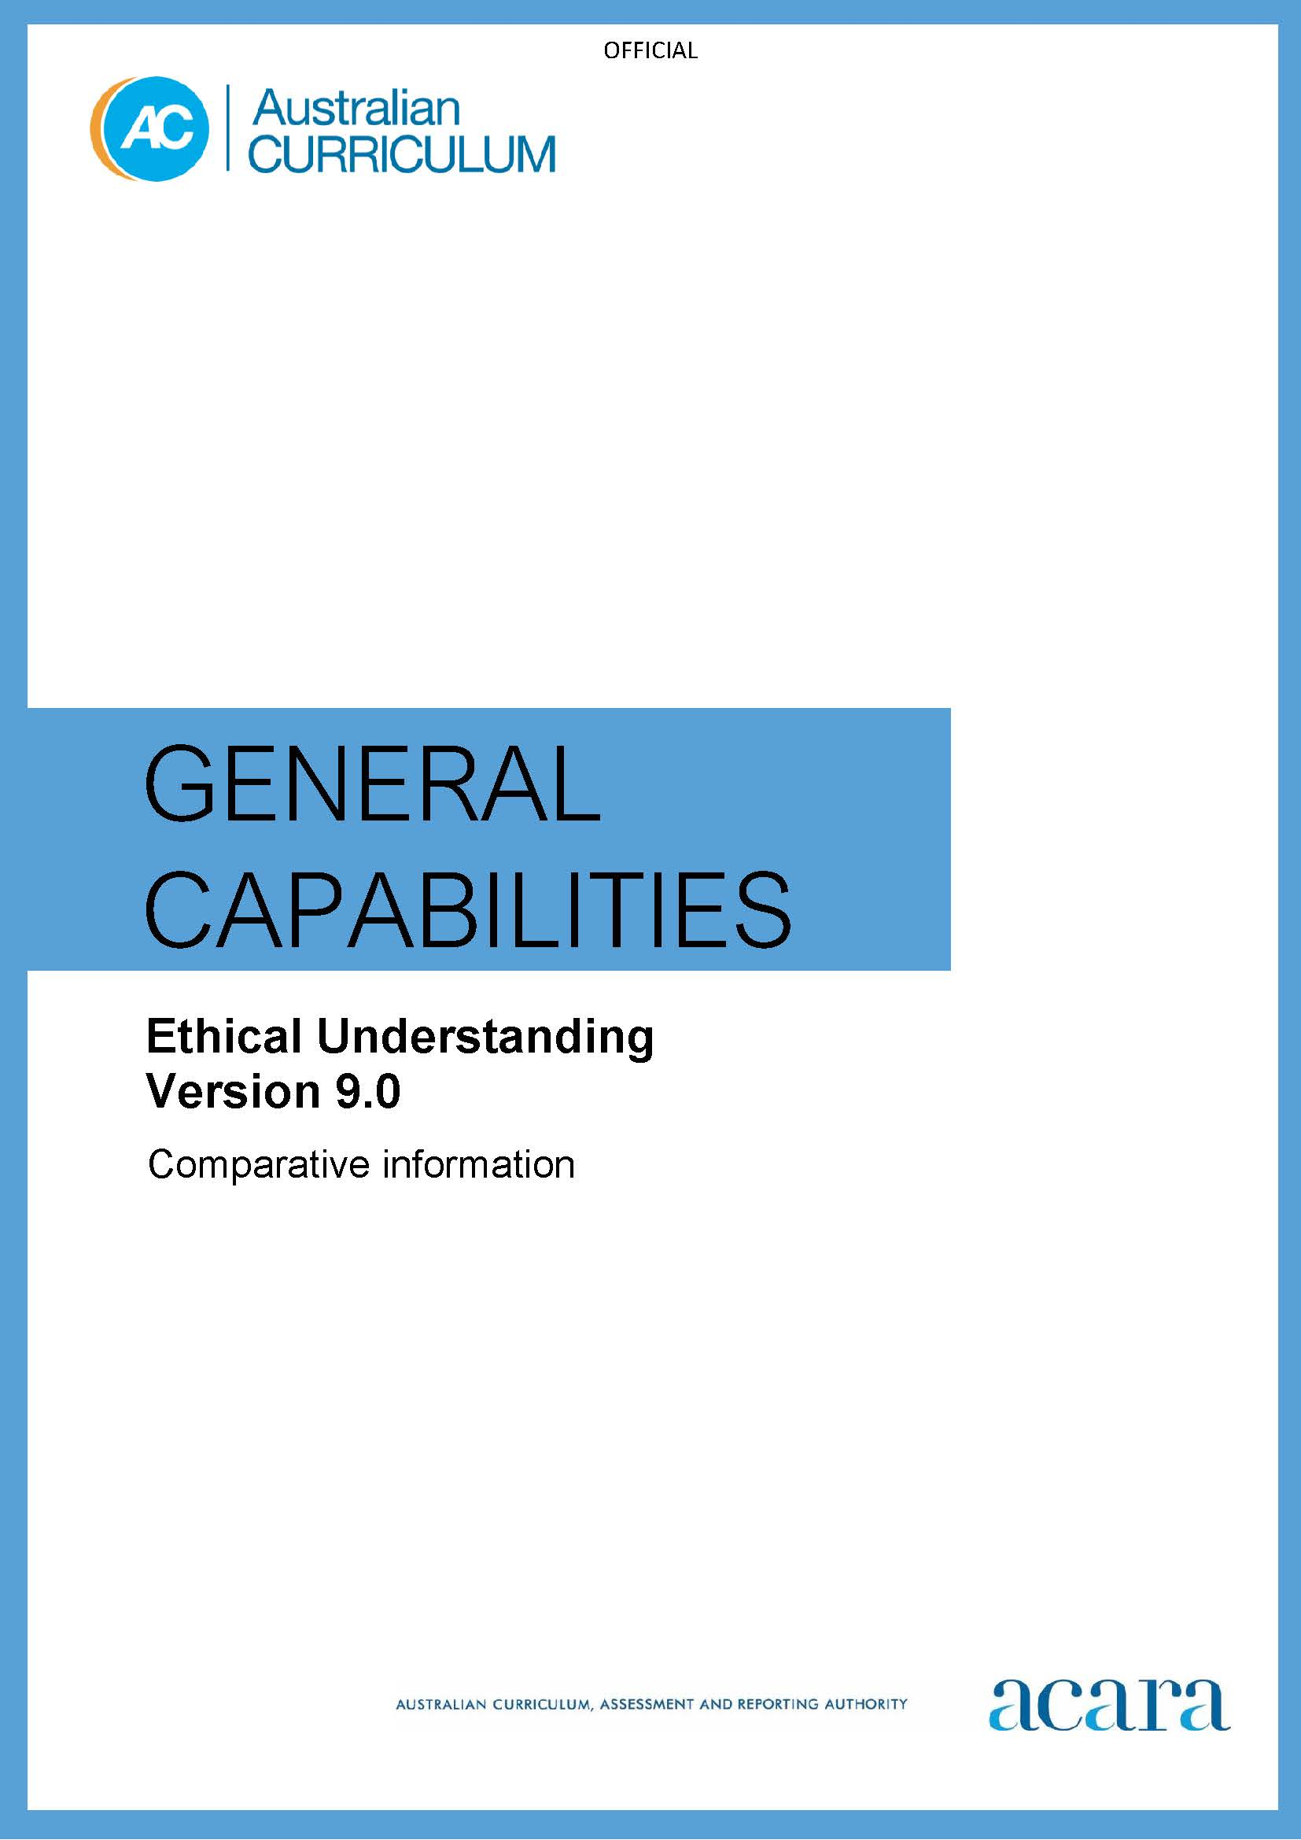

**Copyright and Terms of Use Statement**

**© Australian Curriculum, Assessment and Reporting Authority 2022**

The material published in this work is subject to copyright pursuant to the Copyright Act 1968 (Cth) and is owned by the Australian Curriculum, Assessment and Reporting Authority (ACARA) (except to the extent that copyright is held by another party, as indicated).

The viewing, downloading, displaying, printing, reproducing (such as by making photocopies) and distributing of these materials is permitted only to the extent permitted by, and is subject to the conditions imposed by, the terms and conditions of using the ACARA website (see, especially, clauses 2, 3 and 4 of those terms and conditions). The terms and conditions can be viewed at [https://www.acara.edu.au/contact-us/copyright](https://aus01.safelinks.protection.outlook.com/?url=https%3A%2F%2Fwww.acara.edu.au%2Fcontact-us%2Fcopyright&data=04%7C01%7CSharon.Foster%40acara.edu.au%7C9931e11fa7684c603e6308d98331bbfb%7C6cf76a3aa824427092003d71673ec678%7C0%7C0%7C637685071906340874%7CUnknown%7CTWFpbGZsb3d8eyJWIjoiMC4wLjAwMDAiLCJQIjoiV2luMzIiLCJBTiI6Ik1haWwiLCJXVCI6Mn0%3D%7C1000&sdata=U5O4Vlbpf271IGmGiMh7fDwU4pLzzAiHpCQFylkp6s4%3D&reserved=0)

## *Table 1: Ethical Understanding learning continuum version 9.0*

|  |  |  |  |  |  |  |
| --- | --- | --- | --- | --- | --- | --- |
| **Sub-element** | **Level 1 (Foundation)** | **Level 2**  **(Years 1–2)** | **Level 3**  **(Years 3–4)** | **Level 4**  **(Years 5–6)** | **Level 5**  **(Years 7–8)** | **Level 6**  **(Years 9–10)** |
| **UNDERSTANDING ETHICAL CONCEPTS AND PERSPECTIVES** | | | | | | |
| **Explore ethical concepts** | identify examples of ethical concepts such as right and wrong | identify ethical concepts, such as honesty and fairness, and describe actions and behaviours associated with these | identify ethical concepts, such as respect and tolerance, and describe how a situation or context affects actions and behaviour | identify and describe ethical concepts, such as truth and justice, and explain how perspectives may vary according to the situation or context | analyse the similarities and differences between ethical concepts, such as integrity, loyalty and equality, in a range of situations and contexts | evaluate the consistency in meaning of ethical concepts, such as trust, freedom and rights and responsibilities, in a range of situations and contexts |
| **Examine values, rights and responsibilities, and ethical norms** | identify examples of values, rights and responsibilities | identify values, rights and responsibilities, and shared expectations, and explain why they are important | describe how values, rights and responsibilities, and shared expectations influence responses and decision-making | describe how the relationships between values, rights and responsibilities, and ethical norms influence responses and decisions related to ethical issues | describe the relationship between the role of individual and community values, rights and responsibilities, and ethical norms when responding to ethical issues | describe the importance of values, rights and responsibilities when reaching a position on an ethical issue, and evaluate their role in challenging and defending ethical norms |
| **Recognise influences on ethical behaviour and perspectives** | identify examples of how emotions affect behaviour | identify how emotions and behaviour interact, and share examples of when they match and when they do not | explain how emotions can affect behaviour and decision-making in different situations | explain how habits and behaviour shape character and examine how they inform ethical perspectives | explain how different traits such as honesty, trust, courage and selfishness interact with responsibilities or duties to determine ethically appropriate responses | explore and analyse examples of the tensions between conflicting positions on issues of personal, social and global importance |

| **RESPONDING TO ETHICAL ISSUES** | | | | | | |
| --- | --- | --- | --- | --- | --- | --- |
| **Explore ethical perspectives and frameworks** | identify examples of different consequences and explain how these might affect the way people behave or act | identify the similarities and differences between values such as caring, compassion and empathy | describe the differences and connections between rights and responsibilities, and care and respect, and how these affect decision-making | describe how ethical frameworks that use consequences, virtues and duties guide ethical decision-making | explain how different ethical frameworks support developing ethical perspectives and inform ethical decision-making | analyse and utilise different ethical frameworks when responding to ethical issues and making ethical decisions |
| **Explore ethical issues** | identify different ethical problems or issues from examples such as stories | identify different perspectives and approaches when discussing ethical issues from a given example | use examples to describe how people may have different values and perspectives that they apply to an ethical issue | describe how ethical perspectives or approaches to ethical issues may vary in different situations | analyse the relationships between values, ethical perspectives and ethical frameworks when responding to ethical issues | apply knowledge of ethical concepts, values, perspectives and frameworks when responding to ethical issues |
| **Making and reflecting on ethical decisions** | identify the links between people’s wants and needs and their choices and actions | identify examples of how perspectives and values influence decision-making | describe decision-making processes with reference to ethical perspectives and values | consider alternative ethical responses to an issue when making and reflecting on ethical decisions | consider how values and beliefs influence approaches to ethical issues, and analyse how these affect outcomes | analyse biases when applying ethical concepts, values and ethical frameworks, in order to explore and evaluate ethical decisions |

*Table 2: Ethical Understanding learning continuum version 8.4*

|  |  |  |  |  |  |  |
| --- | --- | --- | --- | --- | --- | --- |
| **Sub-element** | **Level 1**  Typically, by the end of Foundation Year, students: | **Level 2**  Typically, by the end of Year 2, students: | **Level 3**  Typically, by the end of Year 4, students: | **Level 4**  Typically, by the end of Year 6, students: | **Level 5**  Typically, by the end of Year 8, students: | **Level 6**  Typically, by the end of Year 10, students: |
| **Understanding ethical concepts and issues element** | | | | | | |
| **Recognise ethical concepts** | identify ethical concepts arising in familiar contexts such as good and bad behaviours | describe ethical concepts such as right and wrong, honesty, fairness and tolerance | identify ethical concepts, such as equality, respect and connectedness, and describe some of their attributes | examine and explain ethical concepts, such as truth and justice, that contribute to the achievement of a particular outcome | analyse behaviours that exemplify the dimensions and challenges of ethical concepts | critique generalised statements about ethical concepts |
| **Explore ethical concepts in context** | describe familiar situations that involve ethical concepts | discuss ethical concepts within a range of familiar contexts | discuss actions taken in a range of contexts that include an ethical dimension | explain what constitutes an ethically better or worse outcome and how it might be accomplished | analyse the ethical dimensions of beliefs and the need for action in a range of settings | distinguish between the ethical and non-ethical dimensions of complex issues |
| **Reasoning in decision-making and actions element** | | | | | | |
| **Reason and make ethical decisions** | identify examples from stories and experiences that show ways people make decisions about their actions | discuss how people make decisions about their actions and offer reasons why people’s decisions differ | explain reasons for acting in certain ways, including the conflict between self-respect and self-interest in reaching decisions | explore the reasons behind a variety of ethical positions on a social issue | analyse  inconsistencies in personal reasoning and societal ethical decision-making | investigate reasons for clashes of beliefs in issues of personal, social and global importance |

|  |  |  |  |  |  |  |
| --- | --- | --- | --- | --- | --- | --- |
| **Consider consequences** | identify links between emotions and behaviours | describe the effects that personal feelings and dispositions have on how people behave | examine the links between emotions, dispositions, and intended and unintended consequences of their actions on others | evaluate the consequences of actions in familiar and hypothetical scenarios | investigate scenarios that highlight ways that personal dispositions and actions can affect consequences | analyse the objectivity or subjectivity behind decision-making where there are many possible consequences |
| **Reflect on ethical action** | identify and describe the influence of factors such as wants and needs on people’s actions | give examples of how understanding situations can influence the way people act | consider whether having a conscience leads to ways of acting ethically in different scenarios | articulate a range of ethical responses to situations in various social contexts | analyse perceptions of occurrences and possible ethical response in challenging scenarios | evaluate diverse perceptions and ethical bases of action in complex contexts |
| **Exploring values, rights and responsibilities element** | | | | | | |
| **Examine values** | identify values that are important to them | discuss some agreed values in familiar contexts | identify and describe shared values in familiar and unfamiliar contexts | examine values accepted and enacted within various communities | assess the relevance of beliefs and the role and application of values in social practices | analyse and explain the interplay of values in national and international forums and policymaking |
| **Explore rights and responsibilities** | share examples of rights and responsibilities in given situations | identify their rights and associated responsibilities and those of their classmates | investigate children’s rights and responsibilities at school and in the local community | monitor consistency between rights and responsibilities when interacting face-to-face or through social media | analyse rights and responsibilities in relation to the duties of a responsible citizen | evaluate the merits of conflicting rights and responsibilities in global contexts |
| **Consider points of view** | express their own point of view and listen to the views of others | recognise that there may be many points of view when probing ethical dilemmas, and identify alternative views | describe different points of view associated with an ethical dilemma and give possible reasons for these differences | explain a range of possible interpretations and points of view when thinking about ethical dilemmas | draw conclusions from a range of points of view associated with challenging ethical dilemmas | use reasoning skills to prioritise the relative merits of points of view about complex ethical dilemmas |