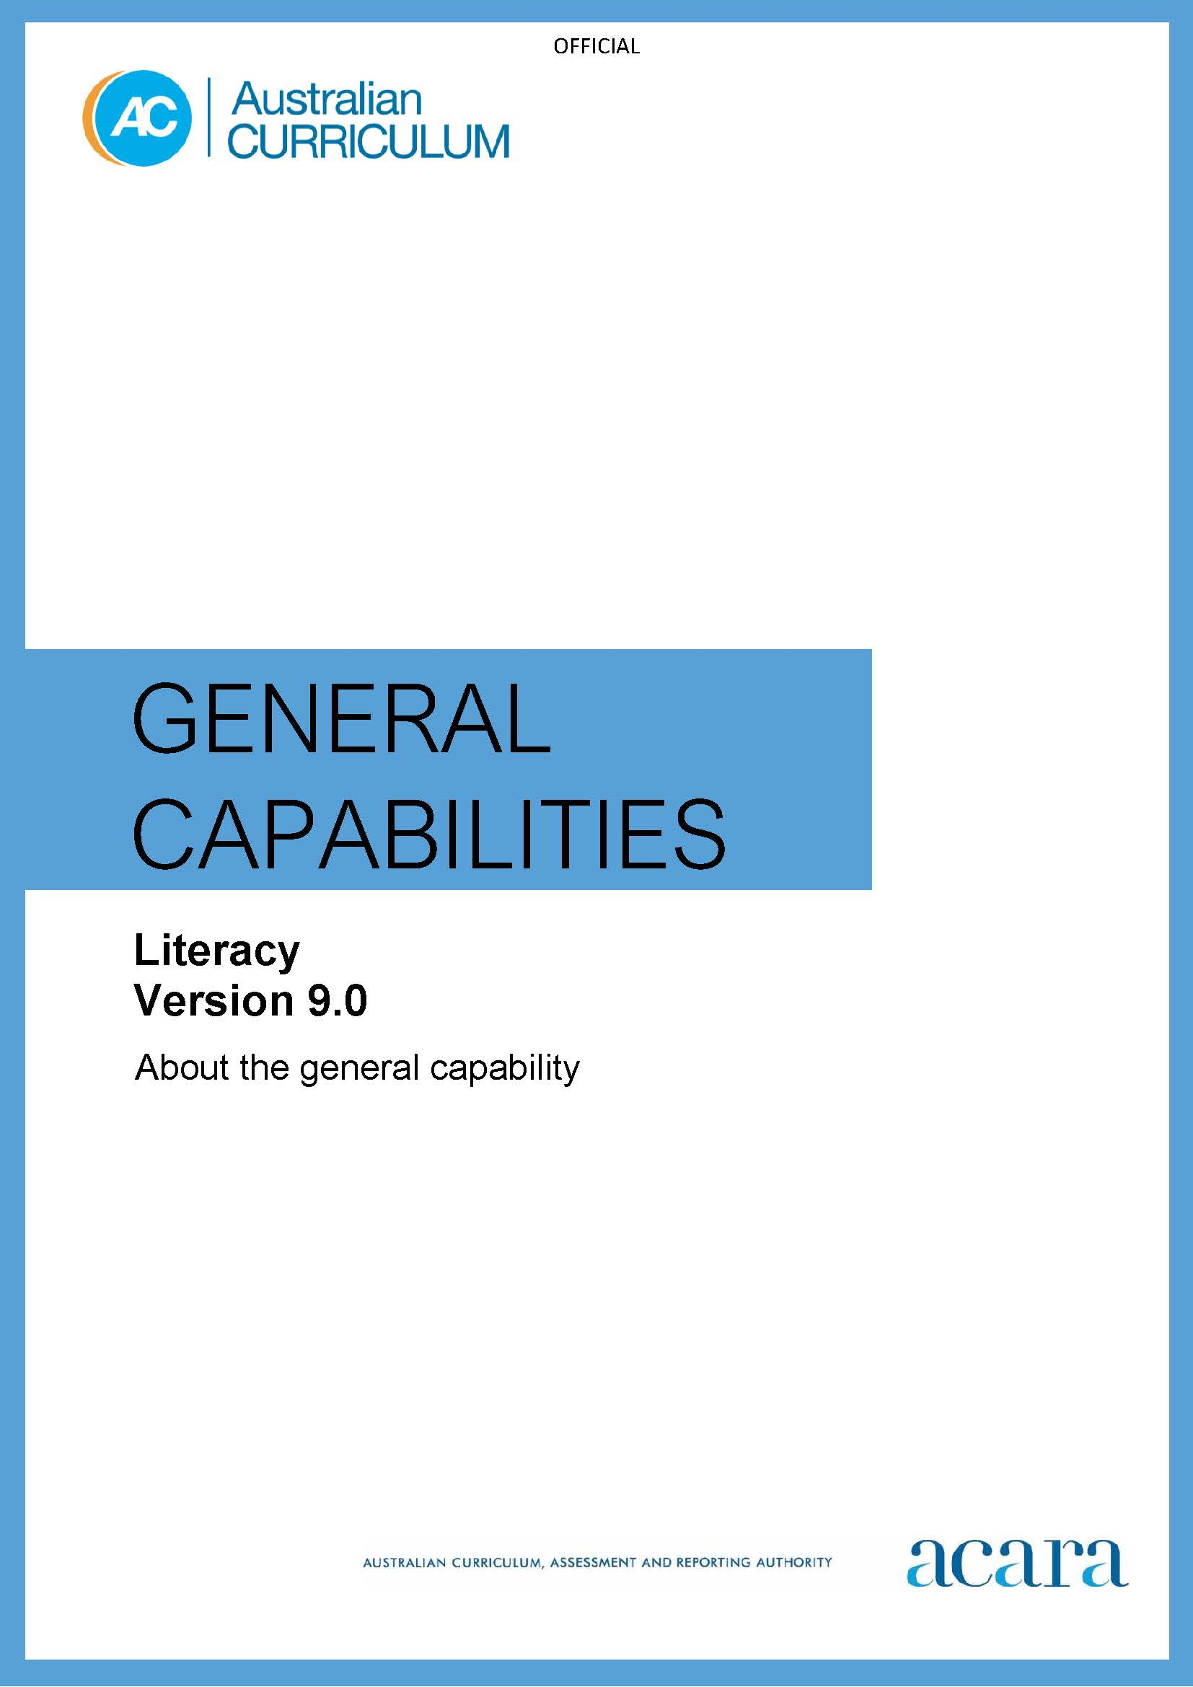

**Copyright and Terms of Use Statement**

**© Australian Curriculum, Assessment and Reporting Authority 2024**

The material published in this work is subject to copyright pursuant to the Copyright Act 1968 (Cth) and is owned by the Australian Curriculum, Assessment and Reporting Authority (ACARA) (except to the extent that copyright is held by another party, as indicated).

The viewing, downloading, displaying, printing, reproducing (such as by making photocopies) and distributing of these materials is permitted only to the extent permitted by, and is subject to the conditions imposed by, the terms and conditions of using the ACARA website (see, especially, clauses 2, 3 and 4 of those terms and conditions). The terms and conditions can be viewed at [https://www.acara.edu.au/contact-us/copyright](https://aus01.safelinks.protection.outlook.com/?url=https%3A%2F%2Fwww.acara.edu.au%2Fcontact-us%2Fcopyright&data=04%7C01%7CSharon.Foster%40acara.edu.au%7C9931e11fa7684c603e6308d98331bbfb%7C6cf76a3aa824427092003d71673ec678%7C0%7C0%7C637685071906340874%7CUnknown%7CTWFpbGZsb3d8eyJWIjoiMC4wLjAwMDAiLCJQIjoiV2luMzIiLCJBTiI6Ik1haWwiLCJXVCI6Mn0%3D%7C1000&sdata=U5O4Vlbpf271IGmGiMh7fDwU4pLzzAiHpCQFylkp6s4%3D&reserved=0)

TABLE OF CONTENTS

F–10 Australian Curriculum: General Capabilities – Literacy 4

Introduction 4

Structure 5

Literacy and the Australian Curriculum: English 6

SPEAKING AND LISTENING 6

Listening 6

Interacting 6

Speaking 6

READING AND VIEWING 10

Phonological awareness 10

Phonic knowledge and word recognition 10

Fluency 10

Understanding texts 10

WRITING 14

Creating texts 14

Grammar 14

Punctuation 14

Spelling 14

Handwriting and keyboarding 14

Appendix 1: Literacy learning progression 18

Speaking and listening 18

Reading and viewing 25

Writing 37

Appendix 2: Text complexity 55

Simple texts 55

Elementary texts 56

Moderately complex texts 58

Complex texts 59

Highly complex texts 60

Appendix 3: Planning for teaching English and other learning areas 62

The Australian Curriculum: English and the Literacy learning progression 62

Using the Literacy learning progression with the Australian Curriculum: English 63

Using the Literacy general capability with the Australian Curriculum learning areas 64

F–10 Australian Curriculum: General Capabilities – Literacy

Introduction

What is literacy?

In the Australian educational context, literacy involves students listening to, reading, viewing, speaking, writing and creating oral, print, visual and digital texts, and using and modifying language for different purposes.

Literacy enables students to: access, understand, analyse and evaluate information and ideas, express thoughts and emotions; present ideas and opinions; and interact with others. All these skills are needed to engage with learning the Australian Curriculum.

What is the Literacy general capability?

The Version 9.0 Australian Curriculum: Literacy general capability is presented as a Literacy learning progression. The Literacy learning progression complements the Australian Curriculum: English by providing more fine-grained descriptions of literacy development. This can support teachers to accurately monitor students’ literacy development and consider how to approach teaching aspects of the English curriculum.

The Literacy learning progression describes the increasing complexity of Standard Australian English and the common developmental pathway of literacy learning across the 3 elements of Speaking and listening, Reading and viewing, and Writing. By providing a comprehensive description of literacy development, this progression gives teachers a tool that complements the essential content in the Australian Curriculum: English. It can help them to develop targeted teaching and learning programs for students who are working at, above or below year-level expectations.

How can you use the Literacy learning progression?

While the Literacy learning progression describes the expected trajectory of skill development, not all students will progress through every progression level in a uniform manner. It is important to remember that indicators at a progression level are not a prescriptive list and the progression is not designed to be used as a checklist. The indicators at each progression level are not hierarchical and students may demonstrate skills and understandings across 2 or more levels.

The Literacy learning progression can be used to support students to successfully engage with the literacy demands of the Foundation to Year 10 Australian Curriculum. It is designed to:

* establish which literacy skills a student understands and can apply
* identify any gaps in students’ literacy skills and knowledge
* plan for the next steps to progress learning, in specific aspects of literacy.

Teachers can use the Literacy learning progression to support the development of targeted teaching and learning programs and to set clearer learning goals for individual students. For example, teaching decisions can be based on judgements about students' skill levels that relate to a single indicator rather than all indicators at a level.

The content and achievement standards of the English curriculum are the reference points for the teaching and learning of all aspects of English. Most of the English curriculum content has been aligned to the Literacy learning progression. This alignment is to a sub-element level, so it is likely that only some of the indicators will relate to a particular content description.

Structure

Elements and sub-elements

The Literacy general capability is organised into 3 elements as shown in Figure 1.

* Speaking and listening
* Reading and viewing
* Writing

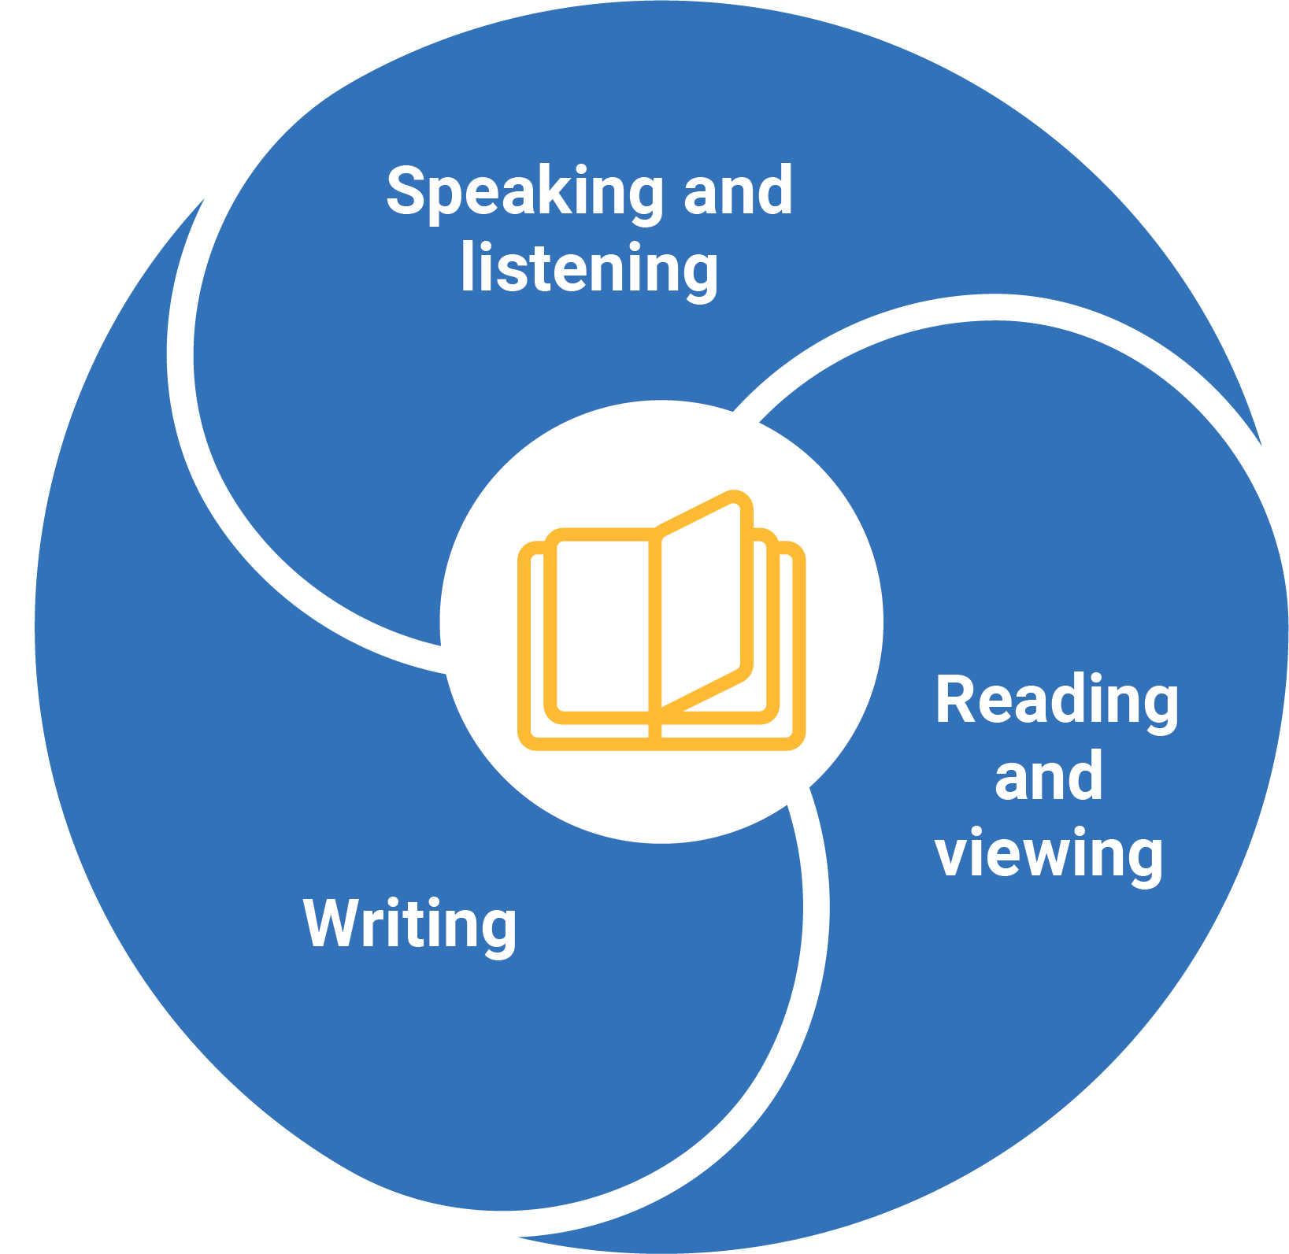

Figure 1: Literacy elements

Each element includes sub-elements that represent evidence-based aspects of literacy development. The sub-elements are organised into progression levels. The number of levels in each sub-element varies, and is determined by available research and evidence. For example, the Phonic knowledge and word recognition sub-element (in the Reading element) has 9 levels whereas Creating texts (in the Writing element) has 11 levels, so students may enter and exit levels over quite different timeframes.

Some sub-elements represent constrained skills, which are those that can be learned in a limited amount of time. Once they are achieved, they require no further teaching. These are Phonological awareness, Phonic knowledge and word recognition, Fluency, Handwriting and keyboarding. Some students may require a longer period of time to achieve these skills. The other sub-elements represent unconstrained skills, which continue to develop.

There is no suggested timeframe for the achievement of progression levels, and they do not represent equal intervals of time in a student's learning. Students may demonstrate skills across more than one progression level. The progression levels in each sub-element are discreet and are not designed to align across sub-elements. The sub-element levels are labelled "P" (progression) and the level number; for example, “P4”.

Literacy and the Australian Curriculum: English

The Australian Curriculum: English describes the knowledge, understandings and skills to be taught in each year of school. The Literacy learning progression describes the typical trajectory of development of literacy skills. It complements the Australian Curriculum: English by providing more fine-grained descriptions of literacy development, to support teachers to accurately monitor students’ literacy development, across all learning areas. The content of the English curriculum is associated with the Literacy learning progression, in the same way, that it is associated with other general capabilities.

The sections that follow use a series of diagrams to explain the Literacy sub-elements, the levels of the Literacy learning progression and their relationship to the Australian Curriculum: English. For more information, see **Appendix 1**: Literacy learning progression, **Appendix 2**: Text complexity and **Appendix 3**: Planning for teaching English and other learning areas.

SPEAKING AND LISTENING

The Speaking and listening element includes 3 sub-elements.

These sub-elements are:

* Listening
* Interacting
* Speaking

Listening

This sub-element describes how a student becomes increasingly proficient at building meaning from a variety of spoken and audio texts. It includes active listening processes to access and understand the increasingly sophisticated language structures of spoken texts for audiences and purposes specific to learning area requirements.

Interacting

This sub-element describes how a student becomes increasingly proficient in two-way interaction processes, to clarify and create understanding. Students interact across an increasing range of curriculum contexts and purposes in pair, group or whole-class oral interactions, expressing their ideas clearly and persuasively and building on the ideas of others.

Speaking

This sub-element describes how a student becomes increasingly proficient at selecting language and using their voice to express and share ideas, appropriate to audience, purpose and task, in planned speaking situations. It includes the development of skills and techniques to demonstrate understanding through fluent, coherent, cohesive speech, for audiences and purposes specific to learning areas and for broader audiences.

The following diagrams demonstrate the alignment of the Australian Curriculum: English with the Speaking and listening sub-elements.

Figure 2 represents the alignment of the Speaking and listening sub-elements (Listening, Interacting and Speaking) with the Australian Curriculum: English Years F–2 levels. There are often multiple Literacy learning progression levels within an English curriculum year level and the progression levels may span across year levels of the curriculum. The number of progression levels is determined by the research evidence and is not the same for each sub-element.

The levels P1a–P1c, marked with an asterisk, address aspects of early Speaking and listening that students would commonly achieve prior to starting school.

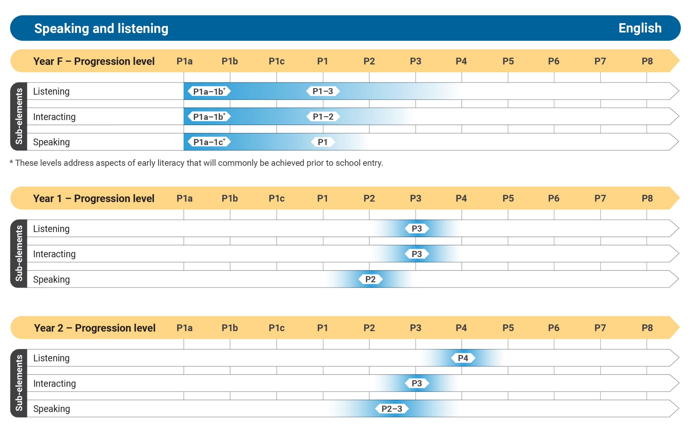

Figure 2: Speaking and listening Years F–2

Figure 3 represents the alignment of the Speaking and listening sub-elements (Listening; Interacting and Speaking) with the Australian Curriculum: English Years 3–6 levels. There are often multiple Literacy learning progression levels within an English curriculum year level and the progression levels may span across year levels of the curriculum. The number of progression levels is determined by the research evidence and is not the same for each sub-element.

*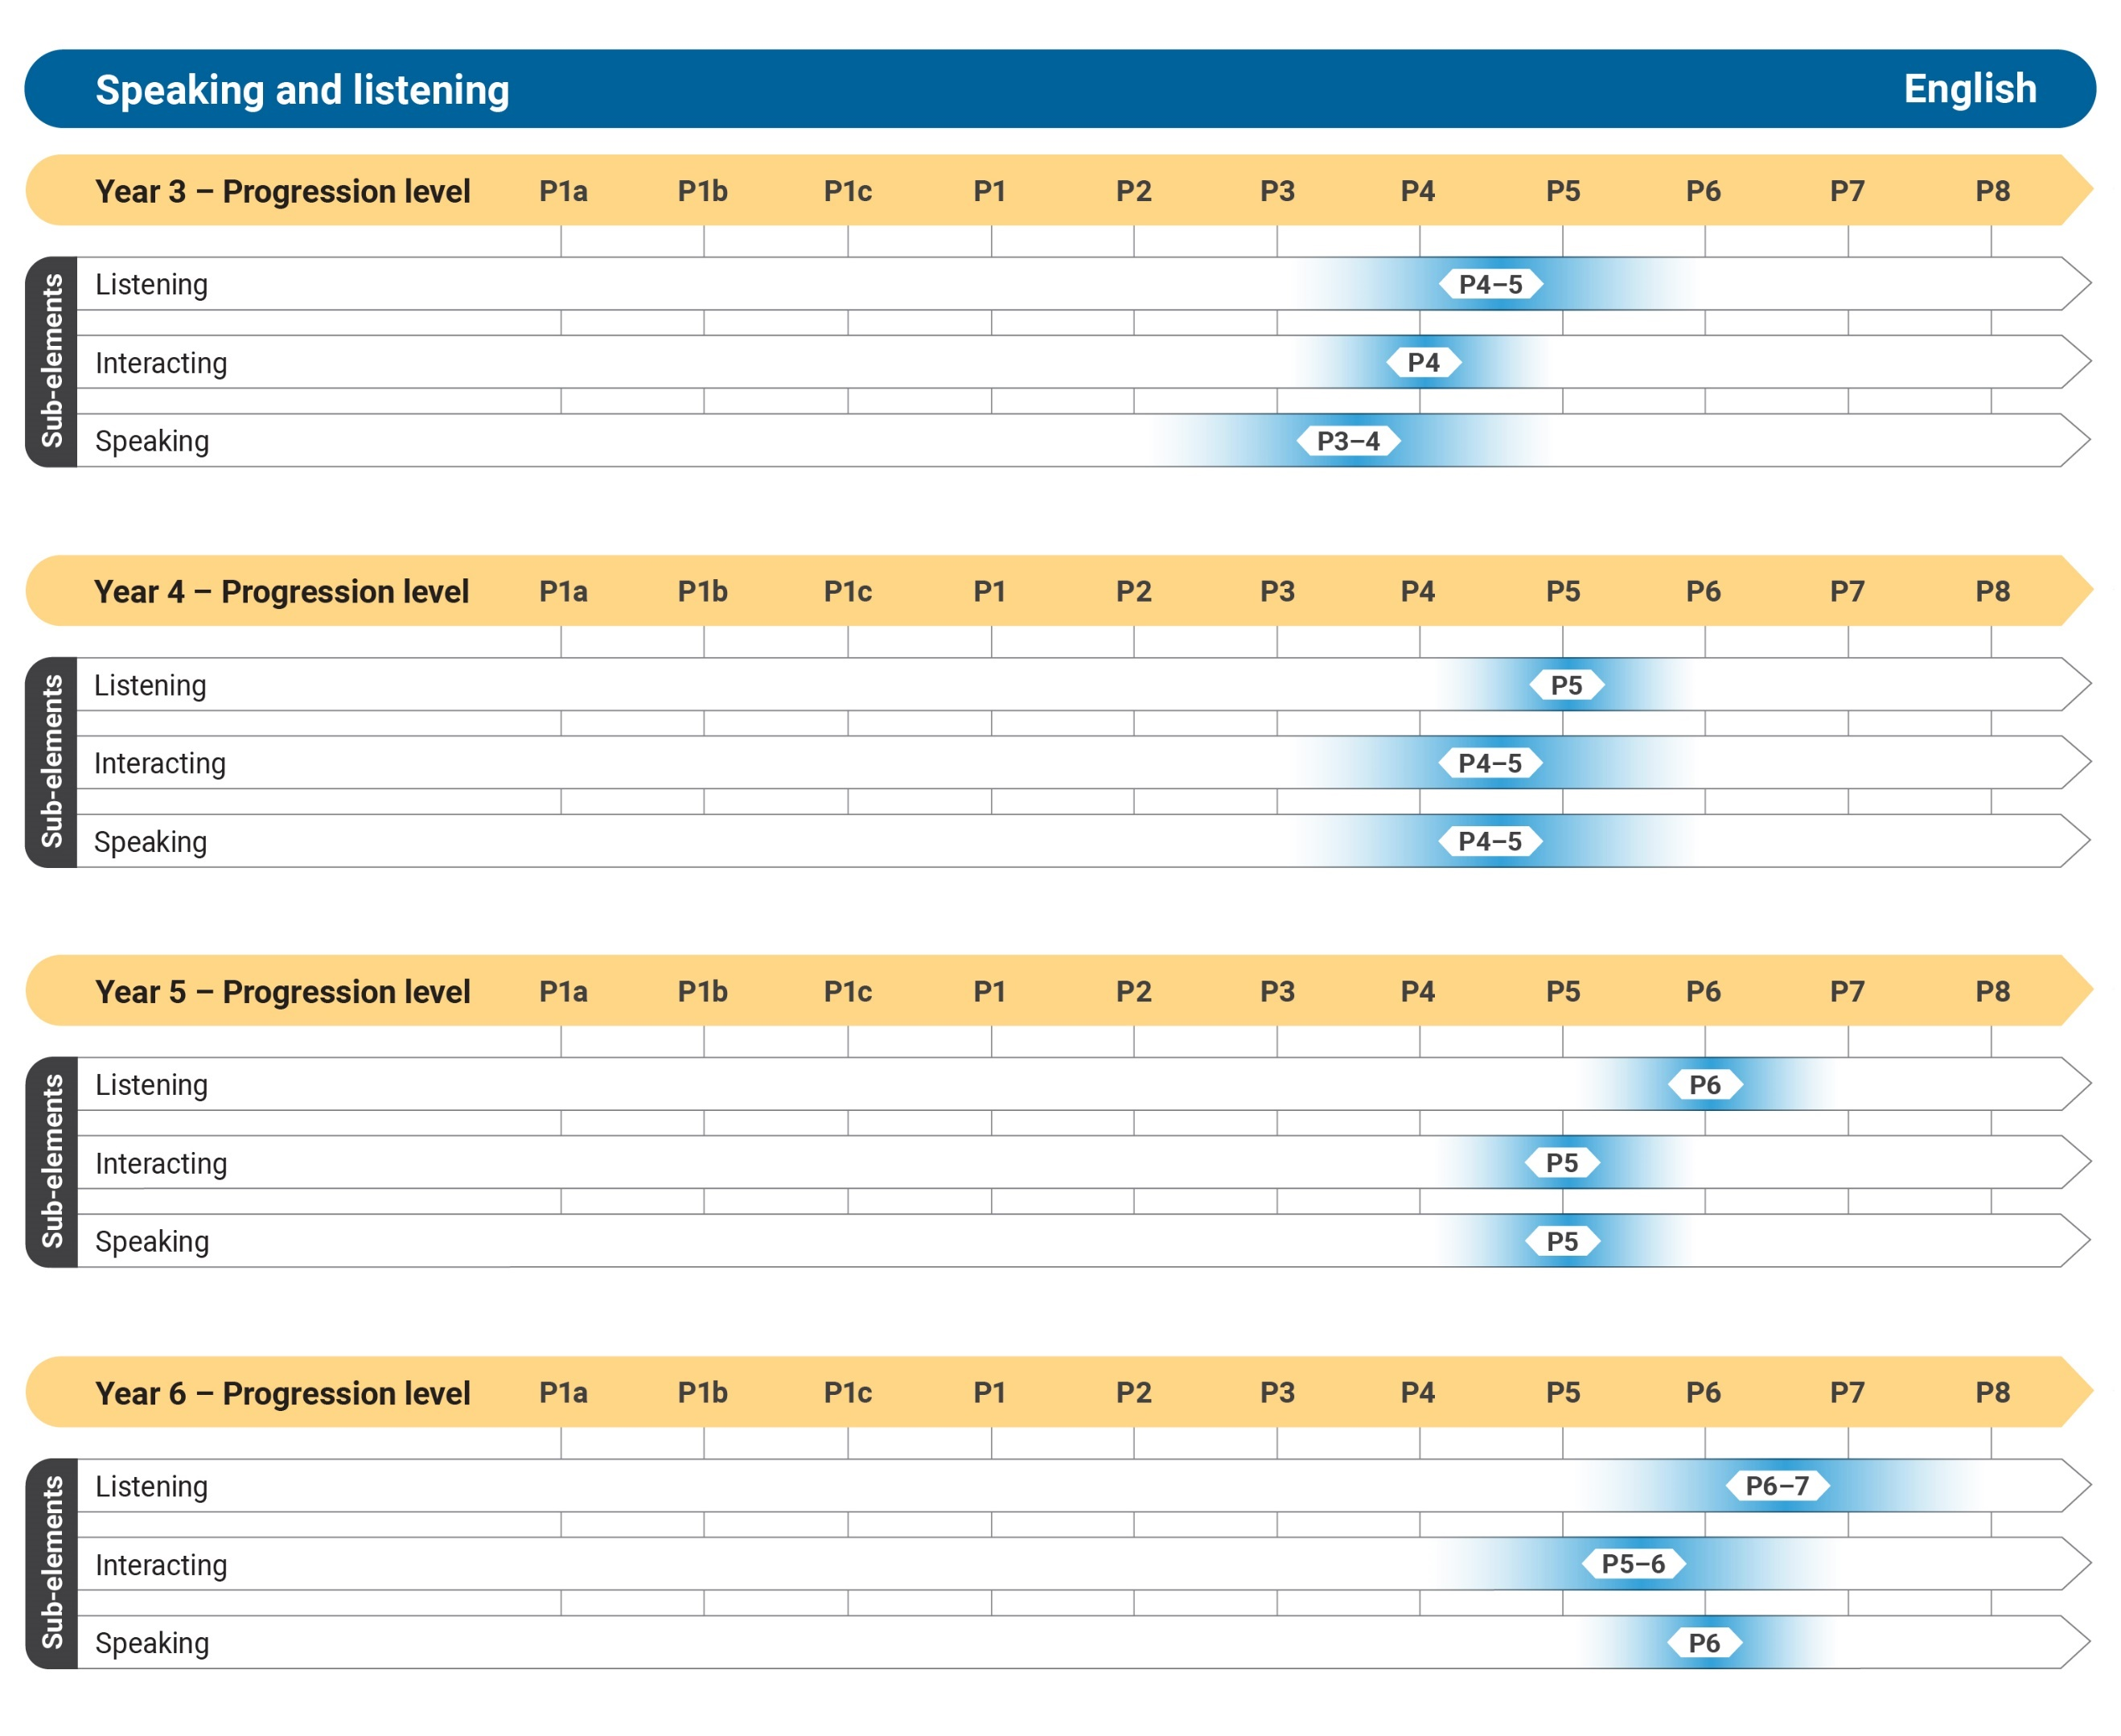Figure 3: Speaking and listening Years 3–6*

Figure 4 represents the alignment of the Speaking and listening sub-elements (Listening, Interacting and Speaking) with the Australian Curriculum: English Years 7–10 levels. There are often multiple Literacy learning progression levels within an English curriculum year level and the progression levels may span across year levels of the curriculum. The number of progression levels is determined by the research evidence and is not the same for each sub-element.

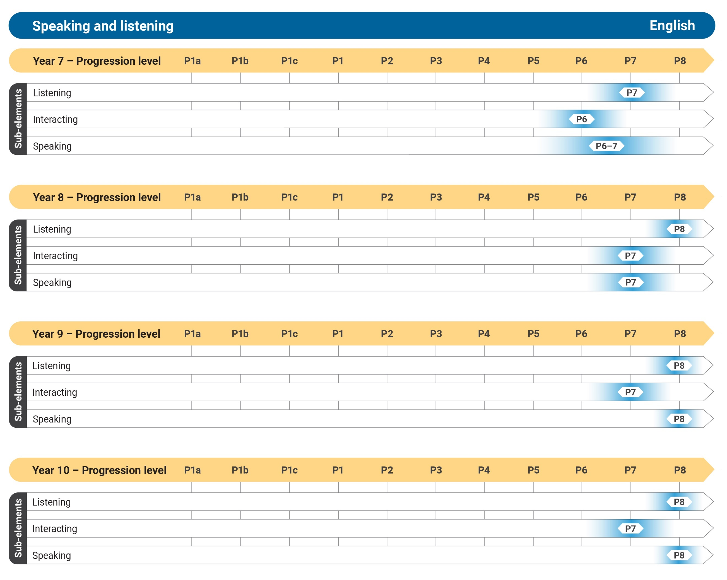Figure 4: Speaking and listening Years 7–10

READING AND VIEWING

The Reading and viewing element includes 4 sub-elements.

These sub-elements are:

* Phonological awareness
* Phonic knowledge and word recognition
* Fluency
* Understanding texts

Phonological awareness

This sub-element describes how a student becomes aware of, and able to work with the individual sounds (phonemes) in spoken words. It includes blending phonemes to create words, segmenting words into phonemes, and manipulating the phonemes in spoken words. Phonological awareness is essential for students to understand the relationship between spoken and written text and to support students ‘sounding out’ words in print.

Phonic knowledge and word recognition

This sub-element describes how a student becomes increasingly proficient at using letter-sound (graph- phoneme) relationships to decode phonetically regular words and visual knowledge to automatically recognise high- frequency words. Phonic knowledge and word recognition are important skills students use to decode and spell words.

Fluency

This sub-element describes how a student becomes progressively faster, smoother, more accurate and expressive as they read aloud increasingly complex print text.

Understanding texts

Understanding texts is a holistic sub-element that is supported by the other sub-elements in the Reading element.

This sub-element describes how a student becomes increasingly proficient in decoding, using, analysing and evaluating texts, to build meaning. It describes how students learn, apply, integrate and adapt strategies and skills as they engage with increasingly complex texts, for a range of purposes. Texts include components of print, image, sound, animation and symbolic representations, in a range of forms including digital forms.

The following diagrams demonstrate the alignment of the Australian Curriculum: English with the Reading and viewing sub-elements.

Figure 5 represents the alignment of the Reading and viewing sub-elements (Phonological awareness, Phonic knowledge and word recognition, Fluency, and Understanding texts) with the Australian Curriculum: English Years F–2 levels. There are often multiple Literacy learning progression levels within an English curriculum year level and the progression levels may span across year levels of the curriculum. The number of progression levels is determined by the research evidence and is not the same for each sub-element.

The levels P1a– P1b, marked with an asterisk, address aspects of early reading that students would commonly achieve prior to starting school.

*Figure 5: Reading and viewing Years F–2*

Figure 6 represents the alignment of the Reading and viewing sub-elements (Phonological awareness, Phonic knowledge and word recognition, Fluency, and Understanding texts) with the Australian Curriculum: English Years 3–6 levels. Most students in the later primary years will have achieved all of the levels of the constrained sub-elements, such as Phonological awareness, which are associated with learning to read. There are often multiple Literacy learning progression levels within an English curriculum year level and the progression levels may span across year levels of the curriculum. The number of progression levels is determined by the research evidence and is not the same for each sub-element.

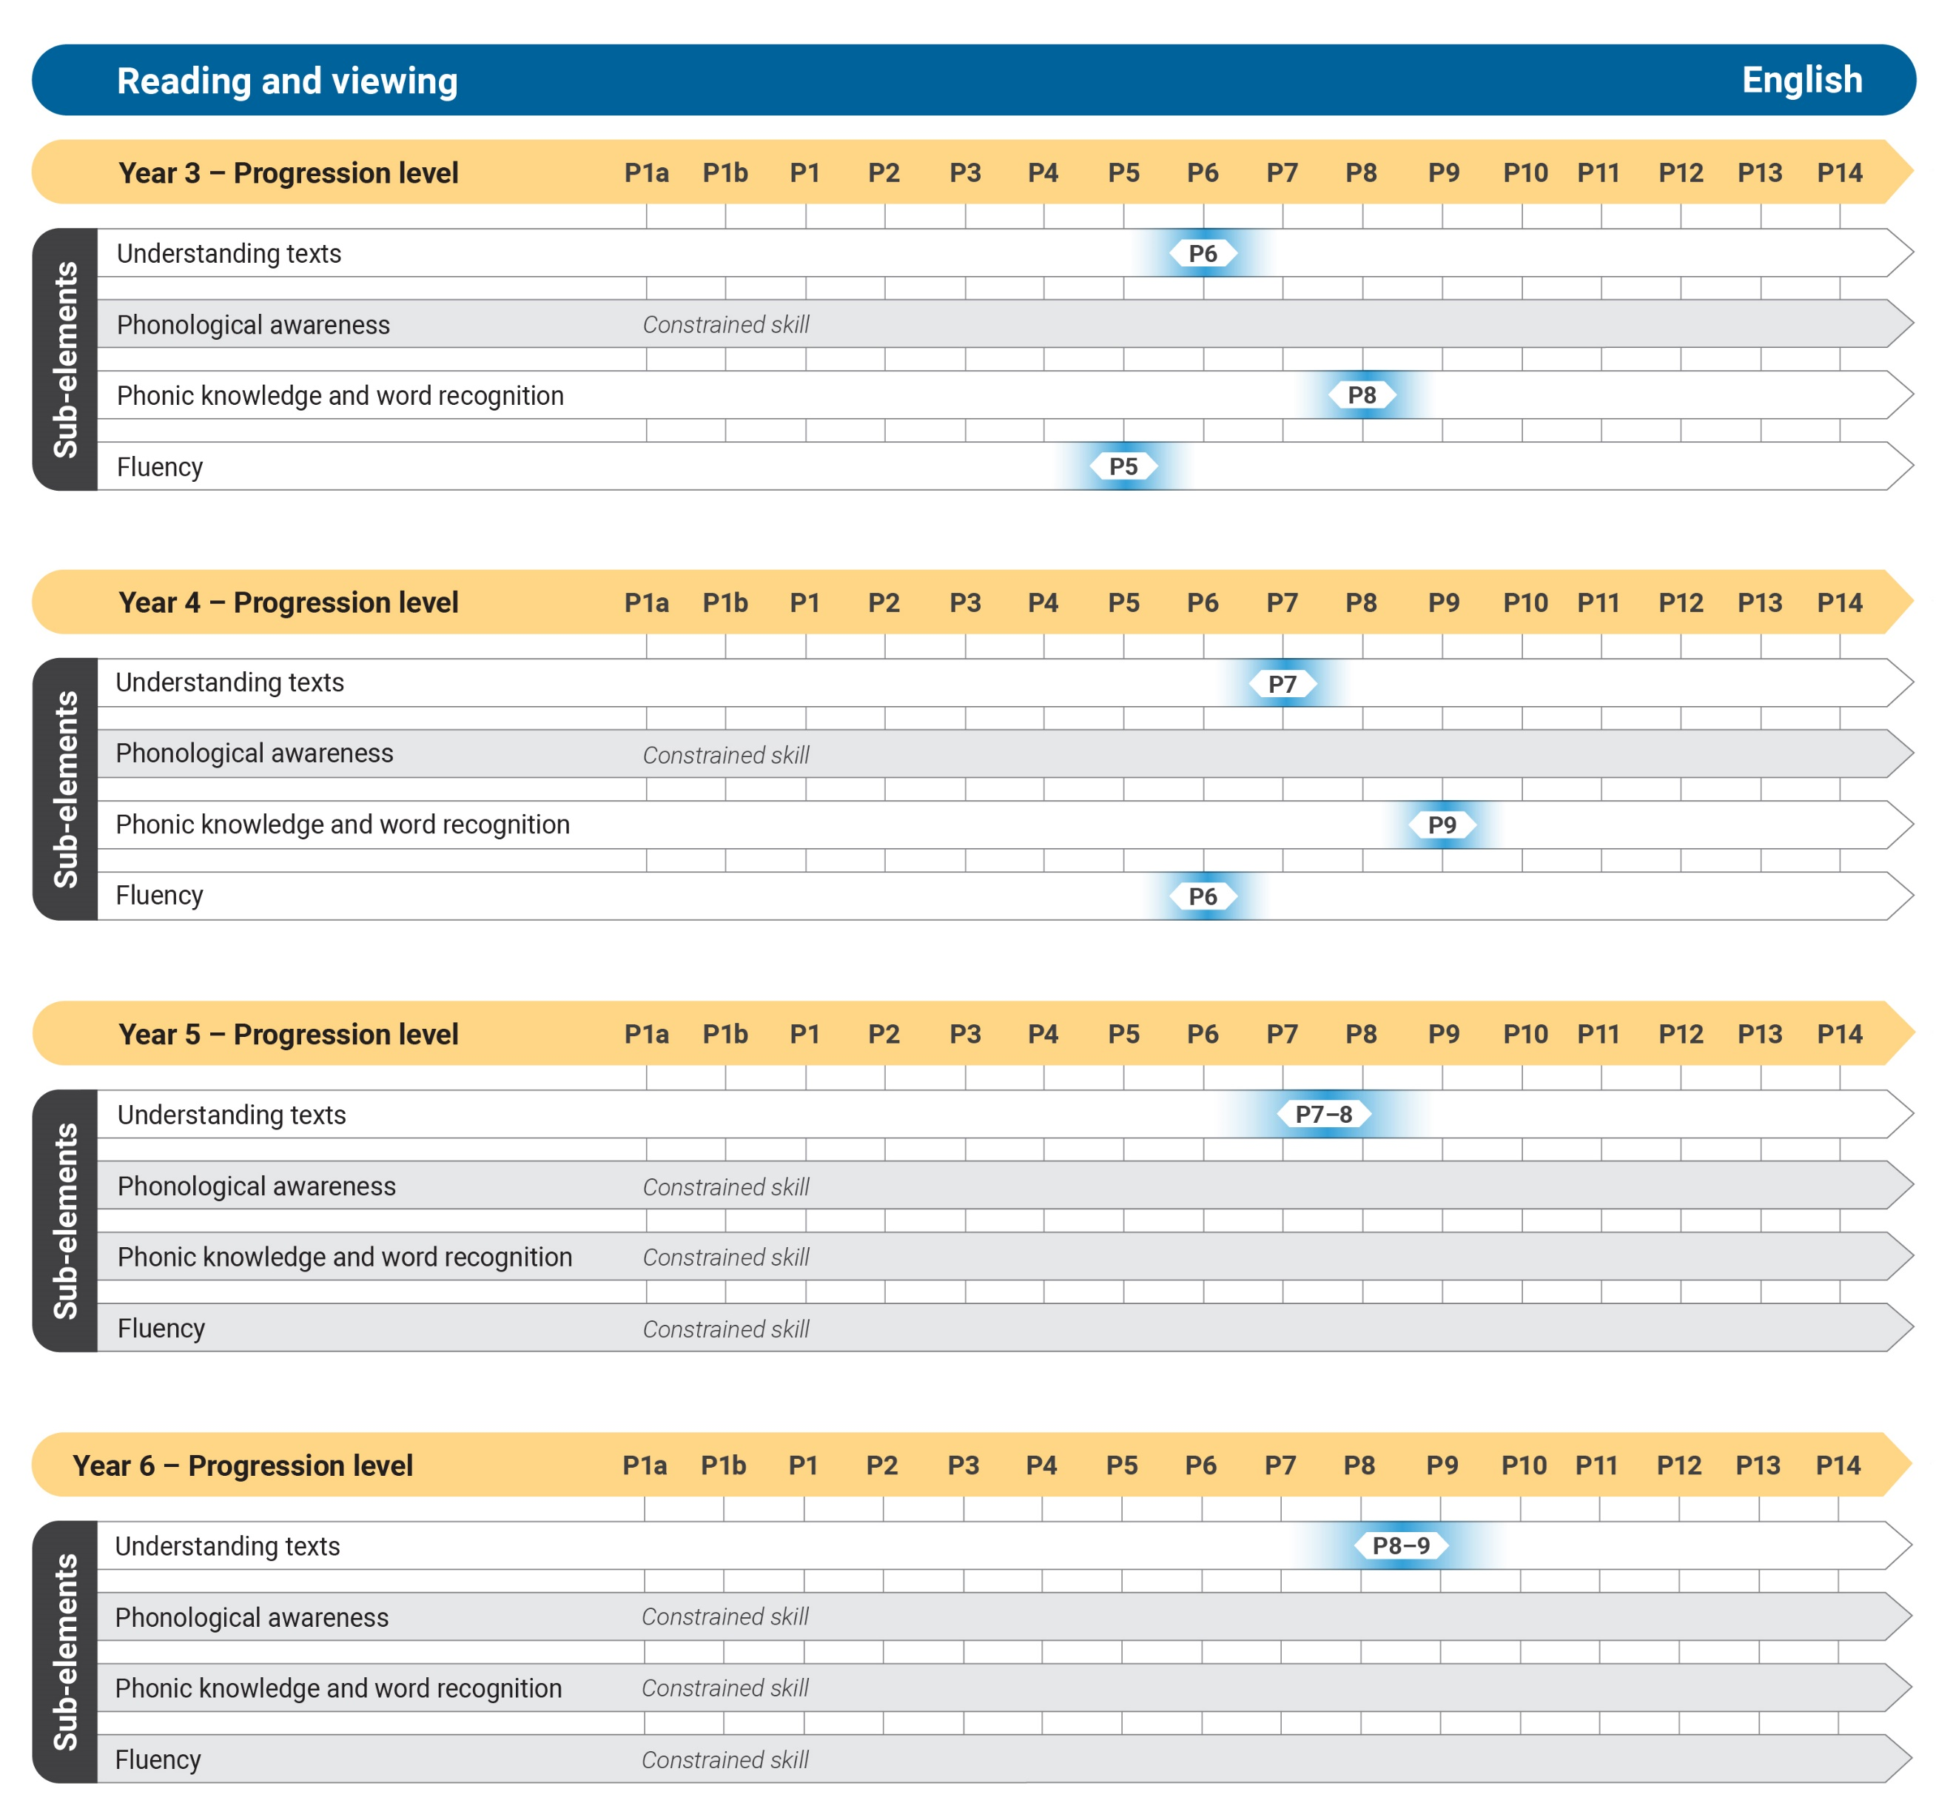

*Figure 6:  Reading and viewing Years 3–6*

Figure 7 represents the alignment of the Reading and viewing sub-element Understanding texts with the Australian Curriculum: English Years 7–10 levels. Most students moving into secondary school have achieved all the levels of the constrained skills, such as Phonological awareness, which are associated with learning to read. The emphasis in secondary school is reading to learn. There are often multiple Literacy learning progression levels within an English curriculum year level and the progression levels may span across year levels of the curriculum. The number of progression levels is determined by the research evidence and is not the same for each sub-element.

*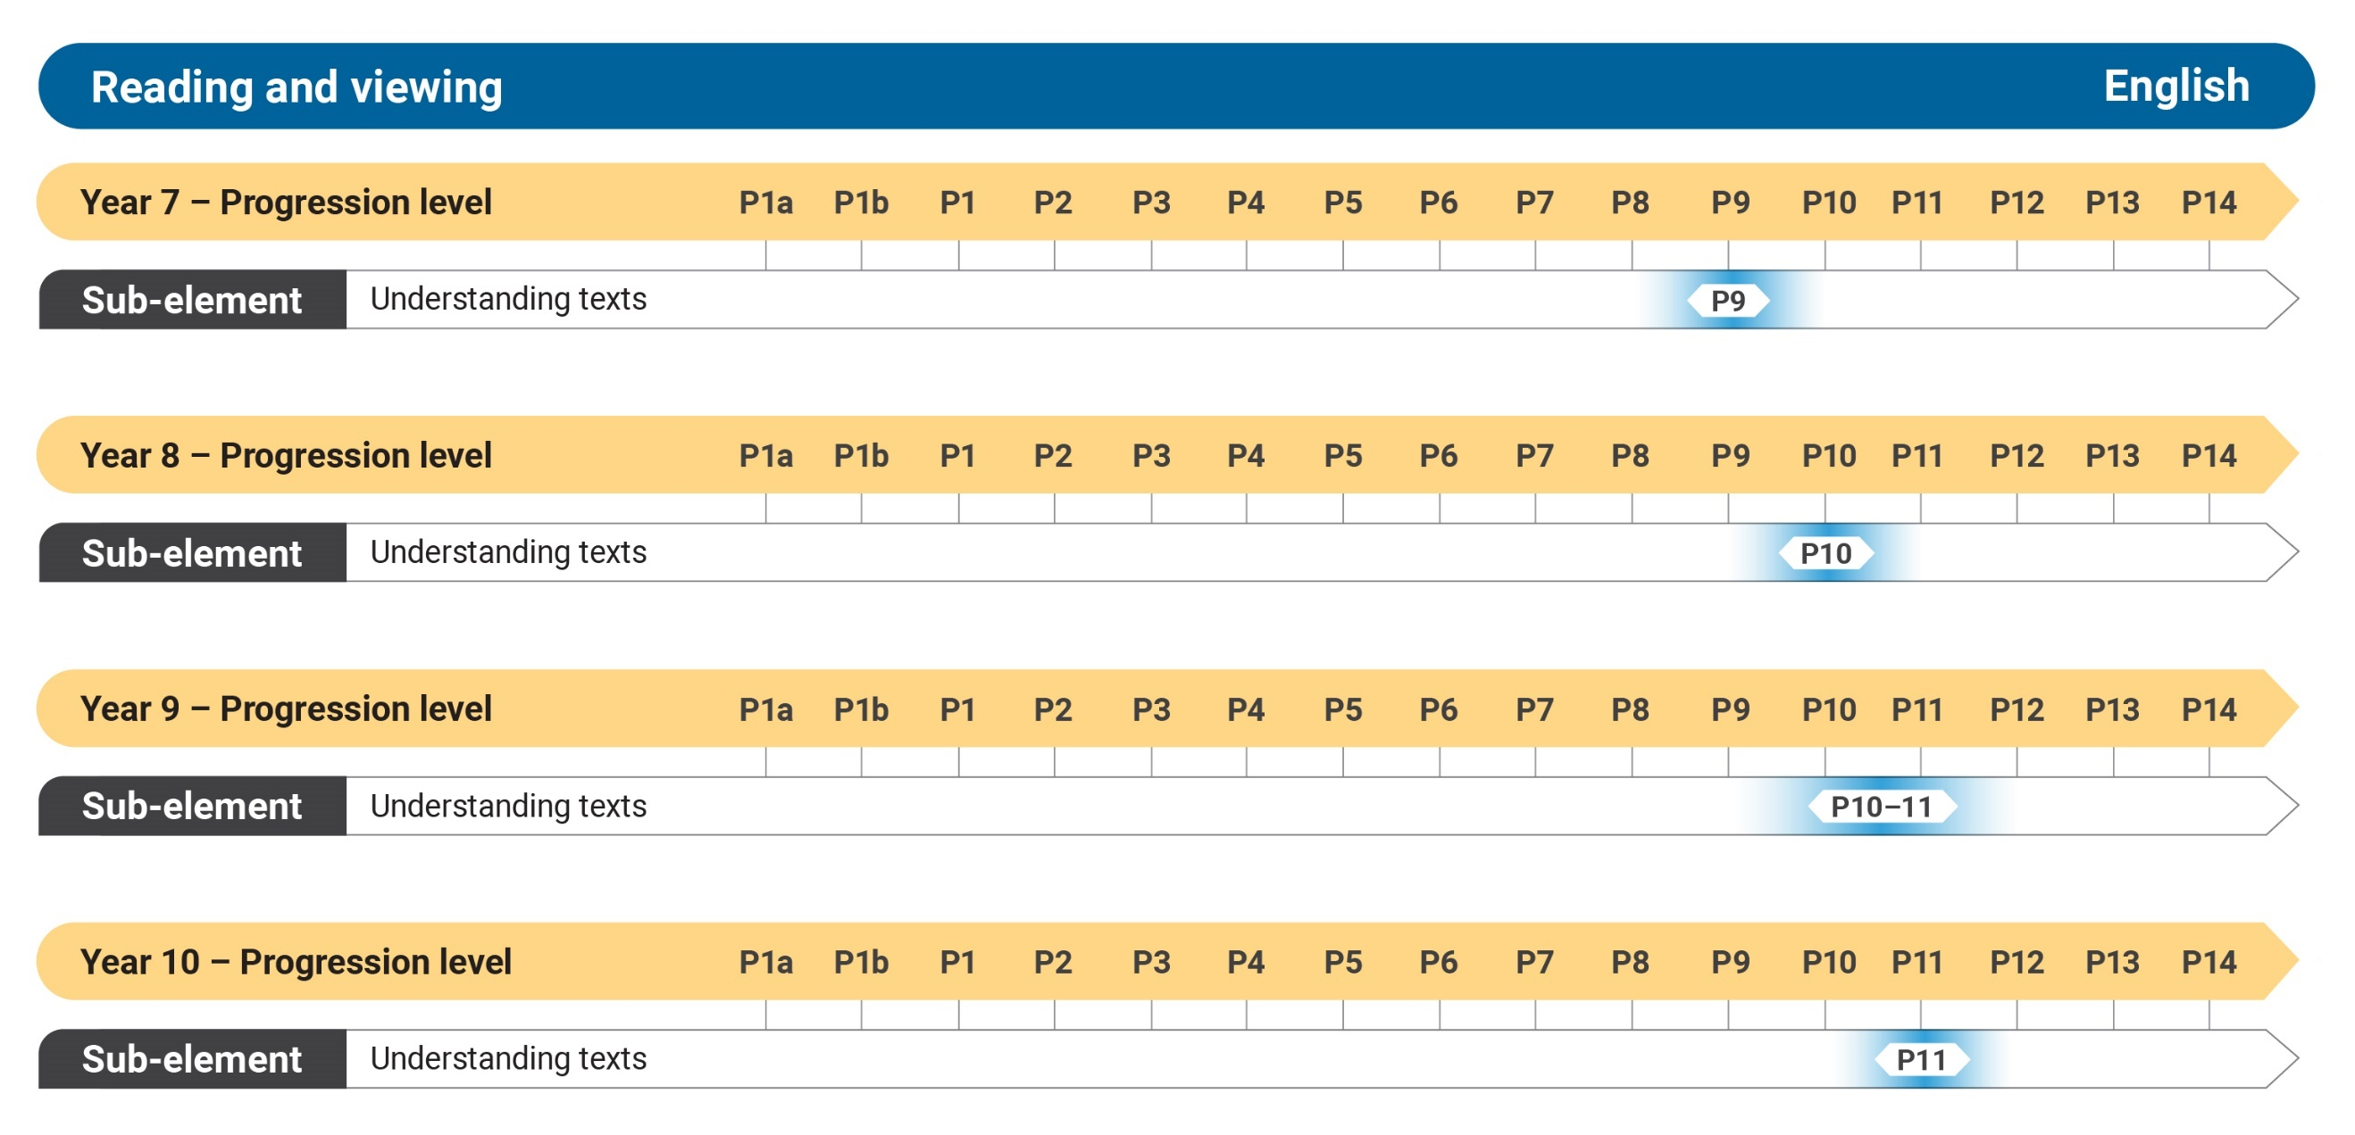Figure 7: Reading and viewing Years 7–10*

WRITING

The Writing element includes 5 sub-elements.

These sub-elements are:

* Creating texts
* Grammar
* Punctuation
* Spelling
* Handwriting and keyboarding

Creating texts

This sub-element describes how a student becomes increasingly proficient at creating texts for a range of purposes and audiences across learning areas. Students’ writing moves from representing basic concepts and simple ideas to conveying abstract concepts and complex ideas, in line with the demands of the learning areas. Creating texts is a holistic sub-element, which is supported by the other sub-elements in the Writing elements.

Grammar

This sub-element describes how a student becomes increasingly proficient at creating coherent and cohesive, grammatically accurate written texts. Students develop control over grammar at the whole text, sentence and word group level.

Punctuation

This sub-element describes how a student becomes increasingly proficient at using correct punctuation to ensure clarity and ease of reading in the texts they create. As students write more complex and technical texts, they will use increasingly complex punctuation to support meaning.

Spelling

This sub-element describes how a student becomes increasingly proficient in selecting and arranging letters to form accurately spelt words, to ensure written texts are clear and easily understood. Students develop increasing skill and knowledge in using spelling as a tool to understand and create meaning in texts. At higher levels of the progression, students monitor their own spelling and explain how spelling affects meaning.

Handwriting and keyboarding

This sub-element describes how a student uses handwriting and keyboarding skills with increasing speed, accuracy and fluency, to compose and edit texts. It describes how a student develops a fluent, legible handwriting style, beginning with unjoined letters and transitioning to joined handwriting.

The following diagrams demonstrate the alignment of the Australian Curriculum: English with the Writing sub-elements.

Figure 8 represents the alignment of the Writing sub-elements (Creating texts, Handwriting and keyboarding, Punctuation, Grammar and Spelling) with the Australian Curriculum: English Years F–2 levels. There are often multiple Literacy learning progression levels within an English curriculum year level and the progression levels may span across year levels of the curriculum. The number of progression levels is determined by the research evidence and is not the same for each sub-element.

The levels P1a–P1b, marked with an asterisk, address aspects of early reading that students would commonly achieve prior to starting school.

*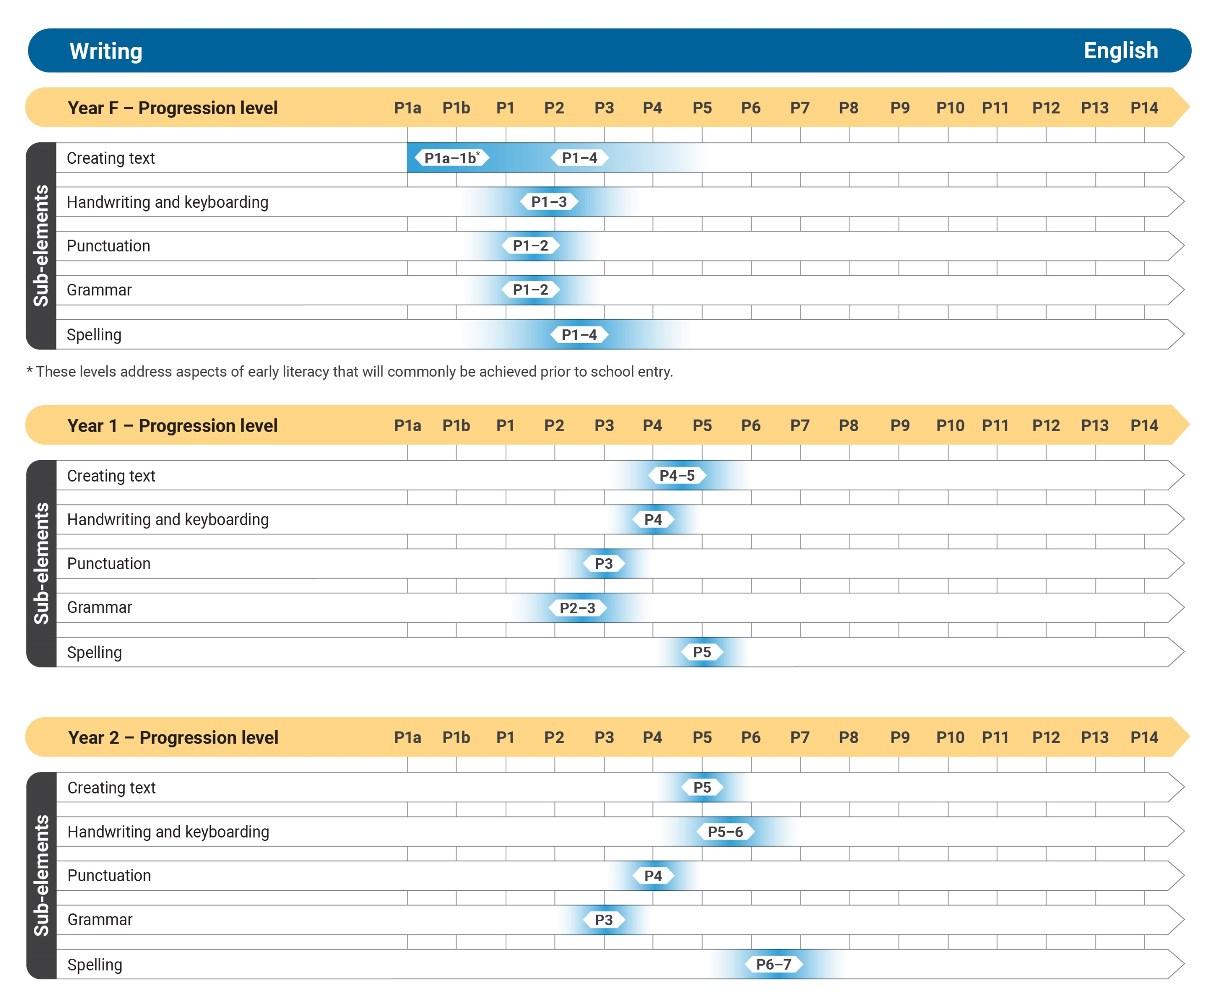Figure 8: Writing Years F–2*

Figure 9 represents the alignment of the Writing sub-elements (Creating texts, Handwriting and keyboarding, Punctuation, Grammar and Spelling) with the Australian Curriculum: English Years 3–6 levels. There are often multiple Literacy learning progression levels within an English curriculum year level and the progression levels may span across year levels of the curriculum. The number of progression levels is determined by the research evidence and is not the same for each sub-element.

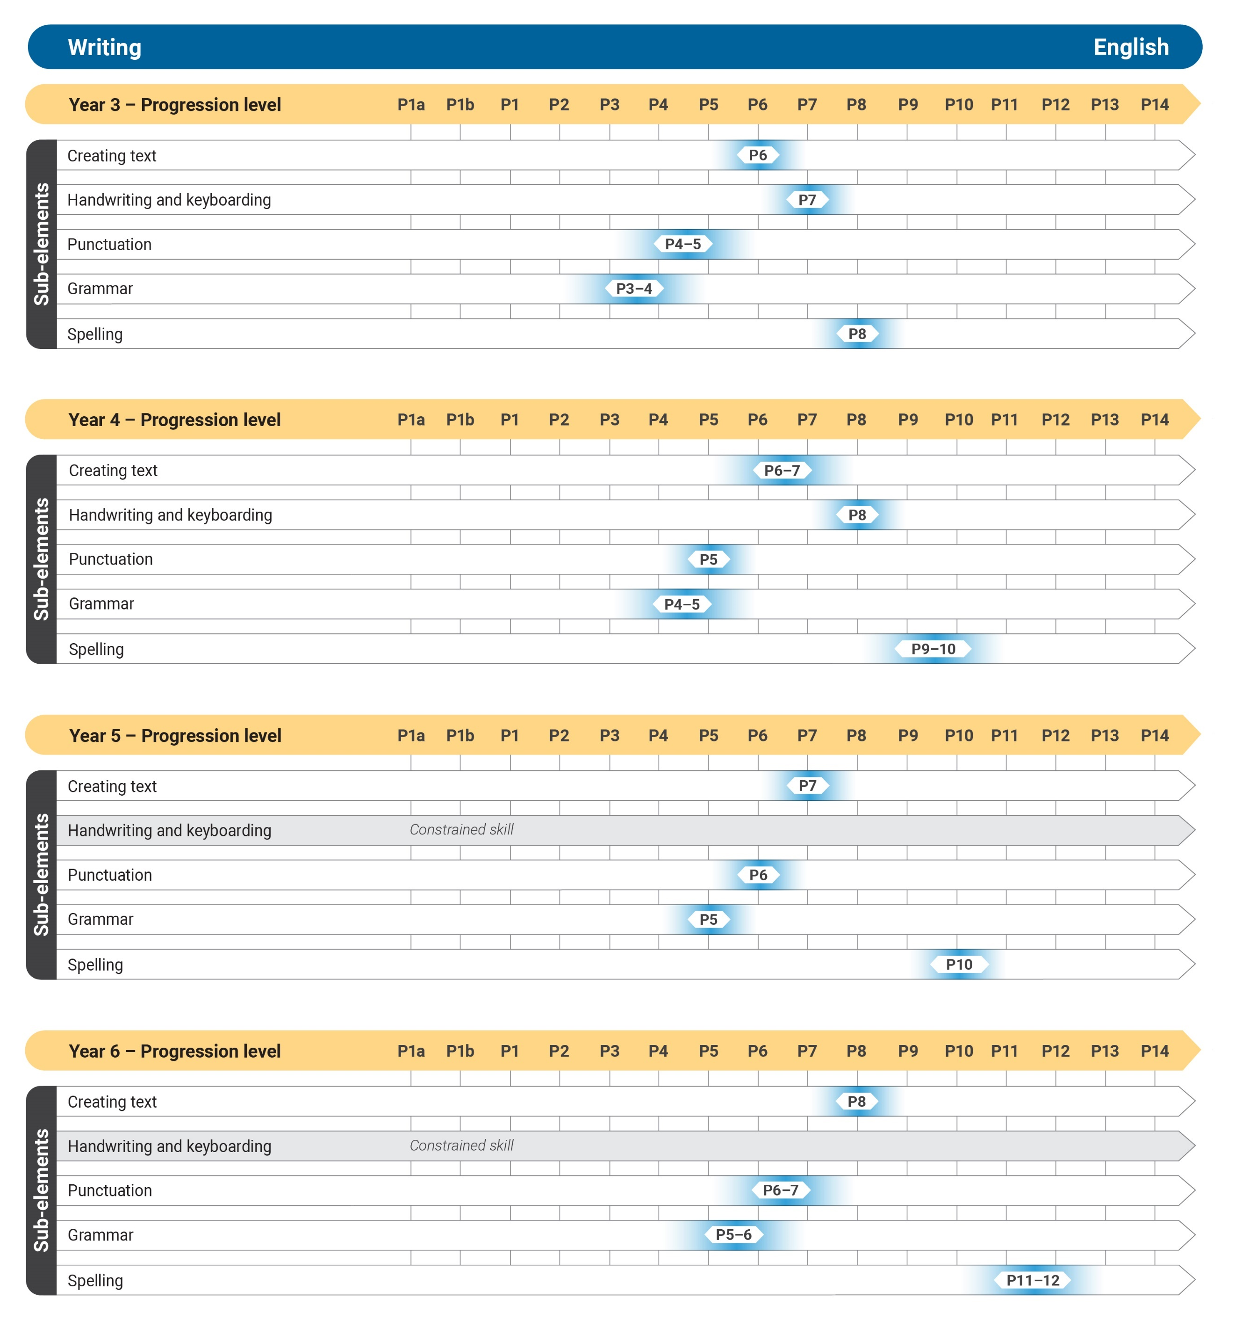Figure 9: Writing Years 3–6

Figure 10 represents the alignment of the Writing sub-elements (Creating texts, Handwriting and keyboarding, Punctuation, Grammar and Spelling) with the Australian Curriculum: English Years 7–10 levels. Most students moving into secondary school have achieved all the levels of the constrained skills, such as Handwriting and keyboarding, which are associated with learning to write. By Year 9 most students have also achieved all the levels of the sub-elements of Punctuation, Grammar and Spelling. Students are applying these to achieve the 2 highest levels of Creating texts: P10 and P11. There are often multiple Literacy learning progression levels within an English curriculum year level and the progression levels may span across year levels of the curriculum. The number of progression levels is determined by the research evidence and is not the same for each sub-element.

*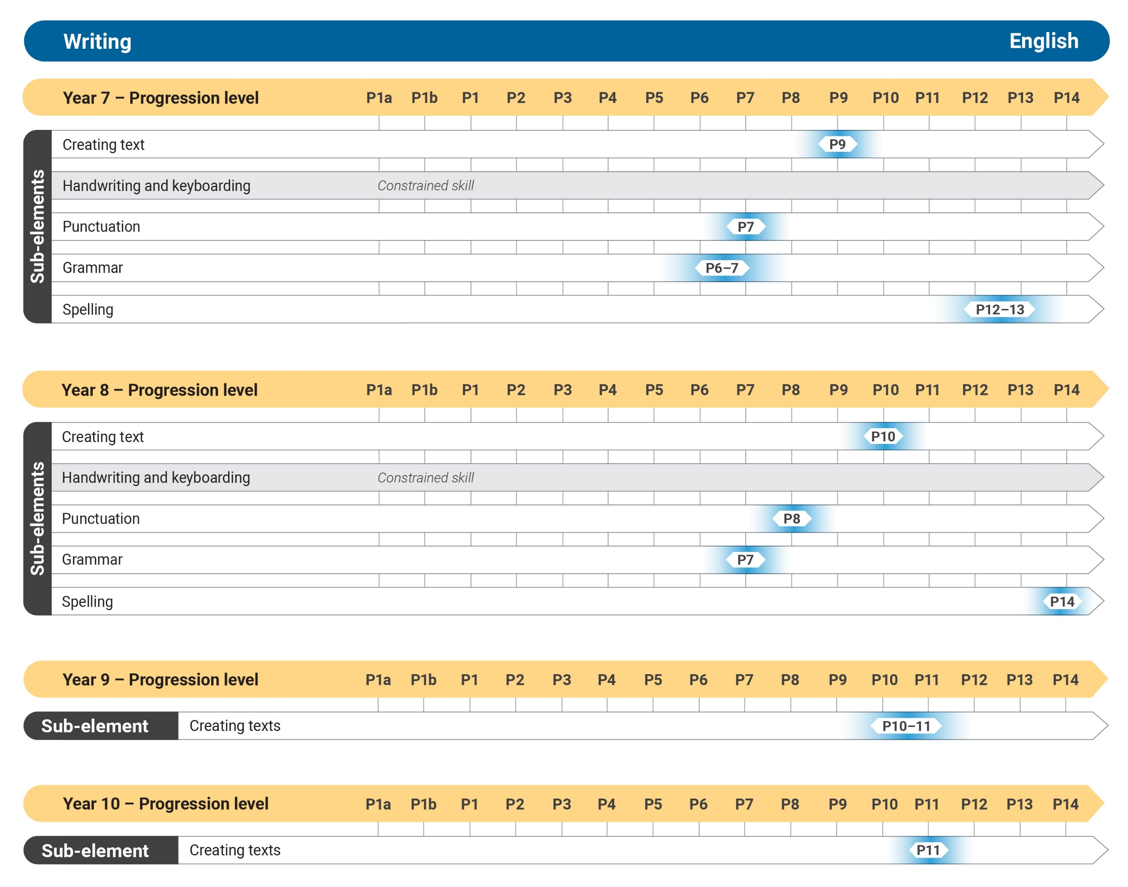Figure 10: Writing Years 7–10*

Appendix 1: Literacy learning progression

Speaking and listening

|  |  |
| --- | --- |
| Listening | |
| **Level** | **Indicators** |
| **P1a** | * shows interest in familiar people, events and activities (e.g. tracks the speaker's movements, turns head in the direction of a speaker) |
| **P1b** | * responds consistently to social interactions with familiar people (see *Interacting*) * uses informal responses, which can include vocalising, moving and touching (e.g. touches a target object in response to a question or directive) (see *Interacting*) |
| **P1** | * responds to a familiar, simple text structure (e.g. indicates yes or no when asked a commonly recurring question such as "Are you hungry?") (see *Speaking*) * uses conventional behaviours to respond, which can include speech, formal gestures and actions (e.g. head nodding and pointing) |
| **P2** | * responds to short spoken texts relying on key words, obvious cues, tone of voice and intonation * follows a simple command * repeats familiar words heard in a text or conversation |
| **P3** | * listens actively and responds to short texts of a few sentences * recalls one or 2 ideas from a short text or interaction * answers simple or literal questions * asks what, when and why questions about a text they have listened to * uses facial expressions, gestures or actions to indicate understanding of tone and intonation * discriminates individual words in a short, spoken sentence (e.g. identifies “lunchtime” in “the meeting for the excursion is at lunchtime”) * describes familiar objects and actions heard in a text or interaction (e.g. “the chicken ate the bug”) * accurately repeats short phrases and statements from a short text or interaction * recognises and generates one-syllable rhyming words (see *Phonological awareness*) |
| **P4** | * responds to simple and elementary texts * recalls specific information from a spoken text (e.g. recalls a message from a school assembly announcement) * answers literal and simple inferential questions from a text they have listened to * infers obvious meaning from a simple, spoken text (e.g. identifies a character’s job as a sales assistant from their dialogue with a shopper) * experiments with a small range of listening strategies (e.g. asks speaker to repeat information, if unclear) * uses learnt vocabulary and simple adjectives to recount key ideas from heard text |
| **P5** | * responds to elementary texts * listens purposefully to texts to identify specific learning area content * recalls specific information from a learning area text * attends to sequence when recounting ideas * infers meaning that may be less obvious (e.g. infers beach context from hearing background sounds of seagulls and surf) * describes tone and intonation of spoken text (e.g. “she spoke with an angry tone”) * retells a familiar story with some possible minor adaptations * selects appropriate listening strategies (e.g. asking questions to elicit extra information, rephrasing others’ contributions to check own comprehension) * listens for cohesive vocabulary to support comprehension (e.g. listens for temporal connectives such as “first”, “then”, “finally”, and conjunctions such as “also” to identify the next section in text) |
| **P6** | * responds to moderately complex texts (see *Text complexity*) * responds to texts with unfamiliar content * identifies main ideas of a spoken text using supporting details * identifies purpose and intended audience of a spoken text * infers layered meaning from texts (e.g. musical overlay that creates mood) * asks relevant questions to extend understanding * describes language and audio features of the text |
| **P7** | * responds to complex texts (see *Text complexity*) * identifies and analyses how spoken language is used for different effects * explains the use of intonation, pausing, rhythm and phrasing to give emphasis and weight to ideas * selects appropriate listening strategies for planned and unplanned situations (e.g. records and organises information from a text in a table or with detailed notes) * explains how vocabulary is used for impact on the target audience |
| **P8** | * responds to highly complex texts (see *Text complexity*) * identifies and paraphrases key points of a speaker’s arguments * describes how listening skills should be applied, according to purpose * evaluates strategies used by the speaker to elicit emotional responses * explains any shift in direction, line of argument or purpose made by the speaker * adopts and re-uses complex abstractions heard in texts * explains how speakers’ language can be inclusive or alienating (e.g. a speaker using language that is only readily understood by certain user groups, such as teenagers or people involved in particular pastimes) |

|  |  |
| --- | --- |
| Interacting | |
| **Level** | **Indicators** |
| **P1a** | * interacts using informal behaviours to express a feeling or need (e.g. vocalising, moving, using facial expressions) |
| **P1b** | * interacts purposefully with familiar people (e.g. to refuse or request) |
| **P1** | * shares simple ideas with peers * responds to questions in class discussion using non-verbal responses (e.g. nodding) * listens without interrupting (see *Listening*) * uses home language or dialect to interact with familiar peers and adults |
| **P2** | * contributes simple ideas and opinions to class or small group discussions * shows signs of active listening by sustaining attention across a short, spoken text * shows beginning awareness of discussion conventions (e.g. pauses when another speaker starts) * uses appropriate language or dialect to interact with speakers of the same language |
| **P3** | * listens actively to stay on topic in a small group discussion * takes an active role in small group and whole-class discussion by volunteering ideas and opinions * asks relevant questions for clarification or to find out others’ ideas (e.g. “What do you think about that?”) * takes turns in interactions * interacts using appropriate language in pairs or a small group to complete tasks |
| **P4** | * interacts to extend and elaborate ideas in a discussion (e.g. provides an additional example) * presents simple ideas clearly in group situations * actively encourages or supports other speakers * shows awareness of discussion conventions (e.g. uses appropriate language to express agreement and disagreement in class discussions) * uses language to initiate interactions in a small group situation (e.g. “I have an idea”) |
| **P5** | * critically evaluates ideas and claims made by a speaker * explains new learning from interacting with others * appropriately presents an alternative point to the previous speaker * initiates interactions confidently in group and whole-class discussions * poses pertinent questions to make connections between a range of ideas * uses open questions to prompt a speaker to provide more information * clarifies task goals and negotiates roles in group learning * monitors discussion to manage digression from the topic * identifies and articulates the perspective of a speaker, to move a conversation forward |
| **P6** | * interacts within school context or the broader community, adjusting language and responses to suit purpose and audience * synthesises ideas from group discussion into a common theme or hypothesis * poses problems, hypothesises and formulates questions about abstract ideas in group situations * restates different views and makes suggestions to negotiate agreement * poses questions to clarify assumptions made by the speaker * questions others to evaluate accuracy of thinking or problem-solving processes * uses language to align the listener with personal position (e.g. “of course”, “as you can imagine”, “obviously”) |
| **P7** | * interacts strategically and confidently with a broad range of interactional partners * gives an extended explanation and evaluation of a complex concept, issue or process * justifies a personal stance, after analysis of arguments on a particular issue, using evidence and elaboration in a group situation * uses language strategically to subtly align others to their own perspective as appropriate to audience and purpose |

|  |  |
| --- | --- |
| Speaking | |
| **Level** | **Indicators** |
| **P1a** | * uses vocalisation, body movement or facial expressions in response to personal feelings and sensory experiences (e.g. looks pleased to be sitting in a particular place) |
| **P1b** | * uses informal responses to indicate a single message with familiar people in familiar environments (e.g. smiles when dinner is served and pushes away unwanted food) (see *Interacting*) |
| **P1c** | * uses conventional behaviours to communicate intentionally with familiar people in different contexts (e.g. single words, gestures, pictorial representations) (see *Interacting*) |
| **P1** | **Crafting ideas**   * speaks in short phrases or simple sentences about familiar objects, people or events * uses simple language to express feelings and needs (e.g. “I’m thirsty”: “Can I have a pencil?”) * indicates a preference when offered a choice (e.g. selects a piece of fruit from a bowl) * uses simple, appropriate personal greetings   **Vocabulary**   * uses a small range of familiar words * names common items from the environment or pictures * uses mainly correct word order in simple sentences |
| **P2** | **Crafting ideas**   * retells personal events and experiences to peers and known adults * shares feelings and thoughts about the events and characters in text * retells key details or points from a learning experience or text viewed or heard * uses mainly appropriate word order * uses appropriate volume for small audiences * uses rehearsed phrases to introduce themselves (e.g. “Good morning, my name is …”)   **Vocabulary**   * uses simple connectives to join ideas (e.g. “and then”) (see *Grammar*) * uses familiar spoken language to communicate connected ideas (e.g. “Let's draw. I'll get paper and pencils.”) * uses simple adjectives and adverbs to add detail (e.g. “yellow”, “quickly”) (see *Grammar*) * uses a small range of qualifying adjectives (e.g. “nice”, “good”) (see *Grammar*) * uses simple language to compare and contrast (e.g. “smaller”, “more”) * uses common time and causal connectives to relate ideas (e.g. “then”, “because”) (see *Grammar*) |
| **P3** | **Crafting ideas**   * creates short texts, using a few connected sentences, on familiar and learnt topics (e.g. retells a familiar story or describes a process) * speaks audibly and clearly to a familiar audience (e.g. own class) * uses some extended sentences * organises key ideas in logical sequence * provides some supporting details * expresses causal relationships (e.g. “when the egg cracked, the chicken came out”) * provides simple justifications (e.g. “I chose cherries because they are red.”) * uses some varying intonation or volume for emphasis * regulates pace with pausing   **Vocabulary**   * uses some precise vocabulary from learning areas * uses connectives to sequence ideas (e.g. “first”, “then”, “next”, “finally”) (see *Grammar*) * uses vocabulary to express cause and effect (e.g. “The excursion was cancelled because it rained.”) * uses some modal language to influence or persuade (e.g. “should”, “will”) (see *Grammar*) |
| **P4** | **Crafting ideas**   * creates spoken texts for a range of purposes across learning areas (e.g. explains how the mathematics problem was solved) * uses complex sentence constructions including relative clauses (e.g. “The boy who drew the picture got a prize.”) (see *Grammar*) * adjusts register according to purpose and audience * elaborates on ideas, using a short sequence of sentences * incorporates learnt content into spoken text * sequences ideas and events appropriately * uses mainly correct grammatical constructions (e.g. pronoun references, noun–verb agreement) * varies volume and intonation to suit purpose and audience * plans and delivers spoken presentations using appropriate structure  and language * includes video and audio enhancements to spoken texts, where appropriate (e.g. includes slides or pictures in a spoken presentation)   **Vocabulary**   * experiments with vocabulary drawn from a variety of sources * uses adverbials to give more precise meaning to verbs (e.g. talking loudly) (see *Grammar*) * uses a range of vocabulary to indicate connections (e.g. consequences) * uses conditional vocabulary to expand upon ideas (e.g. “If Goldilocks ate all the porridge, the bears would be hungry.”) |
| **P5** | **Crafting ideas**   * creates detailed spoken texts on a broad range of learning area topics * includes details and elaborations to expand ideas * uses connectives to signal a change in relationship (e.g. “however”, “although”, “on the other hand”) or to show causal relationships (e.g. “due to”, “since”) (see *Grammar*) * uses a range of expressions to introduce an alternative point of view (e.g. “in my opinion”, “he did not agree with”) * rehearses spoken text to accommodate time and technology * controls tone, volume, pitch and pace to suit content and audience * uses technologies or audio and visual features to enhance spoken text (e.g. videos a spoken presentation with music, sound effect enhancements)   **Vocabulary**   * uses a broader range of more complex noun groups/phrases to expand description (e.g. “protective, outer covering”) * selects more specific and precise words to replace general words (e.g. uses “difficult” or “challenging” for “hard”) * uses some rhetorical devices (e.g. “don’t you agree?”) |
| **P6** | **Crafting ideas**   * creates spoken texts responsive to audience and a broad range of learning area topics, clearly articulating words and ideas * organises more complex ideas or concepts logically, selecting details to accentuate key points * speaks audibly and coherently to a less familiar audience for a sustained period * shows increasing awareness of audience by moderating length, content and delivery of spoken texts * adjusts register according to purpose and audience * does research to prepare spoken texts * uses a range of technology, and audio and visual resources to engage audience and enhance content   **Vocabulary**   * varies vocabulary to add interest and to describe with greater precision (e.g. uses topic-specific noun groups/phrases such as “exploitation of resources”) (see *Grammar*) * uses language creatively (e.g. “the moon shines bravely”) * uses sensory vocabulary to engage the audience (e.g. “a gasp of dismay”) * uses technical vocabulary to demonstrate topic knowledge (e.g. “deforestation”) * consistently uses a range of synonyms to add variety and precision to  spoken text * uses abstractions (e.g. “freedom”, “fairness”) |
| **P7** | **Crafting ideas**   * creates spoken texts that explore and interpret concepts drawn from research or learning area content * selects voice appropriate to purpose (e.g. third person to create distance and authority or first person to achieve personal connection) * develops complex ideas or a central theme across a spoken text * uses language features according to purpose, to impact the audience (e.g. uses more complex connectives such as “consequently”, “accordingly” to explain) * rephrases or clarifies to repair or refine meaning * uses language structures and features appropriate to learning area content * uses technologies, and visual and audio resources to enhance meaning and effect in presentations   **Vocabulary**   * selects vocabulary to intensify and sharpen the focus (e.g. “scarcely”, “absolutely”, “real”, “simply”) * uses a range of evaluative language to express opinions or convey emotion (e.g. “significant benefits”, “devastating consequences”) * uses a range of emotive language appropriate to topic, purpose and audience * uses rich, evocative, descriptive language * uses figurative language (e.g. “hungry for success”) |
| **P8** | **Crafting ideas**   * creates complex and creative spoken texts, which analyse and evaluate issues drawn from research or learning area content * includes a range of alternative viewpoints in spoken texts, where appropriate * controls and manipulates a sophisticated range of language features to affect the audience * uses a range of rhetorical devices and humour to engage an audience * references and quotes authorities or statistics to add authority (e.g. “according to a recent OECD report”) * delivers spoken text flexibly, allowing for questions and maintaining the flow of ideas |

Reading and viewing

|  |  |
| --- | --- |
| Phonological awareness | |
| **Level** | **Indicators** |
| **P1** | * participates in rhymes, chants and songs, including in home language or dialect (see *Listening*) * echoes modelled phonemes and pairs of rhyming words e.g. repeats single phonemes such as /a/ and single-syllable rhyming words such as “in” and “tin” * completes familiar phrases in texts including chants, songs and poems |
| **P2** | * segments a short, spoken sentence of 3 to 5 words into separate spoken words * orally blends and segments words with 2 and 3 syllables (e.g. “hopp-‑ing”, “fam-‑I-‑ly”) * orally blends initial consonants with following letters to say one-syllable words (e.g. “m/um” = “mum”, “h/at” = “hat”, “sh/o p” = “shop”) * provides a word when given a starting phoneme (e.g. “p” – “picture”) * consistently says the first phoneme of a spoken word (e.g. “good” – “g”) * listens and identifies rhyming words from a choice of up to 4 one-syllable words (e.g. “sing”, “thing”, “dog”, “wing”) * listens to a group of words, indicates those that start with the same phoneme and says other words that start with that phoneme |
| **P3** | * orally blends 2 or 3 phonemes together to make a one-syllable word (e.g. “a‑sh”, “s‑u‑n”, “b‑i‑n”, “sh‑i‑p”) * orally segments words of 2 or 3 phonemes into separate phonemes (e.g. “c‑a‑t”, “s‑u‑n”, “k‑i‑ck”) * identifies the number of phonemes that make up a spoken one-syllable word comprised of less than 4 phonemes * identifies first and final phoneme in a word |
| **P4** | * orally blends 4 phonemes together to make a one-syllable spoken word (e.g. “s-t-o-p” – “stop”) * orally segments spoken words comprised of 4 phonemes into separate phonemes (e.g. “fresh” – “f‑r‑e‑sh”) * identifies the number of phonemes that make up a spoken, one-syllable word comprised of less than 5 phonemes * identifies the vowel phoneme in single-syllable words |
| **P5** | * says the new word when asked to delete an initial phoneme (e.g. “cat” becomes “at”) * says the new word when asked to add an initial phoneme (e.g. “all” becomes “ball”) * says the new word when asked to substitute an initial phoneme (e.g. “cat” becomes “bat”) * says the new word when asked to delete a final phoneme (e.g. “puppy” becomes “pup”) * says the new word when asked to add a final phoneme at (e.g. “me” becomes “meet”) * says the new word when asked to substitute a final phoneme (e.g. “bet” becomes “bell”) * says the new word when asked to substitute a medial phoneme (e.g. “mat” becomes “met”) |

|  |  |
| --- | --- |
| Phonic knowledge and word recognition | |
| **Level** | **Indicators** |
| **P1** | **Word recognition**   * indicates words and letters in a variety of situations in the environment (e.g. in written texts, on a whiteboard) (note: not required to read the word or say the sound or name of the letter) |
| **P2** | **Word recognition**   * identifies pictures, words, and spaces between words and numerals in texts (e.g. points to/indicates pictures, words and spaces around words in a continuous text) * recognises some familiar words and identifies them in environmental print (e.g. labels, shop names, street signs) * identifies own name or familiar names when presented in written form * distinguishes own name from a small number of alternative words * identifies 2 or more letters that are the same in 2 words (e.g. “bird”, “red”) |
| **P3** | **Phonic knowledge**   * says the most common phoneme for taught single-letter graphemes (e.g. “Tt”, “Mm”, “Ss”) * identifies and names letters for taught single-letter graphemes * blends phonemes for taught single-letter graphemes to decode vowel–consonant (VC) words (e.g. “at”) and consonant–vowel–consonant (CVC) words (e.g. “hop”) * identifies first phoneme in words * orally segments CVC words (e.g. “c-a-t”, “h-a-t”) * recognises taught graphemes when represented in various fonts, capitals and lower-case (e.g. “Aa”, “Rr”, “Dd”)   **Word recognition**   * reads taught high-frequency words in a text and in the environment (e.g. “the”, “to”, “I”, “no”, “said”) |
| **P4** | **Phonic knowledge**   * says the most common phoneme for all single-letter graphemes * identifies and names letters for all single-letter graphemes including those represented in various letter styles, capitals and lower-case (e.g. “Bb”, “Gg”) * writes/selects corresponding graphemes for all common phonemes * blends phonemes for all common, single-letter graphemes to read VC words (e.g. “in”) and CVC words (e.g. “pan”) and applies this knowledge when reading decodable texts * segments and writes VC and CVC words with letters in correct order and reads them aloud * reads single-syllable words with common double consonants and applies this knowledge when reading decodable texts (e.g. “ss” – “fuss”, “ll” – “will”, “ff” – “puff”)   **Word recognition**   * reads an increasing number of taught high-frequency words in decodable texts and own writing (e.g. “was”, “you”, “one”, “said”, “have”, “were”) |
| **P5** | **Phonic knowledge**   * gives examples of phonemes that can be represented by more than one consonant (e.g. “ck”, “ph”) * blends phonemes for all common, single-letter graphemes to read consonant–consonant–vowel–consonant (CCVC) words (e.g. “blot”), consonant–vowel–consonant–consonant (CVCC) words (e.g. “list”) and applies this knowledge when reading decodable texts * reads words with split digraphs (e.g. “cake”, “blame”) * reads single-syllable words with taught consonant digraphs and applies this knowledge when reading decodable texts (e.g. “sh”, “ch” and “ck” – “sh‑i‑p”, “r‑i‑ch”, “l‑o‑ck”) * reads words with taught common vowel graphemes (e.g. “ee”, “ea”, “ie”, “-e” and including “-y”) and applies this knowledge when reading decodable texts * reads one- and two-syllable words with common suffixes (e.g. “-‑ed”, “-‑ing”, “-‑s/es”) and applies this knowledge when reading decodable texts (e.g. “jumping”, “boxes”) * segments and represents CCVC and CVCC words containing consonant digraphs and/or clusters of consonants (e.g. “ch-‑o-p”, “w-‑i‑-‑sh”, “b-e-‑s-‑t”)   **Word recognition**   * reads an increasing number of taught high-frequency words in decodable texts and different contexts (e.g. own writing, shared reading) |
| **P6** | **Phonic knowledge**   * reads words with taught vowel digraphs (e.g. “ee”, “oo”, “ay”, “ai”, “ea”, “oa”, “ow”) and applies this knowledge when reading decodable texts * reads and writes common, one- and two-syllable words with clusters of consonants (e.g. “plant”, “string”, “object”) * reads 2-syllable words with open or long vowel sounds when reading decodable texts (e.g. “label”, “project”, “even”)   **Word recognition**   * reads most common high-frequency words (e.g. 100 or more) in continuous text |
| **P7** | **Phonic knowledge**   * reads CCVCC words (e.g. “trust”), CCCVC words (e.g. “scrap”), CCCVCC words (e.g. “thrust”) and applies this knowledge when reading continuous texts * reads words with r-controlled vowel diagraphs “ar”, “er”, “or”, “ur”, “ir”, writes words accordingly and applies this knowledge when reading continuous texts (e.g. “ir” – “bird”, “er” – “sister”, “ar” – “card”, “ur” – “hurt”, “or” – “word”) * applies common phonic generalisations when reading continuous texts (e.g. soft “g” – “age”, hard “g” – “game”) * says and represents the new word when asked to delete a phoneme within an initial blend of a single-syllable word (e.g. “spat” – ”sat”) * reads multisyllabic words with common double graphemes and applies this when reading continuous texts (e.g. “ss” – “blossom”, “tt” – “letter”, “zz” – “fizzy”, “ff” – “offend”) * reads words with graphemes representing diphthongs when reading continuous texts (e.g. “ou” – “ground”, “ow” – “cow”, “oi” – “boil”)   **Word recognition**   * reads new words containing taught grapheme–phoneme correspondences in a variety of contexts without using obvious sounding-out strategies * reads high-frequency words within a continuous text accurately and without hesitation (see *Fluency*) |
| **P8** | **Phonic knowledge and word recognition**   * reads less common graphemes that contain alternative spellings for phonemes (e.g. /ch/tch/j/g/) and applies this knowledge when reading continuous texts * reads multisyllabic words, including those with prefixes and suffixes, and applies this knowledge when reading continuous texts (e.g. “in-‑“, “ex-‑“, “dis-‑“, “-‑ful”, “-‑able”, “-‑ly”) * reads words with silent letters in digraphs and applies this knowledge when reading continuous texts (e.g. “kn” – “knot”, “mb” – “lamb”) * reads multisyllabic words with more complex letter combinations and letter clusters (e.g. “-‑igh” – “right”, “-‑tion” – “station”, “-‑ough” – “cough”) |
| **P9** | **Phonic knowledge and word recognition**   * uses grapheme–phoneme knowledge and blending skills to read continuous texts containing multisyllabic, complex and unfamiliar words quickly and accurately (see *Understanding texts, Fluency*) |

|  |  |
| --- | --- |
| 5B5BFluency | |
| **Level** | **Indicators** |
| **P1** | * reads aloud decodable or familiar texts word by word, with emphasis on one-to-one matching * reads with some intonation and expression |
| **P2** | * reads decodable or familiar texts by phrasing 2 words at a time with some attention to expression |
| **P3** | * reads aloud a decodable or simple text at a reasonable pace, grouping words into meaningful phrases (see *Understanding texts*) * uses punctuation cues, and some intonation and expression * reads accurately at an efficient pace without overt sounding and blending |
| **P4** | * reads aloud an elementary text at a flowing pace, pausing to attend to more complex punctuation * uses effective intonation, stress and expression that indicate comprehension * maintains pace and accuracy when reading with an experienced reader * reads without finger tracing |
| **P5** | * reads aloud a range of moderately complex texts with fluency and phrasing, adjusting pace, volume, pitch and pronunciation to enhance meaning and expression * varies pace according to purpose and audience * reads aloud with expression that reflects the author’s purpose and meaning (see *Understanding texts*) |
| **P6** | * reads aloud a range of complex and highly complex texts, which include multisyllabic words and complex sentences, with fluency and appropriate expression * consistently and automatically integrates pausing, intonation, phrasing and rate |

|  |  |
| --- | --- |
| 6B6BUnderstanding texts | |
| **Level** | **Indicators** |
| **P1a** | * shows interest in familiar people, events and activities (e.g. tracks the speaker’s movements, turns head in the direction of the speaker) |
| **P1b** | * responds consistently to social interactions with familiar people * uses informal responses, which can include vocalising, facial expressions, gestures, moving and touching (e.g. touches a target object in response to a question or directive) |
| **P1** | **Comprehension**   * demonstrates interest in texts * recognises images in texts * recognises some icons or symbols from the environment (e.g. familiar logos)   **Vocabulary**   * names familiar objects in texts including texts in the environment (e.g. apple, table, boy) * names some familiar icons or symbols in the environment (e.g. school crossing sign) |
| **P2** | **Comprehension**   * answers simple literal questions about texts read by a proficient reader * repeats fragments of text * invents a spoken text based on images   **Processes**   * recognises symbols and words in texts (e.g. recognises own name) * distinguishes between print and images * shows awareness of correct orientation of text (e.g. holds the book or tablet the right way up) * imitates reading behaviour by turning pages, swiping the screen and inventing own version of the text   **Vocabulary**   * identifies familiar images in texts and comments by adding some detail (e.g. “the dog is wet”) |
| **P3** | **Comprehension**   * listens actively and responds to a range of texts read by others * makes a simple statement about the content of a text (e.g. “it was about the farm”) * engages in group discussion about a text or shared learning experience * talks about images and/or some printed words in a text * answers and poses mainly literal questions about the text * infers and then describes obvious cause and effect relationships (e.g. uses information in the text to infer why a character is smiling in an image)   **Processes**   * follows text direction when read to by a proficient reader * locates the front and back of a book and turns pages correctly * locates the starting point for reading on a page or screen * uses touch or click features to navigate a text (e.g. clicks arrows to move text along, uses pause/play button to start/stop text, clicks icons to view specific aspects of screen-based texts)   **Vocabulary**   * asks questions to find out meaning of unfamiliar words * uses words that have been encountered in simple texts |
| **P4** | **Comprehension**   * reads and views simple texts with support from a proficient reader (see *Text complexity*) * retells a familiar story or shared learning experience * contributes to group discussion, demonstrating understanding of a range of texts read by proficient readers * makes relevant comments or asks relevant questions to demonstrate understanding of a text * makes connections between texts and personal experiences   **Processes**   * uses some phonic and contextual knowledge to decode simple texts (see *Phonic knowledge and word recognition*) * decodes a few words in a text using phonic knowledge (see *Phonic knowledge and word recognition*) * identifies taught high-frequency words in a text (see *Phonic knowledge and word recognition*) * demonstrates one-to-one correspondence by pointing to words in a continuous text or in the environment (see *Phonic knowledge and word recognition*) * tracks text left to right * uses return sweep * consistently reads left page before right page * makes predictions (e.g. uses the cover of a book or screen image to predict the content) * identifies simple grammatical features (e.g. identifies verbs in a set of instructions) (see *Grammar*) * pauses or appeals for support when meaning is disrupted * identifies sentence boundary punctuation and uses it when reading aloud (see *Punctuation*)   **Vocabulary**   * demonstrates knowledge of common morphemic word families when reading (e.g. identifies the word “run” in “running”) * recognises key content or repeated words in a simple text (see *Text complexity)* |
| **P5** | **Comprehension**   * reads and views simple texts independently (see *Text complexity*) * locates directly stated information * recounts or describes sequenced ideas or information * identifies a clearly evident main idea in a simple text * listens to texts to engage with learning area content (e.g. a text about  family histories) * reads and views the content of texts and describes new or learnt information * expresses an opinion or preference for a topic or text with a supporting reason * draws obvious inferences by integrating print, visual and audio aspects of simple texts (e.g. uses images and key words to infer a character’s job) * identifies some differences between imaginative and informative texts (e.g. different styles of images in a fairy tale and instructions for a game)   **Processes**   * uses phonic knowledge, word recognition, sentence structure, punctuation and contextual knowledge to read simple texts (see *Phonic knowledge and word recognition*) (see *Text complexity*) * reads high-frequency words in continuous text * reads using sentence features such as word order and sentence boundary punctuation (e.g. question marks) * pauses when meaning breaks down and attempts to self-correct * uses visual and auditory cues to build meaning (e.g. colour, shape and size of images, sound effects) * selects appropriate reading paths when reading simple texts and navigates simple screen-based texts for specific purposes   **Vocabulary**   * identifies key words and the meaning they carry (e.g. nouns, verbs) * makes plausible interpretations of the meanings of unfamiliar words * understands simple qualifying or emotive words * uses context to understand homonyms |
| **P6** | **Comprehension**   * reads and views simple texts and some elementary texts (see *Text complexity*) * scans texts to locate specific information in elementary print text * recounts or describes the most relevant details from a text * tracks ideas or information throughout the text * identifies main idea by synthesising information across a simple text * identifies the arguments in elementary text * identifies the purpose of elementary informative, imaginative and persuasive texts (e.g. uses verbs and dot points to identify a set of instructions) * explains how inferences are drawn using background knowledge or language features (e.g. infers character’s feelings from actions) * makes connections between texts (e.g. compares 2 versions of a well-known story) * integrates new learning from reading with current knowledge (e.g. “I know that insects have wings but I didn’t know all insects have six legs.”) * predicts the content and purpose of a text based on a range of text features   **Processes**   * uses a bank of phonic knowledge, word recognition skills, and grammatical and contextual knowledge to read simple and elementary texts (see *Phonic knowledge and word recognition*) * recognises when meaning breaks down, pauses and uses phonic knowledge, contextual knowledge, and strategies such as repeating words, re-reading and reading on to self-correct (see *Phonic knowledge and word recognition*) * identifies parts of text used to answer literal and inferential questions * uses cohesive devices to connect ideas or events (e.g. tracks pronoun referencing) (see *Grammar*) * uses phrasing and punctuation to support reading for meaning (e.g. noun, verb and adjectival groups) (see *Fluency and Grammar*) * identifies common features in similar texts (e.g. photographs in informative texts)   **Vocabulary**   * uses morphological knowledge to explain words (e.g. “help” [base] + “less” [suffix] = “helpless”) * interprets language devices (e.g. exaggeration or repetition) * interprets simple imagery (e.g. simile, onomatopoeia) * uses context and grammar knowledge to understand unfamiliar words (e.g. the word “vast” in the phrase “vast desert”) * identifies words that state opinions (e.g. “I think”) * understands the use of common idiomatic or colloquial language in texts (e.g. “get your head around it”) |
| **P7** | **Comprehension**   * reads and views elementary texts (see *Text complexity*) * locates information or details embedded in the text * identifies main idea in an elementary text * identifies the purpose of a broad range of informative, imaginative and persuasive texts (e.g. advertisement, diary entry) * draws inferences and identifies supporting evidence in the text * monitors the development of ideas using language and visual features (e.g. topic sentences, key verbs, graphs) * recognises that texts can present different points of view * distinguishes between fact and opinion in texts * compares and contrasts texts on the same topic to identify how authors represent the same ideas differently   **Processes**   * integrates phonic knowledge, word recognition skills, grammatical and contextual knowledge to read elementary texts (see *Phonic knowledge and word recognition* and *Fluency*) * identifies language features that signal purpose in an elementary text (e.g. diagrams, dialogue) * uses strategies to predict and confirm meaning (e.g. uses sentence structure to predict how ideas will be developed) * navigates texts using common signposting devices such as headings, subheadings, paragraphs, navigation bars and links   **Vocabulary**   * interprets creative use of figurative language (e.g. metaphor, simile, onomatopoeia) * interprets unfamiliar words using grammatical knowledge, morphological knowledge and etymological knowledge * describes the language and visual features of texts using metalanguage (e.g. grammatical terms such as “cohesion”, “tense”, “noun groups/phrases”) * recognises how synonyms are used to enhance a text (e.g. “transport”, “carry”, “transfer”) * draws on knowledge of word origin to work out meaning of discipline-specific terms (e.g. “universe”) * recognises how evaluative and modal words are used to influence the reader (e.g. “important”, “should”, “dirty”) |
| **P8** | **Comprehension**   * reads and views some moderately complex texts (see *Text complexity*) * accurately retells a text, including most relevant details * identifies main idea and related or supporting ideas in moderately complex texts (see *Text complexity*) * evaluates the accuracy within and across texts on the same topic * explains how authors use evidence and supporting detail to build and verify ideas * draws inferences and verifies using textual evidence   **Processes**   * monitors reading for meaning, using grammatical and contextual knowledge (see *Fluency*) * explains how textual features support the text’s purpose * identifies and explains techniques used to present perspective (e.g. emotive or descriptive language, order in which ideas are presented) * predicts the development of ideas based on a partial read (e.g. predicts the final chapter of a narrative, drawing on understanding of the textual features in the previous chapters) * uses prior knowledge and context to read unknown words (e.g. uses morphemic knowledge of “explosion” to decode “explosive”, and uses context and knowledge of metaphorical use of language to understand “explosive outburst”) * uses knowledge of cohesive devices to track meaning throughout a text (e.g. connectives such as “however”, “on the other hand”) (see *Grammar*) * uses knowledge of the features and conventions of the type of text to build meaning (e.g. recognises that the beginning of a persuasive text may introduce the topic and the line of argument) * identifies language features used to present opinions or points of view * skims and scans texts for key words to track the development of ideas * uses sophisticated punctuation to support meaning (e.g. commas to separate clauses in complex sentences)   **Vocabulary**   * uses knowledge of prefixes and suffixes to read and interpret unfamiliar words * identifies how technical and discipline-specific words develop meaning in texts * analyses the effect of antonyms, synonyms and idiomatic language * understands precise meaning of words with similar connotations (e.g. “generous”, “kind-hearted”, “charitable”) |
| **P9** | **Comprehension**   * reads and views complex texts (see *Text complexity*) * identifies the main themes or concepts in complex texts by synthesising key ideas or information * summarises the text, identifying key details only * draws inferences, synthesising clues and evidence across a text * builds meaning by actively linking ideas from a number of texts or a range of digital sources * distils information from a number of texts according to task and purpose (e.g. uses graphic organisers) * identifies different interpretations of the text, citing evidence from the text * evaluates language features for relevance to purpose and audience * analyses texts that have more than one purpose and explains how parts of the text support a particular purpose * analyses the use of language appropriate to different types of texts (e.g. compare the use of pun in imaginative and persuasive texts) * identifies techniques used to obscure the author’s purpose (e.g. inclusion or omission of content)   **Processes**   * uses processes such as predicting, confirming predictions, monitoring and connecting relevant elements of the text to build or repair meaning * uses knowledge of a broader range of cohesive devices to track meaning (e.g. word associations) (see *Grammar*) * selects reading or viewing strategies appropriate to reading purpose (e.g. scans text for evidence) * judiciously selects texts for learning area tasks and purposes   **Vocabulary**   * identifies language used to create tone or atmosphere * analyses language and visual features in texts using metalanguage (e.g. cohesion, interpretation, figurative) * applies knowledge of base words and word origins to understand the meaning of unfamiliar, discipline-specific words * uses a range of context and grammatical cues to understand unfamiliar words * interprets complex figurative language (e.g. euphemisms, hyperbole) |
| **P10** | **Comprehension**   * reads and views complex or some highly complex texts (see *Text complexity*) * interprets abstract concepts integrating complex ideas * analyses how language features are used to support the point of view in the text (e.g. the strategic use of images such as a cartoon in an editorial) * draws inferences, using evidence from the text and discounting possible inferences that are not supported by the text * applies and articulates criteria to evaluate the language structures and features of a text for relevance to purpose and audience * evaluates the reasoning and evidence in a persuasive text * explains how context (e.g. time, place, situation) influences interpretations of a text * analyses the author’s perspectives in complex or some highly complex texts * analyses the techniques authors use to position readers * recognises when ideas or evidence have been omitted from a text to position the reader   **Processes**   * automatically integrates a range of processes, such as predicting, confirming predictions, monitoring and connecting relevant elements of the text, to build meaning * describes how sophisticated cohesive devices establish patterns of meaning (e.g. “class” – “subclass”) * navigates extended texts including complex digital texts   **Vocabulary**   * demonstrates an understanding of nuances and subtleties in words of similar meaning (e.g. “frustrated”, “discouraged”, “baffled”) * verifies interpretations of unfamiliar words using grammatical and contextual cues |
| **P11** | **Comprehension**   * reads and views highly complex texts (see *Text complexity*) * interprets symbolism in texts, providing evidence to justify interpretation * judiciously selects and synthesises evidence from multiple texts to support ideas and arguments * analyses the credibility and validity of primary and secondary sources * evaluates the use of devices such as analogy, irony, rhetoric and satire, and how they contribute to an author’s individual style * analyses the cumulative impact of use of language features and vocabulary across texts * explains assumptions, beliefs and implicit values in texts (e.g. “economic growth is always desirable”) * evaluates the social, moral and ethical positions taken in texts   **Processes**   * strategically adjusts the processes of reading and viewing to build meaning according to the demands of tasks and texts * identifies subtle contradictions and inconsistencies in texts   **Vocabulary**   * interprets complex, formal and impersonal language in academic texts * uses lexical cues to interpret unfamiliar vocabulary * demonstrates self-reliance in exploration and application of word learning strategies |

Writing

|  |  |
| --- | --- |
| 7B7BCreating texts | |
| **Level** | **Indicators** |
| **P1a** | * uses informal responses, such as vocalising, turning, moving, smiling or touching, to indicate a single message with familiar people in familiar environments (e.g. touches a target object in response to a question or directive) |
| **P1b** | * uses conventional behaviours or concrete symbols to communicate intentionally with familiar people in different contexts (e.g. single words, gestures, pictorial representations) |
| **P1** | **Crafting ideas**   * conveys messages through actions or talk (see *Speaking*) * shares ideas using icons and images * acts out texts through play * observes others writing with interest and attention   **Text forms and features**   * intentionally creates letter-like shapes or strings, experimenting with forms and shapes (e.g. horizontal and vertical lines, and/or circular shapes) * draws pictures and shapes to make meaning * asks about words used in the environment (e.g. signs, labels, titles, names, captions) |
| **P2** | **Crafting ideas**   * composes emergent texts for specific purposes (e.g. creates a birthday card) * articulates or draws ideas for writing (see *Speaking*) * dictates a text to a scribe * differentiates between drawing and writing * describes reasons for writing * assigns messages to own texts (e.g. “reads” back own play writing, but with varying meanings)   **Text forms and features**   * writes some recognisable letters (e.g. one or 2 letters of own name) * identifies symbols or letters and words written or drawn with prompting (see *Phonic knowledge and word recognition*)   **Vocabulary**   * searches for and sometimes copies words of personal significance found in written texts or in the environment |
| **P3** | **Crafting ideas**   * expresses an idea by drawing on familiar experiences and topics, using attempted words and pictures * assigns message to own texts by “reading back” own attempts at writing * writes attempted words in a logical sequence   **Text forms and features**   * writes a few words correctly * writes from left to right * writes letters to represent words (*see Phonic knowledge and word recognition*)   **Vocabulary**   * writes own name and other personally significant words (e.g. family names, dog, house) |
| **P4** | **Crafting ideas**   * writes ideas in sentence fragments or a simple sentence (e.g. “I am 6”.) * explains the purpose and audience of familiar imaginative and informative texts * creates short texts in different forms such as a simple recount * combines visuals with written text where appropriate * reads back own writing word by word * talks about own text and describes subject matter and images   **Text forms and features**   * writes some appropriate letter combinations to represent less familiar words (see *Spelling* and *Phonic knowledge and word recognition*) * writes with noun–verb agreement (e.g. “I am”), articles (e.g. “a man”) and personal pronouns (e.g. “my mum”) (see *Grammar*) * writes from left to right using spaces between attempted words * uses basic noun groups/phrases (e.g. “my house”) (see *Grammar*) * uses some sentence punctuation (e.g. capital letters at the beginning of a text)   **Vocabulary**   * writes simple familiar words (e.g. “saw”, “food”, “they”) * includes some learning area vocabulary in own texts (e.g. “season”) * uses taught high-frequency words |
| **P5** | **Crafting ideas**   * creates a text including 2 or 3 related ideas for a familiar purpose such as recounting an event, telling a story, or expressing thoughts, feelings and opinions * includes beginning structural features (e.g. statement of an opinion, a heading, description of an event linked to time and place) * creates texts for learning area purposes (e.g. labelling a simple diagram, ordering events on a timeline)   **Text forms and features**   * writes simple sentences made up of basic verb groups, noun groups and phrases (e.g. “We visited my aunty’s house last week.”) * writes compound sentences using common conjunctions (e.g. "My house is big but the garden is small.”) * makes plausible attempts to write unfamiliar words phonetically (e.g. “enjn” for “engine”) (see *Spelling*) * uses capital letters correctly to indicate proper nouns (see *Punctuation*) * uses capital letters at the start and full stops at the end of sentences (see *Punctuation*) * spells some high-frequency words correctly (see *Spelling*) * uses appropriate key words to represent simple concepts (e.g. “aunty”, “sister”, “cousin” in a text about family)   **Vocabulary**   * uses adjectives to add meaning by describing qualities or features (e.g. “small”, “long”, “red”) (see *Grammar*) * uses words adopted from other writers words in own writing * uses simple words to add clarity to ideas (e.g. modifying and qualifying words such as “very”) |
| **P6** | **Crafting ideas**   * creates texts for a range of purposes such as observing and describing, providing reasons, expressing thoughts and feelings about a topic * includes 4 or more simply stated and clearly connected ideas (e.g. introduces a topic and includes one or 2 facts; states an opinion with a reason; gives a recount of an event) * includes a simple introduction to orient the reader (e.g. states a fact to introduce a report; states an opinion to introduce an argument; introduces a character to begin a narrative) * writes ideas appropriate to a task or topic in sequenced sentences (e.g. writes informative texts with all the facts related to the topic) * selects and discards ideas to make texts suitable for familiar audiences and purposes   **Text forms and features**   * writes simple, compound and some complex sentences related to a topic, using a broader range of conjunctions (e.g. “and”, “but”, “so”, “because”, “when”) (see *Grammar*) * maintains tense within a sentence (see *Grammar*) * selects images to complement writing * spells many high-frequency words correctly (see *Spelling*) * uses sentence punctuation correctly (e.g. !, ?) (see *Punctuation*) * uses noun groups/phrases to add detail (e.g. “the tomato plant in the pot”) (see *Grammar*) * uses a range of simple cohesive devices such as pronoun referencing and sequencing connectives * uses adverbs to give precise meaning to verbs (e.g. “talking loudly”) (see *Grammar*)   **Vocabulary**   * uses a range of qualifying words (e.g. “every day”; “action movie”) * selects more specific adjectives (e.g. “giant” for “tall”, “golden” for “yellow”) * uses learning area topic vocabulary (e.g. “natural”) * uses common homophones correctly (e.g. “two”, “too”, “to”) * uses common idiomatic and colloquial phrases (e.g. “a piece of cake”) |
| **P7** | **Crafting ideas**   * creates informative, imaginative and persuasive texts for a range of learning area purposes, such as to recount a sequence of events; to describe a person, thing or process; to explain a process; to argue with evidence or reasons; to express emotions * includes learnt ideas on a range of topics from learning areas * stages text using typical or familiar features such as an introduction and body paragraphs * supports ideas with some detail and elaboration (e.g. expands on a topic sentence by adding more details in following sentences) * uses sources to support ideas (e.g. introduces ideas from a shared text to add detail and engage the reader)   **Text forms and features**   * writes a range of compound and complex sentences (see *Grammar*) * uses pronouns correctly to link to an object or person across the text (see *Grammar*) * uses images to reinforce ideas in written text * maintains consistent tense within and between sentences (see *Grammar*) * groups sentences on related ideas into simple paragraphs * uses cohesive vocabulary to indicate order, cause and effect (e.g. uses text connectives such as “next”, “since”) * correctly spells some words with irregular spelling patterns (e.g. “cough”) (see *Spelling*) * applies learnt spelling generalisations * accurately spells high-frequency words (see *Spelling*) * consistently uses correct simple punctuation (e.g. uses commas in a list) (see *Punctuation*)   **Vocabulary**   * uses expressive words to describe action and affect the reader (e.g. “tiptoed” instead of “walked”) * uses vocabulary creatively to affect the reader (e.g. repetition, alliteration) * uses synonyms to replace common and generic words, and avoid repetition across a text (e.g. “thrilled” for “excited”) * uses a range of learning area topic words (e.g. “environment”, “equipment”) |

|  |  |  |  |
| --- | --- | --- | --- |
|  | **Informative text indicators** | **Persuasive text indicators** | **Imaginative text indicators** |
| **P8** | **Crafting ideas**   * creates informative texts for a broader range of learning area purposes (e.g. explains a life cycle of a butterfly, recounts a process, describes an artwork) * includes structural features appropriate to the type of text and task, such as opening statements to define the topic and at least 2 body paragraphs * includes ideas that are relevant to the topic and purpose of the text * organises information into paragraphs to support the reader * includes a relevant graphic to support the reader (e.g. a diagram or photo)   **Text forms and features**   * uses cohesive devices to signpost sections of text (e.g. uses text connectives such as “finally”, “as a result”, “in addition”) * uses present or timeless present tense consistently throughout text (e.g. “bears hibernate in winter”) (see *Grammar*) * selects visual and audio features to expand ideas in written texts (e.g. diagrams, tables, images) * uses adjectives to create more accurate descriptions (e.g. “the warm-blooded mammal”) (see *Grammar*)   **Vocabulary**   * uses a range of technical and subject-specific words to add detail and authority to information (e.g. “hibernate” instead of “sleep”) | **Crafting ideas**   * creates persuasive texts for a broader range of learning area purposes (e.g. designs a healthy food campaign) * includes structural features appropriate to the type of text and task, such as an introduction with a statement of position, body paragraphs and simple conclusion * presents a position and supports it with one or a few simply stated arguments * includes arguments and ideas that are relevant to the purpose of the text * organises arguments into paragraphs to support the reader * concludes by restating   **Text forms and features**   * uses cohesive devices to link points in an argument (e.g. uses text connectives such as “however”, “on the other hand”) * uses some rhetorical devices such as repetition * uses adjectives to persuade (e.g. “dangerous behaviour”) * uses simple modal verbs and adverbs (e.g. “should”, “will”, “quickly”) * selects visual and audio features to expand argument in written texts (e.g. images, music) * uses inclusive language (e.g. “we cannot allow this to happen”)   **Vocabulary**   * uses a range of learnt topic words to add credibility to arguments | **Crafting ideas**   * creates imaginative texts for a broader range of learning area purposes (e.g. narrates a historical event) * includes structural features appropriate to the type of text, such as orientation, complication and resolution * includes ideas that are relevant to the purpose of the text (e.g. includes ideas to develop simple narrative theme of good and evil) * organises events into a sequence with a predictable ending   **Text forms and features**   * uses cohesive devices to link ideas (e.g. uses word associations such as repetition, synonyms and antonyms) * uses pronouns to track multiple characters (e.g. “Peter and Leanne … he … they … she … them”) * maintains a point of view (e.g. writes predominantly in first person) * uses complex noun groups/phrases to create more accurate descriptions (e.g. “that tangy, lemon-scented aroma”) * selects visual and audio features to expand ideas in written texts (e.g. matches images to points in a text) * uses simple figurative devices (e.g. simile)   **Vocabulary**   * uses a range of learnt topic words and words from other authors |
| **P8** | **Generic indicators**   * uses tense with variable accuracy throughout the text (see *Grammar*) * consistently writes sentences correctly and uses a greater range of complex sentences (see *Grammar*) * uses a variety of sentence structures and sentence beginnings * spells some complex words with complex letter patterns correctly (e.g. correctly adds prefixes and suffixes to base words) (see *Spelling*) * uses all sentence punctuation, simple punctuation and some complex punctuation correctly (e.g. uses commas to separate clauses) (see *Punctuation*) * uses articles accurately (e.g. “a”, “an”, “the”) (see *Grammar*) * uses adverbial phrases to support the staging of the text (e.g. “before lunch”, “after midnight”) | | |
| **P9** | **Crafting ideas**   * creates informative texts that describe, explain and document (e.g. describe an artwork, document the materials and explain why it was created) * selects structural elements to represent the information comprehensively and accurately (e.g. a fact sheet that includes an opening statement, labelled diagrams and text boxes) * orients the reader to the topic or concept using a definition or classification * develops ideas with details and examples * uses ideas derived from research * uses written and visual supporting evidence   **Text forms and features**   * uses cohesive devices to link concepts across texts (e.g. uses lexical cohesion such as word associations and synonyms) * uses cohesive devices to express cause and effect (e.g. uses text connectives such as “therefore”, “subsequently”) * includes salient visual and audio features to expand on written information (e.g. creates graphs and other technical diagrams from authentic data) * uses language to compare (e.g. “alternatively”, “whereas”) * uses formatting appropriately to reference and label graphics   **Vocabulary**   * uses a range of learnt, technical and discipline-specific terms (e.g. “adapt”, “survive”) * uses more sophisticated words to express cause and effect (e.g. “therefore”, “subsequently”) | **Crafting ideas**   * creates persuasive texts that take a position and supports the position with arguments (e.g. examines the benefits of physical activity for health and wellbeing) * selects structural elements to suit the purpose (e.g. introduces an argument with a clearly articulated statement of position) * includes 2 or more elaborated arguments * develops a clear persuasive line through inclusion of a number of arguments with supporting points * orients the reader to the persuasive premise of the text * concludes by synthesising the arguments   **Text forms and features**   * uses cohesive devices to link arguments, evidence and reasons (e.g. uses text connectives such as “therefore”, “furthermore”) * includes salient visual and audio features to complement written ideas * uses vocabulary to position the reader (e.g. precise nouns and adjectives) * uses a broader range of modal verbs and adverbs (e.g. “definitely”)   **Vocabulary**   * uses words to express cause and effect (e.g. “consequently”, “thus”) * selects vocabulary to persuade (e.g. uses words to introduce an argument such as “obviously”) * uses technical and topic-specific words to add authority (e.g. “innovative design”, “solution”) | **Crafting ideas**   * creates imaginative texts that experiment with textual features (e.g. reinterprets or creates alternative versions of songs or stories) * selects structural elements to suit the purpose (e.g. uses a series of events to build a complication, includes an ending that resolves the complication) * uses ideas that support a less familiar underpinning theme or concept (e.g. survival or heroism) * uses actions and events to develop the character * orients the reader to the imaginary premise (e.g. character/s and situation, and may pre-empt the conclusion) * creates a cohesive text by integrating narrative elements (e.g. character, setting and events)   **Text forms and features**   * uses cohesive devices to develop ideas across the text (e.g. uses lexical cohesion such as word associations and synonyms) * includes salient visual and audio features to enhance the text * intentionally tightens a text by leaving out words that can be readily inferred from the context (e.g. “Kokou must be hungry. But he was not [hungry].”) * selects a point of view appropriate to the purpose and audience * uses figurative devices such as personification and metaphor (e.g. “the fairy lights danced along the street”)   **Vocabulary**   * uses vivid and less predictable vocabulary to affect the reader (e.g. “stroll” or “prowl” for “walk”) * uses words to create imagery (e.g. “the wind whistled and swirled around her”) * uses vocabulary to evoke humour (e.g. pun) |
| **P9** | **Generic indicators**   * maintains appropriate tense throughout the text (see *Grammar*) * uses a range of sentences including correctly structured complex sentences (see *Grammar*) * spells simple, most complex and some challenging words correctly (see *Spelling*) * uses all simple and complex punctuation correctly (e.g. semicolons, apostrophes of possession) (see *Punctuation*) * writes cohesive paragraphs that develop one main idea | | |
| **P10** | **Crafting ideas**   * creates informative texts to explain and analyse (e.g. analyses how artists use visual conventions in artworks) * creates texts to compare and contrast phenomena (e.g. identifies the similarities and differences between species of animals) * orients the reader clearly to the topic or concept (e.g. uses a definition or classification in the opening paragraph) * intentionally selects structural elements for effect (e.g. includes an effective conclusion that synthesises complex ideas) * uses evidence and research including digital resources to expand upon information and elaborate concepts   **Text forms and features**   * varies sentence structure for effect (see *Grammar*) * judiciously uses language, visual and audio features to affect the reader emotionally or intellectually * uses more elaborate noun groups/phrases that include classifying adjectives and specific nouns (e.g. “mineral component of sedimentary rocks”) * creates cohesive flow by condensing previous information into a summarising noun (e.g. “A series of tumultuous events culminated in the outbreak of WWI – modern history’s turning point.”) * uses passive voice and nominalisation to write succinctly (e.g. “the results were analysed”) (see *Grammar*)   **Vocabulary**   * uses discipline-specific terminology to provide accurate and explicit information (e.g. “discipline metalanguage”) * uses a range of synonyms for frequently occurring words in a longer text (e.g. “repair”, “fix”, “remedy”) * uses vocabulary to indicate and describe relationships (e.g. “additionally”, “similarly”) | **Crafting ideas**   * creates persuasive texts to discuss, evaluate and review (e.g. evaluates and reviews design ideas) * includes persuasive points with effective elaborations and supporting evidence * intentionally selects structural elements for effect (e.g. includes an appropriate conclusion that sums up, recommends or reiterates) * includes counterargument or refutation if appropriate * uses evidence and research, including digital resources, to expand upon information and elaborate concepts   **Text forms and features**   * uses rhetorical devices such as rhetorical questions * varies sentence structure for effect (see *Grammar*) * judiciously uses language, visual and audio features to emotionally or intellectually affect the audience * skilfully uses a range of cohesive devices to make connections between arguments (e.g. foreshadows key points in introduction and reinforces key points in topic sentences) * judiciously selects evidence and language to strengthen arguments * uses passive voice and nominalisation strategically to avoid stating the actor in the sentence (e.g. “an expectation of failure became common”)   **Vocabulary**   * uses a range of synonyms for frequently occurring words in a longer text (e.g. “impact”, “consequence”, “result”) * uses topic-specific vocabulary to add credibility and weight to arguments (e.g. “cadence”, “interplanetary”, “silt”) * uses language that evokes an emotional response (e.g. “Although they faced relentless opposition, the netballers triumphed.”) * uses words that create connotations (e.g. “miserly”, “frugal”) | **Crafting ideas**   * creates imaginative texts with less predictable features to engage the reader emotionally and intellectually (e.g. writes to convey character perspective) * includes relevant, rich, evocative description * uses literary techniques such as dialogue and vivid description to carry the plot, develop character and create a sense of place and atmosphere * intentionally selects structural features (e.g. includes an unpredictable ending or circular plot) * generates, selects and crafts ideas to support a theme * selects text form or type to effectively support ideas (e.g. adventure story, short video that provides a fictional representation of a real event)   **Text forms and features**   * uses language features to engage reader (e.g. uses sensory imagery to build atmosphere) * uses a range of figurative devices to effectively impact the reader (e.g. well-crafted metaphor) * includes visual and audio resources to evoke mood or atmosphere of text * varies sentence structure for effect (see *Grammar*)   **Vocabulary**   * uses words that create connotations (e.g. “startled”, “dismayed”) * uses language that evokes an emotional response (e.g. “a piercing scream echoed through the valley”) |
| **P10** | **Generic indicators**   * organises related information and ideas into paragraphs/sections * uses a range of complex punctuation flexibly and correctly to pace and control the reading of a text (see *Punctuation*) * spells complex and most challenging words correctly (see *Spelling*) * uses a range of sentence types for effect | | |
| **P11** | **Crafting ideas**   * creates sustained, informative texts that precisely explain, analyse and evaluate concepts or abstract entities * uses structural features flexibly to organise ideas strategically (e.g. includes a defined, cogent conclusion or summation) * creates texts with forms and features combined strategically for purpose (e.g. describes a historical event from the perspective of a secondary source) * uses evidence and references * creates succinct short-answer explanatory texts as well as complex, multi-staged extended texts   **Text forms and features**   * maintains tone appropriate to the audience * uses extended noun groups/phrases including adjectival phrases (e.g. “a sturdy construction with modern design features”) (see *Grammar*)   **Vocabulary**   * uses complex abstractions (e.g. “economic”, “sociocultural”) | **Crafting ideas**   * creates sustained, robust arguments on complex learning area topics (e.g. “Should bushrangers be afforded hero status?”) * uses structural features flexibly to organise ideas strategically (e.g. includes a defined, cogent summation or call to action) * uses citation and referencing from authoritative sources * anticipates reader knowledge and possible bias, and accommodates these in development of arguments (e.g. “you may have thought that …”) * positions the reader effectively by providing a clear thesis and relevant context (e.g. by previewing the arguments) * strategically selects visual and audio resources to position the reader or viewer (e.g. a video clip of an authoritative source)   **Text forms and features**  uses sophisticated evaluative language devices such as allusion, evocative vocabulary and extended metaphor  **Vocabulary**   * uses vocabulary for precision (e.g. “the underwhelming performance of the opening batters”) | **Crafting ideas**   * creates sustained texts that develop more abstract themes or concepts in imaginative ways * uses structural features flexibly to organise ideas strategically (e.g. deliberate repetition to reinforce a point or create a rhythmic flow) * develops an imaginative text around a theme or social issue   **Text forms and features**   * uses stylistic features for effect (e.g. narrates from an omniscient point of view) * uses recurring imagery for cohesion * uses language to create humour (e.g. irony, satire) * uses complementary noun and verb groups (e.g. “Through narrowed eyes she scrutinised the haggard face.”) (see *Grammar*)   **Vocabulary**   * uses vocabulary for precision (e.g. “shrouded” for “covered”) * uses figurative language to create subtle and complex meaning (e.g. “offering a silent prayer to the deaf sky”) |
| **P11** | **Generic indicators**   * spells a range of challenging words correctly (see *Spelling*) | | |

|  |  |
| --- | --- |
| 8B8BGrammar | |
| **Level** | **Indicators** |
| **P1** | **Group and word level**   * represents people, animals, places and things, using words or phrases such as nouns or basic noun groups as labels (e.g. “my house”) |
| **P2** | **Grammatical accuracy**   * writes sentence fragments (e.g. “me and my dog”) with inconsistencies in subject–verb agreement (e.g. “he play”)   **Group and word level**   * uses regular plural nouns correctly (e.g. “dog”, “dogs”) * represents processes using a small range of verbs (e.g. relating verbs – “is”, “are”; action verbs – “ran”) * writes common prepositional phrases to indicate time and place (e.g. “in the morning”, “to the shops”)   **Whole text level**   * writes sentence fragments or short, simple sentences using subject–verb and subject–verb–object structure (e.g. “I play soccer”) |
| **P3** | **Grammatical accuracy**   * uses articles “a”, “an” and “the” with varying accuracy (e.g. “a dog”, “a apple”) * writes comprehensible sentences that contain some misuse of prepositions (e.g. “mine is different than/then yours”), pronouns (e.g. “me and him went swimming”) and adverbs (e.g. “we walked quick”)   **Group and word level**   * uses pronouns to represent participants (e.g. “she”, “we”, “them”) * uses a small range of adjectives to build description in basic noun groups (e.g. “the little dog”) * uses common and proper nouns * uses single verbs or simple verb groups with subject–verb agreement (e.g. “they are playing”) * uses predominantly simple present, continuous and past tense to represent processes (e.g. “I play”, “I am playing”, “I played”)   **Sentence level**   * writes coherent simple sentences to express an idea or event   **Whole text level**   * sequences sentences to reflect a logical flow of ideas * uses common cohesive devices such as simple pronoun reference when the referent is close to the pronoun (e.g. “I have a bird. It can talk.”) * uses basic text connectives repetitively (e.g. “and”, “then”) |
| **P4** | **Grammatical accuracy**   * writes comprehensible sentences that may contain inaccuracies such as misuse of prepositions (e.g.” they should of waited”) and past tense irregular verbs (e.g. “he goed to the shop”)   **Group and word level**   * uses simple adverbials to give details such as time, place and manner (e.g. “in the afternoon”, “nearby”, “quickly”) * uses simple present, past and future tenses accurately to represent processes * uses adjectives in noun groups/phrases to build more accurate descriptions of participants (e.g. “the spotted dog”) * uses a broader range of prepositions to indicate direction or position (e.g. “across”, “towards”, “through”) * uses articles accurately (e.g. “a”, “an”, “the”)   **Sentence level**   * writes simple sentences correctly * writes compound sentences to make connections between ideas, using coordinating conjunctions (e.g. “and”, “but”, “so”)   **Whole text level**   * writes a few sentences about a related idea * groups related ideas into paragraphs |
| **P5** | **Grammatical accuracy**   * writes generally accurate simple, compound and complex sentences with few run-on sentences and dangling clauses (e.g. “Because he was afraid.”)   **Group and word level**   * uses a wide range of verbs and verb groups (e.g. uses thinking, feeling and perceiving verbs to represent inner processes; uses saying verbs to represent interaction) * employs a range of tenses to represent processes * maintains subject–verb agreement in simple and compound sentences * uses adjectives in noun groups/phrases to include details of participants, give opinion and classify (e.g. “that naughty, little cattle dog”) * uses adverbials to present more surrounding details for time, place, manner and reason   **Sentence level**   * writes simple and compound sentences correctly including a range of sentence types (e.g. command, question, exclamation) * writes complex sentences using conjunctions (e.g. “when”, “because”)   **Whole text level**   * uses cohesive devices (e.g. word groups – repetition, synonyms and antonyms; signposting devices – headings and subheadings; text connectives – “however’, “on the other hand”, “therefore”) * uses determiners to support cohesion (e.g. “this hat”, “those apples”) * uses well-structured paragraphs with topic sentences |
| **P6** | **Grammatical accuracy**   * makes few grammatical errors, such as inappropriate tense selections or lack of agreement between subject and verb   **Group and word level**   * uses an extended range of verbs and verb groups for a particular effect (e.g. characterisation – “howls”, “was trembling”; and expressing causality – “results in”) * adjusts tense in a text if required (e.g. uses simple present tense to represent “timeless” happenings (e.g. “bears hibernate in winter”) and uses continuous present tense when referring to an ongoing event (e.g. “bears are becoming extinct”) * creates elaborated noun groups to build richer description by extending the noun group/phrase (e.g. “that naughty, little cattle dog, with the crooked tail, that ran away last week”) * uses possessive pronouns (e.g. “his”, “hers”, “theirs”) and relative pronouns (e.g. “who”, “which”, “whom”) * uses adverbials to represent a greater range of circumstances (e.g. time – “subsequently”; place – “in their environment”; manner – “excitedly”; reason – “due to several factors”)   **Sentence level**   * selects simple, compound and complex sentences to express and connect ideas, occasionally manipulating the structure for emphasis, clarity or effect   **Whole text level**   * uses cohesive devices to alert the reader about how the text is unfolding (e.g. foreshadowing the key points at the beginning, reinforcing the key points with topic sentences and linking back to key points in the conclusion) * uses subordinating conjunctions (e.g. “even though” in “Even though a storm was predicted, the search and rescue mission still went ahead.”) |
| **P7** | **Grammatical accuracy**   * writes well-structured texts, rarely making grammatical errors   **Group and word level**   * presents elaborated verb groups that capture nuances and complex expressions of time and probability (e.g. “he was thought to have been arriving late”; “the errors could be attributed to faulty equipment”) * selects from succinct noun groups/phrases through to highly elaborated noun groups/phrases for effect, clarity or complexity of description * uses nominalisations to create concise noun groups/phrases * intentionally uses a wide array of adverbials to represent a greater variety of circumstances (e.g. “with whom?” “to what extent?” “how much?” “in what role?” “by what means?” “in what manner?” “compared to what?”) * maintains subject–verb agreement in complex sentences   **Sentence level**   * crafts both compact and lengthy sentences with challenging structures, such as embedded/relative clauses, non-finite clauses, interrupting clauses, nominalisations, passive voice * makes more sophisticated connections between ideas by creating complex sentences expressing relationships of cause, reason, concession   **Whole text level**   * uses a wide range of cohesive devices such as text connectives that link sentences and paragraphs, and patterns of meaning (e.g. part–whole, class–subclass, compare–contrast, cause and effect) |

|  |  |
| --- | --- |
| 9B9BPunctuation | |
| **Level** | **Indicators** |
| **P1** | * identifies capital letters in familiar words (e.g. identifies capital letter in own name) * identifies full stops |
| **P2** | * writes basic sentence boundary punctuation (e.g. capital letter at beginning, full stop at end) * writes capital letters for familiar names * writes capital letters for some proper nouns |
| **P3** | * uses sentence boundary punctuation, including question marks or exclamation marks * writes capital letters for proper nouns (e.g. days of the week, addresses) |
| **P4** | * uses commas in lists of nouns (e.g. “add the sugar, lemon, water and juice”) * uses apostrophes for regular single possessives (e.g. “girl’s”) * capitalises key events, geographic names, titles (e.g. “Easter”, “Sydney”, “Ms”) |
| **P5** | * uses quotation marks for simple dialogue (e.g. “‘I can’t see it,’ he said.”) * uses apostrophes for plural possessives (e.g. “planes' wings”) * follows conventions of use of capitals in headings |
| **P6** | * writes commas to separate clauses where appropriate * punctuates more complex dialogue correctly (e.g. “‘The team have made some interesting recommendations,’ she said, nodding. ‘But I do not want to act upon them before I have read the full report.’”) |
| **P7** | * uses complex punctuation conventions (e.g. colons, semicolons, brackets) * uses punctuation conventions for quotations and referencing |
| **P8** | * uses punctuation to clarify meaning in complex sentences, drawing on their knowledge of sentence structure (e.g. commas before introductory words, phrases or clauses; semicolons; colons; and dashes) (see Grammar) |

|  |  |
| --- | --- |
| 10B10BSpelling | |
| **Level** | **Indicators** |
| **P1** | * writes letters to represent words * spells own name |
| **P2** | * explains that words can be represented with letters * experiments with writing letters and words |
| **P3** | * writes letters of the alphabet and says a common corresponding phoneme (sound) * writes letters to correspond to a given phoneme (sound) |
| **P4** | * writes letters to represent the dominant or first phonemes in words, when attempting to spell words (e.g. “d” for “dog”) * writes some appropriate letters in sequence to represent words (e.g. “bis” for “because”) * writes some common one-syllable words with common phoneme–grapheme correspondences correctly (e.g. “am”) * uses 'sounding out' to spell words (e.g. “p-at”) * writes some common high-frequency words with uncommon phoneme–grapheme correspondences correctly (e.g. “was”) |
| **P5** | * uses visual knowledge, phonic knowledge and morphemic knowledge to attempt to spell words * represents all phonemes when attempting to spell one- and two-syllable words (e.g. “sista” for “sister”) * spells less familiar words using common phoneme–grapheme correspondences (e.g. spells “some” as “sum”) * writes common plurals formed by adding “s” correctly (e.g. “cats”) * writes words with common suffixes that indicate tense (e.g. “play”, “played”, “playing”) * contributes to a group discussion about word origins (e.g. “bi” means “two” in “bicycle”) * writes a range of high-frequency words correctly |
| **P6** | * exchanges one letter in a word to make a new word (e.g. “fan”, “tan”,“tap”) * writes 2-letter consonant blends in words correctly (e.g. “sl” in “slip”) * writes common plurals formed with adding “es” correctly (e.g. “boxes”) * writes words with consonants doubled after a short vowel (e.g. “shopping”) * recognises some spelling errors using visual, phonic and morphemic knowledge * spells simple words with split digraphs correctly (e.g. “blame”, “tide”) * spells common words with simple vowel digraphs (e.g. “tree”, “tail”) * writes simple contractions (e.g. “I’m”, “isn’t”) |
| **P7** | * uses morphemic word families to spell words (e.g. “small”, “smaller”) * writes more difficult, unfamiliar words phonetically, with all phonemes represented (e.g. “enjin” for “engine”) * spells words with learnt consonant digraphs (e.g. “sheep”, “tooth”) * spells multisyllabic words with learnt long vowel phonemes (e.g. “pi-lot”, “di-et”) * writes one- and two-syllable words with consonant blends (e.g. “clapping”) * uses knowledge of morphemes to spell compound words with common base words (e.g. “handbag”, “bedroom”) * uses simple dictionaries and spellcheckers |
| **P8** | * uses a bank of spelling strategies and knowledge to attempt to spell words (e.g. phonic knowledge, visual knowledge, morphemic knowledge) * writes most common and high-frequency words correctly * writes common words with silent letters correctly (e.g. “crumb”, “knee”) * writes some common contractions correctly (e.g. “you're”, “won’t”) * uses three-letter consonant blends in words correctly (e.g. “three”, “string”, “splash”) * uses knowledge of morphemes to spell compound words, where the base word remains unchanged (e.g. “grandmother”) * recognises spelling errors in own writing * spells words with r-controlled vowel digraphs (e.g. “start”, “worm”) |
| **P9** | * uses learnt spelling rules and knowledge, word origins and generalisations to spell (e.g. phonological knowledge, morphemic knowledge, visual knowledge, etymological knowledge and orthographic knowledge) * writes words with common prefixes and suffixes (e.g. “unhappy”, “helpful”) * uses some common spelling generalisations when attempting to spell unfamiliar words (e.g. drop e from base word when adding a suffix) * uses less common vowel digraphs (e.g. “head”, “suit”) * writes all common contractions correctly (e.g. “doesn’t”) * spells common homophones according to context (e.g. “hear” or “here”; “their”, “there” or “they're”) * uses spell check function * uses authoritative sources (e.g. dictionaries or web search to spell unfamiliar words) * identifies errors and attempts to correct spelling * writes words using diphthongs correctly (e.g. “house”, “boil”) * writes all words from the 100 high-frequency words correctly |
| **P10** | * writes words correctly when they do not include common phoneme–grapheme correspondences (e.g. “island”) * spells less common homophones correctly (e.g. “site”, “sight”) * applies spelling generalisations when writing words * explains and uses a range of morphemic word families (e.g. “friend”, “friendship”, “unfriendly”) * uses knowledge of prefixes and suffixes to spell less common words (e.g. “triangle”, “disagree”) * explains that some different areas of the world have different accepted spelling rules and makes choices accordingly when producing text (e.g. “colour”, “color”) * spells a range of words with less common letter groupings correctly (e.g. “ion" – “fashion”) |
| **P11** | * explains how words are spelt using morphemic, visual, phonological, etymological and orthographic knowledge * writes irregular plurals correctly (e.g. “mice”) * spells words with less common silent letters correctly (e.g. “subtle”, “pneumonia”) * explains how the spellings and meanings of some words have changed over time |
| **P12** | * uses less common prefixes and suffixes including those that require changes to the base word (e.g. “glamour” – “glamorous”, “explain” – “explanation”) * spells multisyllabic words including some with more complex letter patterns (e.g. “democracy”) * uses knowledge of Latin and Greek word origins to explain spelling of technical words (e.g. “physical”, “maritime”, “vacuum”) |
| **P13** | * uses spelling rules and generalisations, morphemic, visual, phonological, etymological and orthographic knowledge to spell unfamiliar words * spells a range of challenging words with less common letter groupings (e.g. “naive”, “cadence”) * spells words with less common prefixes and suffixes (e.g. “im-precise” – “imprecise”, “employ-ee” – “employee”) * spells less common plurals (e.g. “octopi”) * explains how spelling can be a support to both reading and writing * explains the limitations of spell check features in digital communication * uses spelling rules and generalisations, word origins and visual memory to spell unfamiliar words |
| **P14** | * integrates spelling knowledge and spelling resources to spell complex, unfamiliar words (e.g. “photosynthesis”) * monitors spelling in own texts and makes appropriate corrections * explains how spelling is used creatively in texts for particular effects (e.g. characterisation and humour and to represent accents and styles of speech) |

|  |  |
| --- | --- |
| 11B11BHandwriting and keyboarding | |
| **Level** | **Indicators** |
| **P1** | * produces simple handwriting movements * experiments with pencils, writing implements or devices during play * writes letters that resemble standard letter formations |
| **P2** | * uses pencils or writing implements appropriately * writes or types some letters or words correctly |
| **P3** | * correctly forms most lower-case letters * correctly forms some upper-case letters * writes or types a few words * uses numeral keys |
| **P4** | * correctly forms all letters * uses spaces between handwritten words * positions letters and words on a line * demonstrates keyboarding skills by typing short letter clusters and short common words as single units (e.g. “er”, “ing”, “the”, “my”) * types using spaces between words and sentence punctuation |
| **P5** | * fluently writes clearly formed, unjoined letters * writes all letters with consistent size and spacing between words * begins to use joined letters * maintains legible handwriting throughout a text * uses some features of text editing applications * recognises and uses keys to show more complex punctuation or symbols |
| **P6** | * writes using joined letters of consistent size * slopes writing if appropriate to script * begins to develop quick finger action when keying * fluently handwrites and types to produce a range of texts |
| **P7** | * writes with a legible, fluent, personal handwriting style * uses a range of digital applications to compose and edit * self-corrects using appropriate keyboard and screen functions |
| **P8** | * uses handwriting efficiently in formal and informal situations * demonstrates automaticity when using keyboarding and screen functions |

Appendix 2: Text complexity

Text complexity advice describes the features and scope of texts students work with in the F–10 Australian Curriculum learning areas.

Throughout their school years, students will be exposed to texts with a range of complexity.

There are 5 levels of text complexity: simple, elementary, moderately complex, complex and highly complex. Text complexity classifications are referenced throughout the progression.

The Australian Curriculum defines text as a means for communication. Text forms and conventions have developed to help us communicate effectively with a variety of audiences for a range of purposes. Texts can be written, spoken or multimodal, and in print or digital/online forms. Multimodal texts combine language with other systems for communication, such as print text, visual images, soundtrack and spoken word as in film or computer presentation media.

Simple texts

Simple texts are the simplest form of continuous texts and include decodable texts0F0F[1]. Simple texts include sentences that are linked to form a cohesive text.

Vocabulary

* names of familiar people, places and things
* common adjectives (e.g. “red”, “big”, “happy”)
* mainly generic words (e.g. “cut” rather than “slice”)
* words used reflect the most common and literal meaning of the words (e.g. “sound” meaning “noise”, not “satisfactory”)
* a few interesting words that may be new, but are easy to understand and are well supported within the text
* high-frequency words
* words that can be used as language play (e.g. rhyming words, nonsense words)

Language

* mainly simple, predictable sentences
* some compound sentences
* mainly shorter sentences: 3–10 words in length
* simple past tense or simple present tense
* simple adverbial phrases of place and time (e.g. “in the playground”, “before lunch”)
* a few simple contractions and possessives
* sentences that are questions
* simple punctuation marks (e.g. full stop, exclamation mark, comma)
* simple rhythm in language

Structure

* repeated or cumulative patterns
* simple chronological patterns
* images support meaning
* structure is familiar and consistent with typical structure for the type of text (e.g. imaginative texts with orientation, complication and resolution)
* simple cause-and-effect relationships
* clear signals and transitions to lead the reader through a story, process or set of concepts

Content

* ideas close to children’s experiences
* content presented from a single perspective
* purpose or main idea is explicit and clear from early in the text
* one or 2 literal ideas explored
* simple plot
* realistic characters, settings and events
* imaginary characters, events (e.g. some containing humour)
* simply stated facts or information (e.g. “The library is closed.”)

Print and layout features

* read in one sitting
* font mostly large and clear
* occasional bolding of text
* some print in speech or thought bubbles
* digital texts navigable by icons with concise words to describe (e.g. “print and colour”, “food”, “animals”)
* illustrations/images engaging, simple and provide visual support
* some labels
* title, author, illustrator listed on front cover and title page

Elementary texts1F1F[2]

Vocabulary

* learning area–specific vocabulary
* large core of high-frequency words
* new or less familiar words scaffolded or supported through context
* synonyms for frequently occurring vocabulary
* descriptive language including made-up words and words that are represented playfully

Language

* a range of cohesive devices including pronouns, determiners and temporal connectives
* a range of sentences including complex sentences with dependent clauses
* simple dialogue with the speaker clearly assigned
* some poetic language (e.g. onomatopoeia, alliteration, rhyme)
* adverbs and prepositional phrases for circumstantial details

Structure

* mainly follows a predictable structure (e.g. a persuasive text that opens with a statement of position)
* explicit signposting using organisational markers such as paragraphs
* some less predictable elements
* little demand on a reader to reference forward or backward to comprehend the text
* clearly signalled deviations from predictable structures
* explicit and clear connections between parts of the text
* clear text purpose
* clear, logical constructs (e.g. cause-and-effect relationships or chronological relationships)
* images enhance the meaning of the text

Content

* ideas or information clearly explained and described
* levels of meaning
* some implicit or inferred meaning
* some implicit or subtle connections between events or ideas
* prior or cultural knowledge may be required to understand content (e.g. some understanding of insects to read texts on butterflies)
* obvious intertextual references (e.g. fairytales)
* low levels of abstraction
* simple elements of fantasy (e.g. anthropomorphic characters)

Print and layout features

* words with varying font sizes, colour and shapes, bolding and italics
* author dedication
* end papers
* simple table of contents
* digital texts navigable by a combination of text and icons
* digital texts that contain multiple pathways to navigate the same “page”
* some use of sidebar navigation
* images in a variety of forms, labels, captions, maps, photographs, animations
* special features that make the text interactive (e.g. flaps, buttons, sound)

Moderately complex texts

Vocabulary

* a range of synonyms and antonyms with subtle shades of meaning
* technical and learning area­–specific words and phrases
* words with multiple connotations or meanings
* figurative language (e.g. similes and metaphors)
* common idiomatic language (e.g. “on thin ice”)
* words that are used ironically to create humour
* occasional words from languages other than English
* words that can be understood using root words and knowledge of prefixes and suffixes (e.g. “unsure”, “sleepily”)

Language

* complex sentences with several subordinate phrases or clauses
* extended noun groups (e.g. “forces of attraction and repulsion”)
* rhetorical devices (e.g. metaphor and hyperbole)
* nominalisation
* tense varied within the text
* complex punctuation
* longer passages of detailed description
* modal language used to express degree of possibility, probability, obligation and permission
* conditional/concessional cohesive devices (e.g. “although”, “instead”, “compared to”)
* literary devices (e.g. sarcasm, irony)
* active and passive voice

Structure

* organisational markers such as subheadings, chapter headings, sidebars and breadcrumbs
* connections between an expanded range of ideas, processes or events are deeper and often implicit or subtle
* text structure related to specific learning area (e.g. explanations and evaluative responses)
* hybrid texts
* multiple reading paths
* images supplement and extend meaning of text
* intertextuality through adaptation of structure and style

Content

* extensive descriptive detail
* multiple perspectives represented
* some abstraction of concepts
* topics or ideas presented with significant details or elaboration
* main idea or message may need to be inferred
* inferred or implicit meanings throughout text (e.g. intertextual references)
* discipline-specific content (e.g. competition among species)
* complex characters
* multiple characters
* images supplement and extend meaning of text

Print and layout features

* texts of variable length (e.g. chapter books, long illustrated texts, picture books)
* digital texts containing multiple “pages” and links with multimodal content
* texts in a wide variety of forms (e.g. webpages, podcasts)
* sidebar and breadcrumb navigation
* acknowledgements, author’s notes, index

Complex texts

Vocabulary

* some complex figurative language (e.g. euphemism and hyperbole)
* less common technical and learning area­–specific words and phrases
* effective imagery
* words with less common affixes, prefixes and suffixes (e.g. “irresponsible”, “fusion”)
* words from other languages
* root words that are learning–area specific

Language

* complex multi-clause sentences as appropriate
* wide range of declarative, imperative or interrogative sentences
* range of tenses used across the text
* complex punctuation used for effect (e.g. clause separation)
* more subtle modal language
* lexical cohesion across the text (“herbivore”, “nocturnal”, “tree-dwelling”)
* rhetorical devices (e.g. rhetorical questions)

Structure

* structural features enhance meaning and impact
* clear and sustained authorial position
* may include unique structural elements (e.g. narrative may include concurrent storylines and shifts in time)
* complex reading paths (e.g. in an extended academic text)
* a broader range of cohesive devices (e.g. word associations)

Content

* non-literal descriptive details appropriate to the purpose and audience
* main idea may be represented through multiple perspectives
* issues or themes represented with multiple and sophisticated techniques
* more complex abstract concepts
* ideas can be challenging or unconventional
* topics or ideas may be drawn from a range of sources
* well-developed and synthesised ideas
* more subtle inferences or implicit meanings

Print and layout features

* texts of variable length with some unusual features
* extended digital texts with unusual layouts and features
* less predictable navigation pathways
* visual and audio features that add subtlety to text meaning
* reference list or bibliography
* strategic use of images

Highly complex texts

Vocabulary

* words appropriated from academic context
* extensive technical and learning area–specific vocabulary (e.g. “increment”)
* subtle integration of figurative language, including in non-fiction texts
* subtle evaluative language reflecting author viewpoint
* vocabulary that requires use of tools such as glossaries
* words requiring sophisticated word-solving strategies
* some archaic words or phrases

Language

* multi-clause sentences with less common constructs
* text may include multiple voices
* dense language with extensive nominalisation
* rhetorical patterns (e.g. “It is accepted that …”)
* extensive noun groups (e.g. “The unexpected reaction to the presence of an acid indicates …”)
* modal nouns (e.g. “assumption”)
* language devices including analogy, satire and irony
* symbolism

Structure

* structural features subverted
* more than one organisational pattern in a text (e.g. conceptual, methodological)
* several levels of inferred meaning conveyed through highly sophisticated literary devices
* author’s position may be disguised or subsumed
* includes citations
* extensive, intricate, essential integrated graphics, tables, charts, etc., necessary to make meaning of text
* sophisticated cohesive devices (e.g. class–subclass pattern)

Content

* ideas recontextualised for different times, modes, media and cultures
* ideas with several levels of inferred meaning
* cultural, historical or literary references
* abstract ideas; obscure, complex, demanding concepts
* theoretical content
* complex issues or themes (e.g. the problems of society such as racism)
* experiences portrayed are remote
* connection of ideas may be subtle
* sophisticated satire, irony and humour
* relationships among characters are complex and often embedded
* the purpose of the text is difficult to determine or deliberately disguised
* critical thinking required to judge authenticity of informative texts

Print and layout features

* extended texts with unusual text features
* collaborative information creation facility allowing the reader to contribute to the text (e.g. Wikipedia)
* visuals that refine or subvert meaning
* complex visual and audio features, including an ensemble of print, image, sound and animation
* footnotes, endnotes, references, bibliography and index

Appendix 3: Planning for teaching English and other learning areas

The Australian Curriculum: English and the Literacy learning progression

When planning for teaching English, including literacy, the content descriptions in the Australian Curriculum: English for each year level are essential and should be the starting point. It is expected that teachers will provide opportunities for students to learn all the content descriptions. This will enable students to provide evidence of the achievement standard and ensure continuity of skill development and understanding across the year levels. Almost all the content descriptions in the English curriculum are aligned to one or more sub-element levels in the Literacy learning progression (Appendix 1), demonstrating a complementary relationship between the curriculum and the progression.

The Literacy learning progression has more fine-grained detail about specific aspects of literacy that may provide useful information to expand on the content descriptions. The Literacy learning progression guides planning for teaching the curriculum content by supporting teachers to focus on specific aspects of the content and to differentiate teaching.

The alignment of progression levels to particular content descriptions may focus on a discreet skill or understanding in that content description. It is likely that the content description will relate to some, but not necessarily all, of the indicators in the progression level. As the progression levels are not tied to curriculum year levels, the content within the year level curriculum may link to more than one level of a progression. In most levels of the progression, a number of separate, but related, skills are described.

For example, in the Reading element, the Understanding texts subelement level 6 (P6) includes a number of comprehension skills. It also includes skills for using features of a text to process that content, and skills for identifying and understanding features of words.

A content description such as (AC9E4LY03) “identify the characteristic features used in imaginative, informative and persuasive texts to meet the purpose of the text” is related to level 6 in Understanding texts but only relates to some of the indicators from level 6: 

* identifies main idea by synthesising information across a simple text
* identifies the arguments in an elementary text
* identifies the purpose of elementary informative, imaginative and persuasive texts   
  (e.g. uses verbs and dot points to identify a set of instructions)
* predicts the content and purpose of a text based on a range of text features
* identifies common features in similar texts (e.g. photographs in informative texts).

Other Year 4 content descriptions such as AC94LA03 and AC94LE01 also align to L6 of Understanding texts but relate to other indicators.

Using the Literacy learning progression with the Australian Curriculum: English

Below are 2 examples of how a teacher might use the Australian Curriculum: English and the Literacy learning progression together.

Example 1

Year 2 English content description (AC9E2LA08) from the Language strand: **understand that images add to or multiply the meanings of a text** aligns to Understanding texts level 5 (P5) of Understanding texts.

Level 5 (P5) is organised under 3 headings: Comprehension, Processes, Vocabulary.

From level 5, the particular indicators that support understanding images (AC9E2LA08) are:

* draws obvious inferences by integrating print, visual and audio aspects of simple texts (e.g. uses images and key words to infer a character’s job)
* identifies some differences between imaginative and informative texts (e.g. different styles of images in a fairy tale and instructions for a game)
* uses visual and auditory cues to build meaning (e.g. colour, shape and size of images, sound effects).

These indicators describe the behaviours that students might demonstrate as they learn to understand how images are used to convey meaning in texts.

Example 2

Year 7 English content description (AC9E7LA05) from the Language strand: **understand how complex and compound-complex sentences can be used to elaborate, extend and explain ideas** aligns to Grammar level 6 (P6).

Grammar level 6 is organised under 4 headings: Whole text level, Sentence level, Group and word level, Grammatical accuracy.

From level 6 (P6) the particular indicators that support understanding compound and complex sentences (AC9E2LA08) are:

* selects simple, compound and complex sentences to express and connect ideas, occasionally manipulating the structure for emphasis, clarity or effect
* uses subordinating conjunctions (e.g. "even though" in "Even though a storm was predicted, the search and rescue mission still went ahead.")

In a situation where a teacher considered that a student was not yet at this level (P6) of skill and understanding, they could refer to the previous level of the Grammar sub-element (P5). The following indicators could guide teaching for that student:

* maintains subject-verb agreement in simple and compound sentences
* writes simple and compound sentences correctly including a range of sentence types (e.g. command, question, exclamation)
* writes complex sentences using conjunctions (e.g. "when", "because").

Using the Literacy general capability with the Australian Curriculum learning areas

Students use speaking, listening, reading and writing across all learning areas. As students learn the content of each learning area, they need to use increasingly sophisticated and complex literacy skills to access new learning and to demonstrate their knowledge and understanding.

Many content descriptions across the learning areas are linked to sub-element levels of the Literacy learning progression. Most often the connection is made to the sub-elements Speaking, Listening, Interacting, Understanding texts or Creating texts.

For example, the content description (AC9HS5S0) “evaluate primary and secondary sources to determine origin, purpose and perspectives” from the Year 5 HASS curriculum is aligned to the Understanding texts sub-element at level 7 (P7).

To achieve this content, students would be using a range of literacy skills from level 7 including:

* draws inferences and identifies supporting evidence in the text
* monitors the development of ideas using language and visual features (e.g. topic sentences, key verbs, graphs)
* recognises that texts can present different points of view
* distinguishes between fact and opinion in texts
* compares and contrasts texts on the same topic to identify how authors represent the same ideas differently
* navigates texts using common signposting devices such as headings, subheadings, paragraphs, navigation bars and links.

1. **Decodable texts** support students to practise the phonic knowledge and skills they have learnt within a controlled text. A decodable text is primarily made up of words containing the phonetic code (e.g. phoneme–grapheme relationships) the student has acquired, and some high-frequency words. The use of decodable texts does not preclude the use of other types of texts to support students’ development of comprehension or vocabulary skills.
2. Elementary texts include decodable texts