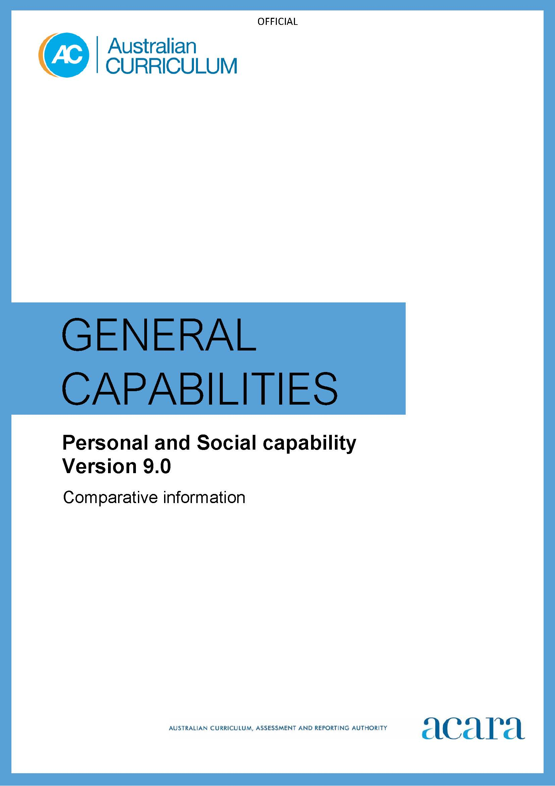

**Copyright and Terms of Use Statement**

**© Australian Curriculum, Assessment and Reporting Authority 2022**

The material published in this work is subject to copyright pursuant to the Copyright Act 1968 (Cth) and is owned by the Australian Curriculum, Assessment and Reporting Authority (ACARA) (except to the extent that copyright is held by another party, as indicated).

The viewing, downloading, displaying, printing, reproducing (such as by making photocopies) and distributing of these materials is permitted only to the extent permitted by, and is subject to the conditions imposed by, the terms and conditions of using the ACARA website (see, especially, clauses 2, 3 and 4 of those terms and conditions). The terms and conditions can be viewed at [https://www.acara.edu.au/contact-us/copyright](https://aus01.safelinks.protection.outlook.com/?url=https%3A%2F%2Fwww.acara.edu.au%2Fcontact-us%2Fcopyright&data=04%7C01%7CSharon.Foster%40acara.edu.au%7C9931e11fa7684c603e6308d98331bbfb%7C6cf76a3aa824427092003d71673ec678%7C0%7C0%7C637685071906340874%7CUnknown%7CTWFpbGZsb3d8eyJWIjoiMC4wLjAwMDAiLCJQIjoiV2luMzIiLCJBTiI6Ik1haWwiLCJXVCI6Mn0%3D%7C1000&sdata=U5O4Vlbpf271IGmGiMh7fDwU4pLzzAiHpCQFylkp6s4%3D&reserved=0)

## *Table 1: Personal and Social capability learning continuum version 9.0*

| **Sub-element** | **Level 1a** | **Level 1b (Foundation)** | **Level 2**  **(Years 1–2)** | **Level 3**  **(Years 3–4)** | **Level 4**  **(Years 5–6)** | **Level 5**  **(Years 7–8)** | **Level 6**  **(Years 9–10)** |
| --- | --- | --- | --- | --- | --- | --- | --- |
| **SELF-AWARENESS** | | | | | | | |
| **Personal awareness** | identify their likes, dislikes, strengths, abilities and interests when showing a personal preference | identify their likes, dislikes, strengths, abilities and interests, and describe how these influence choices | describe personal qualities and how these contribute to growth | explain influences on personal qualities and how these contribute to personal growth | analyse the influence that choices have on developing personal qualities and identify areas for growth | evaluate strategies for developing personal qualities and describe how they assist achieving growth | devise personally appropriate strategies to achieve growth |
| **Emotional awareness** | identify a range of emotions across different situations | identify their own emotional responses | describe the emotional responses of themselves and others | explain the influence that their own behaviour has on the emotional responses of others | analyse the influence of different factors and situations on their emotional responses | evaluate how emotional responses influence behaviour and consider the consequences of these responses | reflect on their emotional responses to different situations |
| **Reflective practice** | identify how their choices can impact their participation in or completion of a task | identify how their choices affect the development of personal abilities and achievements | describe what they have discovered about themselves by engaging with feedback | build on personal abilities and achievements using feedback and self-assessment | analyse personal abilities and achievements by seeking feedback | plan a personal response to a range of contexts using feedback from previous experiences | evaluate goals set for their own personal, social and cognitive development, reflecting on feedback |

| **SELF-MANAGEMENT** | | | | | | | |
| --- | --- | --- | --- | --- | --- | --- | --- |
| **Goal setting** | learn a range of strategies to participate in class activities | co-create goals to assist learning when working independently or collaboratively | collaboratively develop goals to improve learning | plan for learning by setting improvement goals | select and use strategies to monitor own learning and refine goals to plan for further improvement | use and refine strategies that contribute to regulating behaviour and achieving learning goals | adapt goals and plans, and apply strategies, evaluating their suitability and effectiveness |
| **Emotional regulation** | recognise how emotions influence the way we feel and act | express emotions in familiar settings, demonstrating consideration for others | describe ways to moderate emotions in familiar contexts | manage and moderate emotions in familiar contexts, using provided strategies | manage personal factors influencing emotions in a range of contexts including learning | manage emotional responses, designing strategies to self-manage in a range of contexts | regulate emotions in a range of contexts, evaluating and refining their own self-management strategies |
| **Perseverance and adaptability** | persevere when attempting to complete tasks | demonstrate perseverance with familiar tasks when first attempts are unsuccessful, and adapt attempts as needed | demonstrate perseverance and adaptability with unfamiliar tasks | demonstrate perseverance when faced with challenges, adapting approaches based on successes, and learning from setbacks and failure | adapt approaches to tasks to support perseverance when faced with challenging or unfamiliar tasks | select, apply and refine strategies to persevere when faced with unexpected or challenging contexts | devise, evaluate and adapt strategies to engage with unexpected or challenging situations |

| **SOCIAL AWARENESS** | | | | | | | |
| --- | --- | --- | --- | --- | --- | --- | --- |
| **Empathy** | acknowledge that people have different needs, emotions and abilities | demonstrate an awareness of the needs, emotions, cultures and backgrounds of others | describe similarities and differences between the needs, emotions, cultures and backgrounds of themselves and others | discuss the value of different needs, emotions, cultures and backgrounds | explain how the ability to appreciate others’ needs, emotions, cultures and backgrounds assists in the development of social awareness | acknowledge the emotions, needs, cultures and backgrounds of different groups and compare with their own | evaluate the effect of people’s actions towards others’ needs, emotions, cultures and backgrounds, acknowledging the influence empathy has on developing social awareness |
| **Relational awareness** | demonstrate an awareness of how shared interests and behaviours help build relationships | share feelings, needs and interests with others through play and working within diverse groups | describe ways they can initiate and develop relationships, including identifying how others may feel in a range of contexts | identify how they can contribute to healthy relationships and manage challenging relationships | identify and describe a variety of relationships, and the roles and responsibilities of people within them | analyse indicators of healthy and challenging relationships, and how to manage the differences | evaluate how relationships can differ among groups of people and reflect on the skills needed to manage diverse types of relationships |
| **Community awareness** | identify different groups within their community | describe the ways they are connected, and can contribute, to their community groups | describe how they contribute to their communities and how others care for and assist them | describe the various communities beyond their own and what they can do to support them | explain the way their actions and the actions of others influence communities | analyse roles and responsibilities of citizens within communities | evaluate ways of contributing to communities at local, regional, national and global levels |

| **SOCIAL MANAGEMENT** | | | | | | | |
| --- | --- | --- | --- | --- | --- | --- | --- |
| **Communication** | communicate intentionally (verbally and non-verbally) with a range of people in familiar and unfamiliar contexts | develop positive communication skills by initiating, joining or contributing to conversations | use a range of skills to enhance verbal and non-verbal communication | apply verbal and non-verbal communication skills when responding to others | apply skills to address factors that influence verbal and non-verbal communication | demonstrate communication skills in a range of contexts, responding to the enablers of, and barriers to, effective verbal and non-verbal communication | devise strategies that apply effective verbal and non-verbal communication in response to feedback |
| **Collaboration** | engage with peers and other community members | engage with others and participate in group play, tasks and activities | participate cooperatively in groups on common tasks and activities | perform designated roles within groups, appreciating everyone’s contributions to a shared outcome | coordinate contributions of group members, suggesting improvements to ways of working and collaborative outputs | appreciate diverse perspectives in a range of collaborative contexts, demonstrating negotiation skills to improve ways of working and outputs | devise strategies for collaborative work and outputs in a range of contexts, building on the perspectives, experiences and capabilities of group members |
| **Leadership** | show an awareness of personal responsibility | practise self-leadership by taking responsibility for their own actions | practise ways that they can lead self and others, and describe when it is appropriate to adopt a leadership approach | guide and make leadership decisions with a view to how these influence others | select and use different leadership approaches when acting as a sole leader or leading with others | devise a plan for leading action and evaluate the appropriateness of various leadership approaches in the process | propose, implement and evaluate strategies to address needs at local, regional, national or global levels |
| **Decision-making** | make choices that address their needs and wants | identify choices that meet the needs of themselves and others when making decisions | practise individual and group decision-making | describe factors that influence decision-making and predict outcomes of individual and group decisions | explain factors that influence individual and group decision-making and consider the usefulness of these factors when making decisions | devise and analyse individual and group decision-making processes | develop and apply criteria to evaluate the outcomes of individual and group decisions |
| **Conflict resolution** | demonstrate understanding that others have feelings when conflict occurs | listen to conflicting perspectives and apply strategies to calm situations | practise solving simple interpersonal problems, acknowledging there are many ways to prevent and solve conflict | apply a range of conflict resolution strategies to negotiate positive outcomes in a range of contexts | practise different strategies to prevent, defuse or resolve conflict, assessing the causes and effects of conflict | select and apply conflict prevention and resolution strategies in a range of contexts, based on an evaluation of suitability and effectiveness | generate, apply and evaluate strategies to prevent and/or resolve interpersonal and intergroup conflicts |

*Table 2: Personal and Social capability learning continuum version 8.4*

|  |  |  |  |  |  |  |  |  |  |  |  |  |  |  |  |  |  |  |  |  |  |
| --- | --- | --- | --- | --- | --- | --- | --- | --- | --- | --- | --- | --- | --- | --- | --- | --- | --- | --- | --- | --- | --- |
| **Sub-element** | | | | | **Level 1a**  Students: | | | **Level 1b**  Typically, by the end of Foundation Year, students: | **Level 2**  Typically, by the end of Year 2, students: | | | **Level 3**  Typically, by the end of Year 4, students: | | **Level 4**  Typically, by the end of Year 6, students: | | **Level 5**  Typically, by the end of Year 8, students: | | | **Level 6**  Typically, by the end of Year 10, students: | | |
| **Self-awareness element** | | | | | | | | | | | | | | | | | | | | | |
| **Recognise emotions** | | | | | recognise and identify their own emotions | | | identify a range of emotions and describe situations that may evoke these emotions | compare their emotional responses with those of their peers | | | describe the influence that people, situations and events have on their emotions | | explain how the appropriateness of emotional responses influences behaviour | | examine influences on, and consequences of, their emotional responses in learning, social and work-related contexts | | | reflect critically on their emotional responses to challenging situations in a wide range of learning, social and work-related contexts | | |
| **Recognise personal qualities and achievements** | | | | | express a personal preference | | | identify their likes and dislikes, needs and wants, and explore what influences these | identify and describe personal interests, skills and achievements and explain how these contribute to family and school life | | | describe personal strengths and challenges and identify skills they wish to develop | | describe the influence that personal qualities and strengths have on their learning outcomes | | make a realistic assessment of their abilities and achievements, and prioritise areas for improvement | | | assess their strengths and challenges and devise personally appropriate strategies to achieve future success | | |
| **Understand themselves as learners** | | | | | select tasks they can do in different learning contexts | | | identify their abilities, talents and interests as learners | discuss their strengths and weaknesses as learners and identify some learning strategies to assist them | | | identify and describe factors and strategies that assist their learning | | identify preferred learning styles and work habits | | identify and choose a range of learning strategies appropriate to specific tasks and describe work practices that assist their learning | | | evaluate the effectiveness of commonly used learning strategies and work practices and refine these as required | | |
| **Develop reflective practice** | | | | recognise and identify participation in or completion of a ask | | reflect on their feelings as learners and how their efforts affect skills and achievements | | | reflect on what they have learnt about themselves from a range of experiences at home and school | reflect on personal strengths and achievements, based on self-assessment strategies and teacher feedback | | | monitor their progress, seeking and responding to feedback from teachers, to assist them in consolidating strengths, addressing weaknesses and fulfilling their potential | | predict the outcomes of personal and academic challenges by drawing on previous problem-solving and decision-making strategies and feedback from peers and teachers | | | reflect on feedback from peers, teachers and other adults, to analyse personal characteristics and skill sets that contribute to or limit their personal and social capability | | |
| **Self-management element** | | | | | | | | | | | | | | | | | | | |
| **Express emotions appropriately** | recognise and identify how their emotions influence the way they feel and act | | | | | express their emotions constructively in interactions with others | | describe ways to express emotions to show awareness of the feelings and needs of others | | identify and describe strategies to manage and moderate emotions in increasingly unfamiliar situations | | explain the influence of emotions on behaviour, learning and relationships | | forecast the consequences of expressing emotions inappropriately and devise measures to regulate behaviour | | | consider control and justify their emotional responses in expressing their opinions, beliefs, values, questions and choices | | |
| **Develop self-discipline and set goals** | make a choice to participate in a class activity | | | | | follow class routines to assist learning | | set goals in learning and personal organisation by completing tasks within a given time | | explain the value of self-discipline and goal setting in helping them to learn | | analyse factors that influence their ability to self-regulate  devise and apply strategies to monitor own behaviour and set realistic learning goals | | select, use and analyse strategies that assist in regulating behaviour and achieving personal and learning goals | | | critically analyse self-discipline strategies and personal goals and consider their application in social and work-related contexts | | |
| **Work independently and show initiative** | | attempt tasks with support or prompts | | | | | attempt tasks independently and identify when, and from whom, help can be sought | work independently on routine tasks and experiment with strategies to complete other tasks where appropriate | consider, select and adopt a range of strategies for working independently and taking initiative | | | | assess the value of working independently and taking initiative to do so where appropriate | | critique their effectiveness in working independently by identifying enablers and barriers to achieving goals | establish personal priorities, manage resources effectively and demonstrate initiative to achieve personal goals and learning outcomes | | |
| **Become confident,resilient and adaptable** | | identify people and situations where they feel a sense of familiarity or belonging | | | | | identify situations that feel safe or unsafe, and approach new situations with confidence | undertake and persist with short tasks, within the limits of personal safety | persist with tasks when faced with challenges and adapt their approach where first attempts are not successful | | | | devise strategies and formulate plans to assist in the completion of challenging tasks and the maintenance of personal safety | | assess, adapt and modify personal and safety strategies and plans, and revisit tasks with renewed confidence | evaluate, rethink and refine approaches to tasks to take account of unexpected or difficult situations and safety considerations | | |

|  |  |  |  |  |  |  |  |
| --- | --- | --- | --- | --- | --- | --- | --- |
| **Social awareness element** | | | | | | | |
| **Appreciate diverse perspectives** | show an awareness for the feelings, needs and interests of others | acknowledge that people hold many points of view | describe similarities and differences in points of view between themselves and people in their communities | discuss the value of diverse perspectives and describe a point of view that is different from their own | explain how means of communication differ within and between communities and identify the role these play in helping or hindering understanding of others | acknowledge the values, opinions and attitudes of different groups within society and compare to their own points of view | articulate their personal value system and analyse the effects of actions that repress social power and limit the expression of diverse views |
| **Contribute to civil society** | describe ways they can help at home and school | describe how they contribute to their homes, classrooms and local communities, and how others care for and assist them | identify the various communities to which they belong and what they can do to make a difference | identify a community need or problem and consider ways to take action to address it | analyse personal and social roles and responsibilities in planning and implementing ways of contributing to their communities | plan, implement and evaluate ways of contributing to civil society at local, national regional and global levels |
| **Understand relationships** | explore relationships through play and group experiences | identify ways to care for others, including ways of making and keeping friends | describe factors that contribute to positive relationships, including with people at school and in their community | identify the differences between positive and negative relationships and ways of managing these | identify indicators of possible problems in relationships in a range of social and work-related situations | explain how relationships differ between peers, parents, teachers and other adults, and identify the skills needed to manage different types of relationships |

|  |  |  |  |  |  |  |  |  |  |  |
| --- | --- | --- | --- | --- | --- | --- | --- | --- | --- | --- |
| **Social management element** | | | | | | | | | | |
| **Communicate effectively** | respond to the feelings, needs and interests of others | identify positive ways to initiate, join and interrupt conversations with adults and peers | | discuss the use of verbal and non-verbal communication skills to respond appropriately to adults and peers | | identify communication skills that enhance relationships for particular groups and purposes | identify and explain factors that influence effective communication in a variety of situations | analyse enablers of, and barriers to, effective verbal, non-verbal and digital communication | formulate plans for effective communication (verbal, nonverbal, digital) to complete complex tasks | |
| **Work collaboratively** | share experiences of cooperation in play and group activities | | identify cooperative behaviours in a range of group activities | | describe characteristics of cooperative behaviour and identify evidence of these in group activities | contribute to groups and teams, suggesting improvements in methods used for group investigations and projects | assess the extent to which individual roles and responsibilities enhance group cohesion and the achievement of personal and group objectives | critique their ability to devise and enact strategies for working in diverse teams, drawing on the skills and contributions of team members to complete complex tasks | |
| **Make decisions** | identify options when making decisions to meet their needs and the needs of others | | practise individual and group decision-making in situations such as class meetings and when working in pairs and small groups | | contribute to and predict the consequences of group decisions in a range of situations | identify factors that influence decision-making and consider the usefulness of these in making their own decisions | assess individual and group decision-making processes in challenging situations | develop and apply criteria to evaluate the outcomes of individual and group decisions and analyse the consequences of their decision-making | |
| **Negotiate and resolve conflict** | listen to others’ ideas and recognise that others may see things differently from them | | practise solving simple interpersonal problems, recognising there are many ways to solve conflict | | identify a range of conflict resolution strategies to negotiate positive outcomes to problems | identify causes and effects of conflict, and practise different strategies to defuse or resolve conflict situations | assess the appropriateness of various conflict resolution strategies in a range of social and work-related situations | generate, apply and evaluate strategies such as active listening, mediation and negotiation to prevent and resolve interpersonal problems and conflicts | |
| **Develop leadership skills** |  | identify ways to take responsibility for familiar tasks at home and school | discuss ways in which they can take responsibility for their own actions | | discuss the concept of leadership and identify situations where it is appropriate to adopt this role | | initiate or help to organise group activities that address a common need | plan school and community projects, applying effective problem-solving and team-building strategies and making the most of available resources to achieve goals | | propose, implement and monitor strategies to address needs prioritised at local, national, regional and global levels, and communicate these widely | |