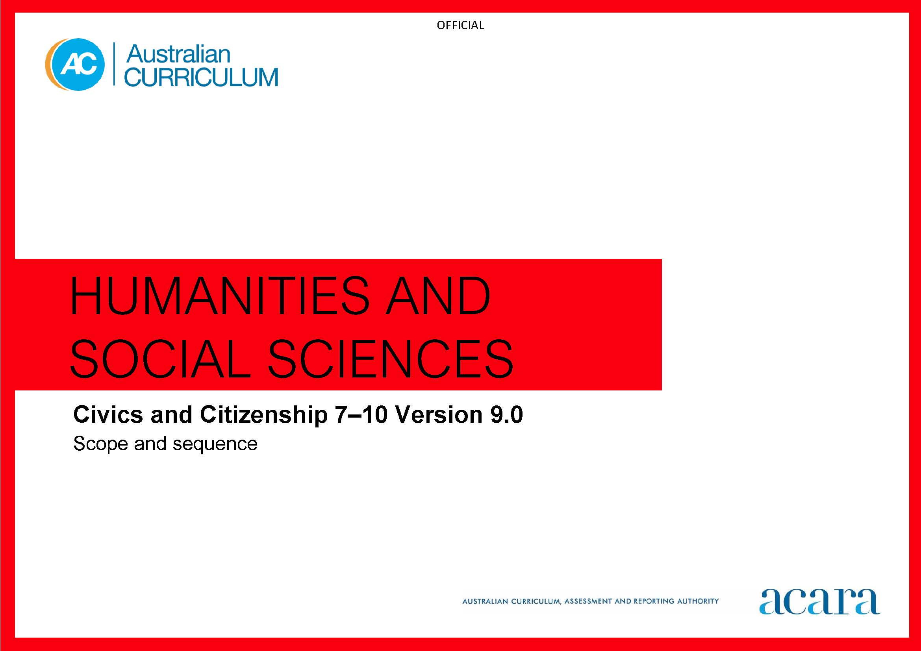

**Copyright and Terms of Use Statement**

**© Australian Curriculum, Assessment and Reporting Authority 2022**

The material published in this work is subject to copyright pursuant to the Copyright Act 1968 (Cth) and is owned by the Australian Curriculum, Assessment and Reporting Authority (ACARA) (except to the extent that copyright is held by another party, as indicated).

The viewing, downloading, displaying, printing, reproducing (such as by making photocopies) and distributing of these materials is permitted only to the extent permitted by, and is subject to the conditions imposed by, the terms and conditions of using the ACARA website (see, especially, clauses 2, 3 and 4 of those terms and conditions). The terms and conditions can be viewed at [https://www.acara.edu.au/contact-us/copyright](https://aus01.safelinks.protection.outlook.com/?url=https%3A%2F%2Fwww.acara.edu.au%2Fcontact-us%2Fcopyright&data=04%7C01%7CSharon.Foster%40acara.edu.au%7C9931e11fa7684c603e6308d98331bbfb%7C6cf76a3aa824427092003d71673ec678%7C0%7C0%7C637685071906340874%7CUnknown%7CTWFpbGZsb3d8eyJWIjoiMC4wLjAwMDAiLCJQIjoiV2luMzIiLCJBTiI6Ik1haWwiLCJXVCI6Mn0%3D%7C1000&sdata=U5O4Vlbpf271IGmGiMh7fDwU4pLzzAiHpCQFylkp6s4%3D&reserved=0)

|  |  |  |
| --- | --- | --- |
| **Year 7** | | **Year 8** |
| **Achievement standard** | | |
| By the end of Year 7, students describe the key features of Australia’s system of government, and the principles and features of the Australian legal system. They explain the characteristics of Australian democracy. Students describe the nature of Australian society, its cultural and religious diversity, and identify the values that support cohesion in Australian society.  Students develop questions and locate, select and organise information from sources to investigate political and legal systems, and contemporary civic issues. They analyse information and identify perspectives and challenges related to political, legal or civic issues. They identify and describe the methods or strategies related to civic participation or action. Students use civics and citizenship concepts, terms and sources to create descriptions, explanations and arguments. | By the end of Year 8, students explain how Australians are informed about and participate in their democracy. They describe the roles of political parties and elected representatives in Australian government. They explain the characteristics of laws, how laws are made and the types of law in Australia. Students identify ways in which Australians express different aspects of their identity and explain perspectives on Australia’s national identity.  Students develop questions and locate, select and organise relevant information from different sources to investigate political and legal systems, and contemporary civic issues. They analyse information and identify and describe perspectives and challenges related to political, legal or civic issues. They explain the methods or strategies related to civic participation or action. Students use civics and citizenship knowledge, concepts, terms and references to evidence from sources to create descriptions, explanations and arguments. | |

|  |  |
| --- | --- |
| **Content descriptions** | |
| **Strand: Knowledge and understanding** | |
| **Sub-strand: Government and democracy** | |
| the key features of Australia’s system of government, including democracy, the Australian Constitution, responsible government and federalism  AC9HC7K01 | how Australians are informed about and participate in democracy  AC9HC8K01 |
| the characteristics of Australia’s democracy, including freedom of speech, association, assembly, religion and movement  AC9HC7K02 | the role of political parties and independent representatives in Australian democracy, including elections and the formation of governments  AC9HC8K02 |
| **Sub-strand: Laws and citizens** | |
| the key principles and features of the Australian legal system, including the Australian Constitution, the rule of law and the court system  AC9HC7K03 | the characteristics of laws and how laws are made in Australia through parliaments (statutory law) and through the courts (common law)  AC9HC8K03 |
|  | the types of law in Australia, including criminal law and civil law, and the place of First Nations Australian customary law  AC9HC8K04 |
| **Sub-strand: Citizenship, diversity and identity** | |
| how Australia’s secular democracy and pluralist, multi-faith society draws upon diverse cultural origins, including Christian and Western heritage, distinct First Nations Australian histories and cultures, and migrant communities  AC9HC7K04 | how culture and religion may influence individuals’ and groups’ perceptions and expressions of citizenship and their actions as citizens  AC9HC8K05 |
| how values based on freedom, respect, fairness and equality of opportunity can support social cohesion and democracy within Australian society  AC9HC7K05 | different experiences of, perspectives on and debates about Australia’s national identity and citizenship, including the perspectives of First Nations Australians as owners of their respective nations, and of different migrant groups  AC9HC8K06 |
| **Strand: Skills** | |
| **Sub-strand: Questioning and researching** | |
| develop questions to investigate Australia’s political and legal systems, and contemporary civic issues  AC9HC7S01 AC9HC8S01 | |
| locate, sort and organise information and data, and ideas from different sources  AC9HC7S02 AC9HC8S02 | |
| **Sub-strand: Analysis, evaluation and interpretation** | |
| analyse information, data and ideas about political, legal or civic issues to identify and explain differences in perspectives and potential challenges  AC9HC7S03 AC9HC8S03 | |
| **Sub-strand: Civic participation and decision-making** | |
| explain the methods or strategies related to making decisions about civic participation  AC9HC7S04 AC9HC8S04 | |
| **Sub-strand: Communicating** | |
| create descriptions, explanations and arguments using civics and citizenship knowledge, concepts and terms that reference evidence  AC9HC7S05 AC9HC8S05 | |

|  |  |  |
| --- | --- | --- |
| **Year 9** | | **Year 10** |
| **Achievement standard** | | |
| By the end of Year 9, students analyse the role of the Australian Constitution, the federal system of government, and the process and reasons for constitutional change. They explain policy development and legislative processes in Australia’s democracy. They identify the key features and jurisdictions of Australia’s court system and explain the role and processes of courts and tribunals. Students identify the reasons individuals and groups participate in and contribute to civic life nationally and globally. They explain the influence of the media on reflections of identity and diversity.  Students develop a range of questions and locate, select and compare information from sources to investigate political and legal systems, and contemporary civic issues. They analyse information to explain perspectives and challenges related to political, legal or civic issues. Students identify and evaluate the methods or strategies related to civic participation or action. Students use civics and citizenship knowledge, concepts and terms to develop descriptions, explanations and evidence-based arguments. | By the end of Year 10, students compare the key features and values of Australia’s system of government to those of another system of government. They describe the Australian Government’s role and responsibilities at a regional and global level. They explain the role of the High Court of Australia. They explain how Australia’s international legal obligations influence the law and government policy. They identify and explain challenges to a resilient democracy and a cohesive society in Australia.  Students develop and refine a range of questions and locate, select and compare relevant and reliable information from a range of sources to investigate political and legal systems, and contemporary civic issues. They analyse information to evaluate perspectives and challenges related to political, legal or civic issues. They evaluate and compare the methods or strategies related to civic participation or action. Students use civics and citizenship knowledge, concepts and terms to develop descriptions, explanations and arguments that synthesise evidence from sources. | |

|  |  |
| --- | --- |
| **Content descriptions** | |
| **Strand: Knowledge and understanding** | |
| **Sub-strand: Government and democracy** | |
| the role of the Australian Constitution in providing the basis for Australia’s federal system of government and democratic processes, including institutions, and the process for constitutional change through a referendum  AC9HC9K01 | the key features and values of Australia’s system of government compared with at least one other democratic or non-democratic system of government in the Asia-Pacific region  AC9HC10K01 |
| the legislative processes through which federal government policy is shaped, developed and implemented  AC9HC9K02 | the Australian Government’s role and responsibilities at a regional and global level  AC9HC10K02 |
| **Sub-strand: Laws and citizens** | |
| the key features and jurisdictions of Australia’s court system, and the operations of courts and tribunals  AC9HC9K03 | the role of the parliament and the High Court of Australia in protecting rights under the Constitution, common law, and through federal and state statute law  AC9HC10K03 |
| the role of courts, judges, lawyers and juries in trials, and the rights of the accused and the rights of victims  AC9HC9K04 | how Australia’s international legal obligations shape Australian law and government policies, including those relating to First Nations Australians, and the issues related to the application of these obligations  AC9HC10K04 |
| **Sub-strand: Citizenship, diversity and identity** | |
| how and why individuals and groups, including community, religious and cultural groups, participate in and contribute to civic life in Australia and to global citizenship  AC9HC9K05 | the challenges to and ways of sustaining a resilient democracy and a cohesive society in Australia and/or in our region or globally  AC9HC10K05 |
| the influence of a range of media, including social media, in shaping identity and attitudes to diversity  AC9HC9K06 |  |
| **Strand: Skills** | |
| **Sub-strand: Questioning and researching** | |
| develop and modify questions to investigate Australia’s political and legal systems, and contemporary civic issues  AC9HC9S01 AC9HC10S01 | |
| locate, select and compare information, data and ideas from a range of sources  AC9HC9S02 AC9HC10S02 | |
| **Sub-strand: Analysis, evaluation and interpretation** | |
| analyse information, data and ideas about political, legal or civic issues to identify and evaluate differences in perspectives and interpretations  AC9HC9S03 AC9HC10S03 | |
| **Sub-strand: Civic participation and decision-making** | |
| evaluate the methods or strategies related to making decisions about civic participation  AC9HC9S04 AC9HC10S04 | |
| **Sub-strand: Communicating** | |
| create descriptions, explanations and arguments using civics and citizenship knowledge, concepts and terms that incorporate evidence  AC9HC9S05 AC9HC10S05 | |