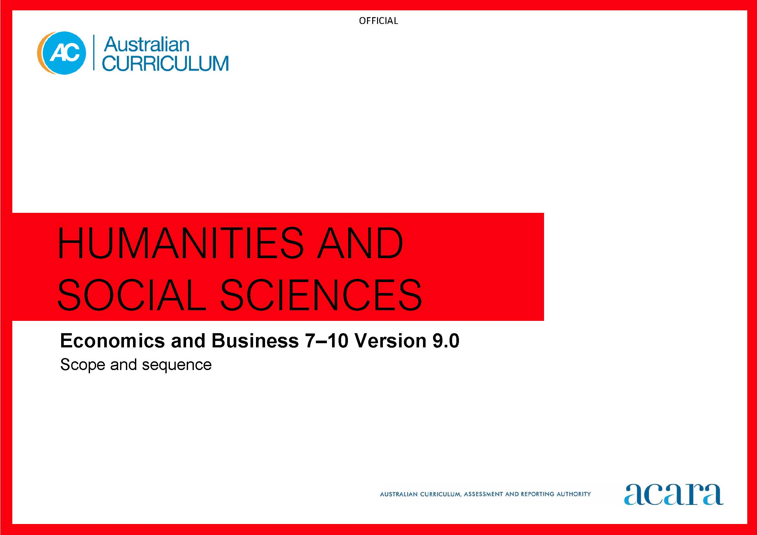

**Copyright and Terms of Use Statement**

**© Australian Curriculum, Assessment and Reporting Authority 2022**

The material published in this work is subject to copyright pursuant to the Copyright Act 1968 (Cth) and is owned by the Australian Curriculum, Assessment and Reporting Authority (ACARA) (except to the extent that copyright is held by another party, as indicated).

The viewing, downloading, displaying, printing, reproducing (such as by making photocopies) and distributing of these materials is permitted only to the extent permitted by, and is subject to the conditions imposed by, the terms and conditions of using the ACARA website (see, especially, clauses 2, 3 and 4 of those terms and conditions). The terms and conditions can be viewed at [https://www.acara.edu.au/contact-us/copyright](https://aus01.safelinks.protection.outlook.com/?url=https%3A%2F%2Fwww.acara.edu.au%2Fcontact-us%2Fcopyright&data=04%7C01%7CSharon.Foster%40acara.edu.au%7C9931e11fa7684c603e6308d98331bbfb%7C6cf76a3aa824427092003d71673ec678%7C0%7C0%7C637685071906340874%7CUnknown%7CTWFpbGZsb3d8eyJWIjoiMC4wLjAwMDAiLCJQIjoiV2luMzIiLCJBTiI6Ik1haWwiLCJXVCI6Mn0%3D%7C1000&sdata=U5O4Vlbpf271IGmGiMh7fDwU4pLzzAiHpCQFylkp6s4%3D&reserved=0)

|  |  |  |
| --- | --- | --- |
| **Year 7** | | **Year 8** |
| **Achievement standard** | | |
| By the end of Year 7, students describe how decisions are made to allocate limited resources to individuals and communities in an economy. They describe the reasons businesses exist and types of businesses and identify how entrepreneurial characteristics contribute to the success of a business. They describe the reasons individuals choose to work, how they may derive an income and the types of work that exist. Students identify the rights and responsibilities of individuals and businesses in terms of products and services.  Students develop questions to investigate an economic and business issue. They locate, select and organise data and information from sources. They interpret information and data to identify economic and business issues, trends or effects. They develop a response and identify potential costs and benefits. Students use economic and business knowledge, concepts, terms, and sources to create descriptions and explanations. | By the end of Year 8, students explain how markets influence the allocation of resources to the production of goods and services. They explain ways that businesses adapt to opportunities in markets and respond to the work environment. They describe the importance of Australia’s taxation system and its effect on decision-making by individuals and businesses. Students explain why individuals and/or businesses budget and plan.  Students develop a range of questions to investigate an economic and business issue. They locate, select and organise relevant information and data. They interpret information and data to identify economic and business issues and trends, and describe economic cause-and-effect relationships. They develop a response to an economic and business issue They identify and evaluate potential costs and benefits. Students use economic and business knowledge, concepts, terms and research findings to create descriptions and explanations. | |

|  |  |
| --- | --- |
| **Content descriptions** | |
| **Strand: Knowledge and understanding** | |
| why opportunity cost exists as decisions are made to allocate limited resources to meet unlimited needs and wants  AC9HE7K01 | how markets influence decisions about the allocation of resources to the production of goods and services, and the effect of prices on these decisions  AC9HE8K01 |
| the reasons businesses exist and how different types of businesses provide goods and services  AC9HE7K02 | different ways that businesses adapt to opportunities in the market and respond to the changing nature of work  AC9HE8K02 |
| characteristics of entrepreneurs and how these influence the success of a business  AC9HE7K03 | how businesses operated by First Nations Australians develop opportunities in the market  AC9HE8K03 |
| the reasons individuals work, the types of work they are involved in, and how they may derive an income  AC9HE7K04 | the importance of Australia’s system of taxation and how this system affects decision-making by individuals and businesses  AC9HE8K04 |
| the rights and responsibilities of individuals and businesses in relation to consumer and financial products and services  AC9HE7K05 | processes individuals and/or businesses use to plan and budget to achieve short-term and long-term financial objectives  AC9HE8K05 |

|  |
| --- |
| **Strand: Skills** |
| **Sub-strand: Questioning and researching** |
| develop questions to investigate a contemporary economic and business issue  AC9HE7S01AC9HE8S01 |
| locate, select and organise information and data from a range of sources  AC9HE7S02AC9HE8S02 |
| **Sub-strand: Interpreting and analysing** |
| interpret information and data to identify economic and business issues, trends and economic cause-and-effect relationships  AC9HE7S03AC9HE8S03 |
| **Sub-strand: Evaluating, concluding and decision-making** |
| develop a response to an economic and business issue, identifying potential costs and benefits  AC9HE7S04AC9HE8S04 |
| **Sub-strand: Communicating** |
| create descriptions, explanations and conclusions, using economic and business knowledge, concepts and terms and reference information and data from sources  AC9HE7S05AC9HE8S05 |

|  |  |  |
| --- | --- | --- |
| **Year 9** | | **Year 10** |
| **Achievement standard** | | |
| By the end of Year 9, students explain the role of Australia’s financial sector and its effect on economic decision-making by individuals and businesses. They explain the interdependence of participants in the global market and the effect on economic decision-making. They explain the reasons for trade and Australia’s pattern of trade with Asia. They explain why businesses seek to create and maintain a competitive advantage. Students explain how individuals and businesses manage consumer and financial risks and rewards.  Students develop and modify questions to investigate an economic and business issue. They locate, select and analyse information and data from a range of sources. They interpret and analyse information and data to explain economic trends and cause-and-effect relationships, and identify consumer and financial impacts. They develop a response to an economic and business issue taking account of economic, business or financial factors. They evaluate a response using criteria and make decisions about how it is to be implemented. Students use economic and business knowledge, concepts and terms to develop descriptions, explanations and arguments that acknowledge research findings. | By the end of Year 10, students analyse how economic indicators influence Australian Government decision-making. They explain ways that government intervenes to improve economic performance and living standards. They explain processes that businesses use to manage the workforce and improve productivity. They explain the importance of Australia’s superannuation system and its effect on consumer and financial decision-making. Students analyse factors that influence major consumer and financial decisions, and explain the short- and long-term effects of these decisions.  Students develop and modify a range of questions to investigate an economic and business issue. They locate, select and analyse relevant and reliable information and data from a range of sources. They interpret and analyse information and data to evaluate trends and economic cause-and-effect relationships and make predictions about consumer and financial impacts. They develop an evidence-based response to an economic and business issue. They evaluate a response using appropriate criteria to decide on a course of action. Students use economic and business knowledge, concepts, and terms to develop descriptions, explanations and reasoned argument that synthesise research findings. | |

|  |  |
| --- | --- |
| **Content descriptions** | |
| **Strand: Knowledge and understanding** | |
| the role of Australia’s financial sector and its effect on economic decision-making by individuals, businesses and global markets  AC9HE9K01 | how and why the economic indicators influence economic decision-making  AC9HE10K01 |
| how economic decision-making involves the interdependence of consumers, businesses, the financial sector and government  AC9HE9K02 | the ways that government intervenes in the economy to improve economic performance and living standards within Australian society  AC9HE10K02 |
| the reasons Australia trades with other nations, and the patterns of trade between Australia and Asia  AC9HE9K03 | factors that influence major consumer and financial decisions and the short- and long-term consequences of these decisions  AC9HE10K03 |
| processes that businesses use to create and maintain competitive advantage, including the role of entrepreneurs  AC9HE9K04 | the importance of Australia’s superannuation system and how this system affects consumer and financial decision-making  AC9HE10K04 |
| how individuals and businesses manage consumer and financial risks and rewards  AC9HE9K05 | processes that businesses use to manage the workforce and improve productivity, including the role of entrepreneurs  AC9HE10K05 |

|  |
| --- |
| **Strand: Skills** |
| **Sub-strand: Questioning and researching** |
| develop and modify questions to investigate a contemporary economic and business issue  AC9HE9S01 AC9HE10S01 |
| locate, select and analyse information and data from a range of sources  AC9HE9S02AC9HE10S02 |
| **Sub-strand: Interpreting and analysing** |
| interpret information and data, explaining economic and business issues, trends and economic cause-and-effect relationships, and make predictions about consumer and financial impacts  AC9HE9S03AC9HE10S03 |
| **Sub-strand: Evaluating, concluding and decision-making** |
| develop and evaluate a response to an economic and business issue, using cost-benefit analysis or criteria to decide on a course of action  AC9HE9S04AC9HE10S04 |
| **Sub-strand: Communicating** |
| create descriptions, explanations and arguments using economic and business knowledge, concepts and terms that incorporate and acknowledge research findings  AC9HE9S05AC9HE10S05 |