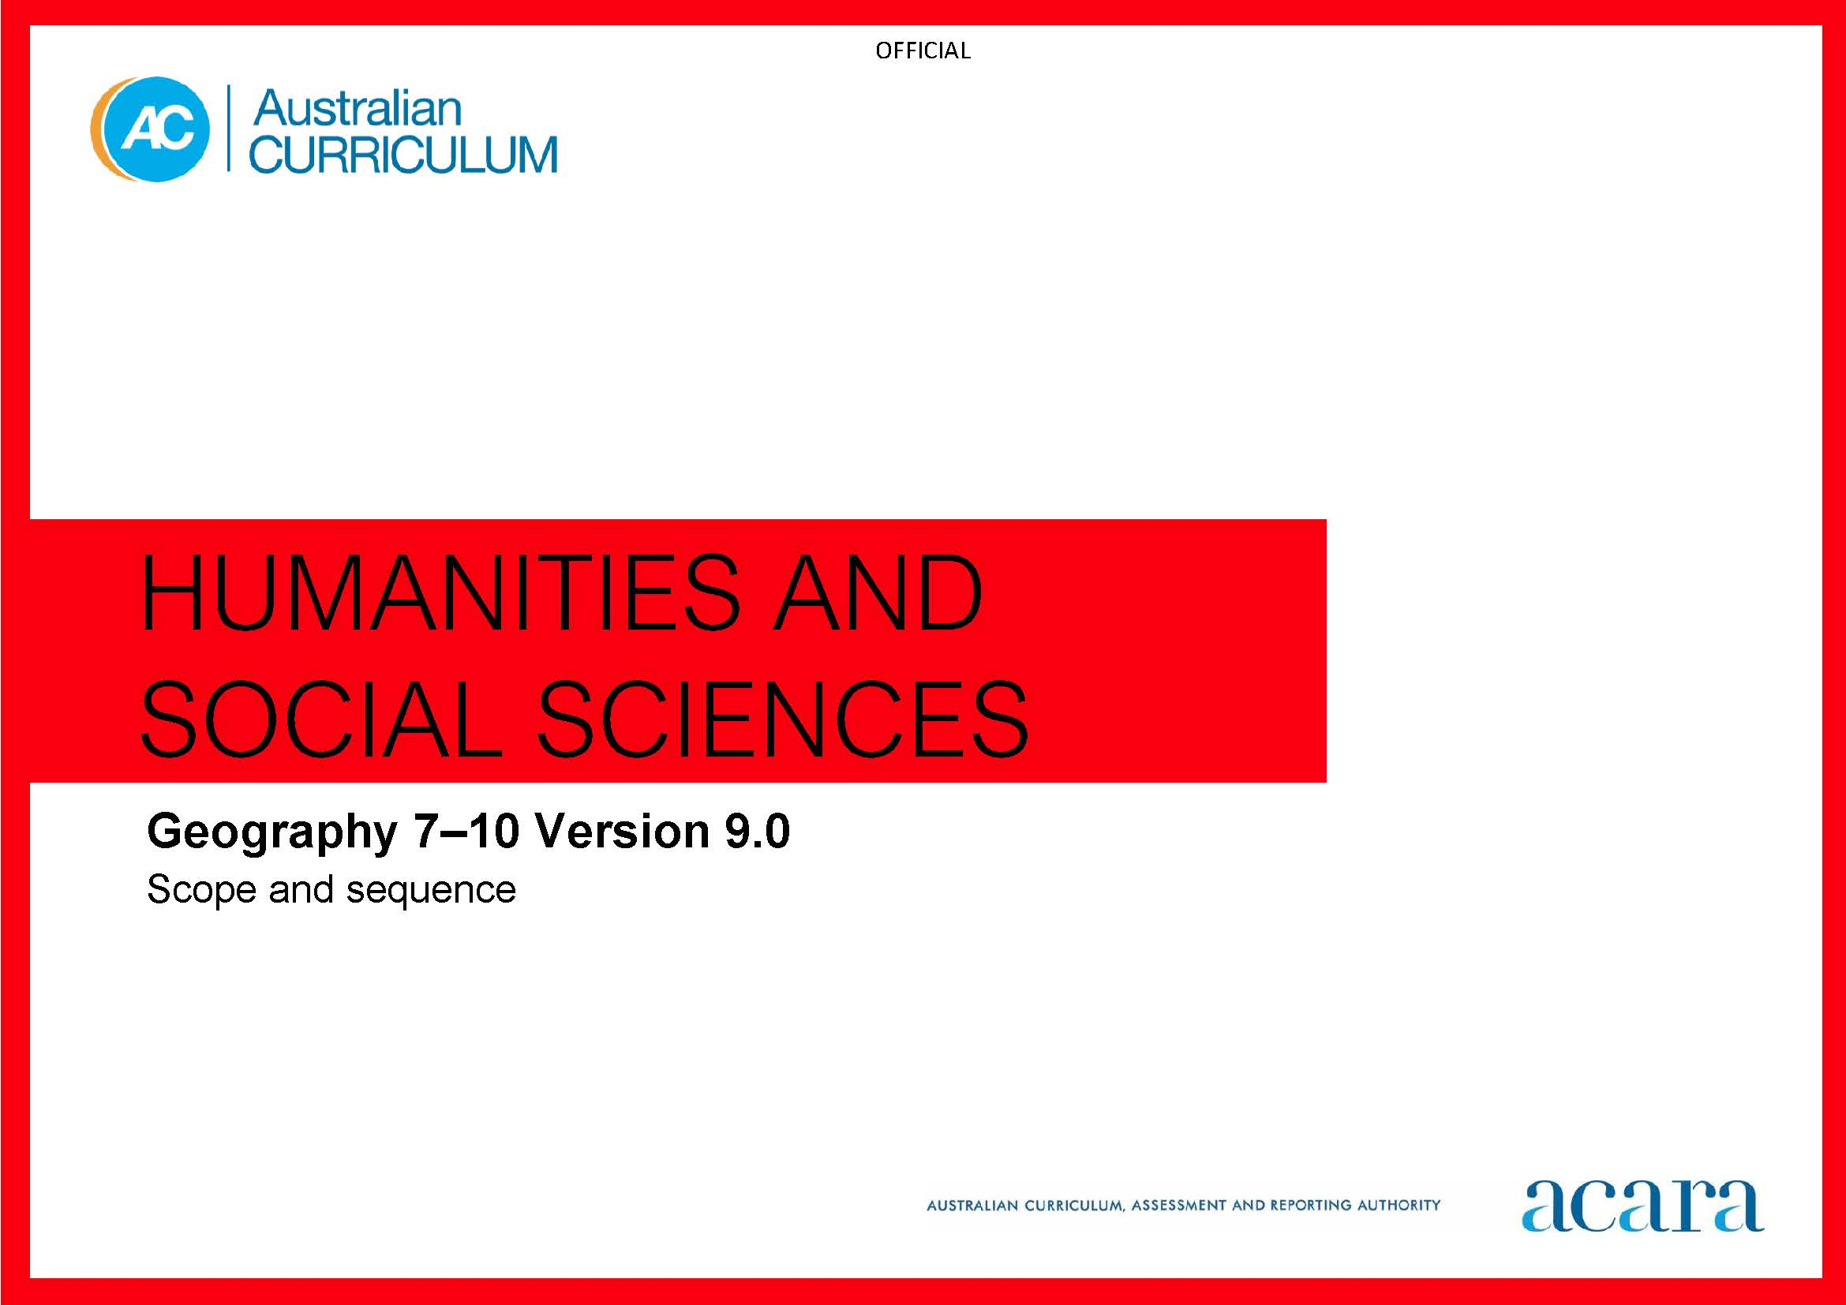

**Copyright and Terms of Use Statement**

**© Australian Curriculum, Assessment and Reporting Authority 2022**

The material published in this work is subject to copyright pursuant to the Copyright Act 1968 (Cth) and is owned by the Australian Curriculum, Assessment and Reporting Authority (ACARA) (except to the extent that copyright is held by another party, as indicated).

The viewing, downloading, displaying, printing, reproducing (such as by making photocopies) and distributing of these materials is permitted only to the extent permitted by, and is subject to the conditions imposed by, the terms and conditions of using the ACARA website (see, especially, clauses 2, 3 and 4 of those terms and conditions). The terms and conditions can be viewed at [https://www.acara.edu.au/contact-us/copyright](https://aus01.safelinks.protection.outlook.com/?url=https%3A%2F%2Fwww.acara.edu.au%2Fcontact-us%2Fcopyright&data=04%7C01%7CSharon.Foster%40acara.edu.au%7C9931e11fa7684c603e6308d98331bbfb%7C6cf76a3aa824427092003d71673ec678%7C0%7C0%7C637685071906340874%7CUnknown%7CTWFpbGZsb3d8eyJWIjoiMC4wLjAwMDAiLCJQIjoiV2luMzIiLCJBTiI6Ik1haWwiLCJXVCI6Mn0%3D%7C1000&sdata=U5O4Vlbpf271IGmGiMh7fDwU4pLzzAiHpCQFylkp6s4%3D&reserved=0)

|  |  |  |
| --- | --- | --- |
| **Year 7** | | **Year 8** |
| **Achievement standard** | | |
| By the end of Year 7, students describe how the characteristics of places are perceived and valued differently by people. They describe the importance of environments to people. They describe the features of a distribution. They explain the interconnections between people and places and environments, and describe how these interconnections change places or environments. Students describe a response or strategy to address a geographical phenomenon or challenge.  Students develop questions about a geographical phenomenon or challenge. They collect, organise and represent relevant data and information, using primary research methods and secondary research materials. They identify similarities and differences, and describe patterns in data and information. They draw conclusions about the impact of the geographical phenomenon or challenge on people, places and environments. They develop a strategy for action. Students use geographical knowledge, concepts, terms, and relevant findings from sources to create descriptions, explanations and responses. | By the end of Year 8, students explain how the interactions of people and environmental processes impact on the characteristics of places. They explain how the characteristics of places are perceived and valued differently by people. They describe the effects of human activity or hazards on environments. They explain the features of a distribution and identify implications. They explain the interconnections between people and places and environments. They explain how these interconnections change places or environments. Students explain responses or strategies to address a geographical phenomenon or challenge, referring to environmental, economic or social factors.  Students develop relevant questions about a geographical phenomenon or challenge. They collect, organise and represent relevant and reliable data and information using primary research methods and secondary research materials. They interpret and analyse data and information to explain patterns and trends and infer relationships. They draw reasoned conclusions about the impact of the geographical phenomenon or challenge. They decide on appropriate strategies for action and explain potential impacts. Students use geographical knowledge, methods, concepts, terms and reference findings from sources, to create descriptions, explanations and responses. | |

|  |  |
| --- | --- |
| **Content descriptions** | |
| **Strand: Knowledge and understanding** | |
| **Sub-strand: Water in the world** | **Sub-strand: Landscapes and landforms** |
| classification of environmental resources and the way that water connects and changes places as it moves through environments  AC9HG7K01 | geomorphological processes that produce different landscapes and significant landforms  AC9HG8K01 |
| the location and distribution of water resources in Australia, their implications, and strategies to manage the sustainability of water  AC9HG7K02 | the location and distribution of Australia’s distinctive landscapes and significant landforms  AC9HG8K02 |
| the economic, cultural, spiritual and aesthetic value of water for people, including First Nations Australians  AC9HG7K03 | the spiritual, aesthetic and cultural value of landscapes and landforms for people, including Country/Place of First Nations Australians  AC9HG8K03 |
| the causes and impacts of an atmospheric or hydrological hazard, and responses from communities and governments  AC9HG7K04 | the interconnections between human activity and geomorphological processes, and ways of managing distinctive landscapes  AC9HG8K04 |
|  | the causes and impacts of a geomorphological hazard on people, places and environments, and the effects of responses  AC9HG8K05 |
| **Sub-strand: Place and liveability** | **Sub-strand: Changing nations** |
| factors that influence the decisions people make about where to live, including perceptions of the liveability of places and the influence of environmental quality  AC9HG7K05 | causes of urbanisation and its impacts on places and environments, drawing on a study from a country such as the United States of America, and its implications  AC9HG8K06 |
| the location and distribution of services and facilities, and implications for liveability of places  AC9HG7K06 | differences in the distribution of urban settlements and urban concentration in Australia compared with another country such as the United States of America, and their implications  AC9HG8K07 |
| the cultural connectedness of people to places and how this influences their identity, sense of belonging and perceptions of a place, in particular the cultural connectedness of First Nations Australians to Country/Place  AC9HG7K07 | reasons for, and effects of, internal migration and international migration in Australia, China or other countries  AC9HG8K08 |
| strategies used to enhance the liveability of a place, including for young people, the aged or those with disability, drawing on studies such as those from Australia or Europe  AC9HG7K08 | strategies to manage the sustainability of Australia’s changing urban places  AC9HG8K09 |

|  |
| --- |
| **Strand: Skills** |
| **Sub-strand: Questioning and researching using geographical methods** |
| develop questions for a geographical inquiry related to a phenomenon or challenge  AC9HG7S01 AC9HG8S01 |
| collect, organise and represent data and information from primary research methods, including fieldwork and secondary research materials, using geospatial technologies and digital tools as appropriate  AC9HG7S02 AC9HG8S02 |
| **Sub-strand: Interpreting and analysing geographical data and information** |
| interpret and analyse geographical data and information to identify similarities and differences, explain patterns and trends and infer relationships  AC9HG7S03 AC9HG8S03 |
| **Sub-strand: Concluding and decision-making** |
| draw conclusions based on the analysis of the data and information  AC9HG7S04 AC9HG8S04 |
| identify a strategy for action in relation to environmental, economic, social or other factors, and explain potential impacts  AC9HG7S05 AC9HG8S05 |
| **Sub-strand: Communicating** |
| create descriptions, explanations and responses using geographical knowledge and methods, concepts, terms, and reference sources.  AC9HG7S06 AC9HG8S06 |

|  |  |  |
| --- | --- | --- |
| **Year 9** | | **Year 10** |
| **Achievement standard** | | |
| By the end of Year 9, students explain how peoples’ activities or environmental processes change the characteristics of places. They explain the effects of human activity on environments, and the effects of environments on human activity. They explain the features of biomes’ distribution and identify implications for environments. They analyse the interconnections between people and places and environments. They identify and explain how these interconnections influence people, and change places and environments. Students analyse strategies to address a geographical phenomenon or challenge using environmental, social or economic criteria.  Students develop a range of questions about a geographical phenomenon or challenge. They collect, represent and compare relevant and reliable geographical data and information by using a range of primary research methods and secondary research materials in a range of formats. They interpret and analyse data and information to explain patterns and trends and infer relationships. They draw evidence-based conclusions about the impact of the geographical phenomenon or challenge. They develop and evaluate strategies, predict impacts and make a recommendation. Students use geographical knowledge, concepts, terms and digital tools as appropriate, to develop descriptions, explanations and responses that acknowledge research findings. | By the end of Year 10, students explain how the interactions of people and environmental processes at different scales change the characteristics of places. They explain the effects of human activity on environments, and the effect of environments on human activity, over time. They evaluate a distribution and its implications. They evaluate interconnections between people and places and environments. They analyse changes that result from these interconnections and their consequences. Students evaluate strategies to address a geographical phenomenon or challenge using environmental, social and economic criteria.  Students develop a range of relevant questions about a geographical phenomenon or challenge. They collect, represent and compare relevant and reliable geographical data and information by using a range of primary research methods and secondary research materials, using appropriate formats. They interpret and analyse data and information to make generalisations and predictions, explain significant patterns and trends, and infer relationships. They draw evidence-based conclusions, based on relevant data and information, about the impact of the geographical phenomenon or challenge. They develop and evaluate strategies using criteria, recommend a strategy and explain the predicted impacts. Students use geographical knowledge, concepts, terms and digital tools as appropriate, to develop descriptions, explanations and responses that synthesise research findings. | |

|  |  |
| --- | --- |
| **Content descriptions** | |
| **Strand: Knowledge and understanding** | |
| **Sub-strand: Biomes and food security** | **Sub-strand: Environmental change and management** |
| the distribution and characteristics of biomes as regions with distinctive climates, soils, vegetation and productivity  AC9HG9K01 | the human-induced changes that challenge the sustainability of places and environments  AC9HG10K01 |
| the effects on environments of human alteration of biomes to produce food, industrial materials and fibres  AC9HG9K02 | the environmental world views of people and their implications for environmental management  AC9HG10K02 |
| the environmental, economic and technological factors that impact agricultural productivity, in Australia and a country in Asia  AC9HG9K03 | First Nations Australians’ approaches to custodial responsibility and environmental management in different regions of Australia  AC9HG10K03 |
| challenges to sustainable food production and food security in Australia and appropriate management strategies  AC9HG9K04 | causes and effects of a change in an identified environment at a local, national or global scale, and strategies to manage sustainability  AC9HG10K04 |
| **Sub-strand: Geographies of interconnections** | **Sub-strand: Geographies of human wellbeing** |
| the ways changing transportation and technologies are used to connect people to services, information and people in other places  AC9HG9K05 | the methods used to measure spatial variations in human wellbeing and development, and how these can be applied to determine differences between places at the global scale  AC9HG10K05 |
| the effects on places of people’s travel, recreational, cultural or leisure choices, and the strategies for managing the impacts on these places  AC9HG9K06 | reasons for, and consequences of, spatial variations in human wellbeing at a regional and national scale, drawing on studies such as from within India or another country in Asia  AC9HG10K06 |
| the ways that places and people are interconnected with other places through trade in goods and services, at all scales  AC9HG9K07 | reasons for, and consequences of, spatial variations in human wellbeing in Australia, including for First Nations Australians  AC9HG10K07 |
| the impacts of the production and consumption of goods on places throughout the world, and strategies to manage sustainability in these places  AC9HG9K08 | responses of international and national government and non-government organisations to improve human wellbeing in Australia, within India and another country in the Pacific  AC9HG10K08 |

|  |
| --- |
| **Strand: Skills** |
| **Sub-strand: Questioning and researching using geographical methods** |
| develop a range of questions for a geographical inquiry related to a phenomenon or challenge  AC9HG9S01 AC9HG10S01 |
| collect, represent and compare data and information from primary research methods, including fieldwork and secondary research materials, using geospatial technologies and digital tools as appropriate  AC9HG9S02 AC9HG10S02 |
| **Sub-strand: Interpreting and analysing geographical data and information** |
| evaluate geographical data and information to make generalisations and predictions, explain patterns and trends, and infer relationships  AC9HG9S03 AC9HG10S03 |
| **Sub-strand: Concluding and decision-making** |
| evaluate data and information to justify conclusions  AC9HG9S04 AC9HG10S04 |
| develop and evaluate strategies using environmental, economic or social criteria; recommend a strategy and explain the predicted impacts  AC9HG9S05 AC9HG10S05 |
| **Sub-strand: Communicating** |
| create descriptions, explanations and responses using geographical knowledge and geographical tools as appropriate, concepts and terms, that incorporate and acknowledge research findings  AC9HG9S06 AC9HG10S06 |