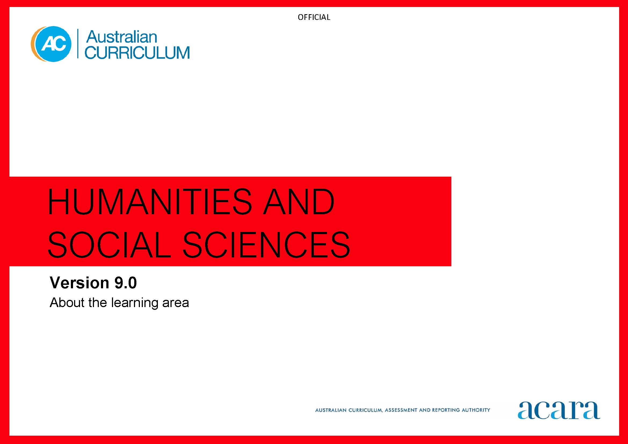

**Copyright and Terms of Use Statement**

**© Australian Curriculum, Assessment and Reporting Authority 2022**

The material published in this work is subject to copyright pursuant to the Copyright Act 1968 (Cth) and is owned by the Australian Curriculum, Assessment and Reporting Authority (ACARA) (except to the extent that copyright is held by another party, as indicated).

The viewing, downloading, displaying, printing, reproducing (such as by making photocopies) and distributing of these materials is permitted only to the extent permitted by, and is subject to the conditions imposed by, the terms and conditions of using the ACARA website (see, especially, clauses 2, 3 and 4 of those terms and conditions). The terms and conditions can be viewed at [https://www.acara.edu.au/contact-us/copyright](https://aus01.safelinks.protection.outlook.com/?url=https%3A%2F%2Fwww.acara.edu.au%2Fcontact-us%2Fcopyright&data=04%7C01%7CSharon.Foster%40acara.edu.au%7C9931e11fa7684c603e6308d98331bbfb%7C6cf76a3aa824427092003d71673ec678%7C0%7C0%7C637685071906340874%7CUnknown%7CTWFpbGZsb3d8eyJWIjoiMC4wLjAwMDAiLCJQIjoiV2luMzIiLCJBTiI6Ik1haWwiLCJXVCI6Mn0%3D%7C1000&sdata=U5O4Vlbpf271IGmGiMh7fDwU4pLzzAiHpCQFylkp6s4%3D&reserved=0)

TABLE OF CONTENTS

F–10 AUSTRALIAN CURRICULUM: HUMANITIES AND SOCIAL SCIENCES: 3

About the learning area 3

Introduction 3

Rationale 3

Aims 4

Structure 4

Key considerations 6

Key connections 7

Resources 13

F–10 AUSTRALIAN CURRICULUM: HUMANITIES AND SOCIAL SCIENCES:

About the learning area

Introduction

The Australian Curriculum: Humanities and Social Sciences Foundation to Year 10 comprises 5 subjects:

* Humanities and Social Sciences from Foundation to Year 6: in these years, students are introduced to the disciplines of History and Geography from Foundation, Civics and Citizenship from Year 3, and Economics and Business from Year 5
* Civics and Citizenship in Years 7–10
* Economics and Business in Years 7–10
* Geography in Years 7–10
* History in Years 7–10.

Humanities and Social Sciences is written on the basis that all students will study Humanities and Social Sciences from F–6. In Years 7–10, students will study History. In Years 7–8, students will study Geography, Civics and Citizenship, and Economics and Business. In Years 9–10, students’ access to Geography, Civics and Citizenship, and Economics and Business will be determined by school authorities or individual schools.

Rationale

The Humanities and Social Sciences are the study of human behaviour and interaction in social, cultural, environmental, economic, business, legal and political contexts. This learning area has a historical and contemporary focus, from personal to global contexts, and considers the challenges that may occur in the future. It plays an important role in assisting students to understand global issues, and building their capacity to be active and informed citizens who understand and participate in the world.

The Humanities and Social Sciences subjects in the Australian Curriculum provide a broad understanding of the world we live in, and how people can participate as active and informed citizens with high-level skills needed now and in the future. They provide opportunities for students to develop their own personal and social learning, and to explore their perspectives as well as those of others.

Through studying Humanities and Social Sciences, students will develop the ability to question, think critically, solve problems, communicate effectively, make decisions and adapt to change. This requires an understanding of the key historical, geographical, legal, political, economic, business and societal factors involved, and how these different factors interrelate.

Aims

Humanities and Social Sciences aims to ensure that students develop:

* a sense of wonder, curiosity and respect about places, people, cultures and systems throughout the world, past and present, and an interest in and enjoyment of the study of these phenomena
* key historical, geographical, civic, business and economic knowledge of people, places, values and systems, past and present, in local to global contexts
* an understanding and appreciation of historical developments, geographic phenomena, civic values and economic factors that shape society, influence sustainability and create a sense of belonging
* an understanding of the key concepts applied to disciplinary and/or cross-disciplinary inquiries
* the capacity to use disciplinary skills, including disciplinary-appropriate questioning, researching using reliable sources, analysing, evaluating and communicating
* dispositions required for effective participation in everyday life, now and in the future, including the ability to problem-solve critically and creatively, make informed decisions, be a responsible and active citizen, make informed economic and financial choices, and reflect on ethics.

Structure

For each of the 5 subjects in Humanities and Social Sciences, content is organised under 2 interrelated strands:

* Knowledge and understanding
* Skills.

Content is presented in year levels for the Knowledge and understanding strand and in bands for the Skills strand in each of the 5 subjects:

* Humanities and Social Sciences (HASS) in F–6
* Civics and Citizenship in Years 7–10
* Economics and Business in Years 7–10
* Geography in Years 7–10
* History in Years 7–10.

Under each strand, curriculum content is further organised into sub-strands depending on the subject.

The Knowledge and understanding strand provides the contexts through which the concepts and skills of each subject are developed in increasing complexity. Skills strand content is developed from HASS F–6 through to the 4 subjects in Years 7–10. Figure 1 shows the relationship between the Skills sub-strands as they develop from Foundation to Year 10 and in each Humanities and Social Sciences subject.

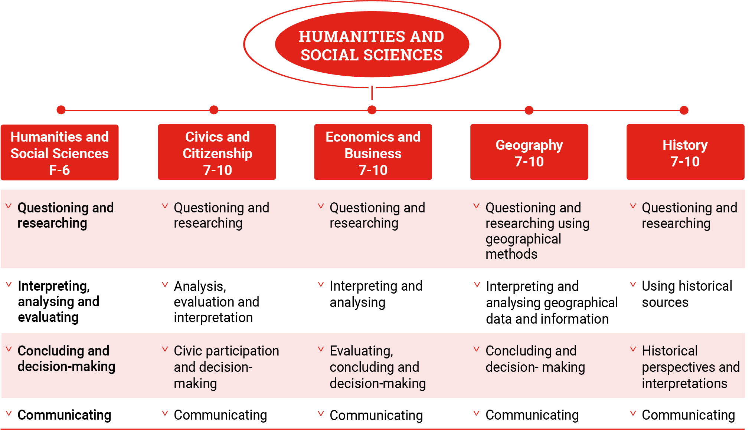

Figure 1: Humanities and Social Sciences Skills strand structure

Key considerations

Protocols for engaging First Nations Australians

When planning teaching activities involving engagement with First Nations Australians, teachers should follow protocols that describe principles, procedures and behaviours for recognising and respecting First Nations Australians and their intellectual property. Teachers should use approved resources such as those that may be provided by their state or territory school system, or First Nations Australian education consultative groups, or other protocols accredited by First Nations Australians.

While the Australian Curriculum uses the terms “First Nations Australians” and “Australian First Nations Peoples”, there may be other terms that First Nations Australians of a particular area or location prefer. It is important to use the terms preferred in a particular area or location.

Meeting the needs of diverse learners

The Australian Curriculum values diversity by providing for multiple means of representation, action, expression and engagement, and allows schools the flexibility to respond to the diversity of learners within their community.

All schools have a responsibility when implementing the Australian Curriculum to ensure that students’ learning is inclusive, and relevant to their experiences, abilities and talents.

For some students with diverse languages, cultures, abilities and talents, it may be necessary to provide a range of curriculum adjustments so they can access age-equivalent content in the Australian Curriculum and participate in learning on the same basis as their peers.

Humanities and Social Sciences is intended for all students, and it is recognised that some students may require adjustments to support how they access and/or process subject-specific content. This includes acknowledging the different ways students observe and interact with the world around them. Further, some students will require adjustments to provide opportunities that extend their abilities or talents. Strategies to support these students could include, but are not limited to, their having access to:

* auditory, visual and kinaesthetic methods of instruction to support the explicit teaching of Humanities and Social Sciences discipline-specific skills
* tactile models or HTML text to explain the data on maps or other visual sources of information and data
* word walls or a visual glossary to support vocabulary development that is discipline-specific
* opportunities to communicate geographical field work in different ways
* field work locations that are appropriate for all students.

Key connections

General capabilities

General capabilities equip young Australians with the knowledge, skills, behaviours and dispositions to live and work successfully. General capabilities support and deepen student engagement with learning area content and are best developed within the context of learning areas.

Opportunities to develop general capabilities in learning area content vary. In addition to literacy and numeracy, which are fundamental to all learning areas, all the other general capabilities have relevance and application to Humanities and Social Sciences. The general capabilities are identified in content descriptions when they are developed or applied through the Humanities and Social Sciences content. They are also identified in content elaborations when they offer opportunities to add depth and richness to student learning.

**Literacy**

In Humanities and Social Sciences, students develop the literacy capability as they learn how to build knowledge in relation to historical, geographical, civic, economic and business information, concepts and ideas. Students progressively learn to use a wide range of informational, persuasive and imaginative texts in multiple modes. These texts include stories, narrative recounts, reports, explanations, arguments, debates, timelines, maps, tables, graphs and images, often supported by references from primary and secondary sources.

Students learn to make increasingly sophisticated language and text choices, understanding that language varies according to context, including the nature and stages of their inquiry. They learn to use language features and text structures to comprehend and compose cohesive texts about places, people, events, processes, systems and perspectives of the past, present and future. These include topic-specific vocabulary, appropriate verb tenses, and complex sentences that describe sequential, cause-and-effect and comparative relationships. Students recognise how language and images can be used to make and manipulate meaning, and evaluate texts for shades of meaning and opinion. Students also participate in debates and discussions, and develop a considered point of view when communicating conclusions, and preferred social and environmental futures to a range of audiences.

**Numeracy**

In Humanities and Social Sciences, students develop the numeracy capability as they apply numeracy skills in relation to historical, geographical, civic, economic and business inquiries. Students count and measure data and information, construct and interpret tables and graphs, and calculate and interpret statistics in their investigations. Students learn to use scaled timelines, including those involving negative and positive numbers, as well as calendars and dates, to recall information on topics of historical significance and to illustrate the passing of time. They collect data through methods such as surveys and field tests. They construct and interpret maps, models, diagrams, and remotely sensed and satellite images, working with numerical concepts of grids, scale, distance, area and projections.

Students learn to analyse numerical data to make meaning of the past, to test relationships in patterns and between variables, such as the effects of location and distance, and to draw conclusions. They make predictions and forecast outcomes based on civic, economic and business data, and environmental and historical information, and represent their findings in numerical and graphical form. Students use numeracy to understand the principles of financial management, and to make informed consumer, financial and business decisions. They appreciate the ways numeracy knowledge and skills are used in society, and apply these to hypothetical and/or real-life experiences.

**Digital Literacy**

In Humanities and Social Sciences, students develop digital literacy when they locate, process, analyse, evaluate and communicate historical, geographic, civic, economic and business information. Students access and use digital literacy, including spatial technologies, as an investigative and creative tool. They seek a range of digital sources of information to resolve inquiry questions or challenges of historical, geographic, civic, economic and business relevance, being aware of intellectual property. They critically analyse evidence and trends, and critique source reliability. Using digital literacy, students present and represent their learning, and collaborate, discuss and debate to co-construct their knowledge. They plan, organise, create, display and communicate data and information digitally, using multimodal elements for a variety of reasons and audiences.

Students enhance their digital literacy by exploring the increasing use of technology and the effects of technologies on people and places, and civic, economic and business activity. They learn about and have opportunities to use social media to collaborate, communicate and share information, and build consensus on issues of social, civic, economic, business and environmental significance, while using an awareness of personal security protocols and ethical responsibilities.

**Critical and Creative Thinking**

In Humanities and Social Sciences, students develop their critical and creative thinking as they investigate historical, geographic, civic, economic and business concepts and ideas through inquiry-based learning. The effective development of critical and creative thinking in Humanities and Social Sciences enables students to learn to apply concepts and skills to new contexts and endeavours. Students build their inquiry skills as they learn to develop and clarify investigative questions, and to assess reliability when selecting information from diverse sources. Students develop analytical skills by using evidence to support an argument or position on a social, cultural or political issue. They interpret and analyse economic data and/or information, and apply discipline-specific knowledge and understandings as they draw conclusions and propose solutions to complex problems.

Students develop creative thinking dispositions when they are encouraged to be curious and imaginative in investigations and field work, to consider multiple perspectives about issues and events, and when thinking deeply about questions that do not have straightforward answers. They imagine alternative futures in response to social, environmental, civic, economic and business challenges that require problem-solving and innovative solutions. They propose appropriate and alternative courses of action and consider the effects on their own lives and the lives of others.

**Personal and Social capability**

In Humanities and Social Sciences, students develop personal and social capability (self- and social awareness) as they gain an understanding of people and places through historical, geographic, civic, economic and business inquiry. Through learning experiences that enhance reflective practice, students develop an appreciation of the insights and perspectives of others. They develop understanding of what informs their personal identity and sense of belonging, including concepts of place, and their cultural and national heritage.

Learning through inquiry enables students to develop self-management skills by directing their own learning and providing opportunities to express and reflect on their opinions, beliefs, values and questions. Social management skills are developed as students collaborate with others to make informed decisions, show leadership and demonstrate advocacy skills to achieve desired outcomes, and to contribute to their communities and society more broadly.

**Ethical Understanding**

In Humanities and Social Sciences, students develop ethical understanding as they investigate the ways that diverse values and principles have influenced human activity. As students develop informed, ethical values and attitudes, they explore different perspectives, ambiguities and ethical considerations related to social and environmental issues. They discuss and apply ethical concepts such as equality, respect and fairness, examine shared beliefs and values that support Australian democracy and citizenship, and become aware of their own roles, rights and responsibilities as participants in their social, economic and natural world.

**Intercultural Understanding**

In Humanities and Social Sciences, students develop intercultural understanding as they learn about the diversity of the world’s places and peoples, and people’s lives, cultural practices, values, beliefs and ways of knowing. They learn the importance of understanding their own and others’ histories, recognising the significance of the histories and cultures of First Nations Australians, and the contributions of Australian migrants. They demonstrate respect for cultural diversity and the human rights of all people.

Students learn of Australia’s economic and political relationships with other countries and the role of intercultural understanding for the present and future. As they investigate the interconnections between people and the significance that places hold, they learn how various cultural identities, including their own, are shaped. They reflect on their own intercultural experiences and explore how people interact across cultural boundaries, considering how factors such as group membership, traditions, customs, and religious and cultural practices impact on civic life.

Cross-curriculum priorities

Cross-curriculum priorities support the Australian Curriculum to be a relevant, contemporary and engaging curriculum that reflects national, regional and global contexts. Cross-curriculum priorities are incorporated through learning area content; they are not separate learning areas or subjects. They provide opportunities to enrich the content of the learning areas, where most appropriate and authentic, allowing students to engage with and better understand their world.

Opportunities to apply cross-curriculum priorities to learning area content vary. All 3 cross-curriculum priorities have relevance and meaning to the Humanities and Social Sciences curriculum.

**Aboriginal and Torres Strait Islander Histories and Cultures**

Humanities and Social Sciences is the primary learning area in which students explore and deepen their knowledge of Aboriginal Peoples and Torres Strait Islander Peoples as the world’s oldest continuous living cultures and First Nations Peoples of Australia.

This learning area provides students with the opportunity to understand the histories of Australian First Nations Peoples, which involve occupation of the Australian continent for more than 60,000 years. Students understand the enduring impacts of colonisation on Australian First Nations Peoples’ cultures and impact of the doctrine of terra nullius on ownership of and access to Country/Place. Importantly, this learning area includes the significant contributions of Australian First Nations Peoples’ histories and cultures on a local, national, regional and global scale.

Students appreciate and celebrate the diversity of Australian First Nations Peoples’ cultures. They understand how these cultures are based on special connections to Country/Place, and have unique belief systems and ways of being, knowing, thinking and doing linked to these physical and spiritual interconnections. The development of these understandings includes exploring contemporary issues that demonstrate the dynamic nature of Australian First Nations Peoples’ cultures.

This learning area develops students’ knowledge of citizenship that positions First Nations Australians as the Traditional Owners of Country/Place and highlights how native title law recognises Australian First Nations Peoples’ rights and interests. Students examine the sophisticated social organisation systems, protocols, kinship structures, economies and enterprises of First Nations Australians.

To study this learning area, students use primary and secondary sources, including oral histories and traditional, culturally appropriate sources to see events through multiple perspectives. This allows them to empathise and ethically consider the investigation, preservation and conservation of sites of significance to First Nations Australians.

**Asia and Australia’s Engagement with Asia**

In Humanities and Social Sciences, students investigate the diversity of cultures, values, beliefs, histories and environments that exists within and between the countries of the Asia region. They learn about how this diversity influences the way people interact with each other, the places where they live, and the social, economic, political and cultural systems of the region as a whole. Students investigate the reasons behind internal migration in the Asia region and migration from Asia to Australia, and develop understanding of the experiences of people of Asian heritage who are now Australian citizens. Students can learn about the shared history and the environmental, social and economic interdependence of Australia and the Asia region. In a changing globalised world, the nature of interdependence between Asia and Australia continues to change. By exploring the way transnational and intercultural collaboration supports shared and sustainable futures, students reflect on how Australians can participate in the Asia region as active and informed citizens.

**Sustainability**

Humanities and Social Sciences helps students develop the ability to question, think critically, solve problems, communicate effectively, make decisions and adapt to change. Students respond to the challenges of sustainability through an understanding of the key historical, geographical, political, economic and societal factors involved, and how these different factors interrelate.

The learning area provides content that supports the development of students’ world views, particularly in relation to judgements about past social and economic systems, and access to and use of the earth’s resources. Students are given opportunities to integrate their study of biophysical processes with investigations of the attitudinal, demographic, social, economic and political influences on human use and management of the environment. The curriculum prepares students to be informed consumers, to act in enterprising and innovative ways, and to perceive business opportunities in changing local, regional, national and global economic environments. Students explore contemporary issues of sustainability, and develop action plans and possible solutions to local, regional, national and global issues that have social, economic and environmental perspectives.

Learning areas

Humanities and Social Sciences provides opportunities to integrate and connect content to other learning areas, in particular, English, Mathematics, Science, Technologies and Languages.

**Humanities and Social Sciences and English**

Humanities and Social Sciences and English share a focus on analysing, interpreting and evaluating information and texts, considering the ways in which points of view shape texts. Both learning areas help students to develop written, visual, digital and multimodal texts by selecting appropriate text and language features for a range of purposes and audiences.

**Humanities and Social Sciences and Mathematics**

Humanities and Social Sciences and Mathematics share a focus on consumer and financial literacy, including understanding the principles of financial management to make informed consumer, financial and business decisions. Mathematics draws on aspects of the Humanities and Social Sciences curriculum to provide ethical considerations and rich contexts through which to teach and apply mathematics. Students learn to organise, interpret, analyse and present information about historical and civic events and developments in numerical and graphical form to make meaning of the past and present. They learn to use scaled timelines, including those involving negative and positive numbers, and calendars and dates to represent information of historical significance and to illustrate the passing of time. In constructing and interpreting maps, students work with numerical concepts associated with grids, scale, distance, area and projections.

**Humanities and Social Sciences and Science**

Humanities and Social Sciences and Science share a focus on understanding patterns of continuity and change in the world. Humanities and Social Sciences subjects draw on students’ scientific understandings of biological and earth and space sciences, and provide an opportunity for students to explore socio-scientific issues through the lens of science as a human endeavour. The 2 learning areas share a focus on developing students’ inquiry skills, through questioning and data collection and analysis, to form evidence-based conclusions and arguments.

**Humanities and Social Sciences and Technologies**

Humanities and Social Sciences and Digital Technologies share a focus on acquiring and examining data. They look for patterns in data as they interpret for relevance and reliability, interacting with digital tools to support the visualisation and representation of data related to people, systems and interactions. Humanities and Social Sciences and Design and Technologies share a focus on examining the factors that influence the design of the built environment and identify reasons for its social, cultural or spiritual significance. Students examine the impact of the use of technologies on people, including how technological developments have changed people’s lives at home and the ways they work, travel and communicate.

Humanities and Social Sciences and Design and Technologies also share a focus on the factors that influence the production of food and fibre, including how to address challenges to sustainable production.

**Humanities and Social Sciences and Languages**

Humanities and Social Sciences and Languages share the learning contexts that developmentally shape students’ worlds. In both learning areas, students’ learning begins with perspectives of their personal worlds. Their perspectives then extend to their local communities and to national and global contexts and perspectives. In the process of understanding an expanding world view, both learning areas help students to learn to reflect on the relationship between cultures and identities.

Resources

Curriculum documents including understanding the learning area, curriculum content in F–6 and 7–10, a scope and sequence representation, the glossary, and comparative information about Version 8.4 and Version 9.0 are available on the download page.