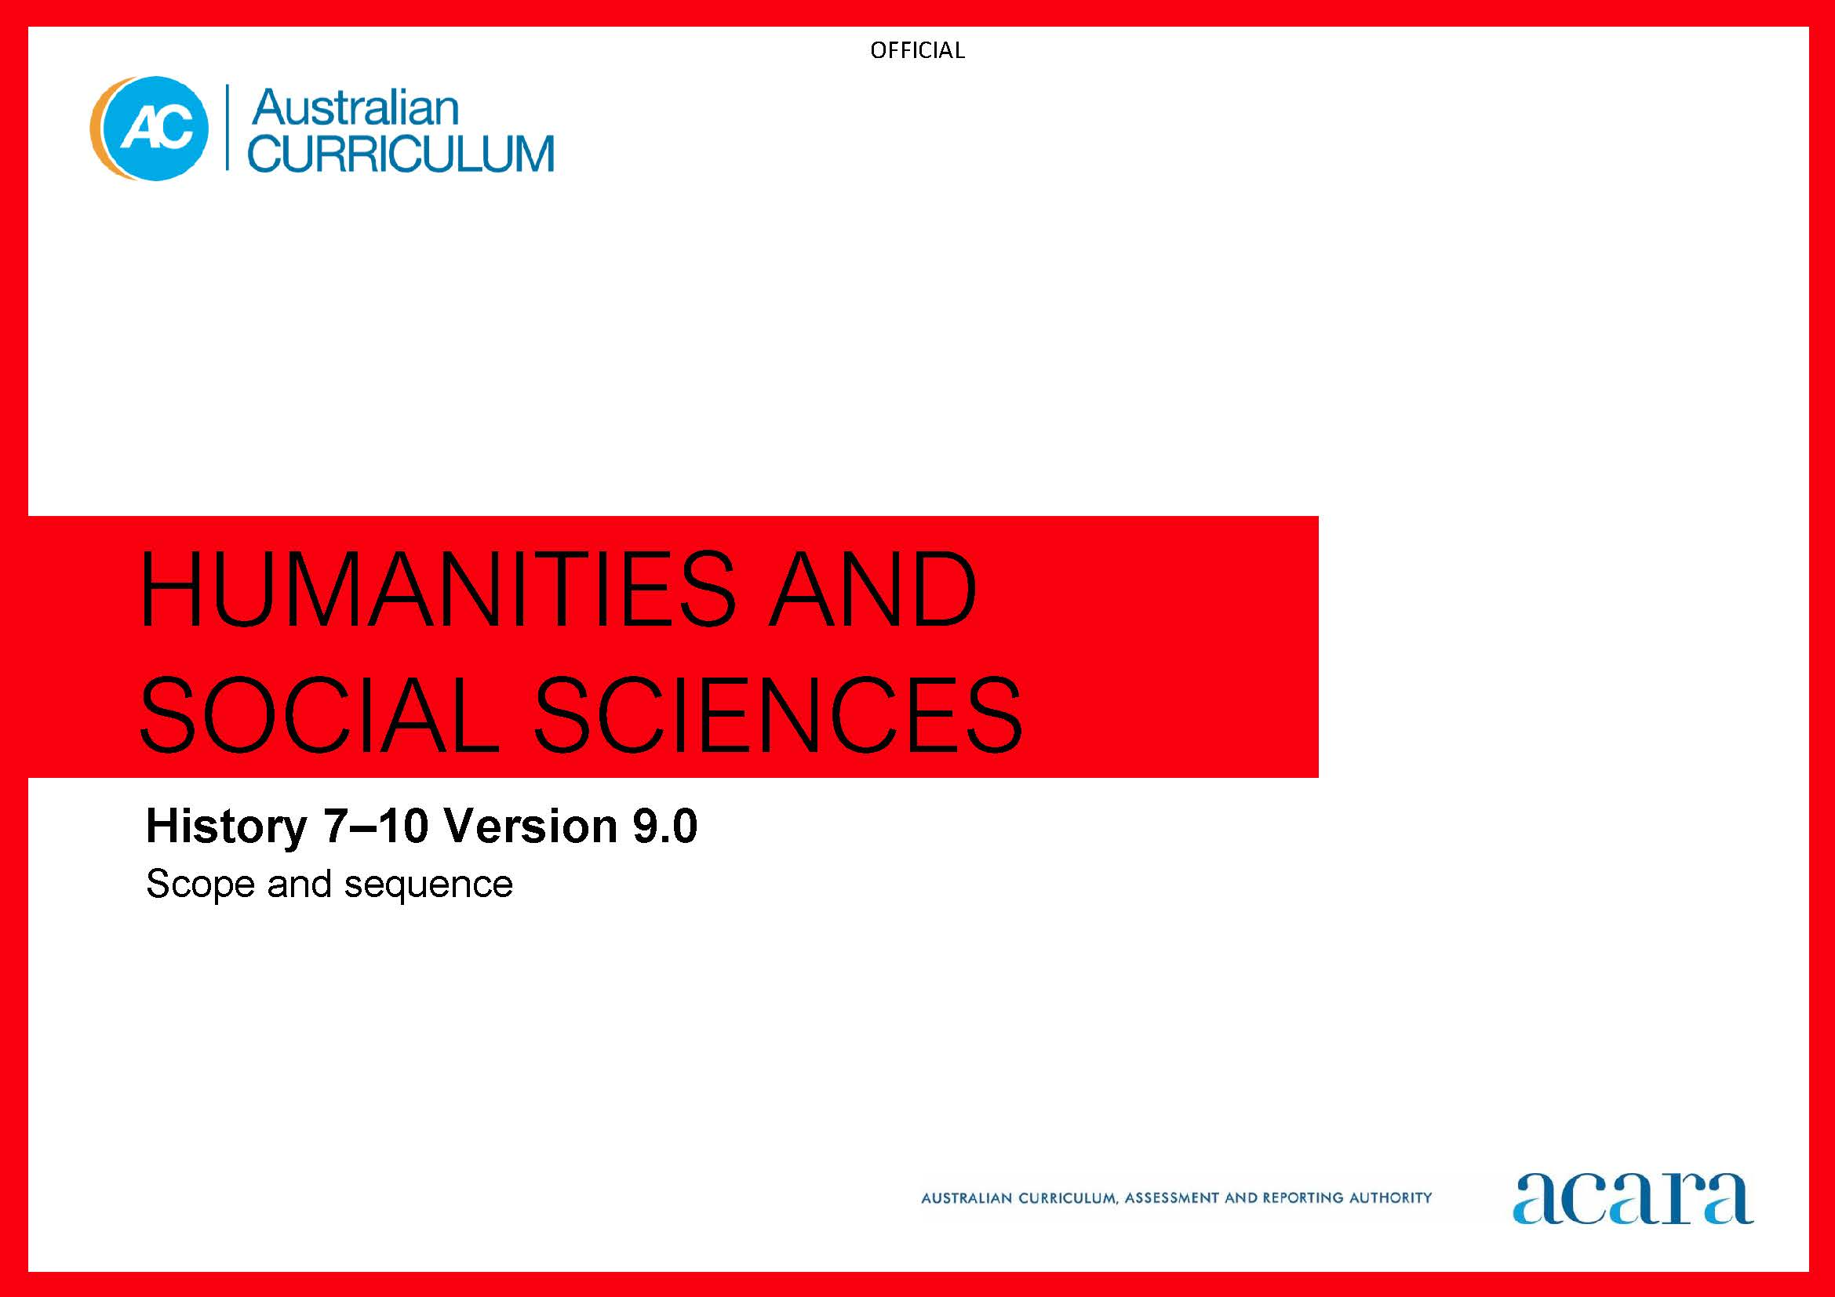

**Copyright and Terms of Use Statement**

**© Australian Curriculum, Assessment and Reporting Authority 2022**

The material published in this work is subject to copyright pursuant to the Copyright Act 1968 (Cth) and is owned by the Australian Curriculum, Assessment and Reporting Authority (ACARA) (except to the extent that copyright is held by another party, as indicated).

The viewing, downloading, displaying, printing, reproducing (such as by making photocopies) and distributing of these materials is permitted only to the extent permitted by, and is subject to the conditions imposed by, the terms and conditions of using the ACARA website (see, especially, clauses 2, 3 and 4 of those terms and conditions). The terms and conditions can be viewed at [https://www.acara.edu.au/contact-us/copyright](https://aus01.safelinks.protection.outlook.com/?url=https%3A%2F%2Fwww.acara.edu.au%2Fcontact-us%2Fcopyright&data=04%7C01%7CSharon.Foster%40acara.edu.au%7C9931e11fa7684c603e6308d98331bbfb%7C6cf76a3aa824427092003d71673ec678%7C0%7C0%7C637685071906340874%7CUnknown%7CTWFpbGZsb3d8eyJWIjoiMC4wLjAwMDAiLCJQIjoiV2luMzIiLCJBTiI6Ik1haWwiLCJXVCI6Mn0%3D%7C1000&sdata=U5O4Vlbpf271IGmGiMh7fDwU4pLzzAiHpCQFylkp6s4%3D&reserved=0)

|  |  |
| --- | --- |
| **Year 7** | **Year 8** |
| **Achievement standard** | |
| By the end of Year 7, students describe the historical significance of the ancient past and the histories of early First Nations Peoples of Australia. They identify the causes and effects of events, developments and achievements connected to groups and individuals in Australia and other societies from the ancient past. Students describe the social, religious, cultural, economic, environmental and/or political aspects related to changes and continuities in these societies. They identify the roles and achievements of significant individuals and groups, and the influences on the development of ancient societies. Students explain the importance of heritage sites connected to Australia and other societies from the ancient past.  Students develop questions about the past. They locate and identify primary and secondary sources as evidence in historical inquiry. They describe the origin, content, context and purpose of primary and secondary sources. Students identify the accuracy and usefulness of sources as evidence. They sequence events and developments to describe causes and effects, and continuities and changes across societies and periods of time. They describe the perspectives, attitudes and values of the past in sources. They identify and describe historical interpretations about significant events and people, Students use historical knowledge, concepts, terms and evidence from sources to create descriptions, explanations and historical arguments. | By the end of Year 8, students describe the historical significance of the periods between the ancient and modern past. They explain the causes and effects of events, developments, turning points or challenges in Medieval, Renaissance or pre-modern Europe, or in the societies connected to empires or expansions, or the societies of the Asia-Pacific world during these periods. They describe the social, religious, cultural, economic, environmental and/or political aspects related to the changes and continuities in a society or a historical period. Students describe the role of significant individuals, groups and institutions connected to the societies of these periods and their influences on historical events.  Students develop questions about the past to inform historical inquiry. They locate and identify a range of primary and secondary sources as evidence in historical inquiry. They describe the origin, content and context of sources, and explain the purpose of primary and secondary sources. Students compare sources to explain the accuracy, usefulness and reliability of sources as evidence. They sequence events and developments to explain causes and effects, and patterns of continuity and change across societies and time periods. They describe perspectives, attitudes and values of the past, and suggest reasons for different points of view. They explain historical interpretations about significant events and people. Students use historical knowledge, concepts, terms and references to evidence from sources to create descriptions, explanations and historical arguments. |

|  |  |
| --- | --- |
| **Content descriptions** | |
| **Strand: Knowledge and understanding** | |
| **Sub-strand: Deep time history of Australia** | **Sub-strand: Medieval Europe and the early modern world** |
| theories and historical interpretations about early human evolution and migration, such as the theory that people moved out of Africa and the causes of migration to other parts of the world, including Australia  AC9HH7K01 | the transformation of the ancient world to the early modern world, from the decline of the Roman Empire in western Europe through Medieval, Renaissance or pre-modern Europe  AC9HH8K01 |
| theories about the causes and effects of the arrival of early First Nations Australians on the Australian continent and their migration routes across the continent  AC9HH7K02 | the roles and relationships of different groups in Medieval, Renaissance or pre-modern Europe  AC9HH8K02 |
| how First Nations Australians are the world’s oldest continuing cultures, displaying evidence of both continuity and change over deep time  AC9HH7K03 | a significant event, development, turning point or challenge that contributed to continuity and change in Medieval, Renaissance or pre-modern Europe  AC9HH8K03 |
| how First Nations Australians have responded to environmental processes and changes over time  AC9HH7K04 | the experiences and perspectives of rulers and of subject peoples, and the interaction between power and/or authority in Medieval, Renaissance or pre-modern Europe  AC9HH8K04 |
| the technological achievements of early First Nations Australians, and how these developed in different places and contributed to daily life, and land and water source management  AC9HH7K05 | the role and achievements of a significant individual and/or group in Medieval, Renaissance or pre-modern Europe  AC9HH8K05 |
| the social organisation and cultural practices of early First Nations Australians, and their continuity and change over time  AC9HH7K06 | interpretations about an event, individual, group, institution or movement in Medieval, Renaissance or pre-modern Europe  AC9HH8K06 |
| the cultural obligations of First Nations Australians about significant heritage sites, including ancestral remains, material culture and artefacts, and the role of collaboration between First Nations Australians and other individuals and groups to ensure cultural preservation  AC9HH7K07 |  |
| **Sub-strand: The ancient world** | **Sub-strand: Empires and expansions** |
| the different methods and sources of evidence used by historians and archaeologists to investigate early societies, and the importance of archaeology and conserving the remains, material culture and heritage of the past  AC9HH7K08 | the significant social, religious, cultural, economic, environmental and/or political features of different groups related to the empire and/or expansion  AC9HH8K07 |
| how the physical, environment and geographical features influenced the development of the ancient society  AC9HH7K09 | a significant event, development, turning point or challenge that contributed to continuity and change related to the empire and/or expansion  AC9HH8K08 |
| the organisation and roles of key groups in ancient society such as the nobility, bureaucracy, women and slaves, and how they influenced and changed society  AC9HH7K10 | the experiences and perspectives of rulers and of subject peoples, and how the interaction between power and/or authority relates to the empire and/or expansion  AC9HH8K09 |
| key beliefs, values and practices of an ancient society, with a particular emphasis on one of the following areas: everyday life, warfare, or death and funerary customs  AC9HH7K11 | the role and achievements of a significant individual and/or group connected to the empire and/or expansion  AC9HH8K10 |
| causes and effects of contacts and conflicts within ancient societies and/or with other societies, resulting in developments such as the conquest of other lands, the expansion of trade and peace treaties  AC9HH7K12 | interpretations about the society and events, and/or individuals and/or groups connected to the empire and/or expansion  AC9HH8K11 |
| the role and achievements of a significant individual in an ancient society  AC9HH7K13 |  |
|  | **Sub-strand: Asia-Pacific world** |
|  | the significant social, religious, cultural, economic, environmental and/or political continuities and changes in the way of life, and the roles and relationships of different groups in the Asian-Pacific society  AC9HH8K12 |
|  | `a significant development, event, turning point or challenge that contributed to continuity and change in the Asian-Pacific society  AC9HH8K13 |
|  | the experiences and perspectives of rulers and of subject peoples, and the interaction between power and/or authority in the Asian-Pacific society  AC9HH8K14 |
|  | the role and achievements of a significant individual and/or group in the Asian-Pacific society  AC9HH8K15 |
|  | interpretations about the Asian-Pacific society and events, and/or individuals and/or groups connected to the society  AC9HH8K16 |

|  |
| --- |
| **Strand: Skills** |
| **Sub-strand: Questioning and researching** |
| develop historical questions about the past to inform historical inquiry  AC9HH7S01 AC9HH8S01 |
| locate and identify primary and secondary sources to use in historical inquiry  AC9HH7S02 AC9HH8S02 |
| **Sub-strand: Using historical sources** |
| identify the origin, content, context and purpose of primary and secondary sources  AC9HH7S03 AC9HH8S03 |
| identify and describe the accuracy and usefulness of primary and secondary sources as evidence  AC9HH7S04 AC9HH8S04 |
| **Sub-strand: Historical perspectives and interpretations** |
| describe causes and effects, and explain continuities and changes  AC9HH7S05 AC9HH8S05 |
| identify perspectives, attitudes and values of the past in sources  AC9HH7S06 AC9HH8S06 |
| explain historical interpretations about significant events, individuals and groups  AC9HH7S07 AC9HH8S07 |
| **Sub-strand: Communicating** |
| create descriptions, explanations and historical arguments using historical knowledge, concepts and terms that reference evidence from sources  AC9HH7S08 AC9HH8S08 |

|  |  |
| --- | --- |
| **Year 9** | **Year 10** |
| **Achievement standard** | |
| By the end of Year 9, students explain the historical significance of the period of the early modern world up to 1918. They explain the causes and effects of events, developments, turning points or movements globally, in Australia and in relation to the First World War or in an Asian context. They describe the social, cultural, economic and/or political aspects related to the changes and continuities in a society or a historical period. Students explain the role of significant ideas, individuals, groups and institutions connected to the developments of this period and their influences on the historical events.  Students develop and modify questions about the past to inform historical inquiry. They locate, select and compare primary and secondary sources, and use information in sources as evidence in historical inquiry. They explain the origin, content, context and purpose of primary and secondary sources. Students compare sources to determine the accuracy, usefulness and reliability of sources as evidence. They explain causes and effects, and patterns of continuity and change connected to a period, event or movement. Students compare perspectives of significant events and developments, and explain the factors that influence these perspectives. They analyse different and contested historical interpretations. Students use historical knowledge, concepts and terms to develop descriptions, explanations and historical arguments that acknowledge evidence from sources. | By the end of Year 10, students explain the historical significance of the period between 1918 and the early 21st century. They explain the causes and effects of events, developments, turning points or movements in 20th-century Australia and internationally, leading up to and through the Second World War, and the post-war world. They describe social, cultural, economic and/or political aspects, including international developments, related to the changes and continuities in Australian society over this historical period. Students explain the role of significant ideas, individuals, groups and institutions connected to the developments of this period and their influences on Australian and global history.  Students develop and modify a range of questions about the past to inform historical inquiry. They locate, select and compare a range of primary and secondary sources and synthesise the information in sources to use as evidence in historical inquiry. They analyse the origin, content, context and purpose of primary and secondary sources. Students evaluate the accuracy, usefulness and reliability of sources as evidence. They sequence events and developments to analyse cause and effect, and patterns of continuity and change, connected to a period, event or movement. They evaluate perspectives of significant events and developments, and explain the important factors that influence these perspectives. They compare and evaluate different and contested historical interpretations. Students use historical knowledge, concepts and terms to develop descriptions, explanations and historical arguments that synthesise evidence from sources. |

|  |  |
| --- | --- |
| **Content descriptions** | |
| **Strand: Knowledge and understanding** | |
| **Sub-strand: Making and transforming the Australian nation (1750 – 1914)** | **Sub-strand: Second World War** |
| the causes and effects of European imperial expansion and the movement of peoples in the late 18th and early 19th centuries, and the different responses to colonisation and migration  AC9HH9K01 | the causes and outbreak of the Second World War and the significance of Australian involvement  AC9HH10K01 |
| the key social, cultural, economic and political changes and their significance in the development of Australian society during the period  AC9HH9K02 | the places where Australians fought, and their perspectives and experiences during the Second World War, such as the fall of Singapore, prisoners of war (POWs), the Battle of Britain and Kokoda  AC9HH10K02 |
| the causes and effects of European contact and extension of settlement, including their impact on the First Nations Peoples of Australia  AC9HH9K03 | the significant events and turning points of the Second World War, including the Holocaust and use of the atomic bomb  AC9HH10K03 |
| significant events, ideas, people, groups and movements in the development of Australian society  AC9HH9K04 | the effects of the Second World War, with a particular emphasis on the continuities and changes on the Australian home front, such as the changing roles of women and First Nations Australians, and the use of wartime government controls  AC9HH10K04 |
| continuities and changes and their effects on ways of life and living conditions, political and legal institutions, and cultural expression around the turn of the 20th century in Australian society  AC9HH9K05 | the significance of the Second World War to Australia’s immediate post-war economic, political and social development, and Australia’s international relationships in the 20th century  AC9HH10K05 |
| different experiences and perspectives of colonisers, settlers and First Nations Australians and the impact of these experiences on changes to Australian society’s, ideas, beliefs and values  AC9HH9K06 | the commemoration of the Second World War, including different historical interpretations and debates  AC9HH10K06 |
| the development of Australian society in relation to other nations in the world by 1914, including the effects of ideas and movements of people  AC9HH9K07 |  |
| **Sub-strand: First World War (1914 – 1918)** | **Sub-strand: Building modern Australia** |
| the causes of the First World War and the reasons why Australians enlisted to fight in the war  AC9HH9K08 | the effects of significant post–the Second World War world events, ideas and developments on Australian society  AC9HH10K07 |
| the places of significance where Australians fought, their perspectives and experiences, including the Gallipoli campaign, the Western Front and the Middle East  AC9HH9K09 | the causes of changes in perspectives, responses, beliefs and values on migration that have influenced Australian society since 1945  AC9HH10K08 |
| significant events and turning points of the war and the nature of warfare, including the Western Front Battle of the Somme and the Armistice  AC9HH9K10 | the causes of First Nations Australians’ campaigns for rights and freedoms before 1965, such as discriminatory legislation and policies, the 1938 Day of Mourning and the Stolen Generations  AC9HH10K09 |
| the effects of the First World War on Australian society such as the role of women, political debates about conscription, relationships with the British Empire, and the experiences of returned soldiers  AC9HH9K11 | the contributions of significant individuals and groups in the campaign for the recognition of the rights of First Nations Australians and the extent to which they brought change to Australian society  AC9HH10K10 |
| the commemoration of the First World War, including different historical interpretations and debates about the nature and significance of the Anzac legend and the war  AC9HH9K12 | the significant events and methods in the movement for the civil rights of First Nations Australians and the extent to which they contributed to change  AC9HH10K11 |
|  | the significant events, individuals and groups in the women’s movement in Australia, and how they have changed the role and status of women  AC9HH10K12 |
|  | the continuing efforts to create change in the civil rights and freedoms in Australia, for First Nations Australians, migrants and women  AC9HH10K13 |
| **Sub-strand: The Industrial Revolution and the movement of peoples (1750-1900)** | **Sub-strand: The globalising world** |
| the social, economic, political, technological and/or environmental causes and effects of the Industrial Revolution on Europe in the late 18th and the 19th century  AC9HH9K13 | changing historical perspectives over time in relation to the developments in technology, public health, longevity, standard of living in the 20th century, and concern for the environment and sustainability  AC9HH10K14 |
| the changing population movements and settlement patterns during the period 1750 to 1900  AC9HH9K14 | the origins and significance of the Universal Declaration of Human Rights, including Australia’s involvement in the development of the declaration  AC9HH10K15 |
| the short-, medium- and long-term effects of population movements and changing settlement patterns during this period, such as global demographic changes, transport, new ideas, and political and social reforms  AC9HH9K15 | causes and effects of the significant events and developments of the major global influences on Australia in the post–the Second World War period  AC9HH10K16 |
| the different perspectives and experiences of men, women and children during the Industrial Revolution, and their changing way of life  AC9HH9K16 | changing social, political, economic, cultural, environmental and technological conditions, and the causes of a major global influence in Australia  AC9HH10K17 |
| the ideas that emerged and influenced change in society, such as nationalism, capitalism, imperialism, socialism, egalitarianism and Chartism  AC9HH9K17 | continuities and changes in perspectives, responses, beliefs and values that have influenced the Australian way of life  AC9HH10K18 |
| the role of a significant individual or group such as agricultural and factory workers, inventors and entrepreneurs, landowners, politicians and religious groups in promoting and enacting some of the ideas that emerged during the Industrial Revolution  AC9HH9K18 | the effects of the global influences on Australia’s changing identity as a nation and its international relationships  AC9HH10K19 |
|  | different historical interpretations and debates during the second half of the 20th century  AC9HH10K20 |
| **Sub-strand: Asia and the World (1750-1914)** |  |
| the key social, cultural, economic and political features of an Asian society during the 18th and early 19th century  AC9HH9K19 |  |
| the causes and effects of European contact, including colonialisation, with an Asian society.  AC9HH9K20 |  |
| significant events, ideas, people, groups and/or movements in the development of an Asian society  AC9HH9K21 |  |
| continuities and changes and their effects on the ways of life and living conditions, political and legal institutions, and cultural expression around the turn of the 20th century in an Asian society  AC9HH9K22 |  |
| different experiences and perspectives of colonisers and Asian peoples from the time and the impact of changes to society, including events, ideas, beliefs and values  AC9HH9K23 |  |
| the development of an Asian society in relation to other nations in the world by 1914, including the effects of ideas such as nationalism and self-determination  AC9HH9K24 |  |

|  |
| --- |
| **Strand: Skills** |
| **Sub-strand: Questioning and researching** |
| develop and modify a range of historical questions about the past to inform historical inquiry  AC9HH9S01 AC9HH10S01 |
| locate, identify and compare primary and secondary sources to use in historical inquiry  AC9HH9S02 AC9HH10S02 |
| **Sub-strand: Using historical sources** |
| identify the origin and content of sources, and explain the purpose and context of primary and secondary sources  AC9HH9S03 AC9HH10S03 |
| explain the usefulness of primary and secondary sources, and the reliability of the information as evidence  AC9HH9S04 AC9HH10S04 |
| **Sub-strand: Historical perspectives and interpretations** |
| analyse cause and effect, and/or evaluate patterns of continuity and change  AC9HH9S05 AC9HH10S05 |
| compare perspectives in sources and explain how these are influenced by significant events, ideas, locations, beliefs and values  AC9HH9S06 AC9HH10S06 |
| analyse different and contested historical interpretations  AC9HH9S07 AC9HH10S07 |
| **Sub-strand: Communicating** |
| create descriptions, explanations and historical arguments using historical knowledge, concepts and terms that incorporate and acknowledge evidence from sources  AC9HH9S08 AC9HH10S08 |