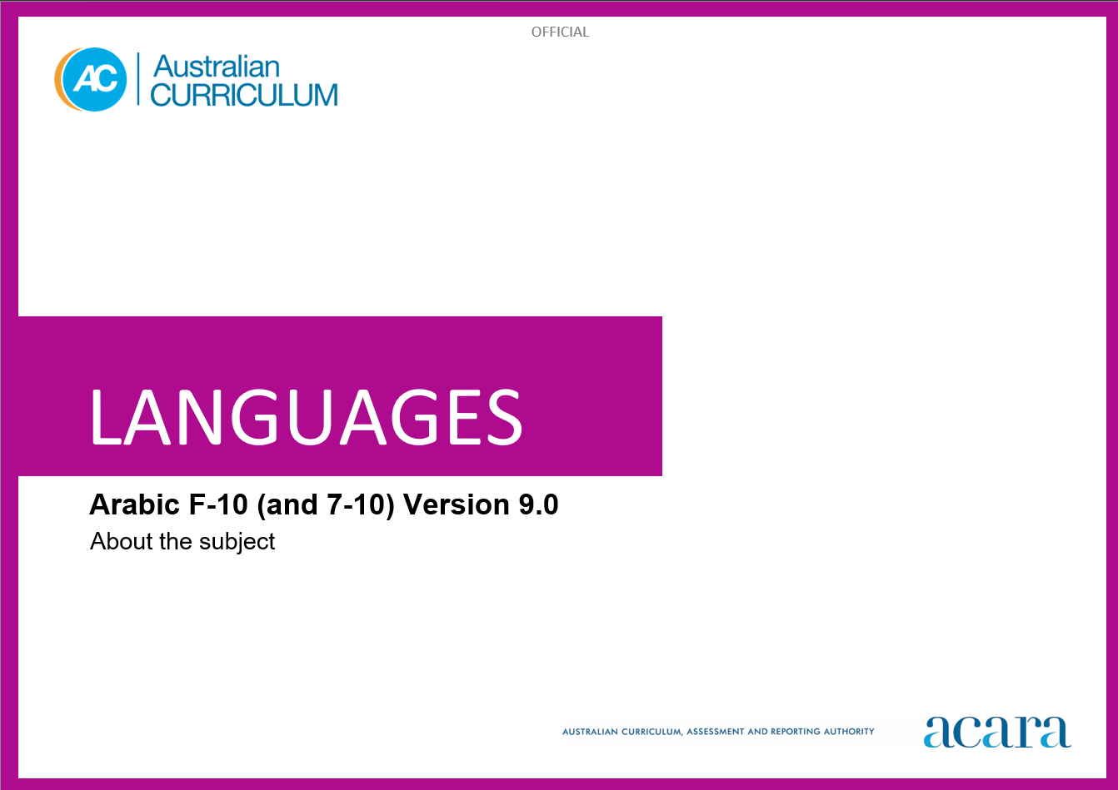­­­

**Copyright and Terms of Use Statement**

**© Australian Curriculum, Assessment and Reporting Authority 2023**

The material published in this work is subject to copyright pursuant to the Copyright Act 1968 (Cth) and is owned by the Australian Curriculum, Assessment and Reporting Authority (ACARA) (except to the extent that copyright is held by another party, as indicated).

The viewing, downloading, displaying, printing, reproducing (such as by making photocopies) and distributing of these materials is permitted only to the extent permitted by, and is subject to the conditions imposed by, the terms and conditions of using the ACARA website (see, especially, clauses 2, 3 and 4 of those terms and conditions). The terms and conditions can be viewed at [https://www.acara.edu.au/contact-us/copyright](https://aus01.safelinks.protection.outlook.com/?url=https%3A%2F%2Fwww.acara.edu.au%2Fcontact-us%2Fcopyright&data=04%7C01%7CSharon.Foster%40acara.edu.au%7C9931e11fa7684c603e6308d98331bbfb%7C6cf76a3aa824427092003d71673ec678%7C0%7C0%7C637685071906340874%7CUnknown%7CTWFpbGZsb3d8eyJWIjoiMC4wLjAwMDAiLCJQIjoiV2luMzIiLCJBTiI6Ik1haWwiLCJXVCI6Mn0%3D%7C1000&sdata=U5O4Vlbpf271IGmGiMh7fDwU4pLzzAiHpCQFylkp6s4%3D&reserved=0)

TABLE OF CONTENTS

ABOUT Arabic 4

Introduction 4

Rationale 4

Structure 4

ABOUT Arabic

Introduction

The Australian Curriculum: Arabic recognises that learners of Arabic in Australian schools have a range of cultural backgrounds and language experiences. Learners may have varying degrees of proficiency in Modern Standard or colloquial Arabic as background-language learners or they may be learning Arabic as a second or additional language.

Rationale

Modern Standard Arabic is an official language common to countries in the Middle East, North Africa and the Gulf States, where it is the language of media and official events. Modern Standard Arabic is one of the 6 official languages of the United Nations and its agencies, such as UNESCO and the World Health Organisation. It is also the language of religious texts across the Islamic world. Colloquial Arabic varies according to geographical location.

The Arabic-speaking world has a rich cultural heritage and history, and has influenced architecture, calligraphy, literature, mathematics and science. It has global economic and political significance.

Arabic speakers have made a significant contribution in shaping multicultural Australia. Arabic has been taught in some Australian schools and universities since the 1980s as well as in community-run organisations prior to this time. The influence of Arabic-speaking communities is evident in areas such as commerce, cuisine, education, industry, journalism, music and religion.

Arabic is a Semitic language. Many English words have been borrowed directly or indirectly from Arabic. Learning Arabic develops students’ understanding of the language and culture of Arabic-speaking communities. It also enhances students’ awareness of the nature of language learning and promotes an appreciation of diverse attitudes, beliefs and values. Knowledge of the Arabic language and culture enriches travel experiences and increases employment opportunities.

Structure

Arabic has been developed to cater for learners with different linguistic experiences, those with a background in Arabic as well as those learning Arabic as a second or additional language.

The Australian Curriculum: Arabic includes 2 sequences:

* Foundation to Year 10
* Years 7 to 10.

Teachers can use the curriculum to make appropriate adjustments to differentiate learning. Content elaborations provide differentiated examples of language use and contexts to assist teachers to meet the needs of a range of learners, including background-language learners and second-language learners.

Content in Arabic is organised under 2 interrelated strands, each with a number of sub-strands. The strands and sub-strands are presented in Figure 2.

*Figure 2: Arabic content structure*

Strand: Communicating meaning in Arabic

This involves students learning to use language for communicative purposes in interpreting, creating and exchanging meaning. There are 3 sub-strands.

**Interacting in Arabic**

Exchanging ideas, opinions, experiences, thoughts and feelings in non-verbal, spoken and written interactions; participating in planning, negotiating, deciding and taking action.

**Mediating meaning in and between languages**

Obtaining, processing, interpreting and conveying information through a range of spoken, written and multimodal texts; moving between languages and cultures non-verbally, orally and in writing, recognising different interpretations.

**Creating text in Arabic**

Creating a range of spoken, written and multimodal texts for specific contexts, purposes and audiences.

Strand: Understanding language and culture

This involves students learning to analyse and understand language and culture as resources for interpreting and shaping meaning in intercultural exchange. There are 2 sub-strands.

**Understanding systems of language**

Understanding the linguistic features of Arabic, including sound, writing, grammatical and textual conventions.

**Understanding the interrelationship of language and culture**

Analysing and reflecting on the role of language and culture in shaping meaning and identity.