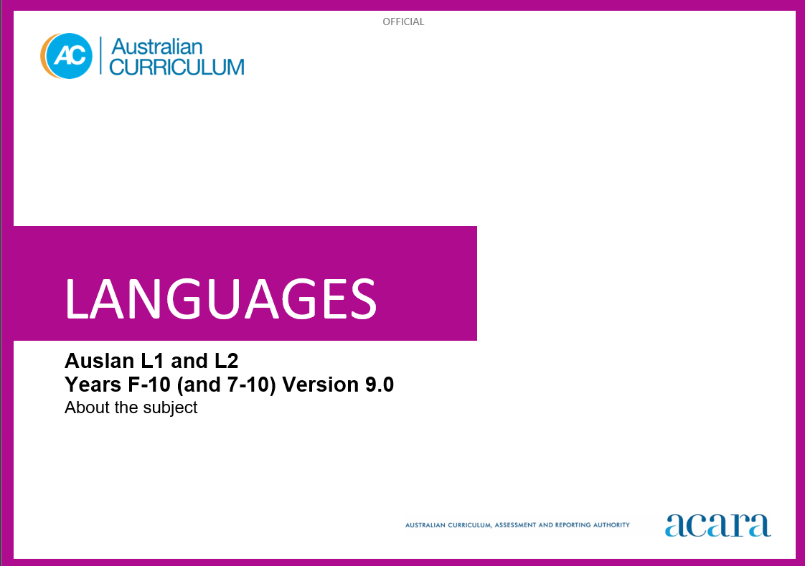

# **TABLE OF CONTENTS**

ABOUT Auslan 3

Introduction 3

Rationale 3

Structure 4

Strands and sub-strands 5

Interacting in Auslan 5

Mediating meaning in and between languages 6

Creating text in Auslan 6

Understanding systems of language 6

Understanding the interrelationship of language, culture and identity 6

# **ABOUT AUSLAN**

## **Introduction**

The Australian Curriculum: Auslan recognises that learners of Auslan (Australian Sign Language) in Australian schools have a range of linguistic and cultural backgrounds, and language-learning experiences. Learners may have varying degrees of proficiency in Auslan as first-language learners, or they may be learning Auslan as a second or additional language.

## **Rationale**

Auslan is the language of the Deaf community of Australia. Auslan is a visual-gestural language with a complete set of linguistic structures and features. Auslan’s rich cultural heritage can be traced to its historical descent from British Sign Language (BSL) and the arrival of Europeans in Australia in the late 1700s.

In the 1980s and 1990s, civil and political events around the world raised the profile and status of Deaf communities. In Australia, this was reflected in changing societal attitudes towards signed languages, from misconceptions and marginalisation to greater understanding and respect for the Deaf community and their language. The Australian government officially recognised Auslan as a legitimate language in 1987.

Signed languages have the same functions as spoken languages in meeting the communicative, cognitive and social needs of users. However, the modes of communication of a signed language are different from those of a spoken language. Although the languages share many linguistic principles, the visual-gestural mode of a signed language results in some unique language features.

Auslan is, increasingly, taught in Australian schools and universities, and has been taught in community-run organisations for decades. The influence of Auslan in Australian society is evident in areas such as education, media and communication.

Signed languages have their own grammar and lexicon which are not based on the spoken language of the country or region, although they are influenced by them. Some signed languages are grouped into language families. Auslan belongs to the BSL family, which includes British, Australian and New Zealand sign languages, which share a similar lexicon and grammar. The link that Auslan shares with BSL gives it historical context as a member of one of the longest continuing signed language families in the world.

Empowering young people whose native language is Auslan to learn their own language at school supports their overall achievement and wellbeing. It fulfils their needs and rights to preserve and embrace their linguistic and cultural heritage. For all students, learning Auslan provides a distinctive means of understanding the community in which they live. It enhances students’ awareness of the nature of language learning and language modes. It promotes an appreciation of diverse attitudes, beliefs and values and increases employment opportunities.

## **Structure**

Auslan has been developed to cater for the diversity of students learning Auslan, with both First-Language (L1) and Second-Language (L2) pathways. Learners may be deaf, hard of hearing or hearing, and may be learning Auslan as a first language or as a second or additional language.

The L1 pathway typically caters for deaf students whose native language is Auslan. These students may be deaf children of deaf parents/carers, deaf children of hearing families/carers who use Auslan at home or hearing children with signing deaf parents/carers. They may also be deaf students who are introduced to Auslan at school and may not have access to Auslan at home.

The L2 pathway typically caters for students who are not members of the Deaf community. These students are mostly hearing students learning Auslan as a second or additional language. Learners may also include deaf or hard of hearing children who use another signed language, as in the case of a recent immigrant, or hard of hearing children who have residual hearing or access to speech.

Each pathway includes a Foundation to Year 10 sequence:

* Foundation to Year 10 sequence (First-Language (L1) learners)
* Foundation to Year 10 sequence (Second-Language (L2) learners)

There is also a combined Years 7 to 10 sequence with differentiated content for First-Language (L1) and Second-Language (L2) learners in content elaborations:

* Years 7 to 10 sequence (First-Language (L1) and Second-Language (L2) learners)

Schools and teachers make decisions about which pathway and sequence best serve their students’ needs and make appropriate adjustments to differentiate learning experiences. To assist teachers to meet the diverse needs of learners, content elaborations in the Years 7 to 10 sequences differentiate examples of language use and contexts.

## **Strands and sub-strands**

Content in Auslan is organised under 2 interrelated strands, each with a number of sub-strands. The strands and sub-strands are presented in Figure 2.

*Figure 2: Auslan content structure*

***Strand: Communicating meaning in Auslan***

This involves students learning to use language for communicative purposes in interpreting, creating and exchanging meaning. There are 3 sub-strands.

**Interacting in Auslan**

Exchanging ideas, opinions, experiences, thoughts and feelings in non-verbal, signed and visual interactions; participating in planning, negotiating, deciding and taking action.

**Mediating meaning in and between languages**

Obtaining, processing, interpreting and conveying information through a range of signed, visual and multimodal texts; moving between languages and cultures non-verbally and visually, recognising different interpretations.

**Creating text in Auslan**

Creating a range of signed, visual and multimodal texts for specific contexts, purposes and audiences.

***Strand: Understanding language and culture***

This involves students learning to analyse and understand language and culture as resources for interpreting and shaping meaning in intercultural exchange. There are 2 sub-strands.

**Understanding systems of language**

Understanding the linguistic features of Auslan, including signing, grammatical and textual conventions.

**Understanding the interrelationship of language, culture and identity**

Analysing and reflecting on the role of language and culture in shaping identity and meaning.

***Macro skills in Auslan***

In Auslan, the macro skills, also known as language modes, include signing and viewing. Reading and writing may also be used when mediating meaning in and between languages.

*Table 1: The relationship between macro skills and the* Communicating meaning in Auslan *strand*

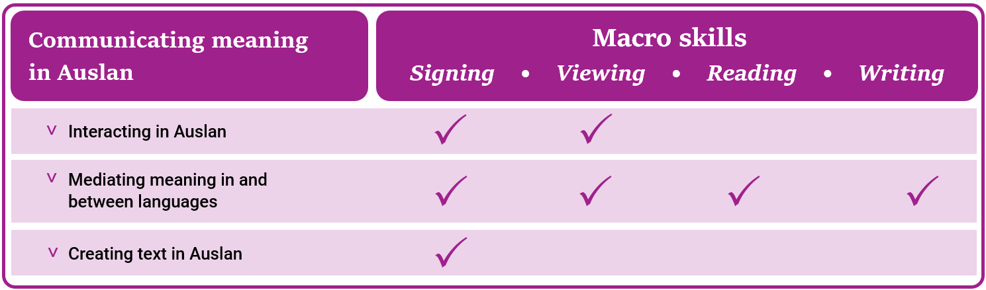

***Protocols***

Education systems can play a significant role in facilitating access to learning Auslan and supporting language maintenance. Schools make choices in relation to the language(s) taught and learnt in their contexts, predominantly in consultation with their local communities. State and territory jurisdictional authorities provide implementation advice.

In introducing an Auslan program in contextually, culturally, sensitive and appropriate ways, it is recommended that schools, in conjunction with jurisdictional requirements, consider:

* engagement and consultation with local, regional or state Deaf community groups, as available to the school
* the proportion of students in the school identifying directly with Auslan
* the appropriate pathways and sequences, or combinations of these, that might apply in their school context, for deaf, hard of hearing and hearing students
* the opportunities for real-world contexts for learning Auslan
* the availability of appropriate school staff and community members, and resources, for developing and teaching Auslan.

***Annotated Auslan text***

Content elaborations include examples of Auslan use. These examples are provided as annotated text and in video. Examples are accompanied by free, rather than literal, English translation. The format and style guidelines of annotated text have been adapted from the following references:

auslan signbank (n.d.), [*auslan signbank*](https://auslan.org.au/), auslan.org.au, accessed January 2024

Johnston T (2019) [*Auslan Corpus annotation guidelines* [PDF 27.09MB]](https://media.auslan.org.au/django-summernote/2020-09-04/69f180d0-04bf-4831-b59c-0b0b8f07cbb5.pdf), auslan signbank website, accessed January 2024

Johnston T and Schembri A (2007) *Australian Sign Language (Auslan): an introduction to sign language linguistics*, Cambridge University Press, New York.