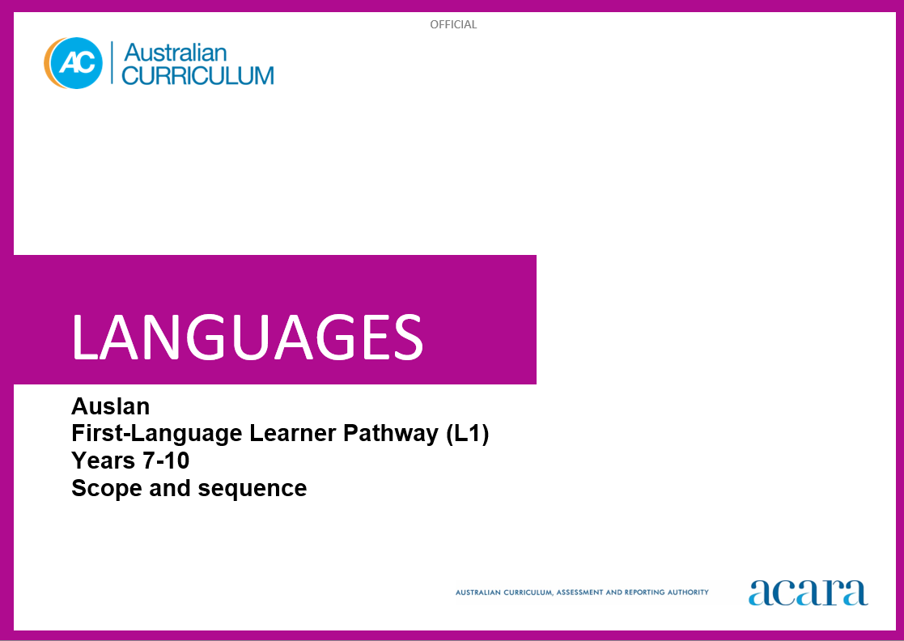

|  |  |
| --- | --- |
| **L1 Years 7–8 (Year 7 entry)** | **L1 Years 9–10 (Year 7 entry)** |
| **Achievement standards** | |
| By the end of Year 8, students use Auslan language to interact and collaborate with others, and to share information and plan activities in familiar contexts. They respond to others’ contributions in exchanges using familiar gestures, questions and instructions. They locate and respond to information in texts and use non-verbal, signed, visual and contextual cues to help make meaning. They respond in Auslan or English, and demonstrate understanding of context, purpose and audience in texts. They use familiar language, modelled grammatical structures, and familiar signs including fingerspelling (FS), lexical signs, depicting signs (DSs), non-manual features (NMFs) and signing space, to create texts.  Students use the parameters of signs and demonstrate understanding that Auslan has conventions and rules for signed communication. They comment on aspects of Auslan and English language structures and features, using metalanguage. They demonstrate awareness that Auslan is connected with culture and identity, and that this is reflected in their own language(s), culture(s) and identity. | By the end of Year 10, students initiate and sustain interactions in Auslan to exchange and compare experiences and ideas about their own and others’ personal worlds. They communicate using non-verbal, signed and visual language to collaborate, plan and reflect on activities and events. They interpret and analyse information and ideas in texts and demonstrate understanding of different perspectives. They synthesise information and respond in Auslan or English, adjusting language to convey meaning and to suit context, purpose and audience. They use structures and features of Auslan, including fingerspelling (FS), lexical signs, depicting signs (DSs), non-manual features (NMFs) and signing space, to create texts.  Students apply features and conventions of signing to enhance communication. They select and apply knowledge of language structures and features to interact, make meaning and create texts. They support discussion of structures and features of texts, using metalanguage. They reflect on their use of Auslan and their own cultural identity to discuss how these influence their ideas and ways of communicating. |

|  |  |
| --- | --- |
| **Content descriptions** | |
| **Strand: Communicating meaning in Auslan** | |
| **Sub-strand: Interacting in Auslan** | |
| interact with others using modelled language to exchange information in familiar contexts about self and personal worlds  AC9L1AU8EC01 | initiate and sustain interactions in familiar and some unfamiliar contexts to exchange ideas, experiences and opinions about their own and others’ personal worlds  AC9L1AU10EC01 |
| engage in modelled signed and visual exchanges with peers to organise activities related to daily life and school environment  AC9L1AU8EC02 | use signed and visual exchanges to discuss, plan and reflect on activities, events and experiences with peers  AC9L1AU10EC02 |
| **Sub-strand: Mediating meaning in and between languages** | |
| locate and process information and ideas in familiar signed, visual and multimodal texts, responding in ways appropriate to cultural context, purpose and audience  AC9L1AU8EC03 | interpret information, ideas and perspectives in a wide range of signed, visual and multimodal texts, and respond appropriately to cultural context, purpose and audience  AC9L1AU10EC03 |
| develop and begin to apply strategies to interpret, translate and convey meaning in Auslan in familiar contexts  AC9L1AU8EC04 | apply strategies to interpret and translate signed interactions, visual and written texts, to convey meaning and intercultural understanding in familiar and unfamiliar contexts  AC9L1AU10EC04 |
| **Sub-strand: Creating text in Auslan** | |
| create signed, visual and multimodal informative and imaginative texts using modelled fingerspelling (FS), lexical signs, depicting signs (DSs), non-manual features (NMFs) and signing space  AC9L1AU8EC05 | create signed, visual and multimodal, informative and imaginative texts, selecting features of signing, depicting signs (DSs), non-manual features (NMFs) and signing space, for familiar and some unfamiliar contexts and purposes, to engage different audiences  AC9L1AU10EC05 |

|  |  |
| --- | --- |
| **Strand: Understanding language and culture** | |
| **Sub-strand: Understanding systems of language** | |
| recognise and use modelled combinations of handshape, orientation, location, movement (HOLM) and non-manual features (NMFs) to form signs and phrases and demonstrate understanding of how these are represented in familiar contexts  AC9L1AU8EU01 | apply features of Auslan sign production including handshape, orientation, location and movement (HOLM), and non-manual features (NMFs), and show how these are represented in familiar and some unfamiliar contexts  AC9L1AU10EU01 |
| develop knowledge, and use structures and features of, the Auslan grammatical system to understand and create signed, visual and multimodal texts  AC9L1AU8EU02 | select and use structures and features of the Auslan grammatical system to enhance meaning and create signed, visual and multimodal texts  AC9L1AU10EU02 |
| compare Auslan language structures and features with English, using familiar metalanguage  AC9L1AU8EU03 | reflect on and evaluate Auslan texts, using metalanguage to discuss language structures and features  AC9L1AU10EU03 |
| **Sub-strand: Understanding the interrelationship of language, culture and identity** | |
| recognise how identity is shaped by language(s), culture(s), attitudes, beliefs and values  AC9L1AU8EU04 | reflect on and explain how identity is shaped by language(s), culture(s), attitudes, beliefs and values, and how these affect ways of communicating  AC9L1AU10EU04 |