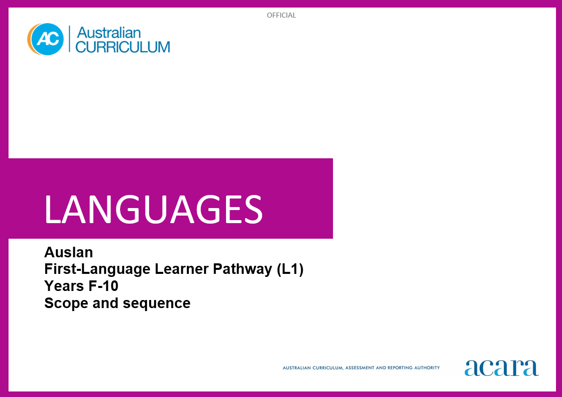

**Auslan L1 SCOPE AND SEQUENCE**

|  |  |
| --- | --- |
| **Foundation** | **Years 1–2** |
| **Achievement standard** | |
| By the end of the Foundation year, students use play and imagination to interact and create Auslan texts, with support. They identify that Auslan and English are different. They recognise that there are languages and cultures as well as their own, and that aspects of language and culture contribute to their own and others’ cultural identity. | By the end of Year 2, students use Auslan to interact and share information related to the classroom and themselves. They use cues to respond to questions and instructions. They locate and convey key items of information in texts using non-verbal, visual and contextual cues to help make meaning. They use familiar signs including fingerspelling (FS), lexical signs, depicting signs (DSs), non-manual features (NMFs) and signing space, to create texts.  Students recognise and use the parameters of signs. They demonstrate understanding that Auslan has conventions and rules for signs and features of language. They give examples of similarities and differences between some features of Auslan and English. They understand that language is connected with culture and identity, and notice how this is reflected in their own language(s), culture(s) and identity. |

|  |  |
| --- | --- |
| **Content descriptions** | |
|  | **Strand: Communicating meaning in Auslan** |
|  | **Sub-strand: Interacting in Auslan** |
| with support, recognise and communicate meaning in Auslan  AC9L1AUF01 | exchange greetings and personal introductions and respond to classroom-related instructions and routines  AC9L1AU2C01 |
| explore, with support, language features of Auslan making connections between Auslan and English  AC9L1AUF02 | participate in a range of play-based activities using modelled expressions and visual cues  AC9L1AU2C02 |
| explore connections between language and culture  AC9L1AUF03 |  |
|  | **Sub-strand: Mediating meaning in and between languages** |
|  | locate, with support, key information in familiar texts, and respond using gestures, images, words and modelled phrases  AC9L1AU2C03 |
|  | recognise language that carries cultural meaning in everyday social interactions  AC9L1AU2C04 |
|  | **Sub-strand: Creating text in Auslan** |
|  | with support, create signed, visual and multimodal texts, using familiar fingerspelling (FS), lexical signs, depicting signs (DSs), non-manual features (NMFs) and signing space  AC9L1AU2C05 |

|  |  |
| --- | --- |
|  | **Strand: Understanding language and culture** |
|  | **Sub-strand: Understanding systems of language** |
|  | recognise modelled combinations of signs and use Handshape, Orientation, Location, Movement (HOLM) and non-manual features (NMFs) to make meaning  AC9L1AU2U01 |
|  | recognise that signs and features of language are used to construct meaning in Auslan  AC9L1AU2U02 |
|  | notice that Auslan has features that may be similar to or different from English  AC9L1AU2U03 |
|  | **Sub-strand: Understanding the interrelationship of language, culture and identity** |
|  | notice that people use language in ways that reflect cultural identity  AC9L1AU2U04 |

|  |  |
| --- | --- |
| **Years 3–4** | **Years 5–6** |
| **Achievement standard** | |
| By the end of Year 4, students use Auslan to initiate structured interactions to share information related to the classroom and their personal worlds. They participate in activities that involve planning and transacting. They locate and respond to key items of information in texts, using strategies to help interpret and convey meaning in familiar contexts. They use familiar and formulaic language and basic syntax, including fingerspelling (FS), lexical signs, depicting signs (DSs), non-manual features (NMFs) and signing space, to create texts appropriate to context.  Students use combinations of signs and demonstrate understanding that Auslan has language conventions and rules to create and make meaning. They identify patterns in Auslan and make comparisons between Auslan and English. They understand that Auslan is connected with cultural identity, and identify how this is reflected in their own language(s), culture(s) and identity. | By the end of Year 6, students initiate and use strategies to maintain interactions in Auslan that are related to experiences of their personal worlds. They collaborate in activities that involve the language of planning and problem-solving to share information, preferences and ideas. They use strategies to locate and interpret information and ideas in texts, and demonstrate understanding by responding in Auslan or English, adjusting their response to context, purpose and audience. They create texts, selecting and using a range of signs, depicting signs (DSs), non-manual features (NMFs) and signing spaces. They sequence information and ideas, and use conventions appropriate to text type.  Students apply rules of signs, pace and signing space to develop fluency. They use modelled and formulaic structures when creating and responding in Auslan. They compare language structures and features in Auslan and English, using some metalanguage. They show understanding of how some language reflects cultural practices and consider how this is reflected in their own language(s), culture(s) and identity. |

|  |  |
| --- | --- |
| **Content descriptions** | |
| **Strand: Communicating meaning in Auslan** | |
| **Sub-strand: Interacting in Auslan** | |
| initiate exchanges and respond to questions about self, others, and classroom environment, using modelled and familiar expressions  AC9L1AU4C01 | initiate and sustain exchanges related to students’ experiences and opinions of their personal worlds and school environment  AC9L1AU6C01 |
| participate in activities that involve planning and transacting with others, using a range of phrases and structures in familiar contexts  AC9L1AU4C02 | participate in activities that involve planning and negotiating with others, using familiar and modelled idiomatic language to agree, suggest and resolve  AC9L1AU6C02 |
| **Sub-strand: Mediating meaning in and between languages** | |
| locate and respond to key information related to familiar content obtained from signed, visual and multimodal texts  AC9L1AU4C03 | locate and process information and ideas in a range of signed, visual and multimodal texts, and respond in different ways to suit purpose  AC9L1AU6C03 |
| develop strategies to comprehend and adjust Auslan to convey cultural meaning  AC9L1AU4C04 | apply strategies to interpret and convey meaning in signed and visual cultural contexts  AC9L1AU6C04 |
| **Sub-strand: Creating text in Auslan** | |
| create and present informative and imaginative signed, visual and multimodal texts, using fingerspelling (FS), lexical signs, depicting signs (DSs), non-manual features (NMFs), signing space, formulaic expressions and modelled textual conventions  AC9L1AU4C05 | create and present a range of informative and imaginative signed, visual and multimodal texts using a variety of modelled language structures and features to sequence information and ideas, appropriate to text type  AC9L1AU6C05 |

|  |  |
| --- | --- |
| **Strand: Understanding language and culture** | |
| **Sub-strand: Understanding systems of language** | |
| recognise and use combinations of signs to form words and phrases  AC9L1AU4U01 | apply knowledge of signs, pace and signing space to develop fluency in familiar contexts  AC9L1AU6U01 |
| recognise and use Auslan conventions, grammatical structures and basic syntax, in familiar texts and contexts  AC9L1AU4U02 | use knowledge of modelled grammatical structures and formulaic expressions to compose and respond to texts, using appropriate textual conventions  AC9L1AU6U02 |
| recognise familiar Auslan structures and features and compare with those of English, in known contexts  AC9L1AU4U03 | compare Auslan structures and features with those of English, using some familiar metalanguage  AC9L1AU6U03 |
| **Sub-strand: Understanding the interrelationship of language, culture and identity** | |
| identify connections between Auslan, cultural practices and identity  AC9L1AU4U04 | recognise that language reflects cultural practices, values and identity, and that this impacts on communication  AC9L1AU6U04 |

|  |  |
| --- | --- |
| **Years 7–8 (F–10)** | **Years 9–10 (F–10)** |
| **Achievement standard** | |
| By the end of Year 8, students initiate and maintain interactions in Auslan in familiar and unfamiliar contexts related to a range of experiences and perspectives. They use Auslan to negotiate solutions and adjust language in response to others. They interpret and analyse information, ideas and opinions in texts. They demonstrate understanding of similarities and differences between languages and in cultural contexts, by reorganising responses to suit context, purpose and audience. They select and use features of signing, structures and expressions, manipulating language to create texts.  Students apply the conventions of signing to enhance fluency. They demonstrate understanding that signed, visual and multimodal texts use different language conventions, structures and features to convey meaning. They explain structures and features of Auslan text, using metalanguage. They reflect on how Auslan language, culture and identity are interconnected, and compare this with their own language(s), culture(s) and identity. | By the end of Year 10, students contribute to and extend interactions in Auslan related to diverse contexts. They interpret and respond to texts by evaluating and synthesising information, ideas and perspectives. They show understanding of how features of language can be used to influence audience response. They create texts, selecting and manipulating language for a range of contexts, purposes and audiences. They apply and use complex structures and language devices to enhance meaning and cohesion.  Students apply features and conventions of Auslan and adjust signing to extend fluency. They demonstrate understanding of the conventions of texts and the connections between them. They apply knowledge of language structures and features to make and predict meaning. They support analysis of Auslan texts, using metalanguage. They reflect on their own cultural perspectives and identity, and draw on their experience of learning Auslan, to evaluate how this learning influences their ideas and ways of communicating. |

|  |  |
| --- | --- |
| **Content descriptions** | |
| **Strand: Communicating meaning in Auslan** | |
| **Sub-strand: Interacting in Auslan** | |
| initiate and sustain exchanges in familiar and unfamiliar contexts related to students’ experiences, feelings and opinions, adjusting their language in response to others  AC9L1AU8C01 | initiate, sustain and extend exchanges in a range of contexts, responding to ideas, opinions and perspectives, adjusting their language in response to others  AC9L1AU10C01 |
| collaborate in activities that involve the language of transacting, negotiating and justifying, to plan projects and events  AC9L1AU8C02 | contribute to discussions that involve diverse views to negotiate outcomes, debate issues and compare experiences  AC9L1AU10C02 |
| **Sub-strand: Mediating meaning in and between languages** | |
| interpret and analyse information, ideas and opinions in a range of signed, visual and multimodal texts, and respond appropriately to cultural context, purpose and audience  AC9L1AU8C03 | evaluate and synthesise information, ideas and perspectives in a broad range of signed, visual and multimodal texts and respond appropriately to cultural context, purpose and audience  AC9L1AU10C03 |
| interpret and translate signed, visual and written language to convey meaning in a range of familiar and unfamiliar cultural contexts  AC9L1AU8C04 | interpret and translate signed, visual and written interactions and texts to reflect cultural context, purpose and audience  AC9L1AU10C04 |
| **Sub-strand: Creating text in Auslan** | |
| create and present signed, visual and multimodal, informative and imaginative texts, manipulating language to suit context, purpose and audience  AC9L1AU8C05 | create and present informative and imaginative texts for diverse contexts and purposes, selecting vocabulary, expressions, grammatical structures and a range of features and conventions to engage different audiences  AC9L1AU10C05 |

|  |  |
| --- | --- |
| **Strand: Understanding language and culture** | |
| **Sub-strand: Understanding systems of language** | |
| apply knowledge of conventions of sign production to enhance fluency, and respond to and create texts in familiar and unfamiliar contexts  AC9L1AU8U01 | apply features and conventions of sign production to extend fluency in response to a range of contexts, purposes and audiences  AC9L1AU10U01 |
| apply understanding of grammatical structures and features to compose and respond to a range of texts  AC9L1AU8U02 | apply knowledge of grammatical structures and features to predict meaning and compose a range of texts that contain complex structures and ideas  AC9L1AU10U02 |
| reflect on similarities and differences between Auslan and English language structures and features, using metalanguage  AC9L1AU8U03 | reflect on and evaluate Auslan texts, using metalanguage to analyse language structures and features  AC9L1AU10U03 |
| **Sub-strand: Understanding the interrelationship of language, culture and identity** | |
| reflect on and explain how identity is shaped by language(s), culture(s), attitudes, beliefs and values, and how these impact on communication  AC9L1AU8U04 | reflect on and evaluate how identity is shaped by language(s), culture(s), attitudes, beliefs and values and how these affect ways of communicating  ACL9L1AU10U04 |