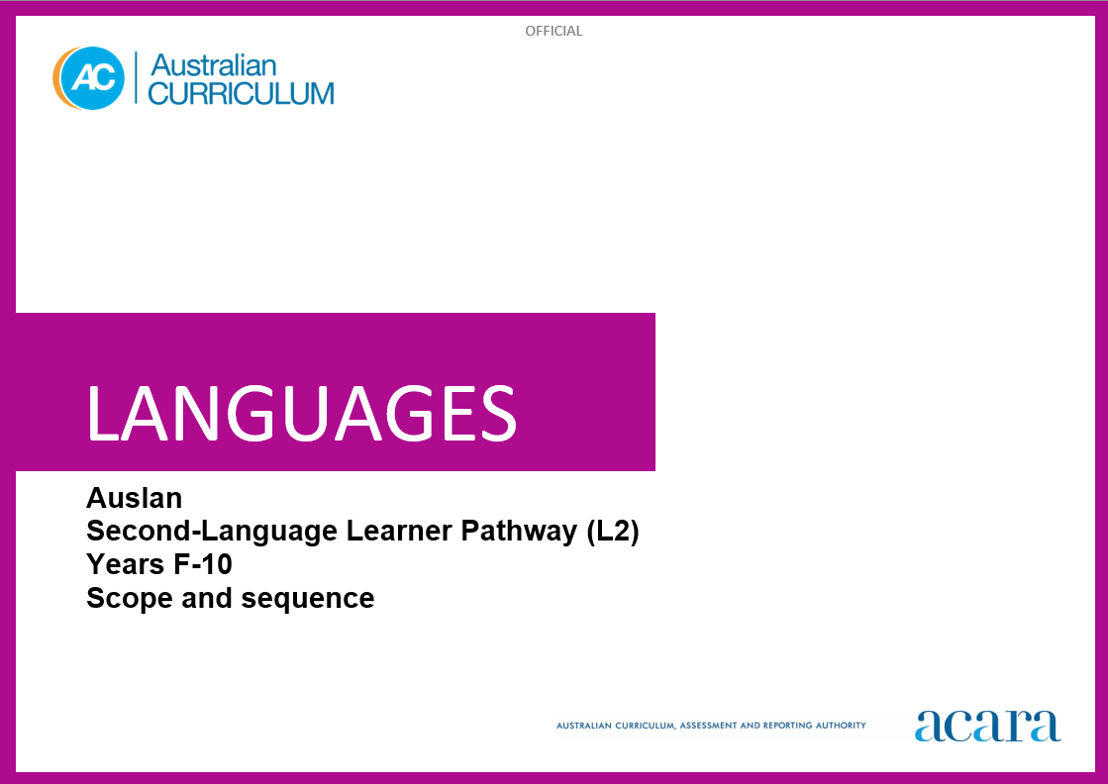

**Auslan L2 SCOPE AND SEQUENCE**

|  |  |
| --- | --- |
| **Foundation** | **Years 1–2** |
| **Achievement standards** | |
| By the end of the Foundation year, students use play and imagination to interact and create Auslan texts, with support. They identify that Auslan and English are different. They recognise that there are languages and cultures as well as their own, and that aspects of language and culture contribute to their own and others’ cultural identity. | By the end of Year 2, students use Auslan to interact and share information related to the classroom and themselves. They use cues to respond to questions and instructions, and use simple formulaic language. They locate and convey key items of information in texts using non-verbal, visual and contextual cues to help make meaning. They use familiar signs and modelled language, including some fingerspelling (FS), lexical signs, depicting signs (DSs), non-manual features (NMFs) and signing space, to create texts.  Students imitate the parameters of signs. They demonstrate understanding that Auslan has conventions and rules for signing. They give examples of similarities and differences between some features of Auslan and English. They understand that language is connected with culture and identity, and notice how this is reflected in their own language(s), culture(s) and identity. |

|  |  |
| --- | --- |
| **Content descriptions** | |
|  | **Strand: Communicating meaning in Auslan** |
|  | **Sub-strand: Interacting in Auslan** |
| with support, recognise and communicate meaning in Auslan  AC9L2AUF01 | recognise and respond to modelled classroom-related greetings, instructions and routines, and personal introductions  AC9L2AU2C01 |
| explore, with support, language features of Auslan noticing similarities and differences between Auslan and English  AC9L2AUF02 | participate in a range of guided, play-based language activities using formulaic expressions and visual cues  AC9L2AU2C02 |
| explore connections between language and culture  AC9L2AUF03 |  |
|  | **Sub-strand: Mediating meaning in and between languages** |
|  | locate, with support, key information in familiar texts, and respond using gestures, images, words and formulaic phrases  AC9L2AU2C03 |
|  | notice that language carries cultural meaning in classroom-related greetings, introductions, instructions and routines  AC9L2AU2C04 |
|  | **Sub-strand: Creating text in Auslan** |
|  | with support, create signed, visual and multimodal texts, using modelled fingerspelling (FS), lexical signs, depicting signs (DSs), non-manual features (NMFs) and signing space  AC9L2AU2C05 |

|  |  |
| --- | --- |
|  | **Strand: Understanding language and culture** |
|  | **Sub-strand: Understanding systems of language** |
|  | recognise that Auslan is a visual-gestural language, and imitate the parameters of signs such as handshape, orientation, location, movement (HOLM) and non-manual features (NMFs)  AC9L2AU2U01 |
|  | recognise that signs and features of language are used to construct meaning in Auslan  AC9L2AU2U02 |
|  | notice that Auslan has features that may be similar to or different from English  AC9L2AU2U03 |
|  | **Sub-strand: Understanding the interrelationship of language, culture and identity** |
|  | notice that people use language in ways that reflect cultural identity  AC9L2AU2U04 |

|  |  |
| --- | --- |
| **Years 3–4** | **Years 5–6** |
| **Achievement standard** | |
| By the end of Year 4, students use Auslan to initiate structured interactions to share information related to the classroom and their personal worlds. They use familiar language to participate in activities that involve planning. They locate and respond to key items of information in texts, using strategies to help interpret and convey meaning in familiar contexts. They use modelled language and basic syntax, including familiar fingerspelling (FS), lexical signs, depicting signs (DSs), non-manual features (NMFs) and signing space, to create texts.  Students use modelled combinations of signs and demonstrate understanding that Auslan has language conventions and rules to create and make meaning. They identify patterns in Auslan and make comparisons between Auslan and English. They understand that Auslan is connected with culture and identity, and identify how this is reflected in their own language(s), culture(s) and identity. | By the end of Year 6, students initiate and use strategies to maintain interactions in Auslan that are related to their immediate environment. They collaborate in activities that involve the language of planning and problem-solving to share information, preferences and ideas. They use strategies to locate and interpret information and ideas in texts, and demonstrate understanding by responding in Auslan or English, adjusting their response to context, purpose and audience. They create texts, selecting and using a variety of signs, depicting signs (DSs), non-manual features (NMFs) and signing spaces. They sequence information and ideas, and use conventions appropriate to text type.  Students apply rules of signs, pace and signing space to develop fluency. They use modelled structures when creating and responding in Auslan. They compare language structures and features in Auslan and English, using some metalanguage. They show understanding of how some language reflects cultural practices and consider how this is reflected in their own language(s), culture(s) and identity. |

|  |  |
| --- | --- |
| **Content descriptions** | |
| **Strand: Communicating meaning in Auslan** | |
| **Sub-strand: Interacting in Auslan** | |
| initiate exchanges and respond to modelled questions about self, others and the classroom environment, using formulaic expressions  AC9L2AU4C01 | initiate and sustain modelled exchanges in familiar contexts related to students’ personal worlds and school environment  AC9L2AU6C01 |
| participate in activities that involve planning with others, using a range of familiar phrases and modelled structures  AC9L2AU4C02 | participate in activities that involve planning and negotiating with others, using language that expresses information, preferences and ideas  AC9L2AU6C02 |
| **Sub-strand: Mediating meaning in and between languages** | |
| locate and respond to key information related to familiar content obtained from signed, visual and multimodal texts  AC9L2AU4C03 | locate and process information and ideas in a range of signed, visual and multimodal texts, and respond in different ways to suit purpose  AC9L2AU6C03 |
| develop strategies to comprehend and adjust Auslan in familiar contexts to convey cultural meaning  AC9L2AU4C04 | apply strategies to interpret and convey meaning in familiar signed and visual cultural contexts  AC9L2AU6C04 |
| **Sub-strand: Creating text in Auslan** | |
| create and present informative and imaginative signed, visual and multimodal texts, using familiar fingerspelling (FS), lexical signs, depicting signs (DSs), non-manual features (NMFs) and signing space, formulaic expressions and modelled textual conventions  AC9L2AU4C05 | create and present a range of informative and imaginative signed, visual and multimodal texts using a variety of modelled structures to sequence information and ideas, and using fingerspelling (FS), lexical signs, depicting signs (DSs), non-manual features (NMFs) and signing space, appropriate to text type  AC9L2AU6C05 |

|  |  |
| --- | --- |
| **Strand: Understanding language and culture** | |
| **Sub-strand: Understanding systems of language** | |
| recognise and use modelled combinations of signs such as handshape, orientation, location, movement (HOLM) and non-manual features (NMFs) to form signed words and phrases  AC9L2AU4U01 | apply knowledge of signs, pace and signing space to develop fluency in familiar contexts  AC9L2AU6U01 |
| recognise Auslan language conventions, grammatical structures and basic syntax in familiar texts and contexts  AC9L2AU4U02 | use knowledge of modelled grammatical structures and formulaic expressions to compose and respond to texts, using appropriate textual conventions  AC9L2AU6U02 |
| recognise familiar Auslan structures and features and compare with those of English, in known contexts  AC9L2AU4U03 | compare some Auslan structures and features with those of English, using some familiar metalanguage  AC9L2AU6U03 |
| **Sub-strand: Understanding the interrelationship of language, culture and identity** | |
| identify connections between Auslan, cultural practices and identity  AC9L2AU4U04 | recognise that language reflects cultural practices, values and identity, and that this impacts on communication  AC9L2AU6U04 |

|  |  |
| --- | --- |
| **Years 7–8 (F–10)** | **Years 9–10 (F–10)** |
| **Achievement standard** | |
| By the end of Year 8, students initiate and maintain interactions in Auslan in familiar and some unfamiliar contexts related to a range of interests and experiences. They use Auslan to negotiate solutions and adjust language in response to others. They interpret information, ideas and opinions in texts. They demonstrate understanding of similarities and differences between languages and in cultural contexts, by reorganising responses to suit context, purpose and audience. They select and use features of signing structures and expressions to create texts.  Students apply the conventions of signing to enhance fluency. They demonstrate understanding that signed, visual and multimodal texts use different language conventions, structures and features to convey meaning. They comment on structures and features of Auslan text, using metalanguage. They reflect on how language, culture and identity are interconnected, and compare this with their own language(s), culture(s) and identity. | By the end of Year 10, students contribute to and extend interactions in Auslan in increasingly unfamiliar contexts related to a wide range of interests and issues. They interpret and respond to texts by evaluating and synthesising information, ideas and perspectives. They show understanding of how features of language can be used to influence audience response. They create texts, selecting and manipulating language for a range of contexts, purposes and audiences. They use complex structures to enhance meaning and cohesion.  Students apply features and conventions of Auslan and adjust signing to extend fluency. They demonstrate understanding of the conventions of texts and the connections between them. They apply knowledge of language structures and features to make and predict meaning. They support analysis of Auslan texts, using metalanguage. They reflect on their own cultural perspectives and identity, and draw on their experience of learning Auslan to evaluate how this learning influences their ideas and ways of communicating. |

|  |  |
| --- | --- |
| **Content descriptions** | |
| **Strand: Communicating meaning in Auslan** | |
| **Sub-strand: Interacting in Auslan** | |
| initiate and sustain exchanges in familiar and some unfamiliar contexts related to students’ experiences, feelings and views, adjusting their language in response to others  AC9L2AU8C01 | initiate, sustain and extend exchanges in familiar and unfamiliar contexts related to students’ own and others’ experiences of the world, adjusting their language in response to others  AC9L2AU10C01 |
| collaborate in activities that involve the language of transaction, negotiation and problem-solving to plan projects and events  AC9L2AU8C02 | contribute to discussions that involve diverse views to negotiate outcomes, address issues and compare experiences  AC9L2AU10C02 |
| **Sub-strand: Mediating meaning in and between languages** | |
| interpret information, ideas and opinions in a range of signed, visual and multimodal texts, and respond appropriately to cultural context, purpose and audience  AC9L2AU8C03 | evaluate and synthesise information, ideas and perspectives in a broad range of signed, visual and multimodal texts and respond appropriately to cultural context, purpose and audience  AC9L2AU10C03 |
| interpret and adjust signed, spoken and written language to convey meaning in a range of familiar and some unfamiliar cultural contexts  AC9L2AU8C04 | interpret and translate signed, spoken, visual and written interactions and texts to convey intercultural understanding in familiar and unfamiliar contexts  AC9L2AU10C04 |
| **Sub-strand: Creating text in Auslan** | |
| create and present signed, visual and multimodal, informative and imaginative texts, selecting fingerspelling (FS), lexical signs, depicting signs (DSs), non-manual features (NMFs) and signing space, appropriate to text type  AC9L2AU8C05 | create and present informative and imaginative texts for diverse contexts and purposes, selecting vocabulary, expressions, grammatical structures and a range of features and conventions, to engage different audiences  AC9L2AU10C05 |

|  |  |
| --- | --- |
| **Strand: Understanding language and culture** | |
| **Sub-strand: Understanding systems of language** | |
| apply knowledge of conventions of sign production to enhance fluency, and respond to and create texts in familiar and some unfamiliar contexts  AC9L2AU8U01 | apply features and conventions of sign production to extend fluency when responding to and creating texts in familiar and unfamiliar contexts  AC9L2AU10U01 |
| apply understanding of grammatical structures and features to compose and respond to texts  AC9L2AU8U02 | apply knowledge of grammatical structures and features to predict meaning and compose texts that contain some complex structures and ideas  AC9L2AU10U02 |
| reflect on similarities and differences between Auslan and English language structures and features, using metalanguage  AC9L2AU8U03 | reflect on and evaluate Auslan texts, using metalanguage to analyse language structures and features  AC9L2AU10U03 |
| **Sub-strand: Understanding the interrelationship of language, culture and identity** | |
| reflect on and explain how identity is shaped by language(s), culture(s), attitudes, beliefs, and values, and how these impact on communication  AC9L2AU8U04 | reflect on and evaluate how identity is shaped by language(s), culture(s), attitudes, beliefs and values, and how these affect ways of communicating  AC9L2AU10U04 |

|  |  |
| --- | --- |
| **Years 7–8 (Year 7 entry)** | **Years 9–10 (Year 7 entry)** |
| **Achievement standard** | |
| By the end of Year 8, students use Auslan language to interact and collaborate with others, and to share information and plan activities in familiar contexts. They respond to others’ contributions, and recognise familiar gestures, questions and instructions in exchanges. They locate and respond to information in texts and use non-verbal, signed, visual and contextual cues to help make meaning. They respond in Auslan or English, and demonstrate understanding of context, purpose and audience in texts. They use familiar language, and modelled grammatical structures to create texts.  Students use the parameters of signs and demonstrate understanding that Auslan has conventions and rules for signed communication. They comment on aspects of Auslan and English language structures and features, using metalanguage. They demonstrate awareness that Auslan is connected with culture and identity, and that this is reflected in their own language(s), culture(s) and identity. | By the end of Year 10, students initiate and sustain interactions in Auslan to exchange and compare experiences and ideas about their own and others’ personal worlds. They communicate using non-verbal, signed and visual language to collaborate, plan and reflect on activities and events. They interpret and analyse information and ideas in texts and demonstrate understanding of different perspectives. They synthesise information and respond in Auslan or English, adjusting language to convey meaning and to suit context, purpose and audience. They use structures and features of Auslan to create texts.  Students apply features and conventions of signing to enhance communication. They select and apply knowledge of language conventions, structures and features to interact, make meaning and create texts. They support discussion of structures and features of texts, using metalanguage. They reflect on their use of Auslan and their own cultural identity to discuss how this influences their ideas and ways of communicating. |

|  |  |
| --- | --- |
| **Content descriptions** | |
| **Strand: Communicating meaning in Auslan** | |
| **Sub-strand: Interacting in Auslan** | |
| interact with others using modelled language to exchange information in familiar contexts about self and personal worlds  AC9L2AU8EC01 | initiate and sustain interactions in familiar and some unfamiliar contexts to exchange ideas, experiences and opinions about their own and others’ personal worlds  AC9L2AU10EC01 |
| engage in modelled signed and visual exchanges with peers to organise activities relating to daily life and school environment  AC9L2AU8EC02 | use signed and visual exchanges to discuss, plan and reflect on activities, events and experiences with peers  AC9L2AU10EC02 |
| **Sub-strand: Mediating meaning in and between languages** | |
| locate and process information and ideas in familiar signed, visual and multimodal texts, responding in ways appropriate to cultural context, purpose and audience  AC9L2AU8EC03 | interpret information, ideas and perspectives in a wide range of signed, visual and multimodal texts and respond appropriately to cultural context, purpose and audience  AC9LA10EC03 |
| develop and begin to apply strategies to interpret, translate and convey meaning in Auslan in familiar contexts  AC9L2AU8EC04 | apply strategies to interpret and translate signed interactions, visual and written texts, to convey meaning and intercultural understanding in familiar and unfamiliar contexts  AC9L2AU10EC04 |
| **Sub-strand: Creating text in Auslan** | |
| create signed, visual and multimodal informative and imaginative texts, for familiar contexts and purposes using appropriate vocabulary, phrases, grammatical structures and some textual conventions  AC9L2AU8EC05 | create signed, visual and multimodal, informative and imaginative texts, selecting vocabulary, expressions, grammatical structures and textual conventions for familiar and some unfamiliar contexts and purposes, to engage different audiences  AC9L2AU10EC05 |

|  |  |
| --- | --- |
| **Strand: Understanding language and culture** | |
| **Sub-strand: Understanding systems of language** | |
| recognise and use modelled combinations of handshape, orientation, location, movement (HOLM) and non-manual features (NMFs) to form signs and phrases and demonstrate understanding of how these are represented in familiar contexts  AC9L2AU8EU01 | apply features of Auslan sign production including handshape, orientation, location and movement (HOLM) and non-manual features (NMFs) and show how these are represented in familiar and some unfamiliar contexts  AC9L2AU10EU01 |
| develop knowledge, and use structures and features of, the Auslan grammatical system to understand and create signed, visual and multimodal texts  AC9L2AU8EU02 | select and use structures and features of Auslan grammar systems to enhance meaning and create signed, visual and multimodal texts  AC9L2AU10EU02 |
| compare Auslan language structures and features with English, using familiar metalanguage  AC9L2AU8EU03 | reflect on and evaluate Auslan texts, using metalanguage to discuss language structures and features  AC9L2AU10EU03 |
| **Sub-strand: Understanding the interrelationship of language, culture and identity** | |
| recognise how identity is shaped by language(s), culture(s), attitudes, beliefs and values  AC9L2AU8EU04 | reflect on and explain how identity is shaped by language(s), culture(s), attitudes, beliefs and values and how these affect ways of communicating  AC9L2AU10EU04 |