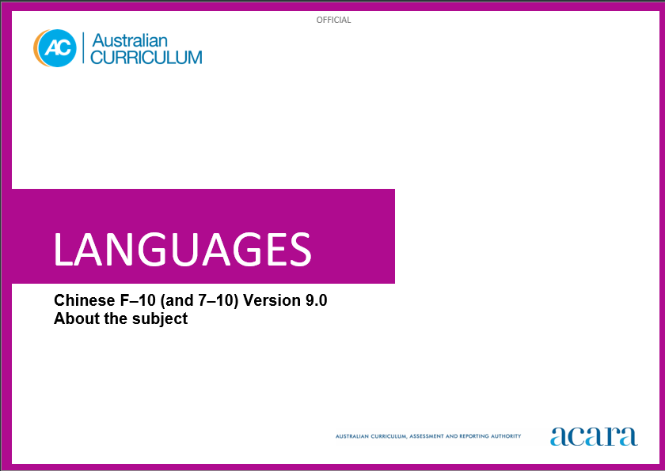

**Copyright and Terms of Use Statement**

**© Australian Curriculum, Assessment and Reporting Authority 2024**

The material published in this work is subject to copyright pursuant to the Copyright Act 1968 (Cth) and is owned by the Australian Curriculum, Assessment and Reporting Authority (ACARA) (except to the extent that copyright is held by another party, as indicated).

The viewing, downloading, displaying, printing, reproducing (such as by making photocopies) and distributing of these materials is permitted only to the extent permitted by, and is subject to the conditions imposed by, the terms and conditions of using the ACARA website (see, especially, clauses 2, 3 and 4 of those terms and conditions). The terms and conditions can be viewed at [https://www.acara.edu.au/contact-us/copyright](https://aus01.safelinks.protection.outlook.com/?url=https%3A%2F%2Fwww.acara.edu.au%2Fcontact-us%2Fcopyright&data=04%7C01%7CSharon.Foster%40acara.edu.au%7C9931e11fa7684c603e6308d98331bbfb%7C6cf76a3aa824427092003d71673ec678%7C0%7C0%7C637685071906340874%7CUnknown%7CTWFpbGZsb3d8eyJWIjoiMC4wLjAwMDAiLCJQIjoiV2luMzIiLCJBTiI6Ik1haWwiLCJXVCI6Mn0%3D%7C1000&sdata=U5O4Vlbpf271IGmGiMh7fDwU4pLzzAiHpCQFylkp6s4%3D&reserved=0)

TABLE OF CONTENTS

ABOUT CHINESE 4

Introduction 4

Rationale 4

Structure 5

Using the Chinese Pathways 5

ABOUT CHINESE

Introduction

In the Australian Curriculum: Languages: Chinese refers to Modern Standard Chinese, Pinyin Romanisation and simplified characters.

As simplified and traditional Chinese characters are used in the media, education and in print, students may develop some knowledge or awareness of both systems.

Students of Chinese in Australian schools have a wide range of language-learning experiences. For some students it is the start of their Chinese language learning, some may have existing connections to Chinese languages and cultures as background-language learners, and some may identify with or use Chinese as their mother tongue.

Rationale

Chinese is the official language of China and Taiwan, and an official language of Hong Kong, Macau and Singapore. Chinese is one of the 6 languages of the United Nations. Chinese-speaking communities are characterised by linguistic, cultural and geographic diversity and can be found in almost every country of the world.

The influences of Chinese cultures, languages and thought can be seen globally in past and contemporary achievements in areas such as the arts and literature, agriculture, astronomy, economic and technological development, manufacturing, paper and printing, and trade.

Communities of Chinese-speaking people have made a significant contribution to shaping multicultural Australia since the gold rush of the 1850s, and patterns of migration in recent decades have seen rapid growth in Australia’s Chinese population. Chinese language has been taught in Australian schools and universities since the 1950s. The influence of Chinese-speaking communities is evident in the arts, agriculture, cuisine and economic development. Current links between China and Australia include bilateral relationships in trade and investment, educational exchanges, and research and development in science and technology.

Chinese belongs to the Sino-Tibetan language family. Learning Chinese enhances students’ understanding of different writing systems and language-learning strategies, and develops an appreciation of the diversity of languages and cultures of Chinese-speaking communities. For students with a Chinese language and/or cultural background, learning Chinese strengthens their awareness of their own cultural and linguistic heritage and identity. Knowledge of Chinese language and cultures also enriches travel experiences, increases employment opportunities and promotes understanding of diverse attitudes, beliefs and values.

Structure

Chinese has been developed to cater for the diversity of students learning Chinese in Australian schools:

The Second-Language Learner pathway caters for students learning Chinese as a second or additional language. This pathway includes 2 sequences:

* Foundation to Year 10
* Years 7 to 10.

The Background-Language Learner Pathway caters for students who use Chinese at home, not necessarily exclusively, and have varying degrees of knowledge of and proficiency in the language. This pathway includes 2 sequences:

* Foundation to Year 10
* Years 7 to 10 (common sequence for both Background-language (BL) and First-language (L1) learners).

The First-Language Learner Pathway caters for students who use and/or identify with Chinese as their mother tongue and use Chinese for primary socialisation and/or education and/or literacy development. This pathway has one sequence combined with the background-learner sequence:

* Years 7 to 10 (common sequence for both Background-language (BL) and First-language (L1) learners).

Using the Chinese Pathways

Schools choose language-learning pathways and/or sequences to best suit their students’ language and/or cultural background needs. The organisation, structure and content of the curriculum supports a wide range of learners. Learner pathways share the same organisation and structure, including some aspects of the content and achievement standards. Teachers can make appropriate adjustments to differentiate learning experiences, including content from across pathways, to best suit the needs of their students. A student with no prior knowledge of the language will be best suited to the Chinese as a second-language learner pathway. Another student with an understanding of the language, using it in everyday communication, will be best suited to the Chinese as a background-language or first-language pathway. A teacher may have both these students in the same class. The teacher can use similar content from across the pathways to differentiate their learning.

To assist teachers to meet the needs of both background-language and first-language learners in the common BL/L1 Years 7 to 10 sequence, content elaborations illustrate differentiated examples of language use and context. Some content elaborations are suitable for a range of learners, others are suggested for Background-Language (BL) or First-Language (L1) learners, as indicated in the elaboration.

Content in Chinese is organised under 2 interrelated strands, each with a number of sub-strands. The strands and sub-strands are presented in Figure 1.

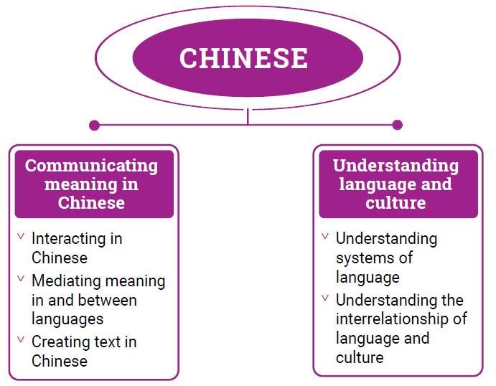

Figure 1: Chinese content structure

Strand: Communicating meaning in Chinese

This involves students learning to use language for communicative purposes in interpreting, creating and exchanging meaning. There are 3 sub-strands.

**Interacting in Chinese**

Exchanging ideas, opinions, experiences, thoughts and feelings in non-verbal, spoken and written interactions; participating in planning, negotiating, deciding and taking action.

**Mediating meaning in and between languages**

Obtaining, processing, interpreting and conveying information through a range of spoken, written and multimodal texts; moving between languages and cultures non-verbally, orally and in writing, recognising different interpretations.

**Creating text in Chinese**

Creating a range of spoken, written and multimodal texts for specific contexts, purposes and audiences.

Strand: Understanding language and culture

This involves students learning to analyse and understand language and culture as resources for interpreting and shaping meaning in intercultural exchange. There are 2 sub-strands.

**Understanding systems of language**

Understanding the linguistic features of Chinese, including sound, writing, grammatical and textual conventions.

**Understanding the interrelationship of language and culture**

Analysing and reflecting on the role of language and culture in shaping meaning and identity.