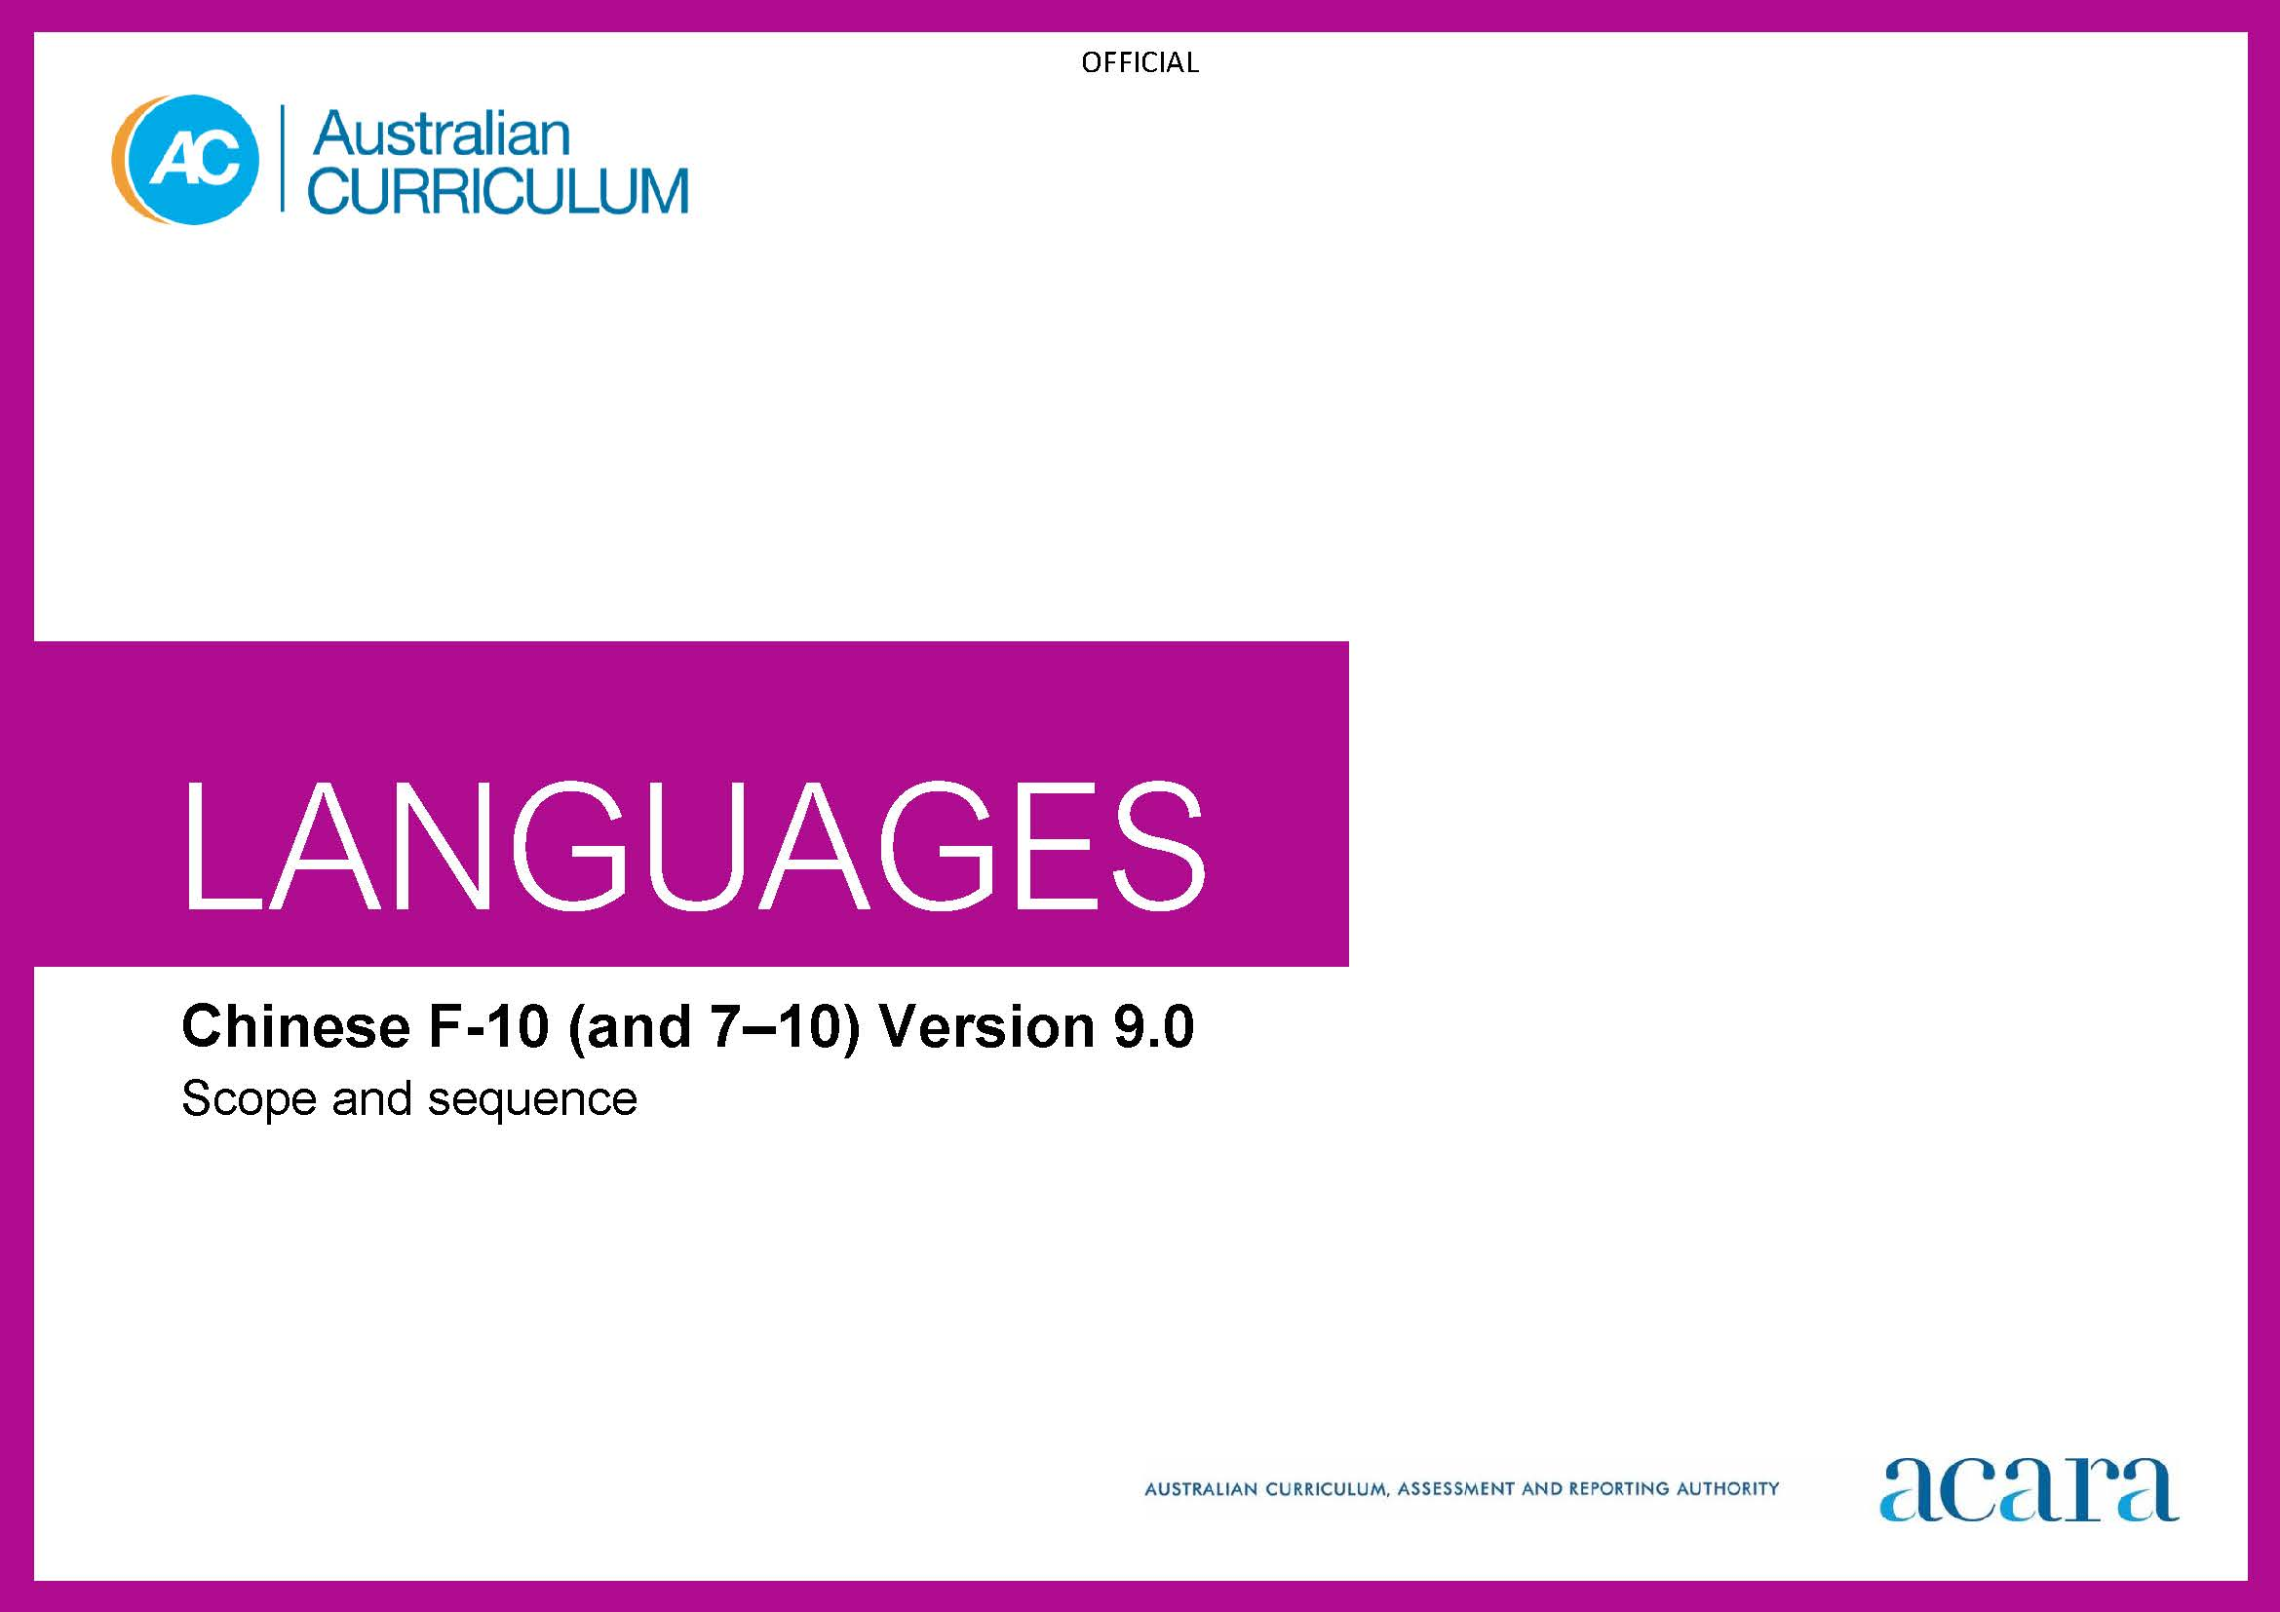

**Copyright and Terms of Use Statement**

**© Australian Curriculum, Assessment and Reporting Authority 2022**

The material published in this work is subject to copyright pursuant to the Copyright Act 1968 (Cth) and is owned by the Australian Curriculum, Assessment and Reporting Authority (ACARA) (except to the extent that copyright is held by another party, as indicated).

The viewing, downloading, displaying, printing, reproducing (such as by making photocopies) and distributing of these materials is permitted only to the extent permitted by, and is subject to the conditions imposed by, the terms and conditions of using the ACARA website (see, especially, clauses 2, 3 and 4 of those terms and conditions). The terms and conditions can be viewed at [https://www.acara.edu.au/contact-us/copyright](https://aus01.safelinks.protection.outlook.com/?url=https%3A%2F%2Fwww.acara.edu.au%2Fcontact-us%2Fcopyright&data=04%7C01%7CSharon.Foster%40acara.edu.au%7C9931e11fa7684c603e6308d98331bbfb%7C6cf76a3aa824427092003d71673ec678%7C0%7C0%7C637685071906340874%7CUnknown%7CTWFpbGZsb3d8eyJWIjoiMC4wLjAwMDAiLCJQIjoiV2luMzIiLCJBTiI6Ik1haWwiLCJXVCI6Mn0%3D%7C1000&sdata=U5O4Vlbpf271IGmGiMh7fDwU4pLzzAiHpCQFylkp6s4%3D&reserved=0)

|  |  |
| --- | --- |
| **Foundation** | **Years 1–2** |
| **Achievement standard** | |
| By the end of the Foundation year, students use play and imagination to interact and create Chinese texts, with support. They identify that Chinese and English look and sound different. They recognise that there are languages and cultures as well as their own, and that aspects of language and culture contribute to their own and others’ cultural identity. | By the end of Year 2, students use Chinese language to interact and share information related to the classroom and themselves. They use cues to respond to questions and instructions, and use simple formulaic language. They locate and convey key items of information in texts using non-verbal, visual and contextual cues to help make meaning. They use familiar words and modelled language to create text. They copy some familiar characters and Pinyin.  Students imitate the sounds, tones and rhythms of Chinese. They demonstrate understanding that Chinese has rules for non-verbal communication, pronunciation and writing, and that characters are a form of writing and Pinyin reflects the sounds of spoken Chinese. They give examples of similarities and differences between some features of Chinese and English. They understand that language is connected with culture, and notice how this is reflected in their own language(s) and culture(s). |

|  |  |
| --- | --- |
| **Content descriptions** | |
|  | **Strand: Communicating meaning in Chinese** |
|  | **Sub-strand: Interacting in Chinese** |
| with support, recognise and communicate meaning in Chinese  AC9LCF01 | recognise and respond to modelled classroom-related greetings, instructions and routines; and personal introductions  AC9LC2C01 |
| explore, with support, language features of Chinese noticing similarities and differences between Chinese and English  AC9LCF02 | participate in a range of guided, play-based language activities using formulaic expressions, visual and spoken cues  AC9LC2C02 |
| explore connections between language and culture  AC9LCF03 |  |
|  | **Sub-strand: Mediating meaning in and between languages** |
|  | locate, with support, key information in familiar texts, and respond using gestures, images, words and formulaic phrases  AC9LC2C03 |
|  | notice that language carries cultural meaning in classroom-related greetings, introductions, instructions and routines  AC9LC2C04 |
|  | **Sub-strand: Creating text in Chinese** |
|  | with support, use words, familiar phrases and modelled language to create spoken, written and multimodal texts, copying some familiar characters and Pinyin  AC9LC2C05 |

|  |  |
| --- | --- |
|  | **Strand: Understanding language and culture** |
|  | **Sub-strand: Understanding systems of language** |
|  | recognise and imitate the sounds and rhythms of Chinese  AC9LC2U01 |
|  | recognise that Chinese components and/or characters are used to construct meaning in texts  AC9LC2U02 |
|  | notice that Chinese has features that may be similar to or different from English  AC9LC2U03 |
|  | **Sub-strand: Understanding the interrelationship of language and culture** |
|  | notice that people use language in ways that reflect cultural practices  AC9LC2U04 |

|  |  |
| --- | --- |
| **Years 3–4** | **Years 5–6** |
| **Achievement standard** | |
| By the end of Year 4, students use Chinese language to initiate structured interactions to share information related to the classroom and their personal world. They use modelled language to participate in spoken and written activities that involve planning. They locate and respond to key items of information in texts using strategies to help interpret and convey meaning in familiar contexts. They use modelled language and basic syntax to create texts. They use familiar characters appropriate to context and make connections with the spelling and tone marks of Pinyin.  Students imitate sounds, tones, pronunciation, and intonation patterns of Chinese language. They demonstrate understanding that Chinese has non-verbal, spoken and written language conventions and rules to create and make meaning. They recognise that some terms have cultural meanings. They identify patterns in Chinese and make comparisons between Chinese and English. They understand that the Chinese language is connected with culture, and identify how this is reflected in their own language(s) and culture(s). | By the end of Year 6, students initiate and use strategies to maintain interactions in Chinese language that are related to their immediate environment. They use key features of pronunciation and intonation, recognising stress and phrasing in spoken texts. They collaborate in spoken and written activities that involve the language of planning and problem-solving to share information, ideas, and preferences. They use strategies to locate and interpret information and ideas in texts, and demonstrate understanding by responding in Chinese or English, adjusting their response to context, purpose and audience. They create texts, selecting and using a variety of vocabulary and sentence structures to suit context. They sequence information and ideas, and use conventions appropriate to text type. They use familiar characters appropriate to context and Pinyin.  Students apply rules for pronunciation and intonation, writing, character formation, punctuation and modelled structures, when creating and responding in Chinese. They compare language structures and features in Chinese and English, using some metalanguage. They show understanding of how some language reflects cultural practices and consider how this is reflected in their own language(s), culture(s) and identity. |

|  |  |
| --- | --- |
| **Content descriptions** | |
| **Strand: Communicating meaning in Chinese** | |
| **Sub-strand: Interacting in Chinese** | |
| initiate exchanges and respond to modelled questions about self, others, and classroom environment, using formulaic expressions  AC9LC4C01 | initiate and sustain modelled exchanges in familiar contexts related to students’ personal world and school environment  AC9LC6C01 |
| participate in activities that involve planning and transacting with others, using a range of familiar phrases and modelled structures  AC9LC4C02 | participate in activities that involve planning and negotiating with others, using language that expresses information, preferences and ideas  AC9LC6C02 |
| **Sub-strand: Mediating meaning in and between languages** | |
| locate and respond to key information related to familiar content obtained from spoken, written and multimodal texts  AC9LC4C03 | locate and process information and ideas in a range of spoken, written and multimodal texts, and respond in different ways to suit purpose  AC9LC6C03 |
| develop strategies to comprehend and adjust Chinese language in familiar contexts to convey cultural meaning  AC9LC4C04 | apply strategies to interpret and convey meaning in Chinese language in familiar non-verbal, spoken and written cultural contexts  AC9LC6C04 |
| **Sub-strand: Creating text in Chinese** | |
| create and present informative and imaginative spoken, written and multimodal texts using formulaic expressions, simple sentences and modelled textual conventions, familiar characters appropriate to context, and/or Pinyin  AC9LC4C05 | create and present informative and imaginative spoken, written and multimodal texts using a variety of modelled sentence structures to sequence information and ideas, textual conventions, familiar characters and/or Pinyin  AC9LC6C05 |

|  |  |
| --- | --- |
| **Strand: Understanding language and culture** | |
| **Sub-strand: Understanding systems of language** | |
| recognise and use modelled combinations of sounds, tone-syllable pronunciation and intonation patterns to form words and phrases, and understand that Pinyin is the romanisation of characters  AC9LC4U01 | apply knowledge of tone-syllables, intonation, stress and phrasing to develop fluency and pronunciation to known words and phrases  AC9LC6U01 |
| recognise some features of the Chinese writing system, familiar components and/or characters, simple sentence structures and basic syntax, in familiar texts and contexts  AC9LC4U02 | use knowledge of modelled sentence structures, formulaic expressions and some characters and writing system features to compose and respond to texts, using appropriate punctuation and textual conventions  AC9LC6U02 |
| recognise familiar Chinese language features and compare with those of English, in known contexts  AC9LC4U03 | compare some Chinese language structures and features with those of English, using some familiar metalanguage  AC9LC6U03 |
| **Sub-strand: Understanding the interrelationship of language and culture** | |
| identify connections between Chinese language and cultural practices  AC9LC4U04 | recognise that language reflects cultural practices, values and identity, and that this impacts on non-verbal and verbal communication  AC9LC6U04 |

|  |  |
| --- | --- |
| **Years 7–8 (F–10)** | **Years 9–10 (F–10)** |
| **Achievement standard** | |
| By the end of Year 8, students initiate and maintain interactions in Chinese language in familiar and some unfamiliar contexts related to a range of interests and experiences. They use Chinese to collaborate and problem-solve, and adjust language in response to others. They interpret information, ideas and opinions in texts. They demonstrate understanding of similarities and differences between languages, in both familiar and some unfamiliar cultural contexts, by adjusting and reorganising responses. They select and use vocabulary, sentence structures, expressions and levels of formality, to create texts. They select and use characters appropriate to context and begin to use Pinyin to transcribe spoken words and short modelled sentences.  Students apply the conventions of spoken Chinese, including differences in sounds and tones, to develop fluency and demonstrate understanding of writing system features and the role and function of character components. They demonstrate understanding that spoken, written and multimodal texts use different conventions, features and linguistic structures to convey meaning. They comment on structures and features of Chinese text, using metalanguage. They reflect on how the Chinese language, culture(s) and identity are interconnected, and compare this with their own language(s), culture(s) and identity. | By the end of Year 10, students contribute to and extend interactions in Chinese language in increasingly unfamiliar contexts related to a wide range of interests and issues. They interpret texts by evaluating and synthesising information, ideas and perspectives. They show understanding of how features of language can be used to influence audience response. They create texts, selecting and manipulating language for a range of contexts, purposes and audiences. They apply and use complex sentences and structures to create and respond to spoken and written texts. They use a variety of tenses to sequence events and use language devices to enhance meaning and cohesion. They select and use a variety of characters appropriate to context, using Pinyin to transcribe spoken texts.  Students incorporate features, conventions and phrasing patterns of spoken Chinese including variations in intonation, rhythm and sounds, to enhance fluency. They demonstrate understanding of the conventions of spoken and written texts and the connections between them. They apply knowledge of grammar and character form and function, and language structures and features, to make and predict meaning. They support analysis of Chinese texts, using metalanguage. They reflect on their own cultural perspectives and identity, and draw on their experience of learning Chinese, to evaluate how this learning influences their ideas and ways of communicating. |

|  |  |
| --- | --- |
| **Content descriptions** | |
| **Strand: Communicating meaning in Chinese** | |
| **Sub-strand: Interacting in Chinese** | |
| initiate and sustain exchanges in familiar and some unfamiliar contexts related to students’ experiences, feelings and views, adjusting their language in response to others  AC9LC8C01 | initiate, sustain and extend exchanges in familiar and unfamiliar contexts related to students’ own and others’ experiences of the world, adjusting their language in response to others  AC9LC10C01 |
| collaborate in activities that involve the language of transaction, negotiation and problem-solving to plan projects and events  AC9LC8C02 | contribute to discussions that involve diverse views to negotiate outcomes, address issues and compare cultural experiences  AC9LC10C02 |
| **Sub-strand: Mediating meaning in and between languages** | |
| interpret information, ideas and opinions in a range of spoken, written and multimodal texts, and respond appropriately to cultural context, purpose and audience  AC9LC8C03 | evaluate and synthesise information, ideas and perspectives in a broad range of spoken, written and multimodal texts and respond appropriately to cultural context, purpose and audience  AC9LC10C03 |
| interpret and adjust non-verbal, spoken and written language to convey meaning in Chinese language in familiar and some unfamiliar cultural contexts  AC9LC8C04 | interpret and translate non-verbal, spoken and written interactions and texts to convey intercultural understanding in familiar and unfamiliar contexts  AC9LC10C04 |
| **Sub-strand: Creating text in Chinese** | |
| create and present spoken, written and multimodal informative and imaginative texts, selecting vocabulary, expressions, sentence structures, textual features and conventions, using characters appropriate to text type and context  AC9LC8C05 | create and present informative and imaginative texts for diverse contexts and purposes, selecting vocabulary, expressions, sentence structures and textual features and conventions to engage different audiences  AC9LC10C05 |

|  |  |
| --- | --- |
| **Strand: Understanding language and culture** | |
| **Sub-strand: Understanding systems of language** | |
| apply knowledge of conventions of spoken Chinese to enhance fluency, and to respond to and create texts in familiar and some unfamiliar contexts  AC9LC8U01 | apply features and conventions of spoken Chinese to extend fluency in responding to and creating texts in familiar and unfamiliar contexts  AC9LC10U01 |
| apply understanding of sentence structures, expressions, character components and writing system features to infer meaning, and compose and respond to texts  AC9LC8U02 | apply knowledge of sentence structures and character form and function to predict meaning and compose texts that contain some complex structures and ideas  AC9LC10U02 |
| reflect on similarities and differences between Chinese and English language structures and features, using metalanguage  AC9LC8U03 | reflect on and evaluate Chinese texts, using metalanguage to analyse language structures and features  AC9LC10U03 |
| **Sub-strand: Understanding the interrelationship of language and culture** | |
| reflect on and explain how identity is shaped by language(s), culture(s), beliefs, attitudes and values  AC9LC8U04 | reflect on and evaluate how identity is shaped by language(s), culture(s), beliefs, attitudes and values, and how these affect ways of communicating  AC9LC10U04 |

|  |  |
| --- | --- |
| **Years 7–8 (Year 7 entry)** | **Years 9–10 (Year 7 entry)** |
| **Achievement standard** | |
| By the end of Year 8, students use Chinese language to interact and collaborate with others, and to share information and plan activities in familiar contexts. They respond to others’ contributions, and recognise familiar gestures, questions and instructions in exchanges. They recognise relationships between spoken and written forms. They locate and respond to information in texts and use non-verbal, visual and contextual cues to help make meaning. They respond in Chinese or English, and demonstrate understanding of context, purpose and audience in texts. They use familiar language, and modelled sentence and grammatical structures to create texts, and demonstrate understanding of how some language reflects cultural practices. They use some familiar characters and Pinyin to support learning.  Students approximate Chinese sound patterns, tones, intonation and rhythms, and recognise the function of tone-syllables and Pinyin. They demonstrate understanding that Chinese has rules for characters, grammar, non-verbal, spoken and written communication. They comment on aspects of Chinese and English language structures and features, using metalanguage. They demonstrate awareness that the Chinese language is connected with culture and identity, and how this is reflected in their own language(s), culture(s) and identity. | By the end of Year 10, students initiate and sustain Chinese language to exchange and compare ideas and experiences about their own and others’ personal world. They communicate using non-verbal, spoken and written language to collaborate, plan and reflect on activities and events. They interpret and analyse information and ideas in texts and demonstrate understanding of different perspectives. They synthesise information and respond in Chinese or English, adjusting language to convey meaning and to suit context, purpose and audience. They use structures and features of spoken and written Chinese to create texts. They use familiar characters appropriate to context and Pinyin to transcribe spoken texts.  Students apply features of the Chinese sound system to enhance fluency, and discern differences in patterns of sound and tone in spoken language. They demonstrate understanding of the sound system in spoken exchanges and characters for written texts, and select and use sentence and grammatical structures to interact, make meaning and create texts. They support discussion of structures and features of texts, using metalanguage. They reflect on their own language use and cultural identity, and draw on their experience of learning Chinese, to discuss how this learning influences their ideas and ways of communicating. |

|  |  |
| --- | --- |
| **Content descriptions** | |
| **Strand: Communicating meaning in Chinese** | |
| **Sub-strand: Interacting in Chinese** | |
| interact with others using modelled language to exchange information in familiar contexts about self and personal world  AC9LC8EC01 | initiate and sustain interactions in familiar and some unfamiliar contexts to exchange ideas, experiences and opinions about their own and others’ personal world  AC9LC10EC01 |
| develop Chinese language to interact in classroom exchanges, routines, tasks and responsibilities  AC9LC8EC02 | use Chinese language in exchanges to question, offer opinions and compare and discuss ideas  AC9LC10EC02 |
| engage in modelled non-verbal, spoken and written exchanges with peers to organise activities relating to daily life and school environment  AC9LC8EC03 | use non-verbal, spoken and written exchanges to discuss, plan and reflect on activities, events and experiences with peers  AC9LC10EC03 |
| **Sub-strand: Mediating meaning in and between languages** | |
| locate and process information and ideas in familiar spoken, written and multimodal texts, responding in ways appropriate to cultural context, purpose and audience  AC9LC8EC04 | interpret information, ideas and perspectives in a wide range of spoken, written and multimodal texts and respond appropriately to cultural context, purpose and audience  AC9LC10EC04 |
| develop and begin to apply strategies to interpret, translate and convey meaning in Chinese in familiar contexts  AC9LC8EC05 | apply strategies to interpret and translate non-verbal, spoken and written interactions and texts, to convey meaning and intercultural understanding in familiar and unfamiliar contexts  AC9LC10EC05 |

|  |  |
| --- | --- |
| **Sub-strand: Creating text in Chinese** | |
| create spoken, written and multimodal informative and imaginative texts, for familiar contexts and purposes using appropriate vocabulary, expressions, sentence structures and some textual conventions, and familiar characters and/or Pinyin  AC9LC8EC06 | create spoken, written and multimodal informative and imaginative texts, selecting vocabulary, expressions, sentence structures and textual conventions for familiar and some unfamiliar contexts and purposes, to engage different audiences  AC9LC10EC06 |

|  |  |
| --- | --- |
| **Strand: Understanding language and culture** | |
| **Sub-strand: Understanding systems of language** | |
| recognise and use tone-syllable pronunciation and intonation patterns to form words and phrases, and Pinyin to support learning pronunciation  AC9LC8EU01 | apply features of the Chinese sound system, and discern differences in patterns of sound and tone, in familiar and some unfamiliar contexts  AC9LC10EU01 |
| develop knowledge of, and use sentence structures, characters and writing system features, to understand and create spoken, written and multimodal texts  AC9LC8EU02 | select and use structures and features of the Chinese grammatical and writing systems to enhance and infer meaning, and create spoken, written and multimodal texts  AC9LC10EU02 |
| compare Chinese language structures and features with English, using familiar metalanguage  AC9LC8EU03 | reflect on and evaluate Chinese texts, using metalanguage to discuss language structures and features  AC9LC10EU03 |
| **Sub-strand: Understanding the interrelationship of language and culture** | |
| recognise how identity is shaped by language(s), culture(s), beliefs, attitudes and values  AC9LC8EU04 | reflect on and explain how identity is shaped by language(s), culture(s), beliefs, attitudes and values and how these affect ways of communicating  AC9LC10EU04 |