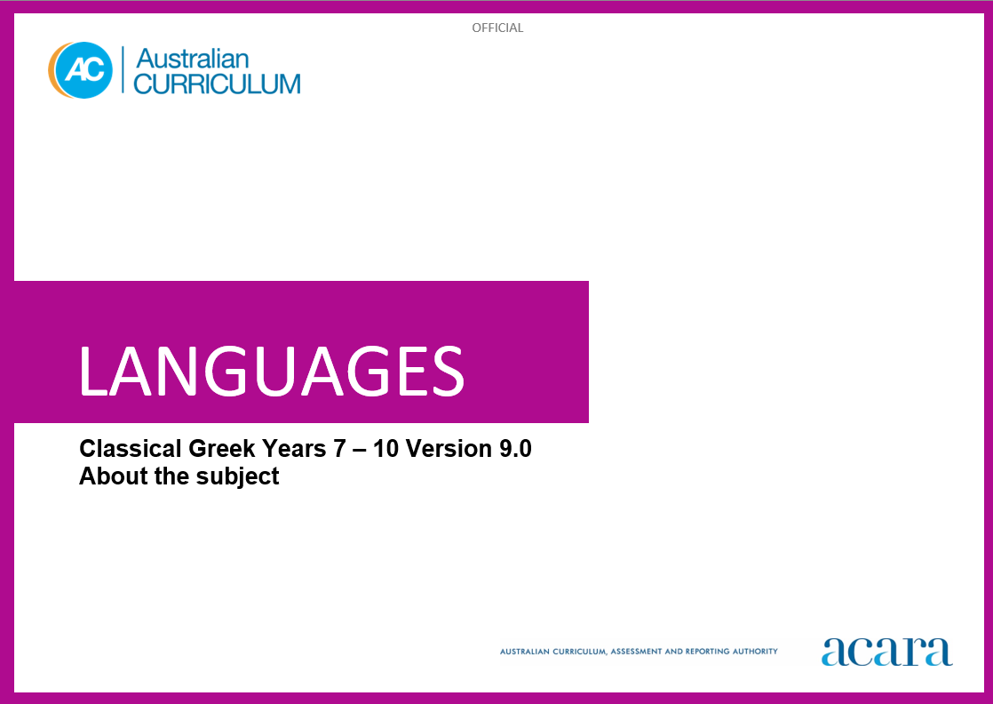

**Copyright and Terms of Use Statement**

**© Australian Curriculum, Assessment and Reporting Authority 2024**

The material published in this work is subject to copyright pursuant to the Copyright Act 1968 (Cth) and is owned by the Australian Curriculum, Assessment and Reporting Authority (ACARA) (except to the extent that copyright is held by another party, as indicated).

The viewing, downloading, displaying, printing, reproducing (such as by making photocopies) and distributing of these materials is permitted only to the extent permitted by, and is subject to the conditions imposed by, the terms and conditions of using the ACARA website (see, especially, clauses 2, 3 and 4 of those terms and conditions). The terms and conditions can be viewed at [https://www.acara.edu.au/contact-us/copyright](https://aus01.safelinks.protection.outlook.com/?url=https%3A%2F%2Fwww.acara.edu.au%2Fcontact-us%2Fcopyright&data=04%7C01%7CSharon.Foster%40acara.edu.au%7C9931e11fa7684c603e6308d98331bbfb%7C6cf76a3aa824427092003d71673ec678%7C0%7C0%7C637685071906340874%7CUnknown%7CTWFpbGZsb3d8eyJWIjoiMC4wLjAwMDAiLCJQIjoiV2luMzIiLCJBTiI6Ik1haWwiLCJXVCI6Mn0%3D%7C1000&sdata=U5O4Vlbpf271IGmGiMh7fDwU4pLzzAiHpCQFylkp6s4%3D&reserved=0)

**TABLE OF CONTENTS**

7–10 AUSTRALIAN CURRICULUM: LANGUAGES –CLASSICAL GREEK 3

ABOUT CLASSICAL GREEK 3

Introduction 3

Rationale 3

Structure 4

7–10 AUSTRALIAN CURRICULUM: LANGUAGES –CLASSICAL GREEK

ABOUT CLASSICAL GREEK

Introduction

The Australian Curriculum: Classical Greek is pitched to second-language learners in Years 7–10, that is, the dominant structure and sequence of learning in the current Australian school context. For most students it is their first experience of learning Classical Greek.

Rationale

Classical Greek is defined as the literary Attic-Ionic dialect used by prominent Greek historians, orators, philosophers and playwrights in the fifth and fourth centuries BCE. The conquests of Alexander the Great in the fourth century BCE extended the influence of Greek language and culture in western Asia and Egypt, and resulted in the upsurge in Greek literature and learning known as the Hellenistic Age. The eastern Roman Empire, based at Constantinople, continued as a Greek-speaking, Christian community until it was conquered by the Turks in 1453 CE.

After the conquest of Constantinople, many Greek scholars moved to western Europe, stimulating the revival of Classical Greek learning, art and culture during the Renaissance period. The Greek language continued to evolve and absorb influences from other languages until the present day.

Modern Greek uses the same alphabet as, and the written language bears strong resemblance to, Classical Greek. The enduring achievements and rich legacy of the ancient Greek world are evident in modern beliefs, customs and values, architecture, art, engineering, laws and forms of government, literature, mathematics, medicine, philosophy and sciences.

Classical Greek has been taught in Australian schools and universities since the 1800s. By accessing and translating Classical Greek texts and engaging with artefacts, students make connections with ancient worlds that have shaped contemporary life and societies. Learning Classical Greek enhances students’ understanding of English due to its influence on the vocabulary of English. Knowledge of Classical Greek and the ancient Greek world enriches students’ awareness of how an ancient civilisation influences life and thought in the modern world. This knowledge promotes understanding of diverse attitudes, beliefs and values.

Structure

Classical Greek has been developed as a second-language learner pathway which caters for students learning Classical Greek as a second or additional language in Years 7–10.

The second-language learner pathway includes one sequence:

* Years 7 to 10.

Teachers use the curriculum to cater for the range of learners by making appropriate adjustments to differentiate learning experiences.

Content in Classical Greek is organised under 2 interrelated strands, each with a number of sub-strands. The strands and sub-strands are presented in Figure 1.

Figure 1: Classical Greek content structure

**Strand: Engaging with the ancient Greek world through texts**

This involves students engaging with the language, culture and history of the ancient Greek world through the interpretation, analysis and translation of Classical Greek texts. There are 2 sub-strands.

**Accessing and responding to Classical Greek texts**

Engaging with and responding to the ideas and people of the ancient Greek world, through texts that reveal language use and social and cultural practices.

**Translating**

Translating Classical Greek texts into English, comparing and explaining different interpretations of the same text.

**Strand: Understanding language and culture**

This involves students learning to analyse language and culture as resources for understanding meaning. There are 2 sub-strands.

**Understanding systems of language**

Understanding the linguistic features of Classical Greek, including sound, writing, grammatical and textual conventions.

**Understanding the interrelationship of language and culture**

Analysing and reflecting on the role of language and culture in shaping meaning and identity.