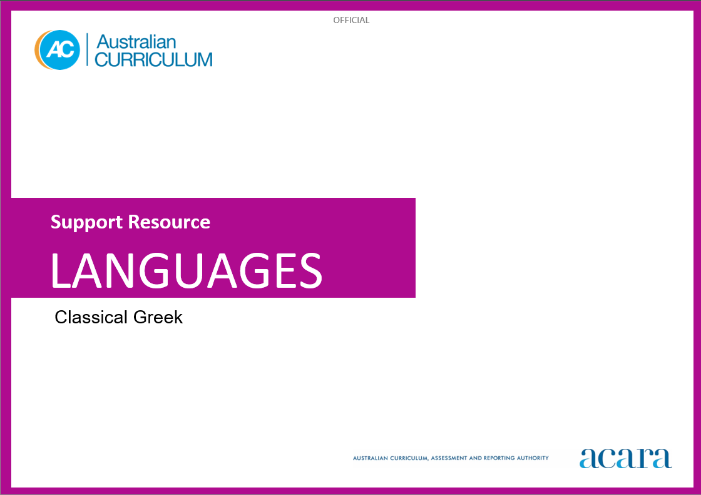

**Copyright and Terms of Use Statement**

**© Australian Curriculum, Assessment and Reporting Authority 2024**

The material published in this work is subject to copyright pursuant to the Copyright Act 1968 (Cth) and is owned by the Australian Curriculum, Assessment and Reporting Authority (ACARA) (except to the extent that copyright is held by another party, as indicated).

The viewing, downloading, displaying, printing, reproducing (such as by making photocopies) and distributing of these materials is permitted only to the extent permitted by, and is subject to the conditions imposed by, the terms and conditions of using the ACARA website (see, especially, clauses 2, 3 and 4 of those terms and conditions). The terms and conditions can be viewed at [https://www.acara.edu.au/contact-us/copyright](https://aus01.safelinks.protection.outlook.com/?url=https%3A%2F%2Fwww.acara.edu.au%2Fcontact-us%2Fcopyright&data=04%7C01%7CSharon.Foster%40acara.edu.au%7C9931e11fa7684c603e6308d98331bbfb%7C6cf76a3aa824427092003d71673ec678%7C0%7C0%7C637685071906340874%7CUnknown%7CTWFpbGZsb3d8eyJWIjoiMC4wLjAwMDAiLCJQIjoiV2luMzIiLCJBTiI6Ik1haWwiLCJXVCI6Mn0%3D%7C1000&sdata=U5O4Vlbpf271IGmGiMh7fDwU4pLzzAiHpCQFylkp6s4%3D&reserved=0)

# **TABLE OF CONTENTS**

F–10 AUSTRALIAN CURRICULUM: Classical Greek language support resource 3

Introduction 3

Language structures and features 4

F–10 AUSTRALIAN CURRICULUM: Classical Greek language support resource

Introduction

This Classical Greek Language resource was developed to support teachers as they plan teaching and learning programs to implement the Australian Curriculum: Classical Greek. It is optional and includes illustrative examples and suggestions for a sequential development of language structures and features.

Content is presented in 2 broad levels – beginner/intermediate and intermediate/advanced – and is independent of the year bands and the time spent on task. Teachers can use suggestions in the resource to assist their planning of programs based on the AC: Classical Greek. The resource may assist teachers to meet the diverse language needs and learning backgrounds of students at different entry points into second-language learning.

For example:

* a Year 9 student is learning Classical Greek for the first time. The teacher can use the cognitive demand of the Years 9 and 10 curriculum achievement standards and content descriptions, supported by the beginner/intermediate language structures and features to cater for the linguistic needs of the student.

This resource provides language structures and features that are neither exhaustive nor mutually exclusive. The 2 levels demonstrate how a particular structure or feature could be developed at different stages of a continuum of second-language learning.

Language structures and features

Table 1 begins with ‘Conventions of phonological and orthographic systems’ followed by structures and features organised in alphabetical order.

Table 1: Language structures and features

|  |  |  |
| --- | --- | --- |
| **Language structures and features** | | |
| Conventions of phonological and orthographic systems | **Beginner/Intermediate** | **Intermediate/Advanced** |
| letters, sounds and pronunciation   * Greek alphabet in lower and upper case, including final sigma, matching letter to sound, for example, *δ=d, γ=g* * diphthongs, double consonants and aspirated consonants, for example, *αι, γγ, ψ, ξ, θ, χ, φ* * diacritical marks to show aspiration and iota subscript, for example, *ἡ ὁδός, τῇ ὁδῷ* * the standard system of transliteration of Greek into English letters, for example, *δ=d, χ=ch*, *ψ=ps* * punctuation conventions for example, the use of the semicolon as question mark in Classical Greek, or a raised dot above the line to indicate a short pause | **reading aloud and performing**   * stress, intonation, tone and emphasis to create effect * sound and spelling changes, for example, those that occur when stops (*β/π/φ, τ/δ/θ/ζ, κ/γ/χ*) are followed by sigma, for example, *σπεύδω/ἔσπευσα, πέμπω/ἔπεμψα, διώκω/ἐδίωξα* * diacritical marks for accentuation to distinguish between words with the same spelling, for example, interrogative and indefinite pronouns such as *τις* and *τίς*, or verbs such as *πονεῖ* and *πόνει* * component parts of compound words involving transfer of aspirates, for example, *κατά+ἵστημι=καθίστημι* * non-Attic versions of common words, for example, *θάλασσα (θάλαττα)*, *ἐς (εἰς), μάτηρ (μήτηρ)* * crasis and elision, for example, *κἀγαθοί=καὶ ἀγαθοί, τἄλλα=τὰ ἄλλα* * iota subscript is given in the upper case when reading Classical Greek inscriptions, for example, *ΑΝΘΡΩΠΩΝ Ο ΣΟΦΩΤΑΤΟΣ ΠΡΟΣ ΘΕΟΝ ΠΙΘΗΚΟΣ ΦΑΝΕΙΤΑΙ ΚΑΙ ΣΟΦΙΑΙ ΚΑΙ ΚΑΛΛΕΙ ΚΑΙ ΤΟΙΣ ΠΑΣΙΝ* |
| Adjectives | declension forms, agreement and position of adjectives   * the three declensions of regular adjectives, for example, *καλός, ῥᾴδιος, σώφρων* * common irregular adjectives, for example, *μέγας/μεγάλη/μέγα, πολύς/πολλή/πολύ, πᾶς/πᾶσα/πᾶν* * agreement between adjectives and nouns in number, gender and case, for example, *ἠ μακρὰ ὁδός, τοῦ ἀληθοῦς λόγου* * attributive and predicative position of the adjective to vary meaning, for example, *ἡ καλή οἰκία/ἡ οἰκία ἡ καλή* (attributive) *καλή ἡ οἰκία / ἡ οἰκία καλή* (predicative) * comparative and superlative degrees of regular adjectives, for example, *ἀνδρεῖος, ἀνδρειότερος, ἀνδρειότατος* | more complex adjectives   * comparative and superlative degrees of common irregular adjectives, for example,   ἀγαθός*/ἀμείνων/ἄριστος, ἀγαθός/βελτίων/βέλτιστος, ἀγαθός/κρείττων/κράτιστος*  *κακός/κακίων/κάκιστος, κακός/χείρων/χείριστος*  *καλός/καλλίων/κάλλιστος*  *μέγας/μείζων/μέγιστος*  *πολύς/πλείων/πλεῖστος*   * indefinite adjective *τις* with nouns to supply the meaning of the indefinite article in English * verbal adjective in *έος*, for example, *οὐ λεκτέοι εἰσὶν οἱ λόγοι* |
| Adverbs | formation of adverbs   * positive, comparative and superlative adverbs formed from adjectives, for example, *ἀληθῶς/ἀληθέστερον/ἀληθέστατα* | **use of irregular adverbs**   * irregular positive, comparative and superlative adverbs, for example,   *εὖ /ἄμεινον/ἄριστα, εὖ /βέλτιον/βέλτιστα, εὖ /κρείττον/κράτιστα*  *κακῶς/κάκιον/κάκιστα, κακῶς/χείρον/χείριστα*  *καλῶς/κάλλιον/κάλλιστα*  *πολύ/πλέιον/πλεῖστα*  *μάλα, μᾶλλον, μάλιστα* |
| Affixes | **prefixes and suffixes**   * prefixes such as *κατά, πρός, ἐπί, παρά* * suffixessuch as *ῶς, -νε, -μεν,* for example, *καταπίπτει πρὸς τὴν γῆν* and *ἆρα ἀληθῶς ἑορτὴν ποιοῦσιν οἱ Ἀθηναῖοι* |  |
| Articles | **definite articles**   * definite article to identify the number, gender and case of nouns, for example**,** *αἱ ὁδοί, τούς δικαστάς* * position of article to indicate attributive or predicative function of adjective, for example, *ἡ οἰκία ἡ καλή* | indefinite pronoun or adjective   * *τίς, τί* (a certain, some, any) can function as an indefinite article and mean ‘a’ or ‘an’ |
| Conjunctions | commonly used conjunctions   * conjunctions, for example, *καί, τε, ἀλλά, μέν ... δέ, ἤ ... ἤ, γάρ, οὔτε ... οὔτε, εἰ, καίπερ, ἵνα,ὅτι, ἤ* | **use in complex sentences**   * conjunctions such as *ὅπως, εἰ, ἐὰν, ὡς, ὥστε* in complex sentences to extend, elaborate and explain ideas, for example, *ἐν τῷ ἄστει μενῶ ὡς τὰς τραγῳδίας θεασόμενος* and *εἰ ὁ Φίλιππος τοῦτο εἶπεν, ἐψεύδετο.* |
| Interrogatives | commonly used interrogatives   * interrogative adverbs, for example, *τί, ποῦ, πότε, πῶς* | additional forms of interrogatives   * interrogative adverbs such as *πόθεν, ποῖ, πῇ, ὁπόθεν,* for example, *ὁ Κύκλωψ τὸν Ὀδυσσέα ἐρωτᾷ πόθεν ἥκει* and *ποῖ πορεύεται ὁ βασιλεύς;* |
| Nouns | forms of nouns   * the three declensions of nouns and adjectives, including variants: * first declension, for example, *ἡ κρήνη, ἡ οἰκία, ἡ θάλαττα, ὁ δεσπότης, ὁ νεανίας* * second declension, for example, *ὁ ἀγρός, ἡ νῆσος, τὸ δένδρον* * third declension, for example, *ὁ φύλαξ, τὸ ὂνομα, ὁ ἀνήρ, ἡ τριήρης, ἡ πόλις, ὁ βασιλεύς, τὸ τεῖχος* * common irregular nouns, for example, *ἠ ναῦς, ὀ βοῦς*   **case usage**   * functions of the nominative, vocative, accusative, genitive and dative cases of nouns, for example, *ὁ νεανίας* (nominative subject), *(ὦ) ἄνθρωπε, (ὦ) γύναι, (ὦ) φυτόν* (vocative), *τὸν* *δεσπότην* (accusative object), *τῶν πολιτῶν πολλοί* (partitive genitive), *τῇ ὑστεραίᾳ* (dative of time when) |  |
| Νumbers | cardinal and ordinal numbers   * cardinal numbers, for example, *εἷς, μία, ἕν, δύο, τρεῖς, τρία* * ordinal numbers, for example, *πρῶτος, δεύτερος, τρίτος* |  |
| Particles | **types of particles**   * interrogative, negative, emphatic, temporal, adversative, coordinating, concessive particles, for example, *ἆρα, γάρ, δέ, μέντοι, τοι, τοιγάρ, δήπου, οὐ, μή, δή, γε, δῆτα, ἅμα, αὖ, οὖν* |  |
| Prepositions | prepositions and case   * prepositions with the accusative, genitive and dative cases, for example*, ἀπό, διά, εἰς, ἐκ, ἐπί, κατά, πρός, σύν, περί, ὑπό* * changes in meaning when the same preposition is used with different cases, for example, *μετά τῶν ἑταίρων*=with, *μετὰ τὸ δεῖπνον*=after |  |
| Pronouns | commonly used pronouns   * personal, for example, *ἐγώ/σύ, ἡμεῖς/ὑμεῖς* * interrogative, for example, *τίς/τί* * indefinite, for example, *τις/τι* * demonstrative, for example, *οὗτος/αὕτη/τοῦτο* * relative pronouns, for example, *ὅς/ἥ/ὅ* | additional pronouns   * definite pronouns, for example, *ὅσπερ* * indefinite relative pronouns, for example, *ὅστις, ὅσοι* * relative pronouns, for example, *οἷος, ὁποῖος* |
| Sentence structures | commonly used sentence structures   * varying word order structures such as: * subject+linking verb+complement, for example, *ὁ αὐτουργός ἐστιν ἰσχυρός* and *μικρὸς ἐστιν ὁ ἀγρός;* * subject+verb+prepositional phrase, for example, *ὁ Δικαιόπολις ἐκβαίνει ἐκ τοῦ οἴκου* * subject+verb+object, for example, *ὁ αὐτουργός ἐλαύνει τούς βοῦς* * subject+object+verb, for example, *ὁ δοῦλος τὸ ἄροτρον φέρει* * verb+subject, for example, *καταδύνει ὁ ἥλιος* * participial clauses, for example, *ὁ δοῦλος οὐ παύεται ἐργαζόμενος* and *ἡ κύων ἡ τὸν λύκον φοβουμένη ἀποφεύγει* * positive and negative commands, for example*, σπεῦδε πρὸς τὸν ἀγρόν, μὴ κάθευδε* * questions, for example*, ἆρα πάντας τοὺς ἑταίρους σῴζει ὁ Ὀδυσσεύς;* * relative clauses, for example*, οἰ ἔμποροι, οἳ ἐν ἐκείνῃ τῇ νηῖ ἔπλεον, τὰ κύματα οὐκ ἐφοβοῦντο* * causal clauses, for example, *Ἀθηναῖοι ἐνόμιζον ἡσσᾶσθαι, ὅτι οὐ πολύ ἐνίκων* * temporal clauses, for example*, ἐπεὶ εἰς τὸ ἄστυ ἀφικόμεθα ...* * concessive clauses, for example, *ὁ παῖς καίπερ τῆς τοῦ πατρὸς χειρὸς ἐχόμενος ἔπταισε* * result clauses, for example, *οὕτω δὲ ταχέως τρέχουσιν ὥστε δι’ ὀλίγου οὐ δυνατόν ἐστιν ὁρᾶν οὔτε τὸν κύνα οὔτε τὸν λαγών* * simple indirect statement, for example, *ἡ μήτηρ λέγει ὅτι οἱ παῖδες μἀλα ἀνδρεῖοι εἰσι* | **more complex sentence and mood structures**   * structure and use of indirect statements with *ὅτι,* the infinitive or the participle, for example, *ὁ ἄγγελος εἶπεν ὅτι οἱ πολέμιοι ἤδη προσχωροῦσιν/ὁ πάτηρ ἔφη ἀνάγκην εἶναι οἴκαδε ἐπανιέναι/οἱ παῖδες εἶδον λύκον μέγαν πρὸς τὴν οἰκίαν προσιόντα* * structure and use of indefinite clauses, for example, *ὅστις ἄν ἔξω τῶν τῆς πόλεως ὁρῶν εὑρεθῇ, ἐν κινδύνῳ μεγάλῳ ἔσται/ἐπειδὰν γένηται ἡ πανήγυρις, πάντες οἱ Ἀθηναῖοι εἰς τὴν ἀγορὰν σπεύδουσιν* * use of the subjunctive mood in: * exhortations, for example, *ταχέως ἵωμεν* * deliberations, for example, *τί ποιῶμεν;* * prohibitions, for example, *μὴ δέξησθε τὰ δῶρα* * purpose clauses, for example, *οἱ στρατιῶται φεύγουσιν ἵνα μὴ ὑπὸ τῶν πολεμίων ληφθῶσιν* * clauses of fearing, for example, *φοβοῦμαι μὴ ὁ δεσπότης οὐκ ἐθέλῃ παῦσαι τὸν πόνον* * use of the optative mood in: * wishes, for example, *εἴθε τὴν πατρίδα σῴζοιμεν* * potential clauses, for example, *βουλοίμεθα ἄν τοῦ ἀοιδοῦ ἀκούειν* * indirect questions, for example*, ὁ Κροῖσος ἐρωτᾷ τίνα δεύτερον μετ’ἐκεῖνον ὀλβιώτατον εἶδε* * indirect statements, for example*, ἔδειξεν ὁ θεός ὅτι ἄμεινόν εἴη ἀνθρώπῳ τεθνάναι μᾶλλον ἢ ζῆν* * the accusative absolute and genitive absolute, for example, *ἡμέρας γενομένης, ἔδοξεν ταῖς κόραις πρὸς τὴν κρήνην βαίνειν* and *δέον τὴν πόλιν ἀμύνεσθαι, οἱ ἄνδρες τὰ ὅπλα ἔφερον* * conditional clauses, for example, *ἐὰν τῷ δημαγωγῷ πιστεύῃς, μῶρος εἶ/ἐὰν τὸν δοῦλον καλέσῃς, βραδέως ἀφίξεται/εἰ ὁ παῖς τοῦτο ἐποίησεν, ἐδέξατο ἄν τον ἔπαινον* * indefinite clauses, for example, *ὅστις ἄν ἔξω τῶν τῆς πόλεως ὁρῶν εὑρεθῇ, ἐν κινδύνῳ μεγάλῳ ἔσται/ἐπειδὰν γένηται ἡ πανήγυρις, πάντες οἱ Ἀθηναῖοι εἰς τὴν ἀγορὰν σπεύδουσιν* |
| Verbs | tenses and conjugations   * variable endings to indicate person and number, for example, *φέρω, φέρουσιν* * present, future, imperfect and aorist tenses, active and middle οf -ω verbs, contract verbs in *-εω/-αω*, for example, *λύω/λύομαι, φιλῶ/φιλοῦμαι, τιμῶ/τιμῶμαι* * imperative in the present and aorist tenses, active and middle, for example, *σπεῦδε/σπεῦσον* * infinitive and participles, active and middle, in the present, future and aorist tenses, for example, *παύειν/παύων, παύσειν/παύσων, παῦσαι/παύσας* * irregular verb ‘to be’ in the present, future and imperfect tenses *εἰμἰ/ἔσομαι/ἦν* * irregular verbs such as *φημί, εἶμι* * impersonal verbs, for example, *ἔξεστι(ν), δεῖ, δοκεῖ, χρή* | **conjugation of more complex tenses and moods**   * perfect and pluperfect tenses, active and middle, indicative, imperative and infinitive forms of -*ω* verbs, contract verbs in -*εω/-αω*, for example, *εἴρηκα/εἴρημαι, ἑόρακα/ἑώραμαι, δεδήλωκα, ἠλευθέρωκα* * *-μι* verbs in all tenses and voices, imperative and infinitive forms, for example, *δίδωμι, τίθημι, ἵστημι, ἵημι, δείκνυμι* * common irregular verbs, for example, *oἶδα, ἒοικα* * forms of the subjunctive mood, for example, *ἵωμεν, ληφθῶσιν, ἐθέλῃ* * forms of the optative mood, for example*, σῴζοιμεν, βουλοίμεθα* * the articular infinitive, for example, *ἀγαθὸς εἰς τὸ λέγειν τε καὶ πράττειν* * verbs that take supplementary participles, for example, *ἔτυχον παροῦσαι αἱ γυναῖκες, οἱ Ἀθηναῖοι ἐφαίνοντο οὐ βουλόμενοι ἀγορεύειν* |