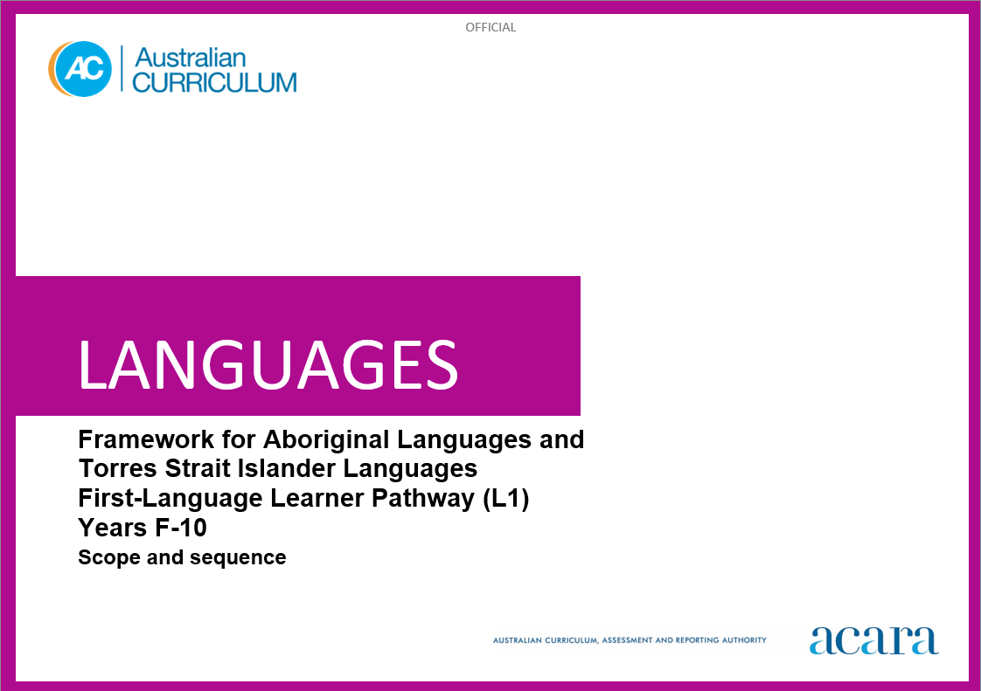**6**

**Framework for Aboriginal Languages and Torres Strait Islander Languages L1**

**SCOPE AND SEQUENCE**

|  |  |
| --- | --- |
| **Foundation** | **Years 1–2** |
| **Achievement standard** | |
| By the end of the Foundation year, students use play and imagination to interact and create [Language] texts, with support. They identify that [Language] and English are different. They recognise that there are languages and cultures as well as their own, and that aspects of languages and cultures contribute to their own and others’ cultural identity. | By the end of Year 2, students use [Language] language to interact and share information related to Country/Place, the classroom and themselves. They use cues to respond to questions and instructions, using modelled language. They locate and convey key items of information in texts, using non-verbal, visual and contextual cues to help make meaning. They use familiar words, sentences and modelled language to create texts.  Students recognise and use the sounds and rhythms of spoken [Language]. They demonstrate understanding that [Language] has conventions and rules for non-verbal communication, pronunciation and writing. They give examples of similarities and differences between some features of [Language] and English. They understand that [Language] belongs to Country/Place and Peoples, and is connected with their culture, and notice how this is reflected in their own language(s), culture(s) and identity. |

|  |  |
| --- | --- |
| **Content descriptions** | |
|  | **Strand: Communicating meaning in [language}** |
|  | **Sub-strand: Interacting in [Language]** |
| with support, recognise and communicate meaning in [Language]  AC9L1FF01 | exchange greetings and personal introductions, and respond to instructions and routines  AC9L1F2C01 |
| explore, with support, language features of [Language] making connections between [Language] and English  AC9L1FF02 | participate in a range of guided, play-based language activities, using modelled expressions and visual and spoken cues  AC9L1F2C02 |
| identify connections between language and culture  AC9L1FF03 |  |
|  | **Sub-strand: Mediating meaning in and between languages** |
|  | locate, with support, key information in familiar texts and respond using gestures, images, words and modelled phrases  AC9L1F2C03 |
|  | recognise that language carries cultural meaning in everyday social interactions  AC9L1F2C04 |
|  | **Sub-strand: Creating text in [Language]** |
|  | use words, familiar phrases and modelled language to create spoken, written and multimodal texts  AC9L1F2C05 |

|  |  |
| --- | --- |
|  | **Strand: Understanding language and culture** |
|  | **Sub-strand: Understanding systems of language** |
|  | recognise that [Language] has an oral tradition; and use the sounds and rhythms of [Language] to make meaning  AC9L1F2U01 |
|  | recognise that [Language] has language conventions and grammatical structures, and has an oral tradition that can be represented in written form  AC9L1F2U02 |
|  | notice that [Language] has features that may be similar to or different from English  AC9L1F2U03 |
|  | **Sub-strand: Understanding the interrelationship of language, culture and identity** |
|  | recognise that [Language] and all Aboriginal languages and Torres Strait Islander languages belong to Country/Place and Peoples  AC9L1F2U04 |
|  | notice that people use language in ways that reflect cultural identity  AC9L1F2U05 |

|  |  |
| --- | --- |
| **Years 3–4** | **Years 5–6** |
| **Achievement standard** | |
| By the end of Year 4, students use [Language] language to initiate structured interactions to share information related to Country/Place, the learning environment and their personal worlds. They use familiar language to participate in spoken and written activities that involve planning and transacting. They locate and respond to key items of information in texts, using strategies to help interpret and convey meaning in familiar contexts. They use familiar and formulaic language, and basic syntax, to create texts.  Students use the sounds, pronunciation and intonation patterns of spoken [Language]. They demonstrate understanding that [Language] has non-verbal, spoken and written language conventions and rules to create and make meaning. They recognise that some terms have cultural meanings. They identify patterns in [Language] and make comparisons between [Language] and English. They understand that the [Language] language is passed down from generation to generation by its Custodians and is connected with culture and identity. They identify how this is reflected in their own language(s), culture(s) and identity. | By the end of Year 6, students initiate and use strategies to maintain interactions in [Language] language that are related to their experiences and views. They collaborate in spoken and written activities that involve the language of planning and problem-solving to share information, preferences and ideas. They use strategies to locate and interpret information and ideas in texts. They demonstrate understanding by responding in [Language] or English, adjusting their response to context, purpose and audience. They create texts, selecting and using a range of vocabulary and sentence structures to suit context. They sequence information and ideas, and use conventions appropriate to text type.  Students apply rules of pronunciation and intonation in spoken [Language] to enhance fluency. They apply conventions of spelling and punctuation, and use modelled structures, when creating and responding in [Language]. They compare language structures and features in [Language] and English, using some metalanguage. They reflect on the importance of maintaining and strengthening [Language] and the protocols associated with language reclamation and revitalisation. They show understanding of how language reflects cultural practices and consider how this is reflected in their own language(s), culture(s) and identity. |

|  |  |
| --- | --- |
| **Content descriptions** | |
| **Strand: Communicating meaning in [language]** | |
| **Sub-strand: Interacting in [Language]** | |
| initiate exchanges and respond to modelled questions about self, others and the learning environment, using modelled expressions  AC9L1F4C01 | initiate and sustain modelled exchanges in familiar contexts related to Country/Place and students’ personal worlds  AC9L1F6C01 |
| participate in activities that involve planning with others, using a range of phrases and modelled structures in familiar contexts  AC9L1F4C02 | participate in activities that involve planning and negotiating with others, using language that expresses information, preferences and ideas  AC9L1F6C02 |
| **Sub-strand: Mediating meaning in and between languages** | |
| locate and respond to key information related to familiar content obtained from spoken, written and multimodal texts  AC9L1F4C03 | locate and process information and ideas in a range of spoken, written and multimodal texts, and respond in different ways to suit purpose  AC9L1F6C03 |
| develop strategies to comprehend and adjust [Language] language to convey cultural meaning  AC9L1F4C04 | apply strategies to interpret and convey meaning in [Language] language in non-verbal, spoken and written cultural contexts  AC9L1F6C04 |
| **Sub-strand: Creating text in [Language]** | |
| create and present informative and imaginative spoken, written and multimodal texts, using formulaic expressions, simple phrases and sentences, and modelled textual conventions  AC9L1F4C05 | create and present a range of informative and imaginative spoken, written and multimodal texts, using a variety of modelled sentence structures to sequence information and ideas, and conventions appropriate to text type  AC9L1F6C05 |

|  |  |
| --- | --- |
| **Strand: Understanding language and culture** | |
| **Sub-strand: Understanding systems of language** | |
| use combinations of sounds, pronunciation and intonation patterns of [Language] to form words and phrases  AC9L1F4U01 | apply knowledge of combinations of sounds, syllables, pronunciation and intonation patterns to develop fluency and rhythm to known words, phrases and expressions  AC9L1F6U01 |
| recognise and use [Language] language conventions, grammatical structures and syntax, in familiar texts and contexts  AC9L1F4U02 | use knowledge of modelled grammatical structures and formulaic expressions to compose and respond to texts  AC9L1F6U02 |
| recognise familiar [Language] language features and compare with those of English, in known contexts  AC9L1F4U03 | compare some [Language] language structures and features with those of English, using some familiar metalanguage  AC9L1F6U03 |
| **Sub-strand: Understanding the interrelationship of language, culture and identity** | |
| recognise that Aboriginal languages and Torres Strait Islander languages are passed down by Custodians, from generation to generation  AC9L1F4U04 | understand how Aboriginal languages and Torres Strait Islander languages are maintained and strengthened  AC9L1F6U04 |
| identify connections among [Language] language, culture, Country/Place and identity  AC9L1F4U05 | recognise that identity is shaped by language(s), culture(s) and Country/Place, and that this impacts on communication  AC9L1F6U05 |

|  |  |
| --- | --- |
| **Years 7–8** | **Years 9–10** |
| **Achievement standard** | |
| By the end of Year 8, students contribute to and maintain interactions in [Language] language in familiar and unfamiliar contexts related to a range of experiences and perspectives. They use [Language] to negotiate solutions, and adjust language in response to others. They interpret and analyse information, ideas and opinions in texts. They demonstrate understanding of similarities and differences among languages, in both familiar and some unfamiliar cultural contexts, by adjusting responses to suit context, purpose and audience. They select and use vocabulary, sentence structures and expressions, manipulating language to create texts.  Students apply the conventions of spoken [Language] to extend fluency. They demonstrate understanding that spoken, written and multimodal texts use different language conventions, structures and features to convey meaning. They explain structures and features of [Language] text, using metalanguage. They reflect on how language Custodians pass down knowledge and cultural norms, and understand the protocols of maintaining and strengthening [Language]. They understand how these are interconnected with their own language(s), culture(s) and identity. | By the end of Year 10, students contribute to and extend interactions in [Language] language related to diverse contexts and perspectives. They interpret and respond to texts by evaluating and synthesising information, ideas and perspectives. They show understanding of how features of language can be used to influence audience response. They create texts, selecting and manipulating language for a range of contexts, purposes and audiences. They apply and use complex structures and language devices to enhance meaning and cohesion.  Students apply and adjust features and conventions of spoken [Language] to extend fluency. They demonstrate understanding of the conventions of spoken and written texts and the connections between them. They apply knowledge of language structures and features to make and predict meaning. They support analysis of [Language] texts, using metalanguage. They understand and apply protocols that relate to learning and using [Language] in their community. They reflect on their own cultural perspectives and identity, and draw on their experience of learning [Language], to evaluate how this learning influences their ideas and ways of communicating. |

|  |  |
| --- | --- |
| **Content descriptions** | |
| **Strand: Communicating meaning in [Language]** | |
| **Sub-strand: Interacting in [Language]** | |
| initiate and sustain exchanges in familiar and some unfamiliar contexts related to Country/Place and students’ experiences, feelings and opinions, adjusting their language in response to others  AC9L1F8C01 | initiate, sustain and extend exchanges in a range of contexts related to students’ own and others’ experiences of the world, adjusting their language in response to others  AC9L1F10C01 |
| collaborate in activities that involve the language of transaction, negotiation and problem-solving, to plan projects and events  AC9L1F8C02 | contribute to discussions that involve diverse views to negotiate outcomes, address issues and compare experiences  AC9L1F10C02 |
| **Sub-strand: Mediating meaning in and between languages** | |
| interpret and analyse information, ideas and opinions in a range of spoken, written and multimodal texts, and respond appropriately to cultural context, purpose and audience  AC9L1F8C03 | evaluate and synthesise information, ideas and perspectives in a broad range of spoken, written and multimodal texts, and respond appropriately to cultural context, purpose and audience  AC9L1F10C03 |
| A interpret and adjust non-verbal, spoken and written language to convey meaning in [Language] language in familiar and some unfamiliar cultural contexts  C9L1F8C04 | interpret and translate non-verbal, spoken and written interactions and texts to reflect cultural context, purpose and audience  AC9L1F10C04 |
| **Sub-strand: Creating text in [Language]** | |
| create and present spoken, written and multimodal, informative and imaginative texts for specific purposes, selecting vocabulary, expressions, grammatical structures and features, and conventions appropriate to text type and context  AC9L1F8C05 | create and present informative and imaginative texts for diverse contexts and purposes, selecting vocabulary, expressions, grammatical structures and a range of features and conventions to engage different audiences  AC9L1F10C05 |

|  |  |
| --- | --- |
| **Strand: Understanding language and culture** | |
| **Sub-strand: Understanding systems of language** | |
| apply knowledge of conventions of spoken [Language] to enhance fluency, and respond to and create texts, in familiar and unfamiliar contexts  AC9L1F8U01 | apply features and conventions of spoken [Language] to extend fluency in response to a range of contexts, purposes and audience  AC9L1F10U01 |
| apply understanding of grammatical structures and features to compose and respond to texts  AC9L1F8U02 | apply knowledge of grammatical structures and features to predict meaning and compose a range of texts that contains complex structures and ideas  AC9L1F10U02 |
| reflect on similarities and differences between [Language] and English language structures and features, using metalanguage  AC9L1F8U03 | reflect on and evaluate [Language] texts, using metalanguage to analyse language structures and features  AC9L1F10U03 |
| **Sub-strand: Understanding the interrelationship of language, culture and identity** | |
| reflect on how language conveys cultural knowledge, practices and norms  AC9L1F8U04 | understand and apply protocols associated with language learning and language using in cultural contexts  AC9L1F10U04 |
| reflect on and explain how identity is shaped by language(s), culture(s), and Country/Place, and how these impact on communication  AC9L1F8U05 | reflect on and evaluate how identity is shaped by language(s), culture(s) and Country/Place, and how these affect ways of communicating  AC9L1F10U05 |