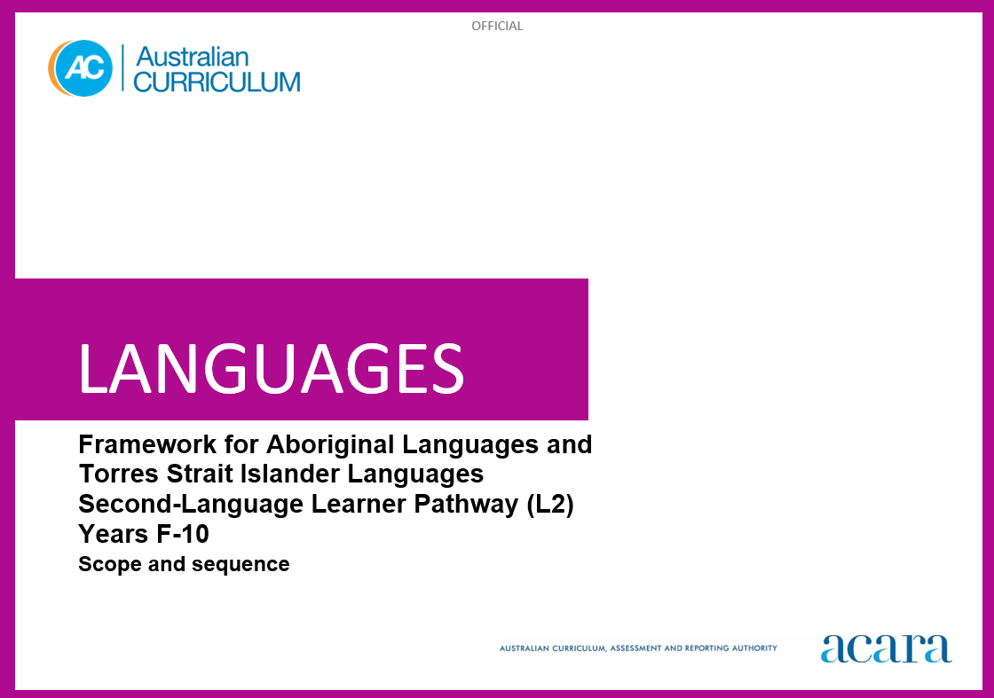

**Framework for Aboriginal Languages and Torres Strait Islander Languages L2**

**SCOPE AND SEQUENCE**

|  |  |
| --- | --- |
| **Foundation** | **Years 1–2** |
| **Achievement standard** | |
| By the end of the Foundation year, students use play and imagination to interact and create [Language] texts, with support. They identify that [Language] and English are different. They recognise that there are languages and cultures as well as their own, and that aspects of languages and cultures contribute to their own and others’ cultural identity. | By the end of Year 2, students use [Language] language to interact and share information related to Country/Place, the classroom and themselves. They use cues to respond to questions and instructions, and use simple formulaic language. They locate and convey key items of information in texts using non-verbal, visual and contextual cues to help make meaning. They use familiar words and modelled language to create texts.  Students reproduce the sounds and rhythms of spoken [Language]. They demonstrate understanding that [Language] has conventions and rules for non-verbal communication, pronunciation and writing. They give examples of similarities and differences between some features of [Language] and English. They understand that [Language] belongs to Country/Place and Peoples, and is connected with their culture, and notice how this is reflected in their own language(s), culture(s) and identity. |

|  |  |
| --- | --- |
| **Content descriptions** | |
|  | **Strand: Communicating meaning in [language}** |
|  | **Sub-strand: Interacting in [Language]** |
| with support, recognise and communicate meaning in [Language]  AC9L2FF01 | recognise and respond to modelled greetings, instructions and routines; and personal introductions  AC9L2F2C01 |
| explore, with support, language features of [Language] noticing similarities and differences between [Language] and English  AC9L2FF02 | participate in a range of guided, play-based language activities, using formulaic expressions and visual and spoken cues  AC9L2F2C02 |
| identify connections between language and culture  AC9L2FF03 |  |
|  | **Sub-strand: Mediating meaning in and between languages** |
|  | locate, with support, key information in familiar texts, and respond using gestures, images, words and formulaic phrases  AC9L2F2C03 |
|  | notice that language carries cultural meaning in greetings, introductions, instructions and routines  AC9L2F2C04 |
|  | **Sub-strand: Creating text in [Language]** |
|  | use words, familiar phrases and modelled language to create spoken, written and multimodal texts  AC9L2F2C05 |

|  |  |
| --- | --- |
|  | **Strand: Understanding language and culture** |
|  | **Sub-strand: Understanding systems of language** |
|  | recognise that [Language] has an oral tradition; and reproduce the sounds and rhythms of [Language]  AC9L2F2U01 |
|  | recognise that [Language] has language conventions and has an oral tradition that can be represented in written form  AC9L2F2U02 |
|  | notice that [Language] has features that may be similar to or different from English  AC9L2F2U03 |
|  | **Sub-strand: Understanding the interrelationship of language, culture and identity** |
|  | recognise that Aboriginal languages and Torres Strait Islander languages belong to Country/Place and Peoples  AC9L2F2U04 |
|  | notice that people use language in ways that reflect cultural identity  AC9L2F2U05 |

|  |  |
| --- | --- |
| **Years 3–4** | **Years 5–6** |
| **Achievement standard** | |
| By the end of Year 4, students use [Language] language to initiate structured interactions to share information related to Country/Place, the classroom and their personal worlds. They use modelled language to participate in spoken and written activities that involve planning. They locate and respond to key items of information in texts, using strategies to help interpret and convey meaning in familiar contexts. They use modelled language and basic syntax to create texts.  Students reproduce sound combinations and rhythms of spoken [Language]. They demonstrate understanding that [Language] has non-verbal, spoken and written language conventions and rules to create and make meaning. They recognise that some terms have cultural meanings. They identify patterns in [Language] and make comparisons between [Language] and English. They understand that the [Language] language is passed down from generation to generation by its Custodians and is connected with culture and identity. They identify how this is reflected in their own language(s) culture(s) and identity. | By the end of Year 6, students initiate and use strategies to maintain interactions in [Language] language that are related to their immediate environment. They collaborate in spoken and written activities that involve the language of planning and problem-solving to share information, preferences and ideas. They use strategies to locate and interpret information and ideas in texts. They demonstrate understanding by responding in [Language] or English, adjusting their response to context, purpose and audience. They create texts, selecting and using a variety of vocabulary and sentence structures to suit context. They sequence information and ideas, and use conventions appropriate to text type.  Students apply rules of pronunciation and intonation in spoken [Language]. They apply conventions of spelling and punctuation, and use modelled structures, when creating and responding in [Language]. They compare language structures and features in [Language] and English, using some metalanguage. They show understanding of why language should be revived following the appropriate protocols, and how some language reflects cultural practices. They consider how this is reflected in their own language(s) culture(s) and identity. |

|  |  |
| --- | --- |
| **Content descriptions** | |
| **Strand: Communicating meaning in [language]** | |
| **Sub-strand: Interacting in [Language]** | |
| initiate exchanges and respond to modelled questions about self, others and the learning environment, using formulaic expressions  AC9L2F4C01 | initiate and sustain modelled exchanges in familiar contexts related to students’ personal worlds and learning environment  AC9L2F6C01 |
| participate in activities that involve planning with others, using a range of familiar phrases and modelled structures  AC9L2F4C02 | participate in activities that involve planning and negotiating with others, using language that expresses information, preferences and ideas  AC9L2F6C02 |
| **Sub-strand: Mediating meaning in and between languages** | |
| locate and respond to key information related to familiar content obtained from spoken, written and multimodal texts  AC9L2F4C03 | locate and process information and ideas in a range of spoken, written and multimodal texts, and respond in different ways to suit purpose  AC9L2F6C03 |
| develop strategies to comprehend and adjust [Language] language in familiar contexts to convey cultural meaning  AC9L2F4C04 | apply strategies to interpret and convey meaning in [Language] language in familiar non-verbal, spoken and written cultural contexts  AC9L2F6C04 |
| **Sub-strand: Creating text in [Language]** | |
| create and present informative and imaginative spoken, written and multimodal texts using formulaic expressions, simple phrases and sentences and modelled textual conventions  AC9L2F4C05 | create and present a range of informative and imaginative spoken, written and multimodal texts using a variety of modelled sentence structures to sequence information and ideas, and conventions appropriate to text type  AC9L2F6C05 |

|  |  |
| --- | --- |
| **Strand: Understanding language and culture** | |
| **Sub-strand: Understanding systems of language** | |
| recognise and use modelled combinations of sounds, pronunciation and intonation patterns of [Language] to form words and phrases  AC9L2F4U01 | apply knowledge of combinations of sounds, syllables, pronunciation and intonation patterns to known words and phrases  AC9L2F6U01 |
| recognise [Language] language conventions, grammatical structures and basic syntax in familiar texts and contexts  AC9L2F4U02 | use knowledge of modelled grammatical structures and formulaic expressions to compose and respond to texts  AC9L2F6U02 |
| recognise familiar [Language] language features and compare with those of English, in known contexts  AC9L2F4U03 | compare some [Language] language structures and features with those of English, using some familiar metalanguage  AC9L2F6U03 |
| **Sub-strand: Understanding the interrelationship of language, culture and identity** | |
| recognise that Aboriginal languages and Torres Strait Islander languages are passed down by Custodians from generation to generation  AC9L2F4U04 | understand how [Language] and Aboriginal languages and Torres Strait Islander languages can be revived, maintained and strengthened  AC9L2F6U04 |
| identify connections between [Language] language, culture, Country/Place and identity  AC9L2F4U05 | recognise that identity is shaped by language(s), culture(s) and Country/Place, and that this impacts on communication  AC9L2F6U05 |

|  |  |
| --- | --- |
| **Years 7–8** | **Years 9–10** |
| **Achievement standard** | |
| By the end of Year 8, students contribute to and maintain interactions in [Language] language in familiar and some unfamiliar contexts related to a range of interests and experiences. They use [Language] to negotiate solutions and adjust language in response to others. They interpret information, ideas and opinions in texts. They demonstrate understanding of similarities and differences among languages, in both familiar and some unfamiliar cultural contexts, by adjusting responses to suit context, purpose and audience. They select and use vocabulary, sentence structures and expressions to create texts.  Students apply the conventions of spoken [Language] to enhance fluency. They demonstrate understanding that spoken, written and multimodal texts use different language conventions, structures and features to convey meaning. They comment on structures and features of [Language] text, using metalanguage. They reflect on how language communities pass down, maintain or revive [Language], knowledge and cultural norms following appropriate protocols, and how these are interconnected with identity. They reflect on their own language(s), culture(s) and identity. | By the end of Year 10, students contribute to and extend interactions in [Language] language in increasingly unfamiliar contexts related to a wide range of interests and issues. They interpret and respond to texts by evaluating and synthesising information, ideas and perspectives. They show understanding of how features of language can be used to influence audience response. They create texts, selecting and manipulating language for a range of contexts, purposes and audiences. They use complex structures to enhance meaning and cohesion.  Students incorporate the features and conventions of spoken [Language] to extend fluency. They demonstrate understanding of the conventions of spoken and written texts and the connections between them. They apply knowledge of language structures and features to make and predict meaning. They support analysis of [Language] texts, using metalanguage. They understand that there are appropriate protocols that relate to learning and using [Language]. They reflect on their own cultural perspectives and identity, and draw on their experience of learning [Language], to evaluate how this learning influences their ideas and ways of communicating. |

|  |  |
| --- | --- |
| **Content descriptions** | |
| **Strand: Communicating meaning in [Language]** | |
| **Sub-strand: Interacting in [Language]** | |
| initiate and sustain exchanges in familiar and some unfamiliar contexts related to students’ experiences, feelings and views, adjusting their language in response to others  AC9L2F8C01 | initiate, sustain and extend exchanges in familiar and unfamiliar contexts related to students’ own and others’ experiences of the world, adjusting their language in response to others  AC9L2F10C01 |
| collaborate in activities that involve the language of transaction, negotiation and problem-solving to plan projects and events  AC9L2F8C02 | contribute to discussions that involve diverse views to negotiate outcomes, address issues and compare experiences  AC9L2F10C02 |
| **Sub-strand: Mediating meaning in and between languages** | |
| interpret information, ideas and opinions in a range of spoken, written and multimodal texts, and respond appropriately to cultural context, purpose and audience  AC9L2F8C03 | evaluate and synthesise information, ideas and perspectives in a broad range of spoken, written and multimodal texts, and respond appropriately to cultural context, purpose and audience  AC9L2F10C03 |
| interpret and adjust non-verbal, spoken and written language to convey meaning in [Language] language in familiar and some unfamiliar cultural contexts  AC9L2F8C04 | interpret and translate non-verbal, spoken and written interactions and texts to convey meaning and intercultural understanding in familiar and unfamiliar contexts  AC9L2F10C04 |
| **Sub-strand: Creating text in [Language]** | |
| create and present spoken, written and multimodal, informative and imaginative texts for specific purposes, selecting vocabulary, expressions, grammatical structures and features, and conventions appropriate to text type and context  AC9L2F8C05 | create and present informative and imaginative texts for diverse contexts and purposes, selecting vocabulary, expressions, grammatical structures and a range of features and conventions to engage different audiences  AC9L2F10C05 |

|  |  |
| --- | --- |
| **Strand: Understanding language and culture** | |
| **Sub-strand: Understanding systems of language** | |
| apply knowledge of conventions of spoken [Language] to enhance fluency, and respond to and create texts, in familiar and some unfamiliar contexts  AC9L2F8U01 | apply features and conventions of spoken [Language] to extend fluency in responding to and creating texts in familiar and unfamiliar contexts  AC9L2F10U01 |
| apply understanding of grammatical structures and features to compose and respond to texts  AC9L2F8U02 | apply knowledge of grammatical structures and features to predict meaning and compose texts that contain some complex structures and ideas  AC9L2F10U02 |
| reflect on similarities and differences between [Language] and English language structures and features, using metalanguage  AC9L2F8U03 | reflect on and evaluate [Language] texts, using metalanguage to analyse language structures and features  AC9L2F10U03 |
| **Sub-strand: Understanding the interrelationship of language, culture and identity** | |
| reflect on how language conveys cultural knowledge, practices and norms  AC9L2F8U04 | understand and apply protocols associated with language learning and language using in cultural contexts  AC9L2F10U04 |
| reflect on and explain how identity is shaped by language(s), culture(s), and Country/Place, and how these impact on communication  AC9L2F8U05 | reflect on and evaluate how identity is shaped by language(s), culture(s) and Country/Place, and how these affect ways of communicating  AC9L2F10U05 |