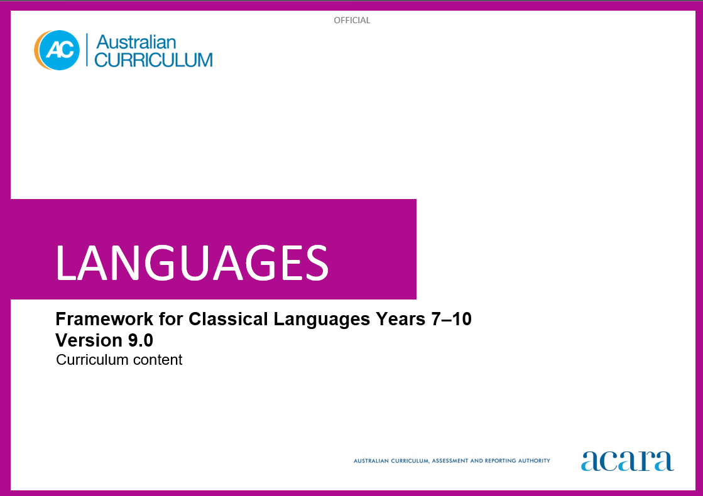

**Copyright and Terms of Use Statement**

**© Australian Curriculum, Assessment and Reporting Authority 2024**

The material published in this work is subject to copyright pursuant to the Copyright Act 1968 (Cth) and is owned by the Australian Curriculum, Assessment and Reporting Authority (ACARA) (except to the extent that copyright is held by another party, as indicated).

The viewing, downloading, displaying, printing, reproducing (such as by making photocopies) and distributing of these materials is permitted only to the extent permitted by, and is subject to the conditions imposed by, the terms and conditions of using the ACARA website (see, especially, clauses 2, 3 and 4 of those terms and conditions). The terms and conditions can be viewed at [https://www.acara.edu.au/contact-us/copyright](https://aus01.safelinks.protection.outlook.com/?url=https%3A%2F%2Fwww.acara.edu.au%2Fcontact-us%2Fcopyright&data=04%7C01%7CSharon.Foster%40acara.edu.au%7C9931e11fa7684c603e6308d98331bbfb%7C6cf76a3aa824427092003d71673ec678%7C0%7C0%7C637685071906340874%7CUnknown%7CTWFpbGZsb3d8eyJWIjoiMC4wLjAwMDAiLCJQIjoiV2luMzIiLCJBTiI6Ik1haWwiLCJXVCI6Mn0%3D%7C1000&sdata=U5O4Vlbpf271IGmGiMh7fDwU4pLzzAiHpCQFylkp6s4%3D&reserved=0)

**TABLE OF CONTENTS**

AUSTRALIAN CURRICULUM: LANGUAGES – FRAMEWORK FOR CLASSICAL LANGUAGES 4

CURRICULUM ELEMENTS 4

Years 7–8 (Year 7 entry) 4

Years 9–10 (Year 7 entry) 9

AUSTRALIAN CURRICULUM: LANGUAGES – FRAMEWORK FOR CLASSICAL LANGUAGES

CURRICULUM ELEMENTS

Years 7–8 (Year 7 entry)

|  |
| --- |
| **Band level description** |
| In Years 7 and 8, students are beginning their learning of [Classical Language], and this will be influenced by prior learning and experiences of language learning. Students access a range of texts in [Classical Language] and English to understand and explore the ancient [Country/City] world. They interact and collaborate with teachers and peers when engaged in activities involving listening, reading aloud, reading, viewing, translating and writing, supported by modelling, scaffolding and feedback. They access authentic and purpose-developed artefacts, spoken, written and multimodal resources which may include cartoons, stories, video clips, textbooks and modified or authentic extracts of literature.  Students use their English literacy knowledge of metalanguage to reflect on similarities and differences between [Classical Language] and English vocabulary, pronunciation and grammatical structures and features. They comment on the impact of ancient [Country/City] culture on the modern world. They recognise that language reflects social and cultural identity, beliefs and values. |
| **Achievement standard** |
| By the end of Year 8, students use their knowledge of [Classical Language] to interpret texts and sources, and respond to information about ancient [Country/City] society. They develop strategies to translate [Classical Language] texts into English, identifying familiar vocabulary and language structures and features to interpret meaning.  Students apply [Classical Language] sound-script relationships and use restored pronunciation when reading familiar texts aloud. They demonstrate understanding that [Classical Language] has conventions and rules for spoken and written communication. They understand that [Classical Language] has influenced English vocabulary and comment on language structures and features, using metalanguage. They demonstrate awareness that language, texts and artefacts from Ancient [Country/City] are connected with culture and identity, and explore the relationships between language(s), culture(s) and identity. |

|  |  |  |
| --- | --- | --- |
| **Strand: Engaging with the ancient [Country/City] world through texts** | | **Years 7–8 (Year 7 entry)** |
| **Sub-strand: Accessing and responding to [Classical Language] texts** | | |
| **Content descriptions** *Students learn to:* | **Content elaborations**  *This may involve students:* | |
| access and interpret [Classical Language] texts to explore the ancient [Country/City] world  ACL9LCLF8E01 | * reading [Classical Language] texts and examining artefacts to learn about ancient [Country/City] daily life, for example, the family, daily routines, food, occupations, schooling, public entertainment and ceremonies, politics and leisure pursuits * researching the purpose and function of spaces in an ancient [Country/City] home, for example, … * examining artefacts from the Ancient [Country/City] to see what they reveal about the everyday lives of people of Ancient [Country/City] * exploring the importance of storytelling in capturing language, heritage and history and recognising that stories connect societies across time and place * reading historical accounts and interpreting the information about significant events in ancient [Country/City] history * gathering information from texts about ancient [Country/City] religious beliefs and practices | |
| respond to texts and convey information in [Classical Language] or English, as appropriate  ACL9LCLF8E02 | * gathering, collating information about daily routine in the ancient [Country/City] world such as about family life, education, food, hygiene and exercise, and presenting in posters or digital displays with annotations in English or words and simple phrases in [Classical Language] * researching artefacts and explaining what they tell us about daily life and cultural practices in Ancient [Country/City] * reading accounts of historical events and presenting the information in a new format such as a news report * researching language that reveals information about ancient [Country/City] government and administration * discussing how characters and plot in [Classical Language] texts are used to create humour, suspense and other effects on the audience, for example, the use of comic episodes and plot twists * discussing influence of ancient [Country/City] culture on modern novels, poetry, drama and film, and creating a visual display highlighting significant elements | |
| **Sub-strand: Translating** | | |
| develop and apply strategies to interpret and translate [Classical Language] texts to convey meaning in English  ACL9LCLF8E03 | * considering multiple meanings of vocabulary by using dictionaries and electronic translation tools, and making appropriate selections according to context * listening to simple sentences in [Classical Language] and using aural cues to infer meaning, such as tone, inflection, emphasis and signpost words * using known vocabulary, in [Classical Language] or English, and context, to deduce the meaning of unknown words * exploring the effect of using the variety of English translations for verb tenses * determining the general sense of texts through initial holistic reading, by identifying familiar people, vocabulary, places or topics and contextualising new vocabulary * collaborating with peers to edit joint translations and to compare and discuss the merits of different translations of the same text | |

|  |  |  |
| --- | --- | --- |
| **Strand: Understanding language and culture** | | **Years 7–8 (Year 7 entry)** |
| **Sub-strand: Understanding systems of language** | | |
| **Content descriptions** *Students learn to:* | **Content elaborations**  *This may involve students:* | |
| understand and begin to apply the phonological and orthographic systems of [Classical Language]  ACL9LCLF8U01 | * learning the [Classical Language] alphabet and/or script, and match letters or script to sound * listening to and reproducing familiar and unfamiliar words, phrases and simple texts in [Classical Language] * using the spoken stress of [Classical Language] and applying dramatic expression appropriate to the tone and purpose of a text * writing simple sentences in [Classical Language] to consolidate knowledge of script * listening to and reproducing familiar and unfamiliar words and phrases, and reciting simple texts in [Classical Language] to convey meaning, using restored pronunciation and appropriate phrasing and expression * reading aloud or reciting, individually or in a class group, for example, performing a short play in [Classical Language] | |
| develop knowledge of the vocabulary and structures and features of [Classical Language] grammatical systems to understand, translate and respond to texts  ACL9LCF8U02 | * identifying parts of speech such as nouns, verbs, adjectives and adverbs, and their functions in texts to determine meaning, by completing a quiz * identifying endings of irregular verbs in different tenses and forms * recognising the comparative and superlative degrees of regular adjectives and adverbs * exploring the concepts of verb number, person and tense, and identifying the endings of regular verbs agreements * recognising prepositional phrases including different forms and meanings * using [Classical Language] word order to deduce meaning in texts, and interpreting compound sentences with conjunctions, by completing information-gap activities | |
| compare [Classical Language] vocabulary and language structures and features with English, using metalanguage  ACL9LCLF8U03 | * understanding conventions of word order and how they may be different in [Classical Language] and English * using terms relating to parts of speech to compare basic sentence structures in [Classical Language] and English * identifying and using [Classical Language] derivatives to expand English vocabulary * identifying and collecting word families in which the same [Classical Language] root is used with different prefixes or suffixes * understanding that one [Classical Language] word may correspond to several different English words and selecting the most appropriate meaning of a word in its context * exploring how use of language techniques in narratives, such as exclamation, repetition, alliteration and onomatopoeia, can encourage the audience to respond in particular ways in both [Classical Language] and English | |

|  |  |
| --- | --- |
| **Sub-strand: Understanding the interrelationship of language and culture** | |
| recognise that language, texts and artefacts provide insights into culture and identity  ACL9LCLF8U04 | * recognising that Ancient [Country/City] encompassed regional and ethnic diversity, and considering how cultural diversity has continued to be an integral feature of society since ancient times * exploring language use that reflects social structures and discussing what these may reveal about cultural attitudes in Ancient [Country/City] * exploring mottos and inscriptions, and discussing their relevance in expressing belonging and/or identity in both the ancient and modern world * exploring First Nations Australians material culture such as instruments, jewellery, music, art, painting and dance, recognising how they provide insights into beliefs, cultural practices and social values, and making connections with those of Ancient [Country/City] * considering how learning about the ancient world through texts and artefacts offers different ways of interpreting the modern world * reflecting on how learning [Classical Language] provides insights into the relationship between language and culture, and how this may have influenced the way they think about their own language(s), culture(s) and identity |

Years 9–10 (Year 7 entry)

|  |
| --- |
| **Band level description** |
| In Years 9 and 10, [Classical Language] language learning builds on each student’s prior learning and experiences. Students access and translate a range of texts in [Classical Language] and English to interpret and analyse the society and culture of Ancient [Country/City]. They communicate their ideas and opinions about the ancient world. They continue to receive guidance, modelling, feedback and support from teachers and peers. They use authentic and purpose-developed resources and artefacts, and a range of spoken, written and multimodal texts which may include extracts from authentic literature, textbooks, audio and video clips, magazines and feature articles.  Students use metalanguage to analyse structures and features of [Classical Language] and explain their influence on English. They evaluate the impact of ancient [Country/City] culture on the modern world. They reflect on how language and social and cultural identity can shape behaviours, beliefs and values. |
| **Achievement standard** |
| By the end of Year 10, students use their knowledge of [Classical Language] to interpret and analyse information from a range of texts and sources about ancient [Country/City] society and culture. They apply strategies to translate and interpret [Classical Language] texts into English and demonstrate understanding of how language conveys cultural meaning.  Students apply [Classical Language] sound-script relationships and use restored pronunciation when reading familiar and unfamiliar texts aloud. They select and apply [Classical Language] grammatical conventions and rules when translating and responding to texts. They explain how [Classical Language] has influenced English vocabulary and analyse language structures and features, using metalanguage. They demonstrate understanding that the language, texts and artefacts from Ancient [Country/City] are connected with culture and identity and reflect on the interrelationship of language(s), culture(s) and identity. |

|  |  |  |
| --- | --- | --- |
| **Strand: Engaging with the ancient [Country/City] world through texts** | | **Years 9–10 (Year 7 entry)** |
| **Sub-strand: Accessing and responding to [Classical Language] texts** | | |
| **Content descriptions** *Students learn to:* | **Content elaborations**  *This may involve students:* | |
| interpret [Classical Language] texts to analyse the society and culture of the ancient [Country/City] world  ACL9LCLF10E01 | * examining how cultural attitudes are conveyed in [Classical Language] texts, such as attitudes to civil rights, women, etc., and compare these with modern social issues * reading extracts from original [Classical Language] texts and analysing how they convey the attitudes of ancient [Country/City] society * researching architectural remains of Ancient [Country/City] through the study of an archaeological site and discussing what they reveal about the values and attitudes of people of Ancient [Country/City] * investigating the importance of storytelling in capturing language, heritage and history, and discussing how stories connect societies across time and place * researching the influence of leading intellectuals. politicians or orators from Ancient [Country/City] * exploring the ancient origins of modern structures and concepts, for example, social classes, property rights and divorce | |
| respond to texts and discuss ideas about ancient [Country/City] society in [Classical Language] or English, as appropriate  ACL9LCLF10E02 | * reading texts in [Classical Language] and responding to questions in English to demonstrate understanding of content, context, purpose and technique * gathering and collating information about ancient [Country/City] art, including sculpture, jewellery and painting, and producing an online exhibition catalogue * researching inscriptions or graffiti and analysing what they reveal about the society of Ancient [Country/City] * evaluating the effectiveness of texts by considering the use of techniques such as simile, metaphor, personification or pathos for particular purposes such as to entertain or persuade * exploring how language is used to reveal character, key messages, purpose and values in texts such as narratives, plays and poems, for example, by performing [Classical Language] plays or creating theatrical interpretations of [Classical Language] stories * reading a text in [Classical Language] and analysing plot, characters, themes and use of literary features | |
| **Sub-strand: Translating** | | |
| apply strategies to interpret and translate [Classical Language] texts to convey meaning and demonstrate understanding of context, purpose and audience  ACL9LCLF10E03 | * exploring print and online [Classical Language] and English dictionaries and thesauruses to consider a variety of meanings and synonyms, and to investigate how vocabulary choices in [Classical Language] and English can express shades of meaning * deducing the meaning of new words by drawing on prior knowledge, derivatives and connections with familiar words * predicting the context and content of [Classical Language] texts through initial holistic reading by identifying key words and phrases * constructing, editing and refining translations collaboratively with peers, using a range of digital tools and software, justifying opinions for the selection of specific words and phrases * conveying the meaning of idiomatic expressions, culture specific vocabulary and shades of meaning, differentiating between the different connotations of a word in a particular context * evaluating the effectiveness of translations of the same or different texts, using criteria such as selection of appropriate vocabulary, grammatical accuracy, fluency, coherence, clarity and idiomatic expression | |

|  |  |  |
| --- | --- | --- |
| **Strand: Understanding language and culture** | | **Years 9–10 (Year 7 entry)** |
| **Sub-strand: Understanding systems of language** | | |
| **Content descriptions** *Students learn to:* | **Content elaborations**  *This may involve students:* | |
| apply the phonological and orthographic systems of [Classical Language] in a range of contexts  ACL9LCLF10U01 | * applying knowledge of the phonological systems of [Classical Language] to read aloud * reciting or presenting extracts from [Classical Language] texts, using expression to convey meaning, tone and emphasis * reading aloud extracts from different genres of [Classical Language] literature with appropriate expression * understanding the writing conventions for original [Classical Language] text, inscriptions, etc. * discussing conventions of [Classical Language] texts, such as metre in poetry * understanding the writing conventions for original [Classical Language] text, inscriptions, etc. | |
| select and use vocabulary, grammatical structures and linguistic features of [Classical Language] to interpret, translate and respond to texts  ACL9LCLF10U02 | * completing gaps in extracts to demonstrate understanding of parts of speech such as nouns, verbs, adjectives and adverbs and their functions in texts to determine meaning * applying expanded knowledge of vocabulary, grammar and problem-solving skills to translate compound sentences and complex sentences with nested clauses * developing tables to show common irregular verbs * using different forms of verbs such as principal parts, infinitives, participles and gerunds * understanding the range of subordinate clauses used in complex sentences to convey sophisticated ideas * applying knowledge of the comparative and superlative degrees of common irregular adjectives and adverbs | |
| explain how [Classical Language] vocabulary, structures and features extend understanding of English, using metalanguage  ACL9LCLF10U03 | * recognising connections between grammatical structures and features in [Classical Language] and English, and applying knowledge to extend grammatical understanding of the English language * reflecting on the particular use of tenses in [Classical Language] and making comparisons with English * identifying [Classical Language] roots in English medical. scientific, technical, legal and academic terminology * explaining how in both [Classical Language] and English, the coherence of complex texts relies on devices that signal text structure and guide readers * analysing language features in [Classical Language] and English, such as imagery and rhetorical devices, that are used to influence the intended audience * investigating and explaining the effect of word order in [Classical Language] and English in producing emphasis and tone, for example, indignation, anger and suspense | |
| **Sub-strand: Understanding the interrelationship of language and culture** | | |
| reflect on and explain how language, texts and artefacts provide understanding of culture and identity  ACL9LCLF10U04 | * explaining why [Classical Language] was the language used by significant authors of Ancient [Country/City], in texts in which they expressed the attitudes, beliefs and values of the time * considering how cultural diversity has continued to be an integral feature of society since ancient times * discussing the enduring use of [Classical Language] in some religious contexts in the contemporary world * investigating First Nations Australians material culture such as instruments, jewellery, music, art, painting and dance, discussing how they provide an understanding of beliefs, cultural practices and social values and making connections with those of Ancient [Country/City] * analysing cultural attitudes and values embedded in language and symbols, and making comparisons with their own language and culture * investigating how language, texts and artefacts provide a means of understanding the social values, attitudes and cultural practices of the people of Ancient [Country/City] and making links and comparisons with their own language(s) and culture(s) | |