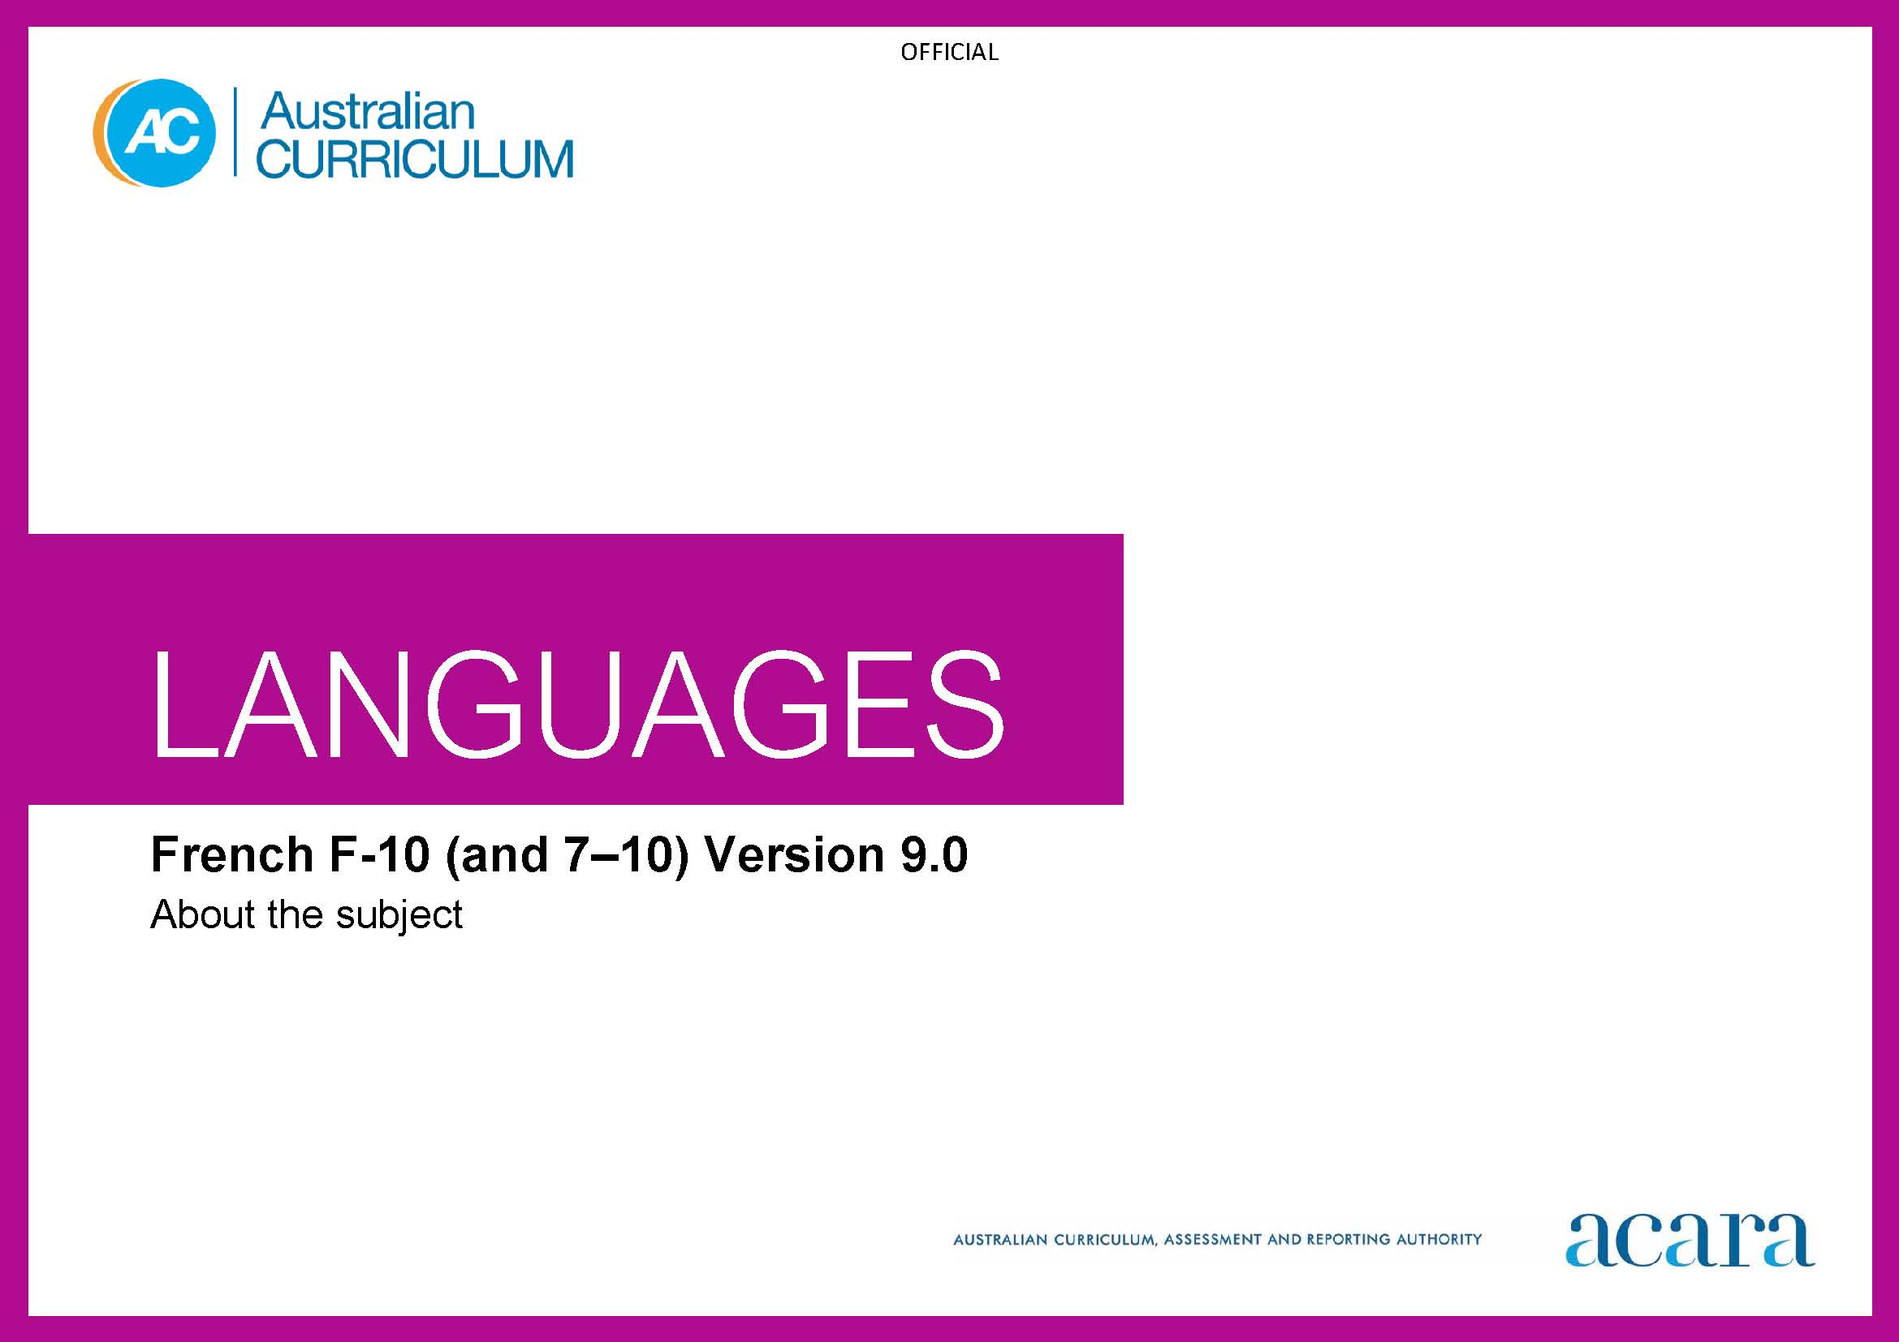

**Copyright and Terms of Use Statement**

**© Australian Curriculum, Assessment and Reporting Authority 2022**

The material published in this work is subject to copyright pursuant to the Copyright Act 1968 (Cth) and is owned by the Australian Curriculum, Assessment and Reporting Authority (ACARA) (except to the extent that copyright is held by another party, as indicated).

The viewing, downloading, displaying, printing, reproducing (such as by making photocopies) and distributing of these materials is permitted only to the extent permitted by, and is subject to the conditions imposed by, the terms and conditions of using the ACARA website (see, especially, clauses 2, 3 and 4 of those terms and conditions). The terms and conditions can be viewed at [https://www.acara.edu.au/contact-us/copyright](https://aus01.safelinks.protection.outlook.com/?url=https%3A%2F%2Fwww.acara.edu.au%2Fcontact-us%2Fcopyright&data=04%7C01%7CSharon.Foster%40acara.edu.au%7C9931e11fa7684c603e6308d98331bbfb%7C6cf76a3aa824427092003d71673ec678%7C0%7C0%7C637685071906340874%7CUnknown%7CTWFpbGZsb3d8eyJWIjoiMC4wLjAwMDAiLCJQIjoiV2luMzIiLCJBTiI6Ik1haWwiLCJXVCI6Mn0%3D%7C1000&sdata=U5O4Vlbpf271IGmGiMh7fDwU4pLzzAiHpCQFylkp6s4%3D&reserved=0)

TABLE OF CONTENTS

F–10 AUSTRALIAN CURRICULUM: LANGUAGES – FRENCH 3

ABOUT FRENCH 3

Introduction 3

Rationale 3

Structure 3

F–10 AUSTRALIAN CURRICULUM: LANGUAGES – FRENCH

ABOUT FRENCH

Introduction

French is pitched to second language learners, that is, to the dominant group of learners in the current Australian context for whom French is an additional language.

Students of French in Australian schools come from a range of backgrounds. For most students it is their first experience of learning French, while some may have existing connections to French as background French speakers.

Rationale

French has been taught in Australian schools and universities since the 1880s. It is a major world language, spoken as the first language in more than 2 dozen countries on 5 continents, and as an official language in many countries. First language speakers include the inhabitants of mainland France, territorial communities of New Caledonia and French Polynesia, the Wallis and Futuna Islands, the majority of the inhabitants of Québec, and significant communities in Europe and Africa. French is an official working language in several international organisations.

French is a language of diplomacy, used by international organisations, and is the dominant working language at the European Court of Justice. French culture has contributed to the shaping of global movements and traditions associated with the arts, philosophy and cultural theory as well as fashion, design, food and wine.

Current links between Australia and the French-speaking world are strong, characterised by bilateral relationships in trade and investment, educational exchanges, research and development in science and technology, humanitarian and environmental initiatives, communications, and strategic and defence priorities. The Pacific region is a particularly important focus of bilateral engagement.

Structure

French has been developed as a Second Language Learner Pathway which caters for students learning French as a second or additional language.

The Second Language Learner Pathway includes 2 sequences:

* Foundation to Year 10
* Years 7 to 10.

Teachers use the curriculum to cater for learners of different backgrounds by making appropriate adjustments to differentiate learning experiences.

Content in the French is organised under 2 interrelated strands, each with a number of sub-strands. The strands and sub-strands are presented in Figure 1.

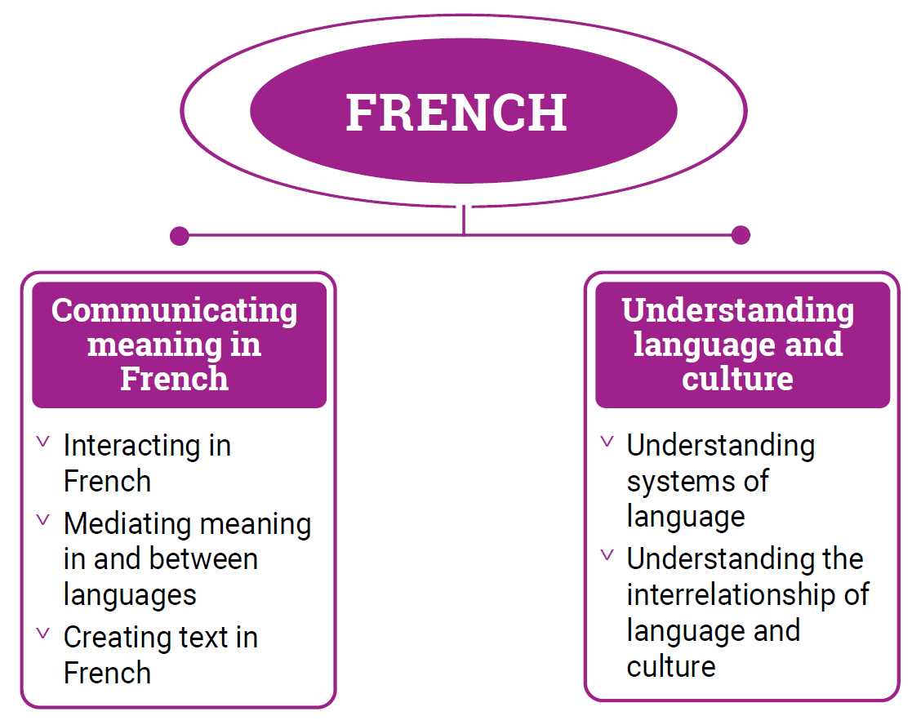

*Figure 1: French content structure*

Strand: Communicating meaning in French

This involves students learning to use language for communicative purposes in interpreting, creating and exchanging meaning. There are 3 sub-strands.

**Interacting in French**

Exchanging ideas, opinions, experiences, thoughts and feelings in non-verbal, spoken and written interactions; participating in planning, negotiating, deciding and taking action.

**Mediating meaning in and between languages**

Obtaining, processing, interpreting and conveying information through a range of spoken, written and multimodal texts; moving between languages and cultures non-verbally, orally and in writing, recognising different interpretations.

**Creating text in French**

Creating a range of spoken, written and multimodal texts for specific contexts, purposes and audiences.

Strand: Understanding language and culture

This involves students learning to analyse and understand language and culture as resources for interpreting and shaping meaning in intercultural exchange.

**Understanding systems of language**

Understanding the linguistic features of French, including sound, writing, grammatical and textual conventions.

**Understanding the interrelationship of language and culture**

Analysing and reflecting on the role of language and culture in shaping meaning and identity.