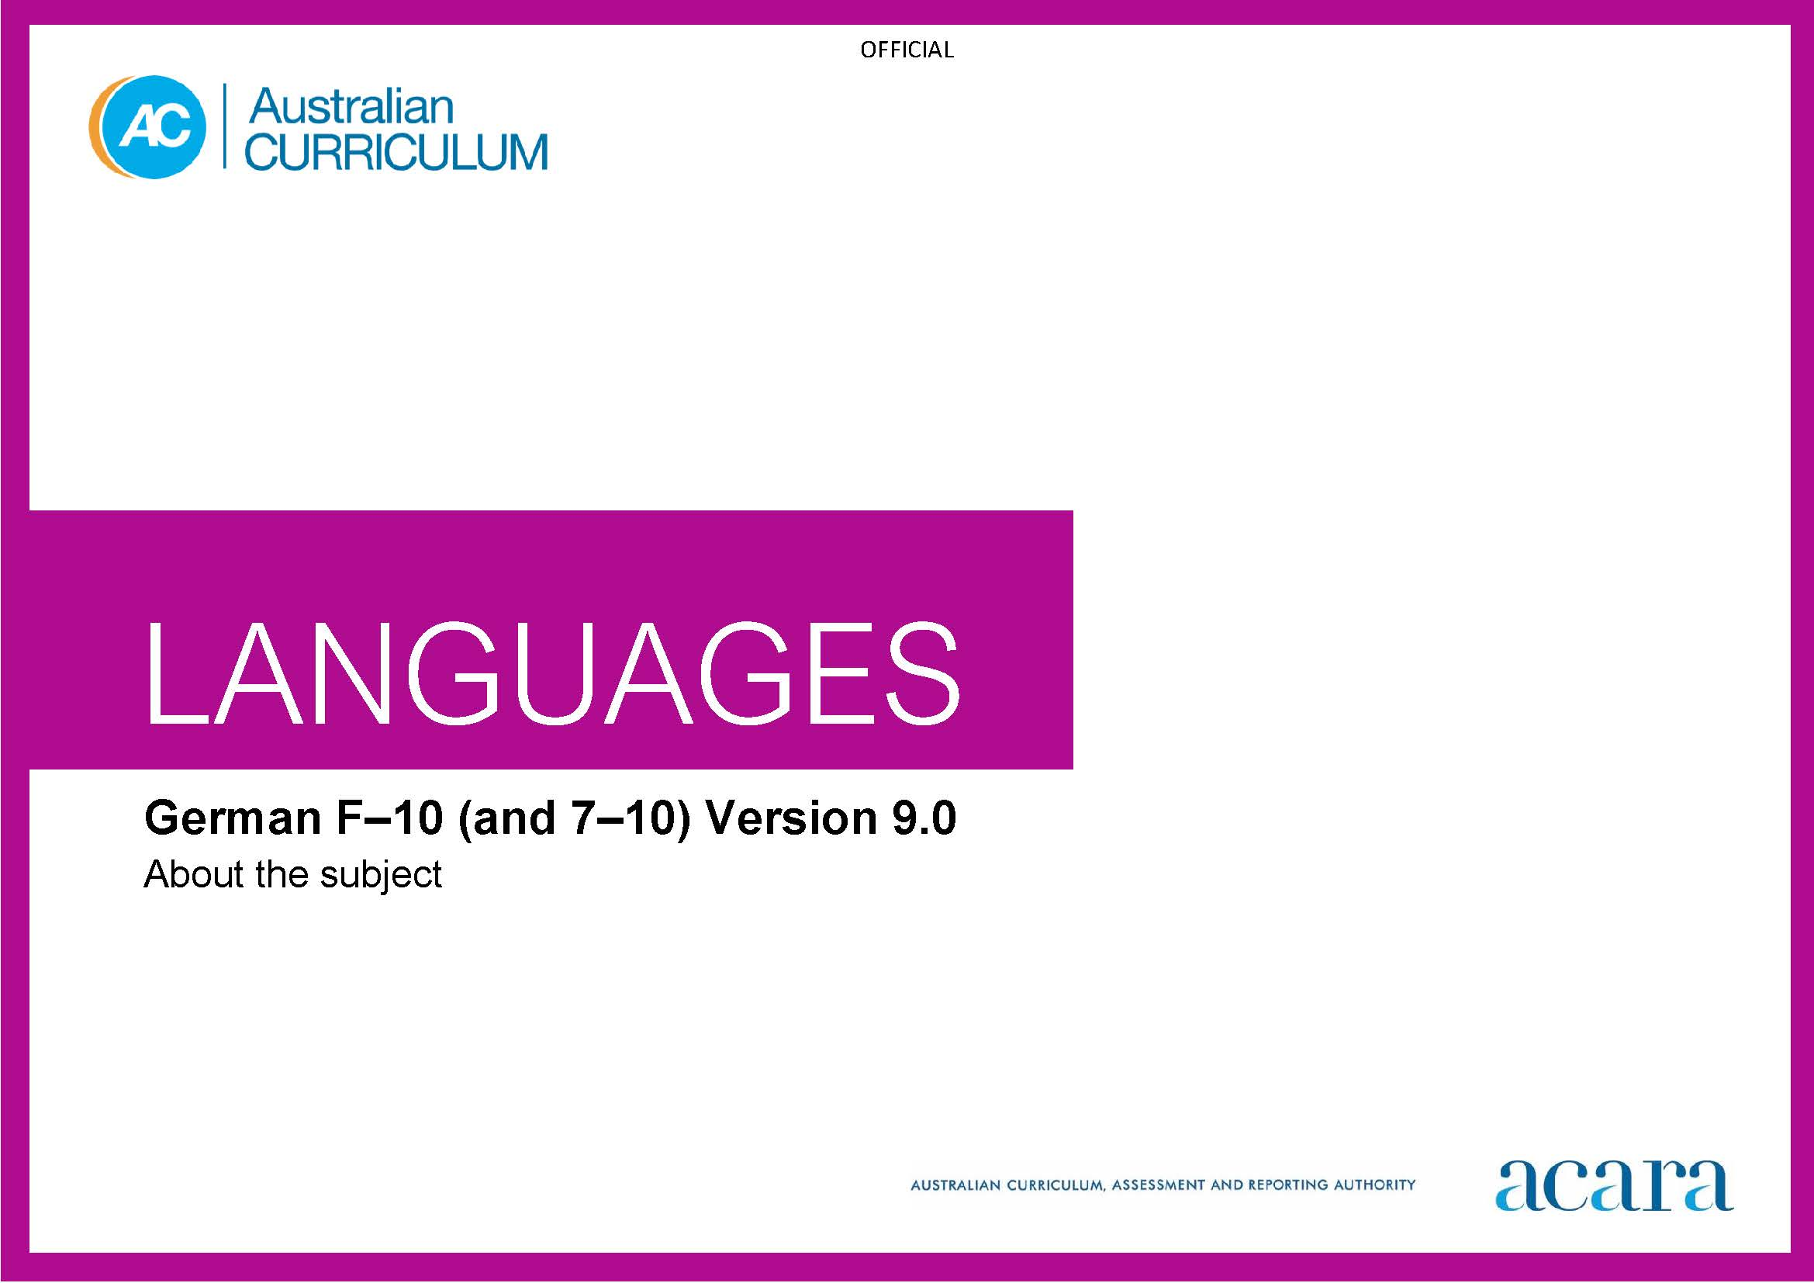

**Copyright and Terms of Use Statement**

**© Australian Curriculum, Assessment and Reporting Authority 2022**

The material published in this work is subject to copyright pursuant to the Copyright Act 1968 (Cth) and is owned by the Australian Curriculum, Assessment and Reporting Authority (ACARA) (except to the extent that copyright is held by another party, as indicated).

The viewing, downloading, displaying, printing, reproducing (such as by making photocopies) and distributing of these materials is permitted only to the extent permitted by, and is subject to the conditions imposed by, the terms and conditions of using the ACARA website (see, especially, clauses 2, 3 and 4 of those terms and conditions). The terms and conditions can be viewed at [https://www.acara.edu.au/contact-us/copyright](https://aus01.safelinks.protection.outlook.com/?url=https%3A%2F%2Fwww.acara.edu.au%2Fcontact-us%2Fcopyright&data=04%7C01%7CSharon.Foster%40acara.edu.au%7C9931e11fa7684c603e6308d98331bbfb%7C6cf76a3aa824427092003d71673ec678%7C0%7C0%7C637685071906340874%7CUnknown%7CTWFpbGZsb3d8eyJWIjoiMC4wLjAwMDAiLCJQIjoiV2luMzIiLCJBTiI6Ik1haWwiLCJXVCI6Mn0%3D%7C1000&sdata=U5O4Vlbpf271IGmGiMh7fDwU4pLzzAiHpCQFylkp6s4%3D&reserved=0)

TABLE OF CONTENTS

F–10 AUSTRALIAN CURRICULUM: LANGUAGES – GERMAN 3

ABOUT GERMAN 3

Introduction 3

Rationale 3

Structure 3

F–10 AUSTRALIAN CURRICULUM: LANGUAGES – GERMAN

ABOUT GERMAN

Introduction

The Australian Curriculum: German is pitched to second language learners, that is, the dominant group of learners in the current Australian context for whom German is an additional language.

Students of German in Australian schools come from a range of backgrounds. For most students it is their first experience of learning German, while some may have existing connections to German as background speakers of the language.

Rationale

German is the official language of Germany, Austria and Liechtenstein, and an official language of Belgium, Luxembourg and Switzerland, and South Tyrol in Italy. It is used in communities throughout the world. German is one of 3 procedural languages of the European Union.

The influences of German culture, language and thought can be seen globally in past and contemporary achievements in architecture, the arts, philosophy, in engineering, environmental and scientific innovations, and in recreational and sporting pursuits.

German migration has made a significant contribution to shaping multicultural Australia, and the German language has been taught in many Australian schools and universities since the mid-1800s. The influence of German-speaking communities is evident in the arts, cuisine, education and viticulture. Strong partnerships have developed to promote German–Australian relationships in educational and cultural exchanges, in diplomatic and research agreements, and in industry, trade and commerce.

German, like English, belongs to the Indo-European family of languages, and both share some similarities such as alphabet, vocabulary, language structures and features. Learning German enhances students’ understanding of English and develops an appreciation of the language and cultures of German-speaking communities. Knowledge of German language and culture enriches travel experiences, increases employment opportunities and promotes understanding of diverse attitudes, beliefs and values.

Structure

German has been developed as a Second Language Learner Pathway which caters for students learning German as a second or additional language.

The Second Language Learner Pathway includes 2 sequences:

* Foundation to Year 10
* Years 7 to 10.

Teachers use the curriculum to cater for learners of different backgrounds by making appropriate adjustments to differentiate learning experiences.

Content in German is organised under 2 interrelated strands, each with a number of sub-strands. The strands and sub-strands are presented in Figure 1.

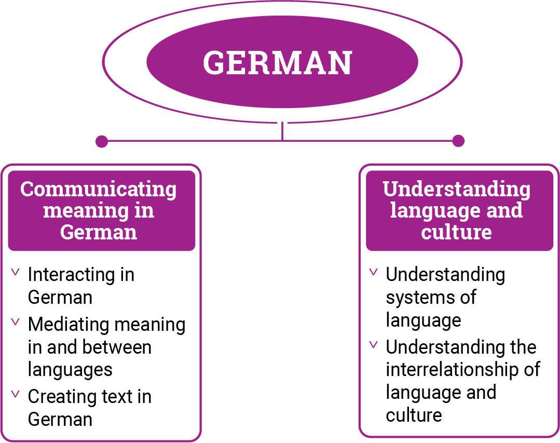

*Figure 1: German content structure*

Strand: Communicating meaning in German

This involves students learning to use language for communicative purposes in interpreting, creating and exchanging meaning. There are 3 sub-strands.

**Interacting in German**

Exchanging ideas, opinions, experiences, thoughts and feelings in non-verbal, spoken and written interactions; participating in planning, negotiating, deciding and taking action.

**Mediating meaning in and between languages**

Obtaining, processing, interpreting and conveying information through a range of spoken, written and multimodal texts; moving between languages and cultures non-verbally, orally and in writing, recognising different interpretations.

**Creating text in German**

Creating a range of spoken, written and multimodal texts for specific contexts, purposes and audiences.

Strand: Understanding language and culture

This involves students learning to analyse and understand language and culture as resources for interpreting and shaping meaning in intercultural exchange. There are 2 sub-strands.

**Understanding systems of language**

Understanding the linguistic features of German, including sound, writing, grammatical and textual conventions.

**Understanding the interrelationship of language and culture**

Analysing and reflecting on the role of language and culture in shaping meaning and identity.