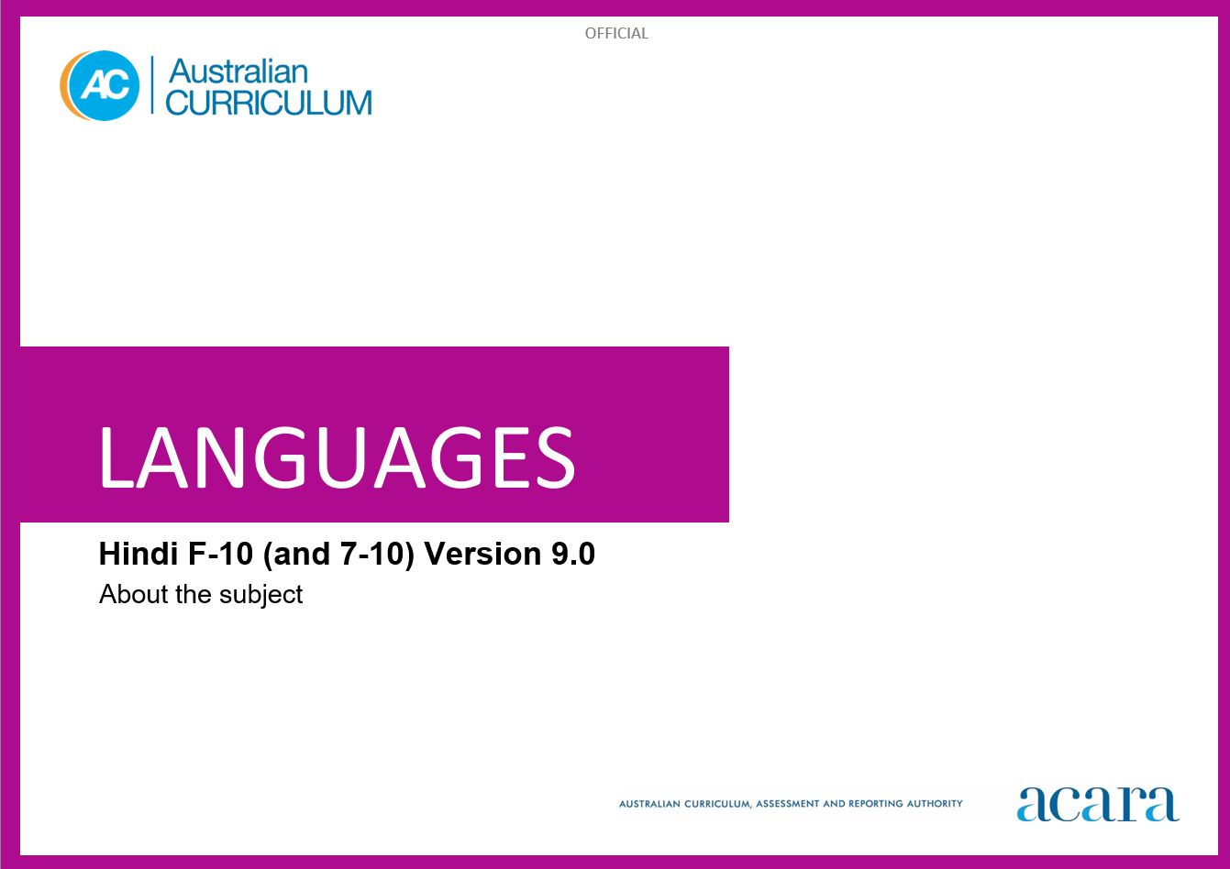

**Copyright and Terms of Use Statement**

**© Australian Curriculum, Assessment and Reporting Authority 2023**

The material published in this work is subject to copyright pursuant to the Copyright Act 1968 (Cth) and is owned by the Australian Curriculum, Assessment and Reporting Authority (ACARA) (except to the extent that copyright is held by another party, as indicated).

The viewing, downloading, displaying, printing, reproducing (such as by making photocopies) and distributing of these materials is permitted only to the extent permitted by, and is subject to the conditions imposed by, the terms and conditions of using the ACARA website (see, especially, clauses 2, 3 and 4 of those terms and conditions). The terms and conditions can be viewed at [https://www.acara.edu.au/contact-us/copyright](https://aus01.safelinks.protection.outlook.com/?url=https%3A%2F%2Fwww.acara.edu.au%2Fcontact-us%2Fcopyright&data=04%7C01%7CSharon.Foster%40acara.edu.au%7C9931e11fa7684c603e6308d98331bbfb%7C6cf76a3aa824427092003d71673ec678%7C0%7C0%7C637685071906340874%7CUnknown%7CTWFpbGZsb3d8eyJWIjoiMC4wLjAwMDAiLCJQIjoiV2luMzIiLCJBTiI6Ik1haWwiLCJXVCI6Mn0%3D%7C1000&sdata=U5O4Vlbpf271IGmGiMh7fDwU4pLzzAiHpCQFylkp6s4%3D&reserved=0)

TABLE OF CONTENTS

ABOUT Hindi 4

Introduction 4

Rationale 4

Structure 4

ABOUT Hindi

Introduction

The Australian Curriculum: Hindi recognises that learners of Hindi in Australian schools have a range of cultural backgrounds and language experiences. Learners may have varying degrees of proficiency in Hindi as background-language learners or they may be learning Hindi as a second or additional language.

Rationale

Hindi is an official language of India and Fiji. It is the most widely spoken language of the Indian subcontinent and is spoken throughout the world. Hindi is written in the Devanāgarī script and is one of the 2 official languages of the government of India, along with English.

Hindi speakers have made a significant contribution in shaping multicultural Australia. Hindi has been taught in some Australian schools and universities since the 1980s as well as in community-run organisations prior to this time. The influence of Hindi-speaking communities is evident in areas such as agriculture, commerce, cuisine, education, film, music and technology. There is increasing interest in Bollywood, the Hindi-language film industry.

Modern Standard Hindi is an alphabetic language, derived from Sanskrit, and belongs to the Indo-Aryan branch of the Indo-European family of languages, the family to which English also belongs. It has been influenced by Arabic, English, Persian and Turkish. Learning Hindi develops students’ understanding of the language and culture of Hindi-speaking communities. It also enhances students’ awareness of the nature of language learning and promotes an appreciation of diverse attitudes, beliefs and values. Knowledge of the Hindi language and culture enriches travel experiences and increases employment opportunities.

Structure

Hindi has been developed to cater for learners with different linguistic experiences, those with a background in Hindi as well as those learning Hindi as a second or additional language.

The Australian Curriculum: Hindi includes 2 sequences:

* Foundation to Year 10
* Years 7 to 10.

Teachers can use the curriculum to make appropriate adjustments to differentiate learning. Content elaborations provide differentiated examples of language use and contexts to assist teachers to meet the needs of a range of learners, including background-language learners and second-language learners.

Content in Hindi is organised under 2 interrelated strands, each with a number of sub-strands. The strands and sub-strands are presented in Figure 2.

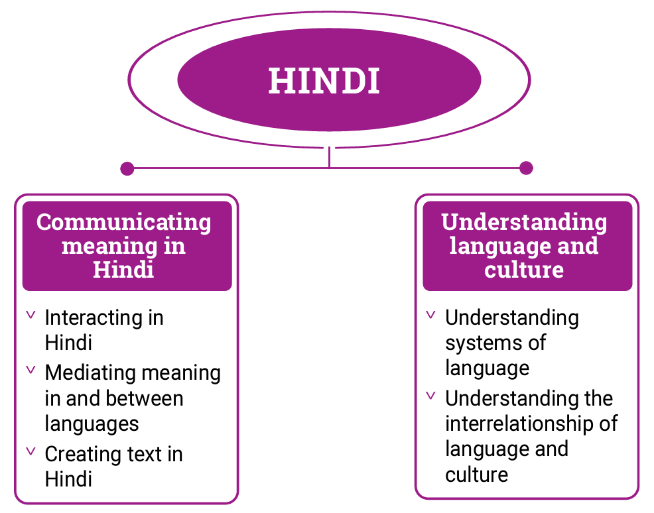

*Figure 2: Hindi content structure*

Strand: Communicating meaning in Hindi

This involves students learning to use language for communicative purposes in interpreting, creating and exchanging meaning. There are 3 sub-strands.

**Interacting in Hindi**

Exchanging ideas, opinions, experiences, thoughts and feelings in non-verbal, spoken and written interactions; participating in planning, negotiating, deciding and taking action.

**Mediating meaning in and between languages**

Obtaining, processing, interpreting and conveying information through a range of spoken, written and multimodal texts; moving between languages and cultures non-verbally, orally and in writing, recognising different interpretations.

**Creating text in Hindi**

Creating a range of spoken, written and multimodal texts for specific contexts, purposes and audiences.

Strand: Understanding language and culture

This involves students learning to analyse and understand language and culture as resources for interpreting and shaping meaning in intercultural exchange. There are 2 sub-strands.

**Understanding systems of language**

Understanding the linguistic features of Hindi, including sound, writing, grammatical and textual conventions.

**Understanding the interrelationship of language and culture**

Analysing and reflecting on the role of language and culture in shaping meaning and identity.