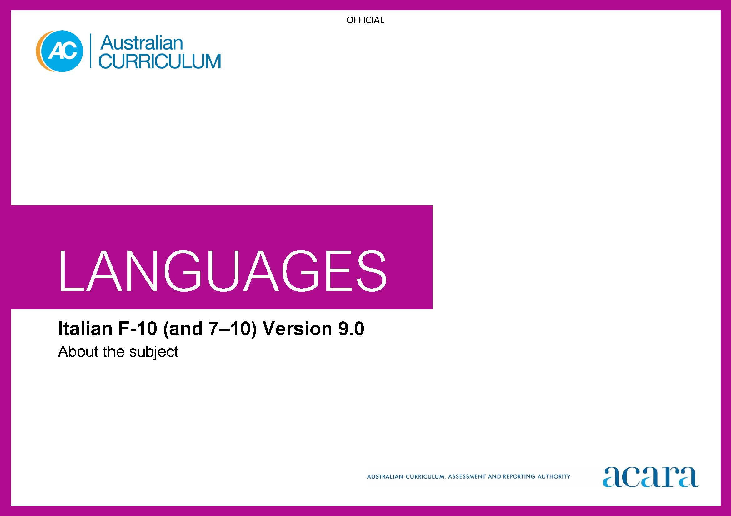

**Copyright and Terms of Use Statement**

**© Australian Curriculum, Assessment and Reporting Authority 2022**

The material published in this work is subject to copyright pursuant to the Copyright Act 1968 (Cth) and is owned by the Australian Curriculum, Assessment and Reporting Authority (ACARA) (except to the extent that copyright is held by another party, as indicated).

The viewing, downloading, displaying, printing, reproducing (such as by making photocopies) and distributing of these materials is permitted only to the extent permitted by, and is subject to the conditions imposed by, the terms and conditions of using the ACARA website (see, especially, clauses 2, 3 and 4 of those terms and conditions). The terms and conditions can be viewed at [https://www.acara.edu.au/contact-us/copyright](https://aus01.safelinks.protection.outlook.com/?url=https%3A%2F%2Fwww.acara.edu.au%2Fcontact-us%2Fcopyright&data=04%7C01%7CSharon.Foster%40acara.edu.au%7C9931e11fa7684c603e6308d98331bbfb%7C6cf76a3aa824427092003d71673ec678%7C0%7C0%7C637685071906340874%7CUnknown%7CTWFpbGZsb3d8eyJWIjoiMC4wLjAwMDAiLCJQIjoiV2luMzIiLCJBTiI6Ik1haWwiLCJXVCI6Mn0%3D%7C1000&sdata=U5O4Vlbpf271IGmGiMh7fDwU4pLzzAiHpCQFylkp6s4%3D&reserved=0)

TABLE OF CONTENTS

F–10 AUSTRALIAN CURRICULUM: LANGUAGES – ITALIAN 3

ABOUT ITALIAN 3

Introduction 3

Rationale 3

Structure 3

F–10 AUSTRALIAN CURRICULUM: LANGUAGES – ITALIAN

ABOUT ITALIAN

Introduction

Italian refers to Standard Italian or *italiano standard.* It is pitched to second language learners, that is, to the dominant group of learners in the current Australian context for whom Italian is an additional language.

Students of Italian in Australian schools come from a wide range of backgrounds. For some students it is their first experience of learning Italian, while others may have existing connections with Italian as background Italian speakers or as multi-generation Italian Australians.

Rationale

Italian has been taught in Australian schools and universities since the 1930s and is, and has been for many years, one of the major community languages in Australia. It is the official language of Italy, the Vatican City, San Marino, parts of Switzerland, and the European Union. It is a major community language in Europe, the United States, Canada, South America and parts of Africa.

Italian belongs to the Romance family of languages that includes Catalan, French, Portuguese, Romanian and Spanish. Italian and English have a common linguistic link with Latin, sharing many Latin-derived words and using the same Roman alphabet.

The history of Italian settlement in Australia can be traced to the First Fleet in 1788 and Italian-speaking communities in Australia continue to play a significant role in Australia’s culturally diverse society.

Australia has strong cultural, political and trade connections with Italy, including economic and commercial cooperation and expanding relationships in science and technology. A significant number of Italian companies have branches in Australia. Italians and the Italian language make a distinctive contribution to politics, art, architecture, cuisine, music, fashion, science, literature, film and theatre.

Structure

Italian has been developed as a Second Language Learner Pathway which caters for students learning Italian as a second or additional language.

The Second Language Learner Pathway includes 2 sequences:

* Foundation to Year 10
* Years 7 to 10.

Teachers use the curriculum to cater for learners of different backgrounds by making appropriate adjustments to differentiate learning experiences.

Content in Italian is organised under 2 interrelated strands, each with a number of sub-strands. The strands and sub-strands are presented in Figure 2.

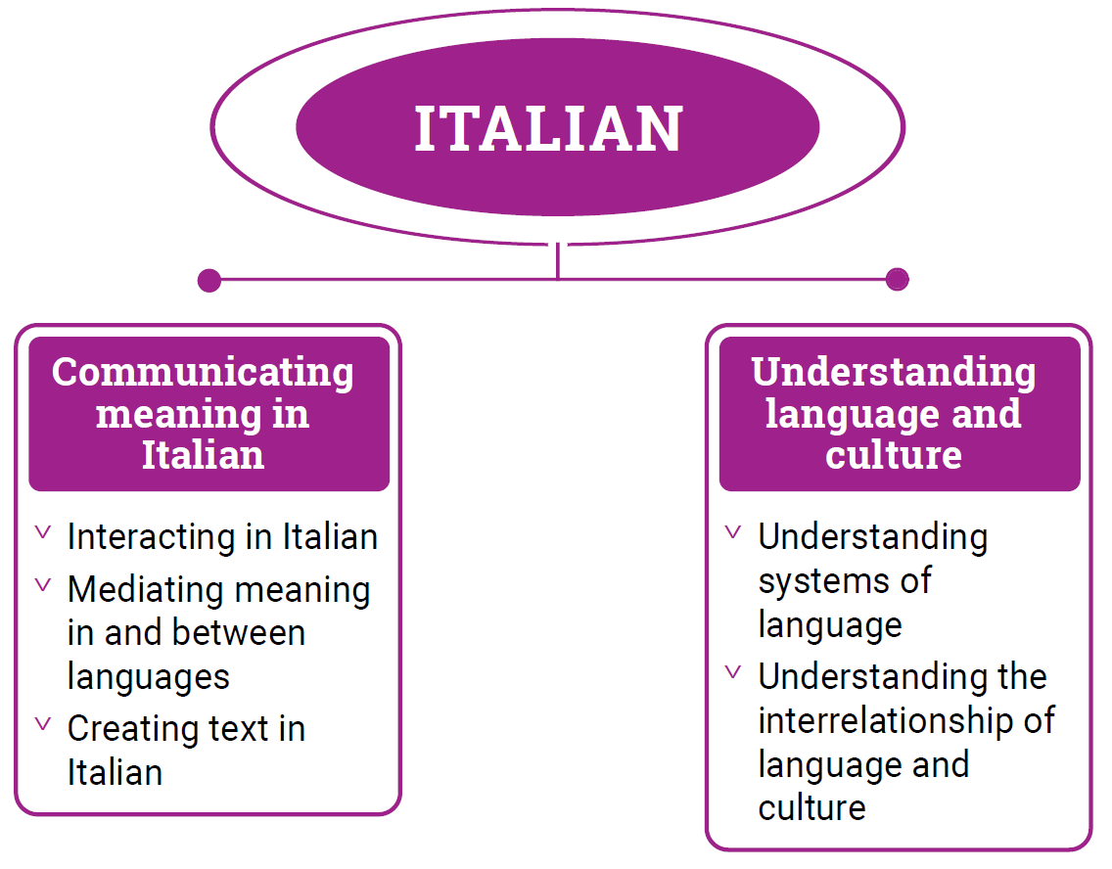

*Figure 1: Italian content structure*

Strand: Communicating meaning in Italian

This involves students learning to use language for communicative purposes in interpreting, creating and exchanging meaning. There are 3 sub-strands.

**Interacting in Italian**

Exchanging ideas, opinions, experiences, thoughts and feelings in non-verbal, spoken and written interactions; participating in planning, negotiating, deciding and taking action.

**Mediating meaning in and between languages**

Obtaining, processing, interpreting and conveying information through a range of spoken, written and multimodal texts; moving between languages and cultures non-verbally, orally and in writing, recognising different interpretations.

**Creating text in Italian**

Creating a range of spoken, written and multimodal texts for specific contexts, purposes and audiences.

Strand: Understanding language and culture

This involves students learning to analyse and understand language and culture as resources for interpreting and shaping meaning in intercultural exchange. There are 2 sub-strands.

**Understanding systems of language**

Understanding the linguistic features of Italian, including sound, writing, grammatical and textual conventions.

**Understanding the interrelationship of language and culture**

Analysing and reflecting on the role of language and culture in shaping meaning and identity.