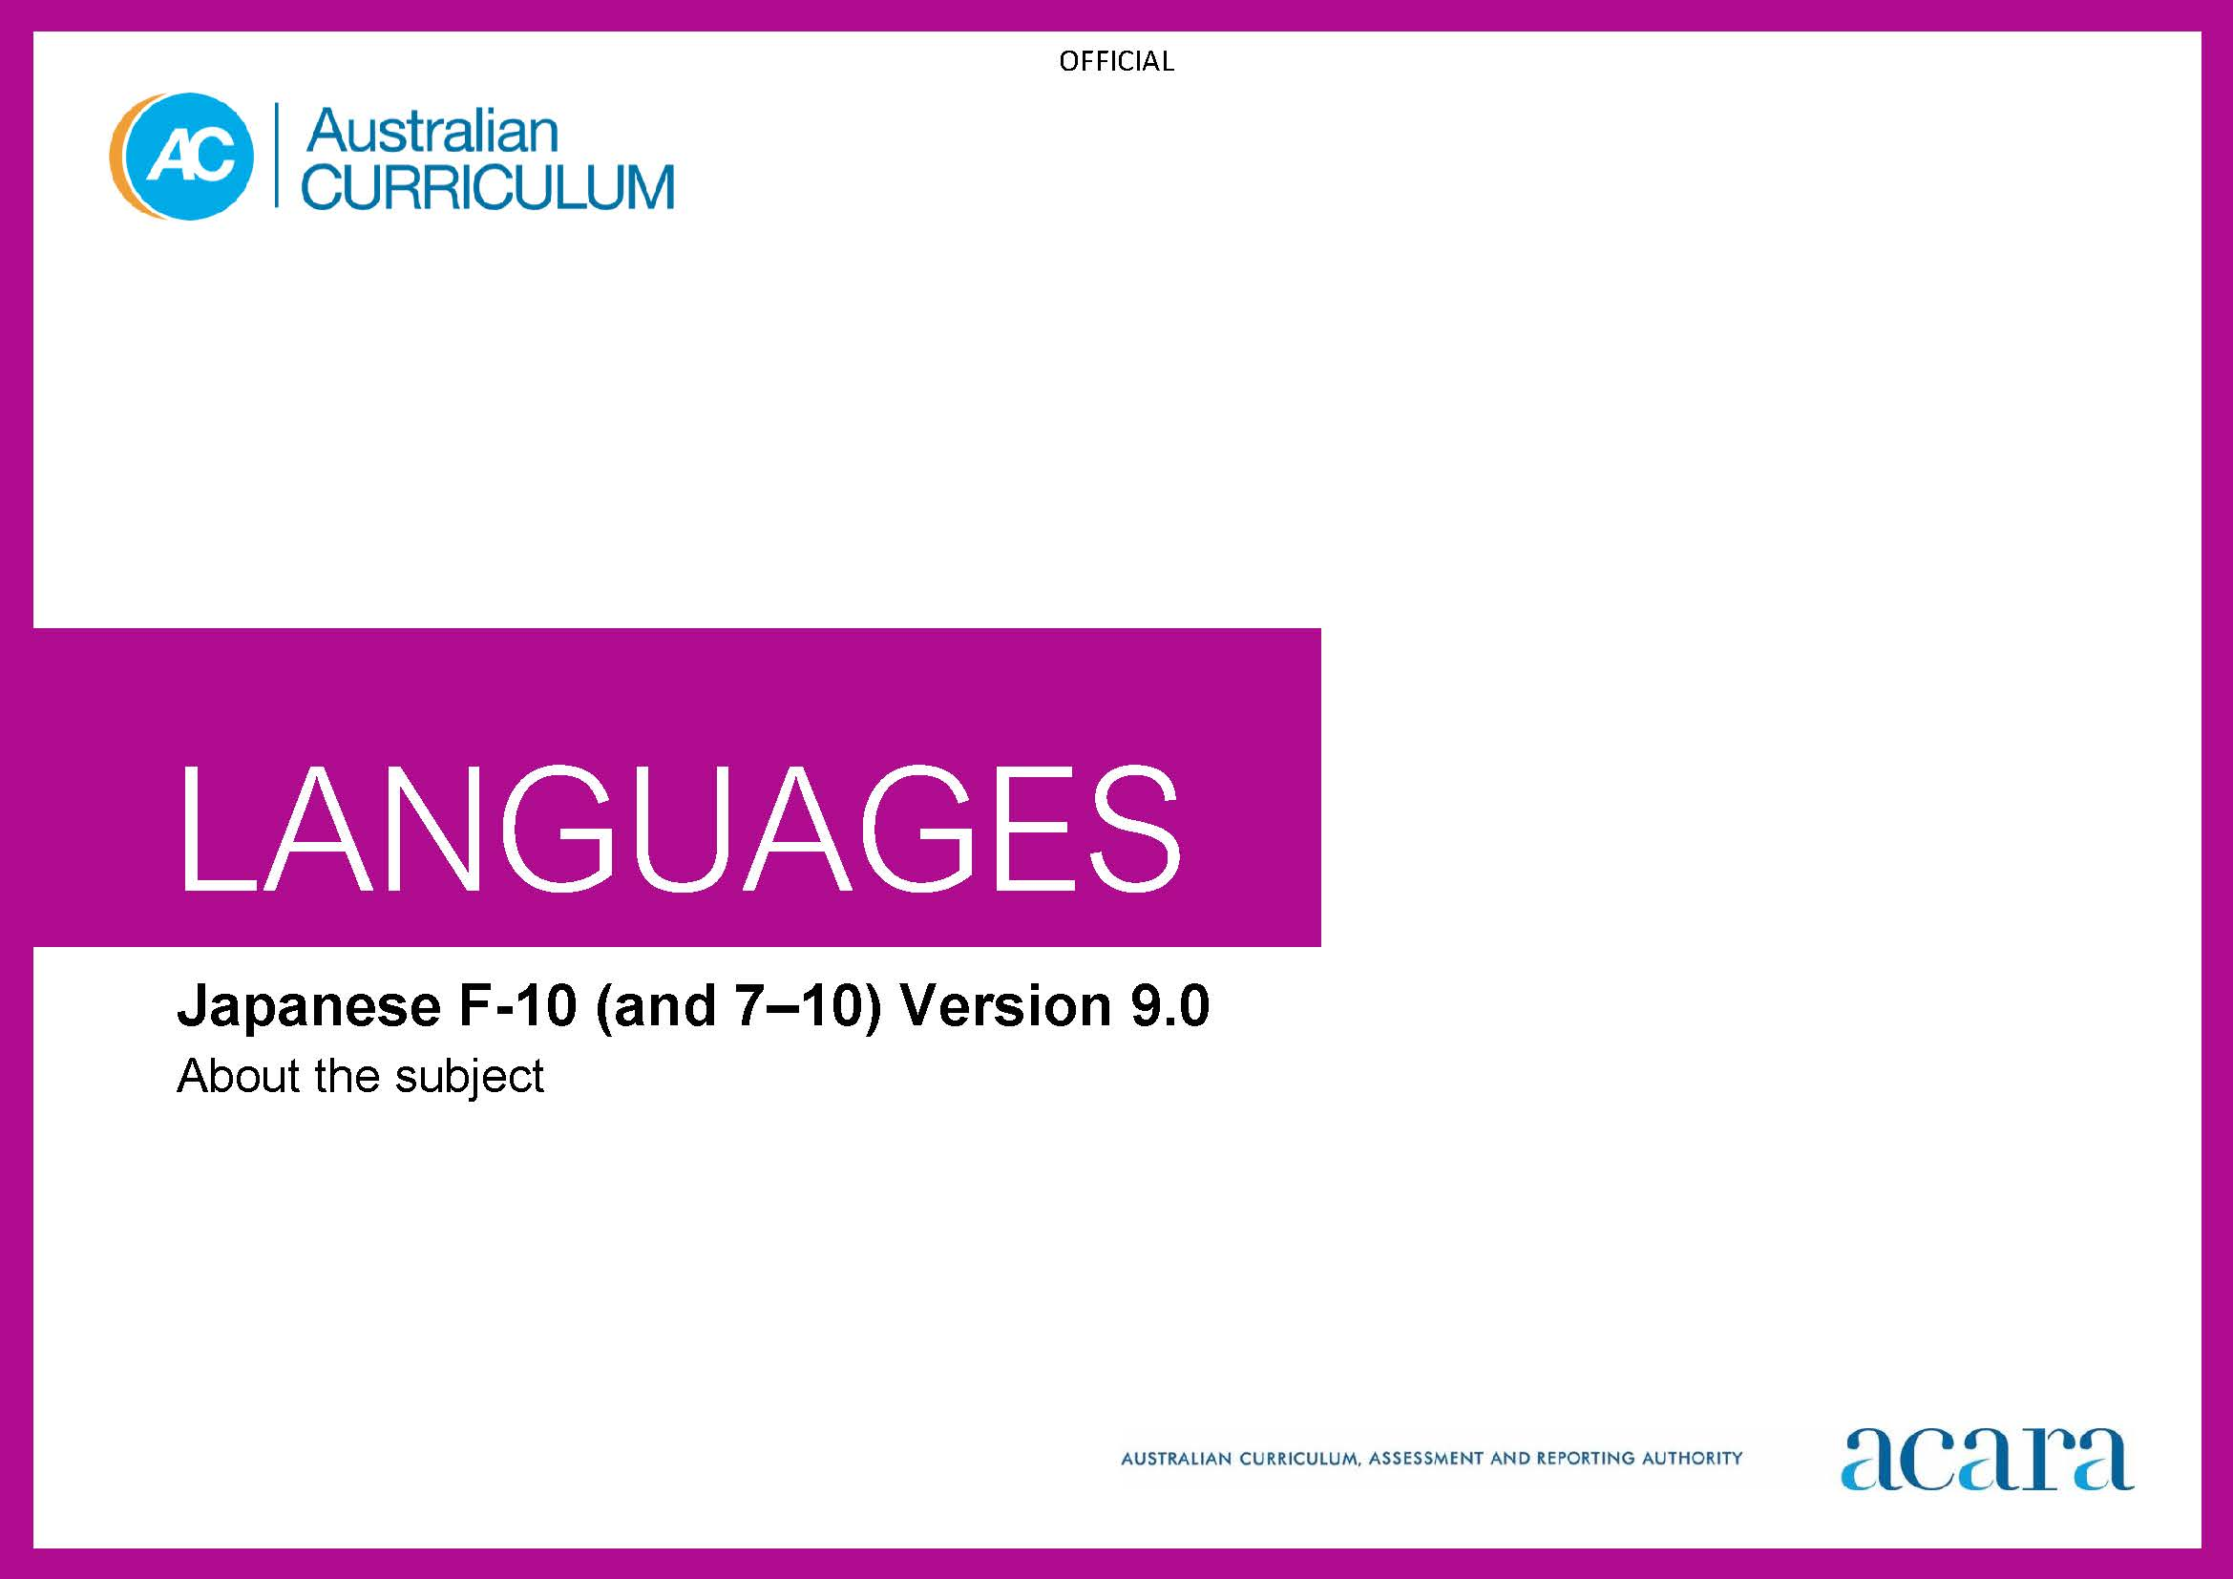

**Copyright and Terms of Use Statement**

**© Australian Curriculum, Assessment and Reporting Authority 2022**

The material published in this work is subject to copyright pursuant to the Copyright Act 1968 (Cth) and is owned by the Australian Curriculum, Assessment and Reporting Authority (ACARA) (except to the extent that copyright is held by another party, as indicated).

The viewing, downloading, displaying, printing, reproducing (such as by making photocopies) and distributing of these materials is permitted only to the extent permitted by, and is subject to the conditions imposed by, the terms and conditions of using the ACARA website (see, especially, clauses 2, 3 and 4 of those terms and conditions). The terms and conditions can be viewed at [https://www.acara.edu.au/contact-us/copyright](https://aus01.safelinks.protection.outlook.com/?url=https%3A%2F%2Fwww.acara.edu.au%2Fcontact-us%2Fcopyright&data=04%7C01%7CSharon.Foster%40acara.edu.au%7C9931e11fa7684c603e6308d98331bbfb%7C6cf76a3aa824427092003d71673ec678%7C0%7C0%7C637685071906340874%7CUnknown%7CTWFpbGZsb3d8eyJWIjoiMC4wLjAwMDAiLCJQIjoiV2luMzIiLCJBTiI6Ik1haWwiLCJXVCI6Mn0%3D%7C1000&sdata=U5O4Vlbpf271IGmGiMh7fDwU4pLzzAiHpCQFylkp6s4%3D&reserved=0)

TABLE OF CONTENTS

F–10 AUSTRALIAN CURRICULUM: LANGUAGES – JAPANESE 3

ABOUT JAPANESE 3

Introduction 3

Rationale 3

Structure 3

F–10 AUSTRALIAN CURRICULUM: LANGUAGES – JAPANESE

ABOUT JAPANESE

Introduction

Japanese is pitched to second language learners, that is, to the dominant group of students in the current Australian context for whom Japanese is an additional language.

Students of Japanese in Australian schools come from a range of backgrounds. For most students it is their first experience of learning Japanese, while others may have existing connections to Japanese as background Japanese speakers.

Rationale

Japanese has been taught in Australia for more than 100 years, significantly as a second or additional language. It is the official language of Japan and widely used by communities of speakers in Hawaii, Peru and Brazil. Large numbers of students in the Republic of Korea, China, Indonesia and Australia learn Japanese as an additional language.

Australia has a significant number of Japanese national residents and Japanese culture influences many areas of contemporary Australian society, including the arts, design, technology, fashion, popular culture and cuisine.

Australia is a close strategic and economic partner of Japan, and there is ongoing exchange between the 2 countries in the areas of education, trade, diplomacy and tourism. Japan is an important nation within Asia and a significant contributor to economic, political and diplomatic relations in the region.

Structure

Japanese has been developed as a Second Language Learner Pathway which caters for students learning Japanese as a second or additional language.

The Second Language Learner Pathway includes 2 sequences:

* Foundation to Year 10
* Years 7 to 10.

Teachers use the curriculum to cater for learners of different backgrounds by making appropriate adjustments to differentiate learning experiences.

Content in Japanese is organised under 2 interrelated strands, each with a number of sub-strands. The strands and sub-strands are presented in Figure 1.

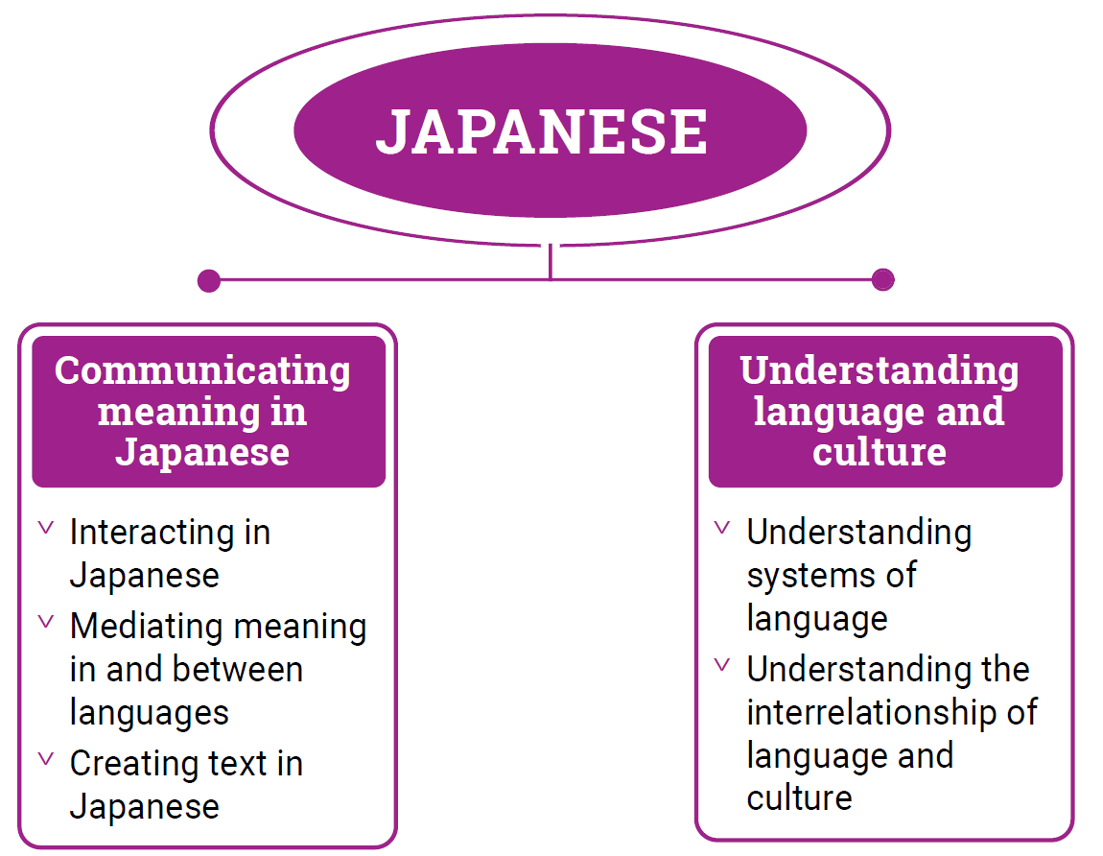

*Figure 1: Japanese content structure*

Strand: Communicating meaning in Japanese

This involves students learning to use language for communicative purposes in interpreting, creating and exchanging meaning. There are 3 sub-strands.

**Interacting in Japanese**

Exchanging ideas, opinions, experiences, thoughts and feelings in non-verbal, spoken and written interactions; participating in planning, negotiating, deciding and taking action.

**Mediating meaning in and between languages**

Obtaining, processing, interpreting and conveying information through a range of spoken, written and multimodal texts; moving between languages and cultures non-verbally, orally and in writing, recognising different interpretations.

**Creating text in Japanese**

Creating a range of spoken, written and multimodal texts for specific contexts, purposes and audiences.

Strand: Understanding language and culture

This involves students learning to analyse and understand language and culture as resources for interpreting and shaping meaning in intercultural exchange. There are 2 sub-strands.

**Understanding systems of language**

Understanding the linguistic features of Japanese, including sound, writing, grammatical and textual conventions.

**Understanding the interrelationship of language and culture**

Analysing and reflecting on the role of language and culture in shaping meaning and identity.