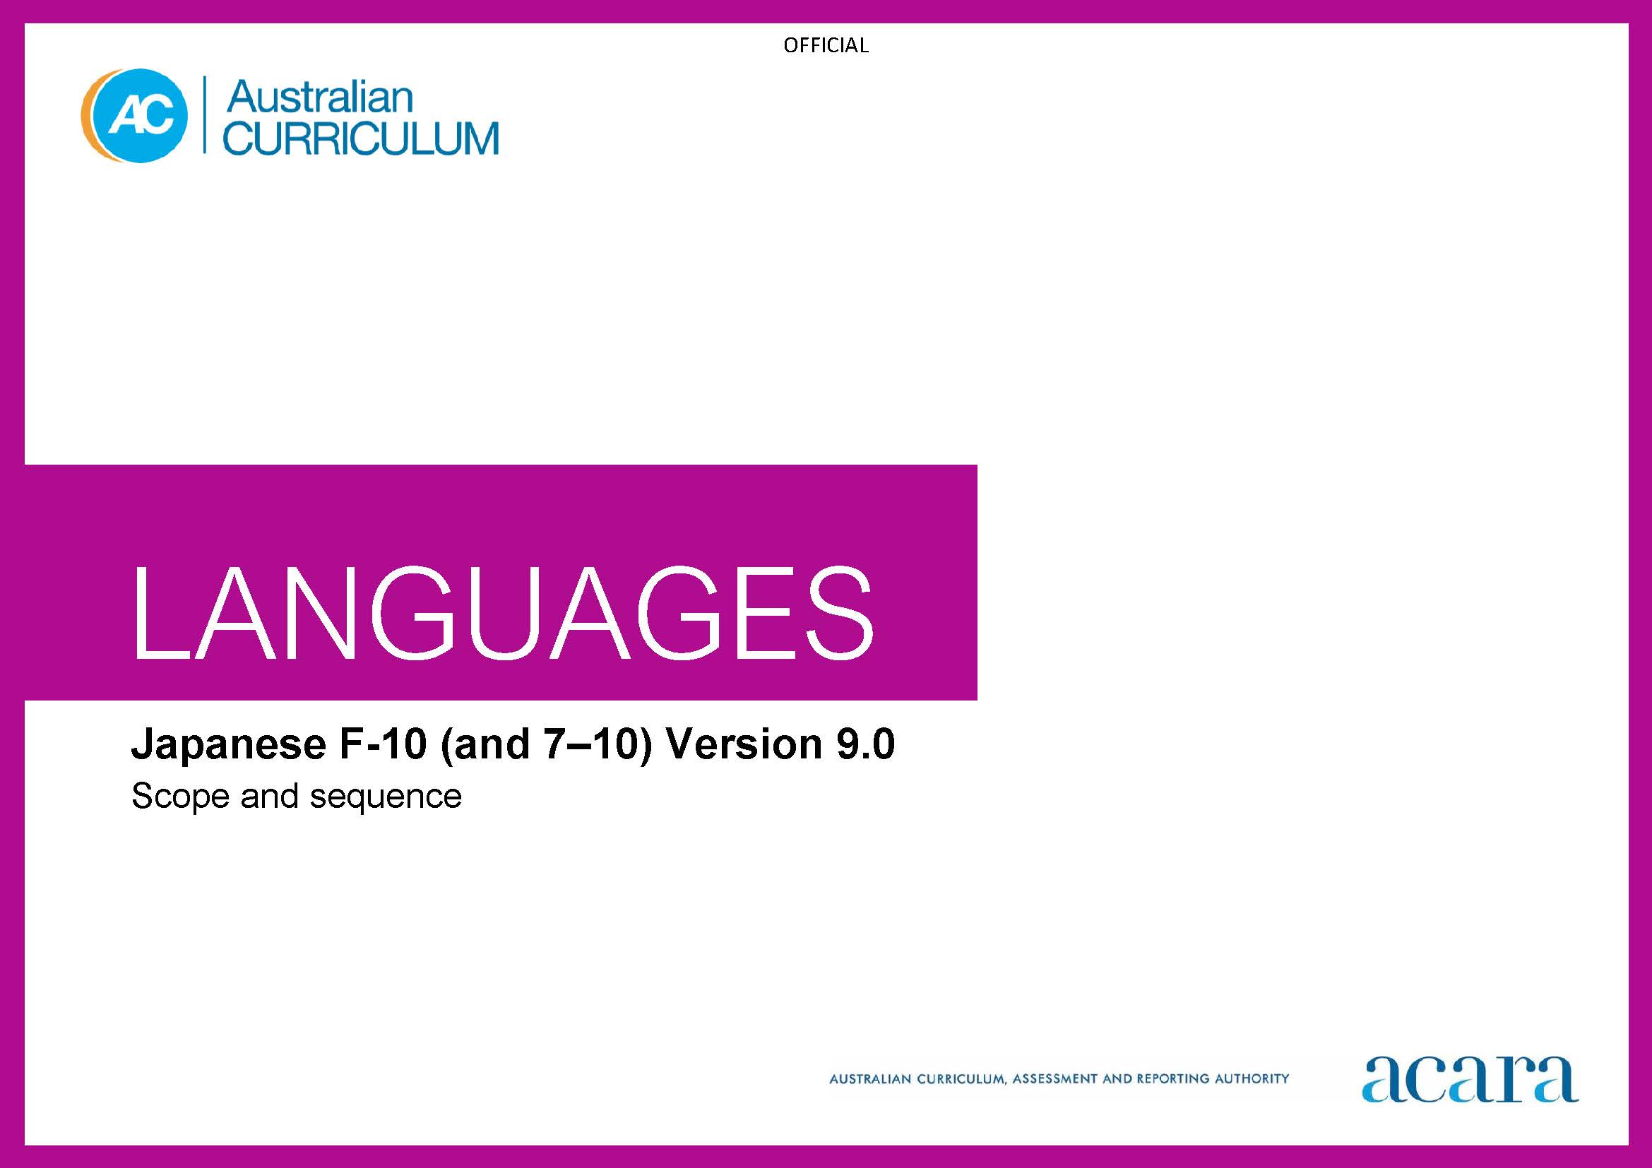

**Copyright and Terms of Use Statement**

**© Australian Curriculum, Assessment and Reporting Authority 2022**

The material published in this work is subject to copyright pursuant to the Copyright Act 1968 (Cth) and is owned by the Australian Curriculum, Assessment and Reporting Authority (ACARA) (except to the extent that copyright is held by another party, as indicated).

The viewing, downloading, displaying, printing, reproducing (such as by making photocopies) and distributing of these materials is permitted only to the extent permitted by, and is subject to the conditions imposed by, the terms and conditions of using the ACARA website (see, especially, clauses 2, 3 and 4 of those terms and conditions). The terms and conditions can be viewed at [https://www.acara.edu.au/contact-us/copyright](https://aus01.safelinks.protection.outlook.com/?url=https%3A%2F%2Fwww.acara.edu.au%2Fcontact-us%2Fcopyright&data=04%7C01%7CSharon.Foster%40acara.edu.au%7C9931e11fa7684c603e6308d98331bbfb%7C6cf76a3aa824427092003d71673ec678%7C0%7C0%7C637685071906340874%7CUnknown%7CTWFpbGZsb3d8eyJWIjoiMC4wLjAwMDAiLCJQIjoiV2luMzIiLCJBTiI6Ik1haWwiLCJXVCI6Mn0%3D%7C1000&sdata=U5O4Vlbpf271IGmGiMh7fDwU4pLzzAiHpCQFylkp6s4%3D&reserved=0)

|  |  |
| --- | --- |
| **Foundation** | **Years 1–2** |
| **Achievement standard** | |
| By the end of the Foundation year, students use play and imagination to interact and create Japanese texts, with support. They identify that Japanese and English look and sound different. They recognise that there are languages and cultures as well as their own, and that aspects of language and culture contribute to their own and others’ cultural identity. | By the end of Year 2, students use Japanese language to interact and share information related to the classroom and themselves. They use cues to respond to questions and instructions, and use simple formulaic language. They locate and convey key items of information in texts using non-verbal, visual and contextual cues to help make meaning. They use familiar words and modelled language to create text. They copy some kana script and single, high-frequency kanji appropriate to context.  Students imitate the sounds and rhythms of Japanese and demonstrate understanding that Japanese has rules for non-verbal communication, pronunciation and writing and identify the 3 different scripts. They give examples of similarities and differences between some features of Japanese and English. They understand that language is connected with culture, and notice how this is reflected in their own language(s) and culture(s). |

|  |  |
| --- | --- |
| **Content descriptions** | |
|  | **Strand: Communicating meaning in Japanese** |
|  | **Sub-strand: Interacting in Japanese** |
| with support, recognise and communicate meaning in Japanese  AC9LJF01 | recognise and respond to modelled classroom-related greetings, instructions and routines; and personal introductions  AC9LJ2C01 |
| explore, with support, language features of Japanese noticing similarities and differences between Japanese and English  AC9LJF02 | participate in a range of guided, play-based language activities using formulaic expressions, visual and spoken cues  AC9LJ2C02 |
| explore connections between language and culture  AC9LJF03 |  |
|  | **Sub-strand: Mediating meaning in and between languages** |
|  | locate, with support, key information in familiar texts, and respond using gestures, images, words and formulaic phrases  AC9LJ2C03 |
|  | notice that language carries cultural meaning in classroom-related greetings, introductions, instructions and routines  AC9LJ2C04 |
|  | **Sub-strand: Creating text in Japanese** |
|  | with support, use words, familiar phrases and modelled language to create spoken, written and multimodal texts, copying some kana and single high-frequency kanji appropriate to context  AC9LJ2C05 |

|  |  |
| --- | --- |
|  | **Strand: Understanding language and culture** |
|  | **Sub-strand: Understanding systems of language** |
|  | recognise and imitate the sounds and rhythms of Japanese and learn how sounds are produced and represented in different scripts  AC9LJ2U01 |
|  | recognise that hiragana, katakana and kanji are used to construct meaning in Japanese texts  AC9LJ2U02 |
|  | notice that Japanese has features that may be similar to or different from English  AC9LJ2U03 |
|  | **Sub-strand: Understanding the interrelationship of language and culture** |
|  | notice that people use language in ways that reflect cultural practices  AC9LJ2U04 |

|  |  |
| --- | --- |
| **Years 3­–4** | **Years 5–6** |
| **Achievement standard** | |
| By the end of Year 4, students use Japanese language to initiate structured interactions to share information related to the classroom and their personal world. They use modelled language to participate in spoken and written activities that involve planning. They locate and respond to key items of information in texts using strategies to help interpret and convey meaning in familiar contexts. They use modelled language and basic syntax to create texts. They use hiragana with support, and familiar kanji appropriate to context.  Students imitate hiragana sounds, pronunciation and intonation patterns of Japanese language. They demonstrate understanding that Japanese has non-verbal, spoken and written language conventions and rules to create and make meaning. They recognise that some terms have cultural meanings. They identify patterns in Japanese and make comparisons between Japanese and English. They understand that the Japanese language is connected with culture, and identify how this is reflected in their own language(s) and culture(s). | By the end of Year 6, students initiate and use strategies to maintain interactions in Japanese language that are related to their immediate environment. They use appropriate combinations of hiragana sounds, intonation and rhythm in spoken texts. They collaborate in spoken and written activities that involve the language of planning and problem-solving to share information, ideas, and preferences. They use strategies to locate and interpret information and ideas in texts, and demonstrate understanding by responding in Japanese or English, adjusting their response to context, purpose and audience. They create texts, selecting and using a variety of vocabulary and sentence structures to suit context. They sequence information and ideas, and use conventions appropriate to text type. They use hiragana and familiar katakana and kanji appropriate to context.  Students apply rules for pronunciation and intonation, punctuation, modelled structures and scripts, when creating and responding in Japanese. They compare language structures and features in Japanese and English, using some metalanguage. They show understanding of how some language reflects cultural practices and consider how this is reflected in their own language(s), culture(s) and identity. |

|  |  |
| --- | --- |
| **Content descriptions** | |
| **Strand: Communicating meaning in Japanese** | |
| **Sub-strand: Interacting in Japanese** | |
| initiate exchanges and respond to modelled questions about self, others, and classroom environment, using formulaic expressions  AC9LJ4C01 | initiate and sustain modelled exchanges in familiar contexts related to students’ personal world and school environment  AC9LJ6C01 |
| participate in activities that involve planning with others, using a range of familiar phrases and modelled structures  AC9LJ4C02 | participate in activities that involve planning and negotiating with others, using language that expresses information, preferences and ideas  AC9LJ6C02 |
| **Sub-strand: Mediating meaning in and between languages** | |
| locate and respond to key information related to familiar content obtained from spoken, written and multimodal texts  AC9LJ4C03 | locate and process information and ideas in a range of spoken, written and multimodal texts, and respond in different ways to suit purpose  AC9LJ6C03 |
| develop strategies to comprehend and adjust Japanese language in familiar contexts to convey cultural meaning  AC9LJ4C04 | apply strategies to interpret and convey meaning in Japanese language in familiar spoken, written and non-verbal cultural contexts  AC9LJ6C04 |
| **Sub-strand: Creating text in Japanese** | |
| create and present informative and imaginative spoken, written and multimodal texts using formulaic expressions, simple sentences, modelled textual conventions, hiragana with the chart as support, and familiar kanji appropriate to context  AC9LJ4C05 | create and present informative and imaginative spoken, written and multimodal texts using a variety of modelled sentence structures to sequence information and ideas, textual conventions, and hiragana and some familiar katakana and kanji appropriate to context  AC9LJ6C05 |

|  |  |
| --- | --- |
| **Strand: Understanding language and culture** | |
| **Sub-strand: Understanding systems of language** | |
| recognise and use modelled combinations of hiragana sounds, pronunciation and intonation patterns of Japanese to form words and phrases  AC9LJ4U01 | apply knowledge of combinations of hiragana sounds, pronunciation and intonation patterns to develop fluency and rhythm to known words and phrases  AC9LJ6U01 |
| recognise Japanese language conventions, some kana and kanji rules, simple grammatical structures and basic syntax in familiar texts and contexts  AC9LJ4U02 | use knowledge of modelled grammatical structures, formulaic expressions and writing system rules to compose and respond to texts using appropriate punctuation and textual conventions  AC9LJ6U02 |
| recognise familiar Japanese language features and compare with those of English, in known contexts  AC9LJ4U03 | compare some Japanese language structures and features with those of English, using some familiar metalanguage  AC9LJ6U03 |
| **Sub-strand: Understanding the interrelationship of language and culture** | |
| identify connections between Japanese language and cultural practices  AC9LJ4U04 | recognise that language reflects cultural practices, values and identity, and that this impacts on non-verbal and verbal communication  AC9LJ6U04 |

|  |  |
| --- | --- |
| **Years 7­–8 (F–10)** | **Years 9–10 (F–10)** |
| **Achievement standard** | |
| By the end of Year 8, students initiate and maintain interactions in Japanese language in familiar and some unfamiliar contexts related to a range of interests and experiences. They use Japanese to collaborate and problem-solve, and adjust language in response to others. They interpret information, ideas and opinions in texts. They demonstrate understanding of similarities and differences between languages, in both familiar and some unfamiliar cultural contexts, by adjusting and reorganising responses. They select and use vocabulary, sentence structures, expressions and levels of formality to create texts. They select and use combinations of kana and familiar kanji appropriate to context.  Students apply the conventions of spoken Japanese and phrasing patterns to develop fluency. They demonstrate understanding that spoken, written and multimodal texts use different conventions, structures and features to convey meaning. They comment on structures and features of Japanese text, using metalanguage. They reflect on how the Japanese language, culture and identity are interconnected, and compare this with their own language(s), culture(s) and identity. | By the end of Year 10, students contribute to and extend interactions in Japanese language in increasingly unfamiliar contexts related to a wide range of interests and issues. They interpret texts by evaluating and synthesising information, ideas and perspectives. They show understanding of how features of language can be used to influence audience response. They create texts, selecting and manipulating language for a range of contexts, purposes and audiences. They apply and use complex sentences and structures to create and respond to spoken and written texts. They use a variety of tenses to sequence events and use language devices to enhance meaning and cohesion. They select and use combinations of kana and a range of kanji appropriate to context.  Students incorporate features, conventions and phrasing patterns of spoken Japanese in informal and formal speech, to extend fluency. They demonstrate understanding of the conventions of spoken and written texts and the connections between them. They apply knowledge of scripts, language structures and features, to make and predict meaning. They identify multiple readings of familiar kanji in different compounds. They support analysis of Japanese texts, using metalanguage. They reflect on their own cultural perspectives and identity, and draw on their experience of learning Japanese, to evaluate how this learning influences their ideas and ways of communicating. |

|  |  |
| --- | --- |
| **Content descriptions** | |
| **Strand: Communicating meaning in Japanese** | |
| **Sub-strand: Interacting in Japanese** | |
| initiate and sustain exchanges in familiar and some unfamiliar contexts related to students’ experiences, feelings and views, adjusting their language in response to others  AC9LJ8C01 | initiate, sustain and extend exchanges in familiar and unfamiliar contexts related to students’ own and others’ experiences of the world, adjusting their language in response to others  AC9LJ10C01 |
| collaborate in activities that involve the language of transaction, negotiation and problem-solving to plan projects and events  AC9LJ8C02 | contribute to discussions that involve diverse views to negotiate outcomes, address issues and compare experiences  AC9LJ10C02 |
| **Sub-strand: Mediating meaning in and between languages** | |
| interpret information, ideas and opinions in a range of spoken, written and multimodal texts, and respond appropriately to cultural context, purpose and audience  AC9LJ8C03 | evaluate and synthesise information, ideas and perspectives in a broad range of spoken, written and multimodal texts and respond appropriately to cultural context, purpose and audience  AC9LJ10C03 |
| interpret and adjust non-verbal, spoken and written language to convey meaning in Japanese language in familiar and some unfamiliar cultural contexts  AC9LJ8C04 | interpret and translate non-verbal, spoken and written interactions and texts to convey meaning and intercultural understanding in familiar and unfamiliar contexts  AC9LJ10C04 |
| **Sub-strand: Creating text in Japanese** | |
| create and present spoken, written and multimodal, informative and imaginative texts for specific purposes, selecting vocabulary, expressions, grammatical structures, textual conventions and features, and combinations of kana and familiar kanji appropriate to context  AC9LJ8C05 | create and present informative and imaginative texts for diverse contexts and purposes, selecting vocabulary, expressions, grammatical structures, a range of features and conventions to engage different audiences, and using combinations of kana and a range of kanji appropriate to context  AC9LJ10C05 |

|  |  |
| --- | --- |
| **Strand: Understanding language and culture** | |
| **Sub-strand: Understanding systems of language** | |
| apply knowledge of conventions of spoken Japanese and phrasing patterns to enhance fluency, and to respond to and create texts in familiar and some unfamiliar contexts  AC9LJ8U01 | apply features, conventions and phrasing patterns of spoken Japanese in both informal and formal speech to extend fluency in responding to and creating texts in familiar and unfamiliar contexts, and recognise multiple readings of familiar kanji in different compounds  AC9LJ10U01 |
| apply understanding of grammatical structures, expressions and writing system rules to compose and respond to texts  AC9LJ8U02 | apply knowledge of grammatical and writing systems to predict meaning and compose texts that contain some structures and ideas  AC9LJ10U02 |
| reflect on similarities and differences between Japanese and English language structures and features, using metalanguage  AC9LJ8U03 | reflect on and evaluate Japanese texts, using metalanguage to analyse language structures and features  AC9LJ10U03 |
| **Sub-strand: Understanding the interrelationship of language and culture** | |
| reflect on and explain how identity is shaped by language(s), culture(s), beliefs, attitudes and values  AC9LJ8U04 | reflect on and evaluate how identity is shaped by language(s), culture(s), beliefs, attitudes and values and how these affect ways of communicating  AC9LJ10U04 |

|  |  |
| --- | --- |
| **Years 7–8 (Year 7 entry)** | **Years 9–10 (Year 7 entry)** |
| **Achievement standard** | |
| By the end of Year 8, students use Japanese language to interact and collaborate with others, and to share information and plan activities in familiar contexts. They respond to others’ contributions, and recognise familiar gestures, questions and instructions in exchanges. They locate and respond to information in texts and use non-verbal, visual and contextual cues to help make meaning. They respond in Japanese or English, and demonstrate understanding of context, purpose and audience in texts. They use familiar language, and modelled sentence and grammatical structures to create texts, and demonstrate understanding of how some language reflects cultural practices. They use some familiar katakana and kanji, and hiragana, with support.  Students approximate Japanese sound patterns, intonation and rhythms, and recognise the relationship between spoken and written forms. They demonstrate understanding that Japanese has conventions and rules for scripts, non-verbal, spoken and written communication. They comment on aspects of Japanese and English language structures and features, using metalanguage. They demonstrate awareness that the Japanese language is connected with culture and identity, and how this is reflected in their own language(s), culture(s) and identity. | By the end of Year 10, students initiate and sustain Japanese language to exchange and compare ideas and experiences about their own and others’ personal world. They communicate using non-verbal, spoken and written language to collaborate, plan and reflect on activities and events. They interpret and analyse information and ideas in texts and demonstrate understanding of different perspectives. They synthesise information and respond in Japanese or English, adjusting language to convey meaning and to suit context, purpose and audience. They use structures and features of spoken and written Japanese to create texts. They use a combination of kana and a range of familiar kanji appropriate to context.  Students apply features of the Japanese sound system to enhance fluency. They demonstrate understanding of the sound system in spoken exchanges and scripts for written texts, and select and use sentence and grammatical structures to interact, make meaning and create texts. They identify multiple readings of familiar kanji in different compounds. They support discussion of structures and features of texts, using metalanguage. They reflect on their own language use and cultural identity, and draw on their experience of learning Japanese, to discuss how this learning influences their ideas and ways of communicating. |

|  |  |
| --- | --- |
| **Content descriptions** | |
| **Strand: Communicating meaning in Japanese** | |
| **Sub-strand: Interacting in Japanese** | |
| interact with others using modelled language to exchange information in familiar contexts about self and personal world  AC9LJ8EC01 | initiate and sustain interactions in familiar and some unfamiliar contexts to exchange ideas, experiences and opinions about their own and others’ personal world  AC9LJ10EC01 |
| develop language to interact in exchanges, routines, tasks and responsibilities related to classroom and interests  AC9LJ8EC02 | use Japanese language in exchanges to question, offer opinions and compare and discuss ideas  AC9LJ10EC02 |
| engage in modelled non-verbal, spoken and written exchanges with peers to organise activities relating to daily life and school environment  AC9LJ8EC03 | use non-verbal, spoken and written exchanges to discuss, plan and reflect on activities, events and experiences with peers  AC9LJ10EC03 |
| **Sub-strand: Mediating meaning in and between languages** | |
| locate and process information and ideas in familiar spoken, written and multimodal texts, responding in ways appropriate to cultural context, purpose and audience  AC9LJ8EC04 | interpret information, ideas and perspectives in a wide range of spoken, written and multimodal texts and respond appropriately to cultural context, purpose and audience  AC9LJ10EC04 |
| develop and begin to apply strategies to interpret, translate and convey meaning in Japanese in familiar contexts  AC9LJ8EC05 | apply strategies to interpret and translate non-verbal, spoken and written interactions and texts to convey meaning and intercultural understanding in familiar and unfamiliar contexts  AC9LJ10EC05 |

|  |  |
| --- | --- |
| **Sub-strand: Creating text in Japanese** | |
| create spoken, written and multimodal, informative and imaginative texts for familiar contexts and purposes using appropriate vocabulary, expressions, grammatical structures and some textual conventions, and hiragana and katakana with support of the chart and some familiar kanji  AC9LJ8EC06 | create spoken, written and multimodal, informative and imaginative texts selecting vocabulary, expressions, grammatical structures and textual conventions for familiar and some unfamiliar contexts and purposes, to engage different audiences, and use a combination of kana and kanji  AC9LJ10EC06 |

|  |  |
| --- | --- |
| **Strand: Understanding language and culture** | |
| **Sub-strand: Understanding systems of language** | |
| recognise and use features of the Japanese sound system, including pitch, rhythm, stress, pronunciation and intonation, and demonstrate understanding of how these are represented in familiar contexts  AC9LJ8EU01 | apply features of the Japanese sound system, including pitch, rhythm, stress, pronunciation and intonation, and show how these are represented in familiar and some unfamiliar contexts, and recognise multiple readings of familiar kanji in different compounds  AC9LJ10EU01 |
| develop knowledge of, and use structures and features of the Japanese grammatical and writing systems to understand and create spoken, written and multimodal texts  AC9LJ8EU02 | select and use structures and features of the Japanese grammatical and writing systems to enhance meaning and create spoken, written and multimodal texts  AC9LJ10EU02 |
| compare Japanese language structures and features with English, using familiar metalanguage  AC9LJ8EU03 | reflect on and evaluate Japanese texts, using metalanguage to discuss language structures and features  AC9LJ10EU03 |
| **Sub-strand: Understanding the interrelationship of language and culture** | |
| recognise how identity is shaped by language(s), culture(s), beliefs, attitudes and values  AC9LJ8EU04 | reflect on and explain how identity is shaped by language(s), culture(s), beliefs, attitudes and values and how these affect ways of communicating  AC9LJ10EU04 |