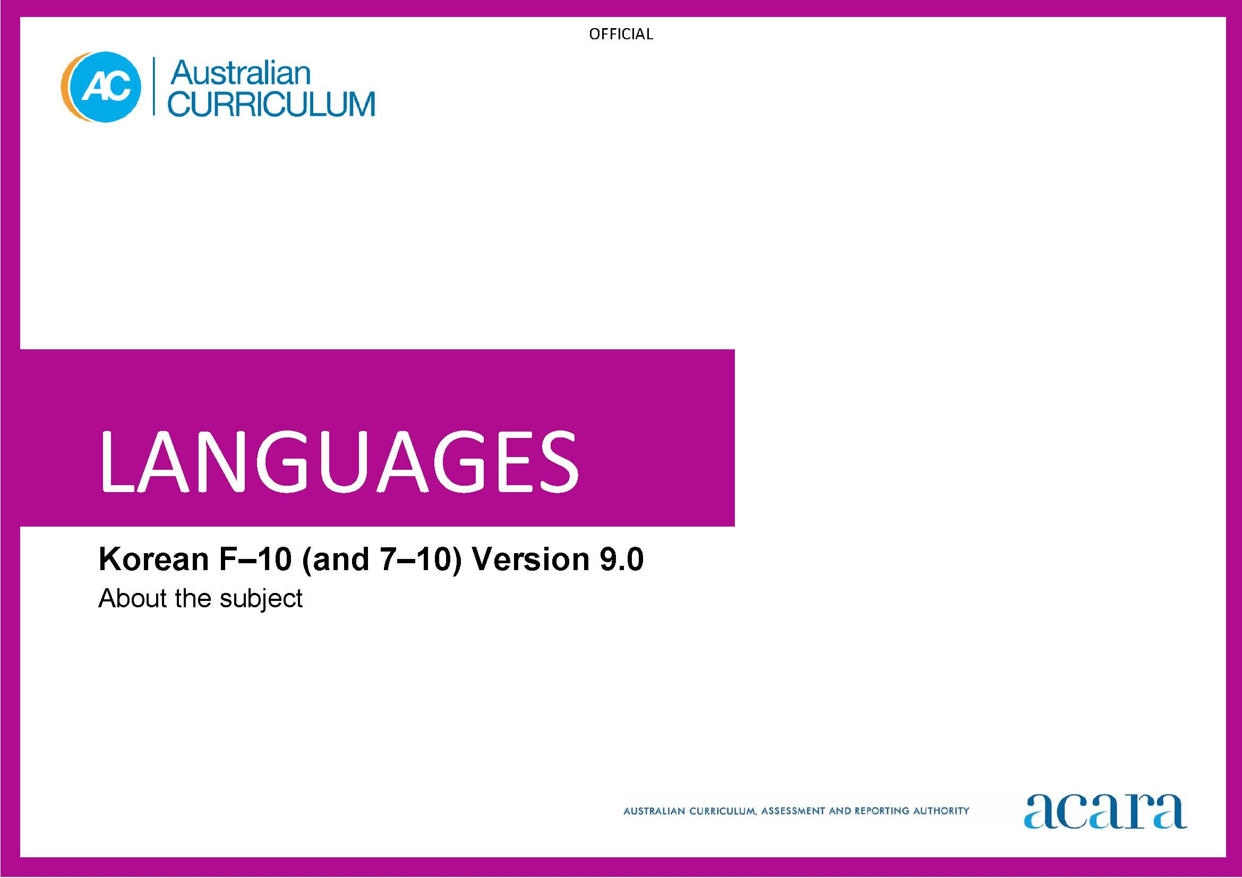

**Copyright and Terms of Use Statement**

**© Australian Curriculum, Assessment and Reporting Authority 2022**

The material published in this work is subject to copyright pursuant to the Copyright Act 1968 (Cth) and is owned by the Australian Curriculum, Assessment and Reporting Authority (ACARA) (except to the extent that copyright is held by another party, as indicated).

The viewing, downloading, displaying, printing, reproducing (such as by making photocopies) and distributing of these materials is permitted only to the extent permitted by, and is subject to the conditions imposed by, the terms and conditions of using the ACARA website (see, especially, clauses 2, 3 and 4 of those terms and conditions). The terms and conditions can be viewed at [https://www.acara.edu.au/contact-us/copyright](https://aus01.safelinks.protection.outlook.com/?url=https%3A%2F%2Fwww.acara.edu.au%2Fcontact-us%2Fcopyright&data=04%7C01%7CSharon.Foster%40acara.edu.au%7C9931e11fa7684c603e6308d98331bbfb%7C6cf76a3aa824427092003d71673ec678%7C0%7C0%7C637685071906340874%7CUnknown%7CTWFpbGZsb3d8eyJWIjoiMC4wLjAwMDAiLCJQIjoiV2luMzIiLCJBTiI6Ik1haWwiLCJXVCI6Mn0%3D%7C1000&sdata=U5O4Vlbpf271IGmGiMh7fDwU4pLzzAiHpCQFylkp6s4%3D&reserved=0)

TABLE OF CONTENTS

F–10 AUSTRALIAN CURRICULUM: LANGUAGES – KOREAN 3

**ABOUT KOREAN** 3

Introduction 3

Rationale 3

Structure 4

F–10 AUSTRALIAN CURRICULUM: LANGUAGES – KOREAN

ABOUT KOREAN

Introduction

The Australian Curriculum: Korean is pitched to second language learners, that is, the dominant group of learners in the current Australian context for whom Korean is an additional language.

Students of Korean in Australian schools come from a range of backgrounds. For many students it may be their first experience of learning Korean, while some may have existing connections to Korean as background speakers of the language.

Rationale

Korean is the official language of South Korea (Republic of Korea) and North Korea (Democratic People’s Republic of Korea) and is spoken in communities worldwide. South Korea is one of the most technologically advanced societies and economies in the Asian region. It is developing global reach in its innovation of high-technology products and vehicles, and popular culture. South Korea and Australia have established relationships through cultural and educational exchanges, and economic, political and trade partnerships.

Korean migration has made a significant contribution in shaping multicultural Australia. There has been an increasing number of Korean-speaking communities throughout Australia since the late 1960s. The influence of and interest in Korean cuisine, as well as pop culture such as K Pop, cosmetics, movies and television shows, are increasingly evident in Australian society.

Learning Korean enhances students’ understanding of different alphabets, writing systems and language learning strategies, and develops an appreciation of the language and cultures of Korean-speaking communities. Knowledge of Korean language and culture enriches travel experiences, increases employment opportunities, and promotes understanding of diverse attitudes, beliefs and values.

Structure

Korean has been developed as a Second Language Learner Pathway which caters for students learning Korean as a second or additional language.

The Second Language Learner Pathway includes 2 sequences:

* Foundation to Year 10
* Years 7 to 10.

Teachers use the curriculum to cater for learners of different backgrounds by making appropriate adjustments to differentiate learning experiences.

Content in Korean is organised under 2 interrelated strands, each with a number of sub-strands. The strands and sub-strands are presented in Figure 1.

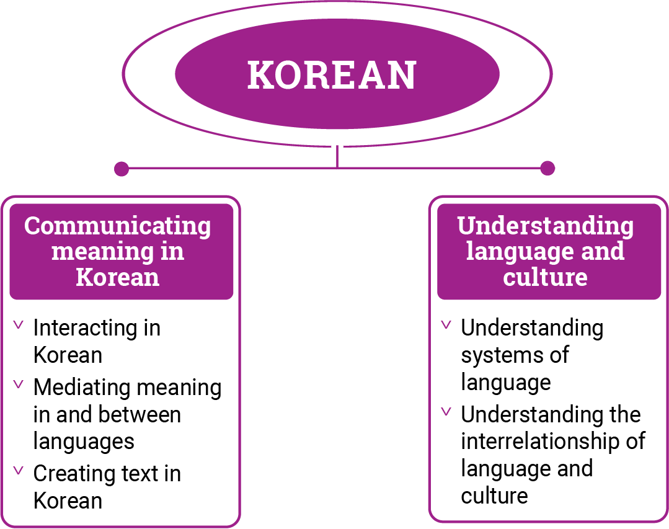

*Figure 1: Korean content structure*

Strand: Communicating meaning in Korean

This involves students learning to use language for communicative purposes in interpreting, creating and exchanging meaning. There are 3 sub-strands.

**Interacting in Korean**

Exchanging ideas, opinions, experiences, thoughts and feelings in non-verbal, spoken and written interactions; participating in planning, negotiating, deciding and taking action.

**Mediating meaning in and between languages**

Obtaining, processing, interpreting and conveying information through a range of spoken, written and multimodal texts; moving between languages and cultures non-verbally, orally and in writing, recognising different interpretations.

**Creating text in Korean**

Creating a range of spoken, written and multimodal texts for specific contexts, purposes and audiences.

Strand: Understanding language and culture

This involves students learning to analyse and understand language and culture as resources for interpreting and shaping meaning in intercultural exchange. There are 2 sub-strands.

**Understanding systems of language**

Understanding the linguistic features of Korean, including sound, writing, grammatical and textual conventions.

**Understanding the interrelationship of language and culture**

Analysing and reflecting on the role of language and culture in shaping meaning and identity.