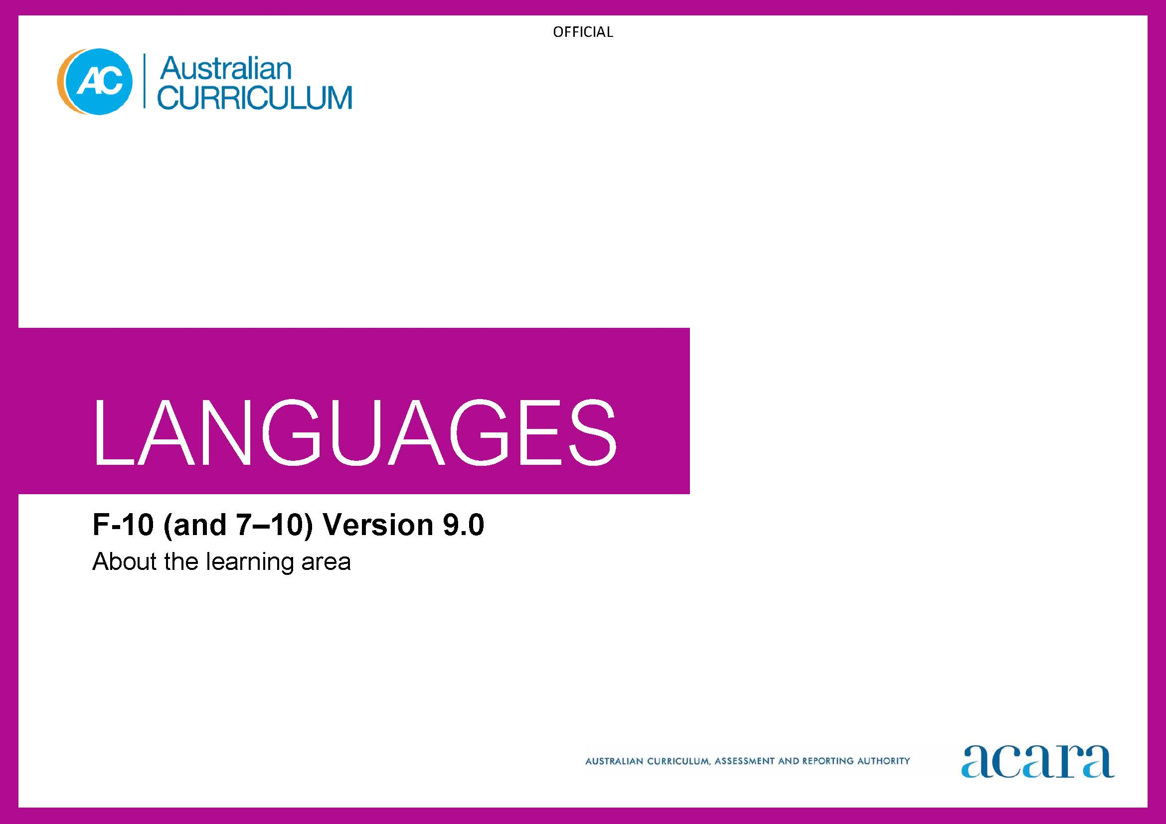

Contents

F–10 AUSTRALIAN CURRICULUM: LANGUAGES 3

ABOUT THE LEARNING AREA 3

Introduction 3

Rationale 3

Aims 4

Structure 5

Key considerations 10

Key connections 13

Resources 17

F–10 AUSTRALIAN CURRICULUM: LANGUAGES

ABOUT THE LEARNING AREA

Introduction

The Australian Curriculum: Languages has been developed to give all students the opportunity to engage in learning a language in addition to English. The design of the Languages curriculum recognises features that all languages share as well as the distinctiveness of each language.

Languages includes language-specific curricula and frameworks for world languages and a Framework for Aboriginal Languages and Torres Strait Islander Languages.

Learners of languages in Australia comprise 3 major groups:

1. **Second-language learners:** Second-language learners are introduced to learning the target language at school as an additional, new language. The first language used before they start school (and/or the language used at home) is not the language being learnt.
2. **Background-language learners:** Background-language learners may use the language at home, not necessarily exclusively, and have varying degrees of knowledge of, and proficiency in, the language being learnt. These learners have a base for literacy development in the language.
3. **First-language learners:** First-language learners are learners who use, and/or identify with, the language as their mother tongue; learners use the language for primary socialisation and/or education and/or literacy development.

Rationale

Communication is a human imperative. Irrespective of which language, communication involves interaction to convey meaning as well as imagination, creativity and a broad understanding of ourselves and others. Language learning provides the opportunity for students to engage with the linguistic and cultural diversity of the world and its peoples, and reflect on their experience in various aspects of social life, including their own participation and ways of being in the world.

Learning a language(s) broadens students’ horizons in relation to the personal, social, cultural and employment opportunities that an increasingly interconnected and interdependent world can offer. The interdependence of countries and communities means people in all spheres of life are required to negotiate experiences and meanings across languages and cultures. Despite its status as a world language, a capability solely in English can limit global opportunities. A bilingual or pluri-lingual capability is the norm in many parts of the world.

Learning language(s) develops learners’:

* communication skills
* literacy skills in their first and additional languages
* intercultural capabilities
* understanding of, and respect for, diversity and difference, and an openness to different experiences and perspectives
* understanding and appreciation of how culture shapes world views and extends their understanding of themselves, their own heritage, values, culture and identity
* critical and creative thinking.

Learning a language provides opportunities for the community to engage socially, culturally and economically in domains which include business, communications, diplomacy, education, health, international relations, law, science, tourism and trade.

For First Nations Australian students, learning their own language(s) is crucial to overall learning and achievement to develop a sense of identity and recognition, and understanding of language, culture, and Country/Place. For all students, learning Aboriginal languages and Torres Strait Islander languages provides a distinctive means of understanding the country in which they live, including the relationship between land, the environment and people. Ongoing and necessary reclamation and revitalisation of these languages contribute to reconciliation.

Aims

The 3 interrelated aims of Languages are to develop knowledge, understanding and skills to ensure students:

* develop linguistic competence
* understand language and culture, and their relationship, and thereby develop an intercultural capability in communication
* understand themselves as communicators.

Structure

The structure in Languages is presented in one or 2 sequences that offer alternative entry points into language learning, from Foundation to Year 10 and/or Year 7 to Year 10.

The Foundation to Year 10 sequence is presented in bands of 2-year levels after the Foundation year. The Years 7 to 10 sequence is presented in bands of 2-year levels: Years 7 and 8; and Years 9 and 10.

Content in Languages is organised under 2 interrelated strands, each with a number of sub-strands.

The strands and sub-strands for modern languages are presented in Figure 1. The strands and sub-strands for classical languages are presented in Figure 2. There are some variations in sub-strands among languages.

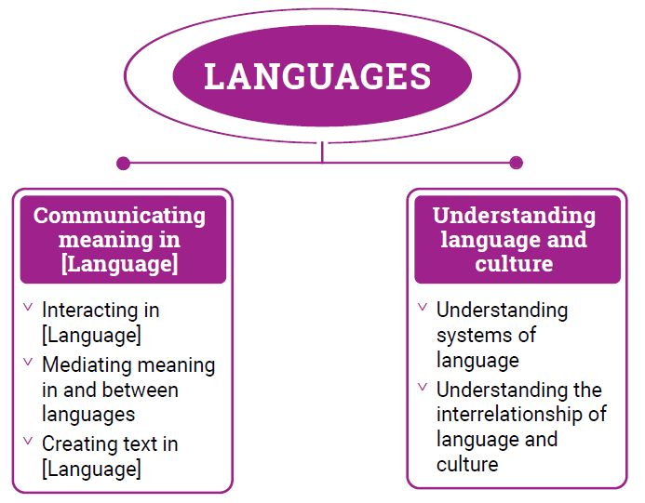

Figure 1: Modern languages content structure

**Strand: Communicating meaning in [Language]**

This involves students learning to use language for communicative purposes in interpreting, creating and exchanging meaning. There are 3 sub-strands.

**Interacting in [Language]**

Exchanging ideas, opinions, experiences, thoughts and feelings in non-verbal, spoken and written interactions; participating in planning, negotiating, deciding and taking action.

**Mediating meaning in and between languages**

Obtaining, processing, interpreting and conveying information through a range of spoken, written and multimodal texts; moving between languages and cultures non-verbally, orally and in writing, recognising different interpretations.

**Creating text in [Language]**

Creating a range of spoken, written and multimodal texts for specific contexts, purposes and audiences.

**Strand: Understanding language and culture**

This involves students learning to analyse and understand language and culture as resources for interpreting and shaping meaning in intercultural exchange. There are 2 sub-strands.

**Understanding systems of language**

Understanding the linguistic features of the language, including sound, writing, grammatical and textual conventions.

**Understanding the interrelationship of language and culture**

Analysing and reflecting on the role of language and culture in shaping meaning and identity.

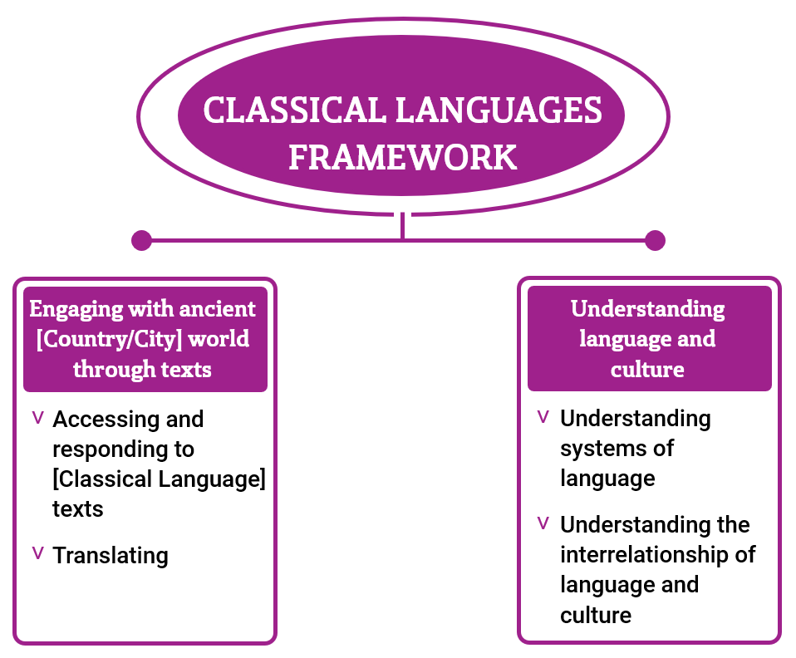

*Figure 2: Classical languages content structure* 

**Strand: Engaging with the ancient [Country/City] world through texts**

This involves students engaging with the language, culture and history of the ancient [Country/City] world through the interpretation, analysis and translation of [Classical Language] texts. There are 2 sub-strands.

**Accessing and responding to [Classical language] texts**

Engaging with and responding to the ideas and people of the ancient world, through texts that reveal language use and social and cultural practices.

**Translating**

Translating [Classical language] texts into English, comparing and explaining different interpretations of the same text.

**Strand: Understanding language and culture**

This involves students learning to analyse language and culture as resources for understanding meaning. There are 2 sub-strands.

**Understanding systems of language**

Understanding the linguistic features of [Classical language], including sound, writing, grammatical and textual conventions. 

**Understanding the interrelationship of language and culture**

Analysing and reflecting on the role of language and culture in shaping meaning and identity.

Key considerations

**Flexible entry points to F–10 and Years 7–10 sequences**

The Languages curriculum provides either one or 2 learning sequences to cater for different entry points into language learning and/or for different learning requirements. The curriculum recognises that these sequences do not necessarily represent the variety of entry points into the curriculum. Teachers can use the sequences flexibly to meet the needs of their students in their teaching and learning contexts.

**Use of English**

In modern languages students use the target language to communicate whenever possible in classroom, local or digital environments. The use of English provides opportunities for students to reflect on, explore and discuss ideas related to languages and cultures, and use metalanguage to talk about and compare languages.

In classical languages, the use of English provides opportunities for students to interpret, translate, and to reflect on, explore and discuss ideas related to languages and cultures, and use metalanguage to talk about and compare languages.

**Macro skills**

The macro skills of listening, speaking, reading, viewing and writing – also known as language modes – are interrelated. The learning of one often supports and extends the learning of others. To acknowledge these interrelationships, content in Languages incorporates these macro skills in an integrated and interdependent way.

Teaching and learning contexts will necessarily draw from more than one of these skills to support students’ effective learning. For example, students will learn new vocabulary, such as words, phrases and expressions, through listening, reading and viewing. They will apply their knowledge and understanding in their speaking and writing, as well as in their comprehension of spoken, visual, written and multimodal texts.

The macro skills are aligned most strongly to the Communicating meaning in [Language] strand in modern languages, and are implicit in the content of the sub-strands and across the content descriptions, as shown in Table 1.

Table 1: The relationship between macro skills and the Communicating meaning in [Language] strand in modern languages

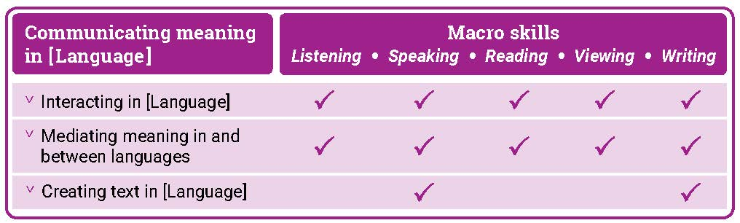

The macro skills are aligned most closely to the Engaging with the ancient [Country/City] world through texts strand in classical languages and are implicit in the content of the sub-strands and across the content descriptions, as shown in Table 2. For example, students will learn new vocabulary and grammatical structures and functions through listening, reading and viewing. They will apply their knowledge and understanding when they access, respond to and translate texts.

Table 2: The relationship between macro skills and the Engaging with the ancient [Country/City] world through texts strand in classical languages

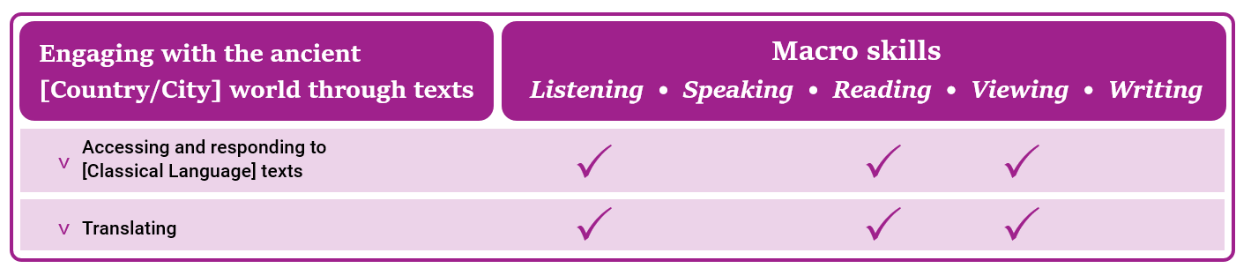

**Texts**

Texts can be spoken, written, visual, multimodal, and in print and digital/online forms. Multimodal texts combine language with other means of communication such as visual images and audio or spoken words in film or digital media. Texts include all forms of augmentative and alternative communication; for example, gesture, signing, real objects, photographs, pictographs and pictograms. Texts provide important opportunities for learning about aspects of students’ experiences of languages and cultures. Many of the tasks that students undertake in and out of school involve understanding and producing informative and imaginative texts in everyday and workplace contexts.

Teachers are best placed to guide the selection of materials for students to listen to, read, view, write and create. They provide purposeful activities that can be organised around these materials to meet the needs of the students in their classes.

**Protocols for engaging First Nations Australians**

When planning teaching activities involving engagement with First Nations Australians, teachers should follow protocols that describe principles, procedures and behaviours for recognising and respecting First Nations Australians and their intellectual property. Teachers should use approved resources such as those that may be provided by their state or territory school system, First Nations Australians education consultative groups or other protocols accredited by First Nations Australians.

While the Australian Curriculum uses the terms ‘First Nations Australians’ and ‘Australian First Nations Peoples’, there may be other terms that First Nations Australians of a particular area or location prefer. It is important to use the terms preferred in a particular area or location.

**Meeting the needs of diverse learners**

The Australian Curriculum values diversity by providing for multiple means of representation, action, expression and engagement, and allows schools the flexibility to respond to the diversity of learners within their community.

All schools have a responsibility when implementing the Australian Curriculum to ensure that students’ learning is inclusive, and relevant to their experiences, abilities and talents.

For some students with diverse languages, cultures, abilities and talents it may be necessary to provide a range of curriculum adjustments so they can access age-equivalent content in Languages and participate in learning on the same basis as their peers.

The study of languages is important in the multilingual societies and the global economy in which we live. Students with diverse identities, languages, cultures, abilities and talents benefit from the study of languages when an appropriate learning environment is provided.

Languages is intended for all students, and it is recognised that some students may require adjustments to support how they see, hear, and/or process language. Students may require access to a wide range of approaches and resources including, and not limited to:

* multi-sensory visual, auditory, tactile, and/or kinesthetic experiences and resources
* simultaneous learning channels such as combinations of listening, speaking, reading, viewing and writing resources to teach a language concept
* resources such as picture cues for words or hand and mouth movements to illustrate a sound, or colour-coding to illustrate number, grammatical gender or subject/verb agreements
* modified equipment and tools
* multilingual labels, signs and posters around the classroom
* devices, mnemonics, rhythms and rhymes to reinforce vocabulary, expressions and features
* peer-assisted learning
* open-ended tasks that provide flexibility and can be completed at different levels of complexity
* challenging individual and group extension activities.

Key connections

**General capabilities**

General capabilities equip young Australians with the knowledge, skills, behaviours and dispositions to live and work successfully. General capabilities support and deepen student engagement with learning area content and are best developed within the context of learning areas.

Opportunities to develop general capabilities in learning area content vary. In addition to Literacy and Numeracy, which are fundamental to all learning areas, the general capabilities of most relevance and application to Languages are Intercultural Understanding, Critical and Creative Thinking, Personal and Social capability, and Digital Literacy. These general capabilities are identified in content descriptions when they are developed or applied through the Languages content. They are also identified in content elaborations when they offer opportunities to add depth and richness to student learning.

**Literacy**

Languages develops students’ ability to listen to, read, view, create, and perform a range of spoken, written and multimodal texts in the target language. It provides opportunities for students to move between the target language and English to analyse, interpret and reflect on texts. Literacy development in the target language and English is interdependent: when learning additional languages, students enhance and extend their knowledge and understanding of English literacy and use their knowledge of English literacy and/or literacy in languages they bring to their learning, to strengthen their literacy development in the target language. They develop increasing fluency in the target language and the ability to reflect on and discuss their understanding of language as a system, using the metalanguage of English.

Learning an additional language(s) and English is mutually beneficial to literacy development. This is reflected in the links between language learning and the National Literacy Learning Progression (NLLP) in Languages. Content is linked to the expected level of literacy development that students, typically, would have achieved at each year/band of years. For example, students in Year 8 are likely to be operating at Level 6 in the Speaking sub-element of the NLLP. These students may not be operating at Level 6 Speaking in a second or additional language(s). However, the teacher can make connections and draw on students’ English literacy skills to support their learning of the second or additional language(s).

**Intercultural Understanding**

The Intercultural Understanding capability is core to Languages. In learning a second or additional language, students develop an appreciation of languages, cultures and beliefs including their own. Students learn about the strong interrelationships between languages and cultures and how these shape identity. They develop and apply intercultural understanding to value and respect diverse ways of communicating, thinking and behaving. They recognise how these are reflected in social and cultural practices, and language use. Students develop connections with communities and cultures, become aware of similarities and differences, and cultivate mutual respect. The Intercultural Understanding capability assists students to navigate and reflect on language use, perspectives and behaviours.

**Critical and Creative Thinking**

Languages develops students’ ability to think logically, critically and creatively. It provides opportunities for students to inquire, generate, analyse and reflect on a range of information, ideas and perspectives in spoken and written texts. Students learn how to analyse texts and interpret how the language of texts conveys meaning. They reflect on the thinking and processes used to mediate meaning between languages. They apply their knowledge of language as a system to new contexts and learn to revise and modify texts when considering context, purpose and audience.

**Personal and Social capability**

Languages enhances students’ personal and social capability. Through the Communicating meaning in [Language] strand, students develop a range of interpersonal skills essential to effective communication, such as decision-making, negotiation and collaboration. Content in both the Communicating meaning in [Language] and Understanding language and culture strands encourages students to develop an appreciation of diverse cultures and perspectives, and recognise how these influence identity, including their own.

**Digital Literacy**

Languages develops students’ digital literacy capability as they use a range of digital tools to access and create information, ideas and perspectives in multimodal texts. Students develop understanding of how they can use digital tools to access diverse language-speaking communities and authentic texts. They evaluate and analyse information in digital formats and develop understanding of their intended context, purpose and audience.

**Numeracy**

Languages develops students’ numeracy capability as they communicate in real or simulated real-life situations. Students use numbers in the target language to share information (time, directions, etc.) and understand how these might be represented in diverse languages and cultures. They use aspects of measurement in the language of transaction when using money, and units of measurement in the number, volume and weight of items. Students use number patterns and algebraic thinking when they recognise and apply the patterns of grammatical and syntactical rules to respond to and create text.

**Cross-curriculum priorities**

Cross-curriculum priorities support the Australian Curriculum to be a relevant, contemporary and engaging curriculum that reflects national, regional and global contexts. Cross-curriculum priorities are incorporated through learning area content; they are not separate learning areas or subjects. They provide opportunities to enrich the content of the learning areas, where most appropriate and authentic, allowing students to engage with and better understand their world.

Opportunities to apply cross-curriculum priorities to learning area content vary. All 3 cross-curriculum priorities have relevance and meaning to the Languages curriculum.

**Aboriginal and Torres Strait Islander Histories and Cultures**

Languages recognises the interrelationship of languages and cultures. Languages together with the Aboriginal and Torres Strait Islander Histories and Cultures cross-curriculum priority enable students to develop knowledge and understanding by engaging students with the languages and cultures of First Nations Australians. Students can make interlinguistic and intercultural connections across languages with First Nations Australian languages and their cultural expression. They develop understanding of concepts related to the diverse linguistic landscape of Australia.

The Framework for Aboriginal Languages and Torres Strait Islander Languages provides opportunities for all students to learn languages of First Nations Australians. Each language is recognised as belonging to a group of people who are its Custodians. Schools must seek advice and consent from the Custodians when developing language-specific curricula and planning language programs.

**Asia and Australia’s Engagement with Asia**

Languages provides learning opportunities in combination with the Asia and Australia’s Engagement with Asia cross-curriculum priority. Students develop knowledge and understanding by engaging with the languages and cultures of Asia, and people of Asian heritage.

Languages enables students to learn languages of the Asian region and to communicate, interact and explore concepts, experiences and perspectives from within and across Asian cultures. Students develop an appreciation for the place of Australia within the Asian region, including the interconnections of languages and cultures, peoples and communities, and histories and economies. They learn how national linguistic and cultural identities continuously evolve in local, regional and international contexts.

**Sustainability**

Languages provides students with opportunities to develop the world views necessary to contribute to a sustainable future by reflecting on how they interpret and engage with the world and its peoples. The learning contexts in which students develop their language learning provide opportunities for them to explore actions to improve sustainability in local, national and global communities.

When learning a language, students develop understanding of diverse attitudes, beliefs and values, and ways of thinking and being. They learn that sustainability is relevant to the dynamic nature of language and its continuous changes and variations over time and place. They develop understanding that sometimes, due to globalisation, societal and political influences, languages may become vulnerable and at risk of losing their uniqueness or usage. Students consider the value of sustaining language knowledge and use, and reflect on its important connection to cultural expression.

**Learning areas**

Languages provides opportunities to integrate and connect content to other learning areas; in particular, English, Humanities and Social Sciences and The Arts.

**Languages and English**

Languages and English support students’ literacy development. Both learning areas share the focus for students to interact with others and create spoken, written and multimodal texts with an awareness of context, purpose and audience. Languages and English help students to understand the relationship between spoken and written language, and recognise how cultural context shapes meaning. They develop students’ understanding of, and ability to use, grammatical and language features.

**Languages and Humanities and Social Sciences**

Languages and Humanities and Social Sciences subjects share learning contexts that progressively shape the students’ world. In both learning areas, students’ learning involves perspectives of their personal worlds, such as personal and family histories and events, their local communities, and national and global contexts. In the process of understanding an expanding world view, both learning areas help students to learn to reflect on the relationship between cultures and identities.

**Languages and The Arts**

Languages and The Arts share a focus on the communication of stories, ideas, perspectives and cultures. Both learning areas help students to explore relationships among people, cultures and identities, and recognise how these are exemplified in and through linguistic and artistic practices and behaviours.

Resources

A scope and sequence representation of the curriculum, the glossary, and comparative information about Version 8.4 and Version 9 are available to download from the Australian Curriculum Version 9 website.

**Language support resource**

Each language curriculum has an optional resource, developed to support teachers as they plan teaching and learning programs. This resource provides suggestions for sequential development in language structures and features, and/or thematic contexts for language use. Teachers can use suggestions in the resource to adapt curriculum content to meet the diverse language and/or cultural background needs of students at different entry points into language learning. This optional resource is available to download from the ‘Learning area downloads’ page for each language.

**The Modern Languages support resource**

A Modern Languages support resource has been created to help jurisdictions and community groups develop curricula for languages outside those that have been published by ACARA in Version 9.0. It has been written to align with all previously published languages so that there may be commonality between these languages and those that may be developed using this resource.

To assess eligibility for developing a new language curriculum using this support resource, community groups should first consult with their local jurisdictions. Where appropriate, the jurisdictions may then provide direct access to the resource.