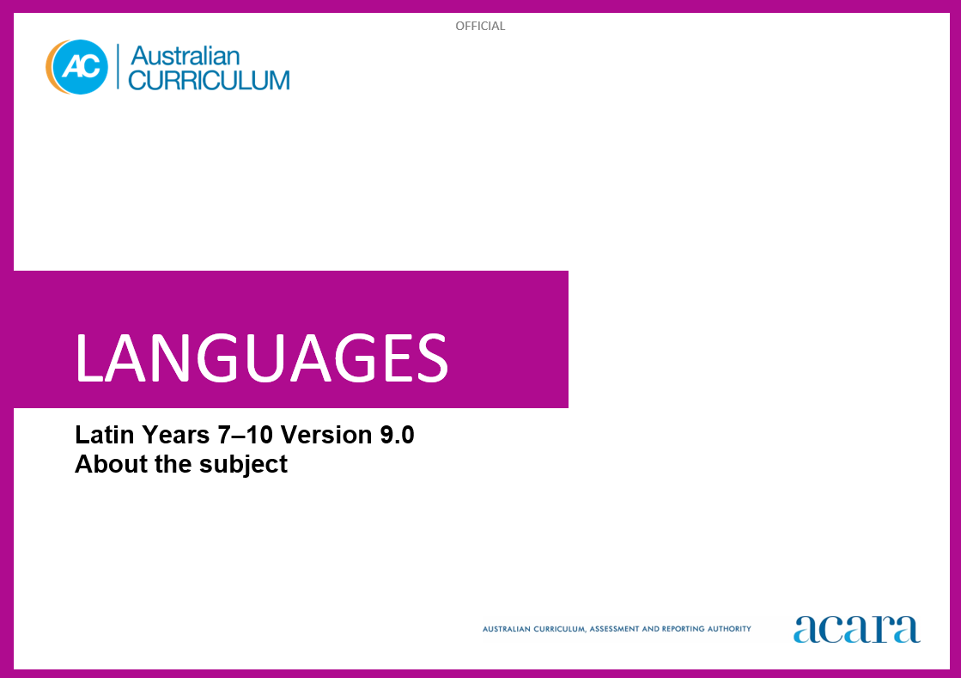**55555555555555555555555555555555555555555555555555555555555555555555555555555555555555555555555555555555555555555555555ient**

**Copyright and Terms of Use Statement**

**© Australian Curriculum, Assessment and Reporting Authority 2024**

The material published in this work is subject to copyright pursuant to the Copyright Act 1968 (Cth) and is owned by the Australian Curriculum, Assessment and Reporting Authority (ACARA) (except to the extent that copyright is held by another party, as indicated).

The viewing, downloading, displaying, printing, reproducing (such as by making photocopies) and distributing of these materials is permitted only to the extent permitted by, and is subject to the conditions imposed by, the terms and conditions of using the ACARA website (see, especially, clauses 2, 3 and 4 of those terms and conditions). The terms and conditions can be viewed at [https://www.acara.edu.au/contact-us/copyright](https://aus01.safelinks.protection.outlook.com/?url=https%3A%2F%2Fwww.acara.edu.au%2Fcontact-us%2Fcopyright&data=04%7C01%7CSharon.Foster%40acara.edu.au%7C9931e11fa7684c603e6308d98331bbfb%7C6cf76a3aa824427092003d71673ec678%7C0%7C0%7C637685071906340874%7CUnknown%7CTWFpbGZsb3d8eyJWIjoiMC4wLjAwMDAiLCJQIjoiV2luMzIiLCJBTiI6Ik1haWwiLCJXVCI6Mn0%3D%7C1000&sdata=U5O4Vlbpf271IGmGiMh7fDwU4pLzzAiHpCQFylkp6s4%3D&reserved=0)

TABLE OF CONTENTS

Years 7–10 AUSTRALIAN CURRICULUM: LANGUAGES – LATIN 3

ABOUT LATIN 3

Introduction 3

Rationale 3

Structure 3

Years 7­–10 AUSTRALIAN CURRICULUM: LANGUAGES – LATIN

ABOUT LATIN

Introduction

The Australian Curriculum: Latin is pitched to second language learners in Years 7–10, that is, the dominant structure and sequence of learning in the current Australian school context. For most students it is their first experience of learning Latin.

Rationale

Latin was the official language of Ancient Rome, and the language of transmission of Roman law, government, literature and cultural knowledge and values throughout much of Europe, North Africa and West Asia during the period 753 BCE–476 CE. After the fall of the Roman empire, Latin evolved into several regional dialects, some of which have become known as the Romance languages, for example, French, Italian, Portuguese, Romanian and Spanish. Latin has remained a language for literary, liturgical, legal, political, philosophical and scientific texts, many of lasting historical and aesthetic value.

Latin continued as the language of Western Christianity, and remains so today for the official business of the Roman Catholic Church and the Vatican City State. The enduring achievements and rich legacy of the ancient Roman world are evident in modern beliefs, customs and values, architecture, art, engineering, laws and forms of government, literature and medicine.

Latin has been taught in Australian schools and universities since the 1800s. By accessing and translating Latin texts and engaging with artefacts, students make connections with ancient worlds that have shaped contemporary life and societies. Learning Latin enhances students’ understanding of English due to its influence on the alphabet and vocabulary of English, some Latin terms and mottos which remain unchanged, and commonly used abbreviations. Knowledge of Latin and the ancient Roman world enriches students’ awareness of how an ancient civilisation influences life and thought in the modern world. This knowledge promotes understanding of diverse attitudes, beliefs and values.

Structure

Latin has been developed as a second-language learner pathway which caters for students learning Latin as a second or additional language in Years 7–10.

The second-language learner pathway includes one sequence:

* Years 7 to 10.

Teachers use the curriculum to cater for the range of learners by making appropriate adjustments to differentiate learning experiences.

Content in Latin is organised under 2 interrelated strands, each with a number of sub-strands. The strands and sub-strands are presented in Figure 1.

Figure 1: Latin content structure

**Strand: Engaging with the ancient Roman world through texts**

This involves students engaging with the language, culture and history of the ancient Roman world through the interpretation, analysis and translation of Latin texts. There are 2 sub-strands.

**Accessing and responding to Latin texts**

Engaging with and responding to the ideas and people of the ancient Roman world, through texts that reveal language use and social and cultural practices.

**Translating**

Translating Latin texts into English, comparing and explaining different interpretations of the same text.

**Strand: Understanding language and culture**

This involves students learning to analyse language and culture as resources for understanding meaning. There are 2 sub-strands.

**Understanding systems of language**

Understanding the linguistic features of Latin, including sound, writing, grammatical and textual conventions.

**Understanding the interrelationship of language and culture**

Analysing and reflecting on the role of language and culture in shaping meaning and identity.